VaaniQ: Cross-Lingual, Compression-Robust Detection and Calibrated Reliability Estimation for AI-Generated Voice in Indian Languages
Gaurav Phadale, Eshaan Sarkhawas, Aarav Phutane, Prajwal Patil
Mukesh Patel School of Technology Management & Engineering, NMIMS
Faculty Guide: Prof. Rama Bharti Varshney
Approved Round 3 research paper - frozen at commit 084bd47ca6ca1b69a7cdbf424e2946f3794c2a95
Abstract-VaaniQ studies multilingual audio-deepfake detection under language and codec shift rather than claiming universal deepfake detection. A bounded V1 benchmark of Kathbath real speech and IndicSynth fake speech covers Hindi, Marathi, and Tamil with speaker-disjoint evaluation (held-out n=584). An acoustic-embedding plus AASIST-compatible head reached 91.61% accuracy and 6.56% EER. Frozen facebook/wav2vec2-xls-r-300m with mean pooling reached 92.12% accuracy, 6.88% EER, and 0.9828 ROC-AUC. Experiments include WhatsApp-style 16 kbps Opus simulation, leave-one-language-out transfer, and validation-selected calibration. Benchmark V2 remains a partial external-source pilot. Human-study protocol ready; participant data collection pending (N=0).
Index Terms-audio deepfake detection, Indian languages, Kathbath, IndicSynth, WhatsApp-style Opus simulation, calibration, frozen XLS-R, speaker-disjoint evaluation

I. INTRODUCTION
Voice cloning can imitate speakers from short recordings and can be delivered as compressed messaging audio. Major anti-spoofing benchmarks remain concentrated in English or Mandarin. VaaniQ studies Hindi, Marathi, and Tamil on a bounded speaker-disjoint benchmark and measures codec shift, cross-lingual transfer, and confidence calibration. It does not claim universal fake-voice detection.
Five research questions are stated. RQ1: How does Opus compression affect detection performance? RQ2: How does English-only anti-spoofing transfer to Hindi, Marathi, and Tamil relative to multilingual training? RQ3: How well does the detector generalize to an unseen Indian language? RQ4: Does validation-selected post-hoc calibration remain reliable under held-out language/condition shift? RQ5: How does model performance compare with human listeners? RQ1-RQ4 are COMPLETE on the declared V1 benchmark. RQ5 is PENDING with N=0.
II. RELATED WORK
AASIST integrates spectro-temporal graph attention for anti-spoofing [1]. XLS-R provides cross-lingual self-supervised speech representations [2]. IndicSUPERB introduced Kathbath, a large human-labelled Indian-language speech resource [3]. IndicSynth provides synthetic speech for Indian languages [4]. Prior work shows that high classification accuracy does not guarantee calibrated confidence [5]. Muller et al. studied human perception of audio deepfakes [6]. To the best of our reviewed literature, the contribution is the integrated evaluation of Indic languages, codec shift, cross-lingual transfer, calibration, and human-study infrastructure rather than invention of XLS-R or AASIST.
III. DATASET
A. Bounded V1 Benchmark
The persisted source subset contains 1800 original clips (3.15 h): 900 Kathbath REAL and 900 IndicSynth FAKE, balanced across Hindi, Marathi, and Tamil. Paired validation/test 16 kbps libopus twins expand evaluation to 2,346 instances. Held-out test n=584. Bonafide clips follow Kathbath packaging terms; generated clips follow IndicSynth CC BY-NC 4.0 for non-commercial academic research.
V1 has a structural weakness: REAL equals Kathbath and FAKE equals IndicSynth. Source identity is therefore associated with class. Speaker-disjoint splitting protects against speaker leakage but does not remove source-domain shortcuts.
B. Partial V2 External-Source Pilot
Benchmark V2 is currently a partial external-source pilot. It adds an independent real-speech source but does not yet eliminate source-label confounding. Current cells are Kathbath×real 1,177, IndicSynth×fake 1,169, and FLEURS×real 50. Generator tags exist (freevc24 805; xtts_v2 364), but generator-disjoint evaluation has n=0 and remains PENDING.
TABLE I. DATASET COMPOSITION
Benchmark | Source | Class | Count | Status
V1 | Kathbath | REAL | 900 | COMPLETE
V1 | IndicSynth | FAKE | 900 | COMPLETE
V2 | Kathbath | REAL | 1,177 | PARTIAL
V2 | IndicSynth | FAKE | 1,169 | PARTIAL
V2 | FLEURS | REAL | 50 | PARTIAL
TABLE II. SPEAKER-DISJOINT V1 PARTITIONS
Partition | Instances | Role
Train | 1254 | Parameter learning
Validation | 508 | Checkpoint and calibration selection
Test | 584 | Final metrics only
IV. METHODOLOGY
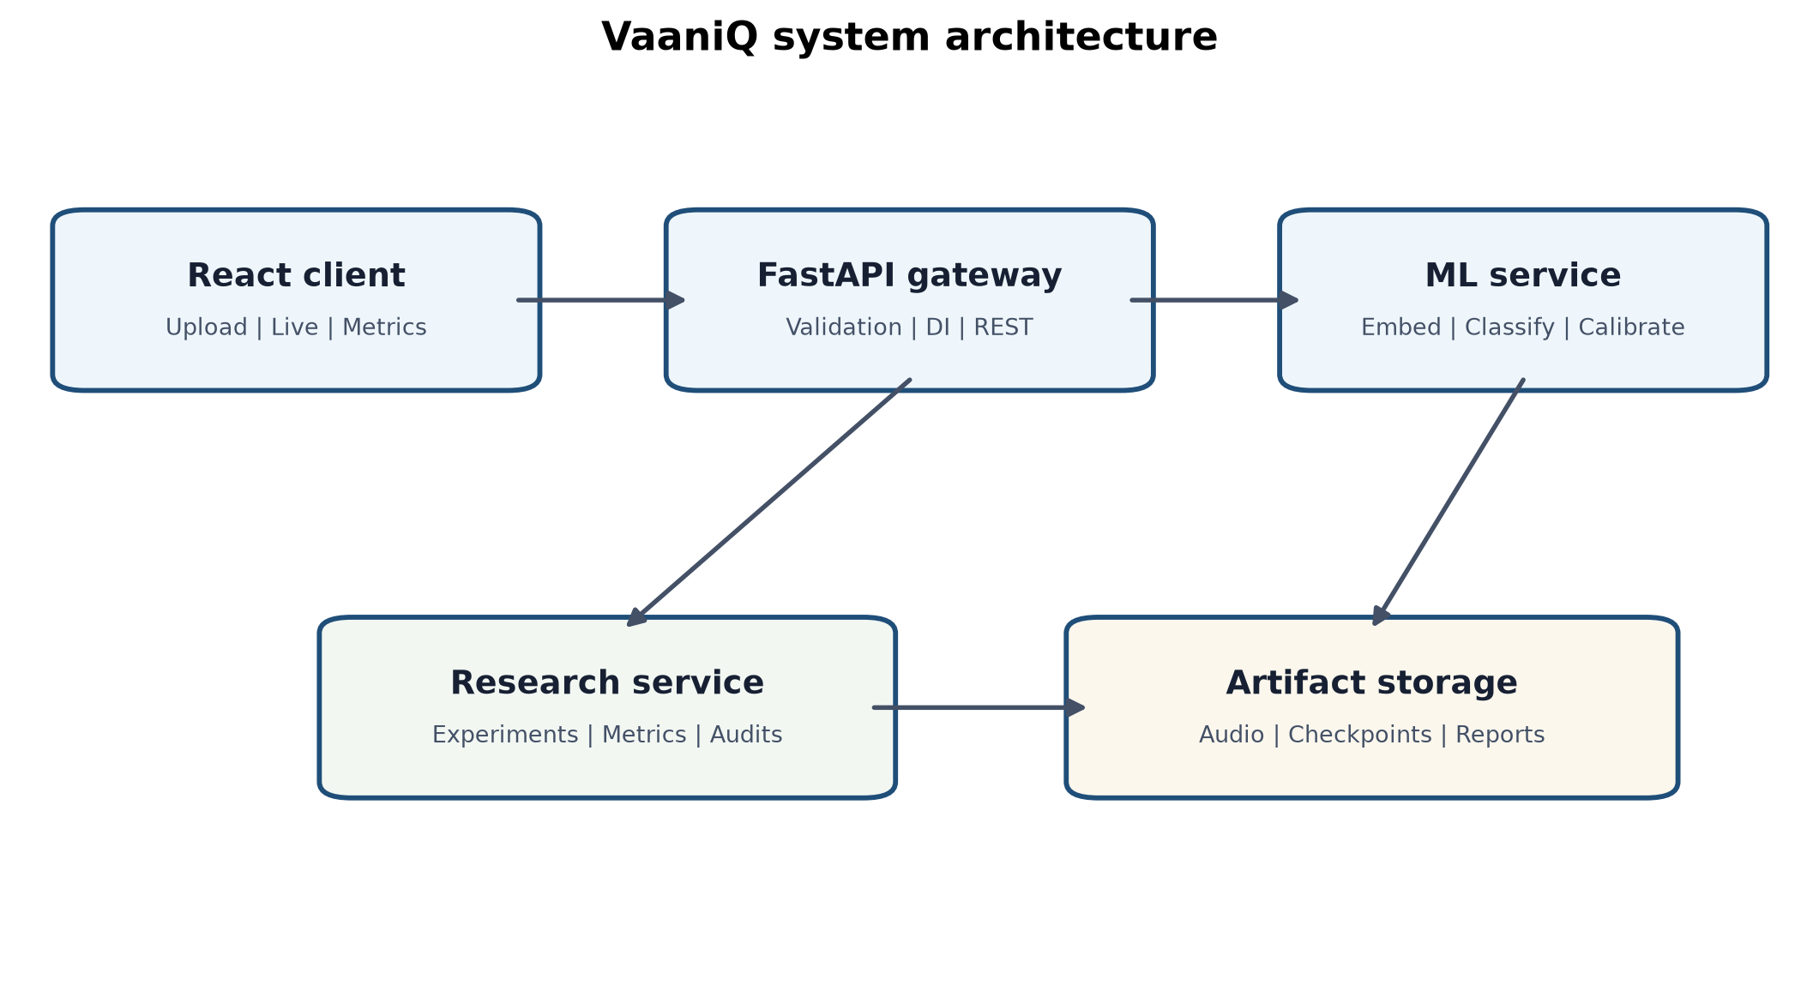
Fig. 1. VaaniQ software architecture. Pipeline: audio ? preprocess ? acoustic or frozen XLS-R path ? AASIST-compatible head ? calibration ? verdict.
A. Acoustic Baseline V1
Baseline V1 uses a deterministic 1024-D acoustic embedding and an AASIST-compatible NumPy classification head. It is not canonical AASIST and not XLS-R. The decision threshold is 0.5 on the fake softmax score. Label 0 is REAL/bonafide, label 1 is FAKE/spoof, and higher score_fake means higher probability of FAKE. Logit order is [real, fake].
B. Frozen XLS-R Main
The separate main path uses frozen facebook/wav2vec2-xls-r-300m, last-layer mean pooling, cached features, and a lightweight trainable AASIST-compatible head. The backbone is not updated. Production calibration for this path is global temperature scaling selected on validation.
C. Baselines and Controls
LFCC-GMM is a complete weak baseline. A RawNet2-style approximate baseline is complete but must not be called faithful RawNet2; faithful RawNet2 remains PENDING. An English-only ASVspoof LA control is evaluated on the same Indic held-out test.
D. Compression and Evaluation Protocol
ffmpeg/libopus at 16 kbps provides a WhatsApp-style Opus simulation. It is not audio transported through the WhatsApp service. EER, ROC-AUC, and normalized min-DCF use the same score direction. min-DCF uses P_target=0.05, C_miss=1, C_fa=1, with normalization denominator P_target × C_miss = 0.05.
V. RESULTS
TABLE III. PRIMARY HELD-OUT MODEL COMPARISON ON THE SAME V1 TEST SET
Model | n | Accuracy | Precision | Recall | F1 | EER | ROC-AUC | min-DCF
Acoustic Baseline V1 | 584 | 91.61% | 85.48% | 98.11% | 91.36% | 6.56% | 0.9729 | 0.7841
Frozen XLS-R main | 584 | 92.12% | 88.38% | 95.08% | 91.61% | 6.88% | 0.9828 | 0.3144
LFCC-GMM | 584 | 54.79% | 0.00% | 0.00% | 0.00% | 23.48% | 0.8195 | 0.4962
RawNet2-style approx. | 584 | 54.79% | 0.00% | 0.00% | 0.00% | 43.18% | 0.5845 | 0.9621
Frozen XLS-R achieved 92.12% accuracy and ROC-AUC 0.9828 on the same 584-instance held-out V1 test set. Its EER of 6.88% was comparable to the acoustic baseline's 6.56%, indicating stronger ranking performance without a uniform improvement across all decision metrics. An earlier acoustic checkpoint produced 93.66% accuracy, but the frozen Round 3 canonical checkpoint produces 91.61%; EER remained 6.56% because ranking behavior remained similar. That 93.66% figure is historical only.
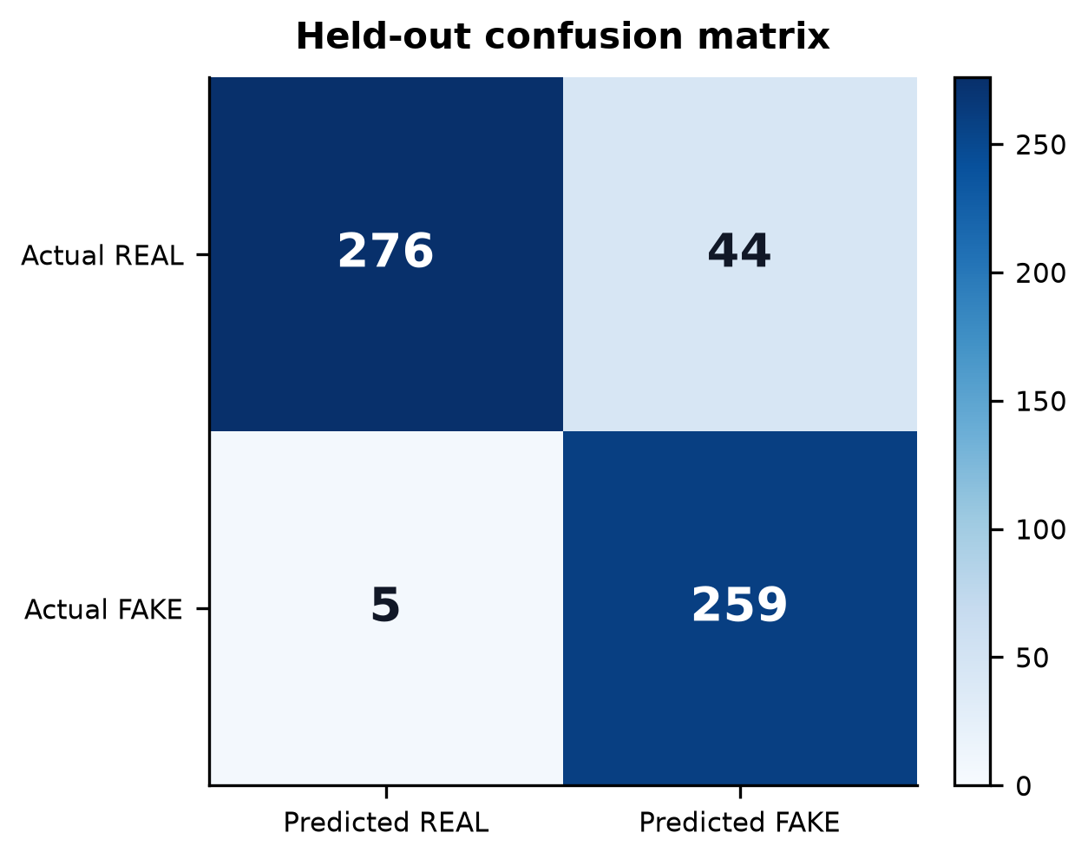
Fig. 2. Confusion matrix for Acoustic Baseline V1 on the held-out V1 test partition (n=584).
VI. COMPRESSION (RQ1)
TABLE IV. RQ1 ACOUSTIC BASELINE V1, CLEAN VERSUS OPUS
Condition | n | Accuracy | EER | F1
Clean | 292 | 93.84% | 5.63% | 93.53%
Opus 16 kbps WhatsApp-style simulation | 292 | 89.38% | 7.58% | 89.27%
TABLE V. RQ1 FROZEN XLS-R, CLEAN VERSUS OPUS
Condition | n | Accuracy | EER | F1
Clean | 292 | 91.44% | 8.13% | 91.04%
Opus 16 kbps WhatsApp-style simulation | 292 | 92.81% | 6.06% | 92.19%
Compression effects were model-dependent. Acoustic Baseline V1 degraded from 93.84% clean accuracy to 89.38% under WhatsApp-style Opus simulation (approximately 4.46 percentage points). Frozen XLS-R did not show the same degradation on this bounded split (91.44% clean, 92.81% Opus). These numbers must not be mixed across models.
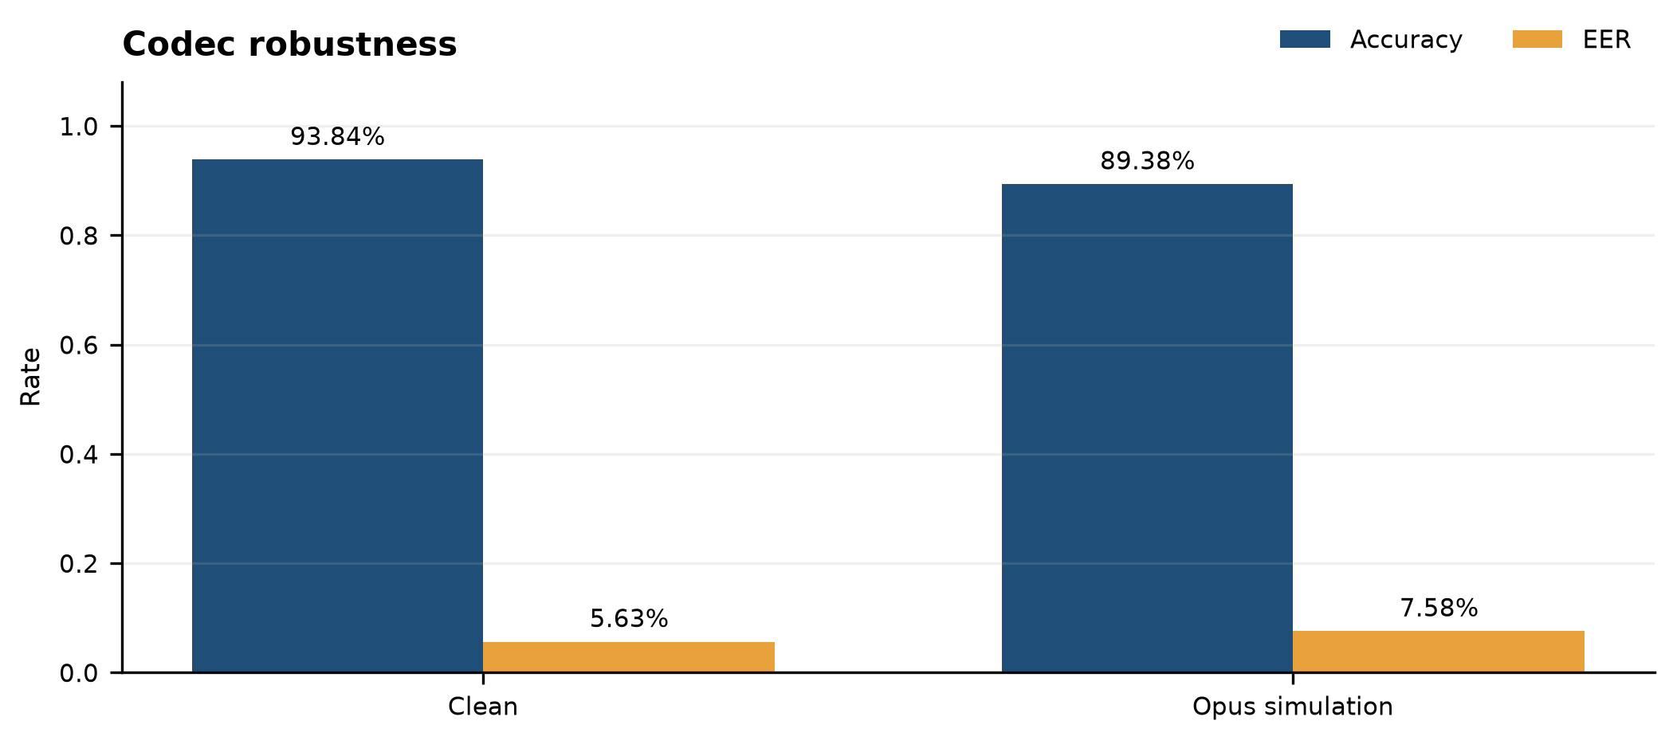
Fig. 3. Acoustic Baseline V1 clean versus WhatsApp-style Opus simulation on paired test instances.
VII. ENGLISH-ONLY TRANSFER (RQ2)
TABLE VI. RQ2 ENGLISH-ONLY VERSUS MULTILINGUAL ON THE SAME INDIC TEST
Model | n | Accuracy | EER | ROC-AUC
English-only ASVspoof LA ? Indic test | 584 | 54.8% | 76.56% | 0.162
Multilingual Acoustic Baseline V1 | 584 | 91.61% | 6.56% | 0.9729
The English-only model failed to transfer effectively to the Indic benchmark: 54.8% accuracy, 76.56% EER, and 0.162 ROC-AUC, predicting every instance as REAL at threshold 0.5. A diagnostic that multiplies scores by ?1 yields ROC-AUC 0.838 and EER 23.44%, but official scores were not flipped. The global VaaniQ score contract is validated by multilingual Baseline V1 (91.61% accuracy, 6.56% EER, 0.9729 ROC-AUC) on the same test. The result is catastrophic English?Indic transfer with anti-correlated ranking, not a generic score-inversion bug.
VIII. CROSS-LINGUAL TRANSFER (RQ3)
TABLE VII. RQ3 LEAVE-ONE-LANGUAGE-OUT TRANSFER
Held-out language | n | Accuracy | EER
Hindi | 222 | 78.83% | 21.83%
Marathi | 164 | 93.29% | 7.14%
Tamil | 198 | 93.94% | 6.35%
Cross-lingual transfer was asymmetric. Hindi held-out accuracy was 78.83% with 21.83% EER, whereas Marathi and Tamil reached 93.29% and 93.94%. The study does not claim uniform language-independent generalization.
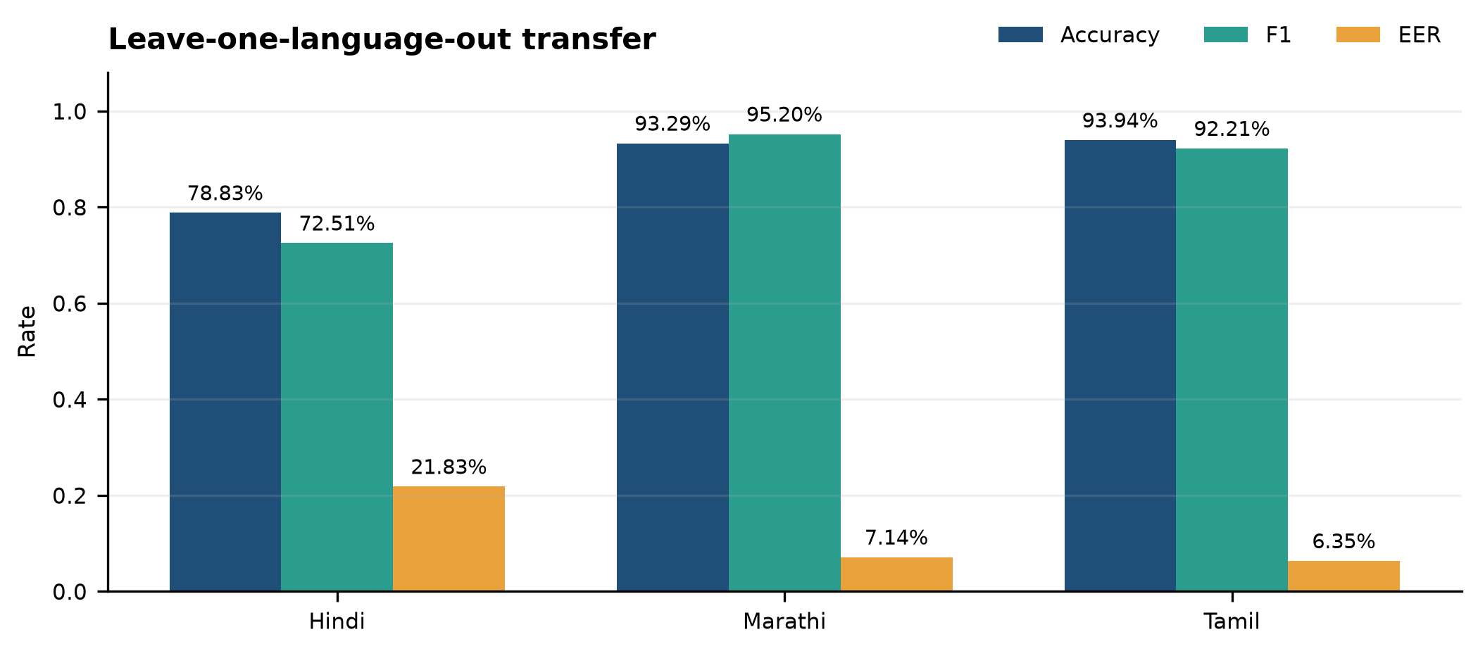
Fig. 4. Leave-one-language-out transfer. Hindi is substantially weaker than Marathi and Tamil.
IX. CALIBRATION (RQ4)
TABLE VIII. RQ4 CALIBRATION SELECTION AND HELD-OUT OUTCOME
Quantity | Value | Split
Selected Baseline V1 strategy | per_language_and_condition | Validation only
Selected strategy val ECE | 0.0487 | Validation
Global TS val ECE | 0.0513 | Validation
Uncalibrated test ECE | 0.0245 | Held-out test
Post-calibration test ECE | 0.0260 | Held-out test
Exploratory best-by-test-ECE | global_temperature | Not used for selection
Calibration strategy was selected using validation only. For Baseline V1, the selected fine-grained per-language-and-condition strategy (val ECE 0.0487 versus global 0.0513) did not improve held-out ECE (0.0245 uncalibrated to 0.026 post-calibration). A standalone test comparison where global temperature scaling looked better (test ECE 0.0378 versus exploratory global TS) is not evidence for selecting the production strategy. Validation-selected calibration did not uniformly improve held-out calibration. Frozen XLS-R used global temperature scaling selected on validation.
X. V2 PILOT AND GENERALIZATION STATUS
TABLE IX. V2 PILOT AND REMAINING GENERALIZATION STATUS
Eval | n | Status | Result
V2 full test | 593 | PARTIAL | Pilot population, not confound-free
FLEURS unseen-real | 9 | PILOT | 55.6% retained only as pipeline validation
Generator-disjoint | 0 | PENDING | No result claimed
V2 source probe | 593 | PARTIAL | 98.48% source identity
Faithful RawNet2 | - | PENDING | Not implemented
RQ5 human study | 0 | BLOCKED ON HUMAN DATA | Protocol ready; N=0
V2 source-probe accuracy is 98.48% versus a 85.83% label probe, showing that source identity remains highly predictable. No statistically useful unseen-source estimate is claimed from the current nine held-out FLEURS clips; the result is retained only as pipeline-validation evidence. Human-study protocol ready; participant data collection pending (N=0).
XI. LIMITATIONS AND THREATS TO VALIDITY
Key threats are: (1) V1 source-label confound; (2) bounded dataset size; (3) academic speech versus actual scam audio; (4) simulated Opus versus real WhatsApp transport; (5) three-language scope; (6) no faithful RawNet2; (7) incomplete V2; (8) V2 source probe 98.48%; (9) FLEURS external pilot n=9; (10) generator-disjoint n=0; (11) RQ5 N=0; (12) calibration transfer uncertainty; (13) validation/test heterogeneity (Tamil val 71.5% versus test 90.9%; Marathi val 98.4% versus test 93.3%) with no proven leakage but no fully resolved cause; and (14) no claim of universal unseen-generator robustness. Strong EER/ROC-AUC can coexist with Baseline V1 min-DCF 0.7841 because min-DCF uses a 5% target prior.
XII. ETHICS
Audio and model weights are excluded from version control. Kathbath access conditions and IndicSynth non-commercial restrictions are respected. The human protocol is anonymous, reveals no gold labels during trials, and has not yet collected participants.
XIII. REPRODUCIBILITY
Authoritative metrics are frozen in artifacts/final_results_manifest.json at commit 084bd47ca6ca1b69a7cdbf424e2946f3794c2a95. Manifests record source, label, speaker, split, duration, checksum, and generation model. Integrity verification is scripts/verify_research_integrity.py. Documents must consume the frozen manifest rather than superseded checkpoints or rounded tables.
XIV. CONCLUSION
VaaniQ establishes a reproducible multilingual research framework for studying audio-deepfake detection under language, codec, and confidence-calibration shift. On the bounded V1 benchmark, both the acoustic and frozen XLS-R pipelines achieve strong held-out discrimination, while cross-language, calibration, and external-source experiments expose important limitations. The current evidence supports the value of multilingual evaluation but does not establish universal source- or generator-independent detection.
. REFERENCES
[1] J. Jung et al., AASIST: Audio anti-spoofing using integrated spectro-temporal graph attention networks, in Proc. ICASSP, 2022.
[2] A. Babu et al., XLS-R: Self-supervised cross-lingual speech representation learning at scale, arXiv:2111.09296, 2021.
[3] T. Javed et al., IndicSUPERB: A speech processing universal performance benchmark for Indian languages, arXiv:2208.11761, 2022.
[4] D. V. Sharma, V. Ekbote, and A. Gupta, IndicSynth: A large-scale multilingual synthetic speech dataset, ACL, 2025.
[5] O. Pascu et al., Towards calibrated and explainable audio deepfake detection, in Proc. Interspeech, 2024.
[6] N. M. Muller et al., Human perception of audio deepfakes, in Proc. ACM Workshop on Information Hiding and Multimedia Security, 2022.
[7] AI4Bharat, Kathbath dataset, Hugging Face: ai4bharat/Kathbath.
[8] D. V. Sharma et al., IndicSynth dataset, Hugging Face: vdivyasharma/IndicSynth.
[9] A. Conneau et al., FLEURS: Few-shot learning evaluation of universal representations of speech, arXiv:2205.12446, 2022.
[10] IETF RFC 6716, Definition of the Opus Audio Codec, 2012.
[11] ASVspoof 2019, logical access evaluation plan; English-only control uses a streaming subset of Bisher/ASVspoof_2019_LA (ODC-By).

