VaaniQ: Cross-Lingual, Compression-Robust Detection and Calibrated Reliability Estimation for AI-Generated Voice in Indian Languages
Gaurav Phadale, Eshaan Sarkhawas, Aarav Phutane, Prajwal Patil
Mukesh Patel School of Technology Management & Engineering, NMIMS
Faculty Guide: Prof. Rama Bharti Varshney
IEEE archival draft — frozen Round 3 evidence at commit 084bd47ca6ca1b69a7cdbf424e2946f3794c2a95. RQ1–RQ4 complete on the bounded machine-evaluated benchmark.
Abstract—Voice cloning enables scalable audio fraud, yet anti-spoofing evidence remains concentrated in English/Mandarin and rarely couples Indian-language stimuli with messaging-style compression, confidence calibration, and cross-lingual transfer. VaaniQ builds a bounded speaker-disjoint benchmark for Hindi, Marathi, and Tamil (Kathbath real; IndicSynth fake) and evaluates detection under clean audio and WhatsApp-style 16 kbps Opus simulation. On 584 held-out instances, an acoustic AASIST-compatible head reaches 91.61% accuracy and 6.56% EER; frozen wav2vec2-xls-r-300m reaches 92.12% accuracy, 6.88% EER, and 0.9828 ROC-AUC. Compression effects are model-dependent; English-only transfer collapses; leave-one-language-out transfer is asymmetric; validation-selected calibration does not uniformly improve held-out ECE. Benchmark V2 remains a partial external-source pilot, so claims are restricted to the declared machine-evaluated corpus and attack sources.
Index Terms—audio deepfake detection, Indian languages, Kathbath, IndicSynth, Opus compression, calibration, XLS-R, speaker-disjoint evaluation, cross-lingual transfer

I. INTRODUCTION
Neural voice cloning can imitate speakers from short enrollments and can be delivered as compressed chat audio. Major anti-spoofing benchmarks remain concentrated in English or Mandarin. VaaniQ studies Hindi, Marathi, and Tamil on a bounded speaker-disjoint benchmark and measures codec shift, cross-lingual transfer, and confidence calibration. It does not claim universal fake-voice detection. Telugu is out of project scope.
Contributions: (1) a versioned V1 publication corpus with paired Opus twins and held-out n=584; (2) complete RQ1–RQ4 results including negative calibration transfer and catastrophic English→Indic transfer retained honestly; (3) a reproducible research stack with frozen manifests and automated validation. Non-claims: not the first Indic detector; V1 source–label confounding is disclosed.
RQ1: Opus compression effects? RQ2: English-only versus multilingual transfer? RQ3: unseen-language (LOLO) generalisation? RQ4: validation-selected calibration under shift? RQ1–RQ4 are complete on the bounded benchmark.
II. RELATED WORK AND COMPARATIVE STUDY
A. Literature Axes
AASIST integrates spectro-temporal graph attention for anti-spoofing [1]. XLS-R provides cross-lingual self-supervised speech representations [2]. IndicSUPERB/Kathbath [3],[6] and IndicSynth [4],[7] supply Indic real and synthetic speech. Pascu et al. study calibrated SSL deepfake detection without Indian languages or an isolated WhatsApp-Opus cell [5]. FLEURS supports cross-lingual evaluation [8]. Opus is defined in RFC 6716 [9]. ASVspoof 2019 LA remains the English control resource [10]. Indic-CodecFake/SATYAM targets codec synthesis—a different attack surface than messaging-style Opus transport of cloning/TTS fraud audio—and does not couple Opus isolation with calibration analysis.
B. Feature Comparison Across Related Work
Cross-paper EER comparison is invalid under mismatched corpora. Table II compares evaluation axes only. VaaniQ does not claim to be first at Indic detection or calibration; the defensible contribution is their combination with isolated Opus and cross-lingual evaluation (proposal §5.7).
Axis summary: ASVspoof+AASIST supplies the non-Indic architecture benchmark; Pascu et al. supply calibration precedent without an isolated Opus cell; IndicSynth supplies Indic synthetic data; SATYAM studies codec synthesis rather than Opus transport; VaaniQ combines hi/mr/ta, a 16 kbps Opus cell, calibration, and LOLO evaluation.
C. Same-Test Empirical Comparison (n=584)
All systems below share identical V1 held-out clips, labels, threshold 0.5, and score contract—the only fair numeric comparison in this paper. Matching 54.79% accuracy for LFCC-GMM and RawNet2-style at threshold 0.5 is a documented coincidence; EER and ROC-AUC differ materially. Faithful RawNet2 remains PENDING.
TABLE I. COMPARATIVE STUDY — SAME VAANIQ V1 TEST
Model | Acc / EER | AUC / min-DCF
LFCC-GMM | 54.79% / 23.48% | 0.8195 / 0.4962
RawNet2-style approx. | 54.79% / 43.18% | 0.5845 / 0.9621
Acoustic AASIST-comp. | 91.61% / 6.56% | 0.9729 / 0.7841
Frozen XLS-R + head | 92.12% / 6.88% | 0.9828 / 0.3144
English-only control | 54.79% / 76.56% | 0.162 / —
D. In-Domain versus Leave-One-Language-Out
TABLE II. COMPARATIVE VIEW — IN-DOMAIN VS LOLO
Language | In-domain Acc / EER | LOLO Acc / EER
Hindi | 90.99% / 7.04% | 78.83% / 21.83%
Marathi | 93.29% / 6.25% | 93.29% / 7.14%
Tamil | 90.91% / 7.14% | 93.94% / 6.35%
Hindi zero-shot collapse (90.99% in-domain → 78.83% LOLO) is the standout RQ3 finding and caution against treating Indian languages as a homogeneous transfer class.
III. DATASET
A. Bounded V1 Benchmark
The persisted source subset contains 1800 original clips (3.15 h): 900 Kathbath REAL and 900 IndicSynth FAKE, balanced across Hindi, Marathi, and Tamil. Paired validation/test 16 kbps libopus twins expand evaluation to 2,346 instances. Held-out test n=584. Bonafide clips follow Kathbath packaging terms; generated clips follow IndicSynth CC BY-NC 4.0 for non-commercial academic research.
V1 has a structural weakness: REAL equals Kathbath and FAKE equals IndicSynth. Source identity is therefore associated with class. Speaker-disjoint splitting protects against speaker leakage but does not remove source-domain shortcuts.
B. Partial V2 External-Source Pilot
Benchmark V2 is a partial external-source pilot. It adds an independent real-speech source but does not eliminate source-label confounding. Current cells include Kathbath×real, IndicSynth×fake, and FLEURS×real. Generator-disjoint evaluation has n=0 and remains PENDING.
TABLE III. DATASET COMPOSITION
Benchmark | Source / Class | Count / Status
V1 | Kathbath / REAL | 900 / COMPLETE
V1 | IndicSynth / FAKE | 900 / COMPLETE
V2 | Kathbath / REAL | 1,177 / PARTIAL
V2 | IndicSynth / FAKE | 1,169 / PARTIAL
V2 | FLEURS / REAL | 50 / PARTIAL
IV. METHODOLOGY
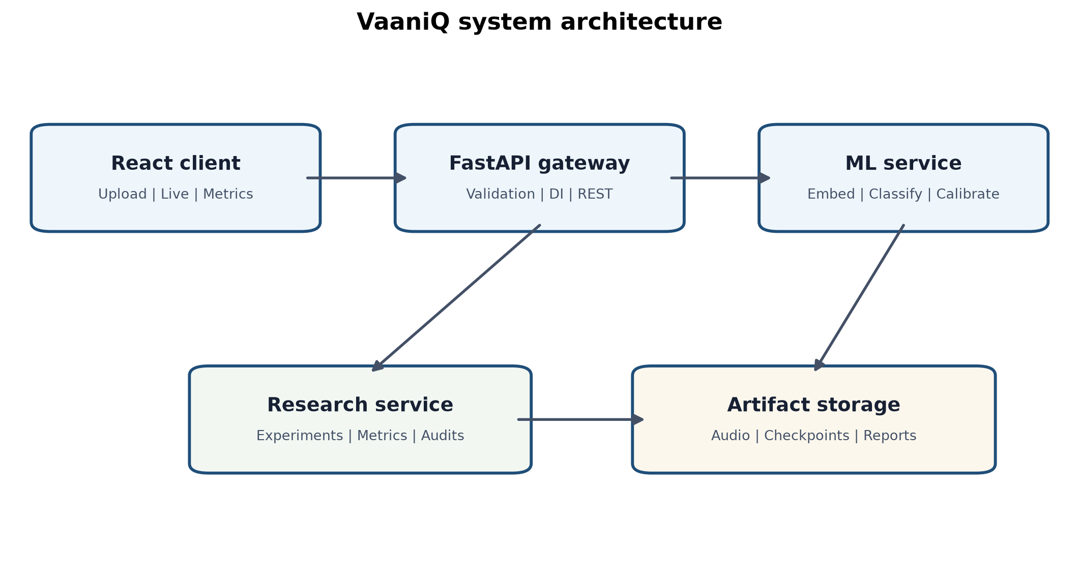
Fig. 1. VaaniQ architecture: preprocess → acoustic or frozen XLS-R → head → calibration.
A. Acoustic Baseline V1
Baseline V1 uses a deterministic 1024-D acoustic embedding and an AASIST-compatible NumPy classification head. It is not canonical AASIST and not XLS-R. Decision threshold 0.5 on the fake softmax score. Label 0=REAL, 1=FAKE; higher score_fake means more fake.
B. Frozen XLS-R Main
Frozen facebook/wav2vec2-xls-r-300m, last-layer mean pooling, cached features, and a lightweight trainable head. Backbone weights are not updated. Production calibration is global temperature scaling selected on validation.
C. Baselines and Controls
LFCC-GMM is a complete weak baseline. A RawNet2-style approximate baseline must not be called faithful RawNet2 (PENDING). An English-only ASVspoof LA control is evaluated on the same Indic held-out test.
D. Compression and Metrics
ffmpeg/libopus at 16 kbps provides a WhatsApp-style Opus simulation, not WhatsApp transport. EER, ROC-AUC, and normalized min-DCF share score direction. min-DCF uses P_target=0.05, C_miss=1, C_fa=1.
V. PRIMARY RESULTS
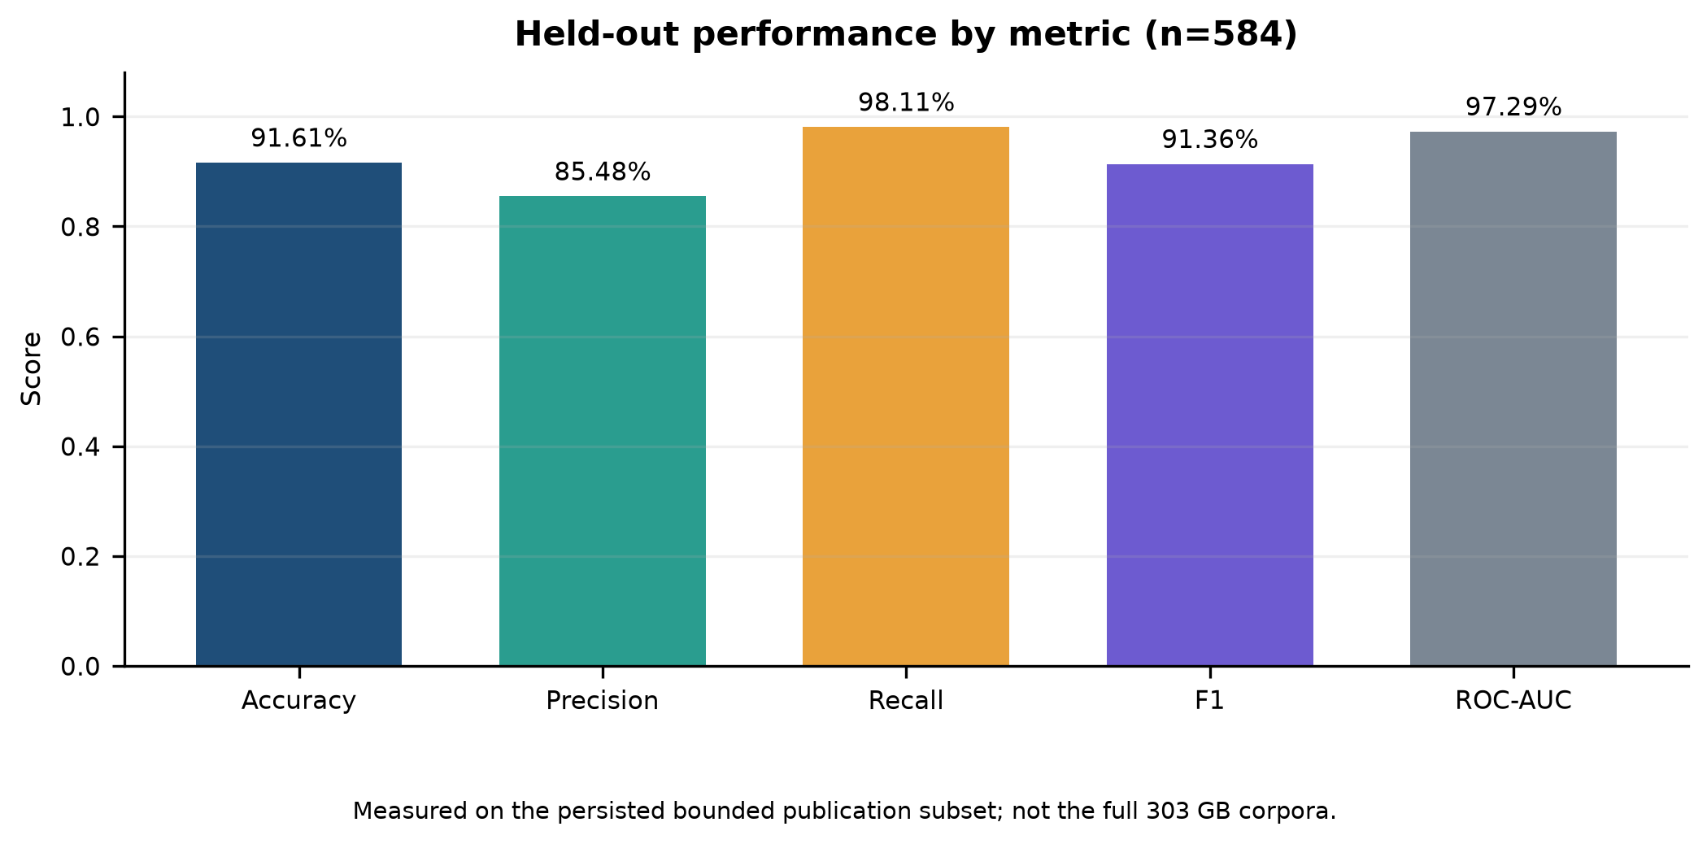
Fig. 2. Held-out performance overview.
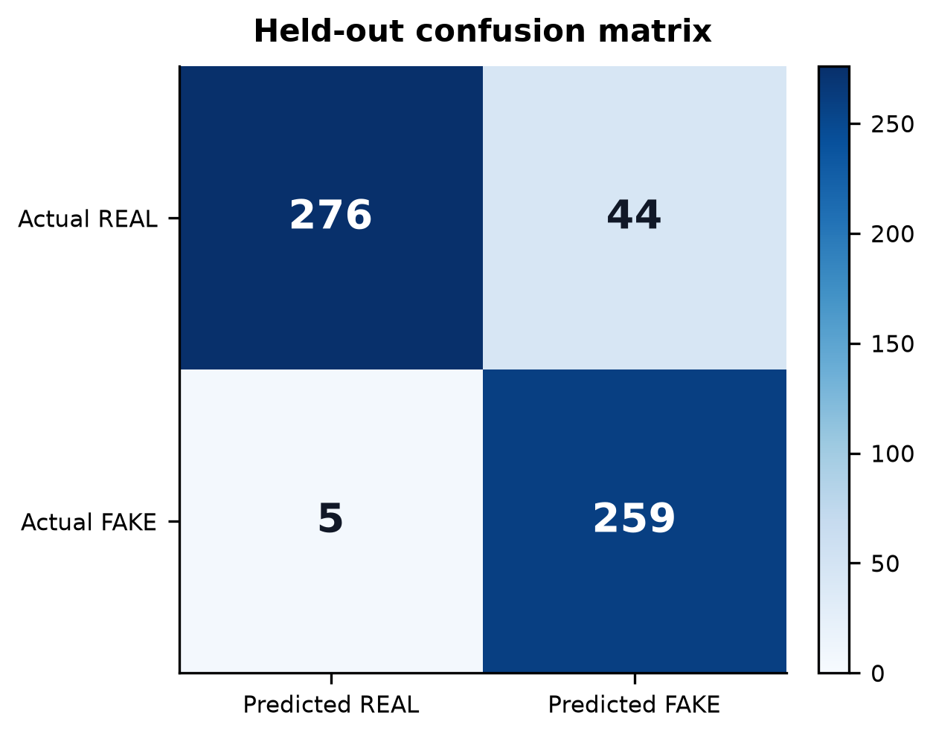
Fig. 3. Confusion matrix (Baseline V1).
TABLE IV. CANONICAL HELD-OUT RESULTS (THRESHOLD 0.5)
System | n | Acc / EER / AUC / min-DCF
Acoustic Baseline V1 | 584 | 91.61% / 6.56% / 0.9729 / 0.7841
Frozen XLS-R | 584 | 92.12% / 6.88% / 0.9828 / 0.3144
Frozen XLS-R improves ranking performance while thresholded accuracy remains broadly comparable to Baseline V1.
VI. COMPRESSION (RQ1)
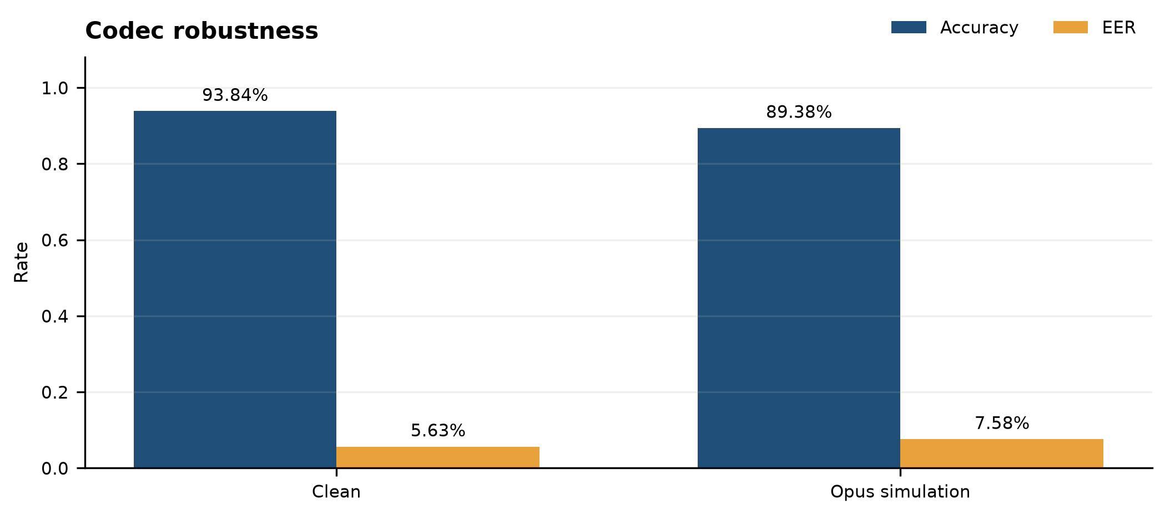
Fig. 4. Clean versus Opus condition breakdown.
TABLE V. RQ1 COMPRESSION (WHATSAPP-STYLE OPUS 16 KBPS)
Model | Clean Acc / EER | Opus Acc / EER
Acoustic | 93.84% / 5.63% | 89.38% / 7.58%
Frozen XLS-R | 91.44% / 8.13% | 92.81% / 6.06%
Compression effects are model-dependent on this benchmark.
VII. ENGLISH-ONLY TRANSFER (RQ2)
TABLE VI. RQ2 ENGLISH→INDIC TRANSFER
System | Acc / EER / AUC | Note
English-only control | 54.79% / 76.56% / 0.162 | All REAL at thr 0.5
Multilingual Baseline V1 | 91.61% / 6.56% / 0.9729 | Same Indic test
English-only anti-spoofing fails to transfer. Official scores are not polarity-flipped to inflate AUC.
VIII. CROSS-LINGUAL TRANSFER (RQ3)
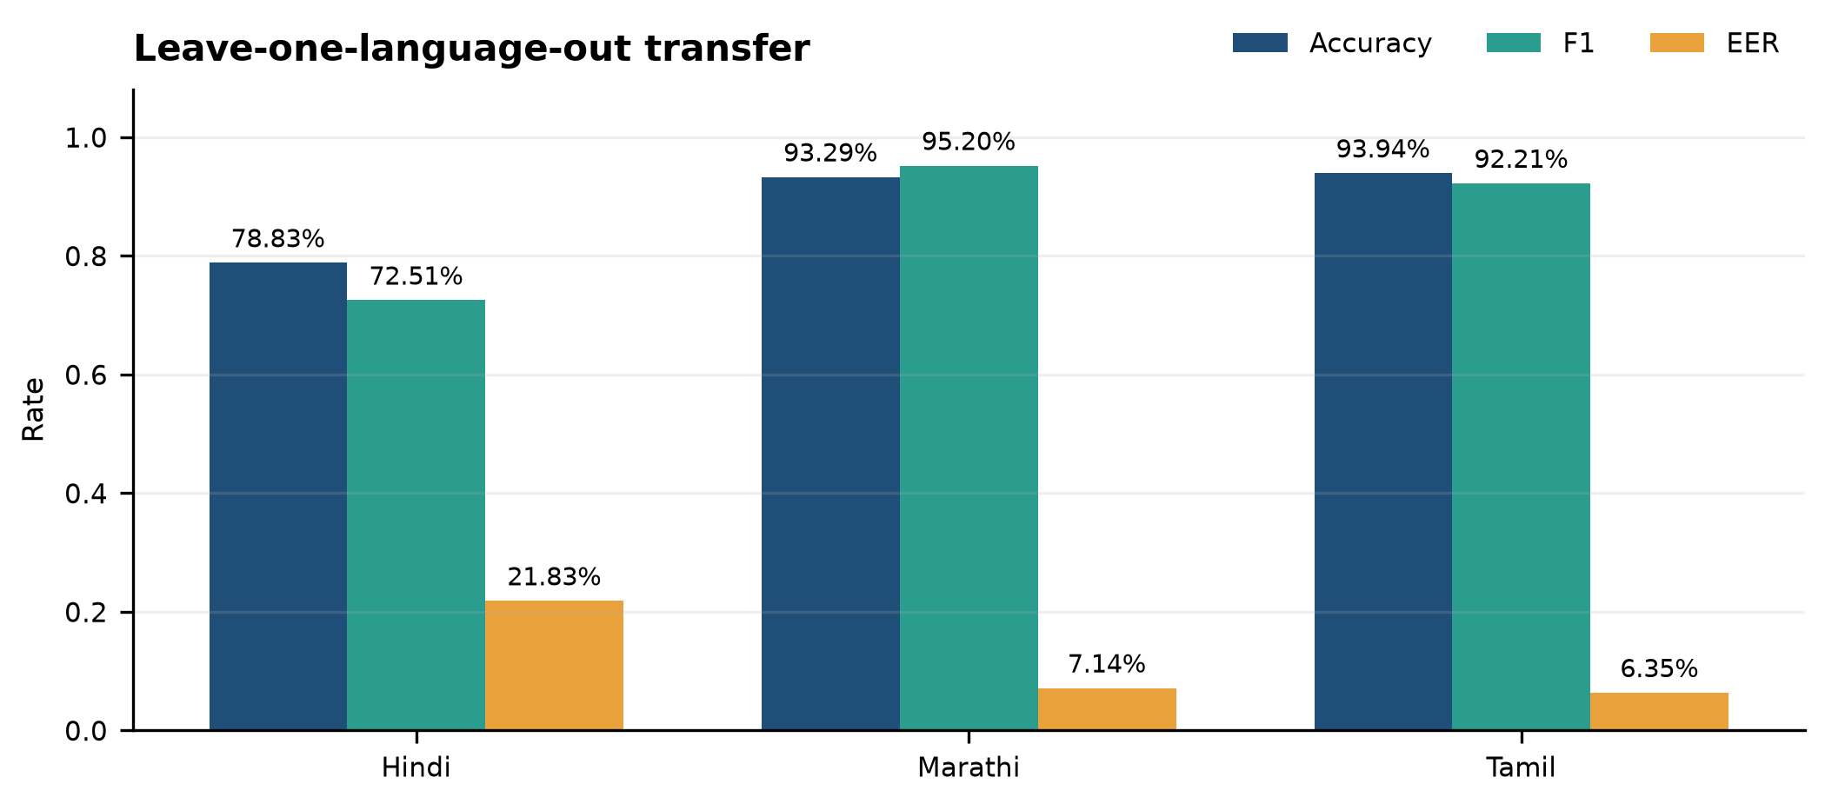
Fig. 5. Cross-lingual / language transfer view.
TABLE VII. RQ3 LEAVE-ONE-LANGUAGE-OUT (ROUND 3)
Held-out language | Accuracy | EER
Hindi | 78.83% | 21.83%
Marathi | 93.29% | 7.14%
Tamil | 93.94% | 6.35%
Transfer is strongly asymmetric; Hindi is the weakest zero-shot cell.
IX. CALIBRATION (RQ4)
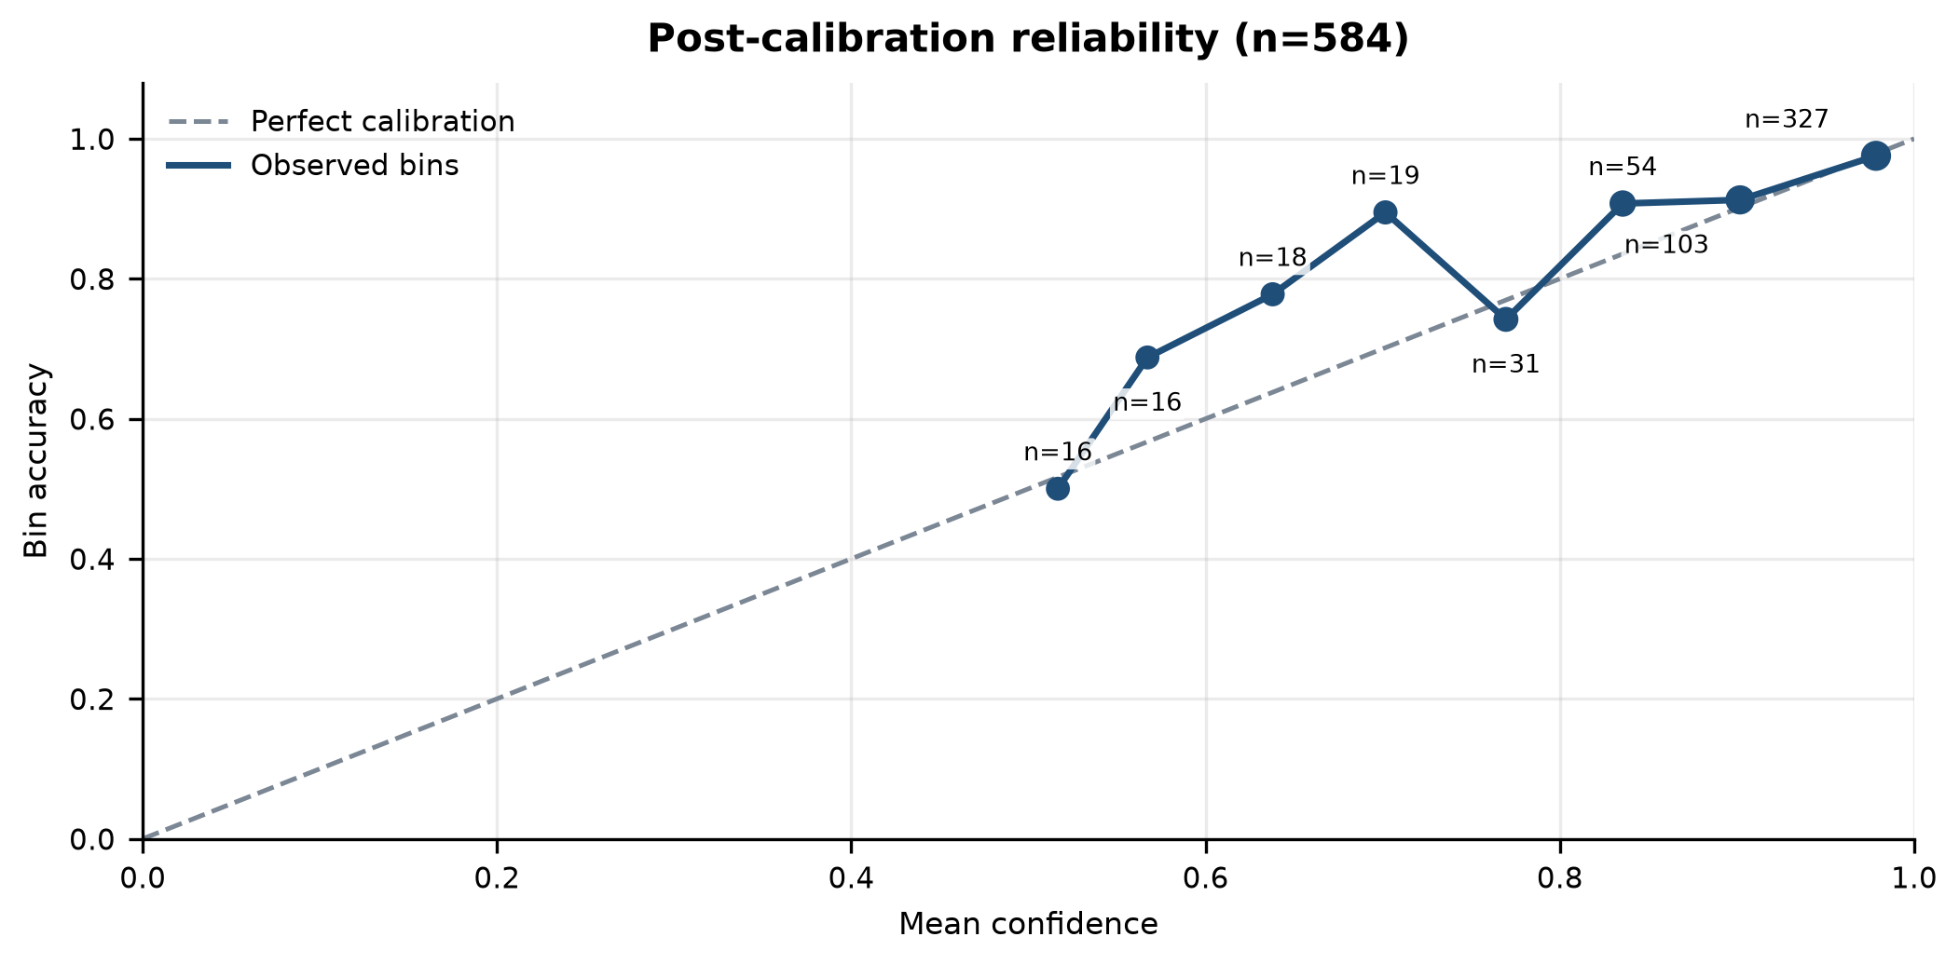
Fig. 6. Reliability diagram.
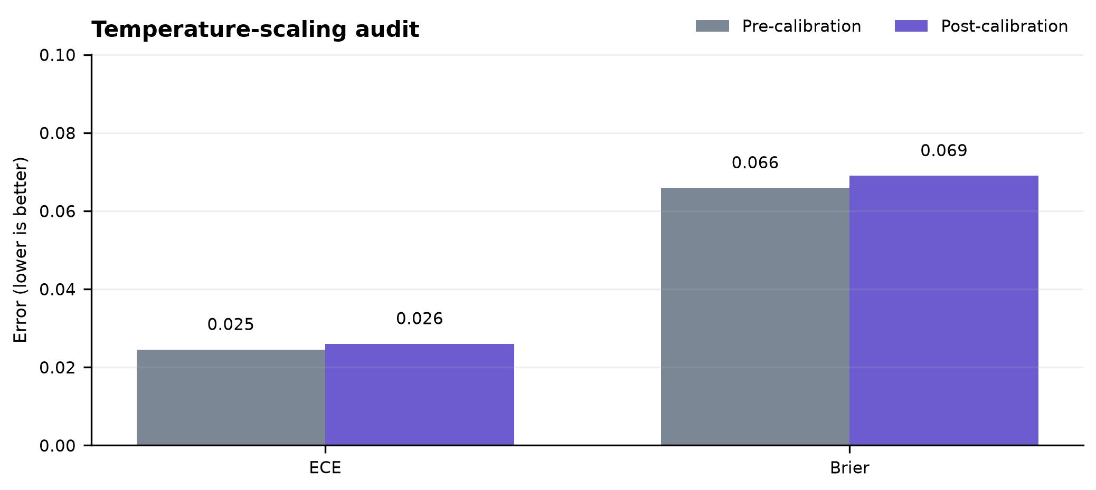
Fig. 7. Pre/post calibration comparison.
TABLE VIII. RQ4 CALIBRATION AUDIT
Quantity | Value | Role
Pre-cal test ECE | 0.0245 | Held-out uncalibrated
Post-cal test ECE | 0.0260 | After val-selected strategy
Selection rule | validation ECE only | No test peeking for production
Validation-selected fine-grained calibration slightly worsened held-out ECE (0.0245 → 0.0260). This negative transfer result is retained.
X. EXTERNAL VALIDITY AND V2 PILOT
TABLE IX. REMAINING GENERALIZATION STATUS
Eval | n | Status / Result
V2 full test | 593 | PARTIAL / not confound-free
FLEURS unseen-real | 9 | PILOT / 55.6% pipeline only
Generator-disjoint | 0 | PENDING / no result
V2 source probe | 593 | PARTIAL / 98.48% source identity
Faithful RawNet2 | - | PENDING / not implemented
XI. DISCUSSION
Strong V1 discrimination coexists with structural threats. Catastrophic English→Indic transfer supports multilingual training for this domain. Asymmetric LOLO results caution against treating Indian languages as a homogeneous transfer class. Negative calibration transfer shows validation ECE gains require held-out audits. The paper therefore scopes its contribution to the reproducible machine-evaluation evidence reported here.
XII. LIMITATIONS
Key threats: (1) V1 source–label confound; (2) bounded size; (3) academic≠scam audio; (4) simulated≠real WhatsApp transport; (5) three-language scope; (6) non-canonical AASIST / pending faithful RawNet2; (7) incomplete V2; (8) source probe 98.48%; (9) FLEURS n=9; (10) generator-disjoint n=0; (11) calibration-transfer uncertainty; (12) unresolved val/test heterogeneity; (13) no universal unseen-generator claim. Strong EER can coexist with high min-DCF under a 5% target prior.
XIII. ETHICS
Audio and weights are excluded from version control. Kathbath access conditions and IndicSynth non-commercial restrictions are respected. Dual-use risks of detection systems are acknowledged; release emphasizes research evaluation.
XIV. REPRODUCIBILITY
Authoritative metrics are frozen in artifacts/final_results_manifest.json at commit 084bd47ca6ca1b69a7cdbf424e2946f3794c2a95. Integrity verification: scripts/verify_research_integrity.py. Documents must consume the frozen manifest rather than superseded checkpoints.
XV. FUTURE WORK
Expand confound-controlled and generator-disjoint evaluation; implement faithful RawNet2 and canonical AASIST; study real messaging-channel audio beyond Opus simulation.
XVI. CONCLUSION
VaaniQ establishes a reproducible multilingual framework for studying audio-deepfake detection under language, codec, and confidence-calibration shift. Acoustic and frozen XLS-R pipelines achieve strong held-out discrimination on bounded V1, while transfer, calibration, and source-domain experiments expose important limits. Evidence supports multilingual machine evaluation but does not establish universal source- or generator-independent detection.
REFERENCES
[1] J. Jung et al., AASIST: Audio anti-spoofing using integrated spectro-temporal graph attention networks, in Proc. ICASSP, 2022.
[2] A. Babu et al., XLS-R: Self-supervised cross-lingual speech representation learning at scale, arXiv:2111.09296, 2021.
[3] T. Javed et al., IndicSUPERB: A speech processing universal performance benchmark for Indian languages, arXiv:2208.11761, 2022.
[4] D. V. Sharma, V. Ekbote, and A. Gupta, IndicSynth: A large-scale multilingual synthetic speech dataset, ACL, 2025.
[5] O. Pascu et al., Towards calibrated and explainable audio deepfake detection, in Proc. Interspeech, 2024.
[6] AI4Bharat, Kathbath dataset, Hugging Face: ai4bharat/Kathbath.
[7] D. V. Sharma et al., IndicSynth dataset, Hugging Face: vdivyasharma/IndicSynth.
[8] A. Conneau et al., FLEURS: Few-shot learning evaluation of universal representations of speech, arXiv:2205.12446, 2022.
[9] IETF RFC 6716, Definition of the Opus Audio Codec, 2012.
[10] ASVspoof 2019, logical access evaluation plan; English-only control uses a streaming subset of Bisher/ASVspoof_2019_LA (ODC-By).

