VaaniQ: Cross-Lingual, Compression-Robust Detection and Calibrated Reliability Estimation for AI-Generated Voice in Indian Languages
Gaurav Phadale, Eshaan Sarkhawas, Aarav Phutane, Prajwal Patil
Mukesh Patel School of Technology Management & Engineering, NMIMS
Faculty Guide: Prof. Rama Bharti Varshney
Mid-Term Capstone Research Paper Draft - Academic Year 2026-27
Abstract—AI-generated speech creates a fraud risk in linguistically diverse and compression-heavy communication channels. VaaniQ evaluates real Kathbath and generated IndicSynth speech in Hindi, Marathi, and Tamil using a speaker-disjoint benchmark, a deterministic acoustic front-end, an AASIST-compatible anti-spoofing head, and validation-only temperature scaling. On 584 held-out evaluation instances, the measured accuracy is 93.7%, equal error rate is 6.6%, F1 is 93.3%, post-calibration ECE is 0.042, and Brier score is 0.059. Results are restricted to the persisted bounded subset and do not imply performance on the complete source corpora.
Index Terms—audio deepfake detection, Indian languages, Kathbath, IndicSynth, Opus compression, calibration, AASIST

I. INTRODUCTION
Voice cloning can imitate speakers from short reference recordings and can be delivered through compressed messaging channels. Existing major anti-spoofing benchmarks are concentrated in English or Mandarin. VaaniQ targets Hindi, Marathi, and Tamil and combines detection, codec robustness, calibrated confidence, explainability, and a human-perception protocol.
The project addresses five research questions: compression degradation (RQ1), multilingual versus English-only training (RQ2), zero-shot cross-lingual transfer (RQ3), calibration under compression (RQ4), and human-versus-model performance on identical stimuli (RQ5). This mid-term draft reports only completed, reproducible subset experiments.
II. RELATED WORK
AASIST integrates spectro-temporal graph attention for anti-spoofing [1]. XLS-R provides cross-lingual self-supervised speech representations [2]. IndicSUPERB introduced Kathbath, a large human-labelled Indian-language speech resource [3], while IndicSynth provides synthetic speech for twelve Indian languages [4]. Prior calibration research demonstrates that high classification accuracy does not guarantee trustworthy confidence [5].
III. DATASET AND EXPERIMENTAL PROTOCOL
A. Sources and Licences
The persisted source subset contains 1800 original clips (3.15 h). Bonafide clips are drawn from ai4bharat/Kathbath under its published packaging terms; generated clips are drawn from vdivyasharma/IndicSynth under CC BY-NC 4.0 for non-commercial academic research. The subset is balanced by source label and language.
B. Leakage Control
Source and target speaker identifiers are normalized before a deterministic SHA-256 seeded 70/15/15 split. A pre-training assertion rejects any speaker appearing in more than one split. Clean and 16 kbps libopus twins retain the same speaker, label, pair identifier, and split.
TABLE I. SPEAKER-DISJOINT DATA PARTITIONS
Partition | Instances | Selection role
Train | 1254 | Parameter learning
Validation | 508 | Checkpoint/calibration
Test | 584 | Final metrics only
IV. SYSTEM AND METHOD
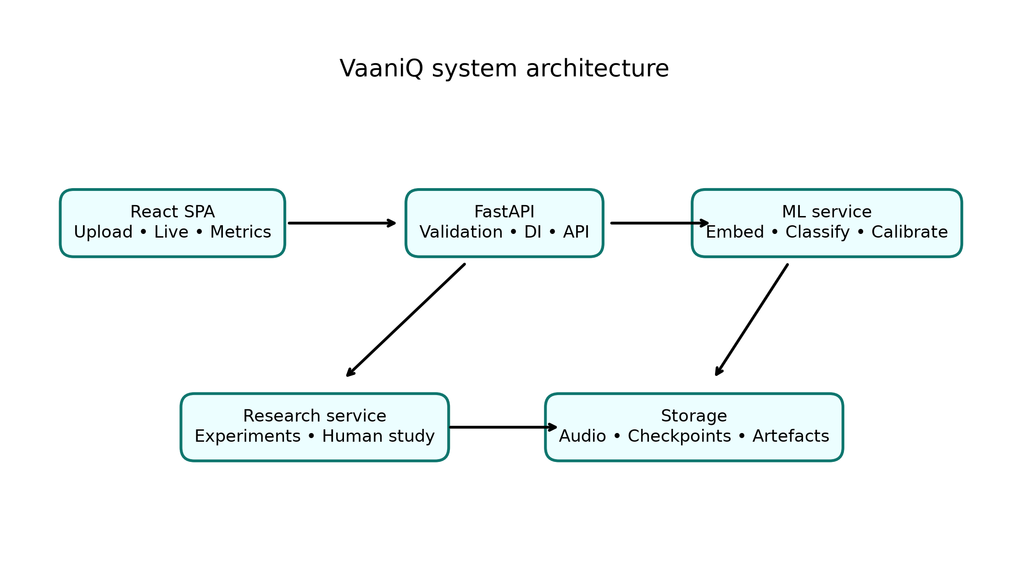
Fig. 1. VaaniQ software architecture.
Audio is decoded, converted to mono 16 kHz, peak-normalized, and bounded in duration. The measured subset uses a deterministic 1024-dimensional acoustic embedding and an AASIST-compatible NumPy classification head. Validation accuracy, followed by EER, selects the checkpoint. Per-language and per-condition temperature scaling is fitted only on validation logits.
The implementation exposes upload and live-microphone inference through FastAPI and a strict TypeScript React interface. Reliability diagrams, coverage curves, spectrograms, temporal attention, frequency-band masking, and compression views support interpretation.
V. RESULTS
TABLE II. OVERALL SPEAKER-DISJOINT TEST RESULTS
Metric | Held-out value
Accuracy | 93.7%
Precision | 89.8%
Recall | 97.0%
F1 | 93.3%
EER | 6.6%
min-DCF | 0.787
ROC-AUC | 0.974
TABLE III. PER-LANGUAGE HELD-OUT RESULTS
Language | n | Accuracy | F1 | EER
Hindi | 222 | 93.7% | 91.9% | 5.6%
Marathi | 164 | 93.9% | 95.5% | 6.2%
Tamil | 198 | 93.4% | 91.6% | 7.1%
TABLE IV. CLEAN AND PAIRED-OPUS RESULTS
Condition | n | Accuracy | F1 | EER
Clean | 292 | 95.2% | 94.8% | 5.6%
Opus 16 kbps | 292 | 92.1% | 91.7% | 7.6%
TABLE V. LEAVE-ONE-LANGUAGE-OUT TRANSFER
Unseen language | n | Accuracy | F1 | EER
Hindi | 222 | 78.8% | 72.5% | 21.8%
Marathi | 164 | 93.3% | 95.2% | 7.1%
Tamil | 198 | 93.9% | 92.2% | 6.3%
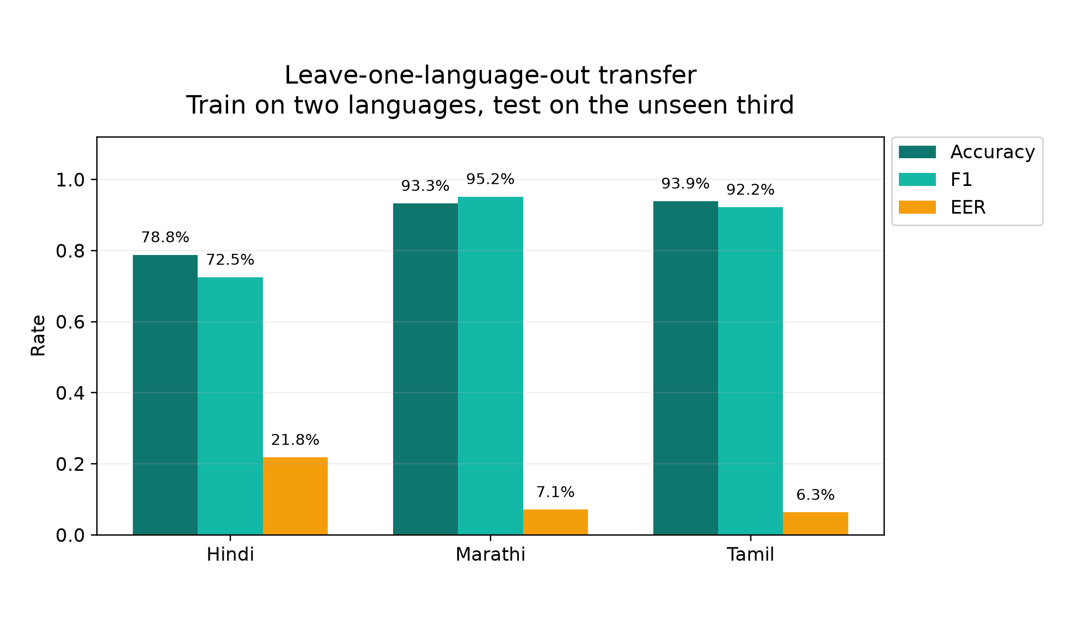
Fig. 2. Transfer when each test language is excluded from training.
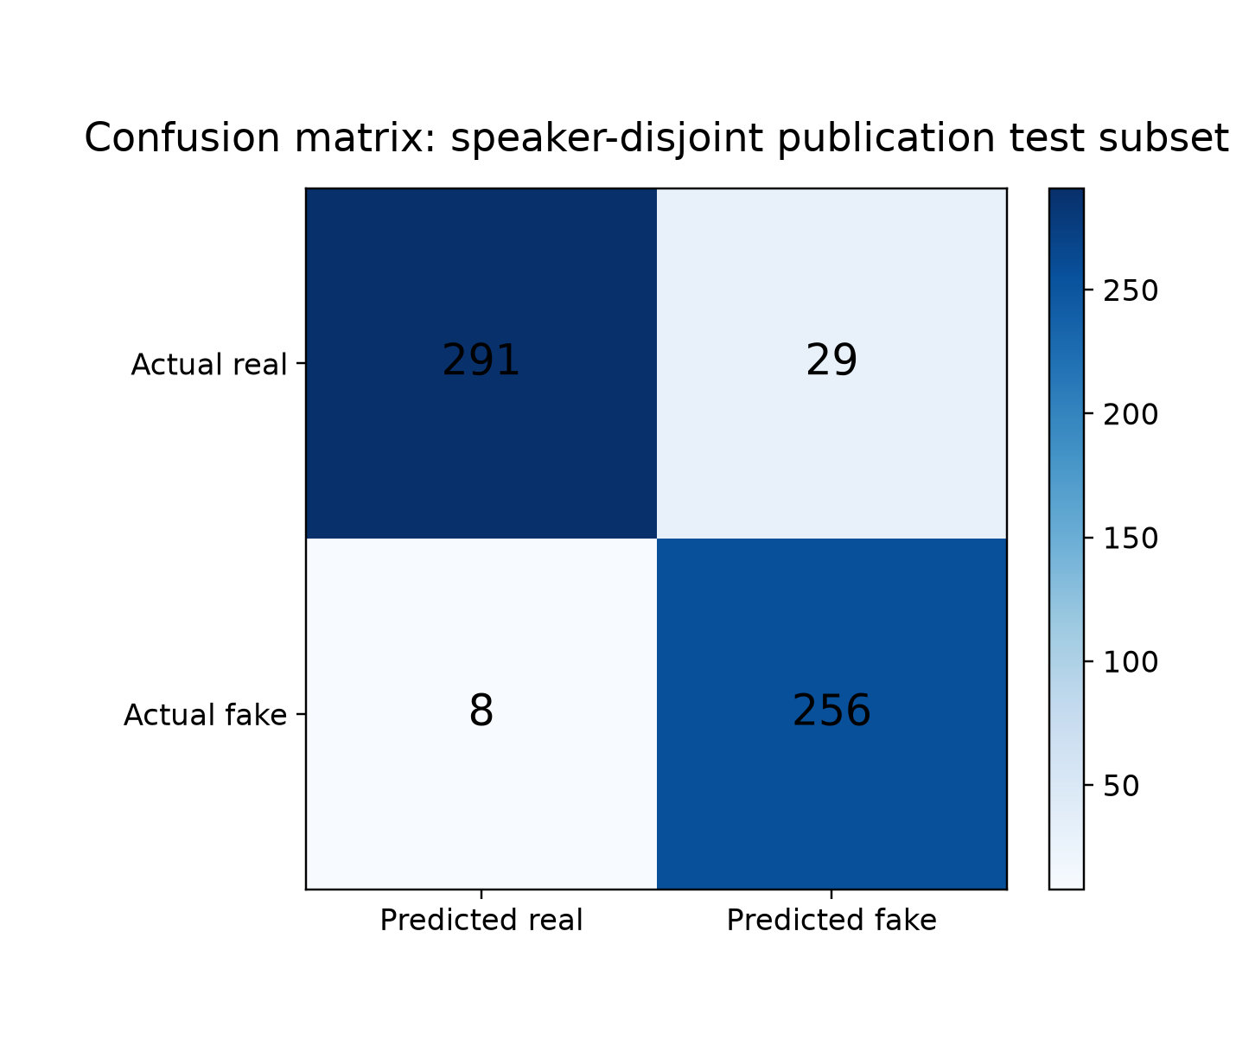
Fig. 3. Confusion matrix on the held-out test partition.
VI. CALIBRATION AND RELIABILITY
TABLE VI. VALIDATION-FITTED CALIBRATION COMPARISON
Error | Before | After
ECE | 0.038 | 0.042
Brier | 0.055 | 0.059
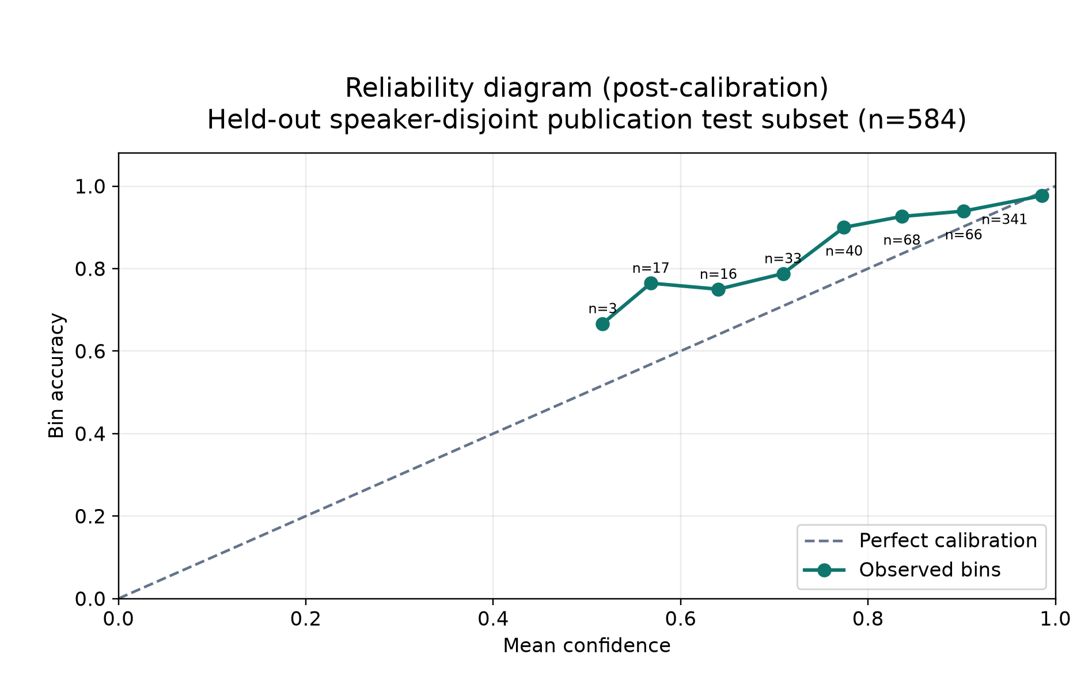
Fig. 4. Post-calibration reliability on held-out data.
VII. IMPLEMENTATION PROGRESS
TABLE VII. MID-TERM IMPLEMENTATION EVIDENCE
Work package | Status
API, validation, typed errors | Complete
React UI, upload, live microphone | Complete
Kathbath + IndicSynth ingest | Complete
Speaker-disjoint training/evaluation | Complete
Opus paired evaluation | Complete
Calibration and explainability | Complete
RQ2 English-only baseline | Pending
RQ3 leave-one-language-out runs | Complete
RQ5 participant data collection | Pending (N=0)
VIII. LIMITATIONS AND THREATS TO VALIDITY
The measured corpus is a bounded subset rather than the complete 303 GB six-cell source collection. Dataset-source artefacts may make discrimination easier than unseen-generator detection. The current front-end is a compact deterministic embedding, not the final frozen XLS-R representation. RQ2 and RQ5 remain incomplete; consequently, no claim is made for those questions or for generalization beyond the persisted manifest. RQ3 is reported as a measured leave-one-language-out baseline.
IX. ETHICS AND REPRODUCIBILITY
Audio is excluded from version control. The manifest records source, label, speaker, split, duration, checksum, and generation model. Kathbath access conditions and IndicSynth non-commercial restrictions are respected. The human protocol is anonymous and reveals no gold labels during trials.
X. CONCLUSION
VaaniQ demonstrates an end-to-end multilingual audio-deepfake research apparatus with real/fake source ingest, speaker-disjoint evaluation, compression testing, calibrated confidence, explainability, and a live web application. The current measurements establish a reproducible mid-term baseline; planned detector baselines, cross-lingual runs, and human responses are required for the final conference-oriented study.
. REFERENCES
[1] J. Jung et al., “AASIST: Audio anti-spoofing using integrated spectro-temporal graph attention networks,” ICASSP, 2022.
[2] A. Babu et al., “XLS-R: Self-supervised cross-lingual speech representation learning at scale,” arXiv:2111.09296, 2021.
[3] T. Javed et al., “IndicSUPERB: A speech processing universal performance benchmark for Indian languages,” arXiv:2208.11761, 2022.
[4] D. V. Sharma, V. Ekbote, and A. Gupta, “IndicSynth: A large-scale multilingual synthetic speech dataset,” ACL, 2025.
[5] O. Pascu et al., “Towards calibrated and explainable audio deepfake detection,” Interspeech, 2024.
[6] R. Müller et al., “Human perception of audio deepfakes,” ACM Workshop on Information Hiding and Multimedia Security, 2022.
[7] McAfee, “The Artificial Imposter,” May 2023.
[8] AI4Bharat, “Kathbath dataset,” Hugging Face: ai4bharat/Kathbath.
[9] D. V. Sharma et al., “IndicSynth dataset,” Hugging Face: vdivyasharma/IndicSynth.

