VaaniQ
Mid-Term Capstone Progress Report
Cross-Lingual, Compression-Robust Detection and Calibrated Reliability Estimation for AI-Generated Voice in Indian Languages
Gaurav Phadale — 70022300092
Eshaan Sarkhawas — 70022300066
Aarav Phutane — 70022300152
Prajwal Patil — 70022300213
Faculty Guide: Prof. Rama Bharti Varshney
MPSTME, NMIMS · Academic Year 2026-27

1. Executive Progress Summary
VaaniQ is operational as an end-to-end research system: authenticated Kathbath and IndicSynth ingest, deterministic speaker-disjoint splitting, actual Opus evaluation pairs, detector training, validation-only calibration, explainability, typed FastAPI endpoints, and a React demonstration interface. This report separates completed measured evidence from remaining work.
TABLE 1. MID-TERM EVIDENCE SNAPSHOT
Evidence item | Current measured state
Source corpus | 1800 original clips; 3.15 h
Evaluation corpus | 2346 clean/Opus instances; 4.11 h
Held-out test | n=584; accuracy 93.7%; EER 6.6%
Leakage control | PASS - no speaker overlap across train/validation/test
Application | Backend API and React UI operational

2. Completed Work Packages
TABLE 2. IMPLEMENTED CAPSTONE COMPONENTS
Work package | Evidence
Problem framing and five RQs | Proposal traceability complete
Three-language data ingest | Hindi, Marathi, Tamil persisted
Balanced real/fake source cells | 900 Kathbath / 900 IndicSynth
Speaker-disjoint split | 1254 train / 508 val / 584 test instances
Compression robustness | 546 paired 16 kbps libopus twins
Detector training | Primary and three RQ3 checkpoints
Calibration | Validation-only per-language/condition temperatures
Explainability | Five stored explanation views per prediction
Web application | Upload, live, dashboard, research, admin, docs
Submission artefacts | Master DOCX and IEEE-style paper generated
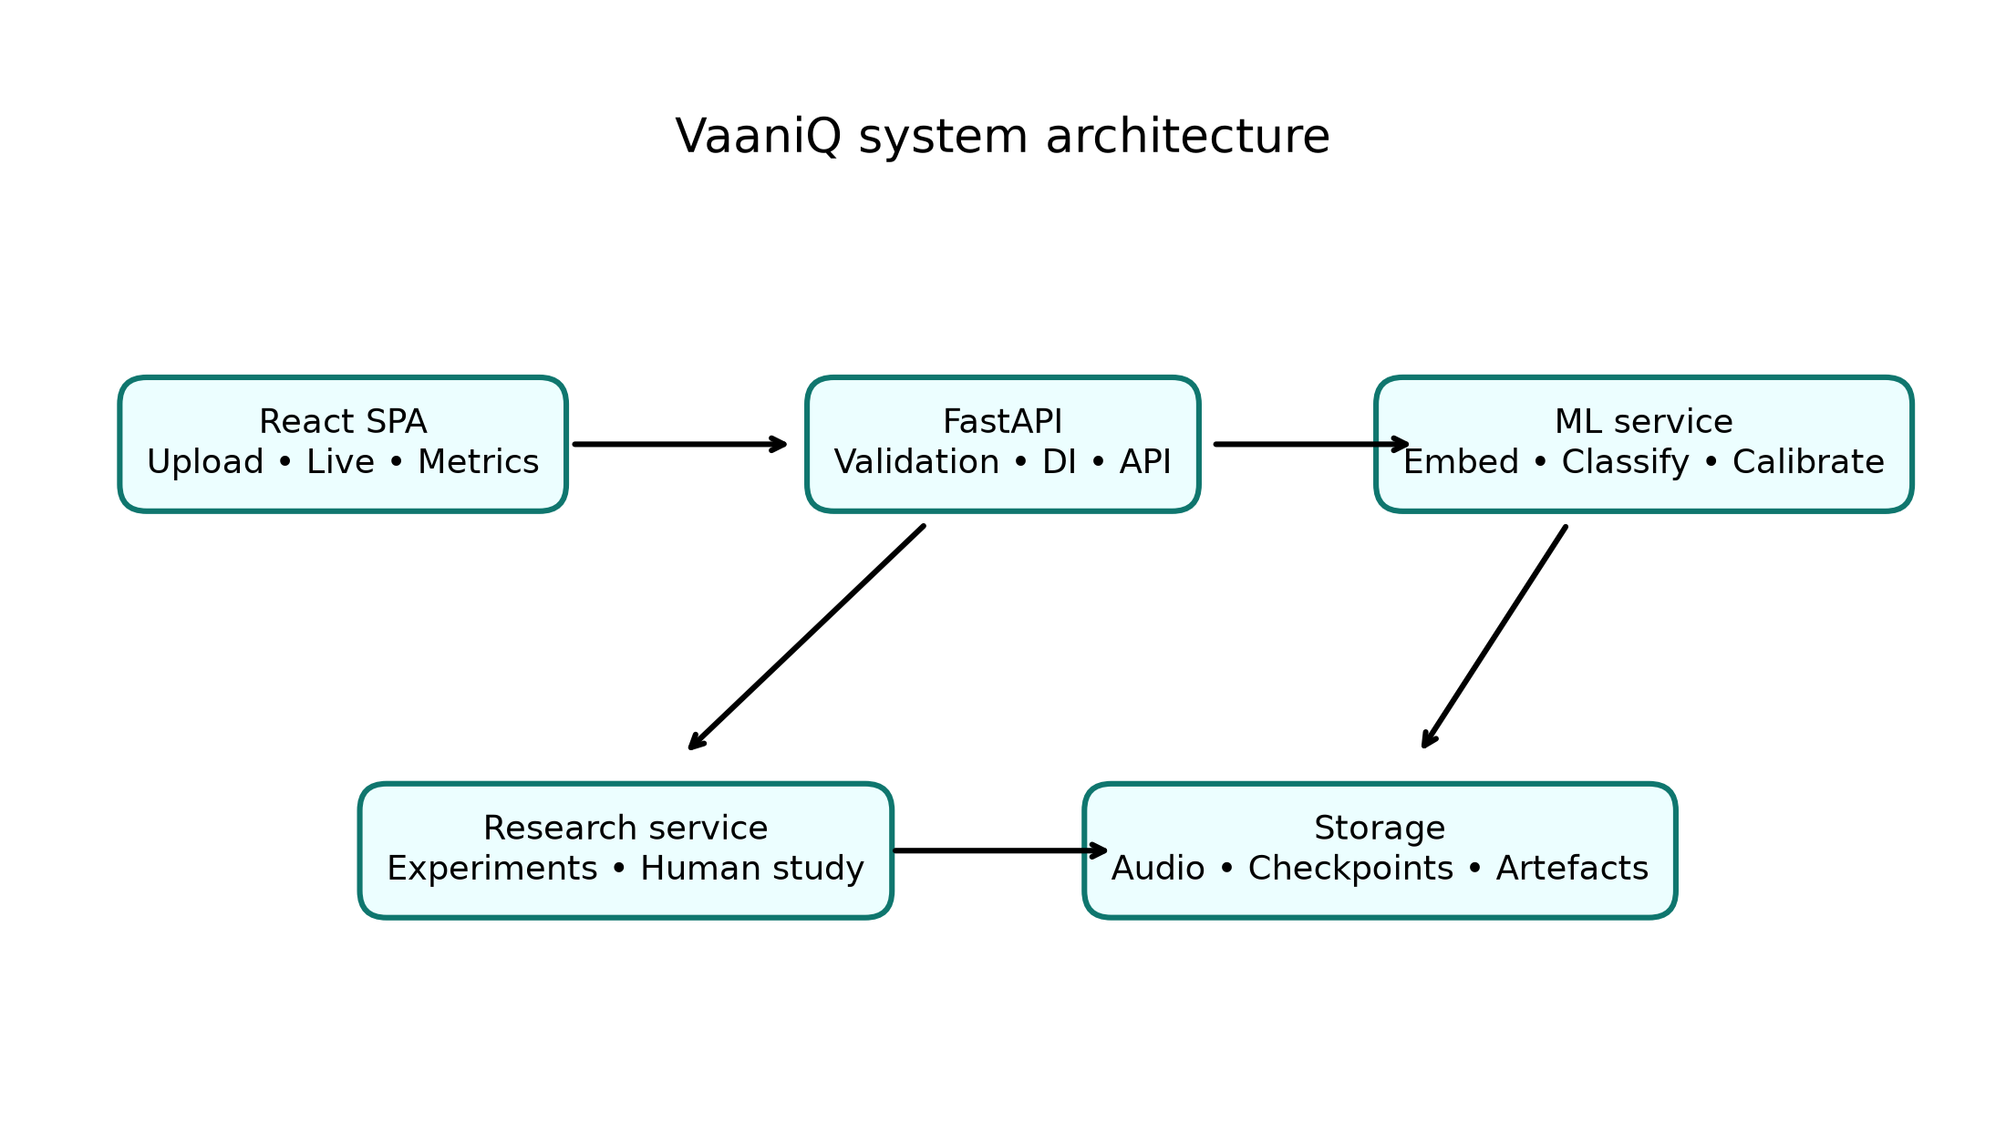
Fig. 1. Implemented VaaniQ three-tier architecture.

3. Dataset and Reproducibility Evidence
The complete six target-language source cells exceed 303 GB. The declared evaluation population is therefore a reproducible bounded subset rather than an unspecified sample. Every manifest row includes source, language, label, speaker, split, duration, checksum, and model provenance. Shared source and target speaker identifiers are assigned to one split before augmentation.
TABLE 3. BALANCED SOURCE CELLS AND LANGUAGE RESULTS
Language | Source clips | Held-out instances | Accuracy | EER
Hindi | 600 | 222 | 93.7% | 5.6%
Marathi | 600 | 164 | 93.9% | 6.2%
Tamil | 600 | 198 | 93.4% | 7.1%

4. Measured Model Results
TABLE 4. OVERALL HELD-OUT PUBLICATION-SUBSET METRICS
Metric | Value
Accuracy | 93.66%
Precision | 89.82%
Recall | 96.97%
F1 | 93.26%
EER | 6.56%
ROC-AUC | 0.9735
min-DCF | 0.7869
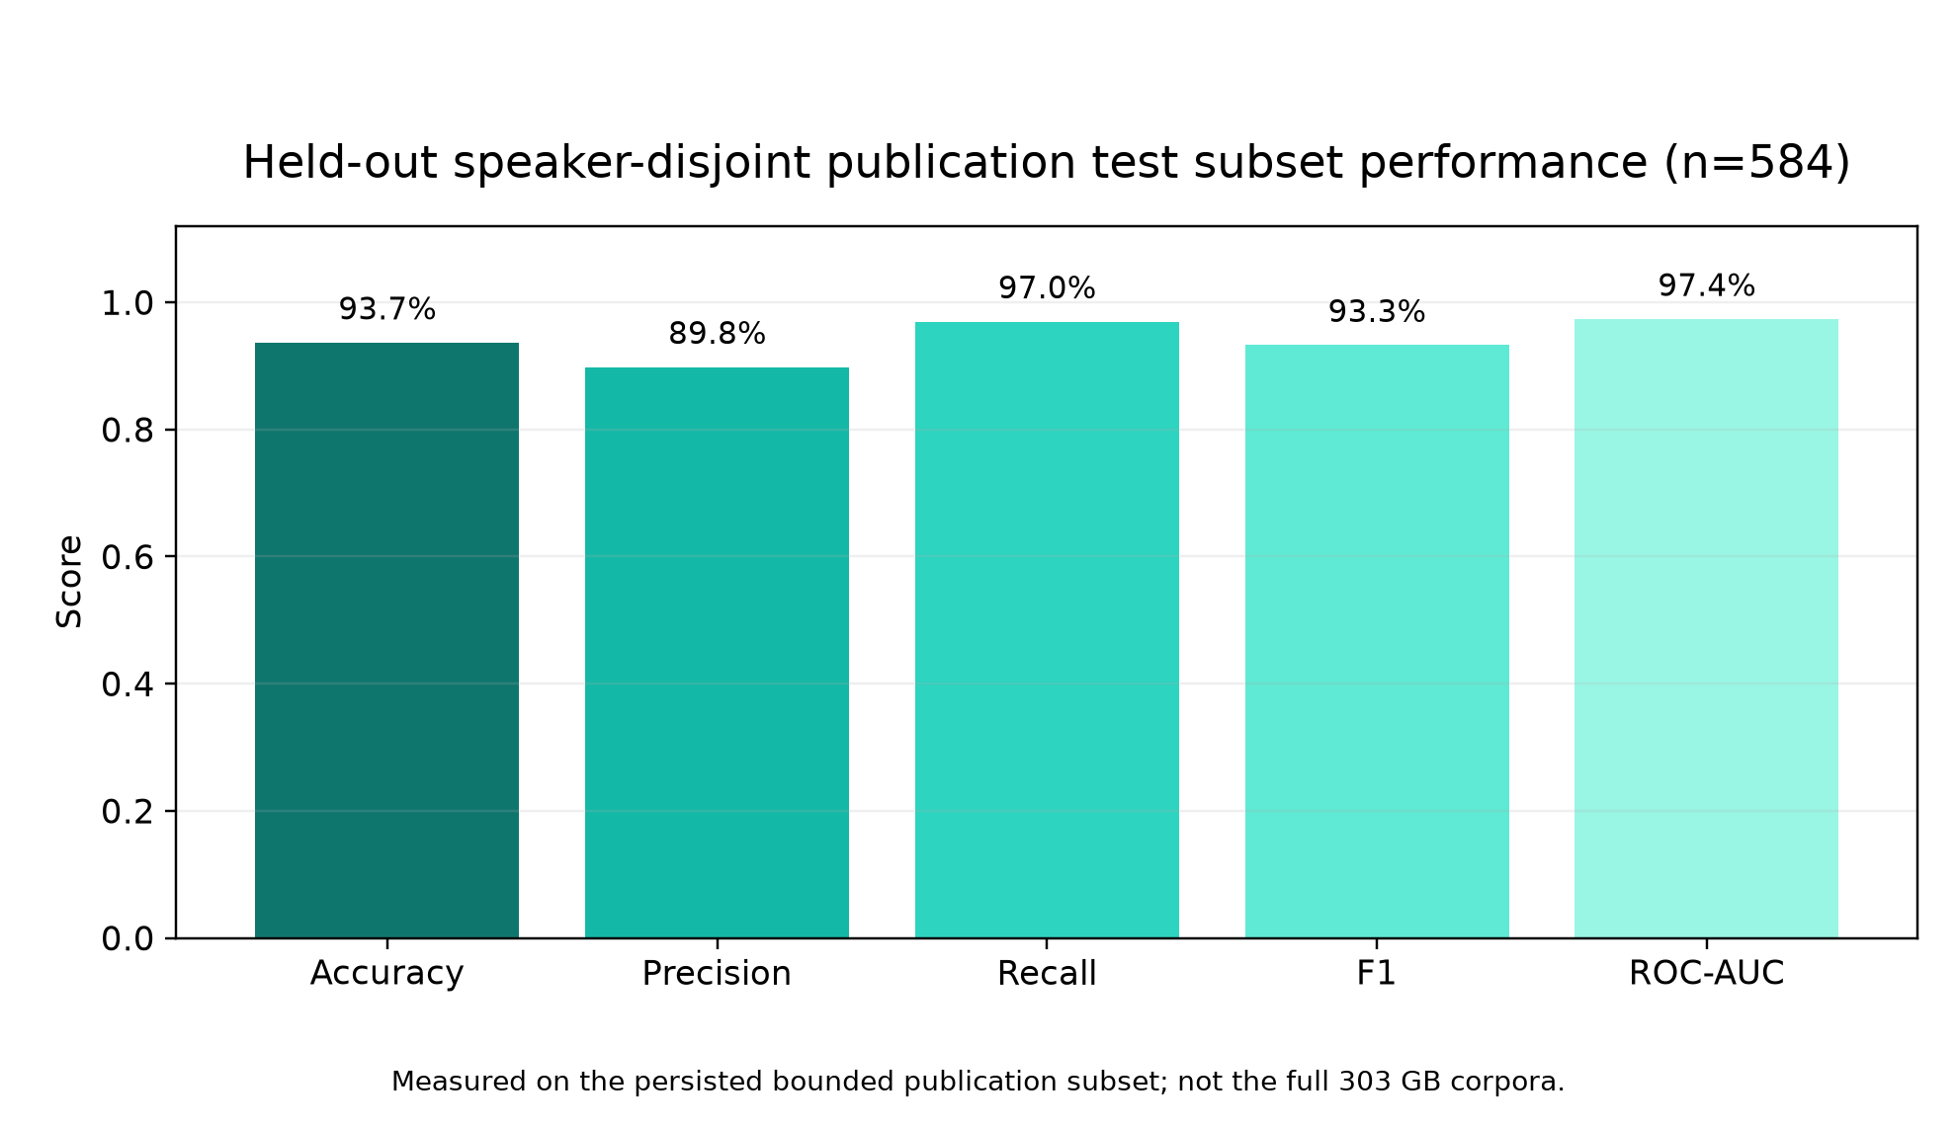
Fig. 2. Overall held-out performance.
TABLE 5. RQ1 COMPRESSION ROBUSTNESS
Condition | n | Accuracy | EER | F1
Clean | 292 | 95.2% | 5.6% | 94.8%
Opus 16 kbps | 292 | 92.1% | 7.6% | 91.7%

5. Calibration and Cross-Lingual Findings
Temperature scaling was fitted only on validation logits. On the held-out distribution it slightly worsened both ECE and Brier score. This negative result is retained because accurate capstone reporting is more important than presenting calibration as universally beneficial.
TABLE 6. RQ4 HELD-OUT CALIBRATION COMPARISON
Calibration error | Before | After
ECE | 0.0378 | 0.0424
Brier | 0.0547 | 0.0589
TABLE 7. RQ3 LEAVE-ONE-LANGUAGE-OUT TRANSFER
Unseen test language | n | Accuracy | EER | F1
Hindi | 222 | 78.8% | 21.8% | 72.5%
Marathi | 164 | 93.3% | 7.1% | 95.2%
Tamil | 198 | 93.9% | 6.3% | 92.2%

6. Research Question Status
TABLE 8. HONEST RESEARCH-QUESTION STATUS
RQ | Status | Current evidence
RQ1 | Measured | Clean versus paired Opus test metrics
RQ2 | Pending | English-only control checkpoint not yet run
RQ3 | Measured | Three leave-one-language-out runs
RQ4 | Measured | Validation-fitted pre/post calibration
RQ5 | Protocol ready | Participant responses N=0; no result claimed

7. Remaining Final-Phase Work
- Run the frozen XLS-R research front-end and detector baseline matrix.
- Add the English-only RQ2 control using a licensed English benchmark.
- Expand attack diversity beyond one published synthetic source.
- Recruit eligible listeners and complete the approved RQ5 protocol.
- Freeze result CSVs, repeat confidence intervals, and prepare the final paper.

8. Mid-Term Demonstration Readiness
The live system can demonstrate upload inference, microphone streaming, dataset provenance, compression-aware metrics, calibration plots, explainability artefacts, experiment records, and API documentation. The master report and IEEE-style paper use persisted metrics rather than manually copied values.

9. Submission Checklist
☐ Master project DOCX generated and package-verified.
☐ IEEE-style hard-copy paper generated and package-verified.
☐ Mid-term progress report generated from the same training report.
☐ All chart source PNGs have automated blank/crop margin checks.
☐ Human-study claims remain explicitly N=0 until responses exist.
☐ Team must bring a laptop, charger, backup copy, and printed hard copies.

