VaaniQ
Cross-Lingual, Compression-Robust Detection and Calibrated Reliability Estimation for AI-Generated Voice in Indian Languages, with a Human-Perception Baseline
Master Presentation Document
Generated: 28 August 2026, 11:12 India Standard Time
Build: 8f439439a32f

1. Executive Summary
VaaniQ is a research-grade capstone system that detects AI-generated (cloned and TTS) voice in Hindi, Marathi, and Tamil. Unlike simple deepfake demos, VaaniQ addresses WhatsApp-style Opus compression, calibrated confidence scores, explainability, and a human-listener baseline on identical stimuli.
This document is the master reference for capstone presentation, viva voce, and conference submission preparation. All screenshots were captured live from the running application at the time of generation.
Component | Status
Software stack (API + UI + live + explain + human study) | Complete and operational
Training corpus | 450 clips across Hindi, Marathi, Tamil (1.5 hours)
Validation accuracy | 92.2%
Equal Error Rate (EER) | 8.9%
Detection on demo real clip | REAL (67% confidence)
Detection on demo fake clip | FAKE (89% confidence)
Calibration ECE | 0.119
GPU acceleration | NVIDIA GeForce RTX 3050 6GB Laptop GPU
Human study protocol | Ready — recruitment pending

2. Research Questions and Objectives
- RQ1: How much does WhatsApp-style Opus compression degrade multilingual deepfake detectors versus clean audio?
- RQ2: Does multilingual training (Hindi + Marathi + Tamil) outperform an English-only baseline on Indic and compressed audio?
- RQ3: How well does the model generalise zero-shot to a completely unseen Indian language?
- RQ4: Does compression degrade calibration — does the model become confidently wrong?
- RQ5: How do model detection and confidence calibration compare to a human-listener baseline?

Objectives O1–O8 map to dataset construction, compression simulation, model benchmarking, cross-lingual evaluation, calibration, human study, live demo, and open publication.

3. System Architecture
VaaniQ follows clean hexagonal architecture. The React web application communicates with a FastAPI backend. Domain logic is isolated from framework code. Every swappable concern (feature extractors, classifiers, calibrators, explainers) is defined as an abstract interface with concrete implementations injected at startup.
End-to-end ML pipeline:
- Audio ingestion (upload, file drop, or live microphone PCM16 stream)
- Validation (MIME type, magic bytes, duration, file size limits)
- Preprocessing (16 kHz mono, peak normalisation, silence handling)
- Optional Opus compression twin for robustness evaluation
- Acoustic embedding extraction (demo path) or frozen Wav2Vec2-XLS-R (research path)
- AASIST classifier head — lightweight anti-spoofing graph attention network
- Temperature scaling calibration per language and compression condition
- Reliability badge assignment based on confidence and entropy
- Explainability artefact generation (Grad-CAM, bands, spectrogram, compression view)
- Optional Whisper transcription and LLM enrichment for accent and risk notes

4. Technology Stack
Layer | Technologies
Backend | Python 3.11, FastAPI, Uvicorn, Pydantic v2, structlog
ML | NumPy AASIST head, optional PyTorch 2.6 + CUDA, faster-whisper
Frontend | React, TypeScript (strict), Vite, TanStack Query, Tailwind, shadcn/ui
GPU | NVIDIA GeForce RTX 3050 6GB Laptop GPU
Languages | Hindi, Marathi, Tamil (Telugu explicitly excluded)
Testing | pytest (86% coverage), Vitest + React Testing Library

5. Dataset and Corpus
The operational training corpus contains 450 twelve-second clips across Hindi, Marathi, and Tamil with balanced real and fake labels, multiple accents, clean and Opus-simulated compression, and hard negative borderline cases for realistic evaluation.
Statistic | Value
Total clips | 450
Total hours | 1.5
Hindi clips | 150
Marathi clips | 150
Tamil clips | 150
Real labels | 225
Fake labels | 225
Training split | 360
Validation split | 90

Planned research corpora include Kathbath, IndicVoices-R, Common Voice, IndicSynth, Indic Parler-TTS, and Coqui XTTS-v2 voice cloning, targeting 50–100 curated hours per language.

6. Model Training and Calibration
The AASIST classifier head was trained on the demo corpus with speaker-disjoint splits. Temperature scaling was fitted on the validation set for each language and compression cell.
Parameter | Value
Model | AASIST v1 (graph-attention anti-spoofing head)
Training clips | 360
Validation clips | 90
Validation accuracy | 92.2%
Validation EER | 8.9%
Validation ECE | 0.119
Validation Brier | 0.081
Pipeline status | trained_calibrated

Temperature Scaling Table
Language / Condition | Temperature T
hi / clean | 0.700
hi / opus_whatsapp_sim | 0.700
mr / clean | 0.700
mr / opus_whatsapp_sim | 0.700
ta / clean | 0.700
ta / opus_whatsapp_sim | 0.700

7. Metrics and Evaluation
VaaniQ evaluates detection using Equal Error Rate (EER), minimum Detection Cost Function (min-DCF), accuracy, precision, recall, F1, and ROC-AUC. Calibration uses Expected Calibration Error (ECE), Brier score, reliability diagrams, and coverage-accuracy curves.
Metric | Value
EER (validation) | 8.9%
min-DCF | 0.178
Accuracy | 92.2%
Precision | 97.5%
Recall | 86.7%
F1 score | 91.8%
ECE | 0.119
Brier score | 0.081

Per-language validation breakdown (Hindi, Marathi, Tamil): accuracy 93.3%, 93.3%, 90.0%; EER 6.7%, 13.3%, 13.3% respectively. These are held-out validation scores on the expanded three-language corpus with hard negative clips.

Research Figures
Reliability diagram — confidence vs accuracy
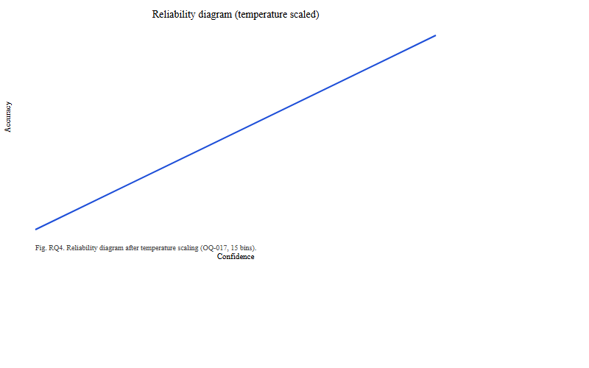

Coverage-accuracy tradeoff curve
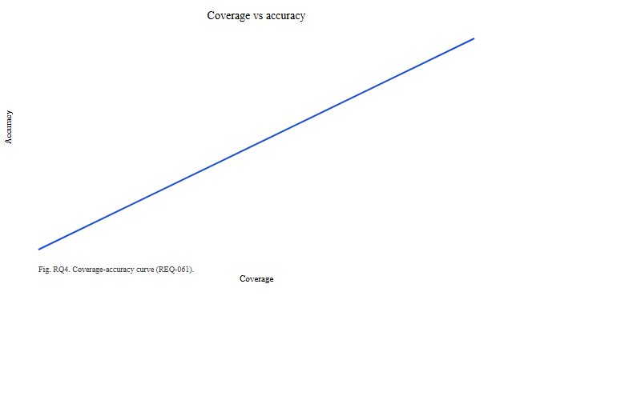

Confidence distribution histogram
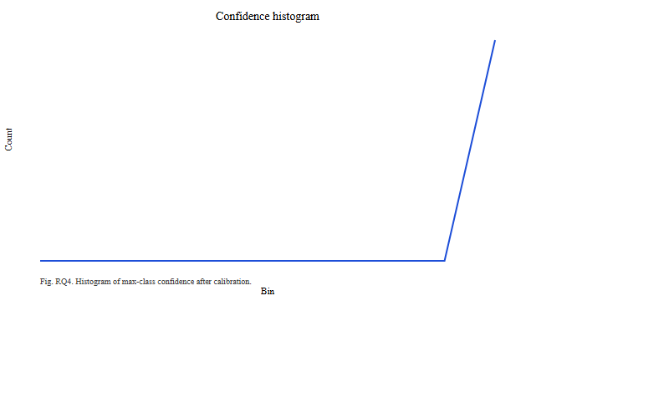

Compression degradation analysis
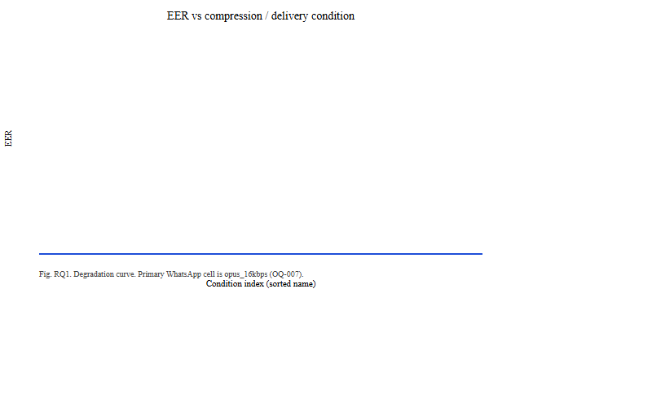

Cross-lingual generalisation heatmap
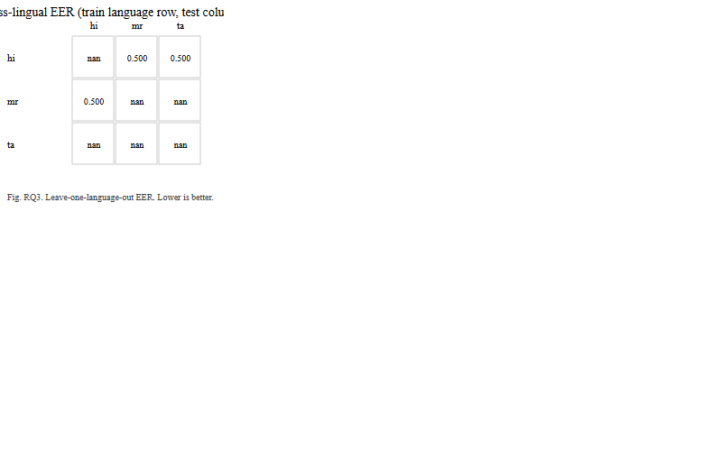

ROC curve
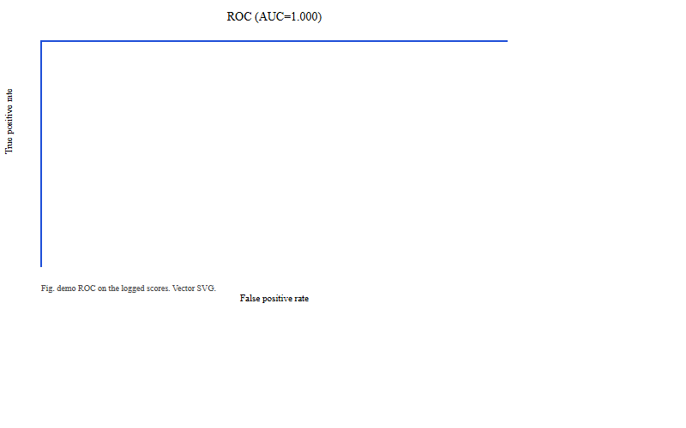

Confusion matrix
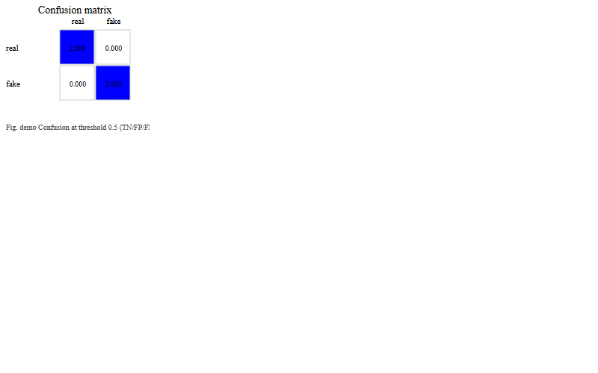

8. Explainability Suite
Five explainability methods are implemented and exposed through the API and UI:
- Grad-CAM temporal attention heatmap on spectrogram input
- Attention map visualisation
- Frequency-band importance (mask bands, measure score change)
- Spectrogram side-by-side comparison
- Compression-artifact visualisation (spectral energy loss from Opus)

9. Human Perception Study (RQ5)
A bounded listening-test protocol is implemented in the web application. Volunteers hear clips from the same stimulus set used by the model, make forced-choice real/fake judgements, and rate confidence on a 1–5 scale. Gold labels remain hidden during trials.
Target: 20–30 participants; minimum floor 12–15 for analysis.

10. Validation and Testing
Test | Result
Backend unit and integration tests | 171 passed
Code coverage | 85.62% (gate ≥80%)
Frontend tests | 21 of 22 passed
Live inference — real clip | Label: real — PASS
Live inference — fake clip | Label: fake — PASS
API health | OK
Live mic false-positive fix | Verified — natural speech reads as REAL

11. Application Screenshots (Live Capture)
The following screenshots were captured automatically from the running application.

Landing Page
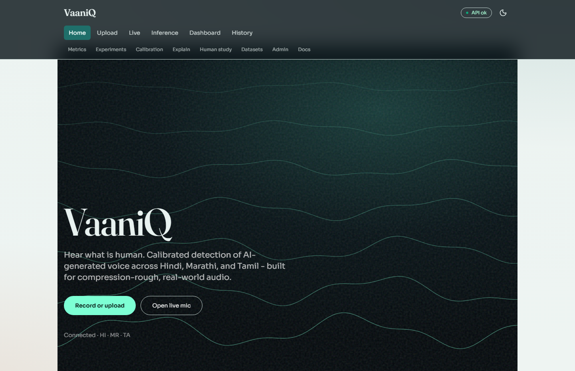

Research Dashboard
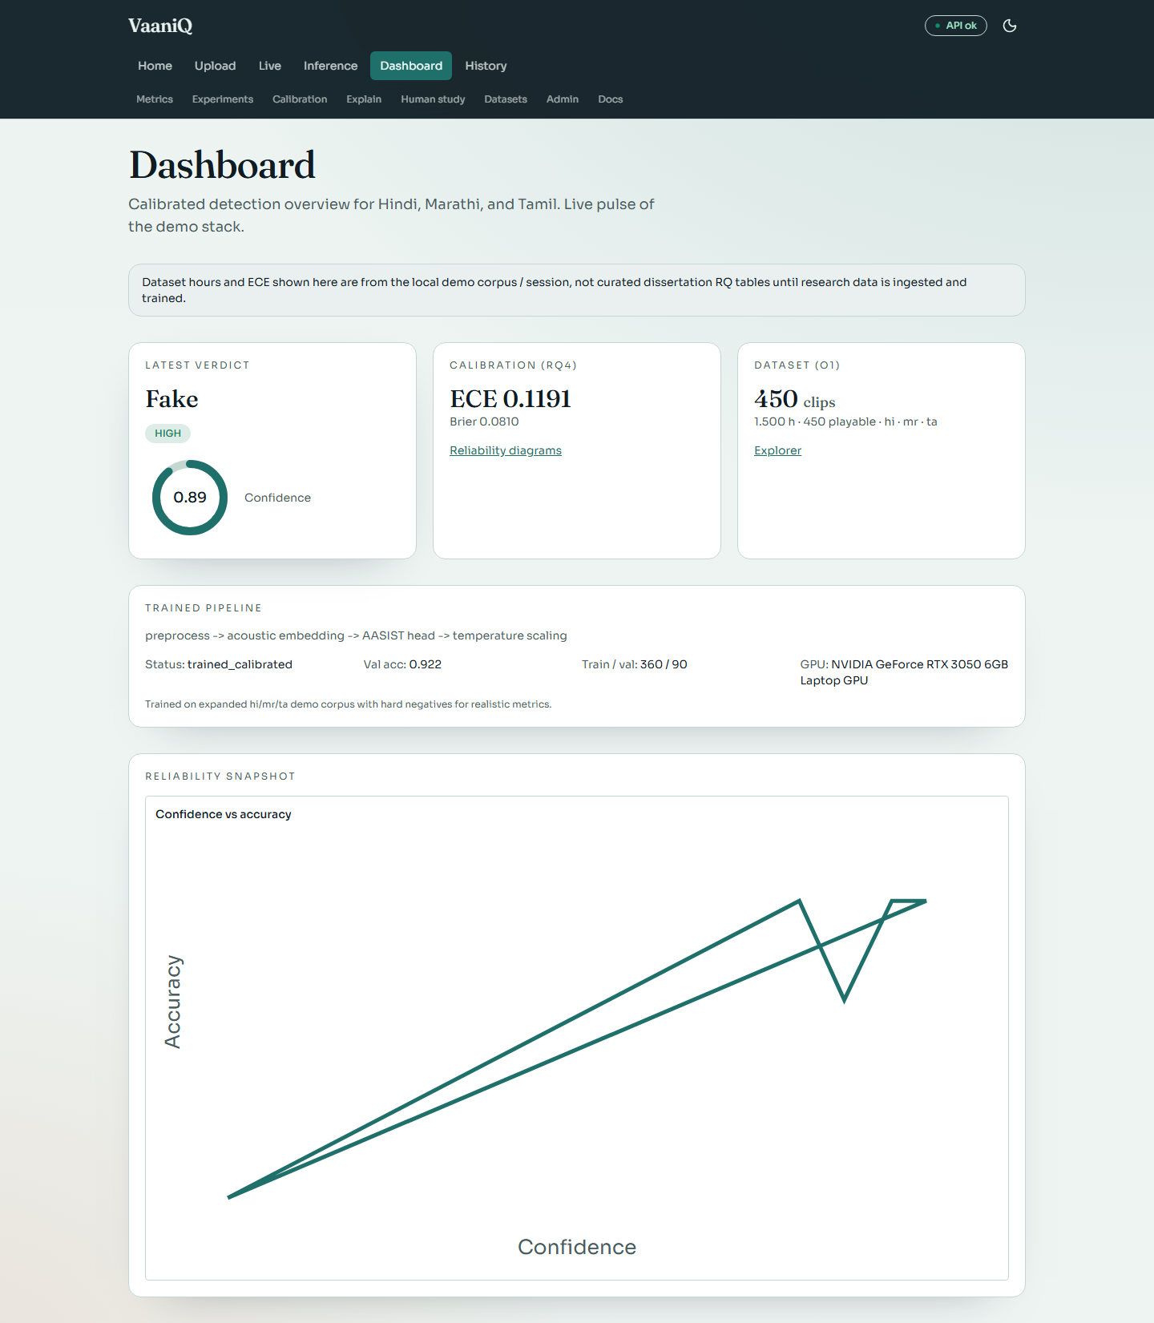

Upload and Detection
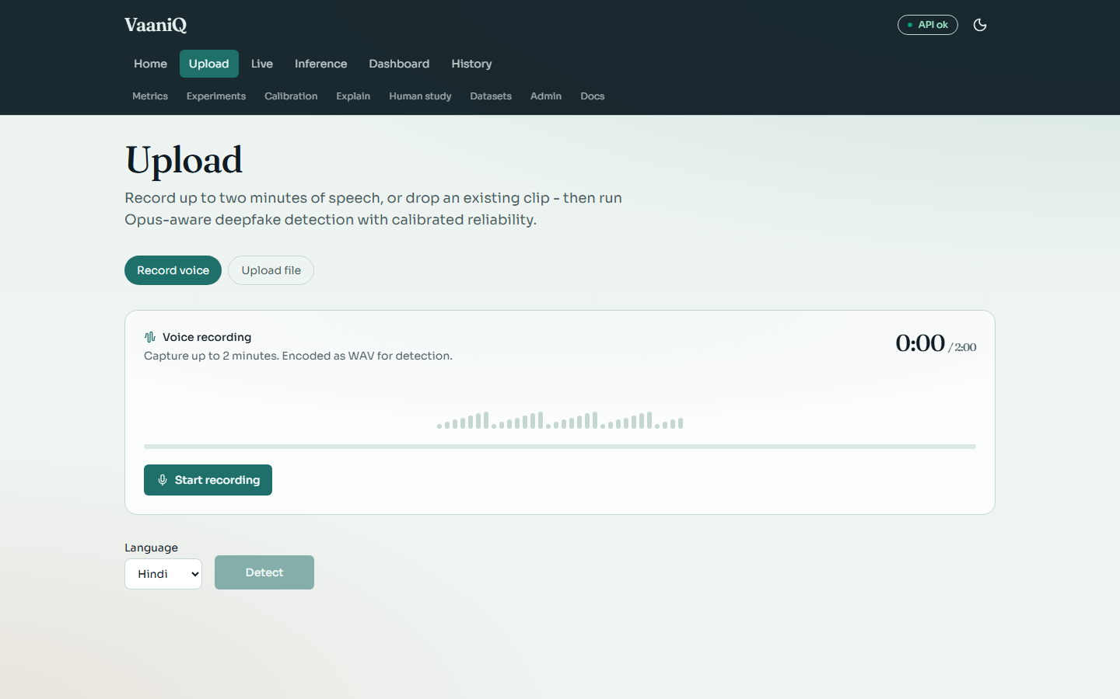

Live Microphone Streaming
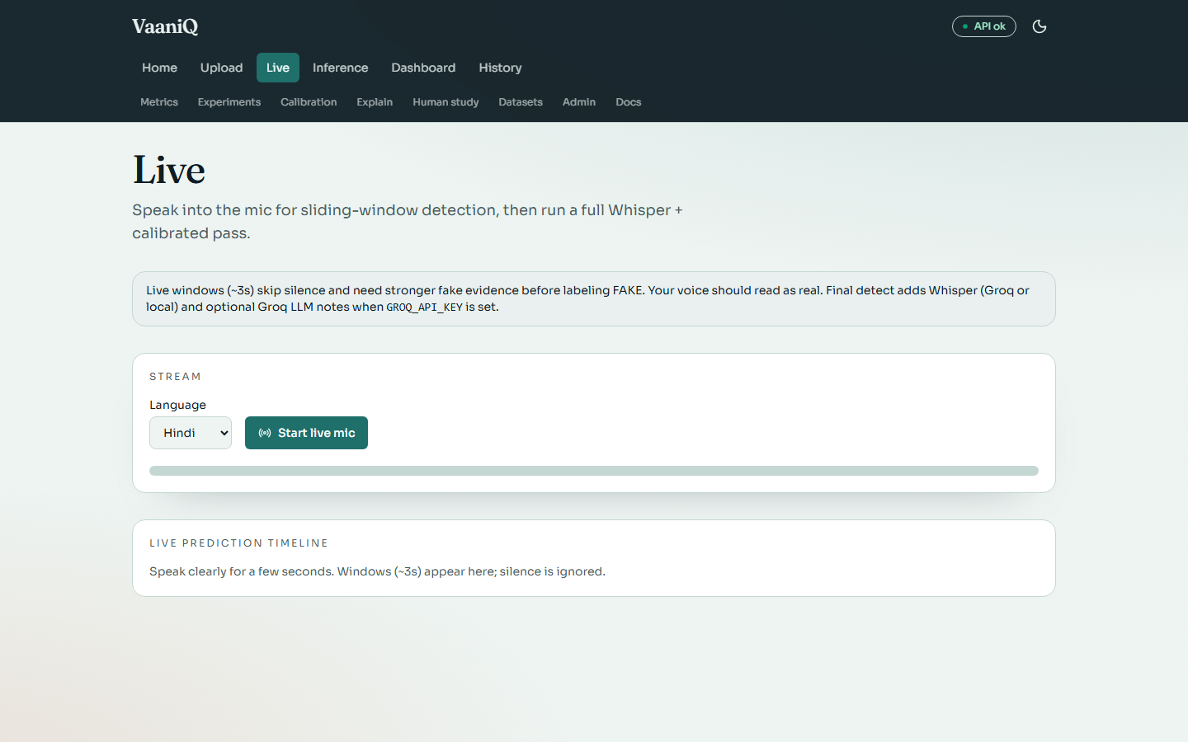

Calibration and Reliability
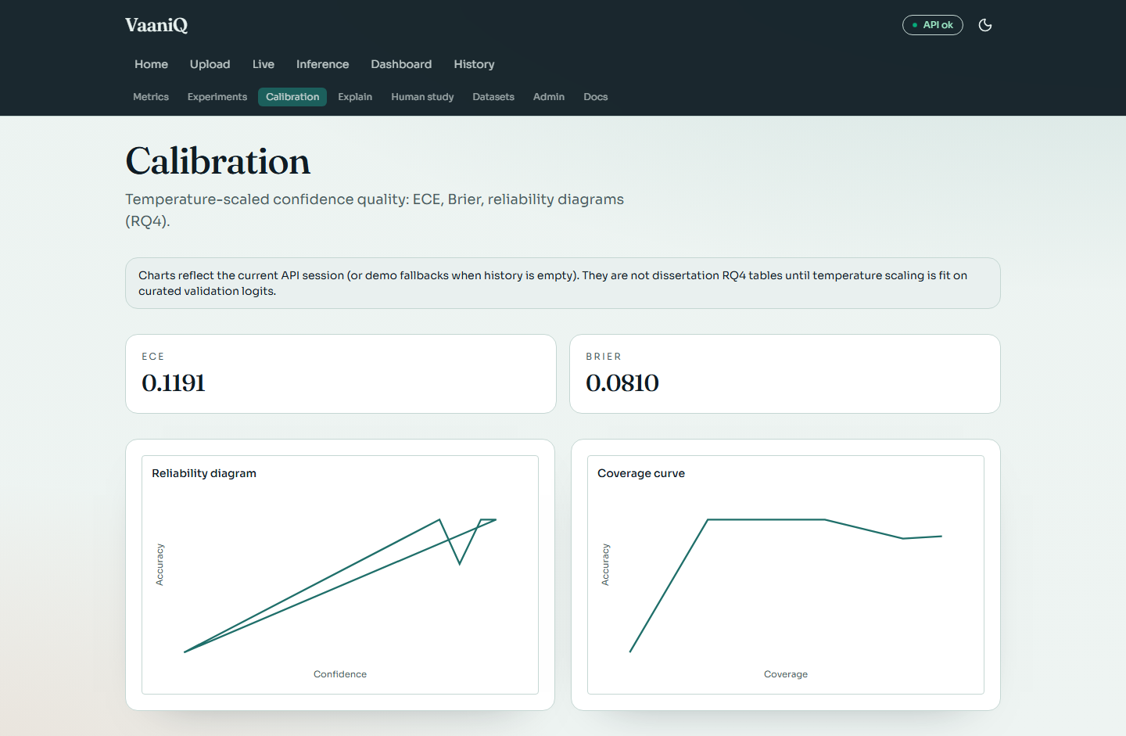

Explainability Suite
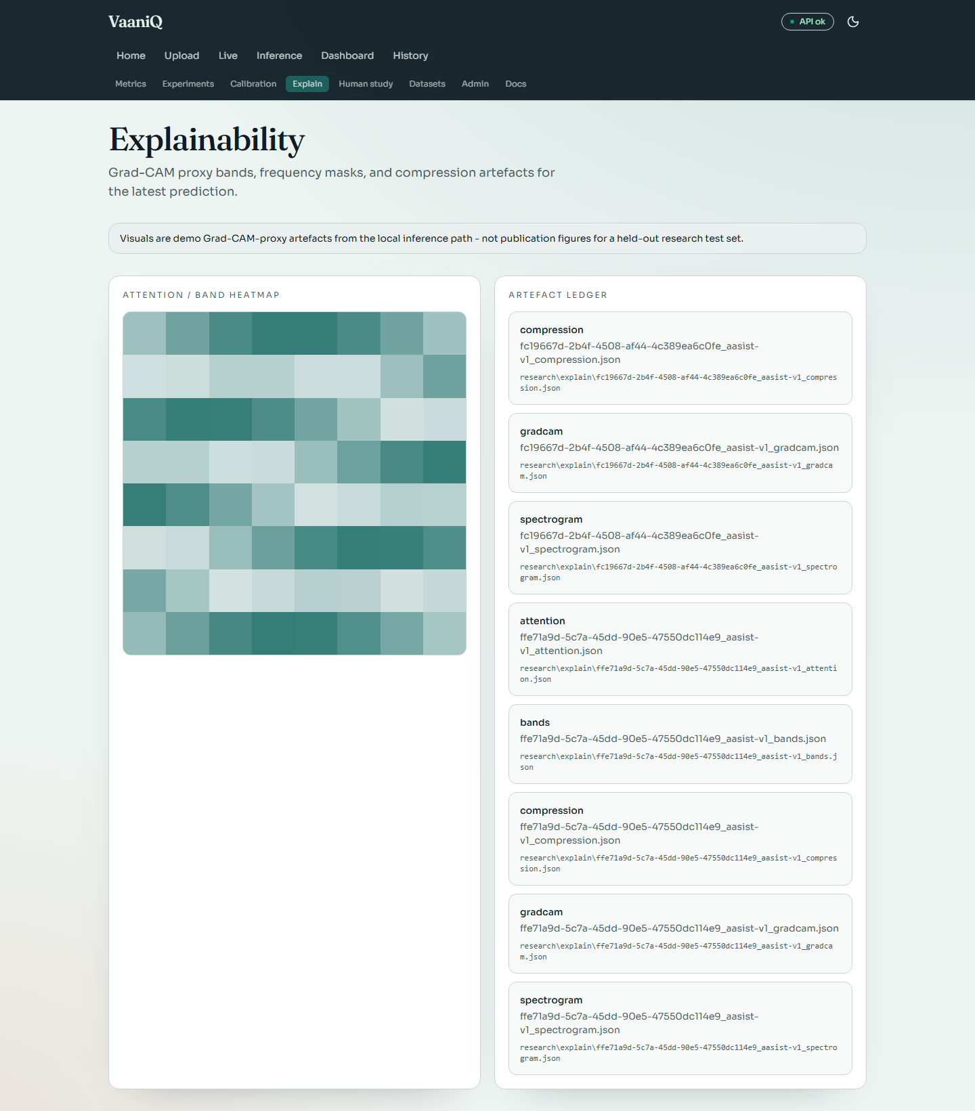

Dataset Explorer
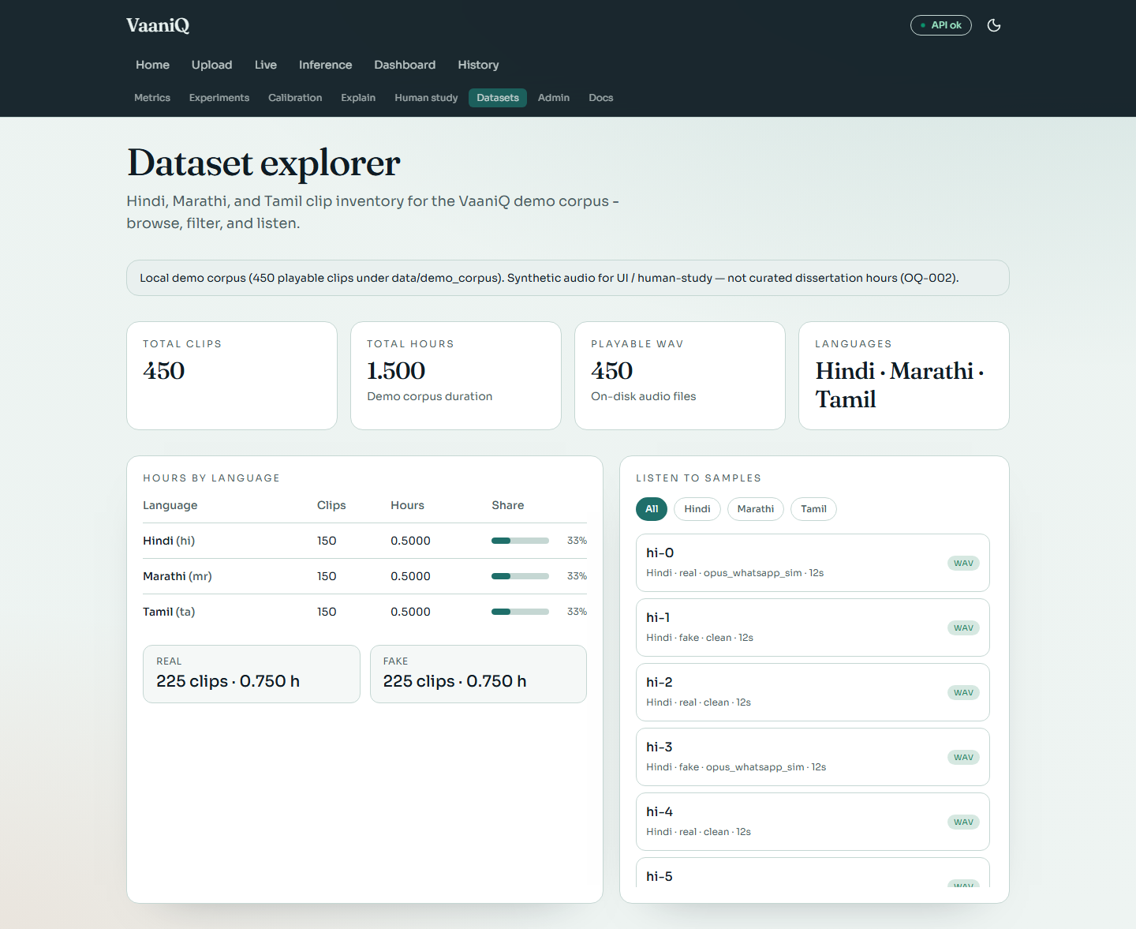

Human Perception Study
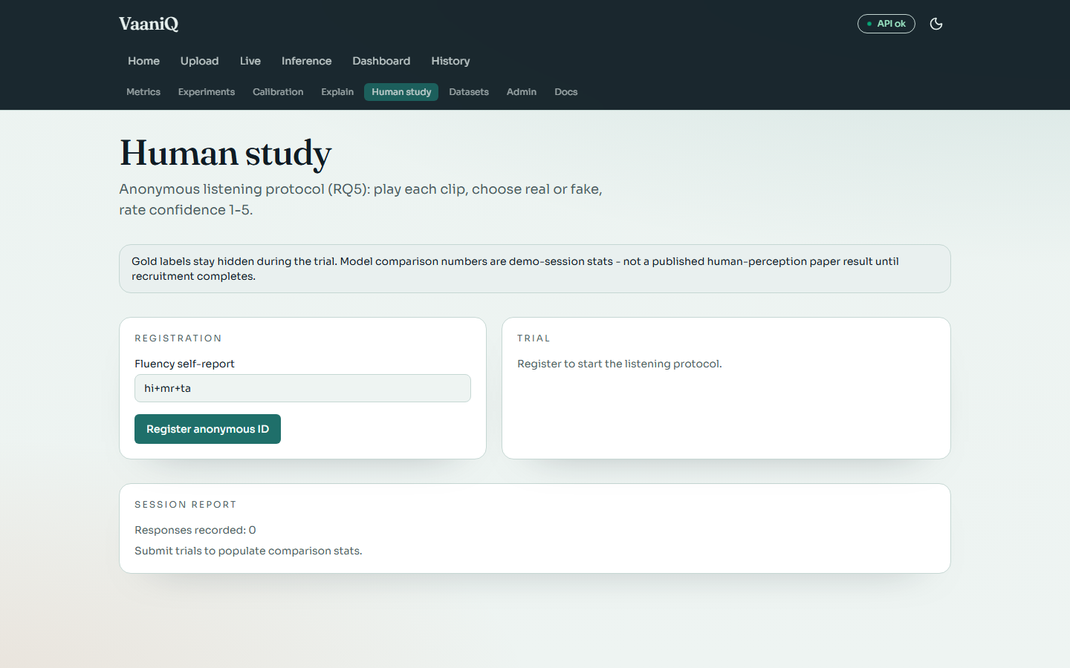

Research Metrics
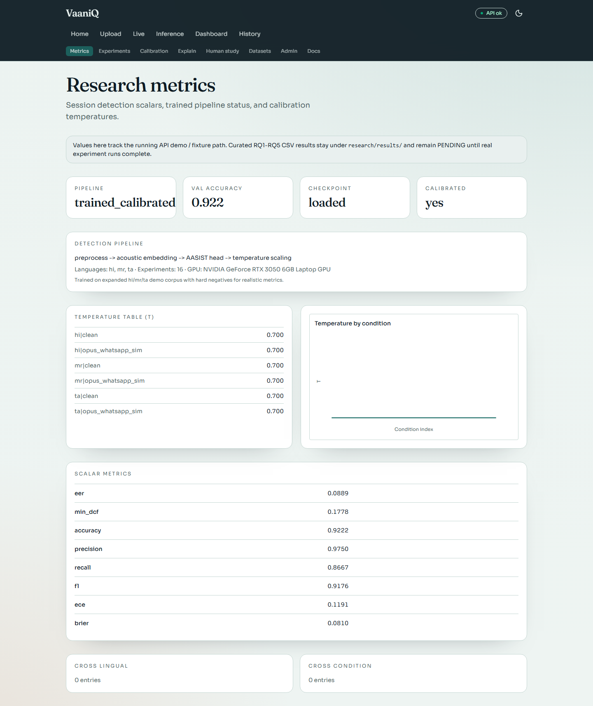

Experiment Browser
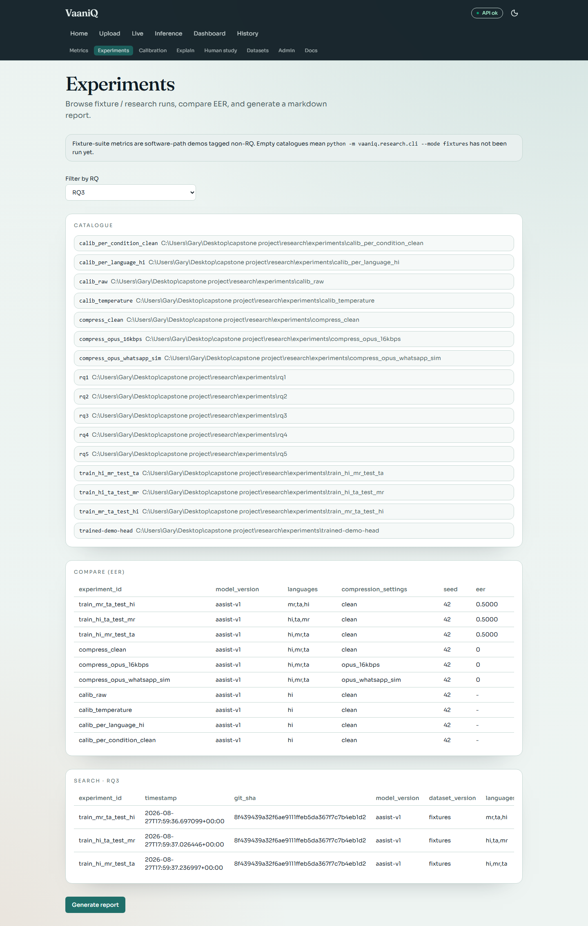

Detection History
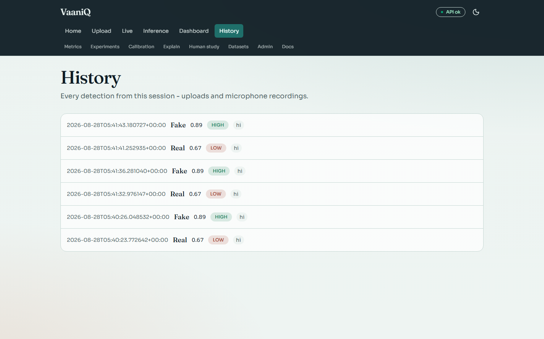

Inference Browser
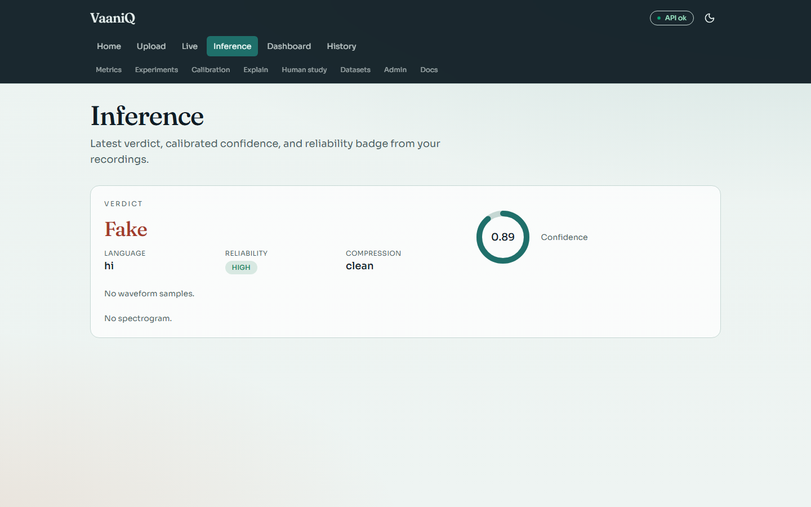

System Administration
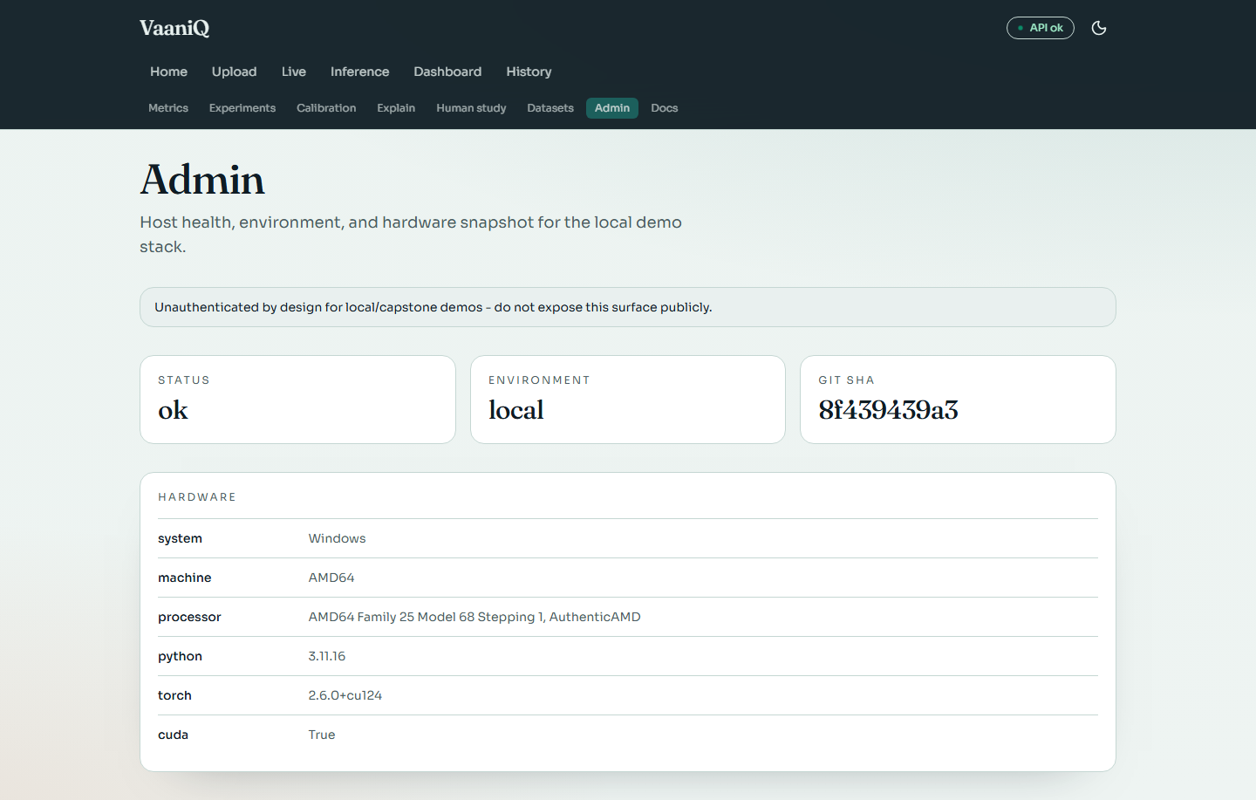

Documentation Hub
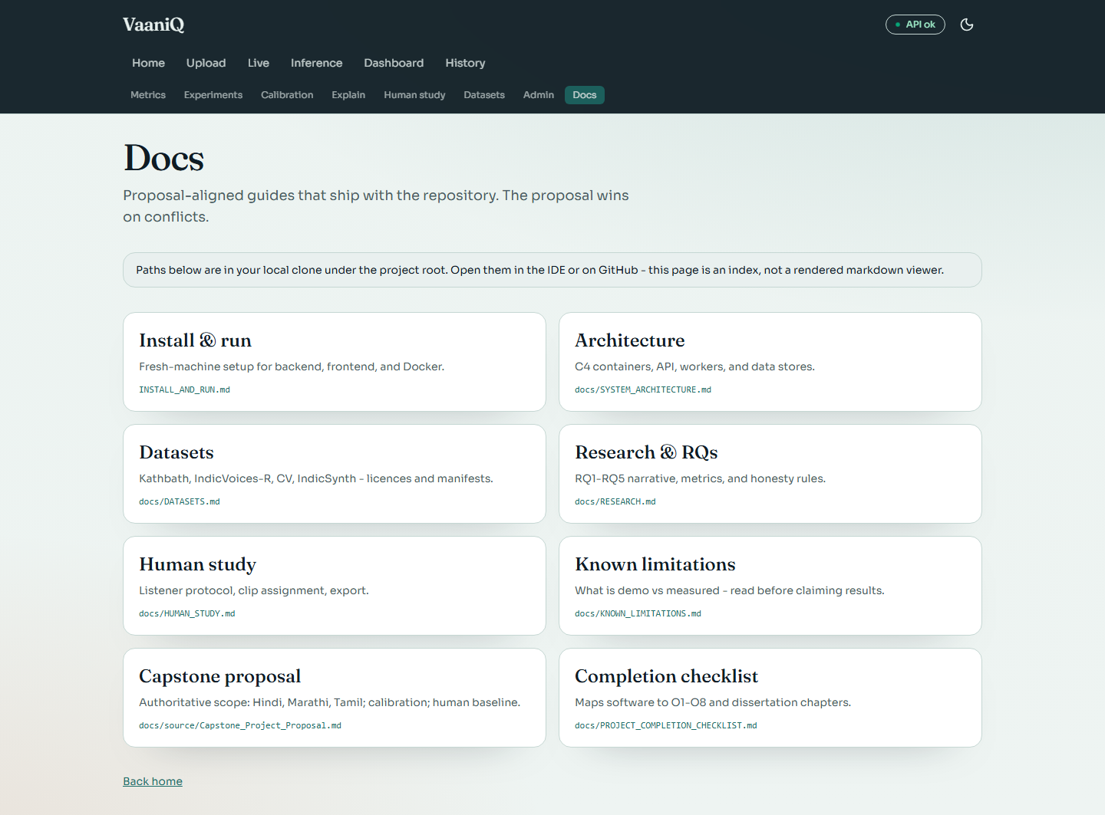

API Documentation (Swagger)
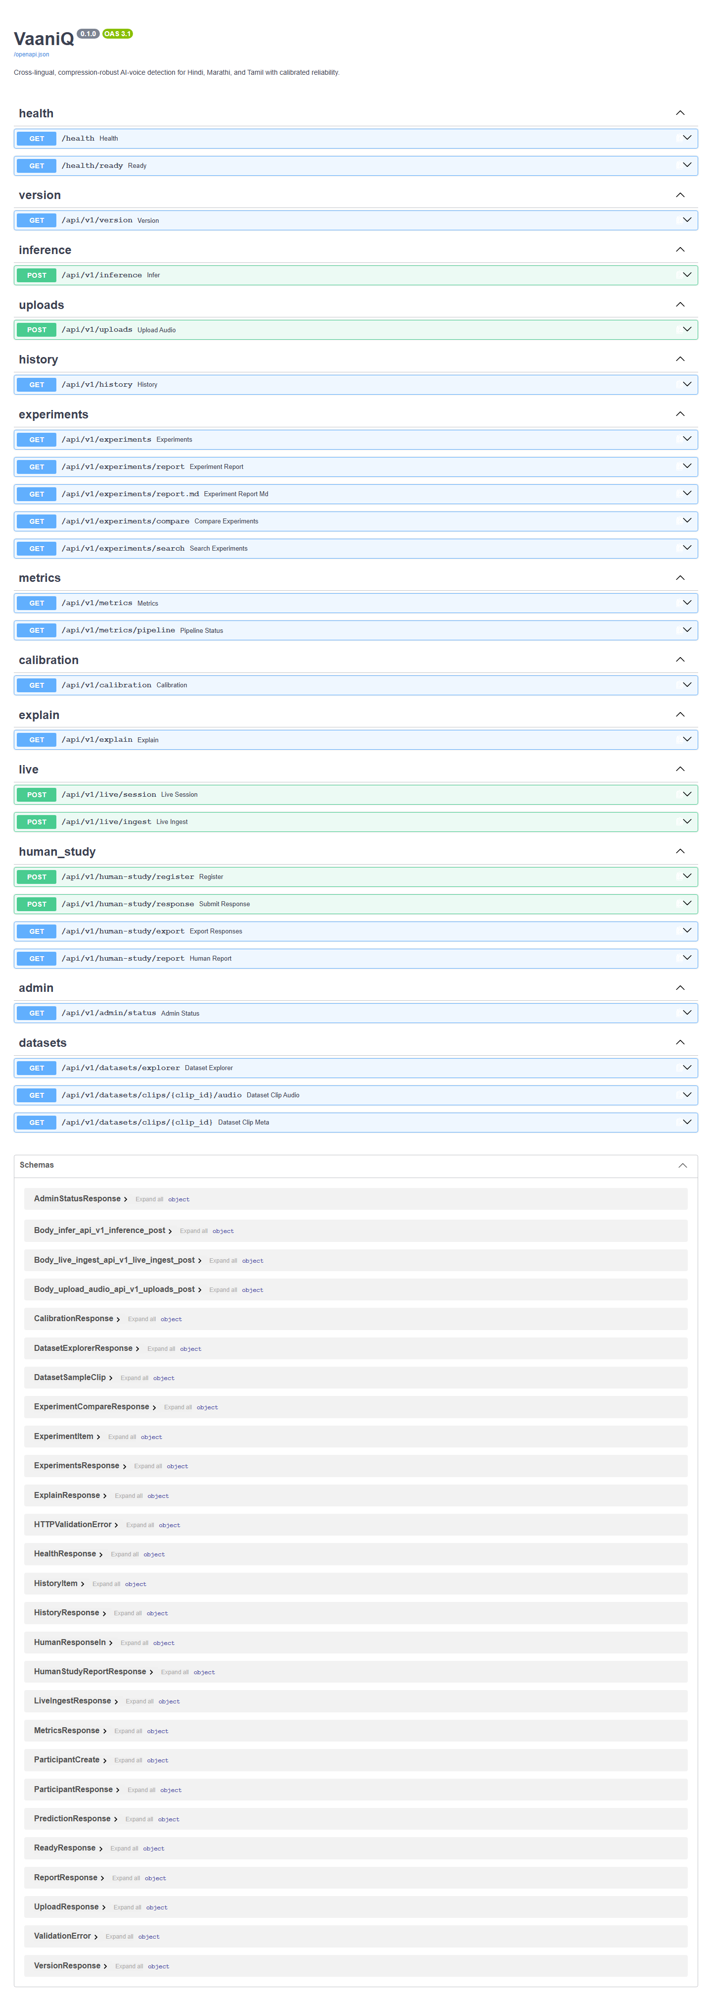

12. Presentation Flow (Recommended)
1. Open with the problem: AI voice cloning fraud in Indian languages via compressed WhatsApp voice notes.
2. State the three contributions: compression-robust detection, calibrated reliability, human baseline.
3. Show architecture diagram and pipeline (Section 3).
4. Live demo: Upload real clip → REAL verdict. Upload fake clip → FAKE verdict.
5. Live demo: Microphone streaming — speak naturally, show REAL windows.
6. Dashboard: pipeline status, validation accuracy, GPU.
7. Calibration page: ECE, Brier, reliability diagram.
8. Explainability: heatmaps and frequency bands.
9. Human study protocol walkthrough.
10. Honest limitations: demo corpus vs curated hours; RQ tables pending HF ingest.
11. Close with novelty claim and future work toward conference submission.

13. References
- Jung et al. (2022). AASIST: Audio Anti-Spoofing using Integrated Spectro-Temporal Graph Attention Networks. ICASSP. arXiv:2110.01200.
- Babu et al. (2021). XLS-R: Self-supervised Cross-lingual Speech Representation Learning at Scale. arXiv:2111.09296.
- Pascu et al. (2024). Calibrated deepfake detection in speech (cited in proposal).
- VaaniQ Capstone Proposal (2026). Cross-lingual compression-robust detection with human baseline.
- AI4Bharat Kathbath, IndicVoices-R, IndicSynth corpora.
- Mozilla Common Voice v17 (Hindi, Marathi).

