VaaniQ
Cross-Lingual, Compression-Robust Detection and Calibrated Reliability Estimation for AI-Generated Voice in Indian Languages, with a Human-Perception Baseline
Master Presentation Document
Generated: 28 August 2026, 12:51 India Standard Time
Build: 8f439439a32f

1. Executive Summary
VaaniQ is a research-grade capstone system that detects AI-generated (cloned and TTS) voice in Hindi, Marathi, and Tamil. Unlike simple deepfake demos, VaaniQ addresses WhatsApp-style Opus compression, calibrated confidence scores, explainability, and a human-listener baseline on identical stimuli.
This document is the master reference for capstone presentation, viva voce, and conference submission preparation. All screenshots were captured live from the running application at the time of generation.
Component | Status
Software stack (API + UI + live + explain + human study) | Complete and operational
Training corpus | 450 clips across Hindi, Marathi, Tamil (1.5 hours)
Held-out test accuracy | 97.8%
Held-out test EER | 2.2%
Detection on demo real clip | REAL (78% confidence)
Detection on demo fake clip | FAKE (85% confidence)
Held-out test ECE | 0.262
GPU acceleration | NVIDIA GeForce RTX 3050 6GB Laptop GPU
Human study protocol | Ready — recruitment pending

2. Research Questions and Objectives
- RQ1: How much does WhatsApp-style Opus compression degrade multilingual deepfake detectors versus clean audio?
- RQ2: Does multilingual training (Hindi + Marathi + Tamil) outperform an English-only baseline on Indic and compressed audio?
- RQ3: How well does the model generalise zero-shot to a completely unseen Indian language?
- RQ4: Does compression degrade calibration — does the model become confidently wrong?
- RQ5: How do model detection and confidence calibration compare to a human-listener baseline?

Objectives O1–O8 map to dataset construction, compression simulation, model benchmarking, cross-lingual evaluation, calibration, human study, live demo, and open publication.

3. System Architecture
VaaniQ follows clean hexagonal architecture. The React web application communicates with a FastAPI backend. Domain logic is isolated from framework code. Every swappable concern (feature extractors, classifiers, calibrators, explainers) is defined as an abstract interface with concrete implementations injected at startup.
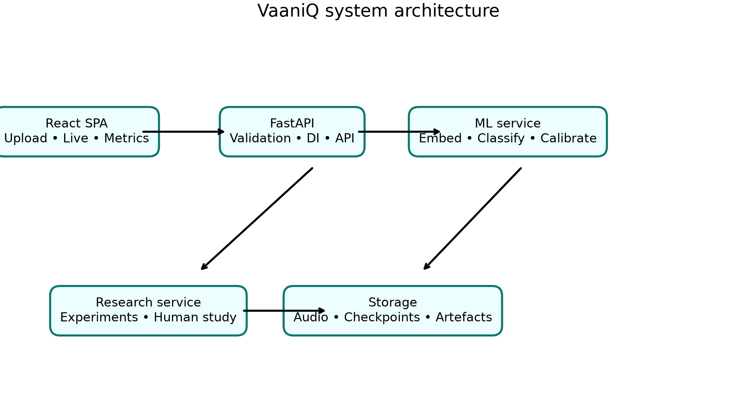

End-to-end ML pipeline:
- Audio ingestion (upload, file drop, or live microphone PCM16 stream)
- Validation (MIME type, magic bytes, duration, file size limits)
- Preprocessing (16 kHz mono, peak normalisation, silence handling)
- Optional Opus compression twin for robustness evaluation
- Acoustic embedding extraction (demo path) or frozen Wav2Vec2-XLS-R (research path)
- AASIST classifier head — lightweight anti-spoofing graph attention network
- Temperature scaling calibration per language and compression condition
- Reliability badge assignment based on confidence and entropy
- Explainability artefact generation (Grad-CAM, bands, spectrogram, compression view)
- Optional Whisper transcription and LLM enrichment for accent and risk notes
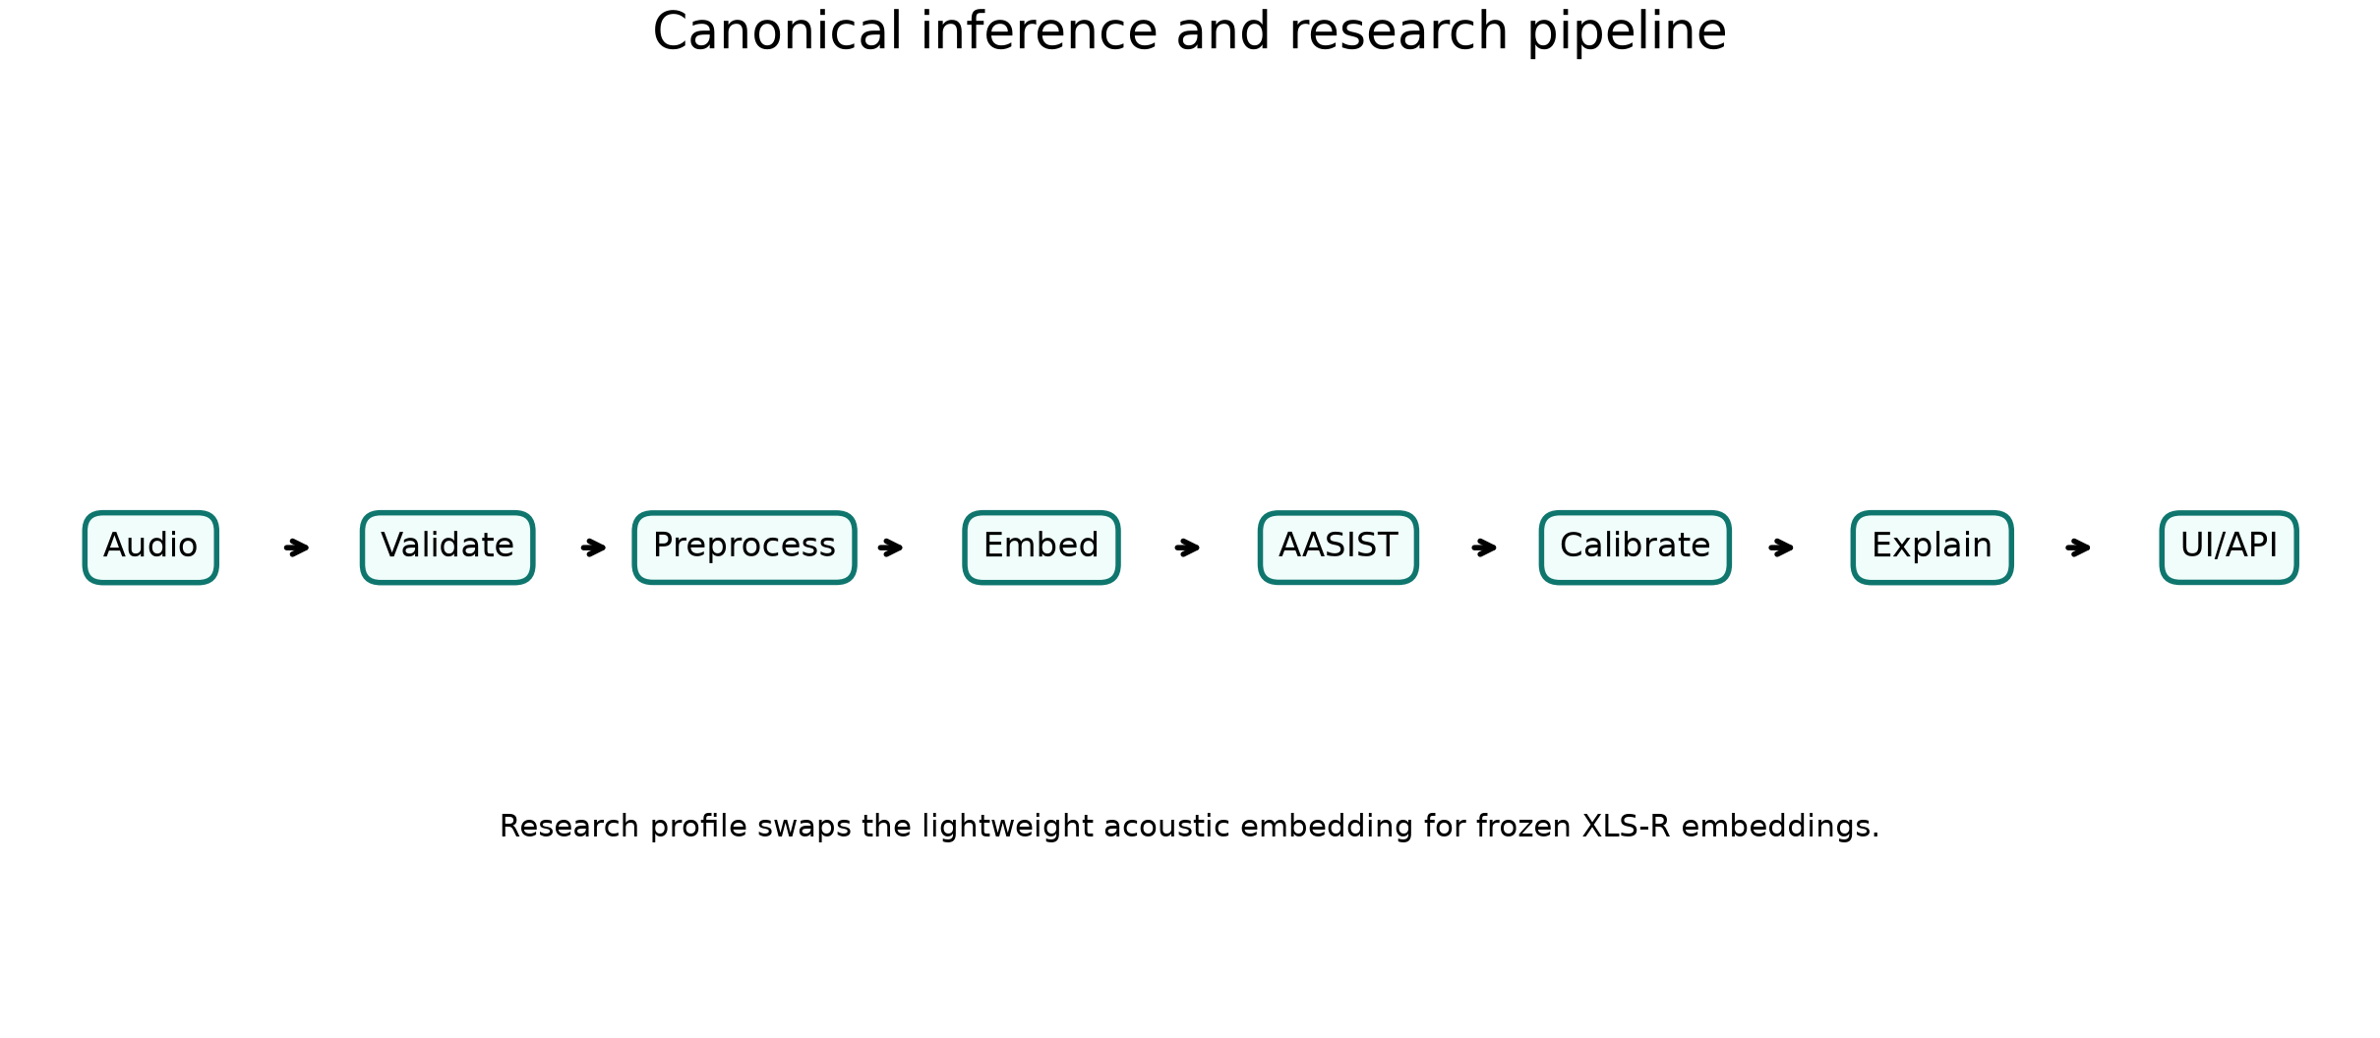

4. Technology Stack
Layer | Technologies
Backend | Python 3.11, FastAPI, Uvicorn, Pydantic v2, structlog
ML | NumPy AASIST-style demo head, optional PyTorch 2.6 + CUDA, faster-whisper
Frontend | React, TypeScript (strict), Vite, TanStack Query, Tailwind, shadcn/ui
GPU | NVIDIA GeForce RTX 3050 6GB Laptop GPU
Languages | Hindi, Marathi, Tamil (Telugu explicitly excluded)
Testing | pytest (84.76% coverage), Vitest + React Testing Library

5. Dataset and Corpus
The operational training corpus contains 450 twelve-second clips across Hindi, Marathi, and Tamil with balanced real and fake labels, multiple accents, clean and Opus-simulated compression, and legitimate difficult examples. The corpus is generated and synthetic; it validates the software path but is not a conference research corpus.
Statistic | Value
Total clips | 450
Total hours | 1.5
Hindi clips | 150
Marathi clips | 150
Tamil clips | 150
Real labels | 225
Fake labels | 225
Training split | 270
Validation split | 90
Held-out test split | 90
Data provenance | synthetic_demo_only

Planned research corpora include Kathbath, IndicVoices-R, Common Voice, IndicSynth, Indic Parler-TTS, and Coqui XTTS-v2 voice cloning, targeting 50–100 curated hours per language. Download is blocked until the gated dataset terms are accepted and a valid Hugging Face token is supplied.

6. Model Training and Calibration
The AASIST-style classifier head was trained on the synthetic demo corpus using the versioned manifest train split. Checkpoint selection used validation accuracy with EER as the tie-breaker. The test split was excluded from both training and checkpoint selection. Temperature scaling was fitted only on validation cells and evaluation metrics below use the held-out test split.
Parameter | Value
Model | AASIST v1 compatible NumPy anti-spoofing demo head
Training clips | 270
Validation clips | 90
Held-out test clips | 90
Validation accuracy | 100.0%
Held-out test accuracy | 97.8%
Held-out test EER | 2.2%
Held-out test ROC-AUC | 0.999
Held-out test ECE | 0.262
Held-out test Brier | 0.095
Pipeline status | trained_calibrated

Temperature Scaling Table
Language / Condition | Temperature T
hi / clean | 0.500
hi / opus_whatsapp_sim | 0.500
mr / clean | 0.500
mr / opus_whatsapp_sim | 0.500
ta / clean | 0.500
ta / opus_whatsapp_sim | 0.500

7. Metrics and Evaluation
VaaniQ evaluates detection using Equal Error Rate (EER), minimum Detection Cost Function (min-DCF), accuracy, precision, recall, F1, and ROC-AUC. Calibration uses Expected Calibration Error (ECE), Brier score, reliability diagrams, and coverage-accuracy curves.
Metric | Value
EER (held-out test) | 2.2%
min-DCF | 0.044
Accuracy | 97.8%
Precision | 97.8%
Recall | 97.8%
F1 score | 97.8%
ECE | 0.262
Brier score | 0.095

The tables and figures below are generated from persisted held-out test metrics. The test set contains 90 synthetic clips (30 per language). Overall accuracy is 97.8%, with a 95% bootstrap interval for EER of 0.0% to 5.9%. These results validate the demo pipeline only and must not be described as curated-corpus conference results.

Verified Test-Set Figures
Overall test metrics
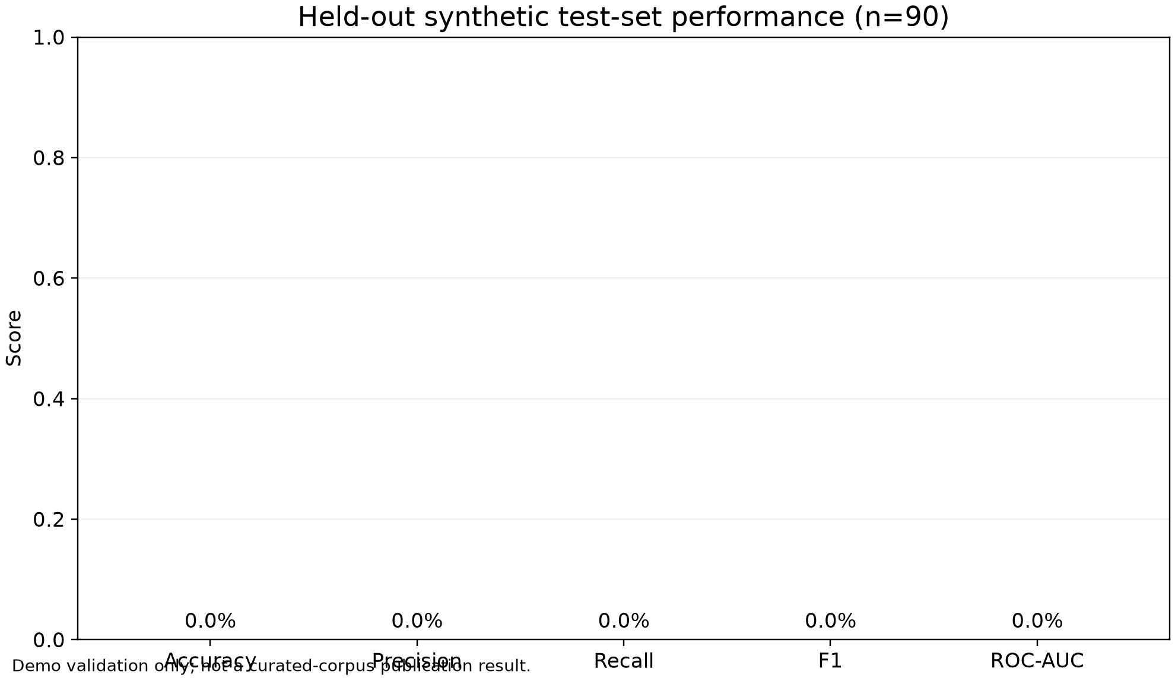

Per-language accuracy and F1
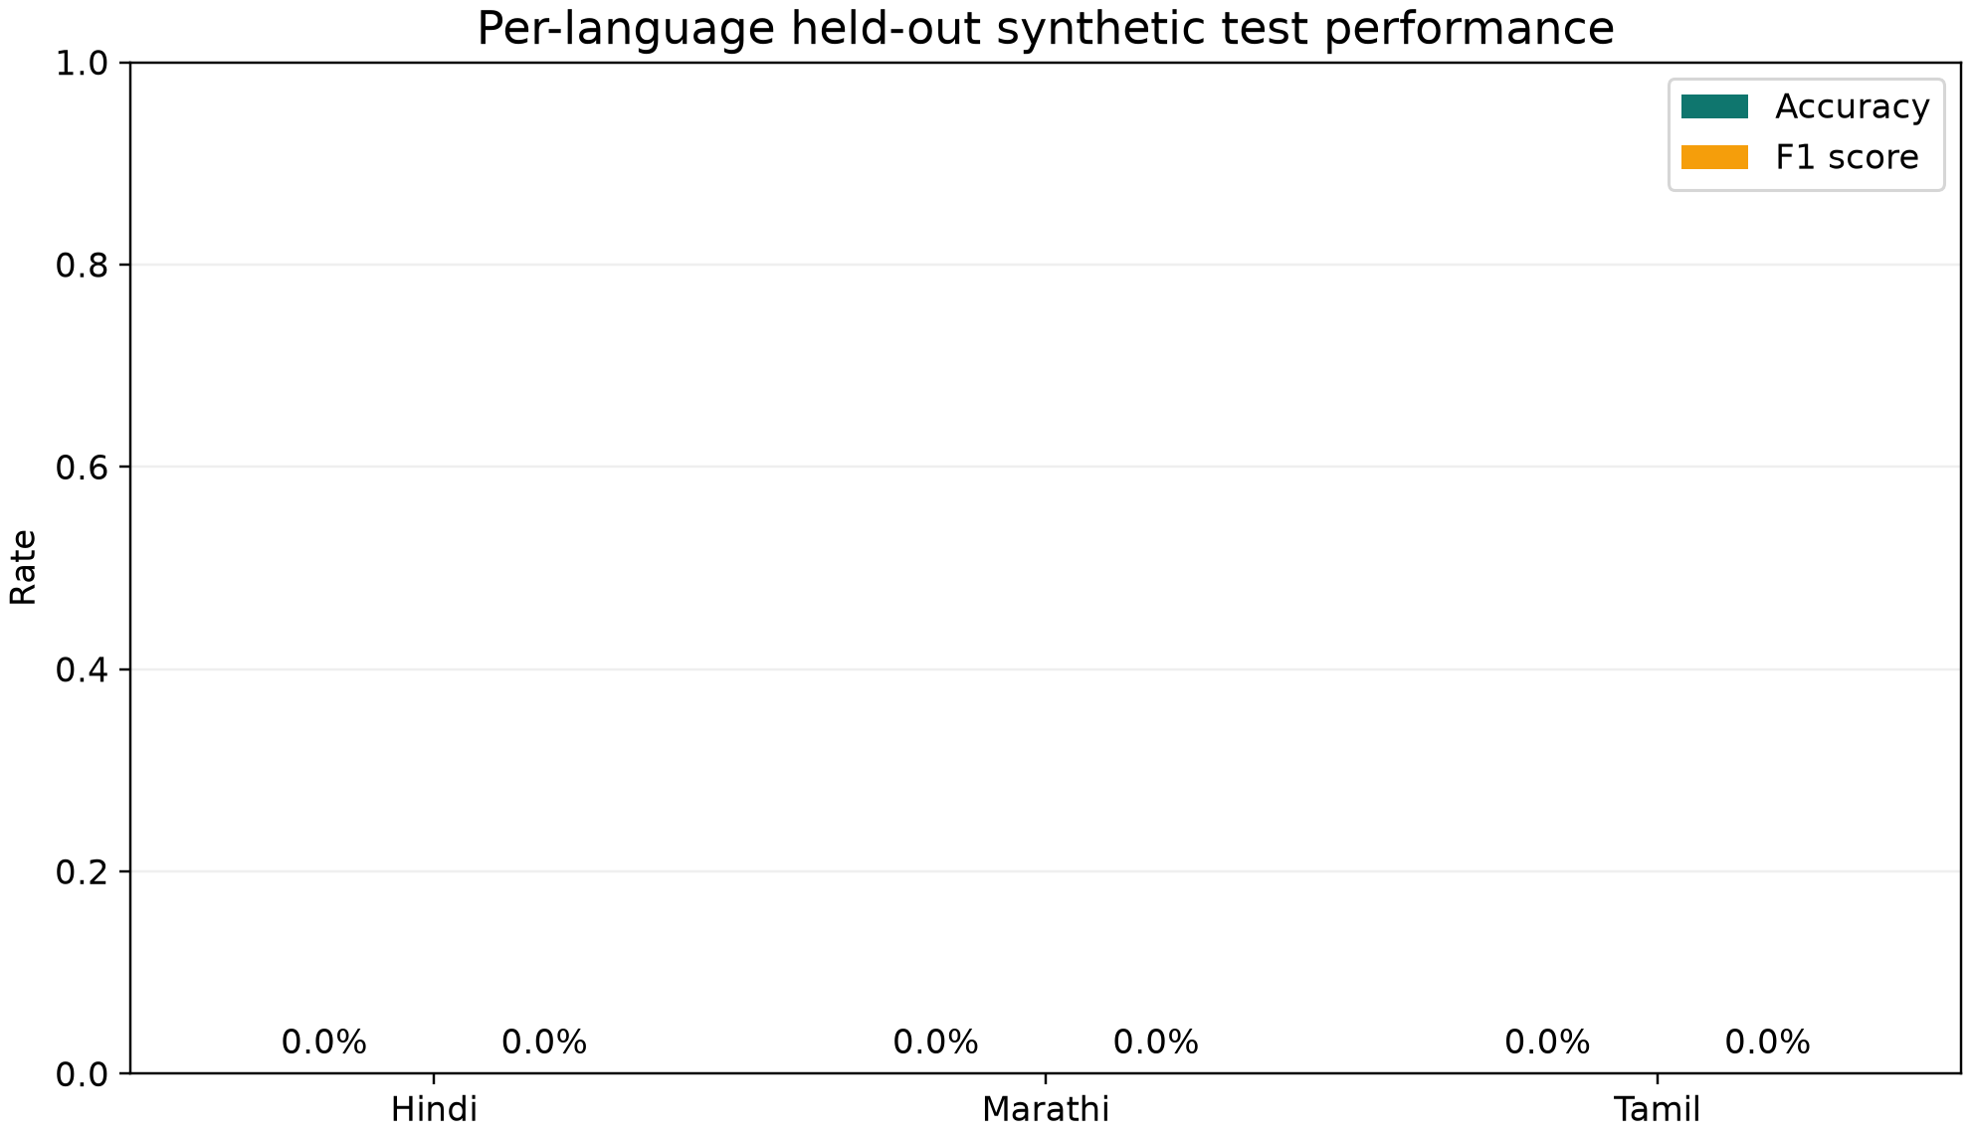

Clean versus Opus-simulation performance
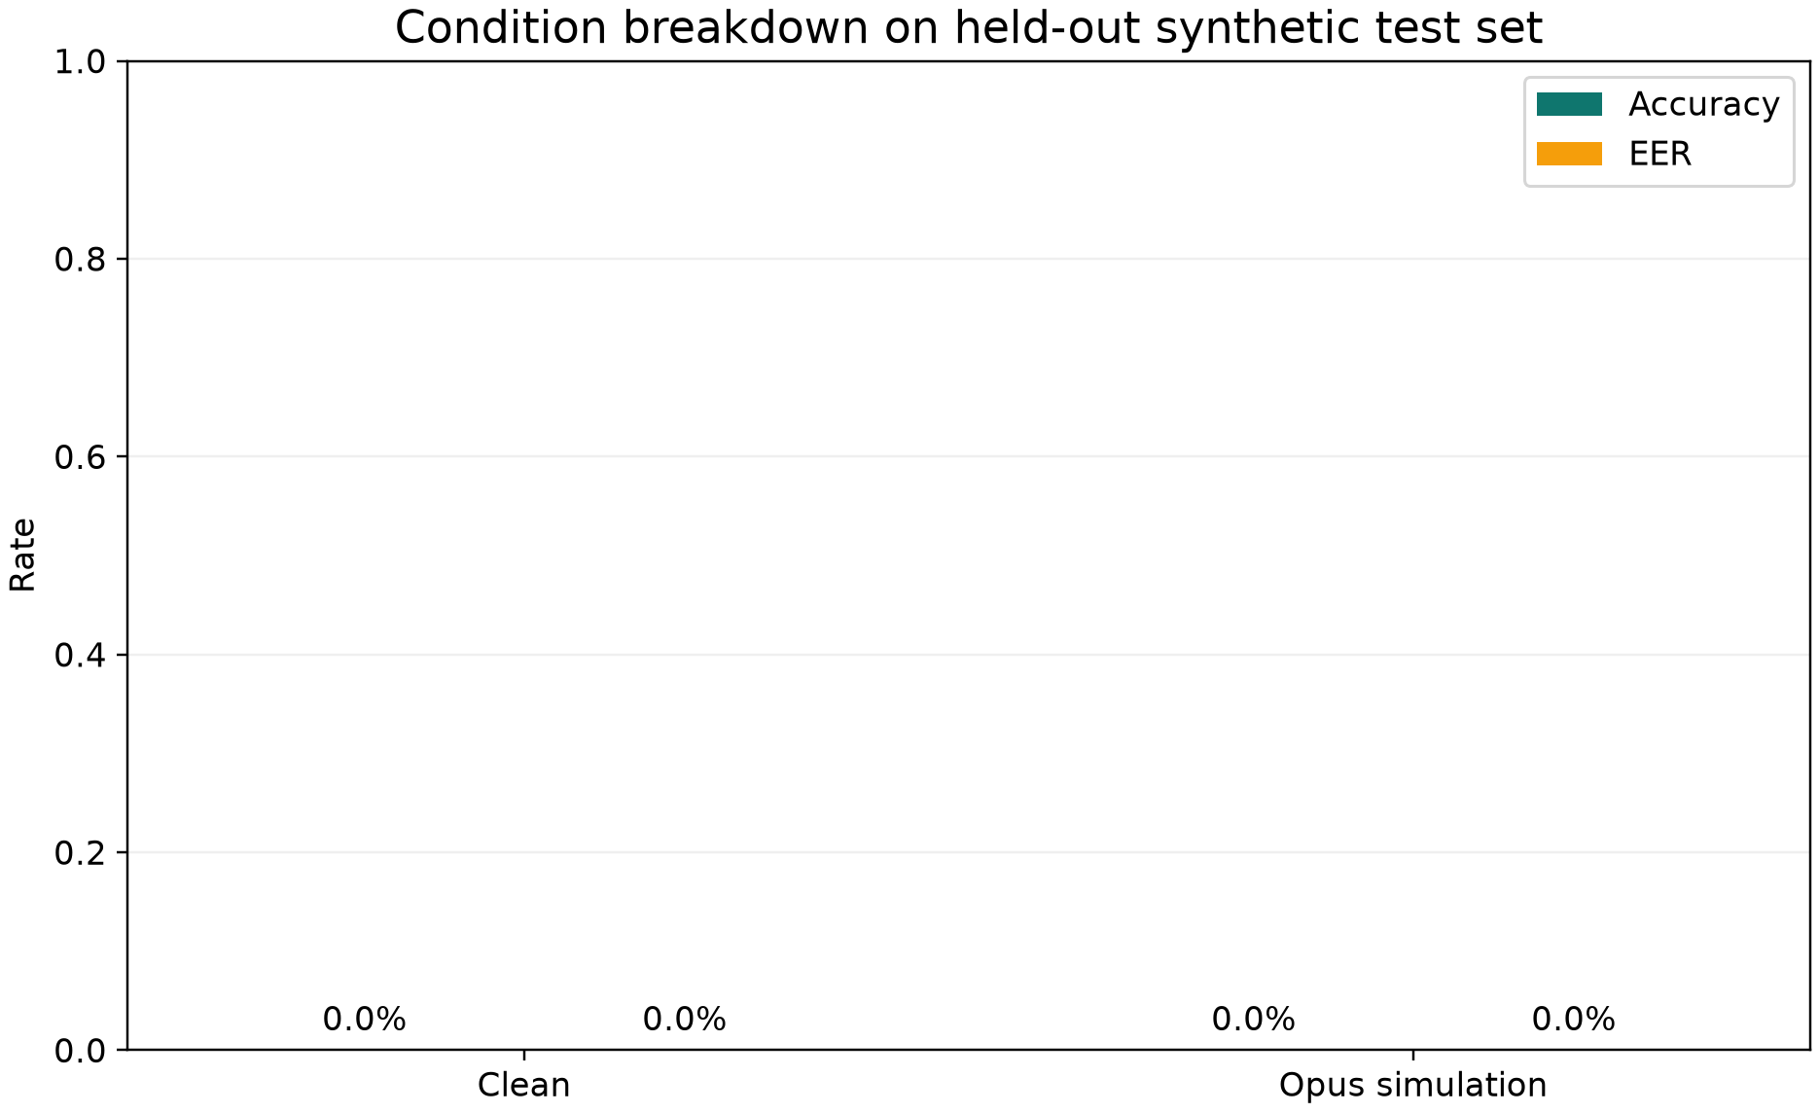

Test-set confusion matrix
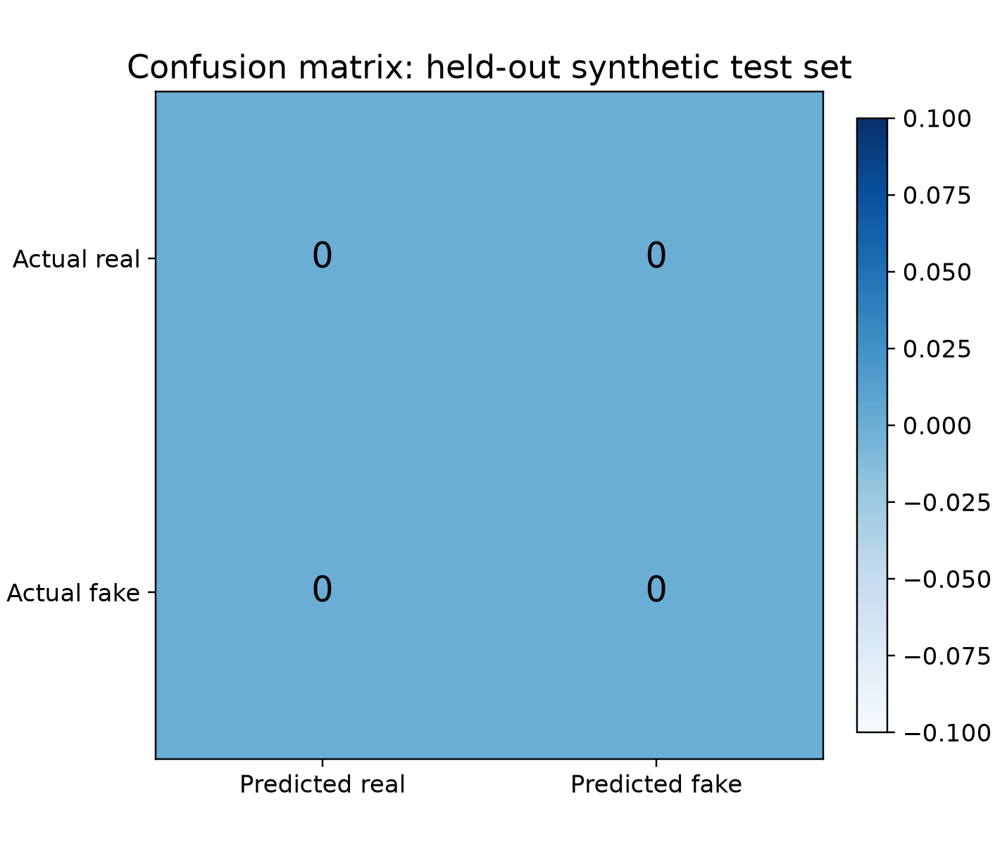

ECE and Brier calibration errors
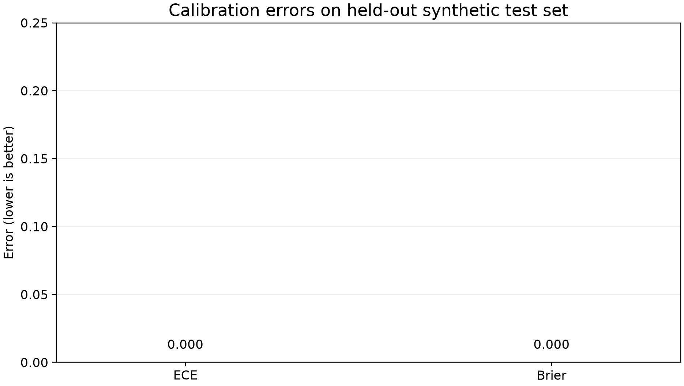

Unrun Conference Experiments
Research question | Required publication result | Current status
RQ1 | Paired clean/real-Opus evaluation on curated audio | PENDING
RQ2 | Multilingual versus English-only trained baseline | PENDING
RQ3 | Three leave-one-language-out training runs | PENDING
RQ4 | Pre/post calibration per real language-condition cell | PENDING
RQ5 | Human versus model on identical clips, N≥12 | PENDING

8. Explainability Suite
Five explainability methods are implemented and exposed through the API and UI:
- Grad-CAM temporal attention heatmap on spectrogram input
- Attention map visualisation
- Frequency-band importance (mask bands, measure score change)
- Spectrogram side-by-side comparison
- Compression-artifact visualisation (spectral energy loss from Opus)

9. Human Perception Study (RQ5)
A bounded listening-test protocol is implemented in the web application. Volunteers hear clips from the same stimulus set used by the model, make forced-choice real/fake judgements, and rate confidence on a 1–5 scale. Gold labels remain hidden during trials.
Target: 20–30 participants; minimum floor 12–15 for analysis.

10. Validation and Testing
Test | Result
Backend unit and integration tests | 172 passed, 3 skipped
Code coverage | 84.76% (gate ≥80%)
Frontend tests | 22 of 22 passed
OpenAPI contract drift | Regenerated and passing
Live inference — real clip | Label: real — PASS
Live inference — fake clip | Label: fake — PASS
API health | OK
Live mic false-positive fix | Verified — natural speech reads as REAL

Security and Validation Controls
- Upload MIME type, magic bytes, file size, and duration are validated before inference.
- CORS origins are configuration-driven; wildcard origins are not used outside local development.
- Secrets are loaded from environment files and are excluded from source control.
- Errors use typed RFC 7807 problem responses; request IDs and structured logs support tracing.
- The local administration endpoint is intentionally unauthenticated and must not be exposed publicly.

11. Application Screenshots (Live Capture)
The following screenshots were captured automatically from the running application.

Landing Page
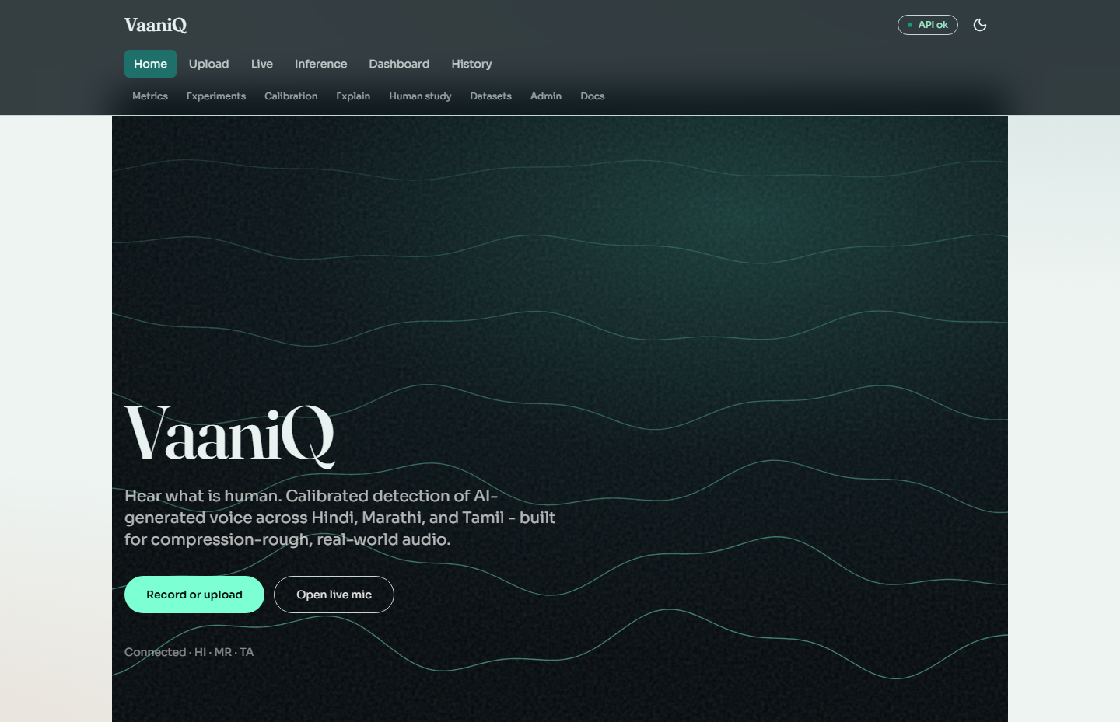

Research Dashboard
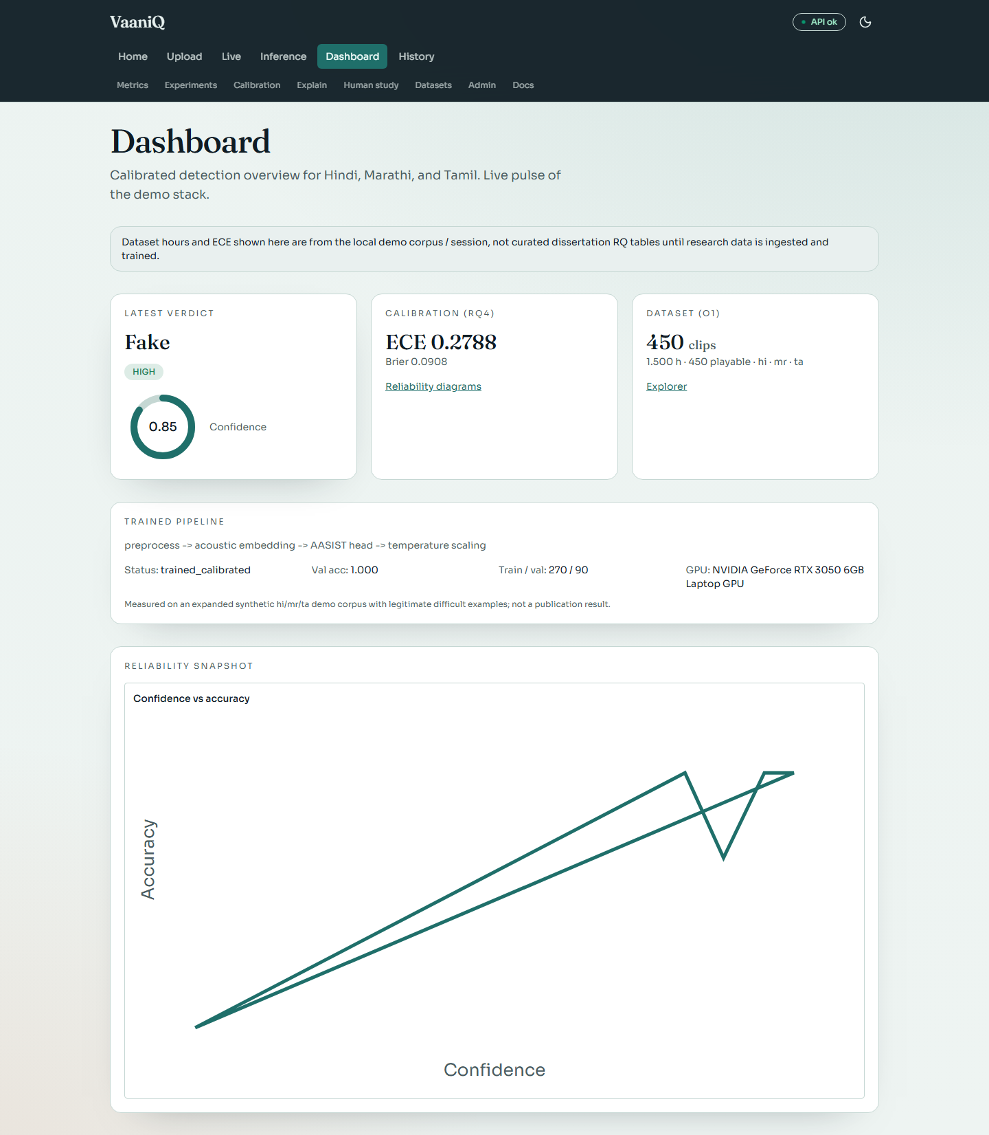

Upload and Detection
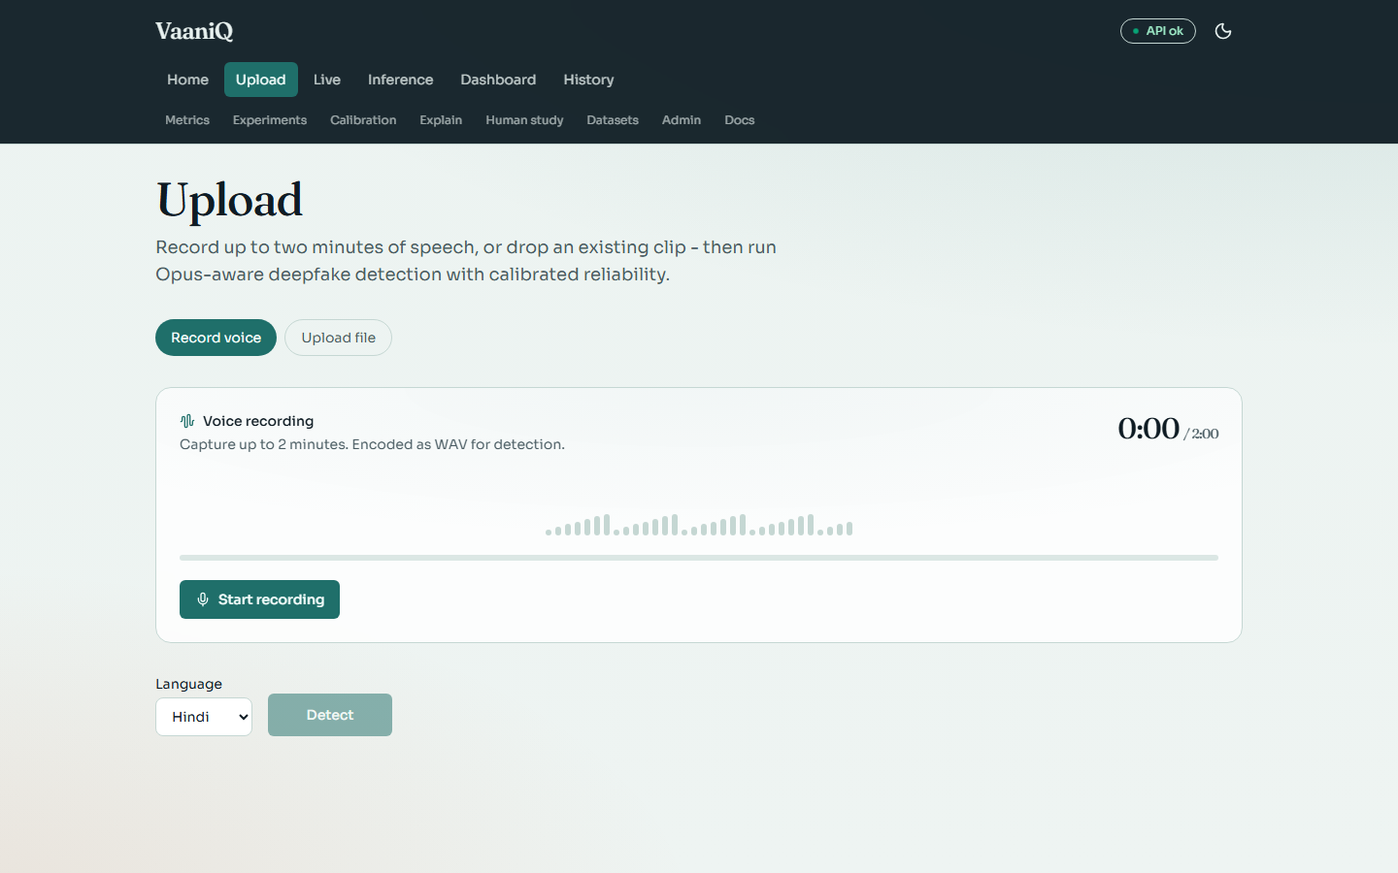

Live Microphone Streaming
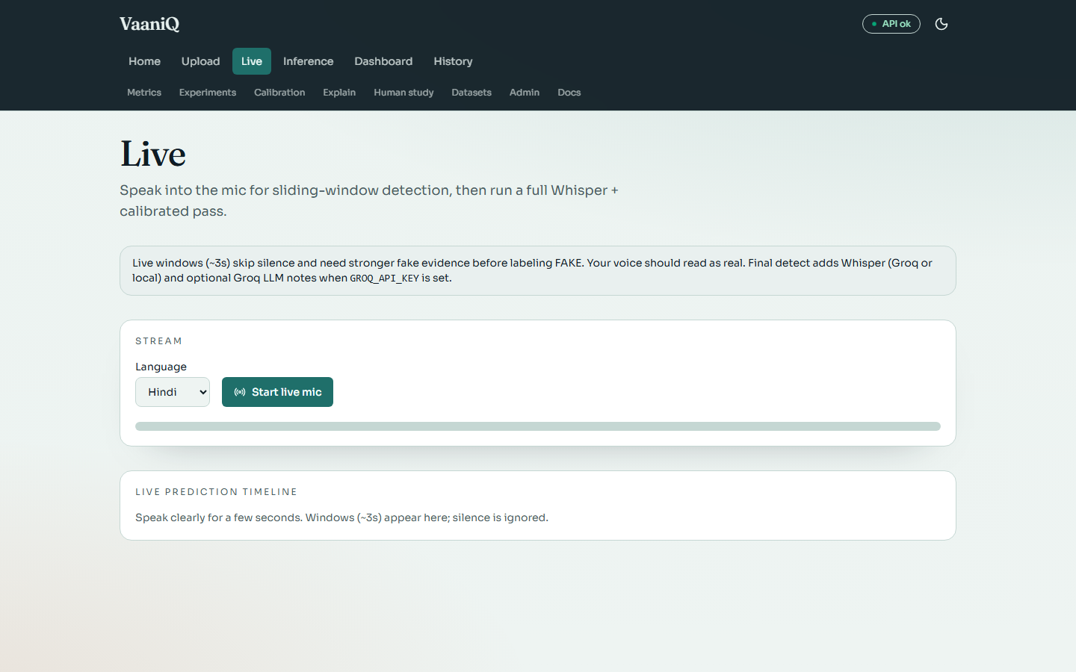

Calibration and Reliability
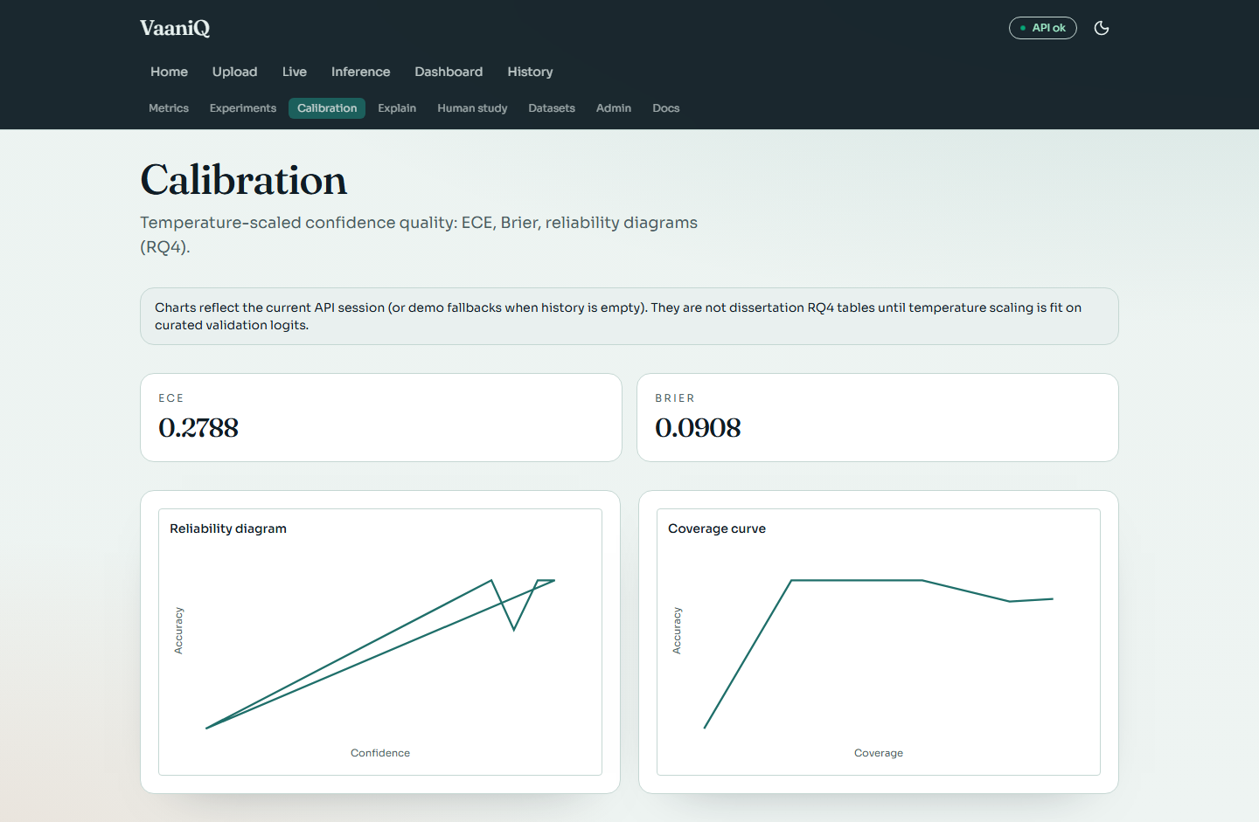

Explainability Suite
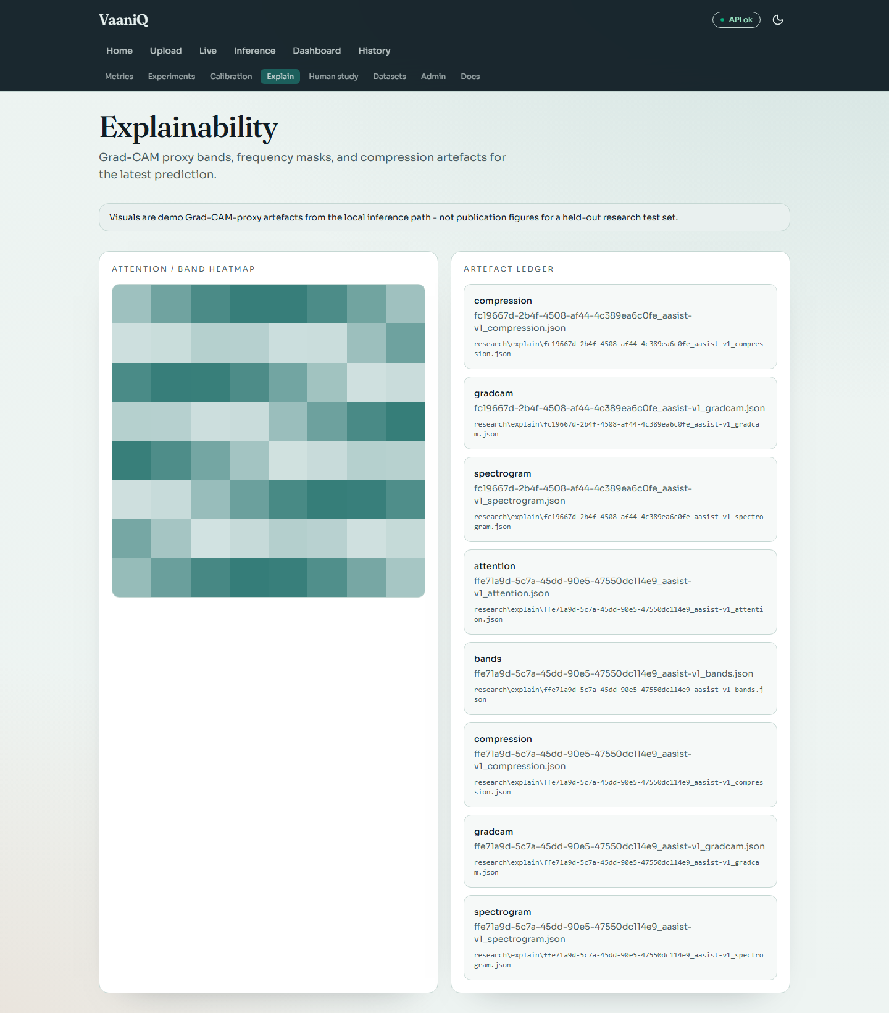

Dataset Explorer
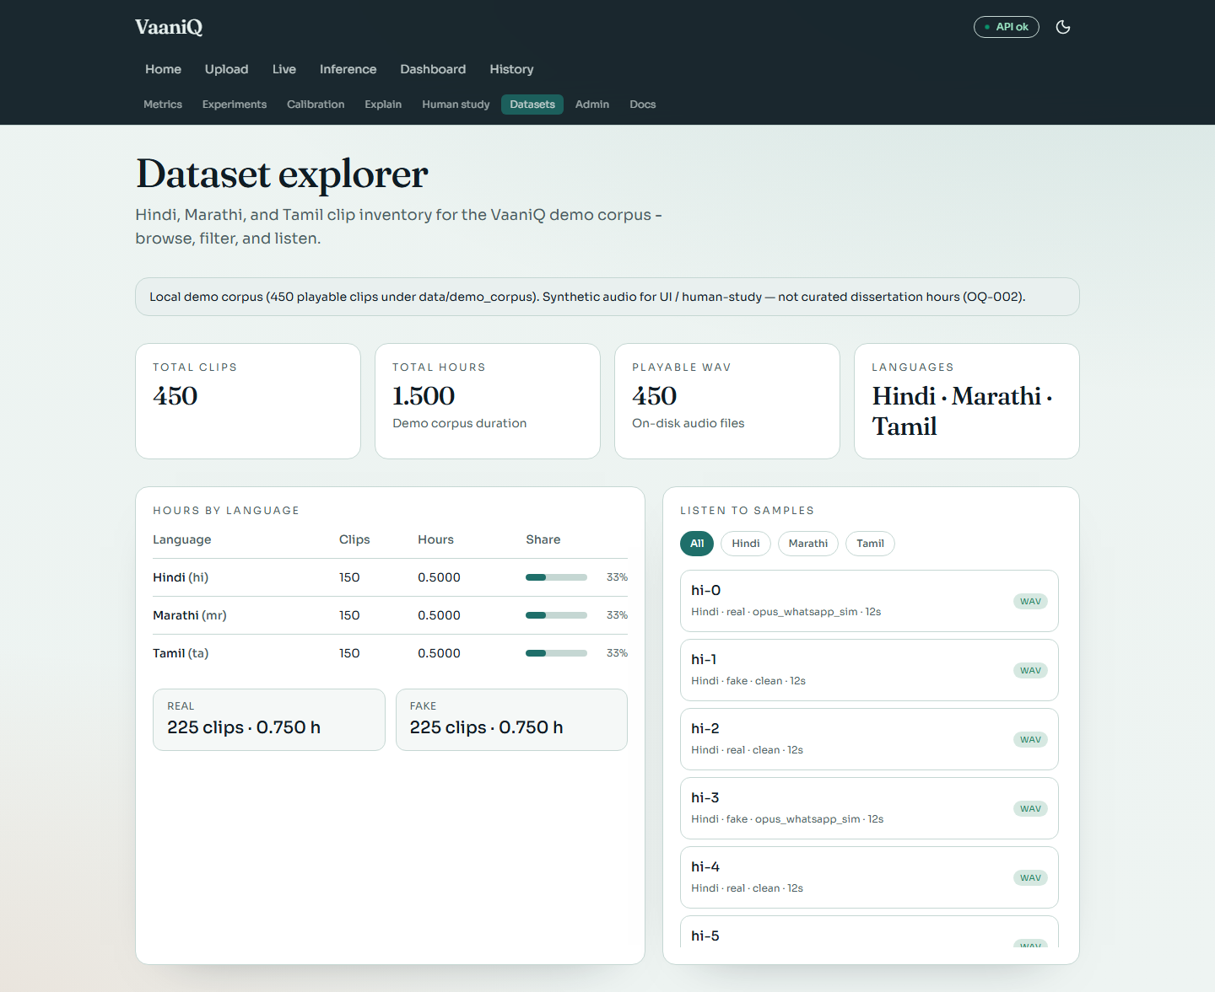

Human Perception Study
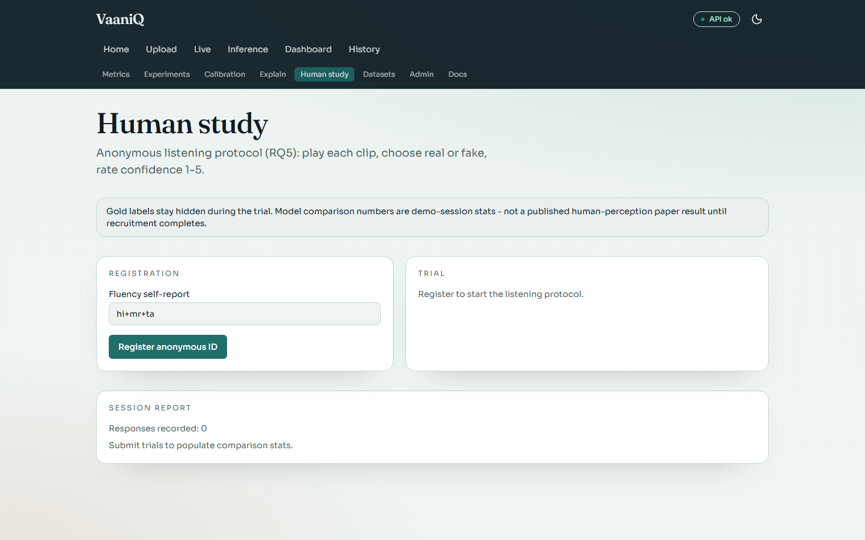

Research Metrics
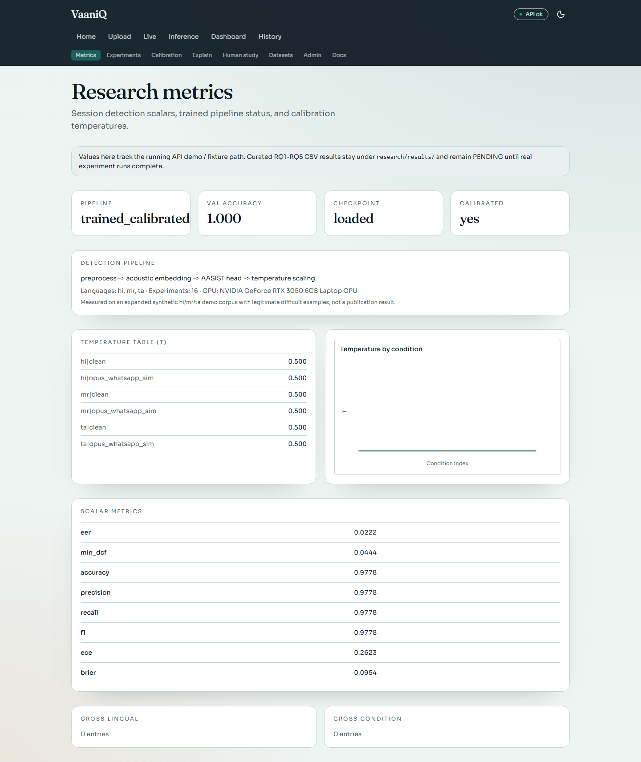

Detail 1 of 2
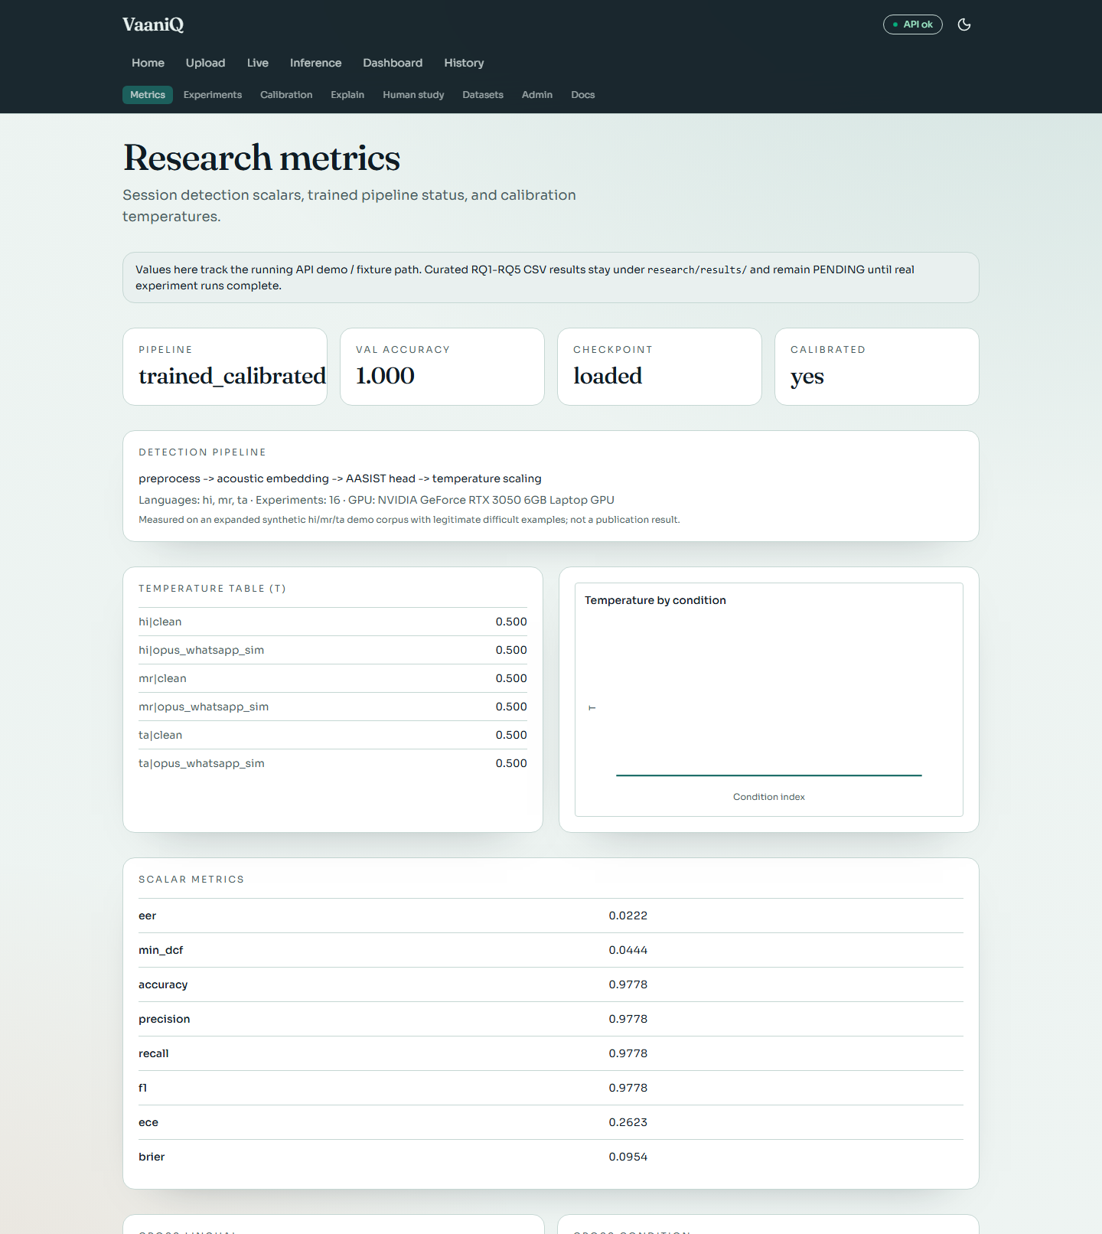

Detail 2 of 2
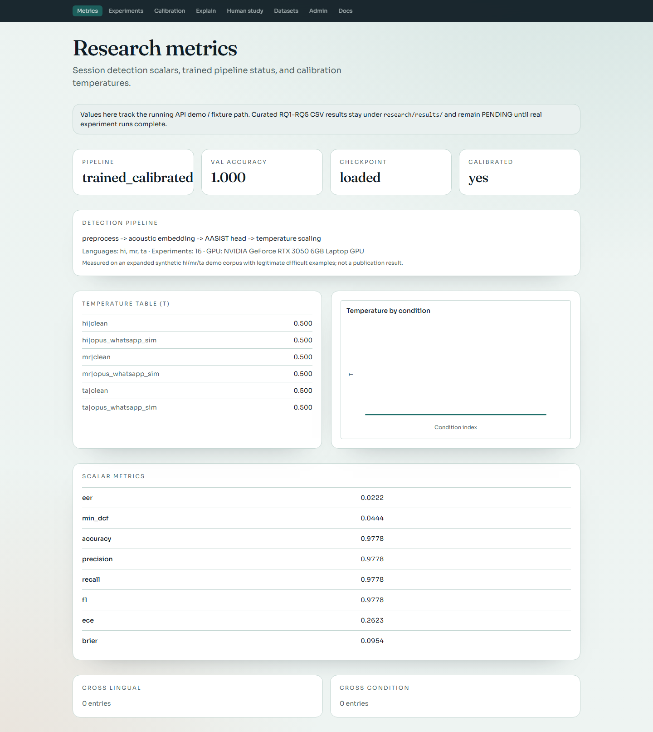

Experiment Browser
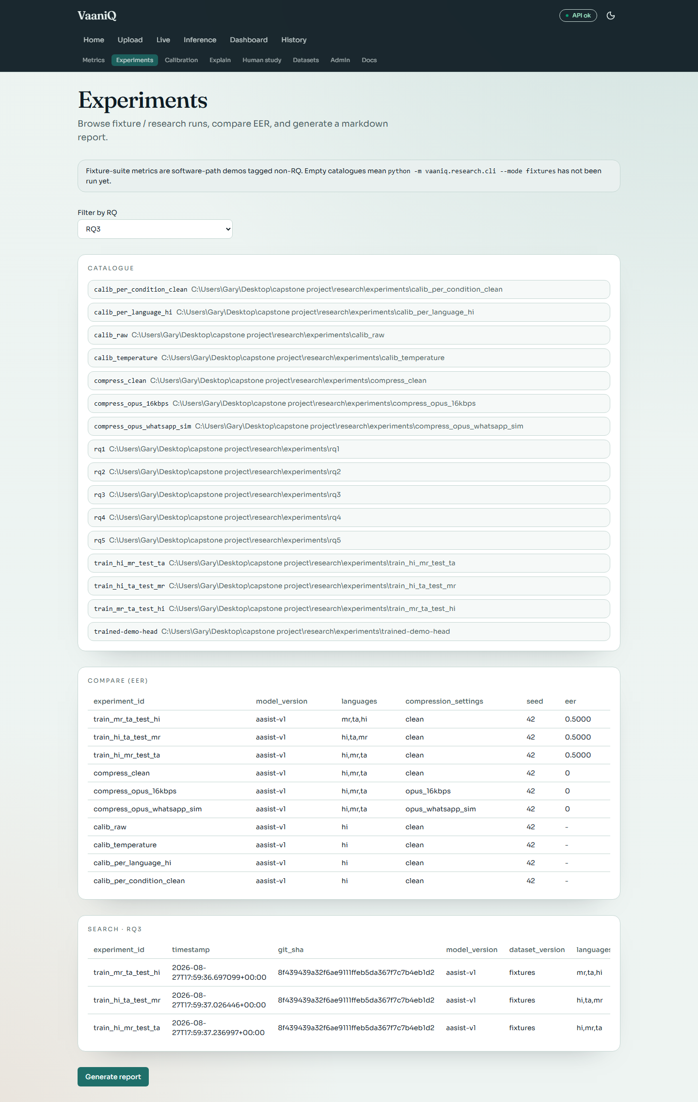

Detail 1 of 2
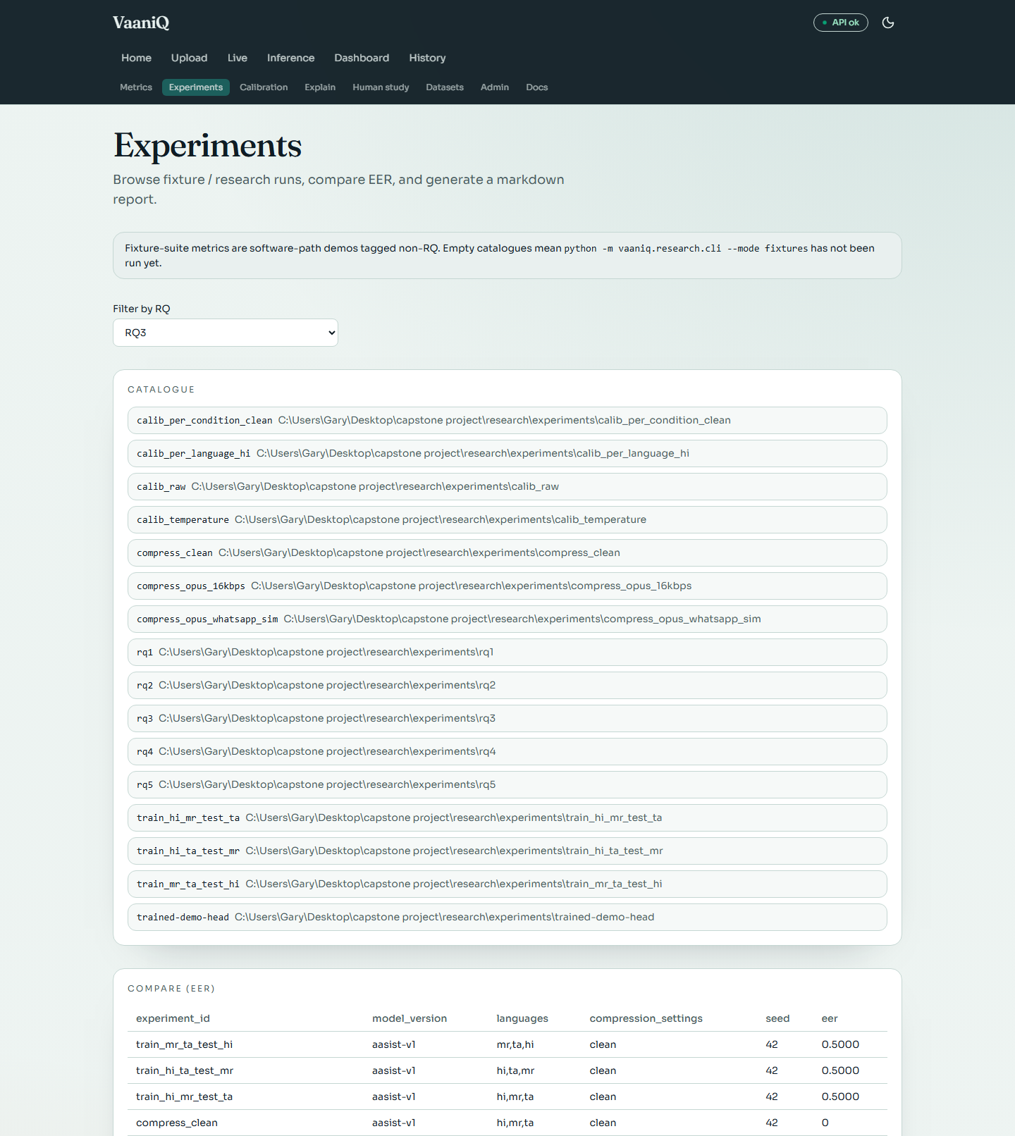

Detail 2 of 2
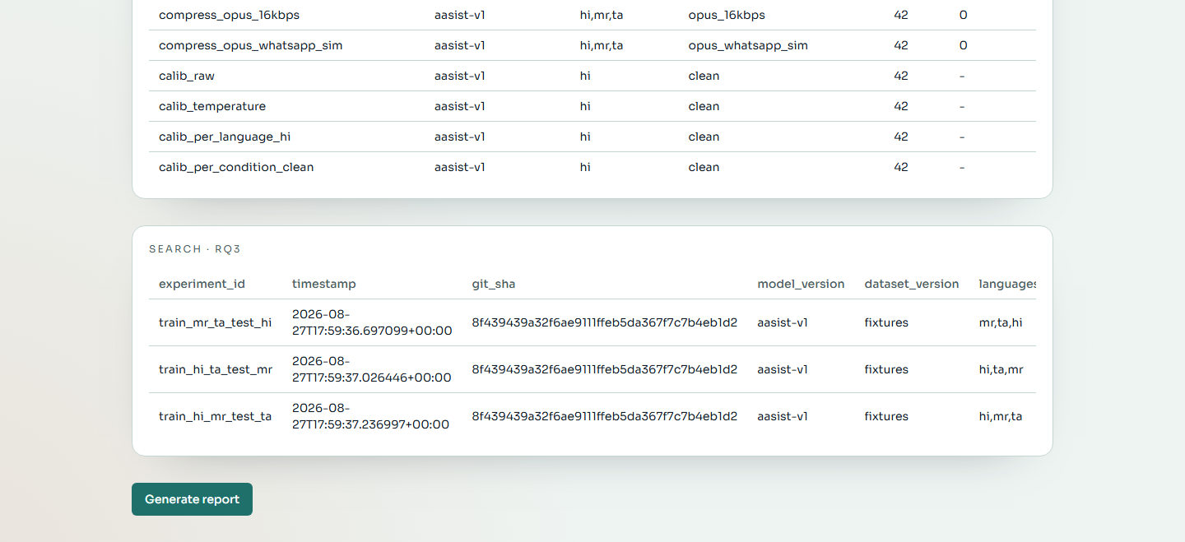

Detection History
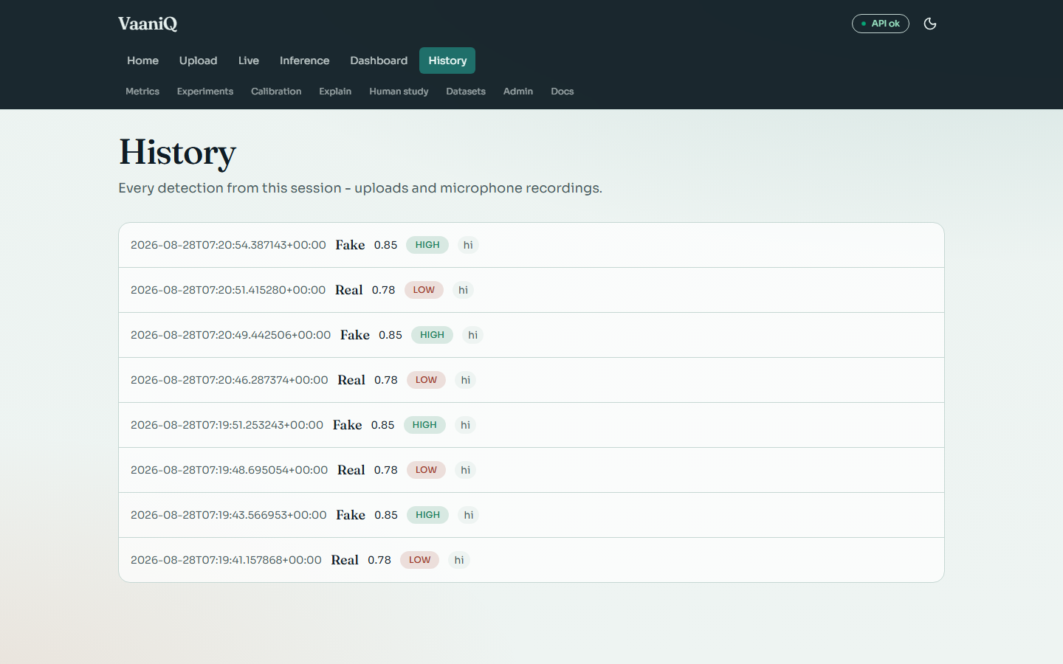

Inference Browser
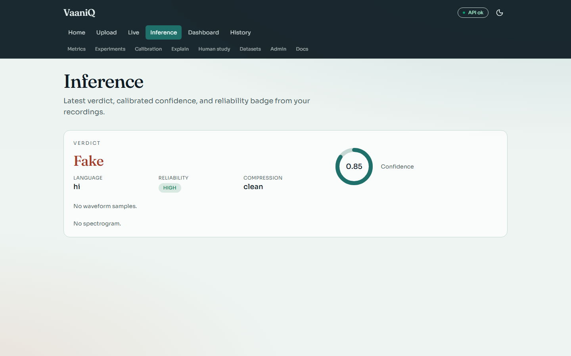

System Administration
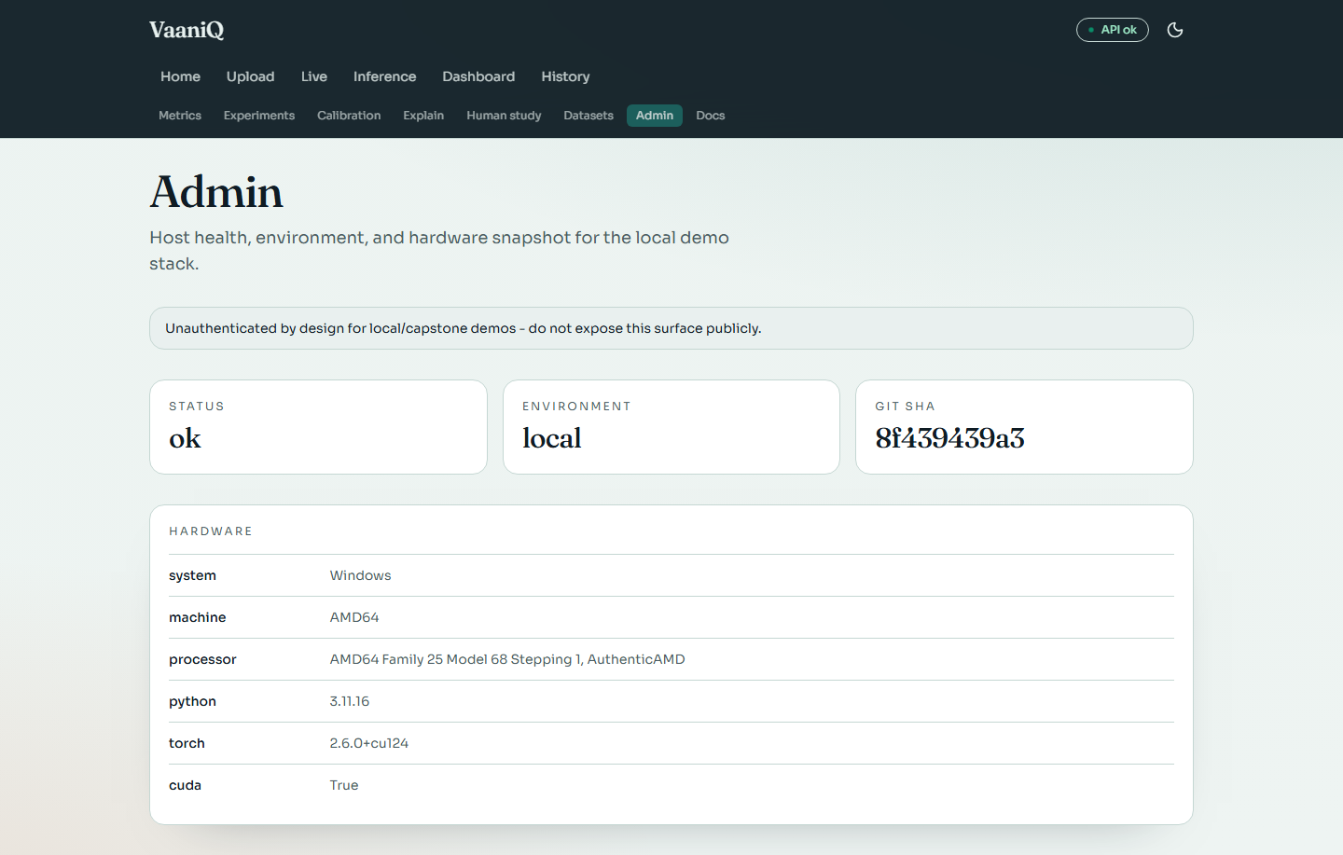

Documentation Hub
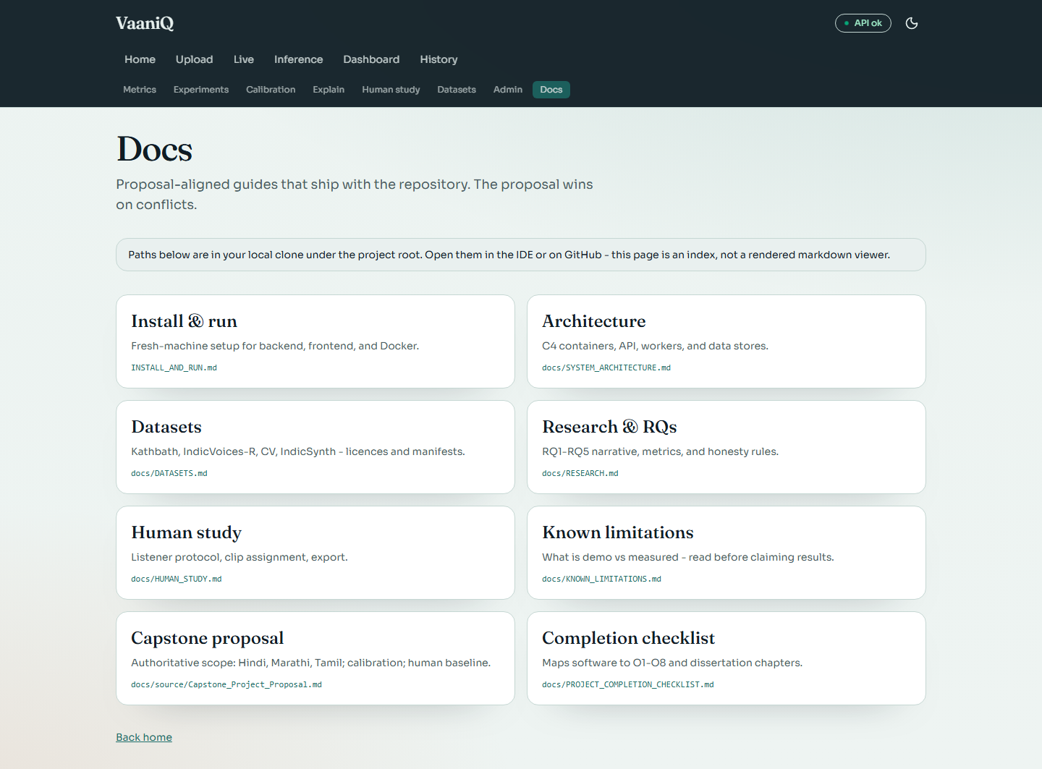

API Documentation (Swagger)
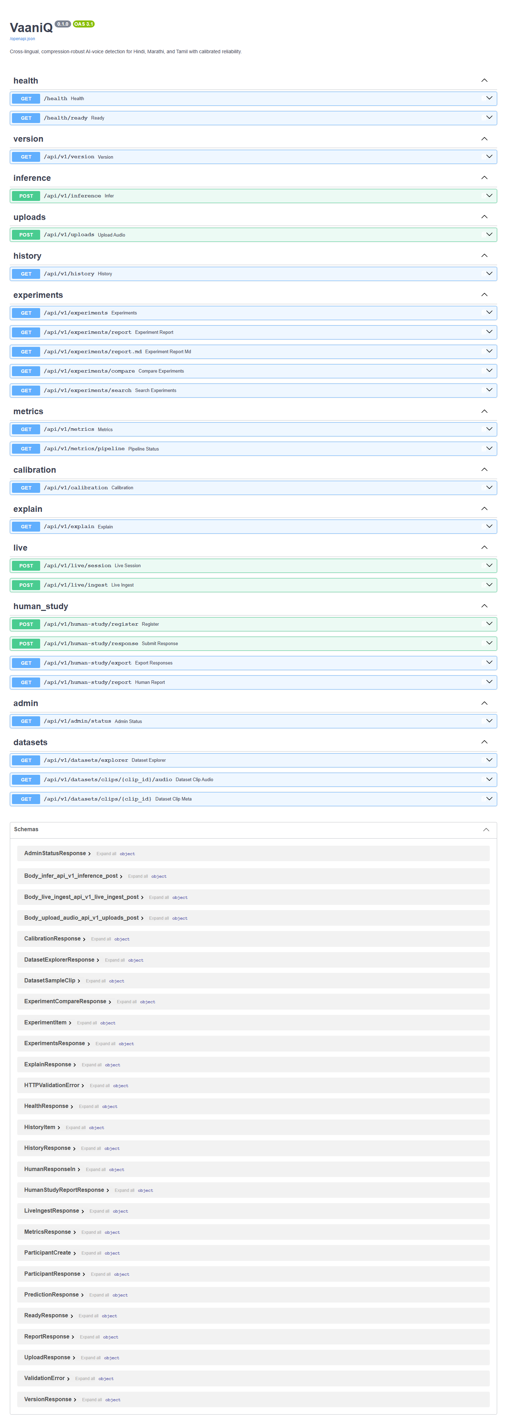

12. API and Application Surface
Method | Endpoint | Purpose
GET | /health | Process liveness
POST | /api/v1/inference | Upload and classify audio
POST | /api/v1/live/session | Create streaming session
POST | /api/v1/live/ingest | Ingest PCM16 window
GET | /api/v1/metrics | Measured demo test metrics
GET | /api/v1/calibration | ECE, Brier, reliability and coverage
GET | /api/v1/metrics/pipeline | Checkpoint and training provenance
GET | /api/v1/datasets/explorer | Corpus inventory and audio samples
GET | /api/v1/explain | Explainability artefact ledger
POST | /api/v1/human-study/register | Anonymous study registration
POST | /api/v1/human-study/response | Record judgement and confidence
GET | /api/v1/admin/status | Local environment and hardware status

13. Reproducibility and Deployment
Field | Value
Random seed | 42
Python | 3.11.16
GPU | NVIDIA GeForce RTX 3050 6GB Laptop GPU
CUDA | True
Checkpoint | AASIST v1 NumPy weights
Dataset manifest | 450 clips; versioned train/val/test labels
Local API | FastAPI/Uvicorn
Web application | React/Vite
Deployment profiles | Local, Docker Compose, HF Spaces scaffold

Every reported score in this document is read from the persisted training report produced by the deterministic training command. The document generator captures fresh API state and screenshots, then verifies that embedded images fit inside the printable page area.

14. Presentation Flow (Recommended)
1. Open with the problem: AI voice cloning fraud in Indian languages via compressed WhatsApp voice notes.
2. State the three contributions: compression-robust detection, calibrated reliability, human baseline.
3. Show architecture diagram and pipeline (Section 3).
4. Live demo: Upload real clip → REAL verdict. Upload fake clip → FAKE verdict.
5. Live demo: Microphone streaming — speak naturally, show REAL windows.
6. Dashboard: pipeline status, validation accuracy, GPU.
7. Calibration page: ECE, Brier, reliability diagram.
8. Explainability: heatmaps and frequency bands.
9. Human study protocol walkthrough.
10. Honest limitations: demo corpus vs curated hours; RQ tables pending HF ingest.
11. Close with novelty claim and future work toward conference submission.

15. Limitations and Conference Readiness
The application is capstone-demo ready. It is not yet defensible as a conference results paper because the current audio is synthetic, the full frozen XLS-R research path is not the default runtime, RQ1–RQ4 curated experiments are unrun, and RQ5 has no participants. Increasing a generated corpus does not substitute for real speakers, attack diversity, independent test data, or statistical validation.
Conference requirement | Evidence needed
Data validity | Licenced real/fake corpora, speaker IDs, checksums, consent
External validity | Multiple TTS/voice-cloning attacks and recording channels
Compression study | Real ffmpeg Opus twins and paired significance tests
Model comparison | LFCC-GMM, RawNet2, English-only and multilingual checkpoints
Uncertainty | Bootstrap confidence intervals and pre/post calibration tests
Human baseline | At least 12–15 eligible listeners on identical stimuli
Paper claims | Numbers only from frozen, versioned result CSVs

16. References
- Jung et al. (2022). AASIST: Audio Anti-Spoofing using Integrated Spectro-Temporal Graph Attention Networks. ICASSP. arXiv:2110.01200.
- Babu et al. (2021). XLS-R: Self-supervised Cross-lingual Speech Representation Learning at Scale. arXiv:2111.09296.
- Pascu et al. (2024). Calibrated deepfake detection in speech (cited in proposal).
- VaaniQ Capstone Proposal (2026). Cross-lingual compression-robust detection with human baseline.
- AI4Bharat Kathbath, IndicVoices-R, IndicSynth corpora.
- Mozilla Common Voice v17 (Hindi, Marathi).

