FORM NO. 2 (Revised)
NOMINATION AND DECLARATION FORM
(For Unexempted/Exempted Establishment)
Declaration and Nomination Form under the Employees Provident Fund & Employees Pension Scheme (Paragraph 33 and 61 (1) of the Employees Provident Fund Scheme, 1952 & Paragraph 18 of the Employees Pension Scheme, 1995)

1. Name (In capital letters) GAURAV GUPTA 6. Account No.
- S/o, W/o, D/o Name Shri Krishna Kaushal 7. Address
- Date of Birth 10-12-1982 Temporary c-2506 JM Florence,
- Sex M Greater noida west ,201306
- Marital Status Married Permanent c-2506 JM Florence
Greater noida west ,201306
8. Date of Appointment 07-11-2022

PART A (EPF)
Name of the Nominee/Nominees | Address | Nominees relation with the member | Date of Birth | Total amount of share of Accumul ation in PF to be paid to each Nominee | If the Nominee is a minor, Name & Relationship & Address of the guardian who may receive the amount during minority of nominee
1 | 2 | 3 | 4 | 5 | 6
Reetika Gupta | c-2506 JM Florence Greater noida west ,201306 | Wife | 28/11/1984 | 100%

- *Certified that I have no family as defined in Para 2(g) of the Employee’s Provident Fund Scheme,
1952 and should I acquire a family hereafter the above nomination should be deemed as cancelled.
- *Certified that my father/mother is/are dependent upon me.

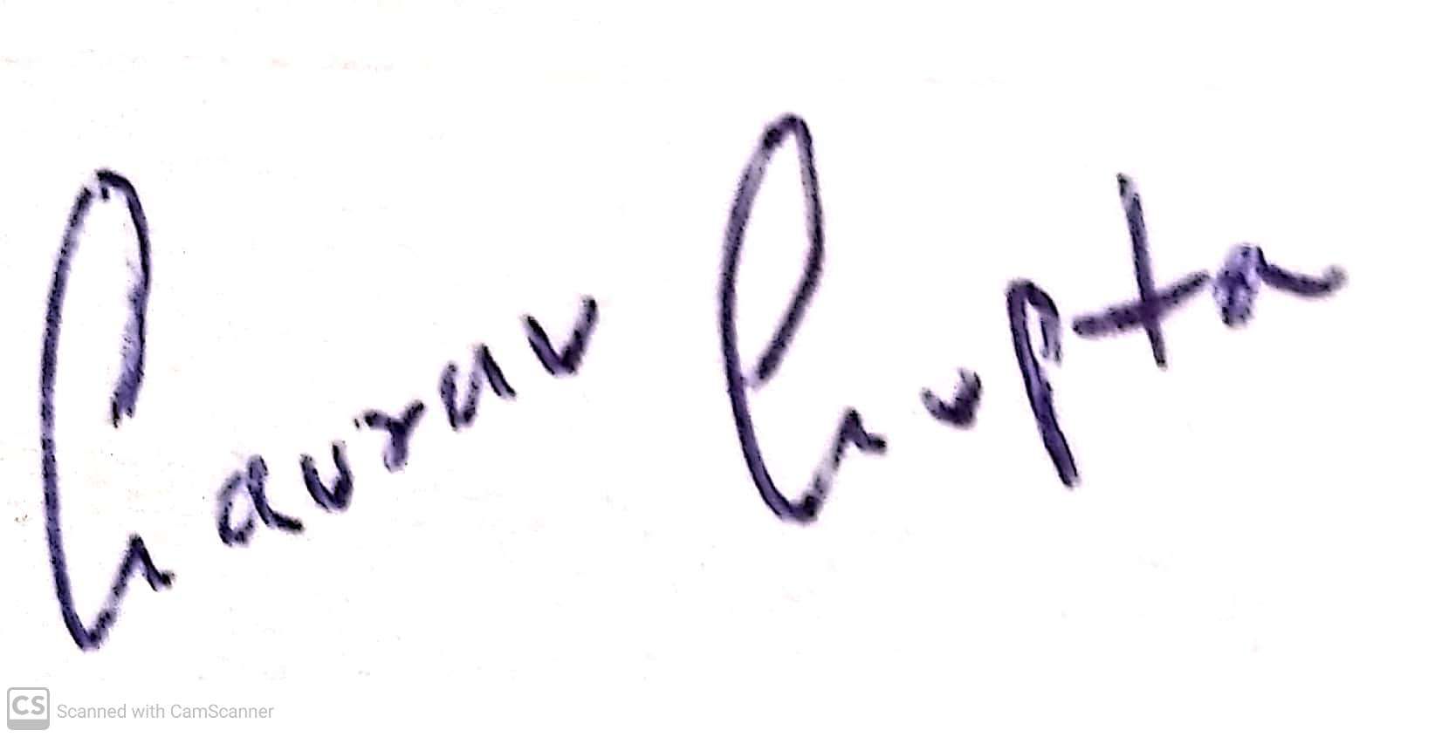

*Strike out whichever is not applicable Signature or thumb impression of the subscriber

PART B (EPS) (Para 18)

I hereby furnish below particulars of the members of my family who would be eligible to receive widow children pension in the event of my death.

Sl. No. | Name | Address | Date of Birth | Relationship with member
1 | 2 | 3 | 4 | 5
 | Reetika Gupta | c-2506 JM Florence Greater noida west ,201306 | 28/11/1984 | Wife

** Certified that I have no family as defined in Para 2 (vii) of Employees’ Pension Scheme, 1995 and should I acquire a family hereafter I shall furnish particulars thereon in the above form.
I hereby nominate the following person for receiving the monthly pension (admissible under Para 16 2(a) (i)
& (ii) in event of my death without leaving any eligible family member for receiving pension.

Sl. No. | Name & address of the Nominee | Date of birth | Relationship with the member.
1 | 2 | 3 | 4
 | Reetika Gupta ,c-2506 JM Florence Greater noida west ,201306 | 28/11/1984 | Wife

Date : - 07-11-2022

Signature or thumb impression of the subscriber

CERTIFICATE BY EMPLOYER
Certified that the above declaration and nomination has been signed/thumb impressed before me by Shri/Smt./Kum employed in my establishment after he/she has read the entries have read over to him/her by me and got confirmed by him/her.

Signature of the employer or other
Authorized officers of the establishment: -

Place :
Designation :-

Dated :-
Name and address of the factory
Establishment or rubber stamp there of :

