Gourav Bansal 191220020 CSE-2nd Year

Lab- 1

Library Management System

* All records of books are stored in the file LibRec.txt in a definite format.
* The schema of the file is of 9 columns-

1. Serial Number
2. Course Id corresponding to the book
3. Book Id
4. Book Name
5. Author
6. Total Copies of that book in the Library
7. Copies Available
8. Roll Numbers of the students of issued that book
9. Issue dates corresponding to the roll numbers who issued the book

* There are two login types- Administrator(1) and Guest(2).
* For Administrator login password is required **(password - “IAmAdmin”)** and for Guest login no password is required.
* There are 5 main function which Administrator can perform-
  + Add a book
  + Borrow book for some student (Book cannot be borrowed from Guest Login)
  + Search for Book
  + Display all the Books in the Library
  + Find how many books are in the library
* A Guest cannot perform Add a Book and Borrow a Book functions.

Below are some examples, each showing performance of the mentioned 5 functions: -

1. Add A Book:

There are two cases-

* + A borrowed book is being returned
  + A new book is being added.

In first case, program asks for the roll number who is returning the book and the Book Id of the book. Fine imposed on him/her will be calculated and displayed. Example-

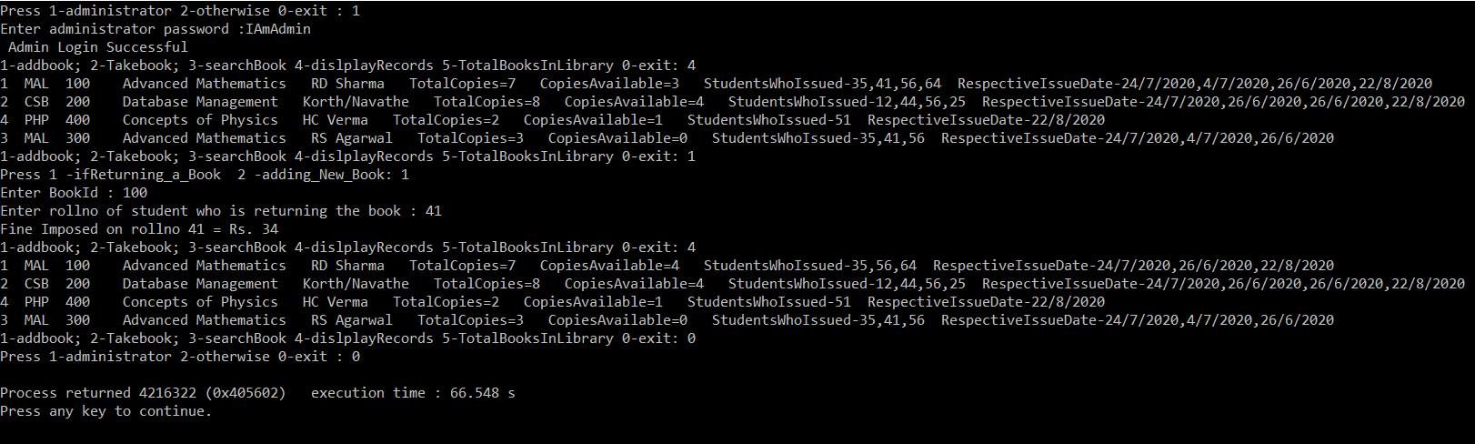

In second case, enter author and book name of new book, if that book already exists then total copies of that will be increased, otherwise program will request for all the details of the book including book ID, if book ID already exists then program will request for unique Book ID. Example -

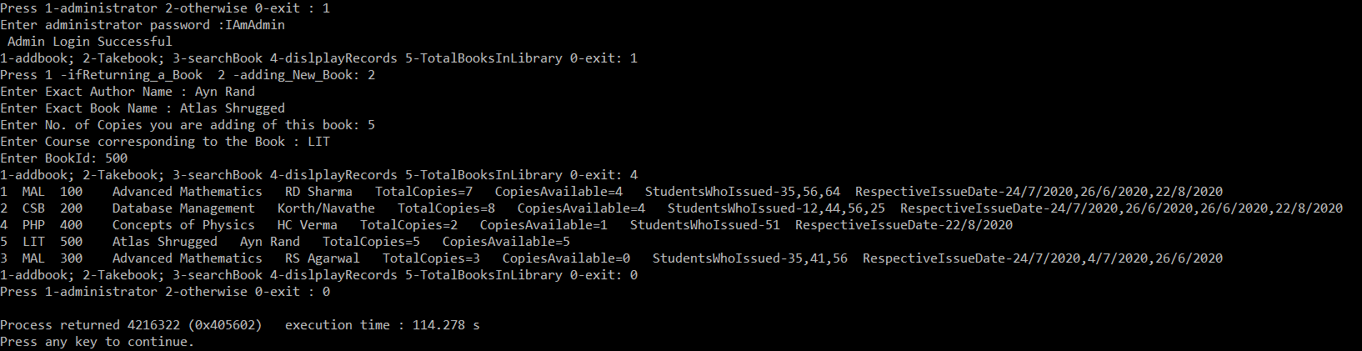

1. Borrow Book:

While, borrowing a book, program will demand for the roll number of the student who is borrowing the book. Then you can borrow a book either by searching the book by its book ID or searching it by it’s Author and Book Name. The book will be issued to that roll number taking today’s date as issue date. Example-

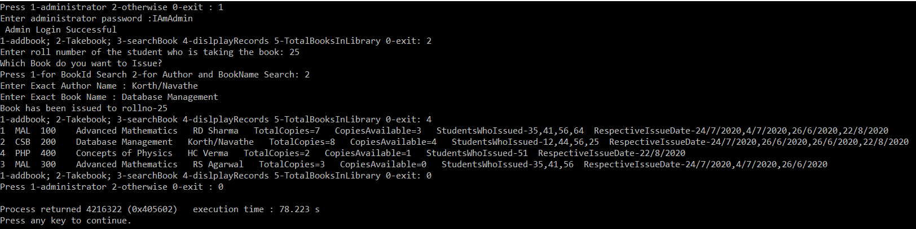

1. Search A book:

Book can be searched either by Book ID or Author Name and Book Name. Both the ways are shown in the following example-

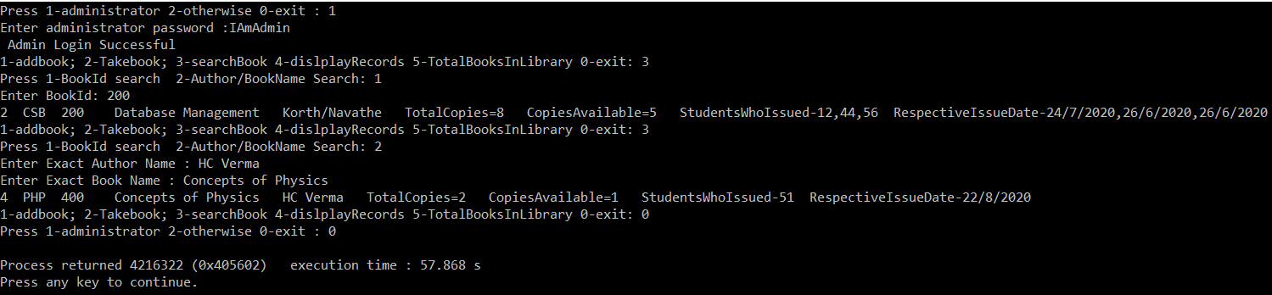

1. Display Records of All books:

Display all the books in the library.

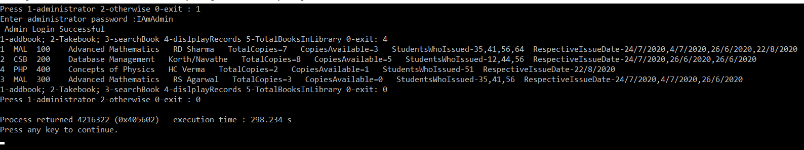

1. Total number of Books:

Displays sum of total copies of every book. Example-

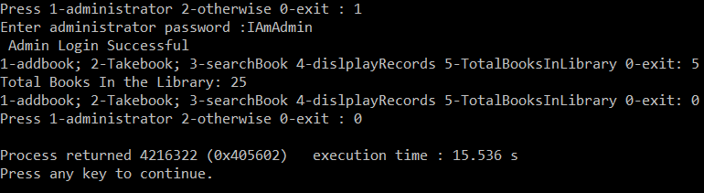

Guest Login: Do not require password.

