WEEK 6 FINAL DATA ANALYTICS PROJECT
Project Title:-
Olist E-Commerce Customer, Sales & Business Performance Analytics
TASK 1 : Git & GitHub Basics
Objective
The objective of this task was to understand the basic Git and GitHub workflow and create a dedicated repository for the Final Data Analytics Project. GitHub was used to maintain project files, track changes, and maintain version history throughout the project.
GitHub Repository
A dedicated public GitHub repository was created for the final Data Analytics project.
Repository Name: final-data-analytics-project
Repository: gauravi152/final-data-analytics-project
Tools Used
- Git
- GitHub
- GitHub Desktop
Steps Performed
- A GitHub account was used to create a new repository named final-data-analytics-project.
- The repository was created as a public repository.
- The repository was cloned locally using GitHub Desktop.
- A README.md file was created containing the project introduction and tools used.
- The changes were committed to the local Git repository.
- The repository was published to GitHub.
- The GitHub repository was verified to ensure that the README file and commit history were available online.
Initial Repository Structure
At the beginning of the project, the repository contained:
final-data-analytics-project/
│
└── README.md
The project files and analysis folders will be added as the project progresses.
GitHub Workflow
The basic workflow followed during the project is:
Create Repository
↓
Clone Repository
↓
Add / Modify Files
↓
Commit Changes
↓
Publish / Push Changes
↓
Verify on GitHub
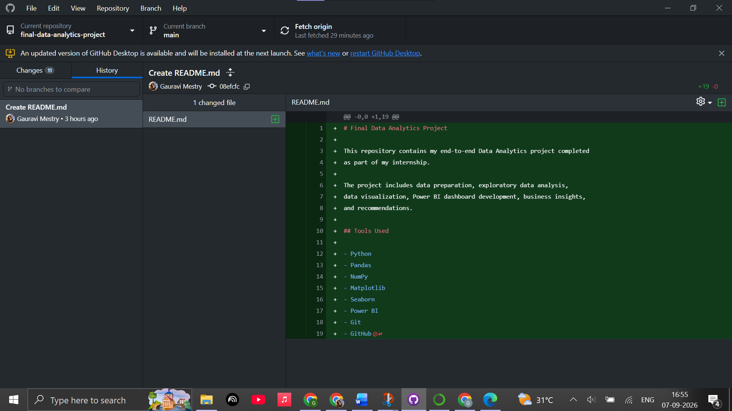
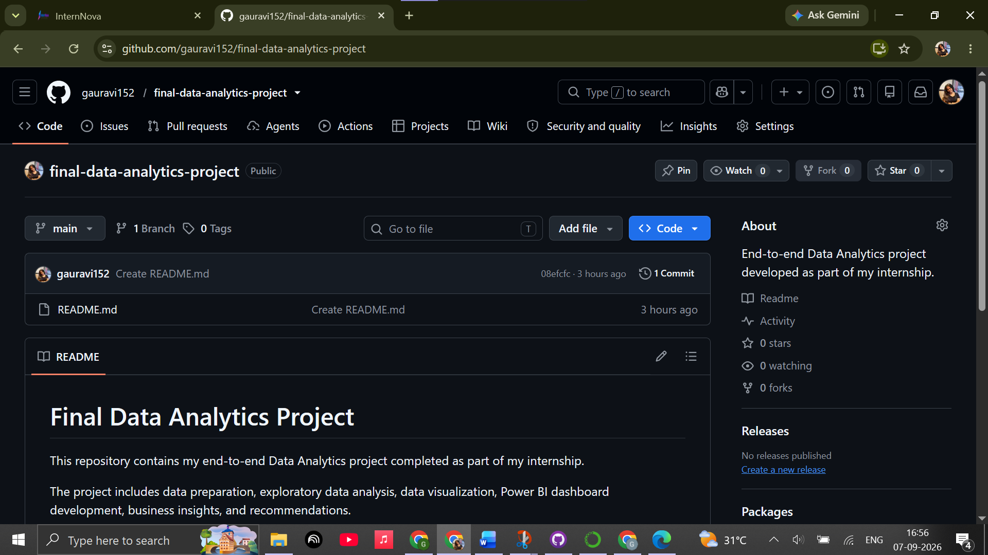
Result
A dedicated GitHub repository was successfully created, cloned, and published. The initial README file was committed and is visible in the GitHub repository.
Conclusion
Task 1 established the Git and GitHub environment required for managing the Final Data Analytics Project. The repository will be used throughout the project to maintain files, track changes, and present the completed project professionally.

TASK 2. Git Workflow Practice
Objective
The objective of this task is to practice the basic Git and GitHub workflow by creating a repository, adding project files, creating meaningful commits, and synchronizing the local project with the remote GitHub repository. This task also helped me understand how GitHub Desktop can be used to track project changes and maintain different versions of a data analytics project.

2.1 Repository Creation
For the final Data Analytics project, I created a dedicated GitHub repository named final-data-analytics-project. The repository was created as a public repository so that the completed project can be easily shared and reviewed.
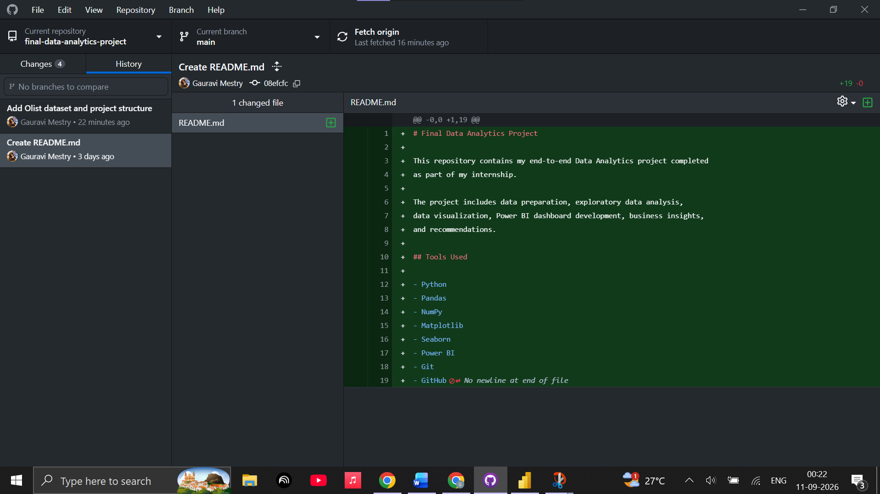

2. GitHub Desktop Workflow
I used GitHub Desktop to manage the project instead of using Git commands through the command line. The basic workflow followed during the project was:
Working Directory → Changes → Commit → Push → GitHub Repository
Whenever files were added or modified, GitHub Desktop detected those changes. I then reviewed the changes, created a meaningful commit message, committed the changes to the main branch, and pushed the commit to the remote GitHub repository.
This workflow helped me understand how Git tracks project development over time.

3. Project Files Added to the Repository
The Olist Brazilian E-Commerce dataset and the main project files were added to the repository. The project includes the dataset, analysis notebooks, Power BI file, and project documentation.
The repository currently contains important project components such as:
- Olist customer dataset
- Olist orders dataset
- Olist order items dataset
- Olist payment dataset
- Olist review dataset
- Olist products dataset
- Olist sellers dataset
- Product category translation dataset
- Python/Jupyter notebooks for analysis
- Power BI project file
- README documentation
The large geolocation dataset was kept outside the GitHub commit because it contains more than one million records and was not required for the main Power BI analysis.
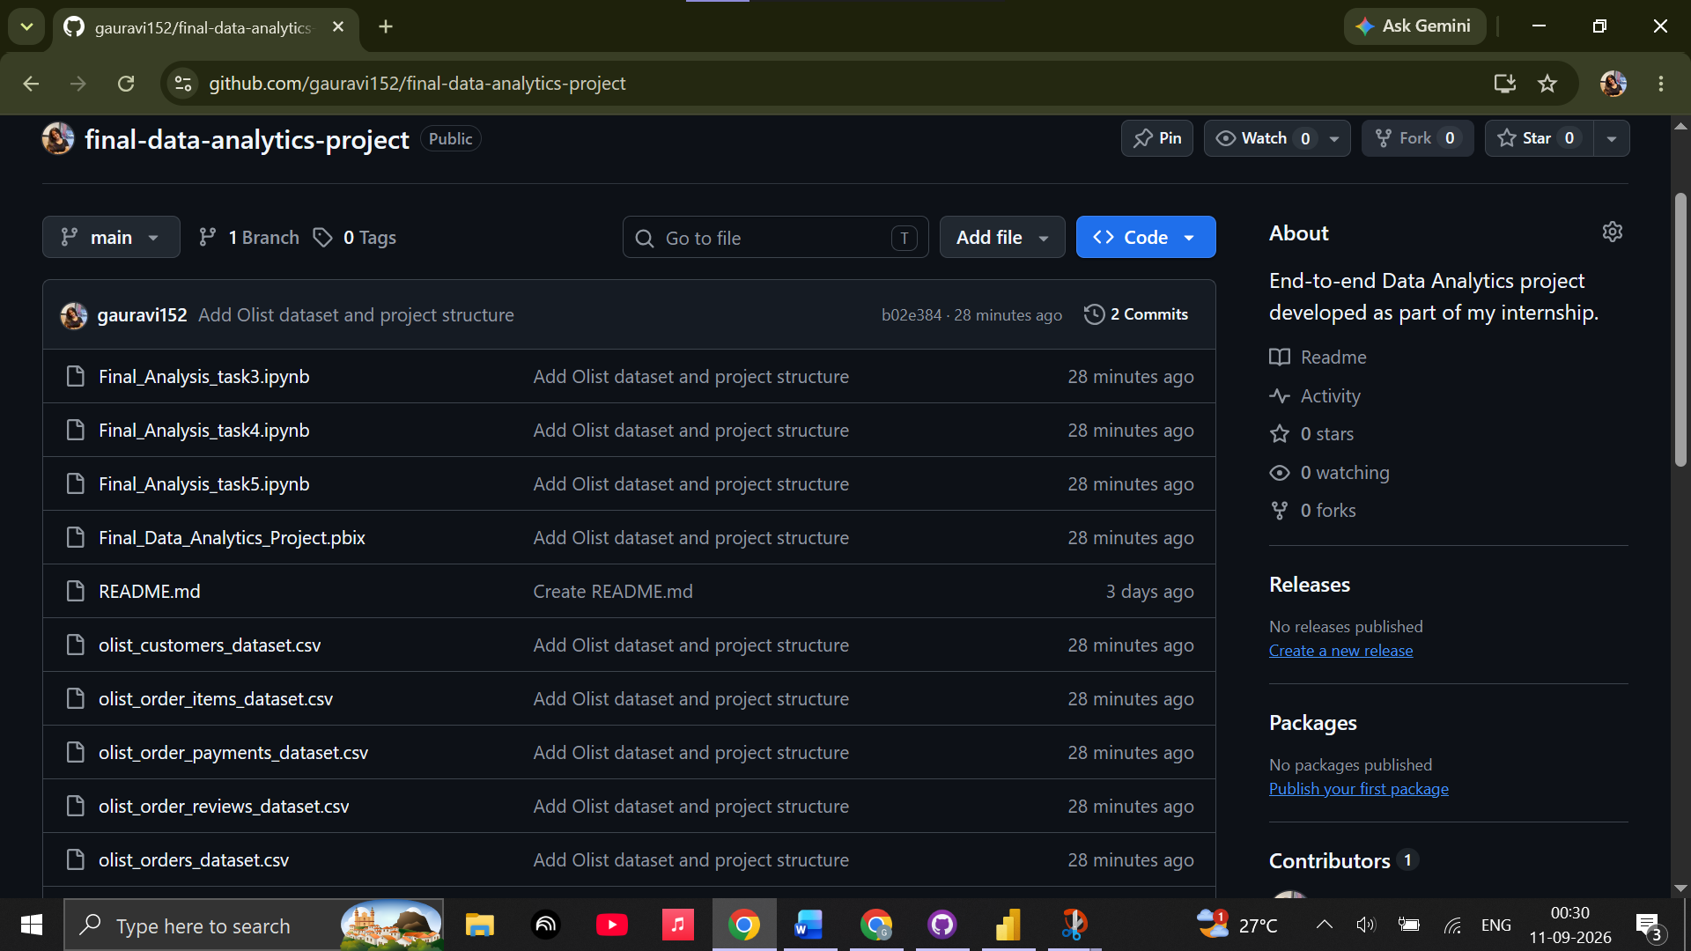

4. Meaningful Git Commits
To demonstrate version control, I created meaningful commits instead of making random or unnecessary commits.
Commit 1 — Create README.md
The first commit created the initial README.md file for the project repository.
Commit message:
Create README.md
This established the basic project documentation and repository structure.

Commit 2 — Add Olist Dataset and Project Structure
The second commit added the main Olist datasets and project files to the repository.
Commit message:
Add Olist dataset and project structure
This commit represents the stage where the project data and initial analysis files were added to the GitHub repository.

Commit 3 — Final Project Documentation
A third meaningful commit was planned to add the completed final project report to the repository.
Planned commit message:
Add final project report
This commit will represent the documentation stage of the project and will complete the minimum three-commit requirement for this task.

5. Commit and Push Process
For each meaningful change, I followed these steps:
1. Open GitHub Desktop and select the project repository.
2. Review the files displayed under the Changes section.
3. Select the files that should be included in the commit.
4. Enter a clear and meaningful commit message in the Summary field.
5. Click Commit to main.
6. Click Push origin to synchronize the local commit with the GitHub repository.
This process ensured that the project files were properly tracked and backed up in the remote repository.

6. GitHub Repository Verification
After pushing the commits, I verified the repository on GitHub to confirm that the project files were successfully uploaded.
The GitHub repository shows the project files and the commit history, allowing the development process to be tracked through different stages.

Conclusion
This task helped me understand the practical use of Git and GitHub for maintaining a data analytics project. I learned how to track changes, create meaningful commits, push files to a remote repository, and maintain a proper project history. Using GitHub Desktop made the process easier to manage and helped me understand how version control can be applied to real-world projects.

TASK 3 : Dataset Selection & Data Preparation
Objective
The objective of this task was to select a real-world dataset and prepare it for further analysis. The selected dataset represents an e-commerce business and contains information about customers, orders, products, sellers, payments, and customer reviews. The data was inspected, cleaned, and validated before proceeding to Exploratory Data Analysis.
1.Dataset Selected
For this project, the Brazilian E-Commerce Public Dataset by Olist was selected. The dataset contains approximately 100,000 orders and is divided into multiple related tables representing different aspects of an e-commerce business.
The main tables used in the project are:
- Customers
- Orders
- Order Items
- Payments
- Reviews
- Products
- Sellers
- Category Translation
The dataset contains 99,441 customer records, 99,441 orders, 112,650 order-item records, 103,886 payment records, 99,224 review records, 32,951 product records, 3,095 seller records, and 71 category-translation records.
2.Initial Data Inspection
The dataset was loaded into Python using Pandas. Each table was inspected individually to understand its structure, number of records, columns, and data types.
The inspection confirmed that the dataset consists of multiple related tables rather than one flat file. This relational structure makes the dataset suitable for SQL joins, Python-based analysis, and Power BI data modeling.
3.Data Type Cleaning
The date columns were initially stored as object data types because the data was read from CSV files. These columns were converted into Pandas datetime64[ns] format.
The following date information was converted:
- Order purchase timestamp
- Order approval timestamp
- Order carrier delivery date
- Order customer delivery date
- Estimated delivery date
- Shipping limit date
- Review creation date
- Review answer timestamp
This conversion will allow date-based analysis such as monthly sales trends and delivery-time calculations.
4.Missing Value Analysis
Missing values were investigated across all tables.
The Orders table contained missing values mainly in approval and delivery-related date fields. These missing values were investigated against order status and were found to be largely associated with orders that had not completed the relevant stage of the order lifecycle.
Therefore, these values were not artificially replaced with dates because doing so could create incorrect delivery or operational metrics.
The Reviews table contained missing review titles and messages. Since customers can provide a numerical rating without writing a comment, these fields were replaced with "No Comment" for analysis.
The Products table contained missing product categories and physical attributes. These records were retained because the missing information does not make the entire product record invalid. Missing product categories were represented as "Unknown" where required for analysis.
5.Duplicate Record Check
A duplicate check was performed on every table.
The result was 0 duplicate rows across all eight tables.
Therefore, no records needed to be removed because of exact row duplication.
Final Data Validation
After the cleaning process, the original row counts and column counts were checked again.
Table | Rows | Columns
Customers | 99,441 | 5
Orders | 99,441 | 8
Order Items | 112,650 | 7
Payments | 103,886 | 5
Reviews | 99,224 | 7
Products | 32,951 | 9
Sellers | 3,095 | 4
Category Translation | 71 | 2
No rows were unintentionally removed during the cleaning process.
6.Cleaning Approach
The cleaning process focused on understanding the reason behind missing values rather than blindly deleting or replacing them. Valid business-related missing values were preserved, while text fields used for analysis were standardized.
The dataset is now prepared for exploratory analysis.
Conclusion
The Olist e-commerce dataset was successfully inspected, cleaned, and validated. Date fields were converted into appropriate formats, missing values were investigated and handled based on their business meaning, and no duplicate records were found. The original dataset structure and record counts were preserved, providing a reliable foundation for the next stage of the project: Exploratory Data Analysis (EDA).
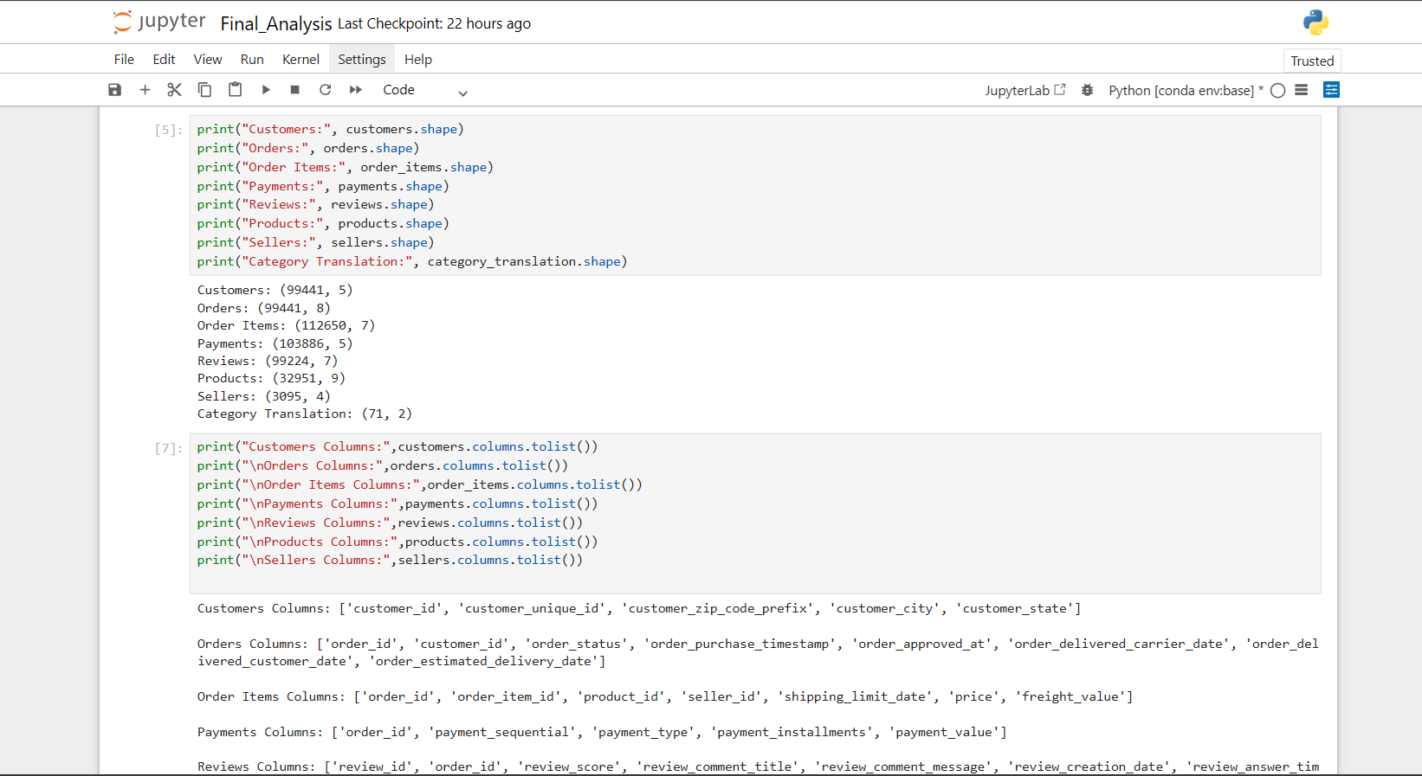
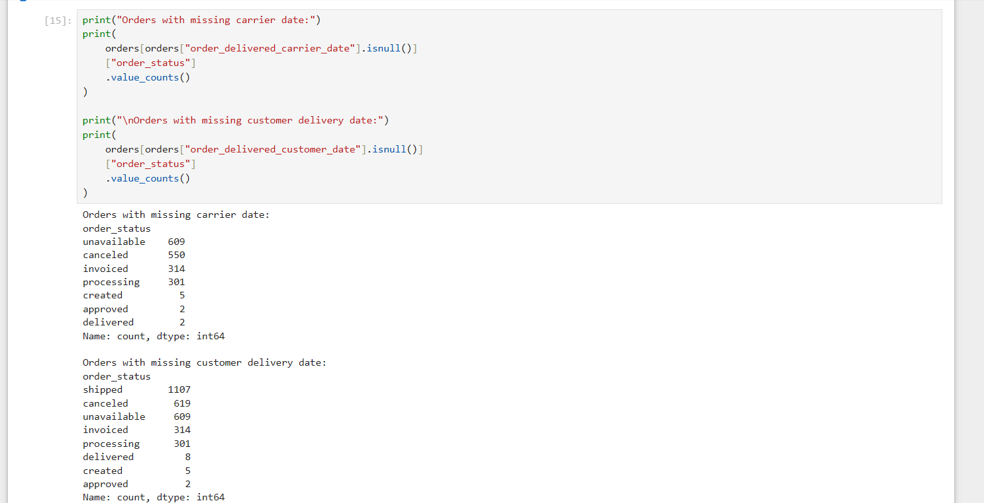
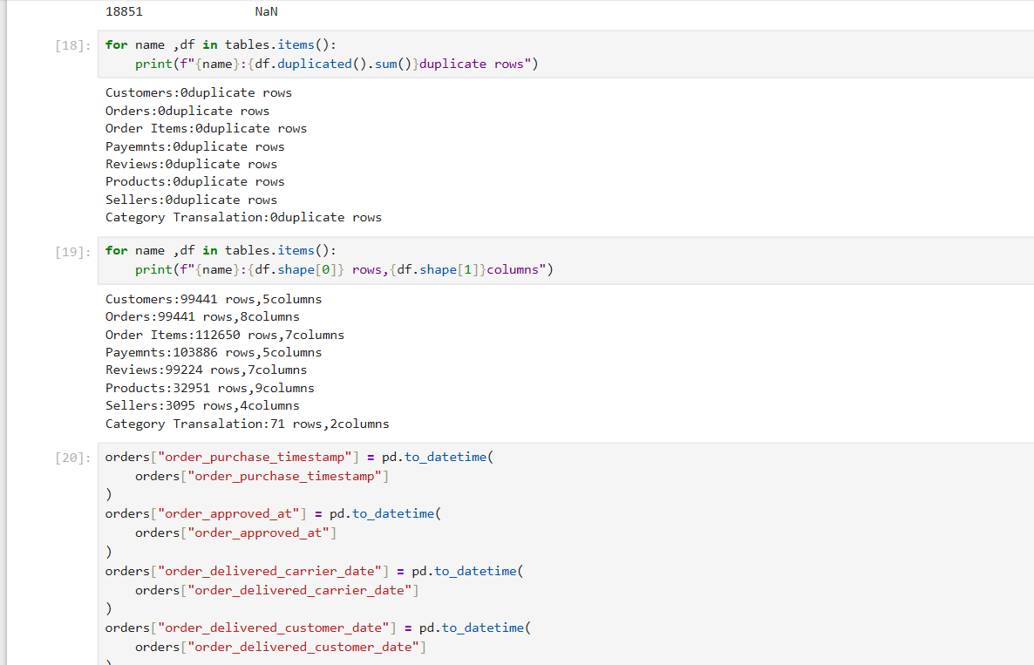
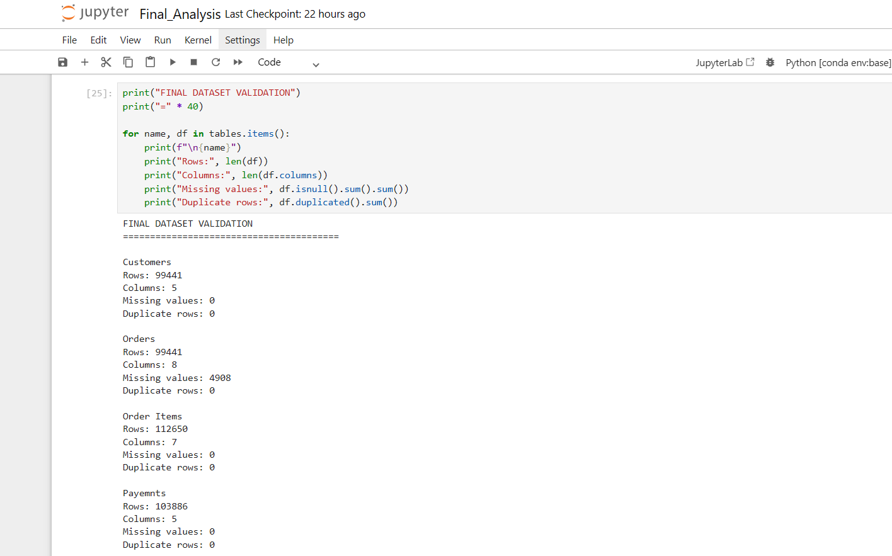

Task 4: Exploratory Data Analysis
Objective
The objective of this task was to perform Exploratory Data Analysis (EDA) on the selected Olist Brazilian E-Commerce dataset. The analysis was conducted to understand the characteristics of the data, identify important patterns and trends, analyze customer and payment behavior, evaluate delivery performance, examine relationships between numerical variables, and identify potential outliers.
Tools Used
- Python
- Pandas
- NumPy
- Matplotlib
- Seaborn
- Jupyter Notebook
1.EDA Approach
The analysis was performed using multiple related tables from the Olist dataset. Instead of combining all tables into one large dataset, targeted data combinations were created based on the analytical requirement. This helped avoid unnecessary duplication of records because some tables contain multiple records for a single order.
The analysis included descriptive statistics, order-status analysis, monthly order trends, product-category analysis, payment behavior, customer review analysis, delivery performance, correlation analysis, and outlier detection.
2.Descriptive Statistics
Descriptive statistics were calculated for important numerical variables such as order sales, freight value, number of items, payment value, and payment installments.
The analysis provided information about the average values, spread, minimum values, maximum values, and quartiles of the numerical variables.
These statistics helped establish a baseline understanding of customer transactions and order-level behavior.
3.Order Analysis
The dataset contains 99,441 orders. The order-status distribution was analyzed to understand the different stages of the e-commerce order lifecycle.
Order statuses such as delivered, shipped, canceled, processing, and unavailable were examined to understand the overall operational condition of the orders.
4.Monthly Order Trend
Orders were grouped by month using the purchase timestamp. This analysis was performed to identify periods with relatively high and low order activity.
The monthly analysis provides useful information for identifying possible seasonal patterns and changes in customer purchasing activity over time.
5.Product Category Analysis
Product sales were analyzed by connecting the Order Items table with product information and the category translation table.
This analysis was used to identify the categories contributing the highest and lowest sales and to understand which product groups had greater customer demand.
6.Payment Analysis
Payment behavior was analyzed using the Payments table.
Different payment methods were compared based on transaction frequency, total payment value, and average payment value. This analysis helps understand customer payment preferences and the contribution of different payment methods to overall transaction value.
7.Customer Review Analysis
Customer satisfaction was analyzed using the review_score field.
The dataset contained complete numerical review scores, allowing ratings from 1 to 5 to be analyzed without removing records because of missing ratings.
The average customer review score was 4.09 out of 5, indicating that the overall rating level in the dataset was relatively positive.
8.Delivery Performance Analysis
Delivery performance was analyzed for orders with a delivered status.
The time between the order purchase timestamp and the actual customer delivery date was calculated to determine the delivery duration.
The average delivery time was 12.09 days.
Actual delivery dates were also compared with estimated delivery dates. Approximately 6.77% of delivered orders were identified as delayed, based on the comparison between actual and estimated delivery dates.
This provides a useful operational metric for evaluating delivery performance and identifying potential opportunities for improving customer experience.
Correlation Analysis
Correlation analysis was performed on selected numerical variables including:
- Total Sales
- Total Freight
- Total Items
The correlation matrix was used to examine the strength and direction of relationships between these numerical variables.
The results will help determine whether larger orders are associated with higher freight costs or whether the number of items in an order is related to its overall sales value.
9.Outlier Analysis
The Interquartile Range (IQR) method was used to identify unusually high or low order sales values.
Approximately 7.96% of orders were identified as potential sales outliers.
The highest-value transactions were then examined individually to determine whether the identified outliers could represent legitimate high-value purchases.
The highest transaction identified among the displayed outliers had a sales value of 13,440.00, with 8 items.
The outliers were not automatically removed, because unusually large transactions may represent legitimate customer purchases rather than data errors.
Key EDA Findings
The exploratory analysis produced the following confirmed findings:
- The dataset contains 99,441 orders, providing a substantial number of transactions for analysis.
- The average customer review score is 4.09/5, indicating generally positive customer ratings.
- The average delivery time is 12.09 days for delivered orders.
- Approximately 6.77% of delivered orders were delayed compared with their estimated delivery dates.
- Approximately 7.96% of orders were identified as potential sales outliers using the IQR method.
- The highest displayed sales outlier had a transaction value of 13,440.00.
Conclusion
The Exploratory Data Analysis provided a detailed understanding of the Olist e-commerce dataset. The analysis covered order activity, product performance, payment behavior, customer satisfaction, delivery performance, correlations, and unusual transactions.
The results show that the dataset contains substantial transaction volume and provides several useful business dimensions for further analysis. The 4.09 average review score, 12.09-day average delivery time, and 6.77% delayed-order rate provide particularly useful measures for evaluating customer experience and operational performance.
The identification of potential sales outliers also demonstrated the importance of investigating unusual transactions rather than automatically removing them. These findings will be used in the next stage to create meaningful visualizations and communicate the results more effectively.

i.Descriptive statistics output
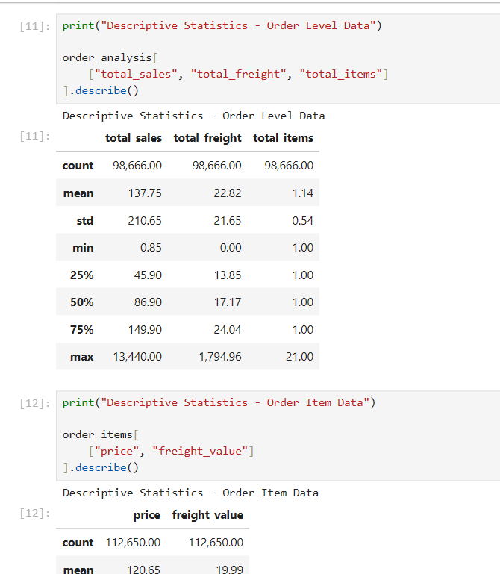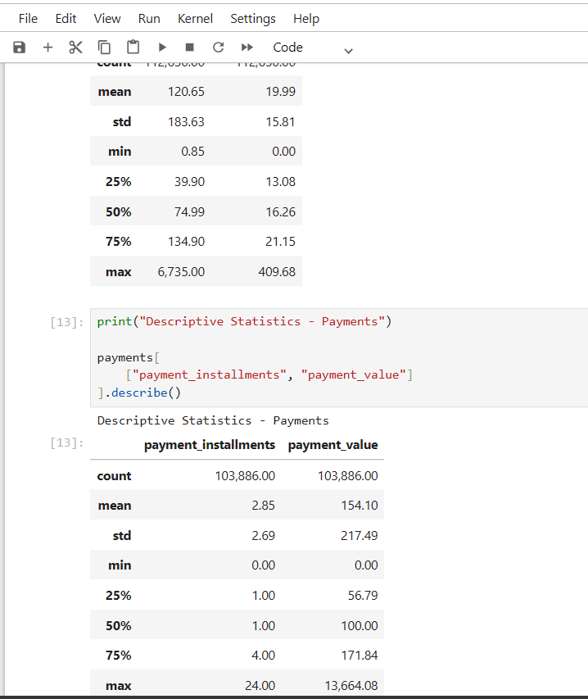

ii.Order status + monthly order analysis
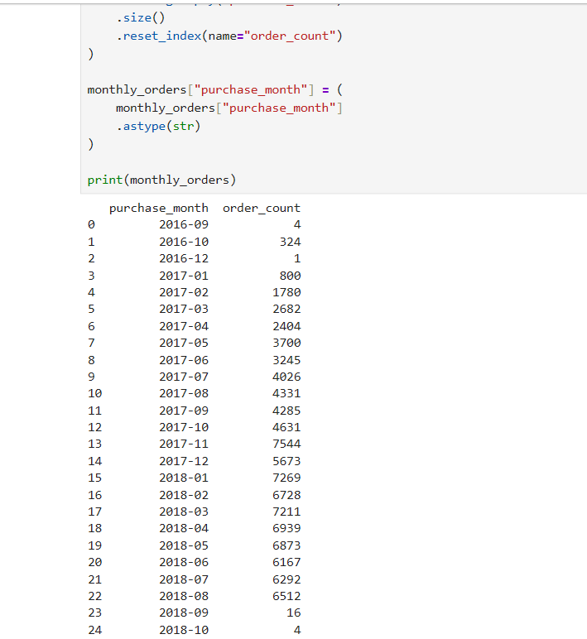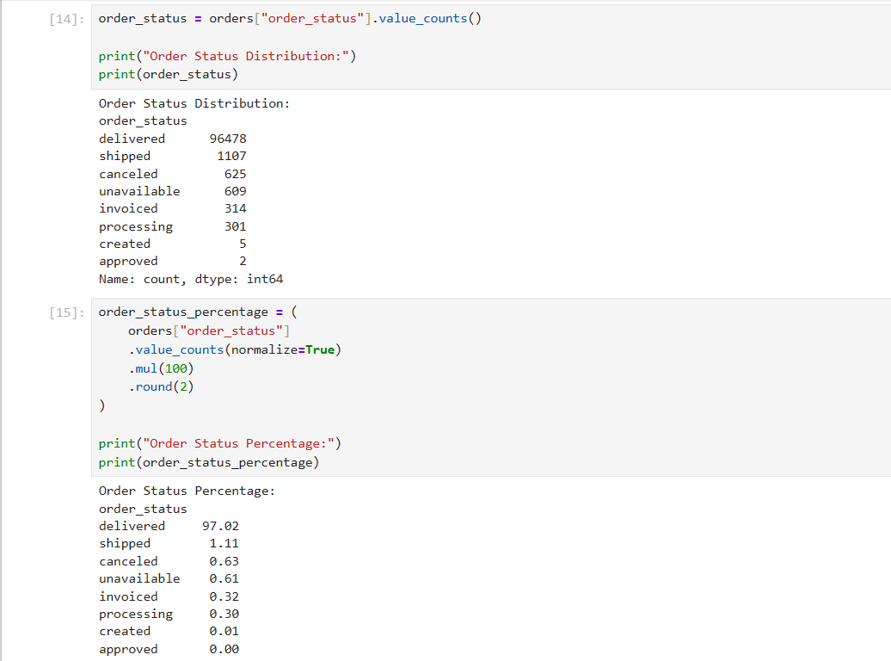
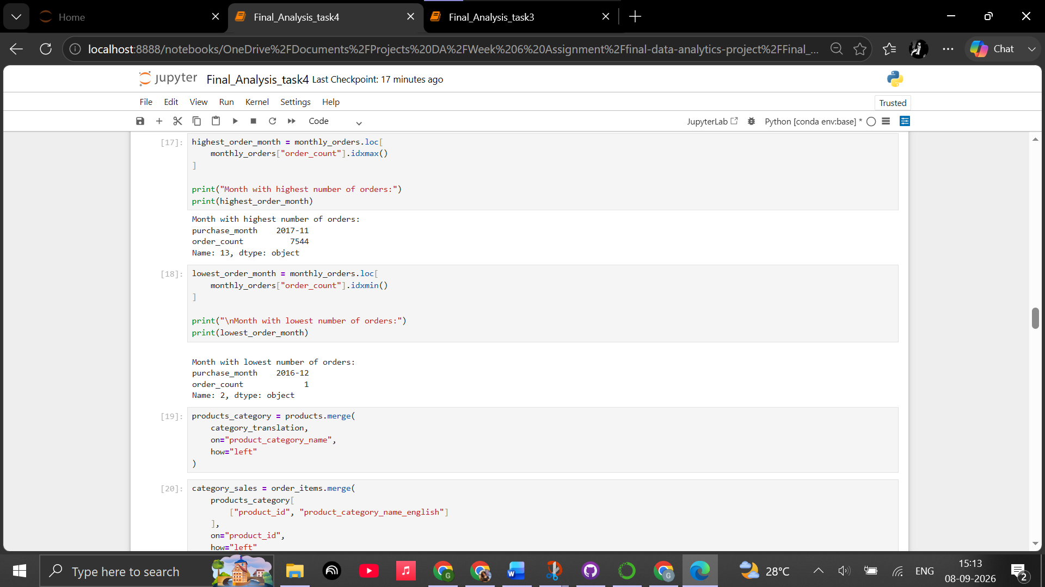

iii.Category + payment analysis

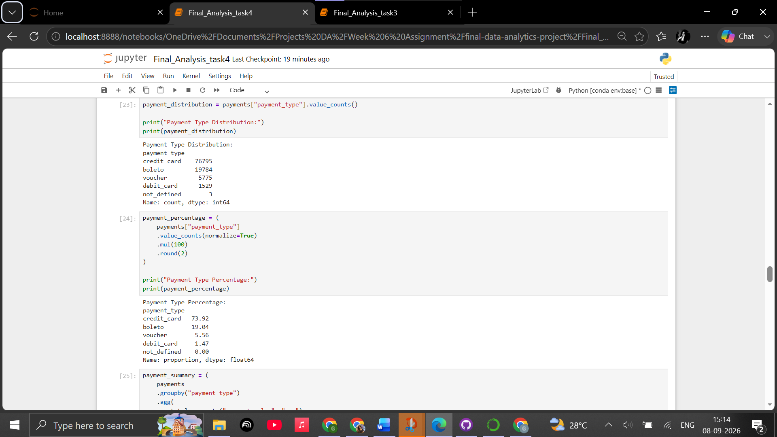

iv.Review + delivery analysis
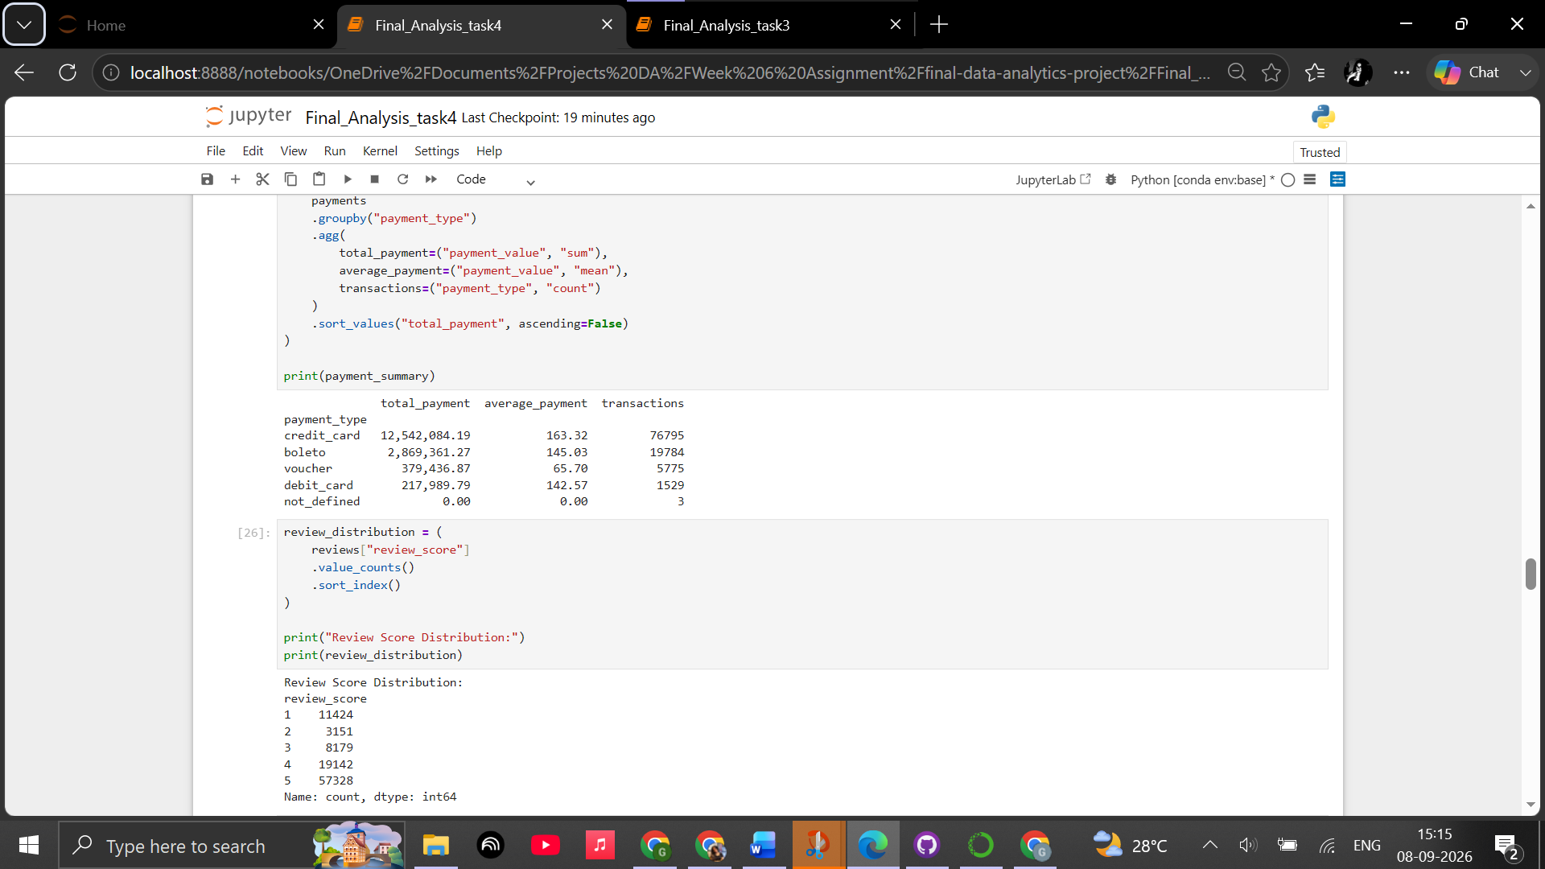
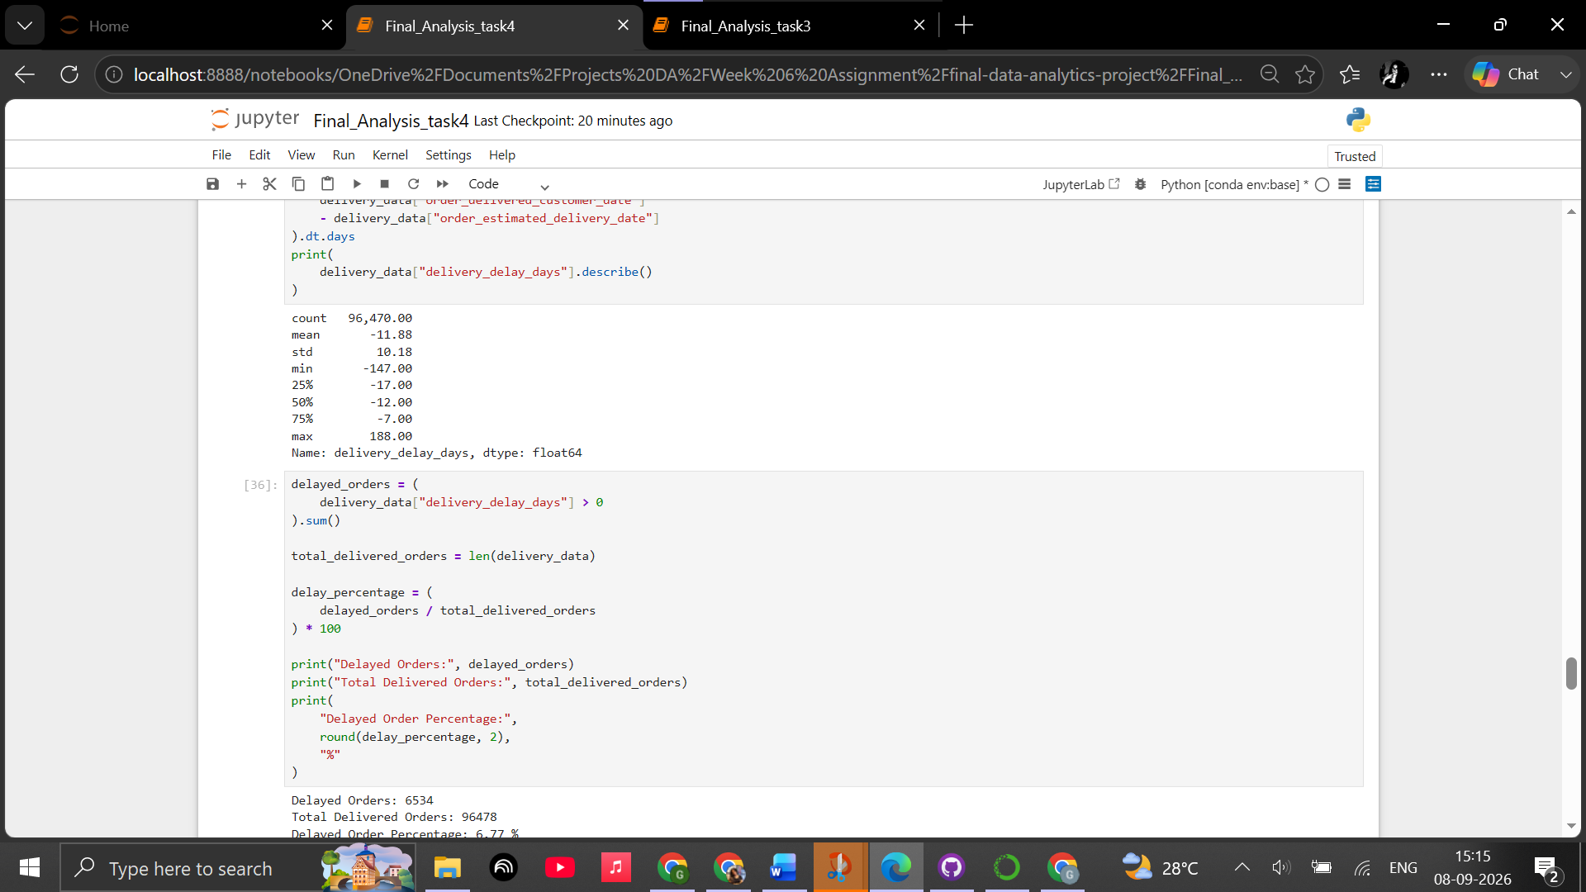

v.Correlation matrix
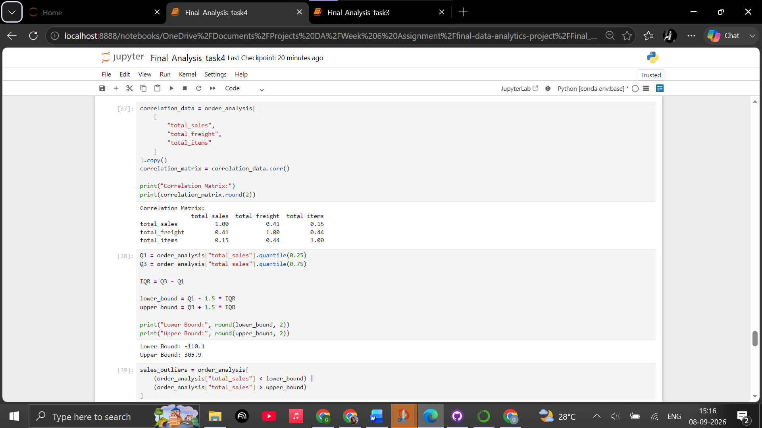
vi.Outlier analysis
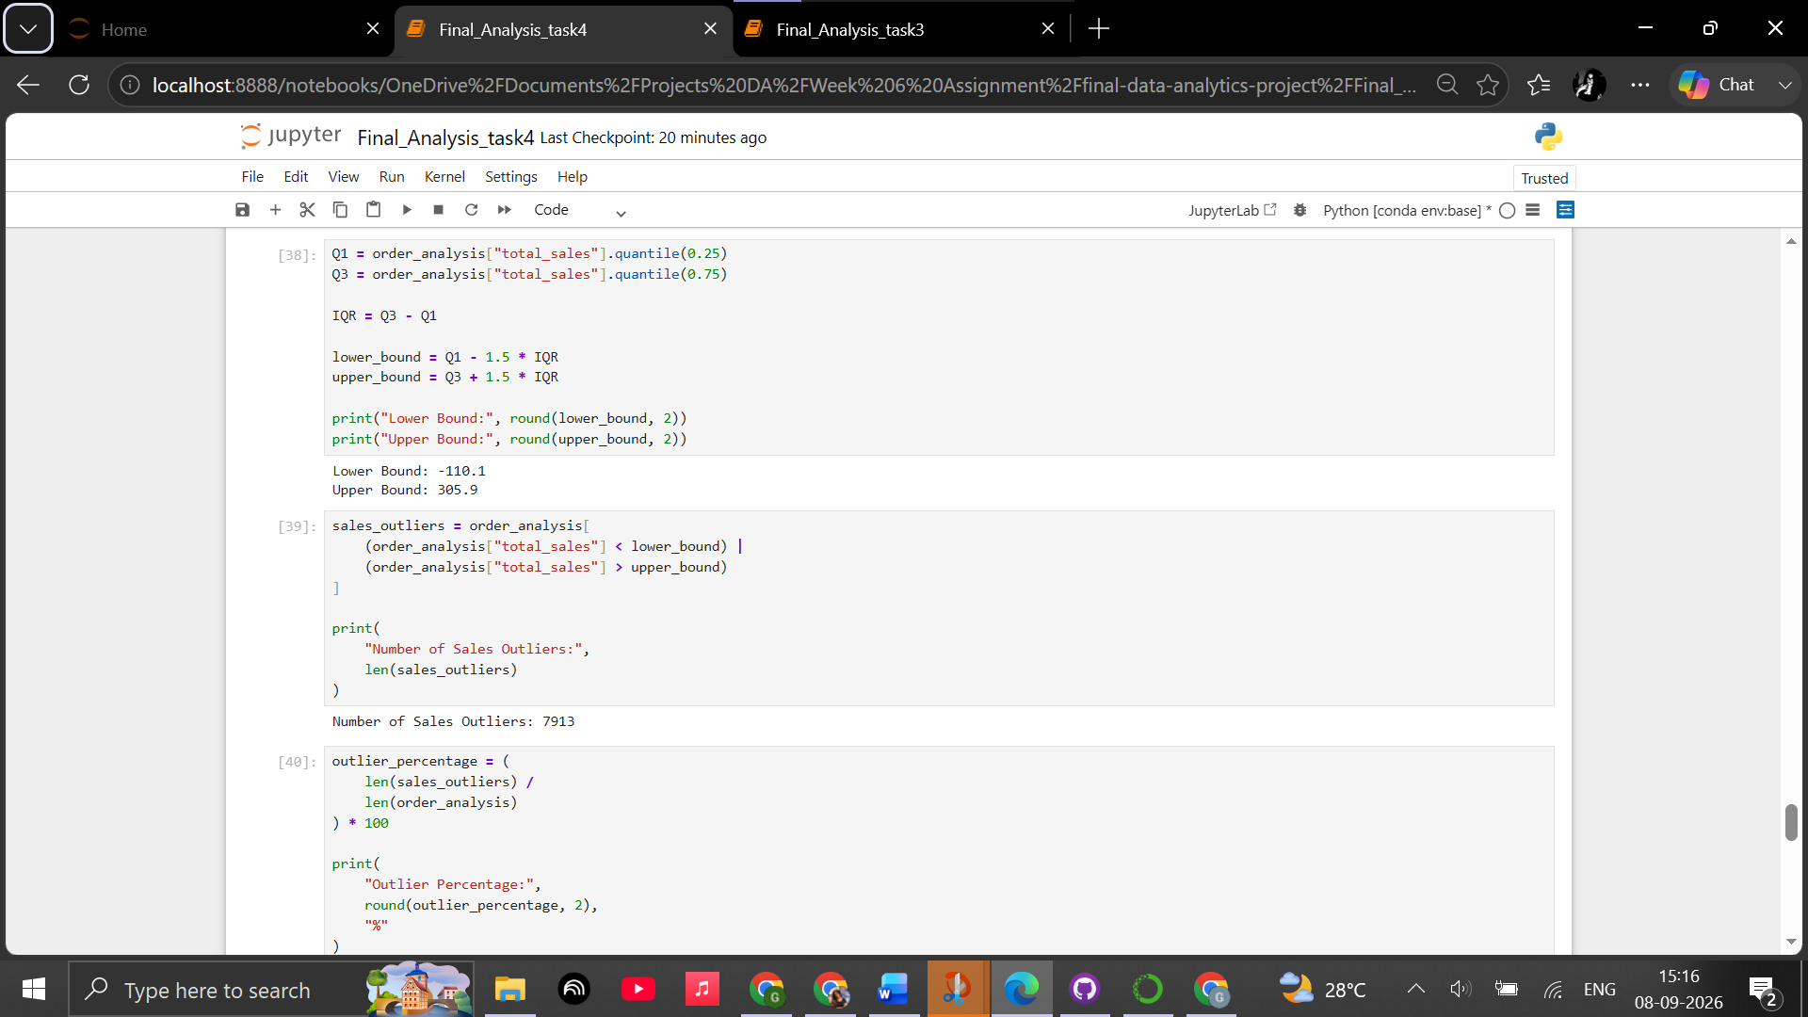
vii.EDA Summary
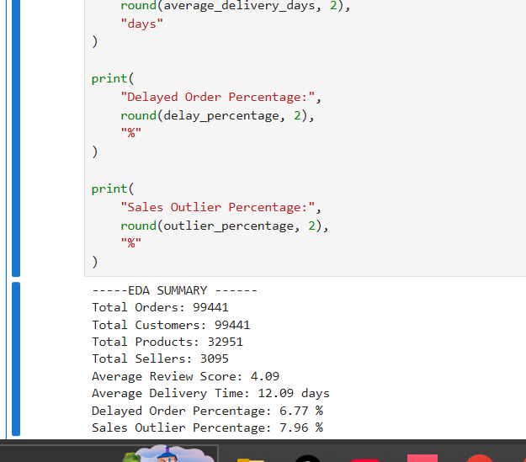

Task 5: Data Visualization
Objective
The objective of this task was to create meaningful data visualizations from the Olist e-commerce dataset. The visualizations were designed to communicate important trends, comparisons, distributions, and relationships identified during the Exploratory Data Analysis.
Tools Used
- Python
- Pandas
- Matplotlib
- Seaborn
- Jupyter Notebook
Visualization Approach
Different types of charts were selected based on the nature of each analytical question. Line charts were used to represent time-based trends, bar charts were used for categorical comparisons, and scatter plots were used to examine relationships between numerical variables.
Each visualization was provided with an appropriate title, axis labels, and readable formatting to improve interpretation.
1. Monthly Order Trend
A line chart was created to visualize the number of orders placed each month.
The visualization helps identify changes in customer order activity over time and highlights periods of relatively high or low demand.
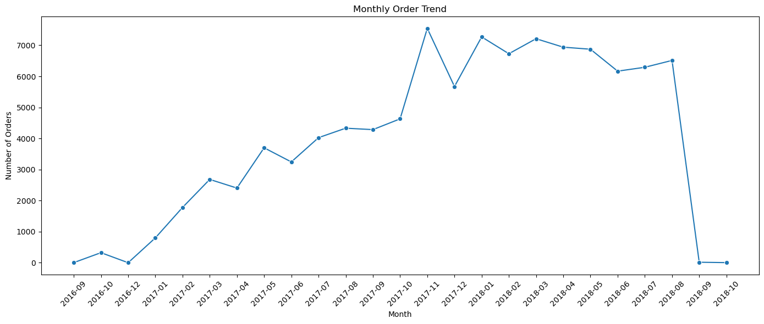
Finding:
- Order volume increased strongly from September 2016 through 2017.
- The highest monthly order volume occurred in November 2017, with approximately 7,500 orders.
- Order activity remained high from January to August 2018, generally staying above 6,000 orders per month.
- The sharp drop in September–October 2018 is due to the dataset ending during that period, so it should not be interpreted as a sudden business collapse.
The monthly order trend shows strong growth in order activity from late 2016 through 2017, reaching its highest level of approximately 7,500 orders in November 2017. Order volume remained consistently high during the first eight months of 2018, indicating sustained marketplace activity.

2. Order Status Distribution
A bar chart was created to compare the number of orders across different order statuses.
The visualization provides an overview of the order lifecycle and makes it easier to identify the dominant order status.
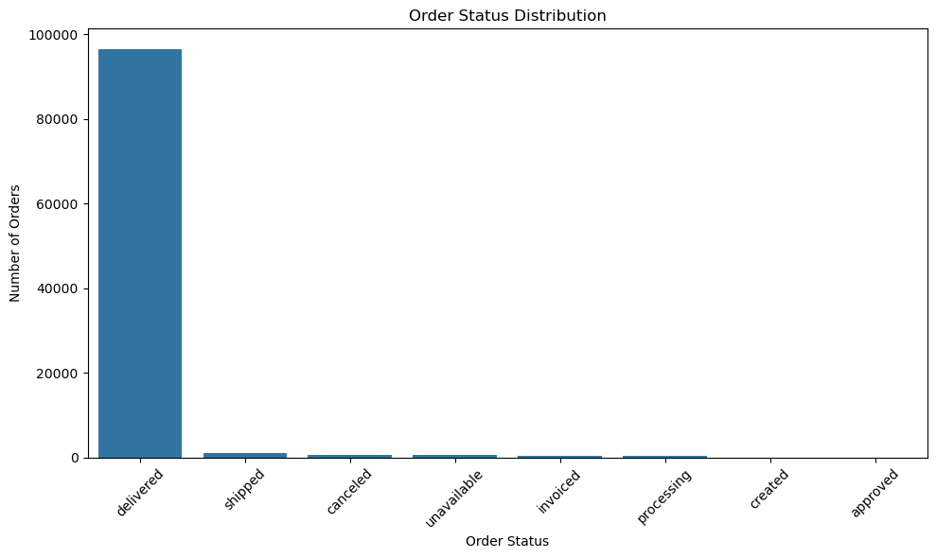
Finding:
- Delivered orders overwhelmingly dominate the dataset.
- There are approximately 99,441 total orders.
- The vast majority are successfully delivered, while shipped, canceled, unavailable, invoiced, and processing orders represent much smaller portions.
- This indicates that the dataset is primarily composed of completed customer transactions.

The order-status distribution shows that delivered orders account for the overwhelming majority of transactions. Other statuses such as shipped, canceled, unavailable, invoiced, and processing occur at substantially lower frequencies, indicating that most recorded orders successfully progressed through the fulfillment process.

3. Top 10 Product Categories by Sales
A horizontal bar chart was created to compare the ten product categories generating the highest sales.
The visualization helps identify the product categories that contribute most significantly to marketplace sales.
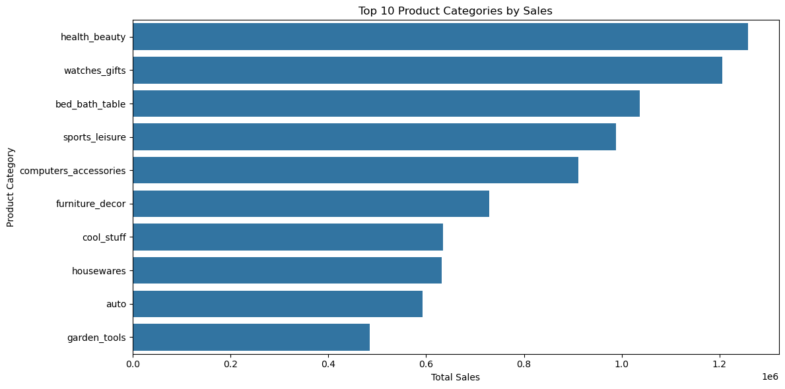
Top categories:
Rank | Category | Approx. Sales
1 | Health & Beauty | ~1.26M
2 | Watches & Gifts | ~1.20M
3 | Bed, Bath & Table | ~1.04M
4 | Sports & Leisure | ~0.99M
5 | Computers & Accessories | ~0.91M
6 | Furniture & Decor | ~0.73M
7 | Cool Stuff | ~0.63M
8 | Housewares | ~0.63M
9 | Auto | ~0.59M
10 | Garden Tools | ~0.48M
Finding:
Health & Beauty was the strongest-performing product category, generating approximately 1.26M in sales, followed by Watches & Gifts at approximately 1.20M. The top five categories each generated close to or above 0.9M in sales, showing that sales were concentrated among several major product segments rather than being driven by a single category.

4. Payment Method Distribution
A bar chart was used to visualize the frequency of different payment methods.
The chart helps identify customer preferences in terms of payment methods.
Finding:
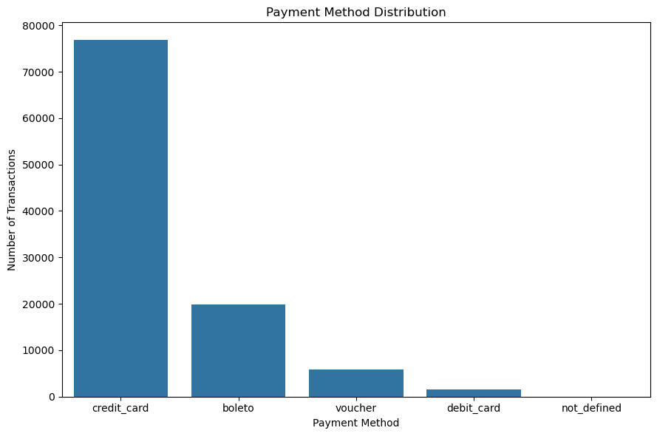
Payment Method | Transactions
Credit Card | 76,795
Boleto | 19,784
Voucher | 5,775
Debit Card | 1,529
Not Defined | 3
Finding:
- Credit card is overwhelmingly the most-used payment method.
- 76,795 transactions used credit cards.
- Boleto was the second most-used method with 19,784 transactions.
- Credit card usage is almost 4× the number of Boleto transactions.
- Debit card usage is relatively low at 1,529 transactions.
Credit cards were the dominant payment method, accounting for 76,795 transactions, compared with 19,784 Boleto transactions. This shows a strong customer preference for credit-based payments, while debit cards and vouchers represented comparatively smaller portions of payment activity.

5. Customer Review Score Distribution
A bar chart was created to show the distribution of customer review scores from 1 to 5.
The visualization provides a clear view of customer satisfaction patterns.
The EDA previously established an average review score of 4.09 out of 5, indicating a generally positive rating level.
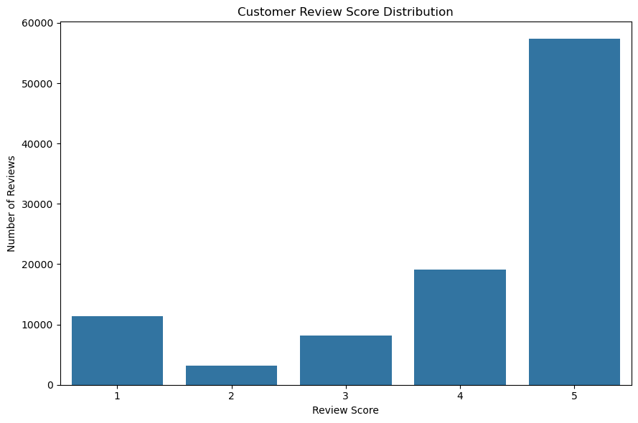
Review Score | Reviews
1 ⭐ | 11,424
2 ⭐ | 3,151
3 ⭐ | 8,179
4 ⭐ | 19,142
5 ⭐ | 57,328
Finding:
- 5-star reviews = 57,328, approximately 57.8% of all reviews.
- 4-star reviews = 19,142.
- Only 3,151 reviews were 2-star.
- Average review score = 4.09 / 5.
Customer reviews were generally positive, with 57,328 five-star ratings representing approximately 57.8% of all reviews. The overall average review score was 4.09 out of 5, indicating a generally favorable customer experience. However, the presence of 11,424 one-star reviews suggests that a meaningful group of customers still experienced dissatisfaction and should be investigated further.

6. Sales vs Freight Value
A scatter plot was created to examine the relationship between total order sales and total freight value.
This visualization helps determine whether higher-value orders tend to be associated with higher freight costs and allows unusual observations to be identified visually.
Finding:
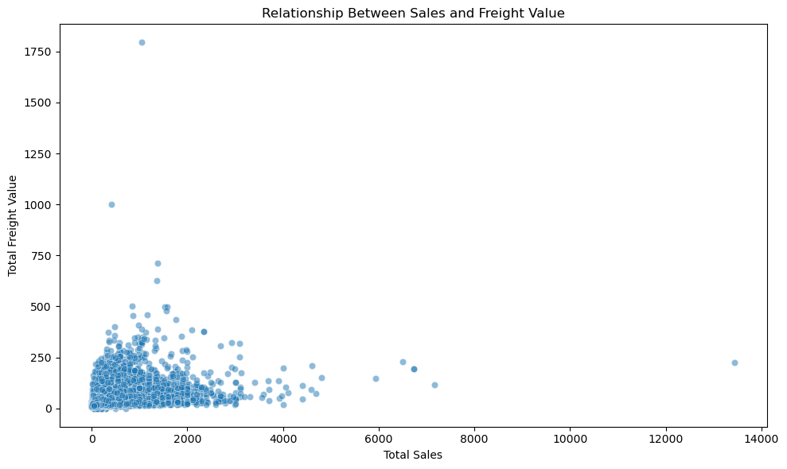
Finding:
The scatter plot shows that:
- Most orders have relatively low sales values and low freight values.
- There are a small number of high-value orders extending far to the right.
- Some orders have unusually high freight values.
- The relationship does not appear perfectly linear.
- The chart also supports the earlier outlier analysis, where 7.96% of orders were identified as potential sales outliers.
- The highest displayed sales transaction was 13,440, with 8 items.
The scatter plot shows that most transactions are concentrated within lower sales and freight ranges, while a small number of high-value transactions form visible outliers. The relationship between sales and freight is not perfectly linear, suggesting that higher-value purchases do not always result in proportionally higher freight costs. The presence of these unusual transactions supports the need for separate outlier analysis.

7. Delivery Delay Distribution
A histogram was created to visualize the distribution of delivery delays compared with estimated delivery dates.
This visualization helps identify the typical delivery-performance pattern and the presence of unusually large delays.
The EDA identified that approximately 6.77% of delivered orders were delayed compared with their estimated delivery dates.

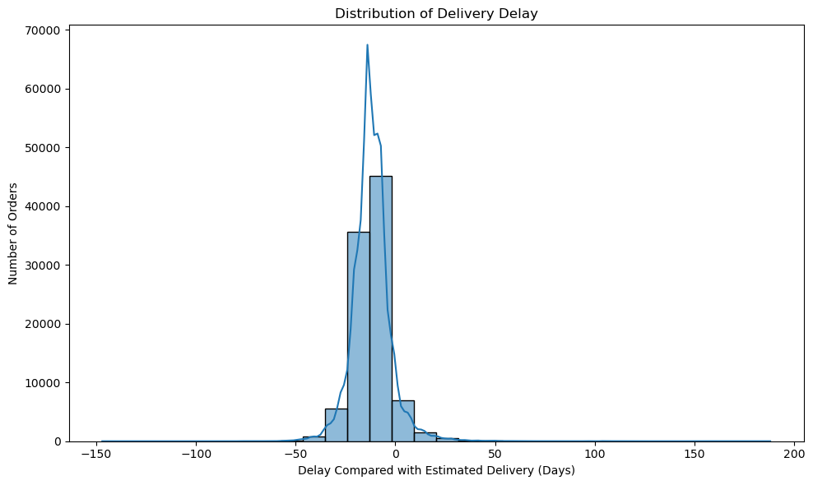
Finding:
- Most observations are concentrated around 0 days of delay.
- A large portion of orders appear to have been delivered on or before the estimated date.
- There is a smaller right-side tail representing significantly delayed orders.
- There are also some extreme observations.
- From your EDA, 6.77% of delivered orders were classified as delayed.
- Average delivery time was 12.09 days.
The delivery-delay distribution shows that most orders were delivered close to their estimated delivery dates, with a large concentration around zero or negative delay values. However, a smaller group of orders experienced substantial delays, creating a noticeable right-side tail. Overall, 6.77% of delivered orders were identified as delayed, while the average delivery time was 12.09 days.

Overall Visualization Findings
The visualizations provide several perspectives on the e-commerce business, including:
- Changes in order activity over time
- Distribution of order statuses
- High-performing product categories
- Customer payment preferences
- Customer satisfaction
- Relationship between sales and freight costs
- Delivery performance
Conclusion
The visualization stage converted the numerical findings from the EDA into clear graphical representations. The use of line charts, bar charts, scatter plots, and histograms made it easier to identify trends, compare categories, understand customer behavior, and examine operational performance.
These visualizations provide a strong foundation for the next stage of the project, where the analytical findings will be incorporated into a Power BI dashboard and transformed into business-focused insights.
Task 6: Power BI Dashboard
1 . Power BI Project Setup
The Power BI Desktop environment was prepared for the final data analytics project. A new Power BI report was created and saved as Final_Data_Analytics_Project.pbix within the project folder. This file will contain the data model, DAX measures, visualizations, interactive dashboard, and related Power BI components developed during the project.
Conclusion
The Power BI project environment was successfully created and prepared for dashboard development.
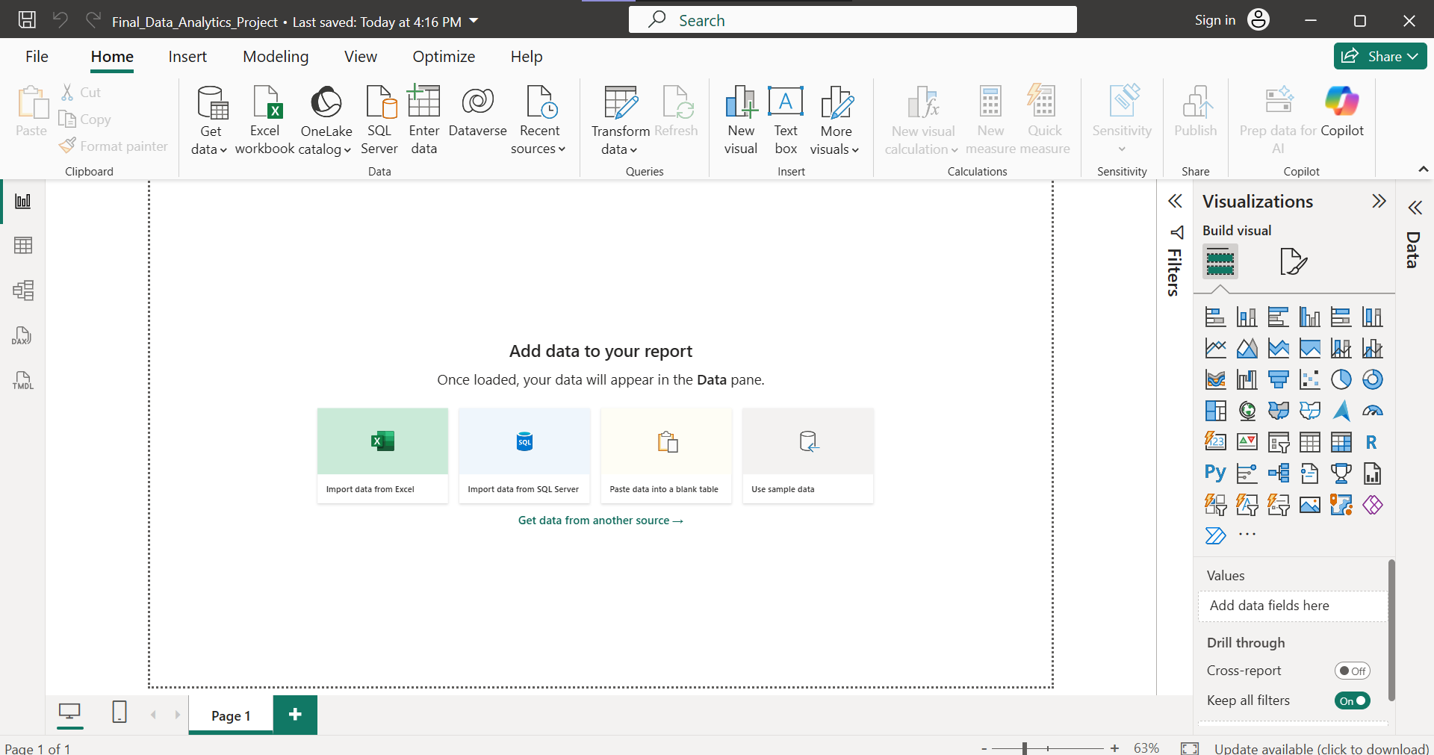
2 .Import the Olist Tables
Data Import
The Olist Brazilian E-Commerce dataset was imported into Power BI Desktop for dashboard development. Eight related tables were loaded into the Power BI project: Customers, Orders, Order Items, Payments, Reviews, Products, Sellers, and Category Translation. The relational structure of the dataset was retained instead of combining all tables into a single dataset, allowing the project to maintain a proper analytical data model.
Conclusion
The required Olist tables were successfully imported into Power BI and are ready for data-type validation and modeling.

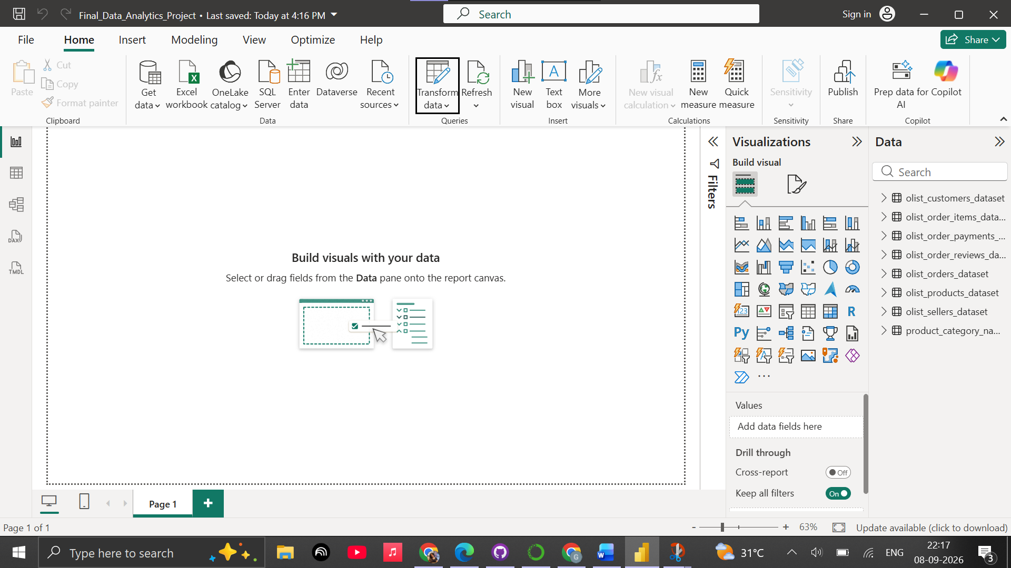
3 . Data Type Check & Preparation
Data Type Validation and Preparation
The imported Olist tables were reviewed in Power Query to ensure that each field was assigned an appropriate data type. Identifier fields such as order IDs, customer IDs, product IDs, and seller IDs were maintained as text fields, while numerical measures such as prices, freight values, payment values, and review scores were assigned suitable numeric data types. Date-related fields were converted to Date/Time to support time-based analysis and dashboard visualizations.
Conclusion
The data types were validated and prepared appropriately for Power BI analysis and subsequent data modeling.
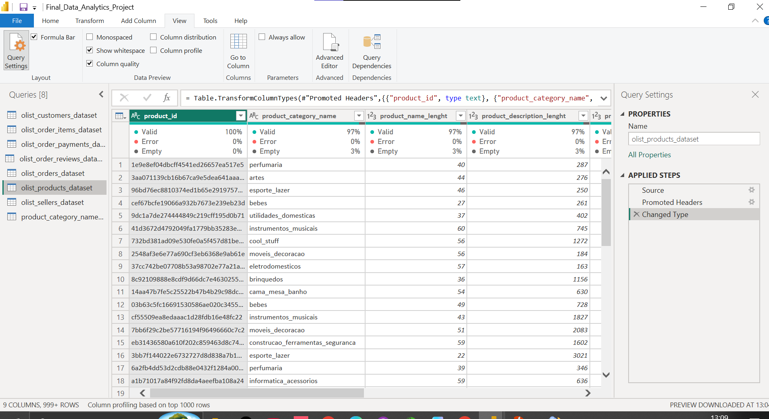
4.Missing Value Handling
Missing values were investigated and handled during the Python data preparation stage. Business-related missing values, such as undelivered order dates and unavailable product attributes, were retained where appropriate. Text fields such as missing review comments and product categories were handled during the analytical preparation process. The cleaned data was then used as the basis for Power BI dashboard development.
Conclusion
The dataset was prepared for visualization while preserving records that contained meaningful business-related missing information.
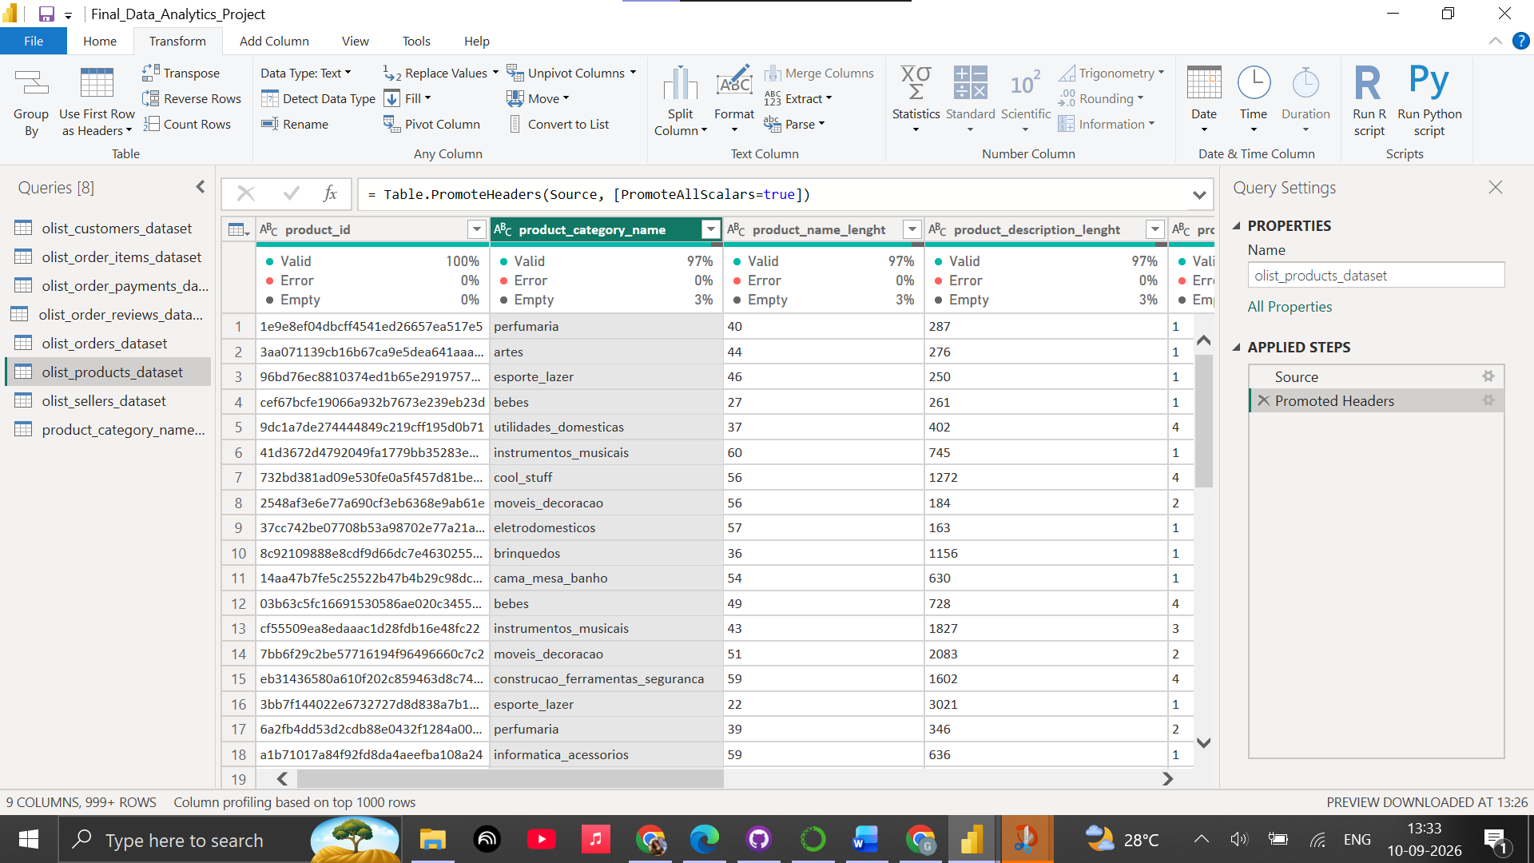
5.Data Modeling and Relationships
The Olist dataset was modeled using relationships between the major transactional and reference tables. The model connects Customers with Orders, Orders with Order Items, Payments and Reviews, and Order Items with Products and Sellers. The Product Category Translation table was also connected with the Products table to enable the use of translated product category names in the dashboard.
All seven relationships were configured as active relationships with appropriate one-to-many cardinality and single-direction filtering.
Conclusion
The relational data model was successfully established in Power BI, allowing data from multiple Olist tables to interact correctly for analysis and visualization.
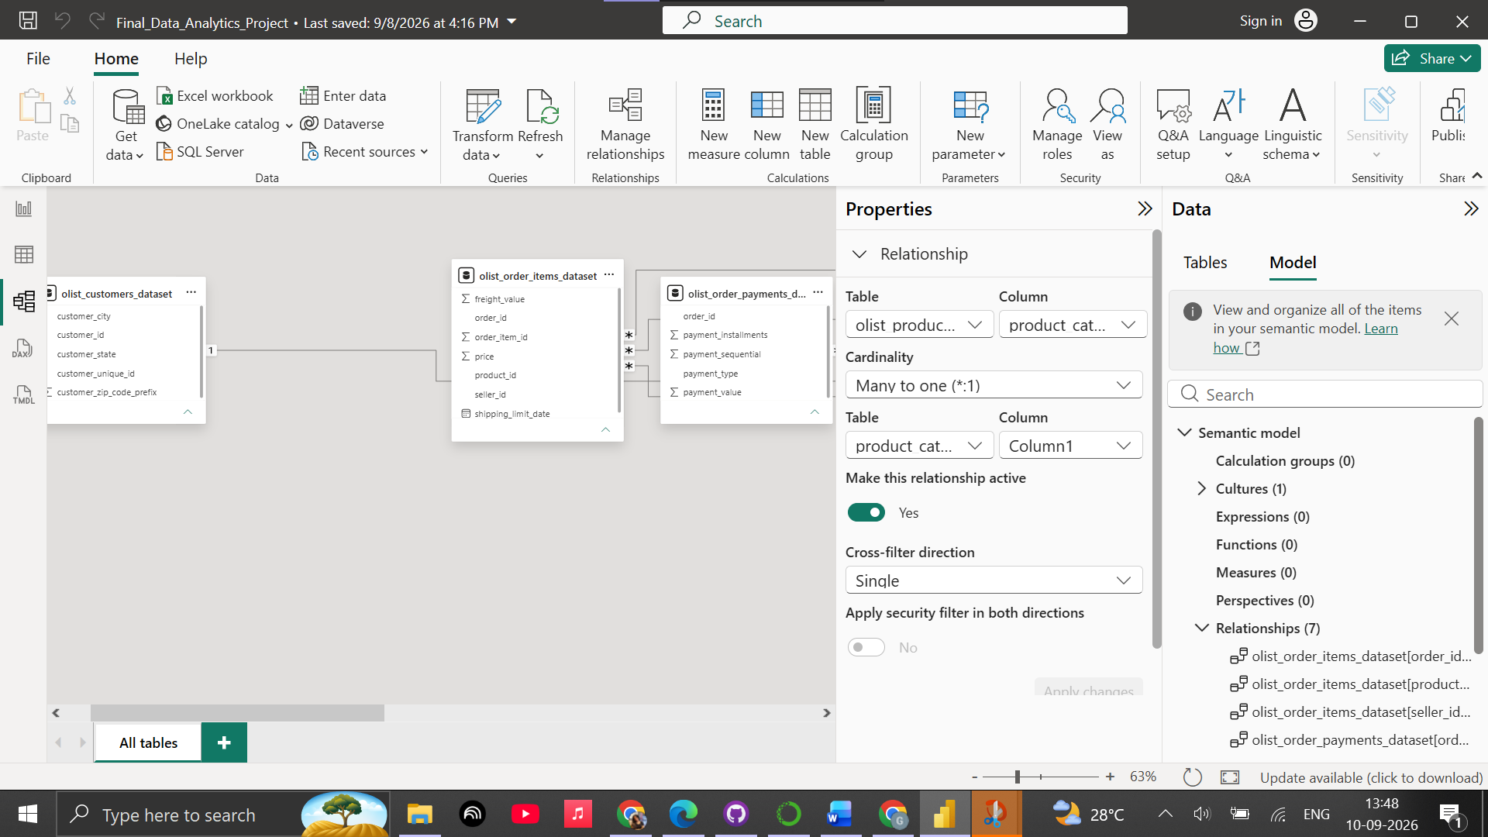
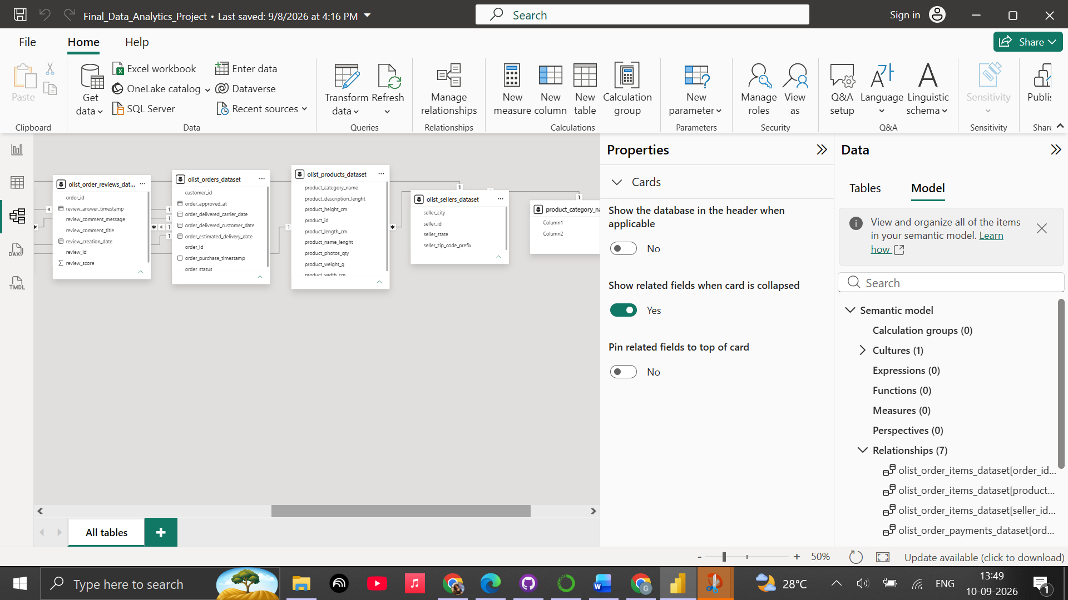

6 .DAX Measures and KPI Metrics
6.6.1 Total Sales
A DAX measure was created to calculate the total sales generated from all products sold through the Olist e-commerce platform.
DAX Measure:
Total Sales = SUM('olist_order_items_dataset'[price])
The measure calculates the sum of the price column from the Order Items table.
The resulting value displayed in Power BI is approximately 13.59 million.

6.6.2 Total Orders
A DAX measure was created to calculate the total number of unique orders in the dataset.
DAX Measure:
Total Orders = DISTINCTCOUNT('olist_orders_dataset'[order_id])
The DISTINCTCOUNT function was used because an order can contain multiple product items. Counting unique order IDs therefore provides the actual number of orders rather than the number of individual order-item records.
The resulting value displayed in Power BI is approximately 99K orders.

6.6.3 Average Order Value
A DAX measure was created to calculate the average sales value generated per order.
DAX Measure:
Average Order Value = DIVIDE([Total Sales], [Total Orders])
The DIVIDE function was used to safely calculate the ratio between total sales and total orders.
The resulting Average Order Value displayed in Power BI is approximately 136.68.

KPI Results
The three measures created in Power BI produced the following key metrics:
KPI | Value
Total Sales | 13.59M
Total Orders | 99K
Average Order Value | 136.68
These metrics provide a concise overview of the overall sales performance and order activity of the Olist e-commerce platform.
Conclusion
Three important DAX measures were successfully created using Power BI: Total Sales, Total Orders, and Average Order Value. These measures provide the foundation for the KPI cards in the final dashboard and allow the business performance of the Olist e-commerce platform to be evaluated using key quantitative metrics.
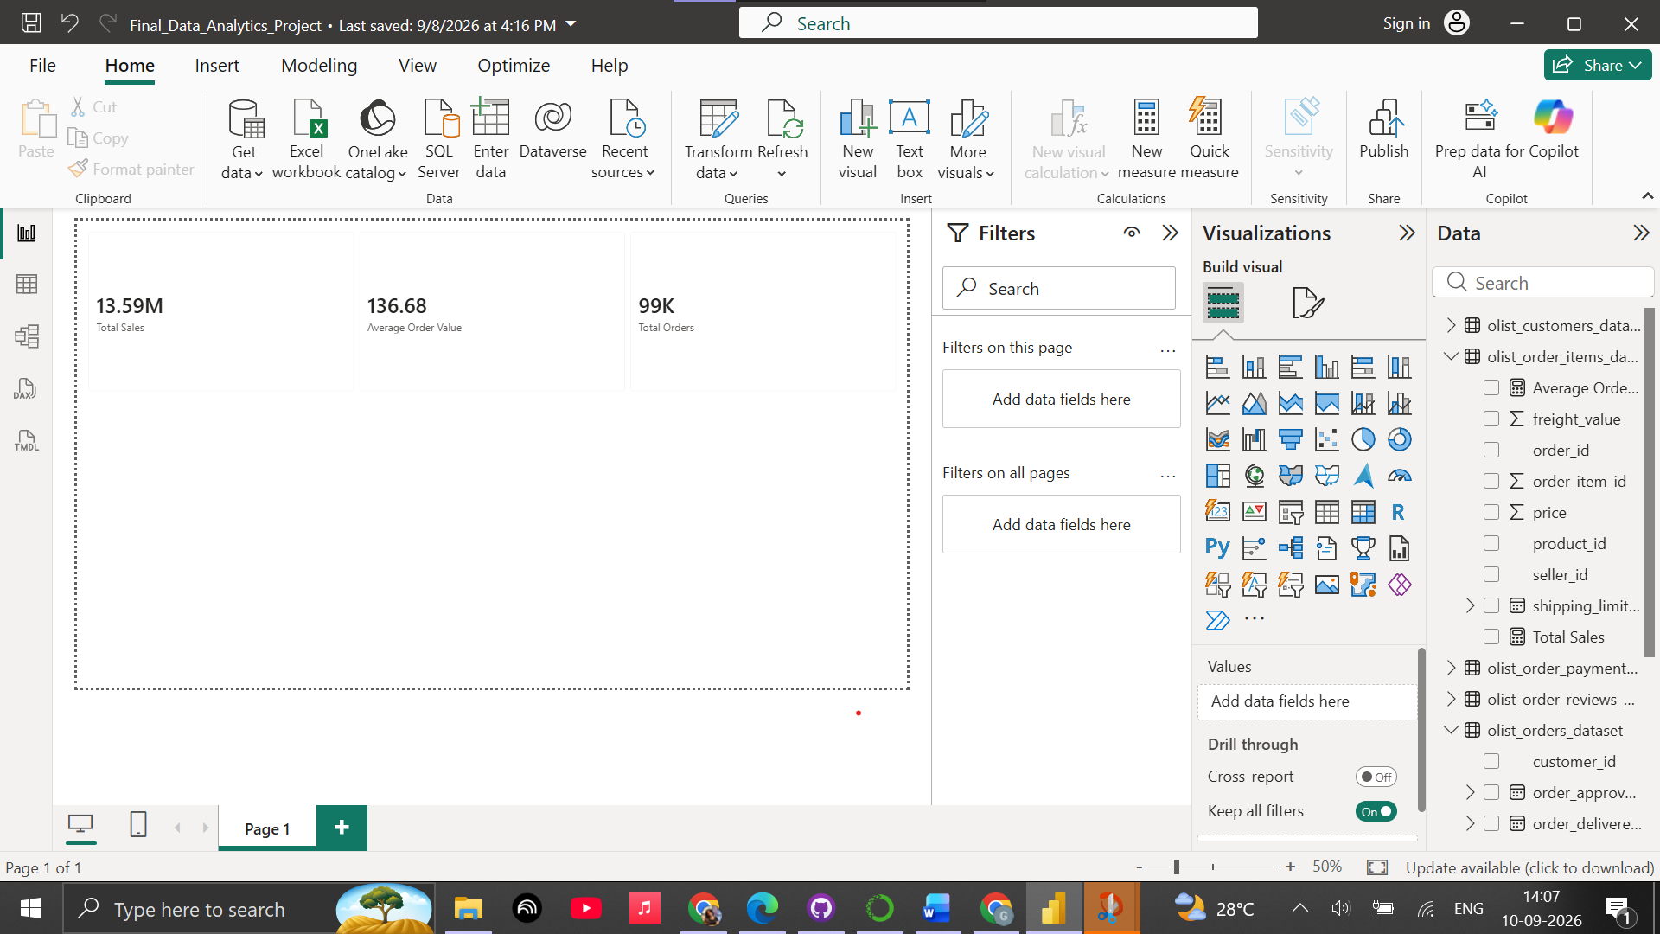
7. Create Dashboard Visualizations
Objective
The objective of this task was to create meaningful visualizations in Power BI to analyze sales performance, product categories, customer locations, and payment methods.
Visualizations Created:
1.Total Sales by Month
A line chart was created to analyze the monthly sales trend of the Olist e-commerce platform.
Visualization:
Chart Type: Line Chart
X-axis: Order Purchase Timestamp
Y-axis: Total Sales
Insight:
The monthly sales trend shows that sales gradually increased from January and reached the highest point in May at approximately 1.5M. Sales then declined slightly in June and remained relatively high during July and August. A significant drop occurred in September, with sales falling to around 0.6M, followed by a recovery in October and November. Sales decreased again in December, showing noticeable fluctuations throughout the year.

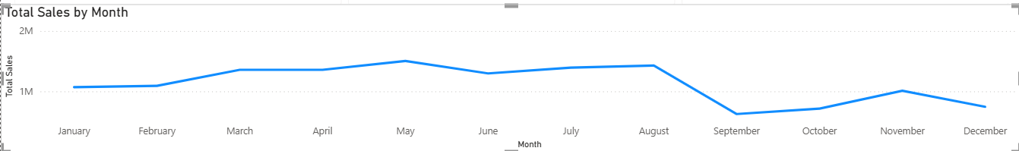

2. Top 10 Product Categories by Sales
A bar chart was created to identify the product categories generating the highest sales.
Visualization:
Chart Type: Bar Chart
Y-axis: Product Category
X-axis: Total Sales
Filter: Top 10 Categories by Total Sales
Insights:
The Top 10 category chart shows that Health & Beauty generated the highest sales at approximately 1.3M, followed by Watches & Gifts at around 1.2M. Bed & Bath Table and Sports & Leisure also recorded strong sales of around 1M, while Garden Tools had the lowest sales among the Top 10 at approximately 0.5M. Overall, the chart shows clear differences in sales performance across product categories.
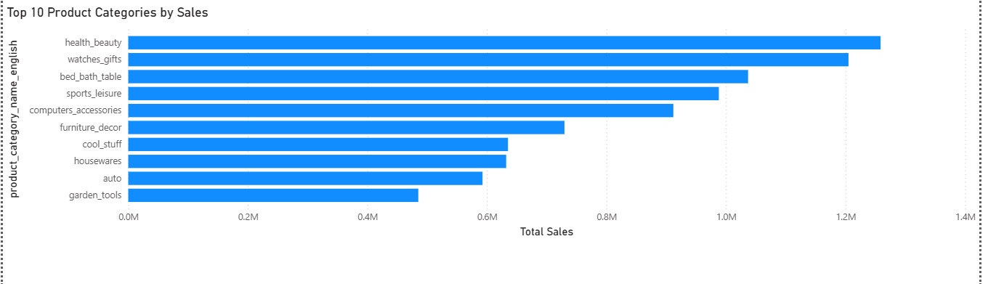
3 .Orders by Customer State
A column chart will be created to compare the number of orders received from different customer states.
Visualization:
Chart Type: Clustered Column Chart
X-axis: Customer State
Y-axis: Count of Order ID
Insights :
The chart shows that São Paulo (SP) has by far the highest number of orders, with over 40K orders, followed by Rio de Janeiro (RJ) and Minas Gerais (MG). The number of orders decreases significantly across the remaining states, with several states contributing comparatively fewer orders. Overall, orders are heavily concentrated in a few major states, particularly SP, RJ, and MG.
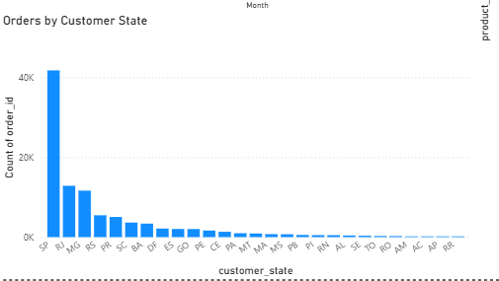

4. Payment Method Distribution
A visualization was created to analyze the distribution of payment methods used by customers on the Olist e-commerce platform.
Visualization:
Chart Type: Donut Chart
Legend: Payment Type
Values: Payment Value
Insight:
The chart shows that credit card is by far the most dominant payment method, accounting for the vast majority of sales at 12.54M (78.34%), followed by boleto at 2.87M (17.92%). Voucher usage represents a much smaller proportion at 0.38M (2.37%), with debit card and not defined options contributing marginally to the remaining share. Overall, sales volume is heavily concentrated in credit card transactions, with boleto serving as the primary alternative.
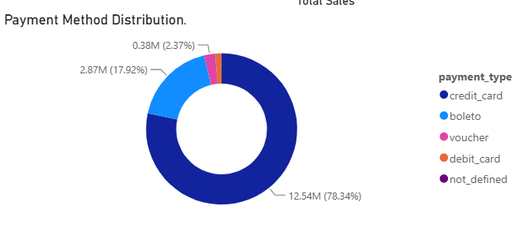

Conclusion
The Power BI dashboard successfully transformed the Olist e-commerce dataset into meaningful business insights. The analysis showed fluctuations in monthly sales, with May recording the highest sales of approximately 1.5M, while Health & Beauty emerged as the top-selling product category at around 1.3M. The geographical analysis showed that orders were highly concentrated in São Paulo, Rio de Janeiro, and Minas Gerais, with São Paulo contributing more than 40K orders. The payment analysis also showed a strong preference for credit card payments, accounting for 78.34% of sales value.
Overall, the visualizations provide a clear understanding of sales trends, product performance, customer geography, and payment preferences. These insights can help the business focus on high-performing categories and regions while improving marketing, inventory planning, and payment services.
8 .Slicers and Dashboard Interactivity
Objective
The objective of this task was to add interactive slicers to the Power BI dashboard so that users can filter the dashboard according to specific business requirements. Two slicers were added based on Customer State and Order Status. These slicers allow users to interact with the dashboard and analyze sales and order performance for selected regions and order statuses.
Slicers Added
- Customer State
- Order Status
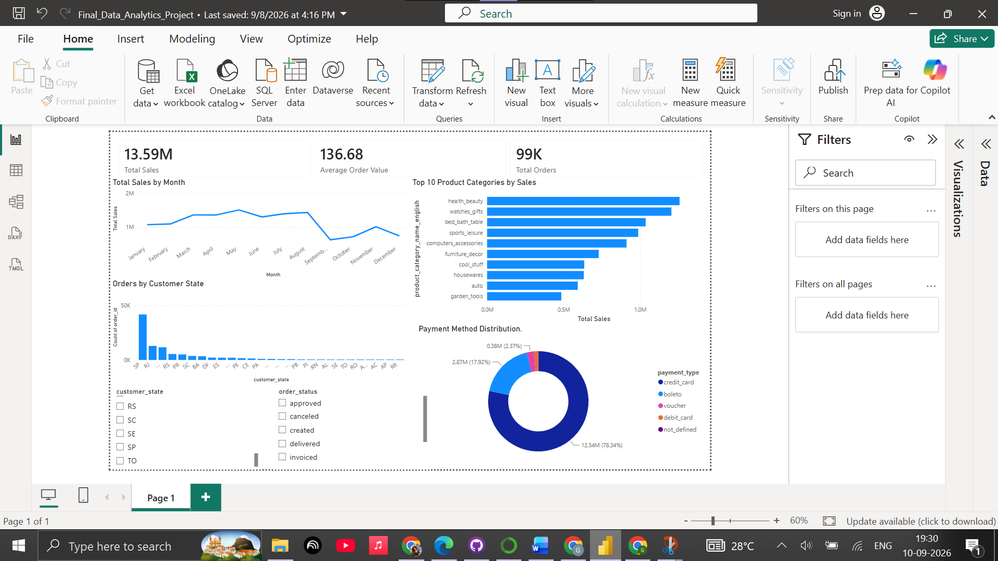
Figure 6.8.1: Interactive Power BI dashboard with Customer State and Order Status slicers.
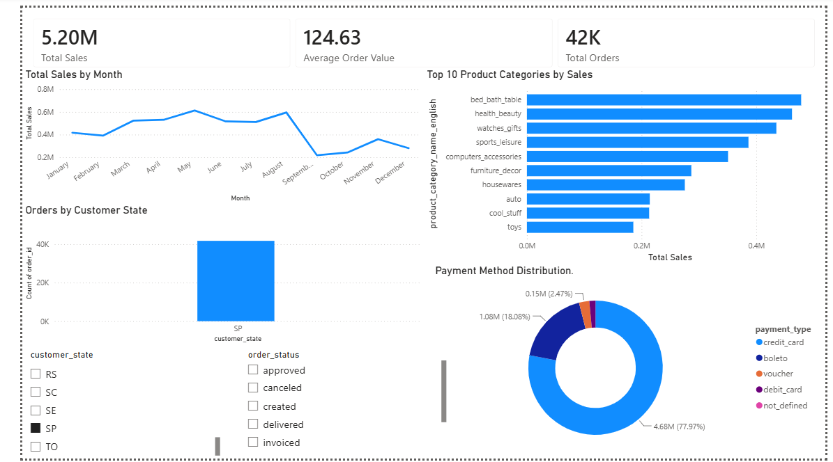
Figure 6.8.2: Dashboard filtered for São Paulo showing dynamic KPI and visual updates.
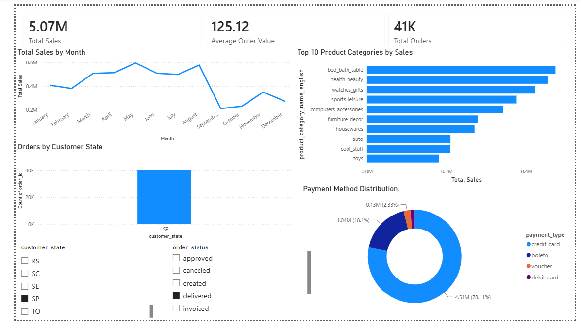
Figure 6.8.3: Dashboard filtered for São Paulo and Delivered orders demonstrating multi-level interactivity.
Insights derived from Slicer – Based Analysis:
Insight 1 :Strong geographic concentration
São Paulo is the largest market in the dataset, generating approximately 5.20M in sales from 42K orders. This indicates that a significant portion of overall business activity is concentrated in one state.
Insight 2 :Delivered orders drive the majority of sales
After filtering São Paulo to Delivered orders, sales remain approximately 5.07M, showing that most of the state's sales are associated with successfully delivered orders rather than orders still moving through the pipeline.
Insight 3 : Customer preferences vary by state
The leading product categories change across states. For example, São Paulo is led by Bed & Bath Table, while Rio de Janeiro is led by Watches & Gifts and Rio Grande do Sul shows strong performance in Bed & Bath Table and Furniture & Decor. This suggests that product demand is not identical across regions.
Insight 4 : Credit card is consistently dominant
Across almost all state-level filters, credit card remains the largest payment method, generally contributing around 70–80% or more of payment value. Boleto is usually the second-largest payment method.
Insight 5 : High AOV (Average Order Value) does not necessarily mean high sales volume
Smaller states can show a higher Average Order Value despite having substantially fewer orders. For example, Paraíba has an AOV of approximately 215, compared with approximately 125 in São Paulo. This shows that order volume and order value represent different dimensions of business performance.
Conclusion
The slicers successfully made the dashboard interactive and allowed the analysis to move from an overall business view to specific state-level and order-status-level insights. Filtering by Customer State and Order Status dynamically updated the KPI cards, sales trend, product category ranking and payment distribution. The analysis also showed strong geographic concentration, differences in category preferences across states and consistent dominance of credit-card payments. Overall, the slicers significantly improved the dashboard's ability to support focused business analysis.

TASK 7. Business Insights & Recommendations
Objective
The objective of this task is to convert the findings from Exploratory Data Analysis, data visualizations, and the Power BI dashboard into meaningful business insights. Based on these insights, practical recommendations are provided to improve business performance, customer experience, and operational decision-making.
7.1 Key Business Insights
Insight 1: Sales are concentrated in a few major product categories
The analysis shows that Health & Beauty is the highest-performing product category, generating approximately 1.3M in sales, followed by Watches & Gifts at around 1.2M. Bed & Bath Table and Sports & Leisure also contribute strongly, with sales close to 1M.
This indicates that a relatively small group of product categories contributes a significant portion of overall sales. These categories can therefore be treated as important revenue drivers.
Insight 2: Orders are heavily concentrated in a few customer states
The customer-state analysis shows that São Paulo (SP) has more than 40K orders, significantly higher than other states. Rio de Janeiro (RJ) and Minas Gerais (MG) follow behind.
This suggests that the business has a strong geographic concentration of customers. These major states represent important markets where logistics, product availability, and customer experience can have a large impact on overall performance.
Insight 3: Credit cards dominate payment value
The payment analysis shows that credit card payments account for approximately 78.34% of payment value, while boleto contributes around 17.92%. Voucher and debit card payments represent much smaller shares.
This indicates a strong customer preference for credit-card-based transactions. Maintaining a smooth and reliable card-payment experience should therefore be a priority.
Insight 4: Delivery performance has a measurable impact on customer experience
The EDA found that the average delivery time was approximately 12.09 days, while around 6.77% of delivered orders were identified as delayed.
Although most orders were delivered within the expected period, the delayed-order percentage represents an area where operational improvements could increase customer satisfaction. The review distribution also shows that the dataset contains 11,424 one-star reviews, indicating that negative customer experiences still exist and should be investigated.
Insight 5: High order volume does not always mean high Average Order Value
The dashboard analysis showed that São Paulo has very high order volume but an AOV of approximately 124.63, whereas some smaller states can show much higher AOV values, such as approximately 215 in PB.
This demonstrates that order volume and order value are two different business dimensions. A state with fewer customers can still generate comparatively valuable orders. However, high AOV in smaller states should be interpreted carefully because a small number of orders can produce unusually high averages.
7.2 Business Recommendations
Recommendation 1: Use a two-level regional strategy instead of focusing only on order volume
The company should not evaluate markets only on the basis of total orders. A better strategy would be to classify states using both order volume and AOV.
High-volume states such as São Paulo can be prioritized for:
- Faster delivery infrastructure
- Better inventory availability
- Regional fulfillment centers
- Customer retention campaigns
At the same time, smaller states showing higher AOV can be targeted with premium product promotions, cross-selling, and personalized offers.
This approach can help the business grow both its customer base and revenue per order.
Recommendation 2: Prioritize delivery improvement for customer-experience gains
Since delivery delays affect customer satisfaction and the dataset contains a significant number of low review scores, the business should identify the stages and regions where delivery performance is weaker.
The company can monitor:
- Delivery time by state
- Delayed-order percentage by region
- Product category with higher delivery delays
- Relationship between delivery delays and review scores
Improving delivery reliability can potentially reduce negative reviews and improve overall customer satisfaction without relying only on additional marketing expenditure.
7.3 Overall Conclusion
The analysis of the Olist e-commerce dataset provided a clear view of sales performance, customer distribution, product categories, payment behavior, and delivery performance.
The results show that sales are driven strongly by specific product categories and major customer states, while credit cards dominate payment value. At the same time, delivery performance and differences in AOV across regions provide opportunities for improvement.
Overall, the project demonstrates how Python, SQL, and Power BI can be combined to transform raw e-commerce data into actionable business insights and recommendations. The findings can support better regional planning, product prioritization, customer experience improvement, and data-driven decision-making.

