**Position Calibration via Machine Learning:** The ML model evaluates positions by analysing the mean and standard deviation of 'fdelt' for each given position. The algorithm first transforms the original data points into polynomial features up to the second degree, essentially generating a curve to best fit the data. The primary objective during the training phase is to minimize the Mean Squared Error (MSE) by adjusting the curve.

**Data Sets:** For the ML model, primary data was derived by adjusting an initial error at the 0 position and utilizing the "2n+1" sequence to achieve a balanced representation. Training encompassed positions from -40 to 40, in increments like -40, -30, and so forth. Specifically, the test data included positions +45 and -45, intentionally chosen due to their deviation from regular training increments. This ensured the model was evaluated on less familiar data points and in no case resulted in overfitting.

**Result:** For the ml model :

Training set mean squared error: 0.0040

Predicted distances: For +45 position: 45.04 cm

For -45 position: -44.21 cm

Mean Absolute Percentage Error: 0.9222%

Accuracy: 99.0778%

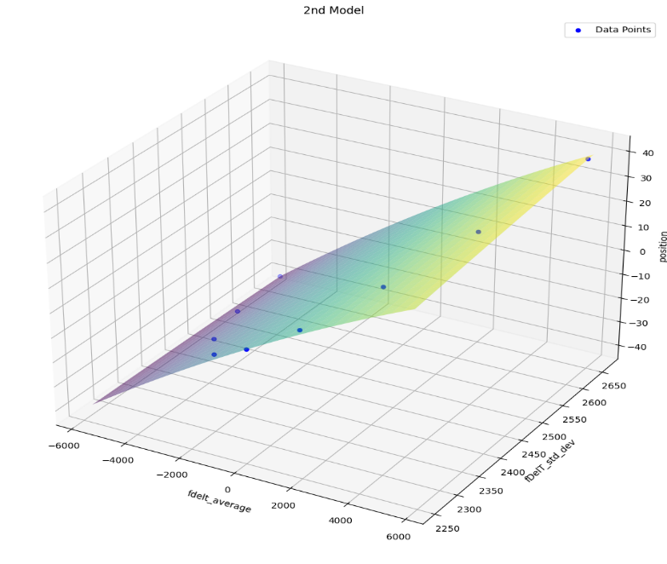

**Conclusion:** The ML model achieved an accuracy of 99.0778%, contrasting with (to be written)% of conventional method. Its focus on the 'time' feature, unlike conventional methods that also account for charge, allows for streamlined handling of large datasets and minimal storage requirements.

**Reference:**

// to write about Detector Setups.

Scikit-learn Developers. (2021). Scikit-learn [Software used]. Available at: <https://scikit-learn.org/stable/>

Uproot: A Pure-Python ROOT file reader [Software library]. Retrieved from https://github.com/scikit-hep/uproot