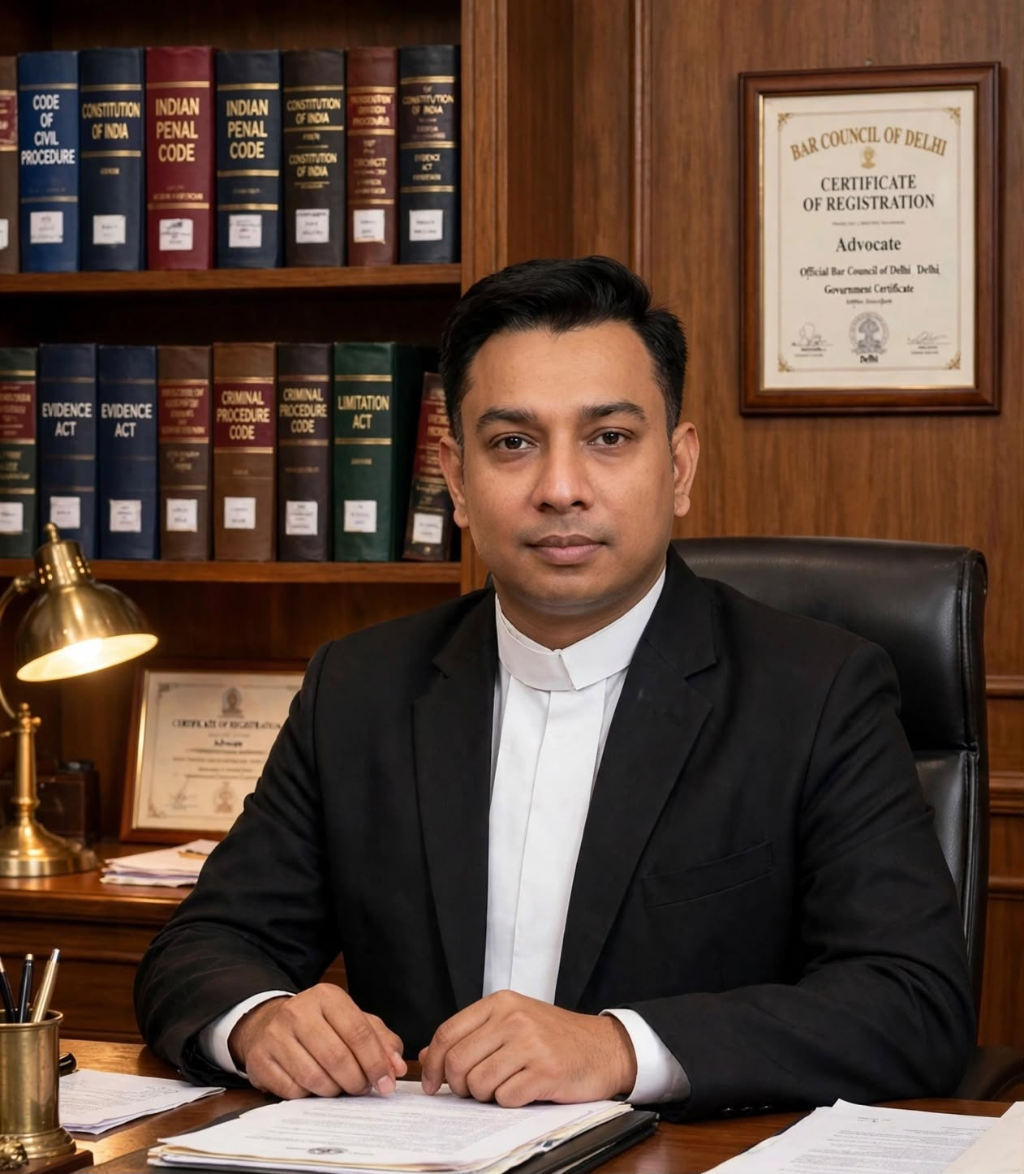

Profile Summary

Advocate with 10 years of litigation experience representing clients before the Supreme Court, Delhi High Court, ITAT, GSTAT and various tribunals.

Specialized in civil, commercial, arbitration, and criminal law, with proven expertise in high-stakes disputes involving real estate, contracts, insolvency, and regulatory matters. Empaneled with prestigious government bodies and known for delivering strategic legal solutions with integrity and efficiency.

EDUCATION

- LL.B. – Institute of Law and Research, Maharshi Dayanand University (2013–2016)

- B.Com. –University of Delhi (2009–2012)
- The Institute of Cost Accountants of India (ICMAI)- (2009-2013)

PROFESSIONAL EXPERIENCE

Accomplished Taxation Professional with extensive expertise in Direct & Indirect Taxation, Regulatory Compliance, and Financial Advisory. Specializing in Income Tax, GST, VAT, and Corporate Accounting, I lead tax strategy and compliance for individuals, SMEs, and growing enterprises across India.

With a client-centric approach and in-depth knowledge of Indian Tax Laws, I ensure timely compliance, optimized tax planning, and risk-free financial operations for 100+ clients.

Core Competencies:
- Direct Taxation & ITR Management (ITR 1-7)
- Indirect Taxation (GST, VAT, Service Tax)
- Statutory Compliance & Regulatory Filings
- Accounting, Auditing & Financial Reporting
- Business Incorporation & Corporate Advisory
- TDS, PF/ESI, MSME & Project Finance

Professional Philosophy:
“Compliance is not just a legal requirement; it’s a foundation for business growth. My role is to make taxation simple, transparent and strategic for every client.”

LinkedIn Headline (Professional):
Head of Taxation | Income Tax & GST Expert | Financial Compliance Advisor | Helping Businesses Save Tax & Stay Compliant | Pan-India Online Consultancy
PANEL ENGAGEMENTS
- North Delhi Municipal Corporation (2017–2018)
- Handled matters relating to civic services, urban bodies, and regulatory compliance.

Website - About Section (Corporate Tone):
- Mr. Sandeep Kaushik - Head, Taxation & Compliance
- Mr. Sandeep Kaushik heads the Taxation & Compliance division at Kaushik Tax & Associates. With a strong command over Income Tax Act, GST Law, and Accounting Standards, he oversees all tax-related advisory and filing operations.
Under his leadership, the firm provides end-to-end financial solutions with accuracy, confidentiality, and commitment. His expertise is trusted by traders, startups, professionals and established businesses in UP & NCR.

ACADEMIC & SOCIAL CONTRIBUTIONS

- Actively engaged in pro bono litigation and NGO collaborations for social causes.

MEMBERSHIPS

- Member, Supreme Court Bar Association.
- Member, Delhi High Court Bar Association, New Delhi.
- Member, Saket Bar Association, New Delhi.

PERSONAL DETAILS

Date of Birth : 22nd September, 1990

Nationality : Indian

