# Cookies

# Overview

Points: 40

Category: Web Exploitation

**Appearance : picoCTF 2021**

# Description

Who doesn't love cookies? Try to figure out the best one. <http://mercury.picoctf.net:6418/>

## Hints

(None)

# Approach

The link goes to something that looks like this:

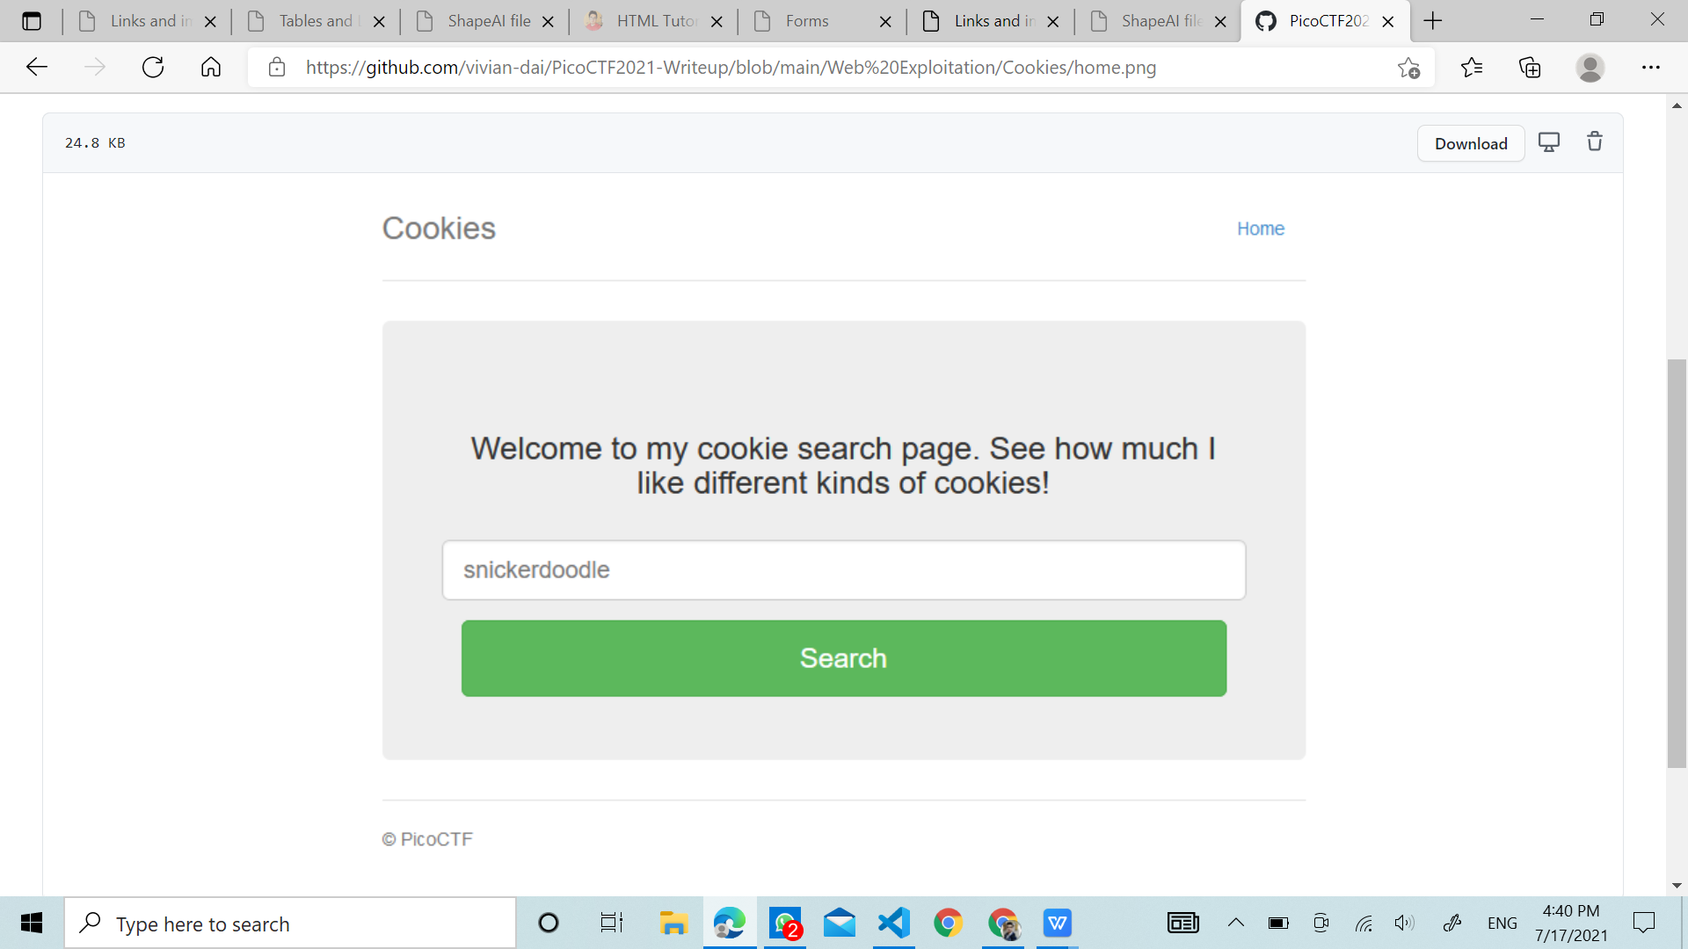

I typed in "snickerdoodle" and entered it. I love snickerdoodle cookies!

Ctrl + Shift + I will reveal some things, navigate to storage, then find cookies storage.

I noticed there's a grand total of one cookie with a value of 0. I changed the value to 1 and refreshed the page. I love chocolate chip cookies!

I kept increasing the numeric value of value by 1 until at 18, it gave the flag:

# Flag

picoCTF{3v3ry1_l0v3s_c00k135_bb3b3535}

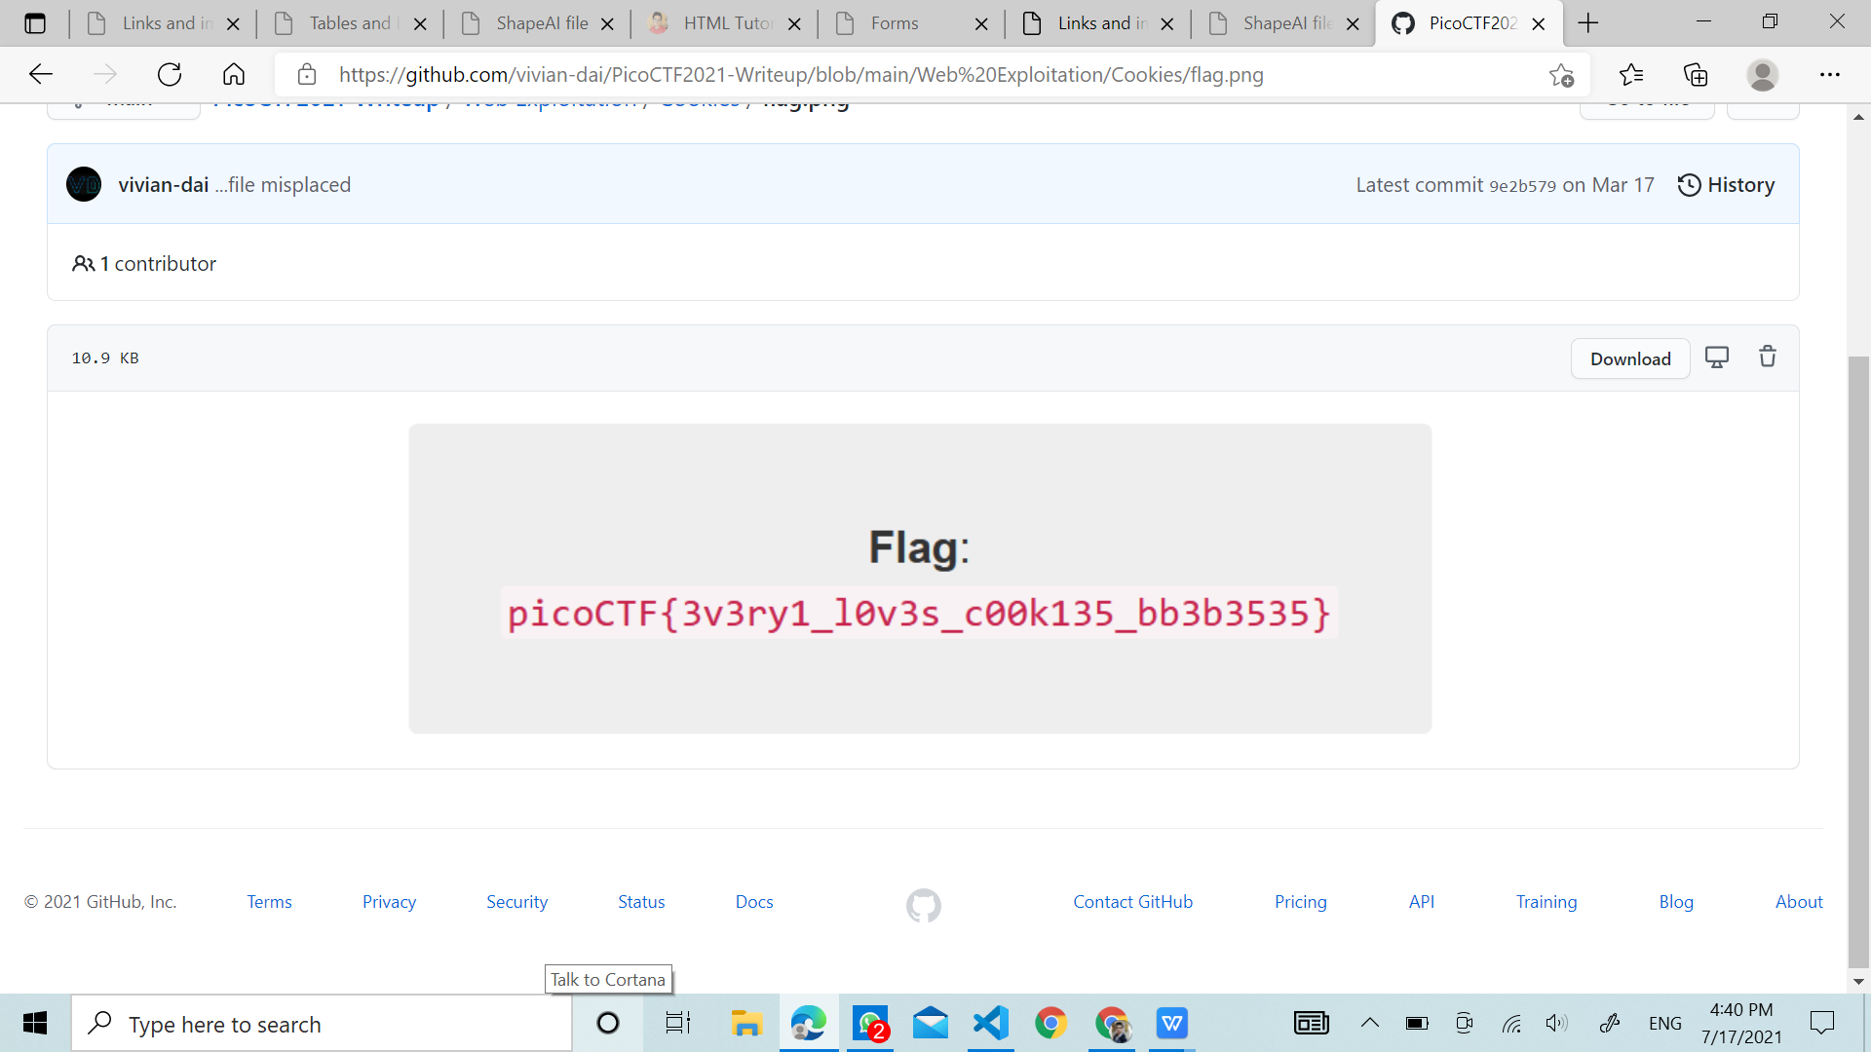

GAURAV JHA