# Logon

# Overview

Points: 100

Category: All Categories

**Appearance : picoCTF 2019**

# Description

The factory is hiding things from all of its users. Can you login as Joe and find what they've been looking at?

<https://jupiter.challenges.picoctf.org/problem/13594/>

## Hints

1.Hmm it doesn't seem to check anyone's password, except for Joe's?

# Approach

The link goes to something that looks like this:

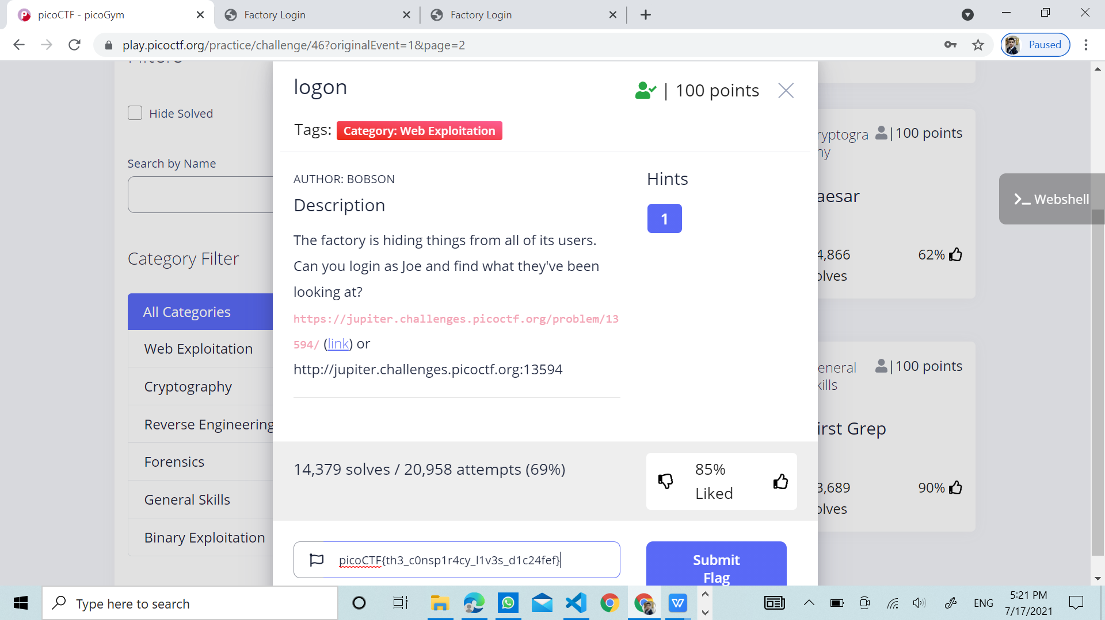

## Solution

Checking out Burp Suite, one of it's main abilities it to intercept and modify requests. <https://jupiter.challenges.picoctf.org/problem/13594/>

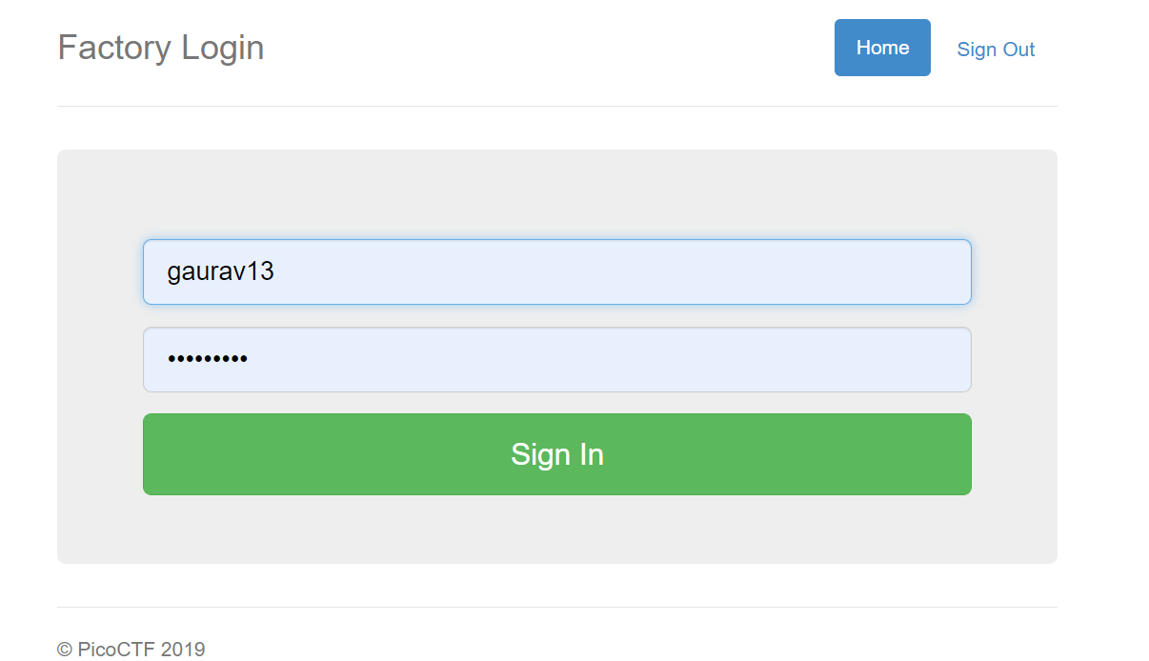

Now by inspecting the webpage, we get something that looks like :

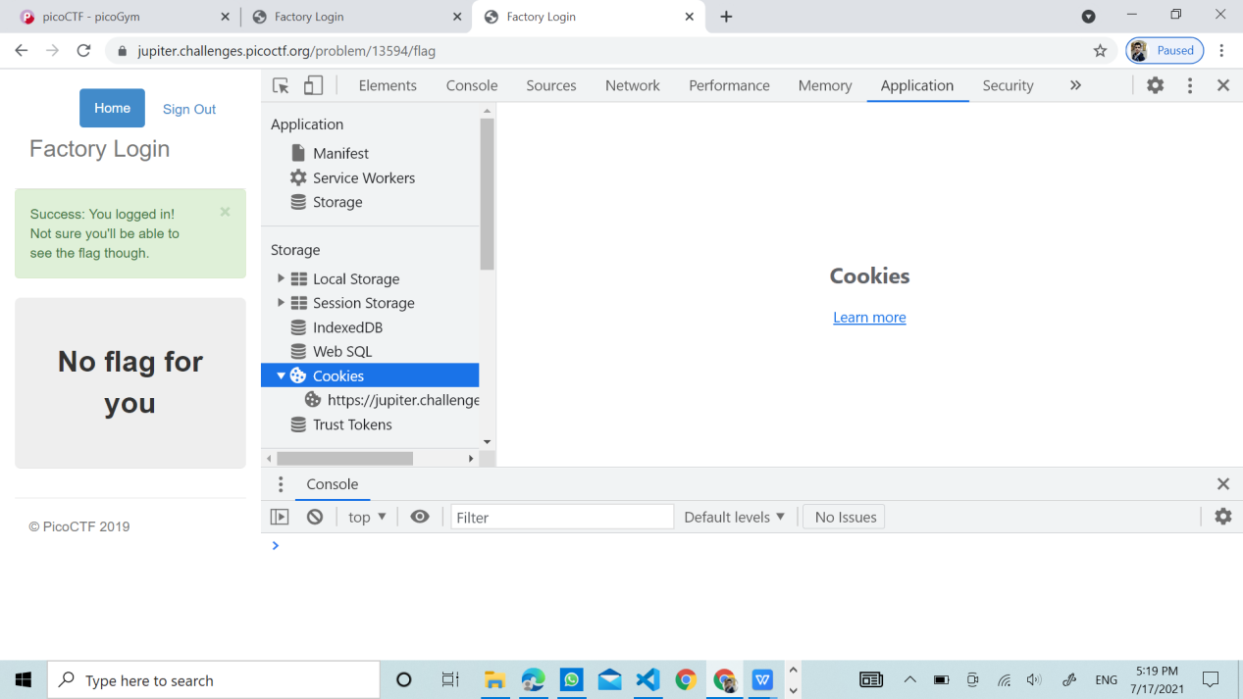



# Flag

picoCTF{th3_c0nsp1r4cy_l1v3s_d1c24fef}

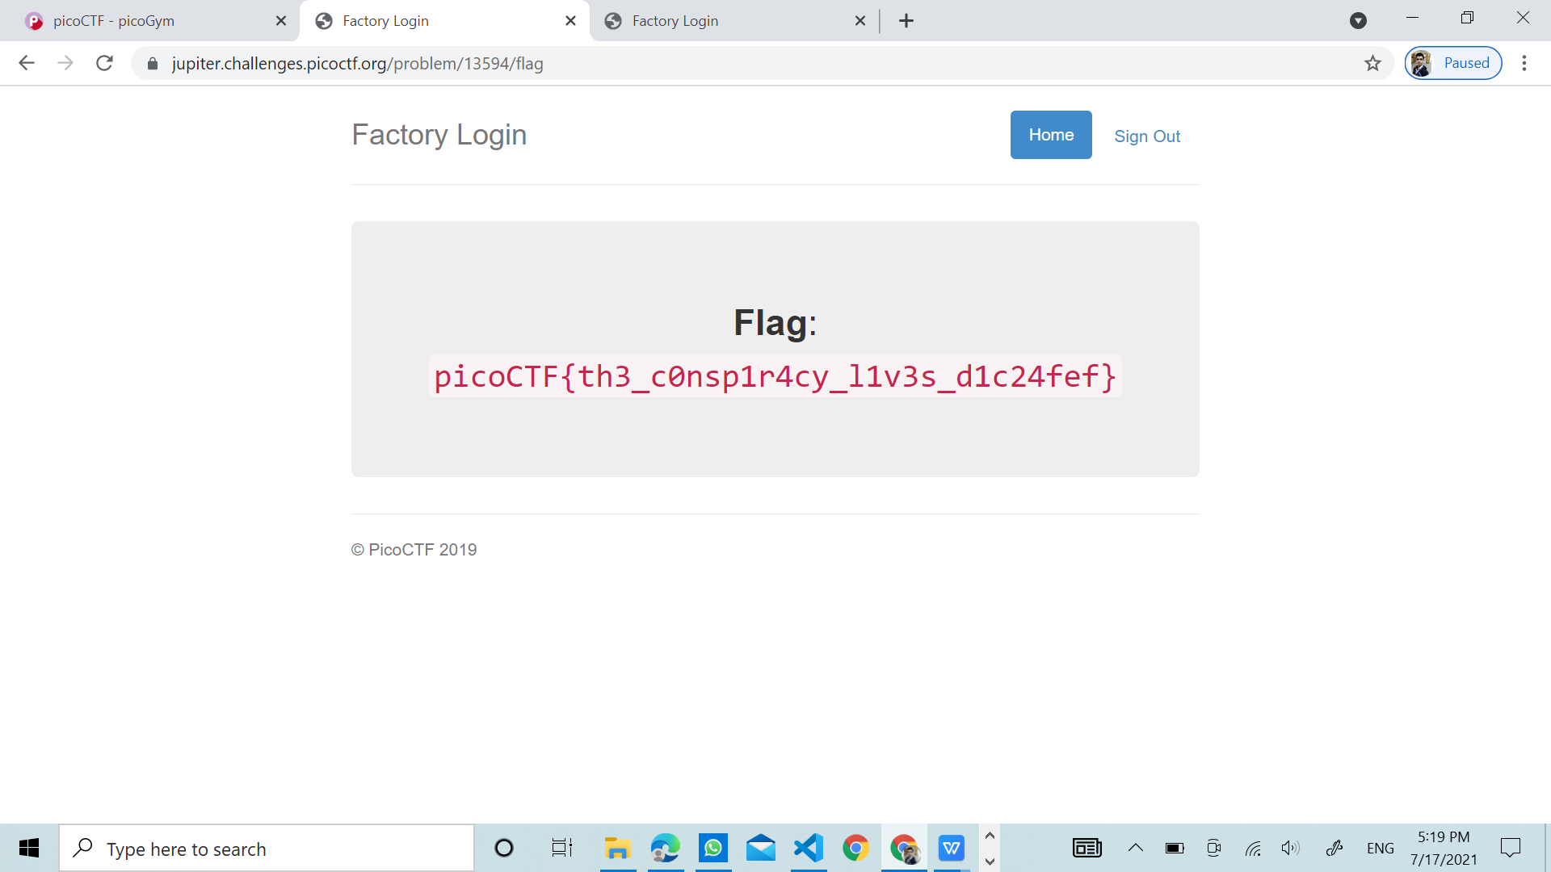

GAURAV JHA