Technical Report
Tourism Demand Prediction & Resource Allocation
NeoAI Tech — AI/ML Internship Assessment
Prepared by: Gaurav Avdhesh Jha
Mail: gauravjha9878@gmail.com
College: Pillai College of Engineering
Branch: Electronic and Computer Science
Dataset: Tourism Economic Resource Allocation Dataset (15,000 records)

1. Executive Summary
This report documents the complete machine learning workflow undertaken to help tourism authorities predict tourism demand levels and recommend appropriate resource allocation strategies. Two classification models were built, evaluated, and compared, with the best-performing model selected for each task based on weighted F1 score.
Task | Target Variable | Best Model | F1 Score
Tourism Demand Prediction | demand_category | XGBoost | 0.9451
Resource Allocation Recommendation | resource_allocation_decision | XGBoost | 0.9860

2. Dataset Overview
- Shape: 15,000 records × 52 columns
- Missing values: 0 (clean dataset)
- Duplicate rows: 0
- Categorical columns: 9 (7 features + 2 targets)
- Target 1 — demand_category: Low, Moderate, High, Very_High
- Target 2 — resource_allocation_decision: 8 classes including Risk_Control_Allocation, Infrastructure_Focused, Balanced_Allocation, etc.
Figure 1: Demand Category Class Distribution
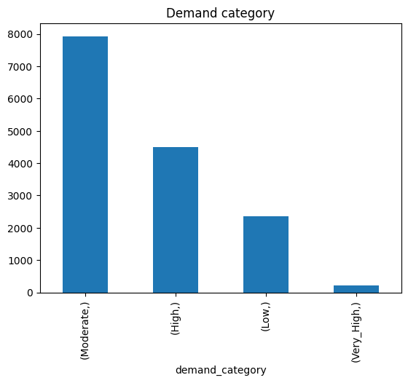

3. Task 1 — Data Preprocessing & Feature Engineering

3.1 Data Cleaning
The dataset was found to be clean with zero missing values and zero duplicate records, requiring no imputation or row removal.

3.2 Leakage Prevention
Four columns were removed prior to modeling to prevent data leakage — these either directly encode the target variable or represent information unavailable at prediction time:
- record_id — row identifier with no predictive value
- tourism_demand_score — composite score that demand_category is derived from
- resource_pressure_score — composite score that resource_allocation_decision is derived from
- public_management_action — a post-decision outcome label

3.3 Categorical Encoding
Seven categorical columns (province, tourism_city, destination_type, season, weather_condition, tourism_event_type, transport_mode_priority) were encoded using Label Encoding rather than One-Hot Encoding. This decision was made because several columns have high cardinality (province and tourism_city each have 20 unique values), and one-hot encoding would have expanded the feature space excessively. Since the modeling approach relies on tree-based algorithms (Decision Tree, Random Forest, XGBoost), which split on values without assuming ordinal relationships, label encoding is an appropriate and efficient choice.

3.4 Feature Engineering
Four new features were engineered to capture relationships not directly present in the raw columns:
Feature | Formula | Purpose
revenue_per_tourist | tourism_revenue_yuan / tourist_arrivals | Revenue intensity per visitor
international_ratio | international_tourists / tourist_arrivals | Market diversification
infra_score | avg(infrastructure, transport, accommodation) | Holistic infra quality
revenue_efficiency | tourism_revenue_yuan / operational_cost_yuan | Operational profitability

3.5 Train/Test Split
Data was split 80/20 into training (12,000 rows) and testing (3,000 rows) sets using stratified sampling on demand_category, ensuring proportional class representation across both sets given the class imbalance (Very_High accounts for only ~1.4% of records).

4. Task 2 — Tourism Demand Prediction
Four classification models were trained and compared on the demand_category target:
Model | Accuracy | Precision | Recall | F1 Score
Baseline (Most Frequent) | 0.5287 | 0.2795 | 0.5287 | 0.3657
Decision Tree | 0.8210 | 0.8192 | 0.8210 | 0.8194
Random Forest | 0.8587 | 0.8515 | 0.8587 | 0.8501
XGBoost ✓ Best | 0.9457 | 0.9459 | 0.9457 | 0.9451

XGBoost was selected as the best-performing model with an F1 score of 0.9451, significantly outperforming the baseline (+158% relative improvement) and the other candidates. Gradient boosting's sequential error-correction mechanism and native handling of class imbalance make it well-suited for this multi-class problem, particularly for the minority Very_High class.
Figure 2: Top 15 Feature Importances — Demand Prediction Model
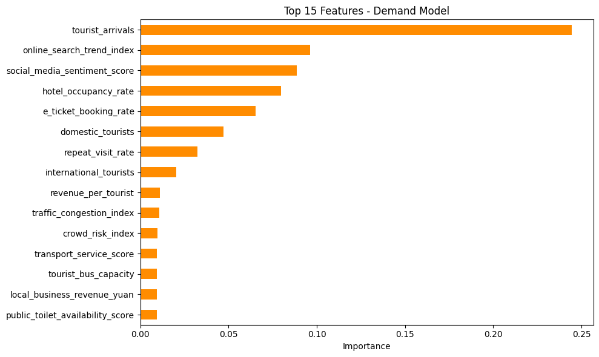

5. Task 3 — Resource Allocation Recommendation
The same four-model comparison was repeated for the resource_allocation_decision target (8 classes):
Model | Accuracy | Precision | Recall | F1 Score
Baseline (Most Frequent) | 0.3853 | 0.1485 | 0.3853 | 0.2144
Decision Tree | 0.9643 | 0.9667 | 0.9643 | 0.9653
Random Forest | 0.9817 | 0.9812 | 0.9817 | 0.9809
XGBoost ✓ Best | 0.9863 | 0.9861 | 0.9863 | 0.9860

XGBoost again achieved the best performance with an F1 score of 0.9860. The high baseline-to-best-model gap (+361% relative improvement) reflects that resource allocation decisions follow strong underlying patterns in the data that the model is able to learn effectively.
Figure 3: Top 15 Feature Importances — Resource Allocation Model
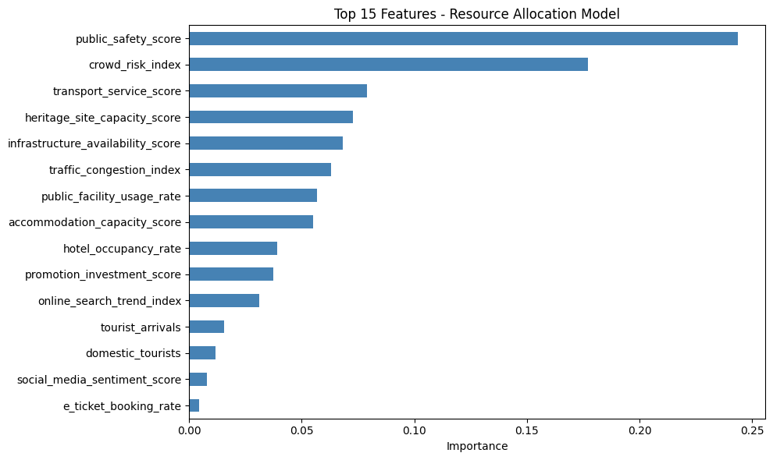

6. Task 4 — AI Insights Report

Q1. What factors most influence tourism demand?
tourist_arrivals is the single strongest predictor (importance 0.245), followed by digital engagement signals — online_search_trend_index (0.096) and social_media_sentiment_score (0.089). hotel_occupancy_rate (0.080) and e_ticket_booking_rate (0.065) also rank highly. This indicates that tourism demand is largely observable in advance through digital footprints (search trends, sentiment, booking activity) before it materializes physically, giving authorities a window for proactive planning.

Q2. What factors most influence resource allocation decisions?
public_safety_score (0.244) and crowd_risk_index (0.177) together account for over 42% of the model's decision-making, making safety and crowd risk the dominant drivers. transport_service_score, heritage_site_capacity_score, and infrastructure_availability_score form a secondary tier of influence. This pattern reflects sound policy logic: deteriorating safety or rising crowd risk triggers Risk_Control_Allocation, while weak transport or facility scores trigger targeted infrastructure investment.

Q3. Which variables have the strongest impact on tourism revenue?
economic_impact_score shows the strongest correlation with tourism_revenue_yuan (r = 0.714). Notably, two engineered features — revenue_efficiency (r = 0.242) and revenue_per_tourist (r = 0.242) — also rank highly, validating that the custom feature engineering captured genuine revenue-related signal. Most raw features show weak linear correlation individually, suggesting that revenue results from non-linear interactions across multiple variables rather than any single dominant factor — which is precisely why machine learning models outperform simple linear analysis here.

Q4. How can tourism authorities reduce crowd risk while maintaining revenue?
The correlation between crowd_risk_index and tourism_revenue_yuan is effectively zero (r = 0.0032), indicating the two are statistically independent. This is a significant policy insight: authorities can implement strict crowd-control measures — staggered entry timings, visitor capacity limits, and real-time monitoring — without risking revenue loss. Since revenue is driven primarily by economic_impact_score and tourist spending efficiency rather than raw crowd volume, smart ticketing systems and off-peak promotional pricing can simultaneously reduce risk and protect revenue.

Q5. What recommendations would you provide for low-demand tourism regions?
Comparing low-demand and high-demand regions reveals a striking pattern: tourist arrivals differ by 4x (22,195 vs 90,491), and online search trend index differs by nearly 2x (35.6 vs 62.9), and social media sentiment also lags meaningfully (0.43 vs 0.65). However, promotion_investment_score is nearly identical between the two groups (54.4 vs 55.1) — meaning the marketing budget itself is not the bottleneck. This points to poor marketing effectiveness rather than insufficient spend. Recommendations: redirect promotion budgets toward targeted digital campaigns (short-video platforms, influencer partnerships), modernize e-ticket booking infrastructure to reduce access friction, and invest in proactive online reputation management to improve social sentiment scores.

7. Conclusion
- XGBoost was the optimal model for both classification tasks, achieving F1 scores of 0.945 (demand) and 0.986 (resource allocation).
- Feature engineering added measurable value — revenue_efficiency and revenue_per_tourist both ranked among the top revenue-correlated variables.
- Leakage prevention (removing pre-computed composite scores) ensures the models generalize to genuinely unseen, real-world inputs.
- The near-zero correlation between crowd risk and revenue is a key actionable insight for tourism authorities seeking to balance visitor safety with economic outcomes.
- Low-demand regions suffer primarily from poor digital visibility, not insufficient promotional spend — suggesting a strategy shift rather than a budget increase.

