**Association:**

So the first kind of relationship we will talk about its called association. It simply denotes a relationship between two or more classes.

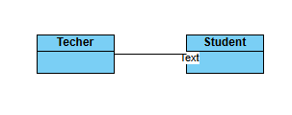

Ex: A teacher can exist independently out of students. And students can also exist independently without the teachers as well.

**Aggregation: (**kind of a weak form of association)

Association is of two types a weak association is called as aggregation. So aggregation has is a weak relationship

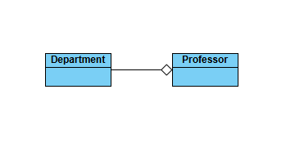

Ex:

One class contains objects of another class. However, the contained objects can exist independently of the container object.

The professors will belong to departments. So each professor has a name, but we don't have information about department here. But the department class is going to contain multiple professors means list of professors.

It’s **has a relationship** likedepartment has professors.

But now can professor identities exist if even if there is no department the answer is yes. Professors can still exist independently. Hence this kind of a relationship is called as aggregation.

**Composition :** ( kind of a weak form of association)

So composition is a strong has a relationship where one class owns objects of another class.If the container object is destroyed the contained objects are destroyed as well.

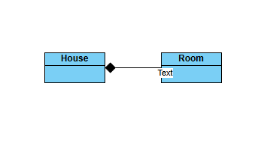

I have a house and this house has rooms. house is one class and room is another class.This room cannot exist independently outside the house.

So if house is destroyed, the room must be destroyed, So in this case, what we can say is there is a composition relationship between the two classes.

**Aggregation and composition:**

EX:

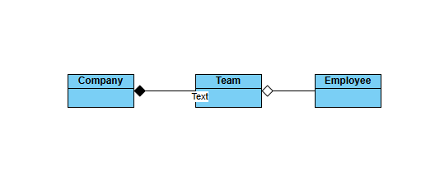

The company has teams and teams have employees.Now what kind of relationships do you think will exist between Company and team and team and employee.

the company owns the team right.So the teams cannot exist outside the company.So this is going to be a composition kind of a relationship and employees

are part of a team but it's a weak association because the employee can still exist without team.

**Inheritance:**

Dog is a animal, Dog is a type of animal, So if you have a animal class you can say fine, it has a dog class which is related to with it.

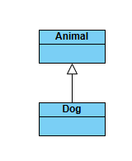

Dependency:

One class relies on another class in some way, often through method parameters,return types, or temporary associations.

Ex:

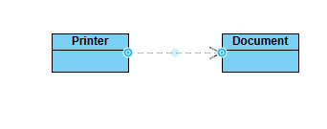

Document class in which the document has a content and a constructor and a getter method.Another class is a printer class.So the printer class

is responsible for let's say printing the documents.So in this case there is a relationship through a method parameter.

The document object is used as a method parameter inside the print method of the printer class.So,there is a dependency relationship right.

the printer class depends upon the document class.

So there is no document is not a printer.Printer does not have a document.But it still depends on the document.