### Project Report on

# Online Movie Ticket Booking System- Infytainment



## By

**(Gaurav Kumar, 201500407)**

**(Priyanka Prasad, 201500220)**

**(Pushp Vashisht, 201500147)**

**(Sakshi Singh, 201500046)**

**(Sandeep Shankar, 201500271)**

*In partial fulfillment of requirements for the award of degree in*

Bachelor of Technology in Computer Science and Engineering

(2019)

\

##### Under the Project Guidance of

**(Mr. Arpan Nema, (System Engineer))**

## DEPARTMENT OF COMPUTER SCIENCE AND ENGINEERING

## SIKKIM MANIPAL INSTITUTE OF TECHNOLOGY

## (A constituent college of Sikkim Manipal University)

MAJITAR, RANGPO, EAST SIKKIM – 737136

### Project Report on

# Online Movie Ticket Booking System-Infytainment



## By

## (Gaurav Kumar, 201500407)

**(Priyanka Prasad, 201500220)**

**(Pushp Vashisht, 201500147)**

**(Sakshi Singh, 201500046)**

**(Sandeep Shankar, 201500271)**

*In partial fulfillment of requirements for the award of degree in*

Bachelor of Technology in Computer Science and Engineering

(2019)



##### Under the Project Guidance of

**(Mr. Arpan Nema, (System Engineer))**

## DEPARTMENT OF COMPUTER SCIENCE AND ENGINEERING

## SIKKIM MANIPAL INSTITUTE OF TECHNOLOGY

## (A constituent college of Sikkim Manipal University)

MAJITAR, RANGPO, EAST SIKKIM – 737136

**Project Completion Certificate**

This is to certify that the below mentioned students of Sikkim Manipal Institute of Technology have worked under my supervision and guidance from **28th Jan 2019 to 20th May 2019** and have successfully completed the project entitled **“Online Movie Ticket Booking System”** in partial fulfillment of the requirements for the award of Bachelor of Technology in Computer Science and Engineering.

|  |  |  |
| --- | --- | --- |
| University Registration No | Name of Student(s) | Course |
| 201500407 | Gaurav Kumar | CSE |
| 201500220 | Priyanka Prasad | CSE |
| 201500147 | Pushp Vashisht | CSE |
| 201500046 | Sakshi Singh | CSE |
| 201500271 | Sandeep Shankar | CSE |

Arpan Nema,

Systems Engineer,

Infosys Limited, Mysore

**PROJECT REVIEW CERTIFICATE**

This is to certify that the work recorded in this project report entitled **“Online Movie Ticket Booking System”** has been carried out **Gaurav Kumar (Reg 201500407), Priyanka Prasad (Reg 201500220), Pushp Vashisht (Reg 201500147), Sakshi Singh (Reg 201500046), Sandeep Shankar (Reg 201500271)** of Computer Science & Engineering Department of Sikkim Manipal Institute of Technology in partial fulfillment of the requirements for the award of Bachelor of Technology in Computer Science and Engineering. This report has been duly reviewed by the undersigned and recommended for final submission for Major Project Viva Examination.

Gide name,

Assistant Professor I,

Department of Computer Science & Engineering

Sikkim Manipal Institute of Technology

Majitar, East Sikkim – 737136.

**CERTIFICATE OF ACCEPTANCE**

This is to certify that the below mentioned students of Computer Science & Engineering Department of Sikkim Manipal Institute of Technology (SMIT) have worked under the supervision of **Mr. Arpan Nema** of **Infosys Limited, Mysore** from 28th Jan 2019 to 20th May 2019 on the project entitled **“Online Movie Ticket Booking System”.**

The project is hereby accepted by the Department of Computer Science & Engineering, SMIT in partial fulfillment of the requirements for the award of Bachelor of Technology in Computer Science and Engineering.

|  |  |  |
| --- | --- | --- |
| University Registration No | Name of Student(s) | Course |
| 201500407 | Gaurav Kumar | CSE |
| 201500220 | Priyanka Prasad | CSE |
| 201500147 | Pushp Vashisht | CSE |
| 201500046 | Sakshi Singh | CSE |
| 201500271 | Sandeep Shankar | CSE |

Dr. Kalpana Sharma

Professor & HOD

Computer Science & Engineering Department

Sikkim Manipal Institute of Technology

Majhitar, Sikkim - 737136

**DECLARATION**

We the undersigned, hereby declare that the work recorded in this project report entitled **“Online Movie Ticket Booking System”** in partial fulfillment for the requirements of award of B. Tech in Computer Science & Engineering from Sikkim Manipal Institute of Technology (A constituent college of Sikkim Manipal University) is a faithful and bonafide project work carried out at **MYSORE** under the supervision and guidance of **Mr. ARPAN NEMA** of **Infosys Limited, Mysore**.

The results of this investigation reported in this project have so far not been reported for any other Degree / Diploma or any other Technical forum.

The assistance and help received during the course of the investigation have been duly acknowledged.

**Gaurav Kumar (Reg 201500407) …………………………….**

**Priyanka Prasad (Reg 201500220) ……………………**

**Pushp Vashisht (Reg 201500147) ………………….**

**Sakshi Singh (Reg 201500046) ……………………….**

**Sandeep Shankar (Reg 201500271) ………………………….**

**ACKNOWLEDGEMENT**

The success and final outcome of this project require a lot of guidance and assistance from many people and I am extremely privileged to have got this all along the completion of my project. All that I have done is only due to such supervision and assistance and I would not forget to thank them.

I am profoundly grateful to **Mr. Arpan Nema**, System Engineer, Infosys, Mysore my external project guide for his valuable guidance, help, suggestions and assessment on his busy schedule.

I owe my deep gratitude to my project guide **Mr. Suman Kalyan Kar**, who took keen interest on my project work and guided me till the completion of my project work by giving necessary information.

I express my gratitude to **Dr. Kalpana Sharma**, Professor and HOD Computer Science Engineering Department for her support and guidance.

I heartily thank the project coordinators for their guidance and suggestions during project work.

I am thankful and fortunate enough to get constant encouragement, support and guidance from all teaching staffs of CSE, SMIT which helped in successfully completing the project work.

Furthermore, I would like to thank my colleagues in developing the project and people who have willingly helped me out of their abilities.

**Gaurav Kumar (Reg 201500407) …………………………….**

**Priyanka Prasad (Reg 201500220) ……………………**

**Pushp Vashisht (Reg 201500147) ………………….**

**Sakshi Singh (Reg 201500046) ……………………….**

**Sandeep Shankar (Reg 201500271) ………………………….**

**DOCUMENT CONTROL SHEET**

|  |  |  |
| --- | --- | --- |
| 1 | Report No | CSE/Major Project/ External /B.Tech/group no/2019 |
| 2 | Title of the Report | Online Movie Ticket Booking System |
| 3 | Type of Report | Technical |
| 4 | Author(s) | Gaurav Kumar  Priyanka Prasad  Pushp Vashisht  Sakshi Singh  Sandeep Shankar |
| 5 | Organizing Unit | INFOSYS LIMITED,MYSORE |
| 6 | Language of the Document | English |
| 7 | Abstract | The purpose of our project is to automate the existing manual system and creating a database consisting the details for booking the movie tickets. |
| 8 | Security Classification | Restricted |
| 9 | Distribution Statement | Restricted |

**LIST OF CONTENTS**

|  |  |  |
| --- | --- | --- |
| **Chapter No.** | **Title** | **Page No.** |
| 0. | Abstract |  |
| 1. | Introduction | 1-13 |
|  | 1.1 General Overview | 1-3 |
|  | 1.2 Literature Survey | 4-5 |
|  | 1.3 Problem Definition | 6 |
|  | 1.4 Analysis of the problem and the SRS | 7-9 |
|  | 1.5 Solution Strategy | 10-11 |
|  | 1.6 Preliminary user’s manual | 12 |
|  | 1.7 Organization of the report | 13 |
| 2. | Design Strategy | 14-16 |
|  | 2.1 Table Design |  |
| 3. | Detailed Test Plan | 17-18 |
| 4. | Implementation Details | 19-21 |
| 5. | Results and Discussions | 22-30 |
| 6. | Summary and Conclusion | 31-33 |
|  | 6.1 Summary of Achievements | 31 |
|  | 6.2 Difficulties Encountered | 32 |
|  | 6.3 Limitation of the Project | 32 |
|  | 6.4 Future Scope | 32 |
|  | 6.5 Conclusion | 33 |
| 7. | Gantt Chart | 34 |
| 8. | References | 35 |

**LIST OF FIGURES**

|  |  |  |
| --- | --- | --- |
| **Figure No** | **Figure Name** | **Page No.** |
|  |  |  |
|  | Entity Relationship Diagram |  |
|  | Use Case |  |
|  | Activity Diagram(Admin) |  |
|  | Activity Diagram(User) |  |
|  |  |  |
|  |  |  |
|  |  |  |
|  |  |  |
|  |  |  |
|  |  |  |
|  |  |  |
|  |  |  |
|  |  |  |
|  |  |  |
|  |  |  |
|  |  |  |
|  |  |  |
|  |  |  |
|  |  |  |

**LIST OF TABLES**

|  |  |  |
| --- | --- | --- |
| **Table No** | **Table Name** | **Page No.** |
| 1.1 | Literature survey paper details |  |
| 2.1 | Movie Table |  |
| 2.2 | Show Timings Table |  |
| 2.3 | Screens Table |  |
| 2.4 | Seats Table |  |
| 2.5 | Bookings Table |  |
| 3.1 | Detailed Test Plan |  |
| 7.1 | Gantt Chart |  |

**ABOUT COMPANY**

**Infosys Limited** is an Indian multinational corporation that provides business consulting [information technology](https://en.wikipedia.org/wiki/Information_technology) and [outsourcing](https://en.wikipedia.org/wiki/Outsourcing) services. It has its headquarters in [Bangalore, Karnataka, India](https://en.wikipedia.org/wiki/Bangalore).

Infosys is the second-largest Indian IT company by 2017 revenues and 596th largest public company in the world based on revenue on September 28, 2018, its [market capitalization](https://en.wikipedia.org/wiki/Market_capitalisation) was $44.32 billion. The [credit rating](https://en.wikipedia.org/wiki/Credit_rating) of the company is A− (rating by [Standard & Poor's](https://en.wikipedia.org/wiki/Standard_%26_Poor%27s))

Infosys was established by seven engineers in [Pune](https://en.wikipedia.org/wiki/Pune), [Maharashtra](https://en.wikipedia.org/wiki/Maharashtra), [India](https://en.wikipedia.org/wiki/India) with an initial capital of $250 in 1981. It was registered as Infosys Consultants Private Limited on 2 July 1981. In 1983, it relocated its office to Bangalore, Karnataka, India.

**Revenue growth**: Its annual revenue reached US$100 million in 1999, US$1 billion in 2004 and US$10 billion in 2017.

Infosys provides software development, maintenance and independent validation services to companies in finance, insurance, manufacturing and other domains.

One of its known products is [Finacle](https://en.wikipedia.org/wiki/Finacle) which is a universal banking solution with various modules for retail & corporate banking.

Its key products and services are:

* NIA – Next Generation Integrated AI Platform (formerly known as Mana)
* [Infosys Consulting](https://en.wikipedia.org/wiki/Infosys_Consulting) – a global management consulting service
* Infosys Information Platform (IIP) – Analytics platform
* [EdgeVerve Systems](https://en.wikipedia.org/wiki/EdgeVerve_Systems) which includes [Finacle](https://en.wikipedia.org/wiki/Finacle), a global banking platform
* [Panaya](https://en.wikipedia.org/wiki/Panaya) Cloud Suite
* Skava

Infosys had a total of 225,501 employees at the end of December 2018.Its workforce consists of employees representing 129 nationalities. In 2016, 89% of its employees were based in India. Out of its total workforce, 79% are software professionals, 16% are working in its BPM arm and remaining 5% work for support and sales.

During financial year 2018, Infosys received 1,540,498 applications from prospective employees, interviewed 143,872 candidates and had a gross addition of 53,943 employees, a 4% hiring rate. These numbers do not include its subsidiaries.

The attrition rate of Infosys Ltd., excluding its subsidiaries, for financial year 2018 was 16.4%.

Infosys is a global leader in next-generation digital services and consulting. We enable clients in 45 countries to navigate their digital transformation. With over three decades of experience in managing the systems and workings of global enterprises, we expertly steer our clients through their digital journey. We do it by enabling the enterprise with an AI-powered core that helps prioritize the execution of change. We also empower the business with agile digital at scale to deliver unprecedented levels of performance and customer delight.

We recognize the importance of nurturing relationships that reflect our culture of unwavering ethics and mutual respect. It’ll come as no surprise, then, that 98.2 percent (Q2 FY19) of our revenues come from existing clients. Infosys has a growing global presence with 217,700 employees. Globally, we have 82 sales and marketing offices and 123 development centers as on March 31, 2018.

At Infosys, we believe our responsibilities extend beyond business. That is why we established the Infosys Foundation – to provide assistance to some of the more socially and economically depressed sectors of the communities in which we work. And that is why we behave ethically and honestly in all our interactions – with our clients, our partners, and our employees.

**ABSTRACT**

This project is aimed at developing an online ticket reservation system for Multiplex. The Ticket Reservation System is an Internet based application that can be accessed by the authenticated user of Infosys. This application will automate the reservation of tickets.

User is directly logged in to the system as it is windows authenticated and the amount will be deducted from the salary.

Watching movies with family and friends in theaters is one of the best medium of entertainment after having a hectic schedule. But all this excitement vanishes after standing in hours in long queues to get tickets booked. The website provides complete information regarding currently running movies on all the screens with details of show timings, available seats and fare charges. Ticket reservations can be cancelled if needed.

Our online tickets reservation system is one of the best opportunities for those who cannot afford enough time to get their tickets reserved standing in long queues.

1. **INTRODUCTION**
   1. **General Overview: -**

Cinema-going is one of the most popular out-of-home cultural activities, affecting a serious of social, economic and cultural phenomena in modern societies. Cinemas are considered to be an integral part of cities and they contribute to the definition of a local geography and identity. They also contribute to the preservation of the collective memory, since they constitute a significant social and cultural practice linked to a specific place, which acts as a common reference or landmark for many individuals. Through this project we present a comprehensive solution for ticket booking in multiplexes. Theater management system, an online ticket selling software that is easy to understand, easy to use and offers the simplicity of fast point-and-click service to the infoscion. Theater management controls all back-end functionalities like, movie details, ticket rate and show time, saved in a database, etc.

Infytainment is a web application for online ticket booking of movies. This application will be used by admin for adding and updating movies and show timings, etc. This application will be used by users for viewing, booking of movie shows, giving ratings, comments etc. The main aim of the application is to help users for booking movies tickets easily without hassle of login as it will use windows authentication login.

The Ticket Reservation System is an Internet based application that can be accessed by the authenticated user of Infosys. This application will automate the reservation of tickets.

Agile methodology is being used for the project. Agile software development is an approach to software development under which requirements and solutions evolve through the collaborative effort of self-organizing and cross-functional teams and their customer/end user. It advocates adaptive planning, evolutionary development, early delivery, and continual improvement, and it encourages rapid and flexible response to change.

The proposed system consists of the following goals:

● To automate the existing manual system.

● To reduce the queue for ticket booking.

●To develop a scalable system.

●To be highly available.

**Terminologies used:**

The involved technologies that are used to build the proposed model are listed below: -

●HTML

●ANGULAR 6

●MYSQL

●CSS

●JAVASCRIPT

●NODE.JS

**HTML**

* HTML stands for Hyper Text Mark-up Language.
* HTML describes the structure of Web pages using mark-up
* HTML elements are the building blocks of HTML pages
* HTML elements are represented by tags
* HTML tags label pieces of content such as "heading", "paragraph", "table", and so on
* Browsers do not display the HTML tags, but use them to render the content of the page

**ANGULAR 6**

* **Angular** is a perfect framework for developing Single Page Applications
* Angular 6 is a JavaScript framework for building web applications and apps in JavaScript, html, and Typescript.
* Angular provides built-in features for animation, http service, and materials which in turn has features such as auto-complete, navigation, toolbar, menus, etc.
* Angular code is written in Typescript, which compiles to JavaScript and displays the same in the browser.

**MYSQL**

* MySQL is a database system used on the web
* MySQL is a database system that runs on a server
* MySQL is ideal for both small and large applications
* MySQL is very fast, reliable, and easy to use
* MySQL uses standard SQL
* MySQL compiles on a number of platforms
* MySQL is free to download and use
* MySQL is developed, distributed, and supported by Oracle Corporation

**CSS**

* CSS stands for Cascading Style Sheets
* CSS describes how HTML elements are to be displayed on screen, paper, or in other media
* CSS saves a lot of work. It can control the layout of multiple web pages all at once
* External style sheets are stored in CSS files

**JAVASCRIPT**

* JavaScript is an object-based and interpreter based scripting language.
* It is lightweight and most commonly used as a part of web pages, whose implementations allow client-side script to interact with the user and make dynamic pages.
* JavaScript uses Less server interaction.

**NODE.JS**

* + Node.js is a JavaScript run-time environment.
  + The Node run-time environment includes everything you need to execute a program written in JavaScript.
  1. **Literature Survey**

Literature survey constitutes a vital component in any new project. No project can be completed without proper survey. We had in depth discussion with our project guide about various solution strategies of the project and also had discussion about the manual record management. Initially the project was maintained in hardcopies. To design our project, we have grown through the following papers: -

|  |  |  |  |
| --- | --- | --- | --- |
| Sl. No. | Paper & Author Details | Findings | Relevant to the project |
| 1. | “Online Movie Ticket Reservation” by Prof. Prithviraj Y J1 S Vaishnav, Swathi, Vemala Susmitha (International Journal for Technological Research in Engineering, May-2016) | This application will automate the reservation of tickets and Enquiries about availability of the tickets. | To manage the selling of ticket and how to automate the reservation of tickets. |
| 2. | “Online Cinema Ticket Booking System” by Rahul Rajouria, Vishal Yadav, Ruchika Mishra, Swati Jain(International Journal of Modern Engineering & Management Research, March 2015) | This application is basically an easier way to book tickets for the movie which provides an interface for users to manage a multiplex ticket booking process. | To make the application user friendly so that user does not face any issue to book tickets. |
| 3. | “A Comprehensive Review of the Bookmyshow Website and System” by Tamizharsi T, Pulkit Suhasaria, Ashwani Agarwal, Harshit Manchanda, Himanshu Jain (Imperial Journal of Interdisciplinary Research (IJIR),2017) | Ticket Booking reservation system is a standalone system in which each Theatre uses its own system and disconnected from other Theatre used by customers and employees to book tickets for movies. | Ticket booking can be done only by windows authentication only by the authenticated user. |

**Table 1.1** Literature survey paper details

**1.3 PROBLEM DEFINITION**

Nowadays, websites are coming in so many aspects. All these websites are full of latest technological advancements and are highly responsible for the growth of a business. The present scenario requires all businesses to have a rock-solid web existence in order to make their position in a competitive environment. This application is being build due to lack of updated software’s for booking at cinema office which leads in long queues for ticket booking. Even after being in queue for long hours there is no flexibility to users for choosing the seats of their own choice. It takes large number of staff and lot of time required to manage ticket booking and keeping the update of the seats that are booked and which are left empty. This leads to a problem even for the people standing in queue for long time and the people who are managing the status as the status of the vacancy of seats are not known in advance and manual ticket bookings can possibly lead to human errors.

The management faces many problems because their mode of processing is manual. There is some basic problem that declined the performance of the multiplex by manual system. These are: -

1. Huge paperwork.

2. Error detection and correction.

3. Searching of seat status.

**1.4 ANALYSIS OF THE PROBLEM AND SRS**

**1.4.1 Analysis of the problem: -**

The development of “Online Movie Ticket Booking System” is implied by the problem definition. It aims to provide a solution with all web contents stored in a database and fetched as one into the web page when the web page is stipulated. These websites have become increasingly more widespread as to reduce human errors and manual working to get the status of seats and to reduce the queue in the multiplex before the show.  It contains the information that changes, depending on the movie, the time and day of the movie, and other factors.

The problem was analyzed and the following points were considered: -

* Building a simple, user friendly and effective interface for users.
* Compatible with multiple browsers.
* Easy update.
* Effective security.
* Windows authenticated.
* Involvement of latest technologies.
* Provide extensive and incremental growth.

**1.4.2 Software Requirement Specification**

SRS document or Software Requirement Specification is a technical specification of requirements for the software. The aim of software requirements definition is to completely and consistently specify the technical requirements of the software in a concise and unambiguous manner. The SRS document usually contains the entire user requirement in structured though informal form.

Among all document produced during a software development life cycle, writing the SRS document is probably the toughest. One reason behind this difficulty is that the SRS document is expected to fulfill to the needs of a wide variety of audience.

**1.4.2.1 FUNCTIONAL REQUIREMENTS: -**

The functional requirements discuss the functionalities required by the users from the system. The functional requirements of the system as documented in the SRS document should clearly describe each function, which the system would support along with the corresponding Input and output data set.

Following are the requirements:

**R1: -ADMIN HOME PAGE:**

Input: Choose any operation from main menu.

Output: Perform the desire operation.

Processing: It consist all the available functions and operations. The user can choose any operation on the main menu.

**R1.1: -ADD MOVIES**

Input: To add the details of the movie according to date, time, description etc.

Output: Display's the added movie in the database.

Processing: It will consist of all the information of the movies that has been added.

**R1.2: - ADD SHOWS:**

Input: To add the show timings and date of the movie according.

Output: Display's the added show timings in the database.

Processing: It will consist of all the information of the show timings that has been added.

**R1.3: - BOOKINGS:**

Input: None.

Output: Admin can view the status of seats.

Processing: Viewing of the booking of status.

**R1.4: - Reviews:**

Input: None.

Output: Admin can view the reviews of the movie.

Processing: Viewing of the reviews.

**R2: -USER HOME PAGE:**

Input: Choose the movie that the user wants to book.

Output: Perform the desire operation.

Processing: It consist all the available functions and operations.

**R2.1: -MOVIE DETAILS:**

Input: Choose the day that the user wants to watch the movie on.

Output: The user is asked to select for the show timings.

Processing: It consist all the available functions and operations.

**R2.2: -BOOKING LAYOUT:**

Input: Booking the seats the user wants.

Output: Perform the desire operation.

Processing: It consist all the available functions and operations.

**1.4.2.2 NON FUNCTIONAL REQUIREMENTS: -**

The non-functional requirements deal with the characteristics of the system that cannot be expressed as functions. Examples of non-functional requirement include aspects concerning maintainability, portability, and usability. The non-functional requirement includes aspects concerning maintainability, portability, and usability. The non-functional requirement may also include reliability issues, accuracy of results, human- computer interface issues, and constraints on the system.

Platform Independent: The software works on Visual Studio.

Interactive: The software should provide an appealing and easy GUI with full of features and hence provide a clear output.

Robustness: The System, which is going to be developed, will be capable of performing continuously with negligible cost incurred in maintenance.

Portability: The ease with which the developed system can be transferred from one computer to another.

Reliability: The system is capable of performing the required function under suitable conditions.

Correctness: The extent to which software is free from design defects and from coding defects and extent to which software meets its requirement and the extent with which the software meets user expectation is 90%.

**1.4.2.3 SOFTWARE ENVIRONMENT: -**

MS-Windows 10 operating system

Visual Studio, Node JS (Back End)

HTML, CSS, MySQL, Angular 6, Java Script (Front End)

**1.4.2.4 HARDWARE ENVIRONMENT: -**

Minimum 256 MB of RAM

Intel Pentium processor IV 1.6 GHz or above.

2GB of free hard disk space.

**1.4.2.5 GOALS OF IMPLEMENTATION: -**

1. Planned approach towards: -The working in the organization will be well planned and organized. The data will be stored properly in data stores; this will help in retrieval of information as well as its storage.

2. Accuracy: -The level of accuracy in the proposed system will be higher. All operations would be done correctly and it ensures that whatever information is coming from center is accurate.

3. Reliability: -The reliability of the proposed system will be high due to the above stated reasons. The reason for the increased reliability of the system is that now there would be proper storage of information.

4. No Redundancy:-In the proposed system utmost care would be that no information is repeated anywhere, in storage or otherwise. This would assure economic use of storage space and consistency in the data stored.

5. Immediate retrieval of information: -The main objective of proposed system is to provide for a quick and efficient retrieval of information. Any type of information would be available whenever the user requires.

6. Immediate retrieval of information:-In manual system there are many problems to store the largest amount of information.

7. Easy to Operate: -The system should be easy to operate and should be such that it can be developed within a short period of time and fit in the limited budget of the user.

* 1. **SOLUTION STRATEGY**

This application will help the user and the manager to save the time and let users book tickets and the seats online at their convenience to avoid long queues. The booking amount will be deducting from the users bank account as this application is windows authenticated so only authenticated users can use it. Online ticket receipt generated can be used for proper identification by theater owners. With these benefits in mind, the use of latest tools like Node Js, MS SQL, ANGULAR 6 are the right strategic solutions to overcome the limitations by following ways: -

* **Responsive:** The proposed model aims to build a responsive website that can **adapt to the size of the user’s viewport**. The goal is to content to render differently depending on the device or screen size so that users have an optimal experience no matter how they access a website. The primarily benefit of responsive website is that sites load quickly without any distortions, so users don’t need to manually resize anything to view content.
* **Creative designing solutions:** There are many frameworks and libraries available for front-end development. The latest evolved technologies used to create useable UI components that provide flexible designing solutions for handling view layer in website.
* **Advanced development tools:** That advanced technologies provide a useful, tool for the implementation of a successful website Many factors that are associated with advanced technology include maintenance, flexibility, ease of modification, reliability, accuracy and scalability for growth and more.
* **Performance:** Using a prebuilt NodeJs framework for server side applications makes the proposed model as faster and smarter. Along with that, various routing functions are also provided as a part of web application that contributes towards the performance of this website.

**1.6 PRELIMINARY USER MANUAL**

In order to implement this website, the following steps were performed:

**Step 1:** User/ Employee do not have to register or login as it is windows authenticated it will directly redirect to the website only for authenticated user.

**Step 2:** User/ Employee will be directed into the Home Page/Dashboard where they can see all different modules such as movie details, booking of tickets according to the date and time. Not only this they will also be aware of different contexts of this website such as Terms and Conditions and Privacy Policy by viewing them.

**Step 3:** User/Employee can logout.

**Step 4:** Admin also do not have to login as it is windows authenticated it will directly redirect to the website only for authenticated admin.

**Step 5:** Admin will be directed into the Home Page/Dashboard where they can see all different modules such as add movie, add show timings, booking status.

**Step 6:** Admin can logout.

**1.7 ORGANIZATION OF THE REPORT**

This report is organized in a very simple easy and understandable manner. A brief introduction about the chapter is given below:

**Chapter 1:** This chapter is focused in understanding the problem and its requirements. The general overview of problem, literature study is carried out in this chapter to explain the requirements and problem definition of the user with proposed solution strategy is explained with the help of SRS, Functional and Non-functional Requirements.

**Chapter 2:** This chapter is focused in detailed design strategy for the project problem with the help of Use Case Diagram, Activity Diagram and Entity Relationship Diagram.

**Chapter 3:** This chapter is focused in detailed test plan with testing methods like implementation details.

**Chapter 4:** This chapter is focused on implementation details with screen-shots for various activities of the project.

**Chapter 5:** This project is focused in the outcome of the project that is discussed with screen-shots for various activities throughout the project are listed, and the image showing output of the various operations.

**Chapter 6:** In the following chapter the detailed summary of the project with difficulties faced during the project, limitations of the project, its future scope, special observations and conclusion of the project is elaborated with details.

**2. DESIGN STRATEGY**

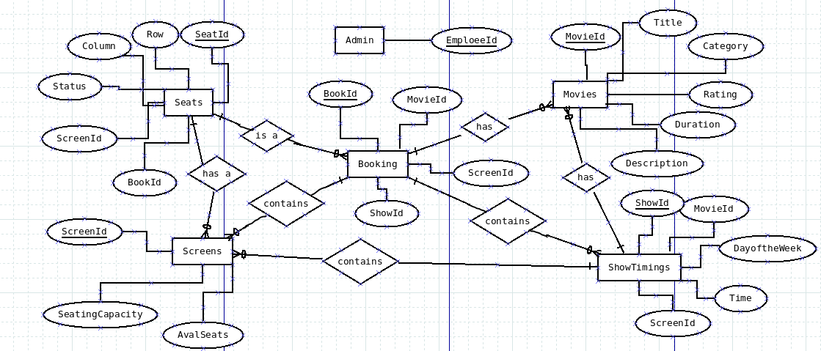

**Fig:2.1** Entity Relationship Diagram

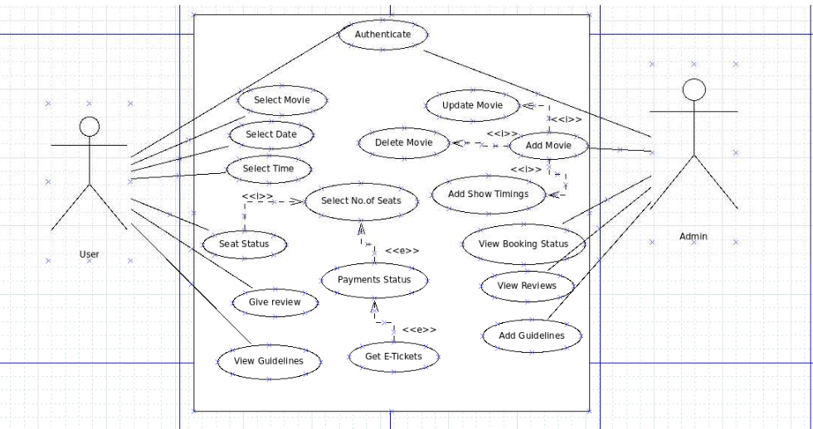

**Fig:2.2** Use Case

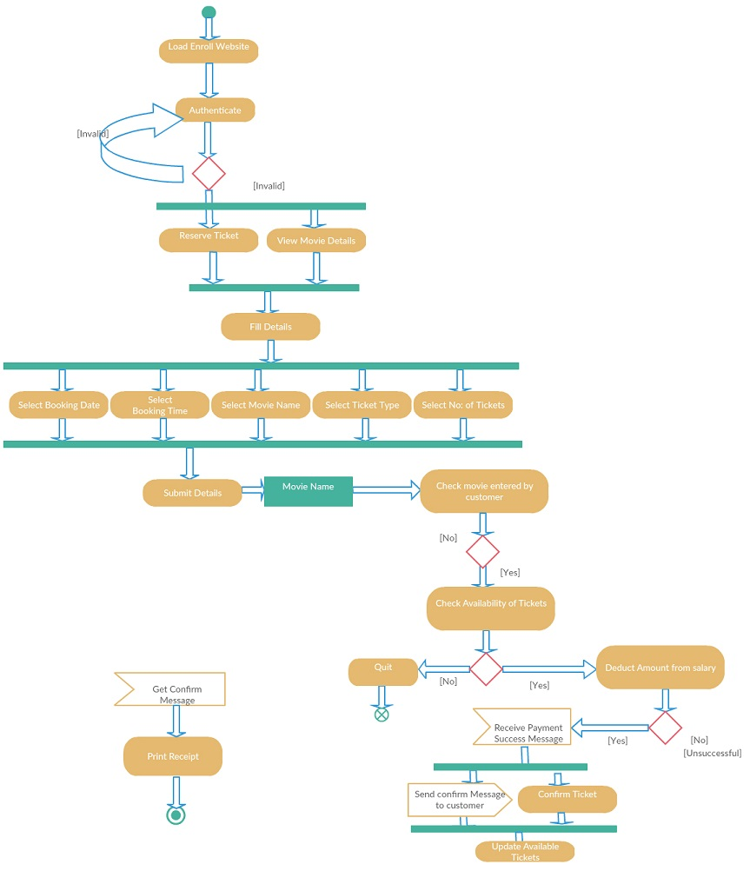**Fig: 2.3** Activity Diagram(Admin)

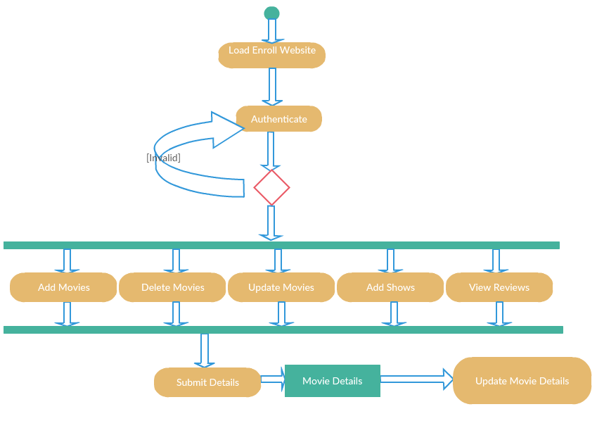

**Fig:2.4** Activity Diagram(User)

**2.1 TABLE DESIGN**

|  |  |  |  |
| --- | --- | --- | --- |
| **Data field** | **Data Type** | **Constraints** | **Description** |
| MovieID | Varchar(30) | Primary Key | Id of Movie |
| MovieName | Varchar(30) | NotNull | Movie Name |
| Category | Varchar(15) | NotNull | Type Of Movie |
| Language | Varchar(50) | NotNull | Language |
| Duration | Varchar(10) | NotNull | Duration |
| ReleaseDate | Date | NotNull | Release Date |
| Director | Varchar(15) | NotNull | Name of Director |
| Cast | Varchar(50) | NotNull | Name of celebrities |

**Table 2.1** Movie Table

|  |  |  |  |
| --- | --- | --- | --- |
| **Data field** | **Data Type** | **Constraints** | **Description** |
| ShowID | Varchar(20) | Primary Key | Id Of Show |
| MovieID | Varchar(30) | Foreign Key | Movie Id |
| DayofTheWeek | Varchar(10) | NotNull | Day of week |
| Time | Varchar(10) | NotNull | Time |
| ScreenId | Varchar(10) | Foreign Key | Screen ID |

**Table 2.2** Show Timings Table

|  |  |  |  |
| --- | --- | --- | --- |
| **Data field** | **Data Type** | **Constraints** | **Description** |
| ScreenID | Varchar(20) | PrimaryKey | Screen Id |
| SeatingCapacity | Integer | NotNull | Total No of seats |
| AvlblSeats | Integer | NotNull | No of available seats |

**Table 2.3** Screens Table

|  |  |  |  |
| --- | --- | --- | --- |
| **Data field** | **Data Type** | **Constraints** | **Description** |
| SeatID | Varchar(20) | PrimaryKey | Seat Id |
| Row | Integer | NotNull | Row |
| Column | Integer | NotNull | Column |
| Status | Boolean | NotNull | Booked or Not |
| ScreenID | Varchar(20) | ForeignKey | Screen Id |
| BookingID | Varchar(20) | ForeignKey | Booking Id |

**Table 2.4** Seats Table

|  |  |  |  |
| --- | --- | --- | --- |
| **Data field** | **Data Type** | **Constraints** | **Description** |
| BookID | Varchar(20) | PrimaryKey | Booking Id |
| MovieID | Varchar(20) | ForeignKey | Movie ID |
| ShowID | Varchar(20) | ForeignKey | Shoe ID |
| UserID | Varchar(20) | NotNull | User Name |

**Table 2.5** Bookings Table

**3. DETAILED TEST PLAN**

This being a web application project, we need to consider various dimensions of quality. It is incorporated into a web application as a consequence of good design. The whole test plan is based on reviewing and examining the following dimensions:

* **Content:** This includes evaluation at both syntactic as well as semantic level. At the syntactic level, spelling, punctuation and grammar are assessed for hard-coded tests appearing on the client screen of the website. At the semantic level, correctness of information presented, consistency and lack of ambiguity are all assessed.
* **Function:** All the functions specified in the requirements specification document will be tested. The errors in the main function that can confuse and disappoint the client needs to be handled with appropriate error messages. The three levels of testing were done i.e., unit testing, system testing and integration testing.
* **Usability:** This is tested to ensure that each category of the user is supported by the interface and can learn and apply all the required navigation syntax and semantics.
* **Navigability:** This is tested to ensure that all the navigation syntax and semantics are exercised to uncover any navigation errors (e.g. dead links, improper links etc.). Every link on each pages and frames were tested.
* **Performance:** Performance is tested under a variety of operation conditions, configuration and loading to ensure that the system is responsive to user interaction and handles extreme loading without unacceptable operational degradation. This document describes the testing plan of the web application. Software testing is a critical element of a software quality assurance and represents the ultimate review of specification, design and coding. The application will be successful with the acceptance of the testing. All the major testing activities are specified here.

|  |  |  |  |
| --- | --- | --- | --- |
| **Sl. No.** | **TEST CASES** | **CONDITION BEING CHECKED** | **EXPECTED OUTPUT** |
| 1. | Add movies module | Entered data are checked for validation. | Successful submission alert is displayed. |
| 2. | Add show timings module | Entered data are checked for validation. | Successful submission alert is displayed. |
| 3. | Booking ticket module | Entered data are checked for validation. | Successful submission alert is displayed. |
| 4. | Add review module | Review and ratings of the movie is added. | Successful submission alert is displayed. |
| 4. | Logout Module | The employee’s session condition is checked. | Successful logout |

**Table 3.1:** Detailed Test Plan

1. **IMPLEMENTATION DETAILS**

**5.RESULTS AND DISCUSSIONS**

**6. SUMMARY AND CONCLUSION**

The proposed application involved upgraded technologies like Angular 6 as the front-end and MySQL as the database for successful completion. Along with that, we have used Node.js that have contributed for the benefits of the proposed model. Using this web application, one can book tickets in a single click without waiting for long time.

**6.1 SUMMARY OF ACHIEVEMENTS**

Listed below is the summary of achievement:

* This application aims to build an interactive model which maximizes the chances of user interaction and display different content each time it's viewed.
* The proposed model has been developed to enhance flexibility, ease of modification, responsiveness, consistency and reliability.
* Interactive as well as effective modules for employee where they can retrieve, update and display them as per their requirement.

**6.2 DIFFICULTIES ENCOUNTERED DURING THE PROJECT AND HOW THEY WERE TACKLED**

The development of the proposed model undergoes various difficulties as listed below:

* The use of Angular 6 involves some of the framework (npm, node.js etc.) that needs to be properly installed for the implementation of this JavaScript library.
* During database connection, it was encountered that application gets crashed several times and it was resolved by killing ports on which they are running.
* Ensuring the security of each module is intact.
* Conceptualization of relationship among various entities along with their roles and attributes.

**6.3 LIMITATION OF THE PROJECT**

The following are the limitations of the proposed model:

* The application will stop functioning if something in the database fails/crashes as everything is dependent on each other and a simple fail in database will make the whole application suffer.
* The implementation of some modules has a slow-processing capability due to growing database, increasing traffic and amount of memory being consumed.

**6.4 FUTURE SCOPE**

In this ever-changing world, there is always scope for improvement. Similarly, there are multiple aspects where improvement can be made in the application.

The following points show the direction of improvement:

* The search module may be added which facilitates user interaction, lengthens visit time and provides valuable data about the application.
* In the module, efforts can be made to retrieve the contents of last movie watched by the user from database.

**6.5 CONCLUSION**

**Effectiveness and efficiency** are the key factors of web application development that is responsible for its maintenance. As the technology is constantly advancing, the web applications are only getting better and maximize profits even in a better way. Trends in web development keep changing even before they can be implemented. These are in response to the scaling user expectation and demand for more engaging & intuitive digital experience. Keeping an eye on this essential feature, the proposed model uses these features as a building block for its implementation. The requirement of advanced technologies is highly considered for the development of a top-notch web application. The right technology, to a great extent, is the key to the website’s success, while the wrong choice of web app development technologies may be a reason for failure.  Website developers always need to be updated constantly with the latest technologies related to web development as they provide both users and developers with better functionalities and features.

The efforts are put to develop the website into an effective, efficient and user-friendly application. It is useful in terms of accessibility as well as with respect to applied analysis by various entities. The developed website is more useful than current website.

The task of building interactive user interfaces with any of the development platforms like react opens a new ways and provides a number of possibilities to the developers to make them more creative. It is an extremely easy framework to work with and provides interactivity to the layout of any UI. The proposed models aim to build a responsive website that can **adapt to the size of the user’s viewport**. The goal is to content to render differently depending on the device or screen size so that users have an optimal experience no matter how they access a website. The primarily benefit of responsive website is that sites load quickly without any distortions, so users don’t need to manually resize anything to view content and also enhances ease of modification, flexibility, reliability, consistency and accuracy. Having this application with effective modules means the ability to access any information at any point of time.

**7.GANTT CHART**

|  |  |  |  |  |  |
| --- | --- | --- | --- | --- | --- |
| **ACTIVITY** | **TIME FRAME** | | | | |
|  | **JANUARY** | **FEBRUARY** | **MARCH** | **APRIL** | **MAY** |
| Learning concepts |  |  |  |  |  |
|  |  |  |  |  |
| Relevant Assignments |  |  |  |  |  |
|  |  |  |  |  |
| Automation Testing |  |  |  |  |  |
|  |  |  |  |  |
| Deployment |  |  |  |  |  |
|  |  |  |  |  |
| Development |  |  |  |  |  |
|  |  |  |  |  |
| Documentation |  |  |  |  |  |
|  |  |  |  |  |

|  |  |  |  |  |  |
| --- | --- | --- | --- | --- | --- |
|  | Proposed Activity |  | Completed Activity |  | Ongoing Activity |

Initiated from 26th December, 2018

**8. REFERENCES**

[1] “Online Movie Ticket Reservation” by Prof. Prithviraj Y J1 S Vaishnav ,Swathi,Vemala Susmitha (International Journal For Technological Research In Engineering,May-2016)

[2]“Online Cinema Ticket Booking System” by Rahul Rajouria, Vishal Yadav, Ruchika Mishra, Swati Jain(International Journal of Modern Engineering & Management Research, March 2015)

[3] “A Comprehensive Review of the Bookmyshow Website and System” by Tamizharsi T, Pulkit Suhasaria, Ashwani Agarwal, Harshit Manchanda, Himanshu Jain (Imperial Journal of Interdisciplinary Research (IJIR),2017)

[4]<https://angular.io/>

[5]<https://angular.io/guide/quickstart>

[6]<https://lex.infosysapps.com/toc/lex_31364648044580110000/about>

[7]<https://docs.microsoft.com/enus/aspnet/core/security/authentication/windowsauth?view=aspnetcore-2.2&tabs=visual-studio>

[8]<https://lex.infosysapps.com/viewer/lex_31364648044580110000/lex_11423422781482320000>

[9]<https://lex.infosysapps.com/viewer/lex_31364648044580110000/lex_6900907208182035000>