PLANET OF TWINS
Playtester Reference — Controls & Abilities

Controls

Key | Action
WASD | Move both twins simultaneously. WASD always controls both — Left Shift switches which twin is selected for abilities.
Left Shift | Switch active twin (Kai ↔ Lyra) / Dash (during Empower)
E | Attack (melee, 2m range) / Left Mouse Button
Q | Primary ability (Stun or Possess) / Right Mouse Button
C | Weaver's Gate — only available during a rescue event
F | Rescue mash / Hold for Soul Convergence (when charged) / Hold for Setsuna (when in Accord State + SC charged)
R | Hold for Empower / Hold for Accord Spirits (during Accord State)
B | Hold for top-down overview (5s max, then cooldown)
Tab | Open / close Skill Tree
X | Hold to activate Accord State (when bar is full) / Cancel active Weaver’s Gate or QTE lock-in

Debug Keys (remove before release)
Key | Action
L | +1 skill point
O | +10 skill points
P | +100 skill points
I | Reset points to 0
K | Reset all upgrades

Twin Switching
Both twins move simultaneously — WASD always drives both. Pressing Left Shift switches which twin is selected: the selected twin moves in the direction you press, while the unselected twin mirrors the input in reverse (left becomes right, and vice versa). Switch to use each twin’s abilities independently.
Press Left Shift to switch. Use this to use abilities — for example: stun with Kai, possess with Lyra.
Note: yellow colour indicates the selected twin
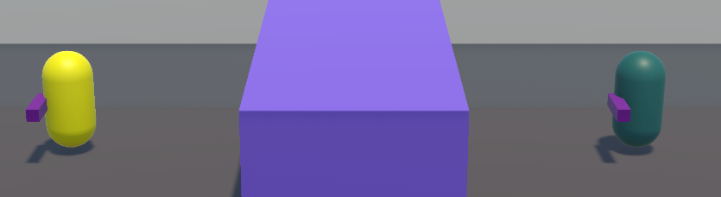

Abilities

Kai — Stun [Q]
Kai emits a pulse that freezes nearby enemies in place. Stunned enemies cannot move or attack for the duration.
Base: 3s duration · 7s cooldown
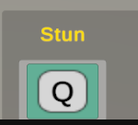

Lyra — Possession [Q]
Lyra seizes control of a nearby enemy, turning it against its allies. The possessed enemy fights for the twins until the effect expires.
Base: 3s duration · 7.5s cooldown
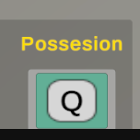

Shared — Weaver's Gate [C]
Either twin opens a rift that the other twin’s soul can instantly travel through. The Gate closes the distance between the twins regardless of where they are on the map.
The Gate is only available when a rescue event or their health is below certain level (20%) is active — meaning one twin has been killed and is in the TTK (Time To Kill) countdown state. Outside of a rescue or low health, pressing C does nothing.
Once cast, the soul travels to the dying twin's position. After it arrives, hold X for 0.75 seconds to cancel early — the cooldown starts immediately either way.
Base: 4s open · 9s cooldown
Note: The Gate cannot be cast if no rescue event is active or health is not low (20%). Watch the health bars — when a twin hits zero, the Gate icon becomes available.
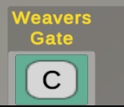

Special Abilities (Skill Tree)

Coalesce [automatic]

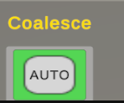
Stunned and possessed enemies emit a damaging aura around them. Any enemy that walks too close takes damage. Activates automatically whenever Stun or Possession lands — no input required.
Base: 1.5m radius · 6 DMG/s · lingers 2.5s after effect ends
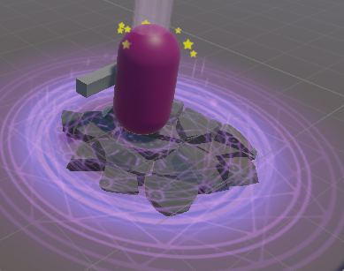
Note: Summoner enemy in Coalesce aura

Soul Convergence [Hold F for 0.75s when charged]

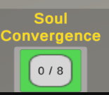
Every enemy killed feeds a soul counter (max 20 toned to 8 for prototype). When the counter hits 20, hold F to release the power.
While active: +35% damage dealt, -35% damage taken, lasting 7 seconds. The counter resets when the power fires, not when it expires. If Accord State is also active, holding F triggers Setsuna instead — see Accord State section.
Note: Cannot activate during an active rescue event.
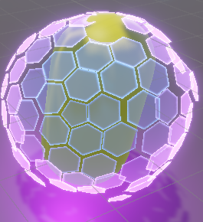
Note: twins shield in soul convergence.

Empower [Hold R]

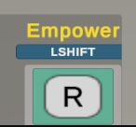
One twin anchors in place and enters a meditative state, channelling power to the other. The anchoring twin is locked but periodically emits a shockwave that pushes nearby enemies outward. The empowered twin gains +35% movement speed, +45% damage, and can dash with Shift.
Base: 6s active · 12s cooldown · Shockwave every 1.5s · 5m knockback radius
Note: Cannot activate during an active rescue event or while Accord State is active. Hold X for 0.75s to cancel early.

Accord State
The Accord bar fills as the twins deal and take damage together. When full, hold X for 1.25s to activate. Both twins enter a heightened synchronised state and their abilities transform. All Accord State abilities listed below are only available while Accord is active.
Base: 12s active · Bar cap: 35 points (Less in the game for demonstration around 4-5 points) · Kills = 1pt · Damage taken (below 60% health) = 0.5–1pt
Note: Cannot activate while Soul Convergence or Empower is active. If damage is taken in the first 0.7s of the charge, the charge is cancelled.



Accord bar filled and ready.

Accord Melee [E during Accord State]
Both twins perform a synchronised melee strike. Kai swings Dagger tail and Lyra swings Radiant Sweep — a 120° arc that hits all enemies in range and briefly slows them.
Base: 5m range · 120° arc · 1.25s slow · Enemies lose aggro for 0.75s, Deals damage

Void Strike [Q — Kai, Accord only]
Kai seeds the area around him with void hazard points. Every 0.25 seconds a new point spawns within 3m, keeping up to 5 actives at once. Any enemy that steps into a point takes 0.6 damage per tick for as long as they remain inside. Points last for the full 5 second duration then disappear together.
Base: 3m spawn radius · 5 points max · 0.25s spawn interval · 0.6 dmg/tick · 5s duration · 4s cooldown
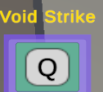

Radiant Seeker [Q — Lyra, Accord only]
Lyra launches a seeking orb that tracks the nearest enemy. On contact it possesses the target directly. If the target dies while the orb is travelling, the orb re-seeks the next nearest enemy.
Base: 2s possession · 0.55s re-seek cooldown · 5s ability cooldown
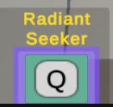

Accord Spirits [Hold R — Accord only]
Both twins summon a spirit each. The spirits path finds to the nearest enemy. On arrival, Phase 1 cleanses nearby enemies of their aggro. Phase 2 opens a portal at the spirit’s position that deals damage to all enemies inside for its duration.
Base: 4m cleanse radius · 12 DPS portal · 3.5s portal duration · 2m portal radius · 7s cooldown
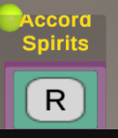

Setsuna [Hold F during Accord State when Soul Convergence is charged]
An enhanced form of Soul Convergence available only inside Accord State. The world slows to 15% speed while the twins move freely at full speed. After 7 seconds, time restores and both twins rewind to their cast positions. Health is restored to the snapshot taken at activation.
7s active window (unscaled) · 2.5s rewind · Health restored to cast snapshot · SC damage buffs remain active
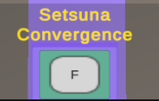
Note: Requires Soul Convergence to be purchased and charged. Unlocks automatically when both Soul Convergence and Accord State are purchased — no separate node.

Rescue Event
When a twin is killed their HP hits zero, they enter a TTK (Time To Kill) countdown instead of dying immediately. A timer starts — if it reaches zero before they are rescued, the run ends.
The free twin must cast Weaver’s Gate (C) to send the soul to the dying twin, then mash F rapidly to fill the rescue bar before the mash window expires. If the mash window closes, there is a short cooldown before another attempt.
E Mash (Self-Rescue): The Tether-Breaker chain allows the grabbed twin to fight back directly. Mash E to fill a struggle bar and break free before health reaches zero. No Gate required — the grabbed twin acts alone. If the E mash fails, health drains to zero and a normal rescue event triggers automatically.
The soul can die if it takes enough damage while active. This resets the rescue attempt — cast the Gate again when it comes off cooldown.
- Both twins being captured at the same time is an instant game over — no rescue is possible.
- Enemies stop targeting the dying twin when TTK begins.
- On a successful rescue the rescued twin gets 2 seconds of invincibility.
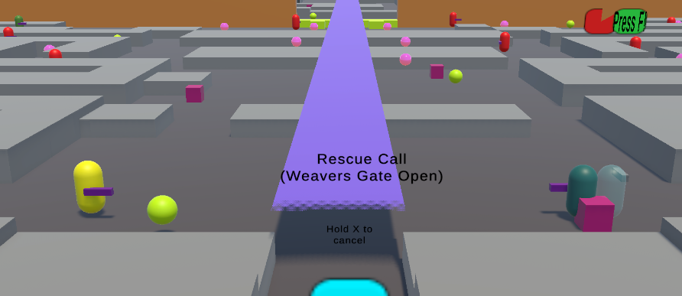

Puzzle — Gate QTE
At the end of the first area there is a locked gate that requires both twins to operate simultaneously. When both twins enter the gate zone, the QTE activates and two trigger points light up.
Walk each twin to their trigger point and press F to lock in. Once both twins are locked in, a button-mash phase begins — mash F as fast as possible to fill the progress ring before the timer runs out.
The progress ring fills as you mash. The timer ring drains and turns red as time runs out. Fill the progress ring completely before the timer empties to open the gate.
- Hold X to cancel your lock-in at any point. Both twins are released if either cancels.
- If the mash timer runs out, both twins are released and you can retry from the trigger points.
- Enemies are frozen for the duration of the QTE sequence, including retries.
- The gate opens permanently once the mash succeeds.
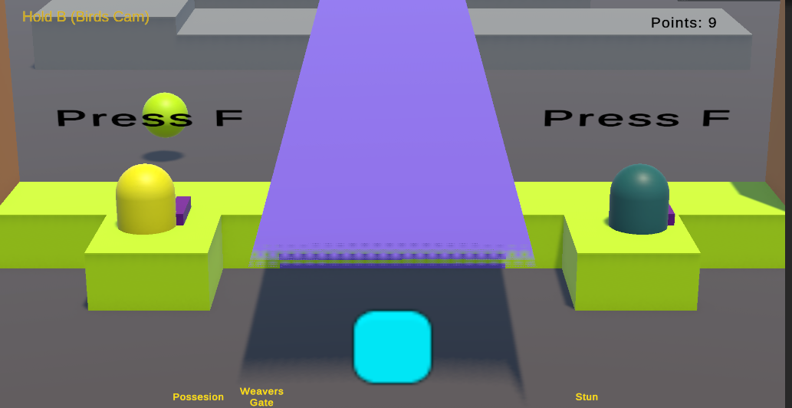
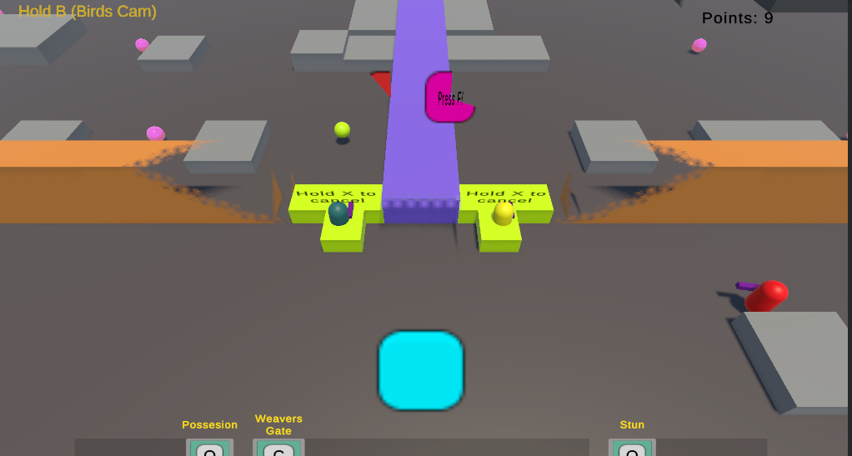

Game Over Conditions
The run ends and the Battle Lost screen appears when:
- A dying twin's TTK timer runs out without a successful rescue.
- Both twins are captured simultaneously — no rescue is possible.
- The soul is destroyed during a rescue attempt and the TTK timer expires before the Gate can be recast.

From the Battle Lost screen you can:
- Restart — reloads the level from the beginning with no upgrades or skill points.
- Load Checkpoint — reloads the level from the last checkpoint with your skill points and unlocked upgrades restored. Only available if a checkpoint was reached.

Enemies
Enemies spawn continuously in waves on both sides of the barrier. Learning how each type behaves will help you prioritise targets and position the twins effectively.

Melee
Closes in and attacks at short range. Straightforward — it will chase a twin until it can strike. Stun or possess it to create space.
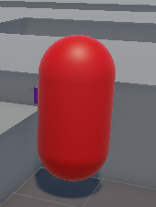

Ranged
Attacks from a distance using projectiles. If you move too close it retreats to maintain a safe shooting distance, so chasing it directly is inefficient. Use Stun or Possession to lock it in place, or let a possessed enemy close the gap for you.
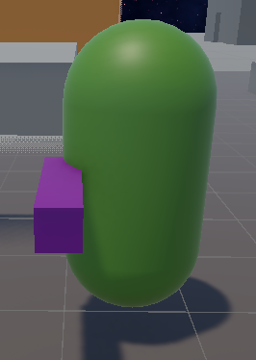

Summoner
Stays at range and periodically summons additional enemies onto the field. It will shoot projectiles between summons, so it applies pressure at all times. Killing the summoner stops further reinforcements. Minions it spawns behave as standard melee or ranged enemies depending on the summoner type.
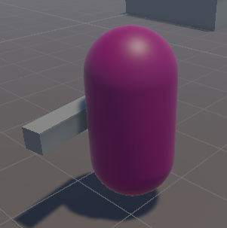

Group Grab
When a Group Grab enemy reaches a twin, it locks them in place and begins a TTK countdown — the same rescue flow as a normal death. The free twin must cast Weaver's Gate and mash F to rescue before the timer runs out. The grabbed twin cannot move or act until rescued or until the TTK expires.
- The grab triggers the rescue event immediately — the Gate becomes available as soon as the grab lands.
- There is no way to break the grab other than a successful rescue.
- If both twins are grabbed simultaneously, it is an instant game over.
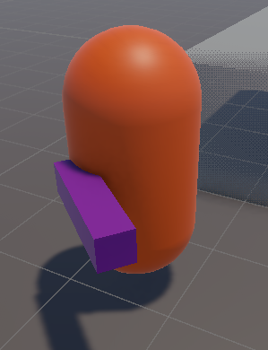

Traps (Skeleton Hand Trap)
The skeleton traps take a second to arm itself. It grabs the player in attack range and drags the player in the ground triggering a rescue event.
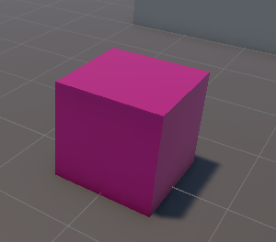

The Siphon
A ranged kiting enemy with a unique rescue mechanic. The Siphon maintains distance and retreats if a twin gets too close, dropping a panic bomb on the way out. Its real threat activates during a rescue event: if a Siphon is within range when the soul launches, it spawns a Ghost that pursues the soul.

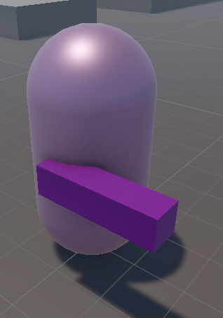

Siphon Ghost: The ghost chases the soul. You have a 2.2 second window to kill it with E attacks before it becomes immune. If it reaches the soul it binds it in a chain — mash E rapidly to break free. Mashing fills a bar; fill it completely to send the ghost away. If the mash timer expires, the ghost retries after a short delay. The loop continues until the Siphon is killed or the rescue resolves.
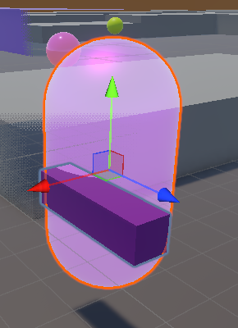
Priority: Kill the Siphon before triggering a rescue. If a ghost spawns, the soul player should attack it immediately in the 2.2s window — killing it prevents the bind entirely.

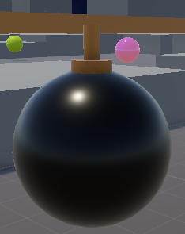

The Severed
Always spawns as a pair — one on each side of the barrier. Their health is linked: damage dealt to one transfers 40% to the other simultaneously. Killing one without killing the other triggers Grief Rage in the survivor: full speed, non-stop attacks for 8 seconds, then it auto-dies.
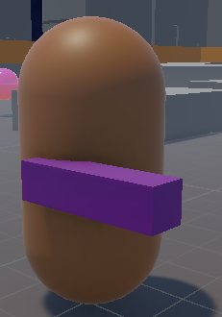
Ideal play: Kill both simultaneously. Every 4 seconds both Severed pause to reach toward the barrier — a 1.2 second window where neither moves nor attacks. Hit both during this window to maximise the linked damage and avoid triggering Grief Rage.

The Tether-Breaker
Throws a visible chain projectile at a twin. If it connects, the twin is frozen and dragged away from the barrier — forcibly stretching the tether. Mash E to break the chain before health drains to zero. If the chain is broken, the Tether-Breaker enters a Rage state: it charges aggressively with no cooldowns until it dies.
Note: The chain has a visible travel time — sidestep to dodge it. If you can’t dodge, mash E immediately on connect. The chain has a ground marker showing where it will land.
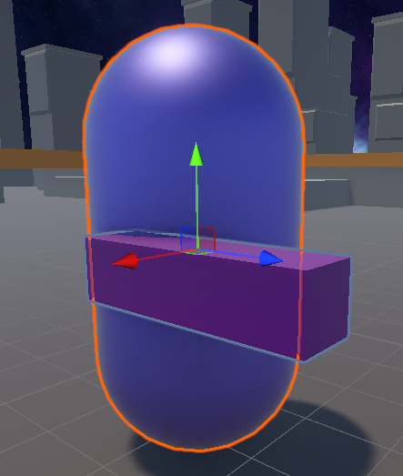

The Witness
A support enemy that shadows a melee ally and buffs nearby enemies: +40% damage and halved attack cooldowns within 6m. It does not chase twins directly but throws a bomb if one gets too close, then retreats. If its ally dies, it channels a 4 second ritual to summon a new one — interrupting the ritual forces it to flee and restart.
Priority target: The Witness makes every nearby enemy significantly more dangerous. Possessing it inverts the aura — nearby enemies are debuffed instead. Kill or possess it first. Its 4 second vulnerability window after its ally dies is the easiest kill opportunity.
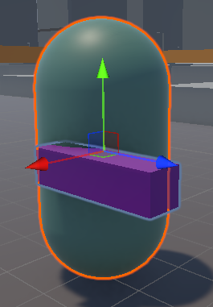

Checkpoints
Checkpoints are marked by glowing objects placed at key points in the level. Walk through a checkpoint to save your current progress — a brief message confirms the save.
What a checkpoint saves:
- Your position — both twins respawn at the checkpoint location.
- Skill points — the exact number you had at the time of saving.
- Unlocked upgrades — all purchased ability nodes are restored.
What resets on a checkpoint load:
- Enemy positions and spawns — all enemies reset as if the level just started.
- Traps — any active grabs are released.
- HP — both twins respawn at full health.
Note: Checkpoint progress is only restored when you choose Load Checkpoint from the Battle Lost screen. Restarting the scene does not load the checkpoint.

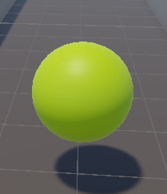

Skill Point Loop
Skill Point Orbs are placed throughout each level. Walk over an orb to collect it (+1 point). Open the Skill Tree with Tab and spend points to unlock upgrades.
Upgrades are permanent for the run. Each ability has 3 upgrade nodes purchased in order — nodes cannot be skipped. Your skill points and upgrade state are saved at checkpoints and restored on a checkpoint load.
