**Exp6.html**

<html>

<head>

<title>log-in form</title>

<script language="javascript" src="java.js"></script>

<link rel="stylesheet" type="text/css" href="./style.css">

</head>

<body>

<div class="form-1">

<form align="center" name="login" onsubmit="return gaurav()">

<fieldset>

<legend>form</legend>

<input type="text" size="20" name="username" placeholder="username">

<br><br>

<input type="password" size="20" name="password" placeholder="password">

<br><br>

<input type="submit" name="submit" value="submit">

</fieldset>

</form>

</div>

</body>

</html>

**Java.js**

function gaurav() {

if (document.login.username.value == "") {

alert("please enter username");

return false;

}

if (document.login.password.value == "");

{

alert("please enter password");

return false;

}

}

**Style.css**

body{

background: rgb(155, 149, 149);

font-size: 30px;

}



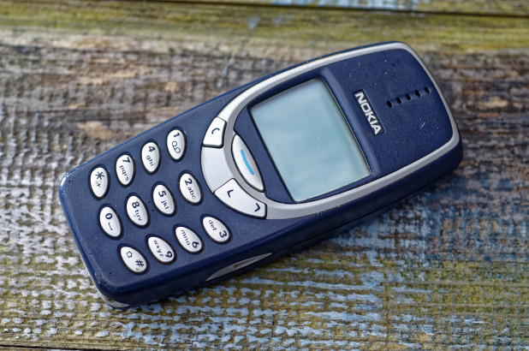  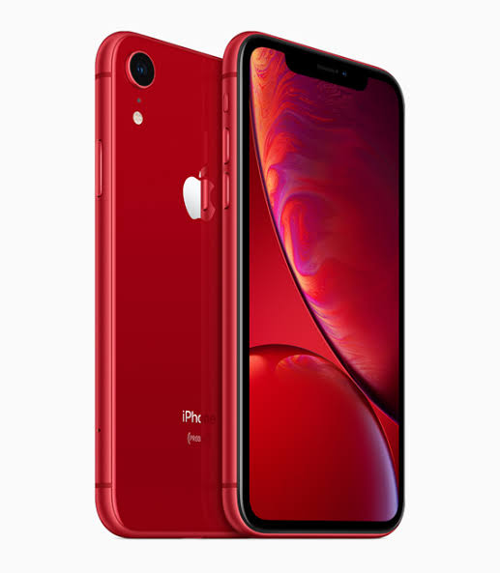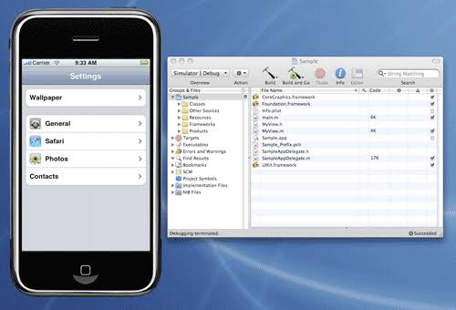 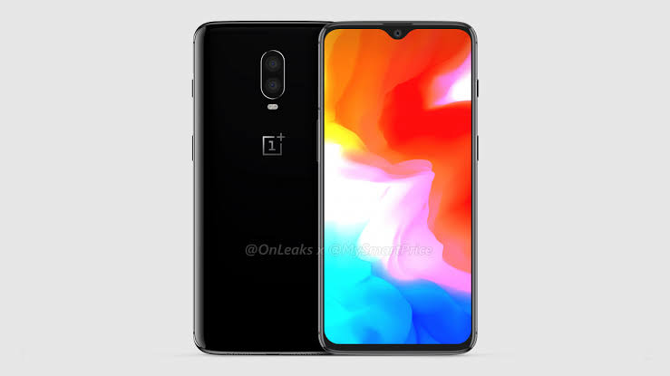 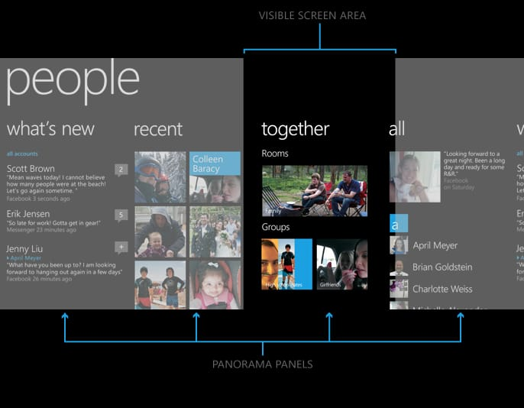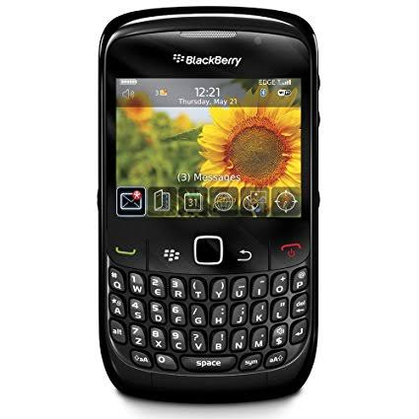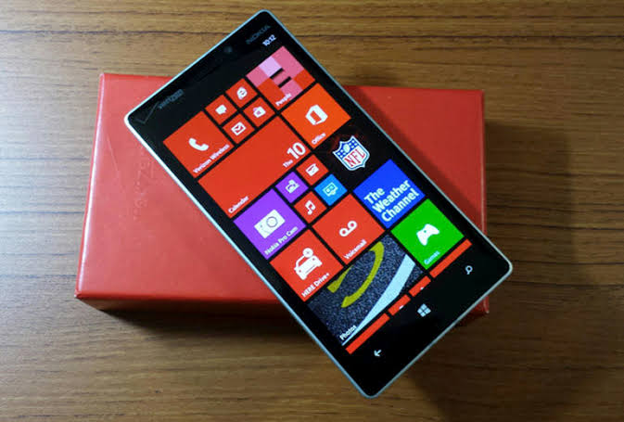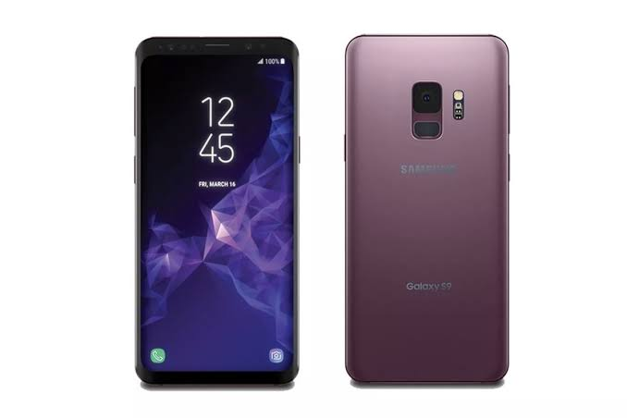

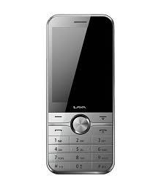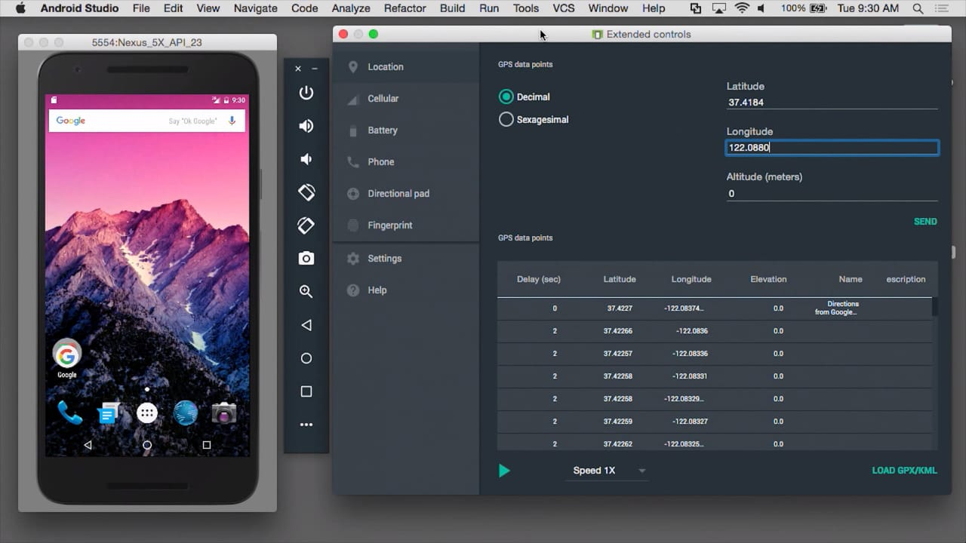

Exp7

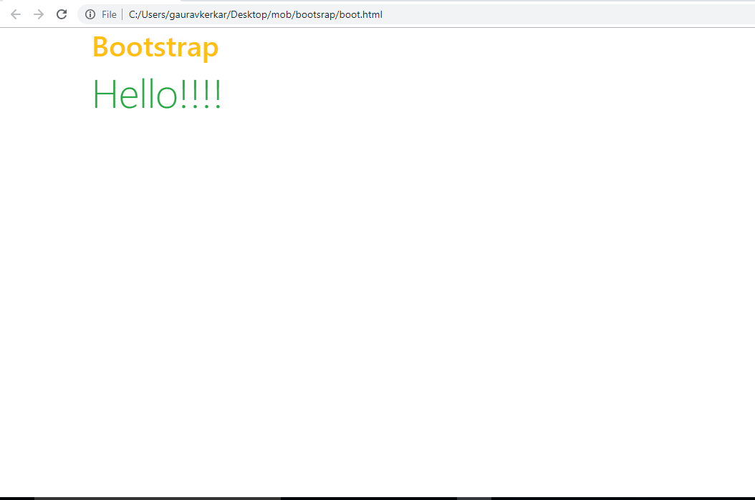

<!doctype html>

<html lang=en>

<head>

<title>bootstrap</title>

<meta charset="utf-8">

<meta name="viewport" content="width=device-width, initial-scale=1">

<link rel="stylesheet" href="https://maxcdn.bootstrapcdn.com/bootstrap/4.0.0/css/bootstrap.min.css" integrity="sha384-Gn5384xqQ1aoWXA+058RXPxPg6fy4IWvTNh0E263XmFcJlSAwiGgFAW/dAiS6JXm" crossorigin="anonymous">

<script src="https://maxcdn.bootstrapcdn.com/bootstrap/4.0.0/js/bootstrap.min.js" ></script>

</head>

<body>

<div class="container">

<h1 class="text-warning">Bootstrap</h1>

<p class="display-4 text-success">Hello!!!!</p>

</div>

</body>

</html>

Exp8

<!DOCTYPE html>

<html>

<head>

<title>exp8</title>

<link rel="stylesheet" href="https://maxcdn.bootstrapcdn.com/bootstrap/4.0.0/css/bootstrap.min.css" integrity="sha384-Gn5384xqQ1aoWXA+058RXPxPg6fy4IWvTNh0E263XmFcJlSAwiGgFAW/dAiS6JXm" crossorigin="anonymous">

<script src="https://maxcdn.bootstrapcdn.com/bootstrap/4.0.0/js/bootstrap.min.js" ></script>

<script src="https://ajax.googleapis.com/ajax/libs/jquery/3.3.1/jquery.min.js"></script>

<script>

$(document).ready(function(){

$("tr:odd").click(function(){

$(this).hide();

});

});

</script>

</head>

<body>

<p>when you click, this will be dissappeared</p>

<p class="intro">hello</p>

<h1 class="intro">hello</h1>

<ul>

<li>apple</li>

<li>mango</li>

</ul>

<ul>

<li>apple</li>

<li>mango</li>

</ul>

<a href="#intro">click</a>

<table border="2">

<tr>

<th>sr.no</th><th>name</th>

</tr>

<tr>

<th>01</th><th>chandu</th>

</tr>

<tr><th>02</th><th>nandu</th></tr>

</table>

</body>

</html>

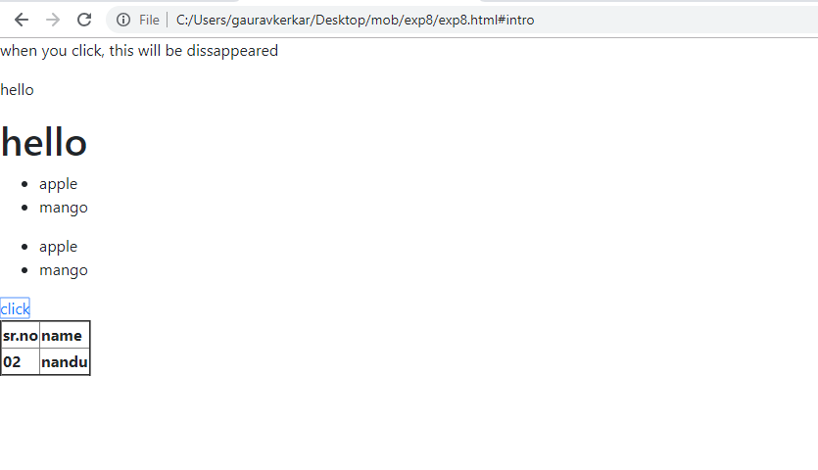

Exp9A

<!DOCTYPE html>

<html>

<head>

<title>exp9</title>

<meta name="viewport" content="width=device-width, initial-scale=1">

<link rel="stylesheet" href="http://code.jquery.com/mobile/1.4.5/jquery.mobile-1.4.5.min.css" />

<script src="http://code.jquery.com/jquery-1.11.1.min.js"></script>

<script src="http://code.jquery.com/mobile/1.4.5/jquery.mobile-1.4.5.min.js"></script>

</head>

<body>

<div datatype="page">

<div data-role="header">

<h1>welcome to my homepage</h1>

</div>

<div data-role="main" class="ui-content">

<p>I am now devlopers!!</p>

</div>

<div data-role="footer">

<h1>footer text</h1>

</div>

</div>

</body>

</html>

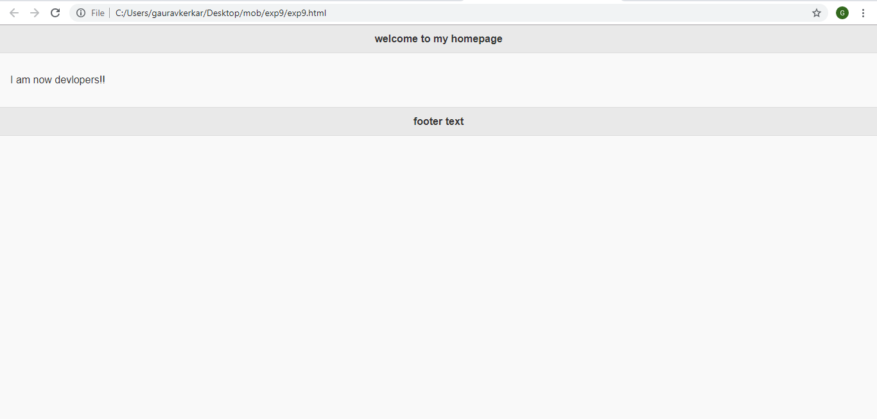

Exp9b

<!DOCTYPE html>

<html>

<head>

<title>exp9/b</title>

<meta name="viewport" content="width=device-width, initial-scale=1">

<link rel="stylesheet" href="http://code.jquery.com/mobile/1.4.5/jquery.mobile-1.4.5.min.css" />

<script src="http://code.jquery.com/jquery-1.11.1.min.js"></script>

<script src="http://code.jquery.com/mobile/1.4.5/jquery.mobile-1.4.5.min.js"></script>

</head>

<body>

<div data-role="page" id="section1">

<div data-role="main" class="ui-content">

<a href="#section2" data-tarnsition="fade">click here</a>

</div>

</div>

<div data-role="page" data-dialog="true" id="section2">

<div data-role="main" class="ui-content">

<a href="#section1" data-tarnsition="flip">click here</a>

</div>

</div>

</body>

</html>

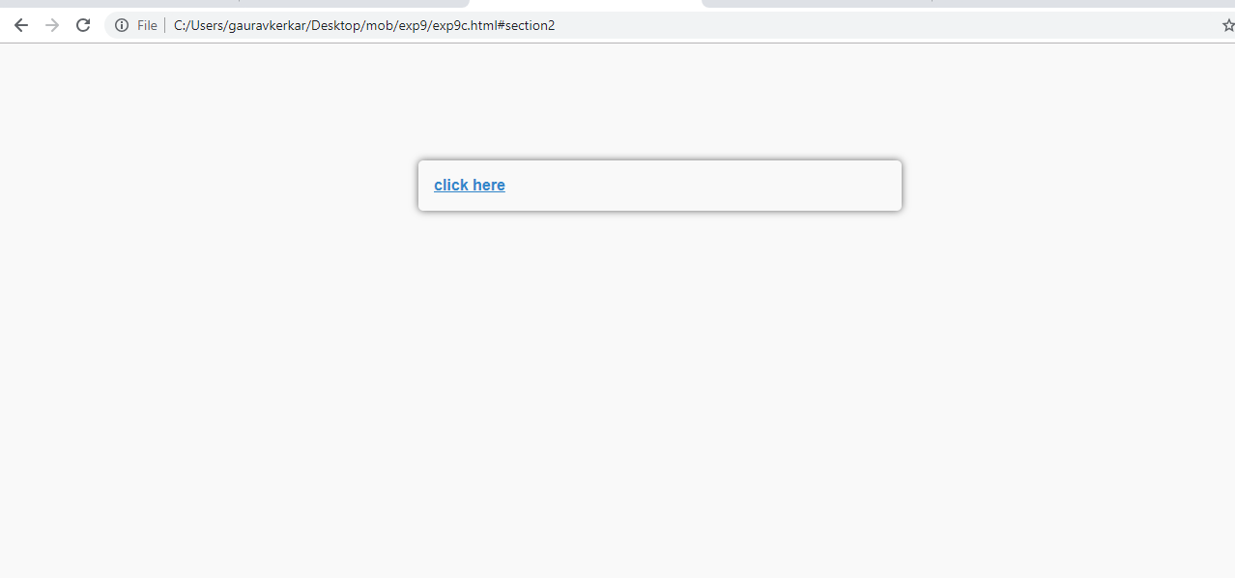

Exp11

<!DOCTYPE html>

<html>

<head>

<title>exp10-b</title>

<meta name="viewport" content="width=device-width, initial-scale=1">

<link rel="stylesheet" href="http://code.jquery.com/mobile/1.4.5/jquery.mobile-1.4.5.min.css" />

<script src="http://code.jquery.com/jquery-1.11.1.min.js"></script>

<script src="http://code.jquery.com/mobile/1.4.5/jquery.mobile-1.4.5.min.js"></script>

</head>

<body>

<div data-role="controlgroup" data-type="horizontal">

<a href="./exp9/exp9" class="ui-btn ui-btn-b ui-corner-all ui-mini">button_1</a>

<a href="./exp9/exp9" class="ui-btn">button_2</a>

<a href="./exp9/exp9" class="ui-btn">button_3</a></div>

<div data-role="controlgroup" data-type="horizontal">

<a href="./exp9/exp9" class="ui-btn ui-overlay-shadow">button_1</a>

<a href="./exp9/exp9" class="ui-btn ui-overlay-shadow">button_2</a>

<a href="./exp9/exp9" class="ui-btn ui-overlay-shadow">button_3</a>

</div>

<div data-role="controlgroup" data-type="horizontal">

<a href="./exp9/exp9" class="ui-btn ui-mini">button_1</a>

<a href="./exp9/exp9" class="ui-btn ui-mini">button_2</a>

<a href="./exp9/exp9" class="ui-btn ui-mini">button_3</a>

</div></body></html>

