Bootstrap

<!doctype html>

<html lang=en>

<head>

<title>bootstrap</title>

<meta charset="utf-8">

<meta name="viewport" content="width=device-width, initial-scale=1">

<link rel="stylesheet" href="https://maxcdn.bootstrapcdn.com/bootstrap/4.0.0/css/bootstrap.min.css" integrity="sha384-Gn5384xqQ1aoWXA+058RXPxPg6fy4IWvTNh0E263XmFcJlSAwiGgFAW/dAiS6JXm" crossorigin="anonymous">

<script src="https://maxcdn.bootstrapcdn.com/bootstrap/4.0.0/js/bootstrap.min.js" ></script>

</head>

<body>

<div class="container">

<h1 class="text-warning">Bootstrap</h1>

<p class="display-4 text-success">hi....</p>

</div>

</body>

</html>

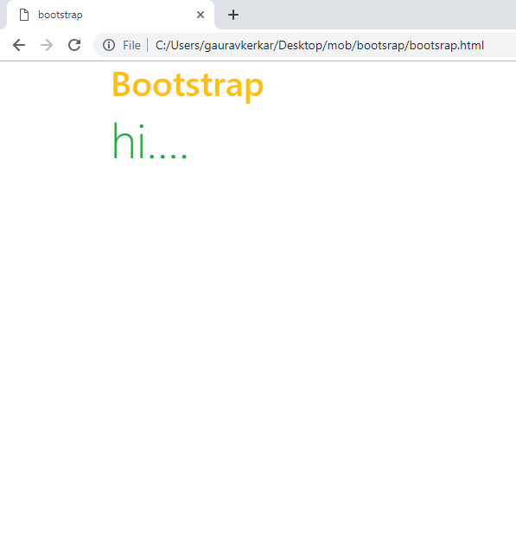

Exp8

<!DOCTYPE html>

<html>

<head>

<title>exp8</title>

<link rel="stylesheet" href="https://maxcdn.bootstrapcdn.com/bootstrap/4.0.0/css/bootstrap.min.css" integrity="sha384-Gn5384xqQ1aoWXA+058RXPxPg6fy4IWvTNh0E263XmFcJlSAwiGgFAW/dAiS6JXm" crossorigin="anonymous">

<script src="https://maxcdn.bootstrapcdn.com/bootstrap/4.0.0/js/bootstrap.min.js" ></script>

<script src="https://ajax.googleapis.com/ajax/libs/jquery/3.3.1/jquery.min.js"></script>

<script>

$(document).ready(function(){

$("tr:odd").click(function(){

$(this).hide();

});

});

</script>

</head>

<body>

<p>when you click, this will be dissappeared</p>

<p class="intro">hi</p>

<h1 class="intro">how are you...</h1>

<ul>

<li>bmw</li>

<li>volvo</li>

</ul>

<ul>

<li>apple</li>

<li>chiku</li>

</ul>

<a href="#intro">click</a>

<table border="2">

<tr>

<th>sr.no</th>

<th>name</th>

</tr>

<tr>

<th>01</th>

<th>oppo</th>

</tr>

<tr>

<th>02</th>

<th>vivo</th>

</tr>

</table>

</body>

</html>

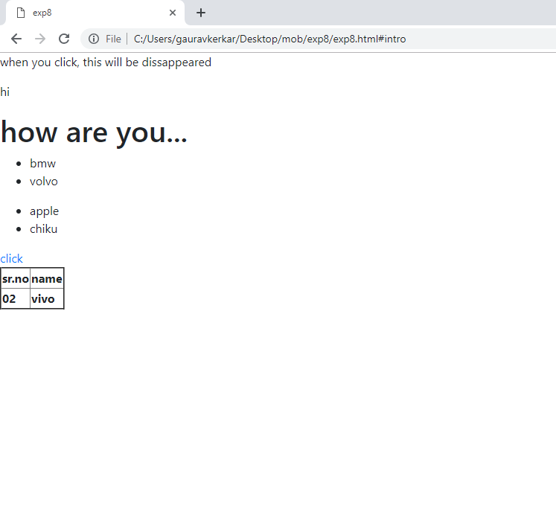

Exp9

<!DOCTYPE html>

<html>

<head>

<title>exp9</title>

<meta name="viewport" content="width=device-width, initial-scale=1">

<link rel="stylesheet" href="http://code.jquery.com/mobile/1.4.5/jquery.mobile-1.4.5.min.css" />

<script src="http://code.jquery.com/jquery-1.11.1.min.js"></script>

<script src="http://code.jquery.com/mobile/1.4.5/jquery.mobile-1.4.5.min.js"></script>

</head>

<body>

<div datatype="page">

<div data-role="header">

<h1>welcome to my homepage</h1>

</div>

<div data-role="main" class="ui-content">

<p>I am now devlopers!!</p>

</div>

<div data-role="footer">

<h1>footer text</h1>

</div>

</div>

</body>

</html>

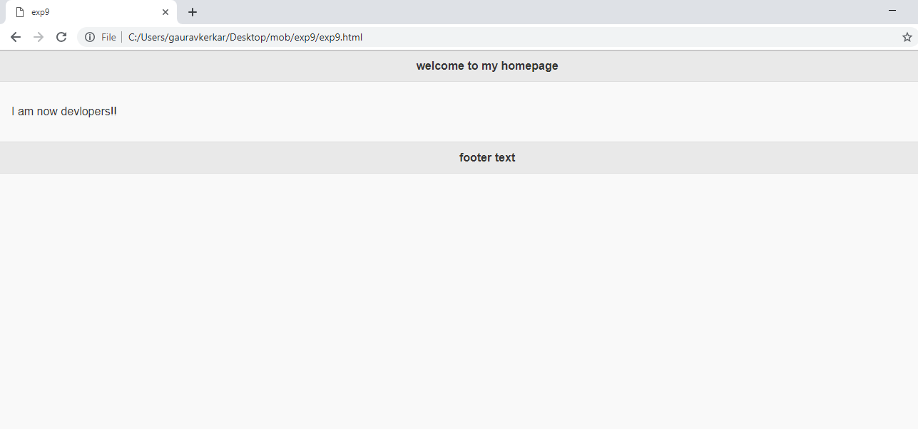

Exp9c

<!DOCTYPE html>

<html>

<head>

<title>exp9/b</title>

<meta name="viewport" content="width=device-width, initial-scale=1">

<link rel="stylesheet" href="http://code.jquery.com/mobile/1.4.5/jquery.mobile-1.4.5.min.css" />

<script src="http://code.jquery.com/jquery-1.11.1.min.js"></script>

<script src="http://code.jquery.com/mobile/1.4.5/jquery.mobile-1.4.5.min.js"></script>

</head>

<body>

<div data-role="page" id="section1">

<div data-role="main" class="ui-content">

<a href="#section2" data-tarnsition="fade">click here</a>

</div>

</div>

<div data-role="page" data-dialog="true" id="section2">

<div data-role="main" class="ui-content">

<a href="#section1" data-tarnsition="flip">click here</a>

</div>

</div>

</body>

</html>

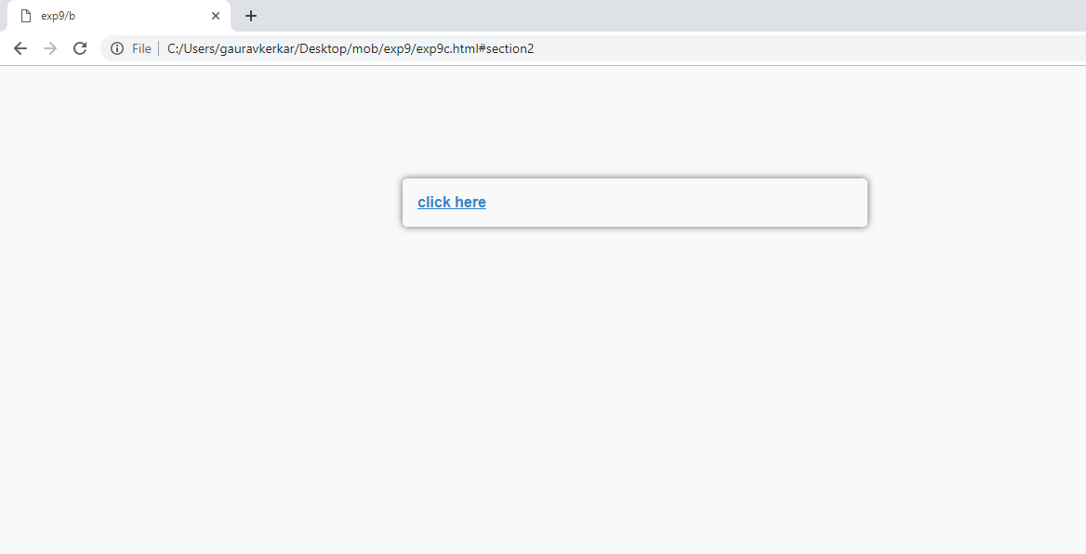

Exp11

<!DOCTYPE html>

<html>

<head>

<title>exp10-b</title>

<meta name="viewport" content="width=device-width, initial-scale=1">

<link rel="stylesheet" href="http://code.jquery.com/mobile/1.4.5/jquery.mobile-1.4.5.min.css" />

<script src="http://code.jquery.com/jquery-1.11.1.min.js"></script>

<script src="http://code.jquery.com/mobile/1.4.5/jquery.mobile-1.4.5.min.js"></script>

</head>

<body>

<div data-role="controlgroup" data-type="horizontal">

<a href="./exp9/exp9" class="ui-btn ui-btn-b ui-corner-all ui-mini">button_1</a>

<a href="./exp9/exp9" class="ui-btn">button_2</a>

<a href="./exp9/exp9" class="ui-btn">button_3</a>

</div>

<div data-role="controlgroup" data-type="horizontal">

<a href="./exp9/exp9" class="ui-btn ui-overlay-shadow">button_1</a>

<a href="./exp9/exp9" class="ui-btn ui-overlay-shadow">button_2</a>

<a href="./exp9/exp9" class="ui-btn ui-overlay-shadow">button_3</a>

</div>

<div data-role="controlgroup" data-type="horizontal">

<a href="./exp9/exp9" class="ui-btn ui-mini">button_1</a>

<a href="./exp9/exp9" class="ui-btn ui-mini">button_2</a>

<a href="./exp9/exp9" class="ui-btn ui-mini">button_3</a>

</div>

<div>

<input type="button" value="button">

<button class="ui-btn ui-btn-b ui-corner-all">Button</button>

<a href="./exp9/exp9" class="ui-btn ui-mini ui-shadow">button</a>

</div>

</body>

</html>

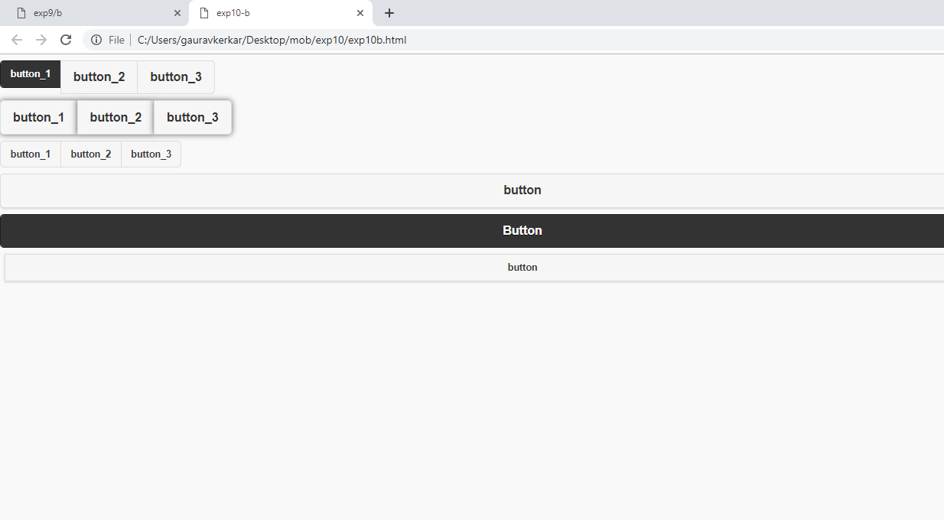

First asa tho

