What is Nexus?

“Sonatype Nexus Repository Manager provides a central platform for storing build artifacts, saving us significant maintenance and hardware costs.

**Install Process of Nexus: -**

**Step 1: -** Install Nexus image on container

You can first configure docker ce on your nexus server.

$ sudo yum install -y yum-utils

You can create docker repository

$ sudo yum-config-manager --add-repo <https://download.docker.com/linux/rhel/docker-ce.repo>

$ sudo yum install docker-ce docker-ce-cli containerd.io docker-buildx-plugin docker-compose-plugin

$ sudo firewall-cmd --permanent --add-port={6443,2379,2380,10250,10251,10252,25,465}/tcp

$ sudo firewall-cmd --reload

$ sudo firewall-cmd --list-all

$ sudo docker run --name nexus -d -p 8081:8081 sonatype/nexus3

Link:- 192.168.56.118:8081

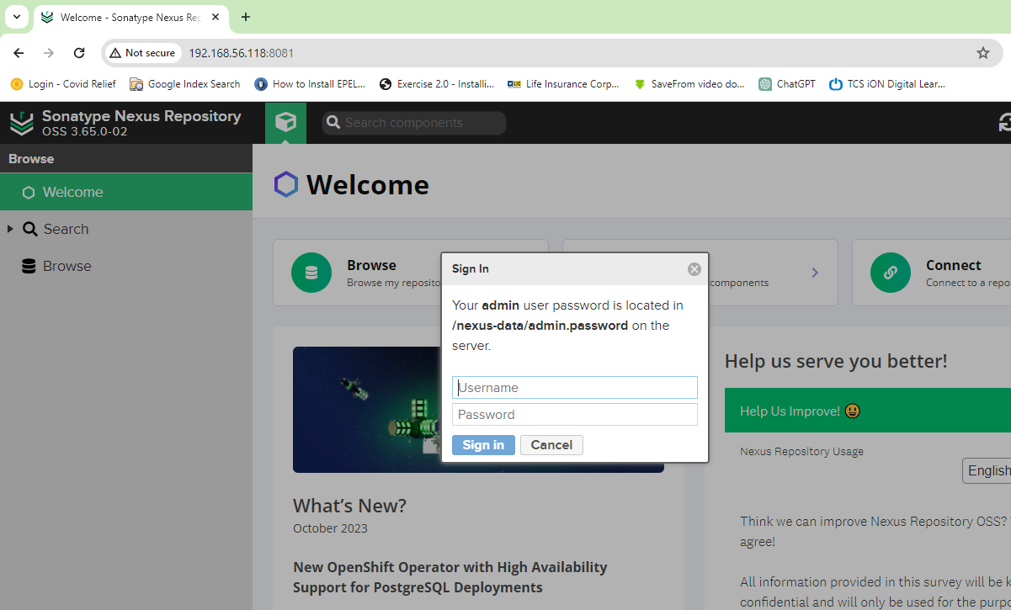

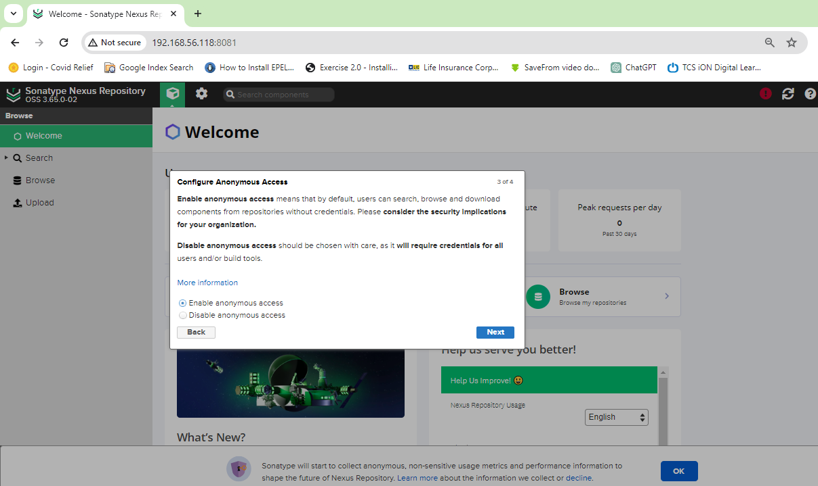

$ sudo docker exec -it nexus /bin/bash