Student Details:

Full Name: Gaurav Kharel

Student ID: C7275297

Project Github Link: <https://github.com/gauravkharel/tbc-ase-finalcomponent.git>

Youtube Video Link: <https://youtu.be/_OWRlMzEJ7I>

**Software Screenshot:**

The main interface of the software:

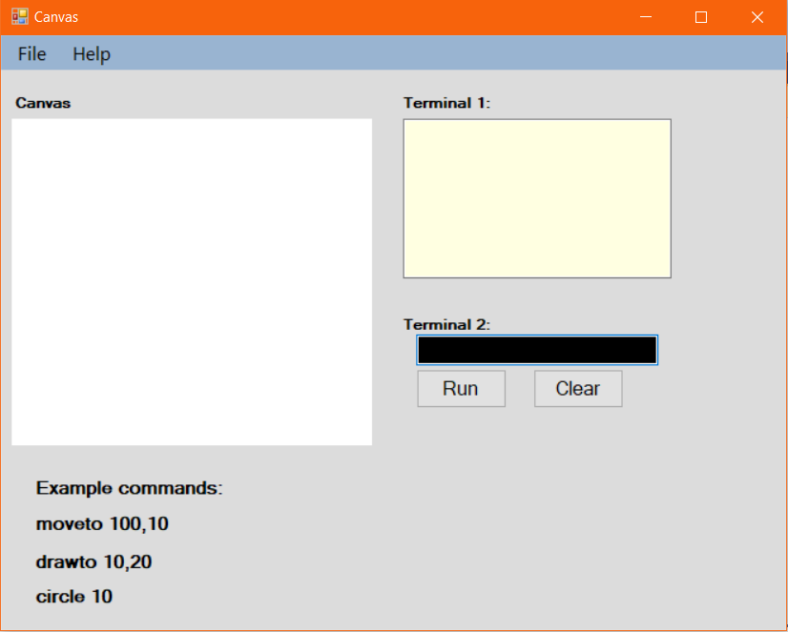

The navigation bar comprises File and Help. The File navigation has two options which are Save and Load which saves command to the local storage and can again load in .txt format.

**Single Line Command:**

This screenshot represents Terminal 1 execute the drawline command which is the single line command.

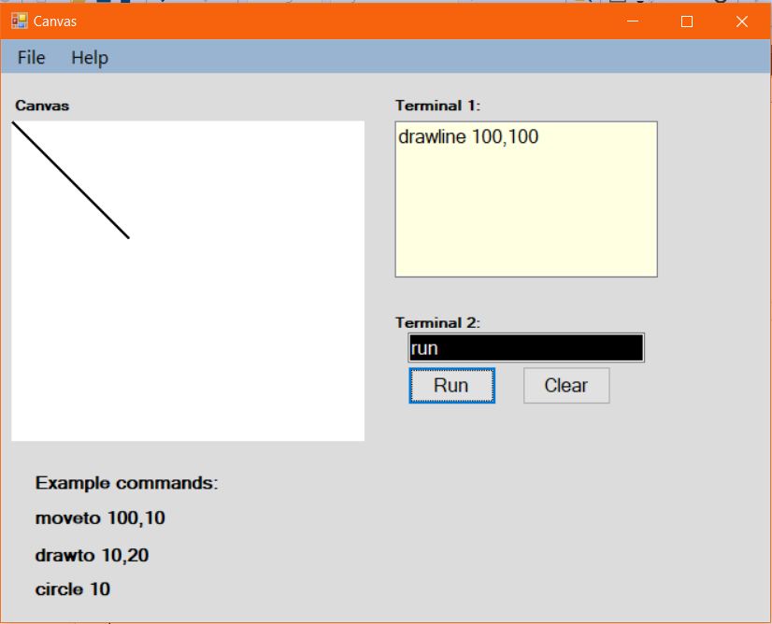

**Double Line Command:**

As the single line command, the double-line command is implemented using Factory Design Pattern with the Shapes having its own class along with class Shape and Factory class.

Using “moveto” and “rectangle ” commands in terminal 1 and “run” commands in terminal 2 as in the below screenshot.

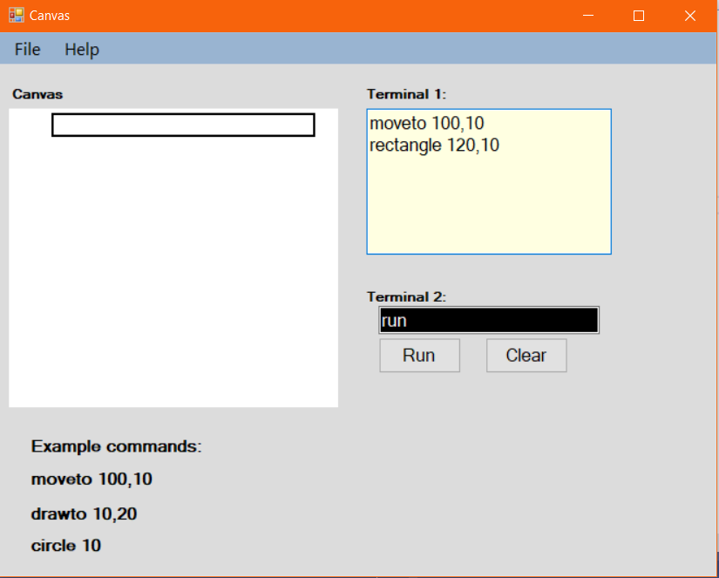

Using “moveto” and “triangle ” commands in terminal 1 and “run” commands in terminal 2 as in the below screenshot.

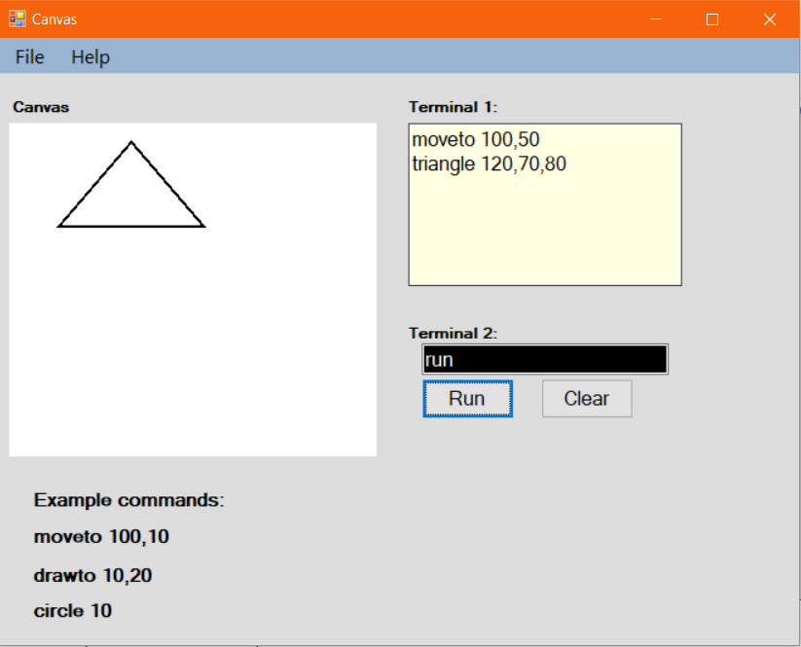

**Exception Handling:**

The exception handling is done using try and catch exception handling. The try statement allows to define a block of code to be tested for errors while it is being executed and the catch statement allows to define a block of code to be executed, if an error occurs in the try block.

The if-else statement is used to check the syntax and to show the error method box is used.

**Syntax-checking in single-line command:**

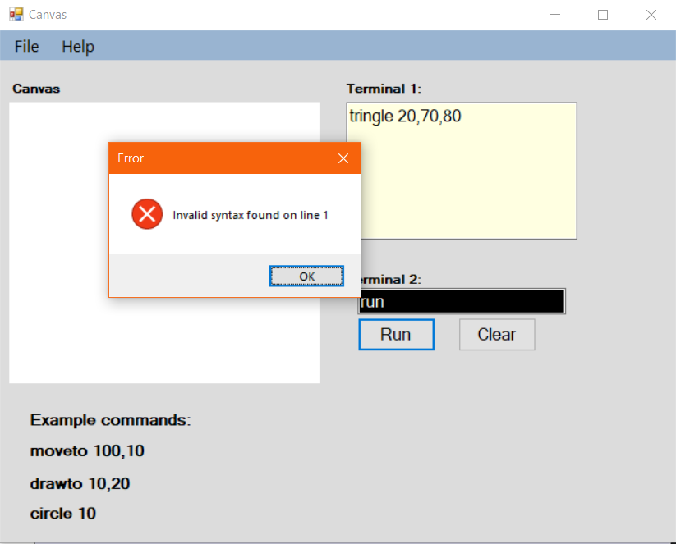

**Syntax checking on double-line command:**

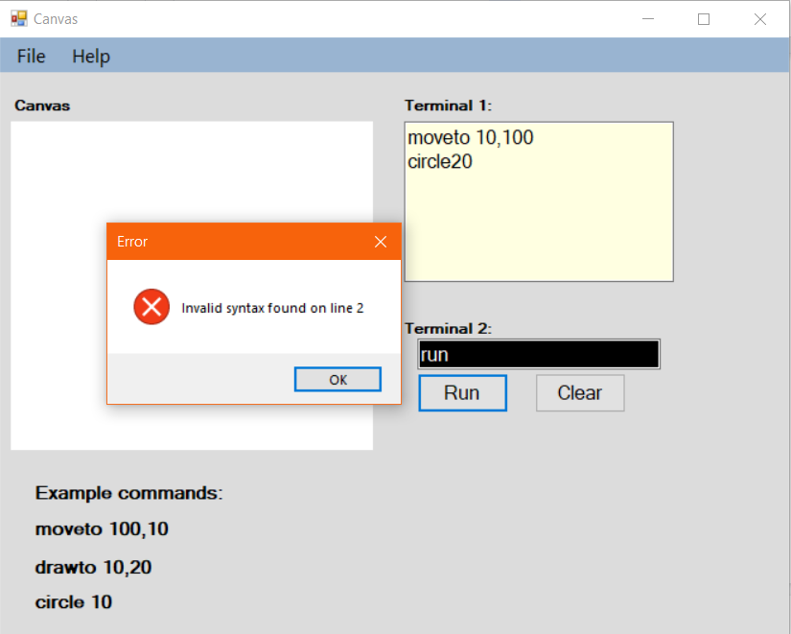

Design and Implementation Standard:

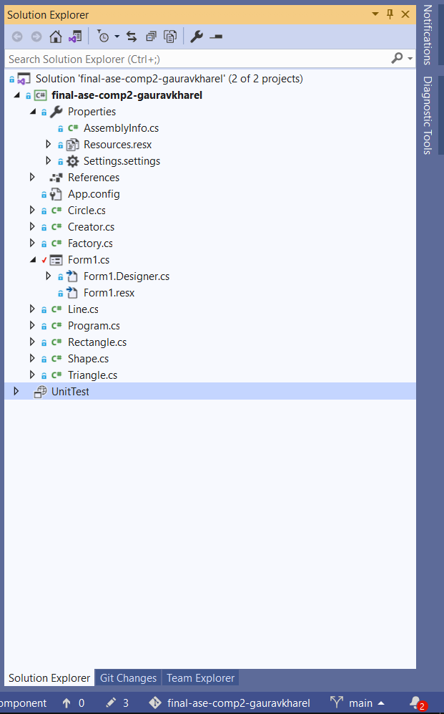

The above screenshot represents the implementation of factory design with inheritance which comprises many classes working together to make the code more efficient and reusable.

Github Commits:

