Report
Of
AI-Powered Customer Support Chatbot
Submitted
To
School of Computer Science and Engineering
IILM University, Greater Noida, U.P.
In partial fulfilment of the requirement of degree of
B.Tech CSE

By
Roll Number of Student: 25SCS1003002706
Name of Student: GAURAV KUMAR
Batch: 2025-29

CANDIDATE'S DECLARATION
I, GAURAV KUMAR, do hereby declare that the internship report titled “AI-Powered Customer Support Chatbot” has been completed by me to fulfil the requirement for the award of the degree of Bachelor of Technology in CSE. All the references have been quoted and I have not taken as such any material from any other source. I affirm to you that this report is my own and has not been submitted to any other institute for any degree/diploma requirement and further I shall be solely responsible for any kind of copyright violation in this regard.
Signature
Student Name: GAURAV KUMAR
Roll No.: 25SCS1003002706

ACKNOWLEDGEMENT
I am using this opportunity to express my gratitude to everyone who supported me throughout the Internship Program. I am thankful for their aspiring guidance, invaluably constructive criticism and friendly advice during this work. I am sincerely grateful to them for sharing their truthful and illuminating views on a number of issues related to this work.
I would like to thank Codec Technologies Pvt. Ltd. for providing me the opportunity to undertake this internship, and my project mentors for their continuous support and guidance throughout the development of this project. I also thank the faculty of the School of Computer Science and Engineering, IILM University, for their encouragement.
I express my gratitude to my parents for their blessings.
Signature
Student Name: GAURAV KUMAR
Roll No.: 25SCS1003002706

TABLE OF CONTENTS
Chapter No. | Chapter Name | Page Nos.
 | Cover Page | —
1. | Candidate's Declaration | i
2. | Acknowledgment | ii
3. | Internship Completion Certificate | iii
4. | Project Description  4.1 Introduction  4.2 Organization Profile  4.3 Problem Statement  4.4 Project Objectives  4.5 Scope of the Project  4.6 Technologies and Tools Used  4.7 System Architecture  4.8 Methodology  4.9 Expected Outcomes  4.10 Certificates of completion and other communication mail proof | 1
5. | Bibliography/References | —

INTERNSHIP COMPLETION CERTIFICATE
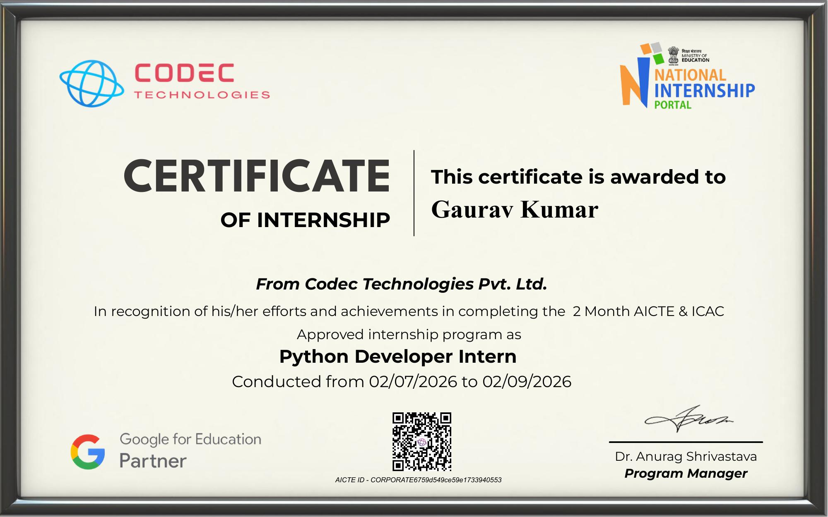

4. Project Description

4.1 Introduction
This internship report documents the design, implementation, and functioning of an AI-Powered Customer Support Chatbot, developed as part of a 2-month internship undertaken as a Python Developer Intern at Codec Technologies Pvt. Ltd. The application is a self-contained, web-based conversational agent built entirely with free, open-source tools — no paid or third-party AI APIs are used.
The chatbot is designed to answer customer-support and FAQ-style questions, recognize the same question asked in different ways, maintain minimal conversational context for follow-up questions, and log every conversation to a local database. It follows a retrieval-based design: rather than generating novel text the way a large language model would, it matches a user's message against a curated set of frequently asked questions (FAQs) and returns a pre-approved response, making the system fast, predictable, and fully explainable.

4.2 Organization Profile
Codec Technologies Pvt. Ltd. is a global platform dedicated to empowering learners and connecting diverse talent to create meaningful career opportunities worldwide. Codec Technologies delivers dedicated IT and business consultancy services across 27+ countries, empowering global innovation and strategic growth. The organization is a Google for Education Partner and is ISO 9001:2015 certified, and runs its internship programs through the National Internship Portal under an AICTE-approved corporate ID. The internship was carried out in Pan India, Hybrid mode, under the designation of Python Developer Intern, from 02/07/2026 to 02/09/2026, reporting to the assigned Project Head(s).

4.3 Problem Statement
Customer support teams routinely spend a large portion of their time answering repetitive, predictable questions — account issues, pricing, payments, refunds, business hours, and order status. Handling these manually is slow, inconsistent, and does not scale as the number of customers grows. There is a need for an automated first line of response that can instantly recognize a customer's intent, even when phrased differently from one user to the next, and reply with an accurate, pre-approved answer — while remaining transparent, low-cost, and easy to maintain, unlike opaque and expensive third-party AI services.

4.4 Project Objectives
- Build a working, locally-hosted chatbot web application without any dependency on paid AI APIs.
- Apply core NLP techniques (tokenization, stop-word removal, lemmatization) to normalize free-form user text.
- Implement intent detection using TF-IDF vectorization and cosine similarity.
- Design a lightweight mechanism for basic multi-turn conversational context.
- Provide a persistent conversation log using SQLite for traceability.
- Deliver a clean, responsive chat interface (HTML/CSS/JavaScript) that communicates with the backend via a JSON REST endpoint.
- Implement robust error handling across the frontend, backend, and database layers.

4.5 Scope of the Project
The chatbot understands and responds to customer queries across 15 predefined intents — greetings, goodbyes, thanks, account creation/password/deletion, services offered, services pricing, payment methods and failures, refund policy and requests, contact information, business hours, and order tracking. It handles variation in phrasing through text normalization and similarity scoring rather than exact keyword matching, maintains short-term conversational context so simple follow-up questions are understood, persists every conversation exchange to a SQLite database, and is designed to fail gracefully so that the server never crashes on malformed input.

4.6 Technologies and Tools Used
Layer | Technology | Purpose
Backend | Python 3.9+, Flask 3.0.3 | Web server, routing, session handling
NLP | NLTK 3.9.1 | Tokenization, stop-word removal, lemmatization
Machine Learning | scikit-learn 1.5.2 | TF-IDF vectorization, cosine similarity
Numerical Computing | NumPy 1.26.4 | Underlying array operations for scikit-learn
Database | SQLite (built-in sqlite3) | Local, file-based conversation logging
Frontend | HTML5, CSS3, Vanilla JavaScript | Chat UI and client-side interaction

4.7 System Architecture
The application follows a simple three-tier architecture: a browser-based frontend, a Flask backend that exposes a REST endpoint, and an NLP engine backed by a SQLite database. The user types a message in the chat UI, which sends a POST request to the /chat endpoint. Flask (app.py) validates the request, retrieves the last conversational topic from the session, and passes the message to the NLP engine (nlp_engine.py), which cleans the text, vectorizes it with TF-IDF, computes cosine similarity against the FAQ dataset (faq_data.py), and determines the best-matching intent. The chosen response is returned to Flask, logged to SQLite via database.py, and sent back to the frontend as JSON.
Component flow (textual):
Browser (index.html + script.js) → Flask App (app.py) → NLP Engine (nlp_engine.py + faq_data.py) → SQLite (database.py → chatbot.db) → JSON reply back to Browser

4.8 Methodology
The chatbot uses a classical, explainable NLP pipeline rather than a neural/generative model:
- Preprocessing: incoming text is lowercased, stripped of punctuation, tokenized with NLTK's word_tokenize, cleared of English stop-words, and lemmatized with WordNetLemmatizer.
- Vectorization: a TfidfVectorizer is fitted once at start-up over every FAQ pattern, using the preprocessing function as its custom analyzer.
- Similarity scoring: each incoming message is transformed into the same TF-IDF space, and cosine_similarity is computed against every stored FAQ pattern; the best score per intent is kept.
- Context handling: a small bonus (+0.12) is added to the previous turn's intent score, so short follow-up questions stay anchored to the current topic.
- Decision thresholds: a score ≥ 0.35 answers directly (high confidence); ≥ 0.15 is accepted only with context support (low confidence); anything lower triggers a randomized fallback message.
- Response selection: once an intent is chosen, one response is picked at random from its list of pre-written responses, and the exchange is logged to SQLite (conversations table: id, user_message, bot_response, intent, timestamp).

4.9 Expected Outcomes
- A fully functional, locally-hosted chatbot capable of answering 15 categories of customer queries with consistent, pre-approved responses.
- Reliable recognition of varied phrasings of the same question through TF-IDF and cosine similarity matching.
- A persistent, queryable log of every conversation for review and analytics.
- A responsive, easy-to-use chat interface that works on both desktop and mobile browsers.
- A codebase that is easy to extend — new FAQ topics can be added with no changes to the matching logic.
- Hands-on, industry-level experience applying NLP, web development, and database design as part of the internship program.

4.10 Certificates of completion and other communication mail proof
The Internship Offer Letter issued by Codec Technologies Pvt. Ltd. is attached below as proof of the internship engagement.
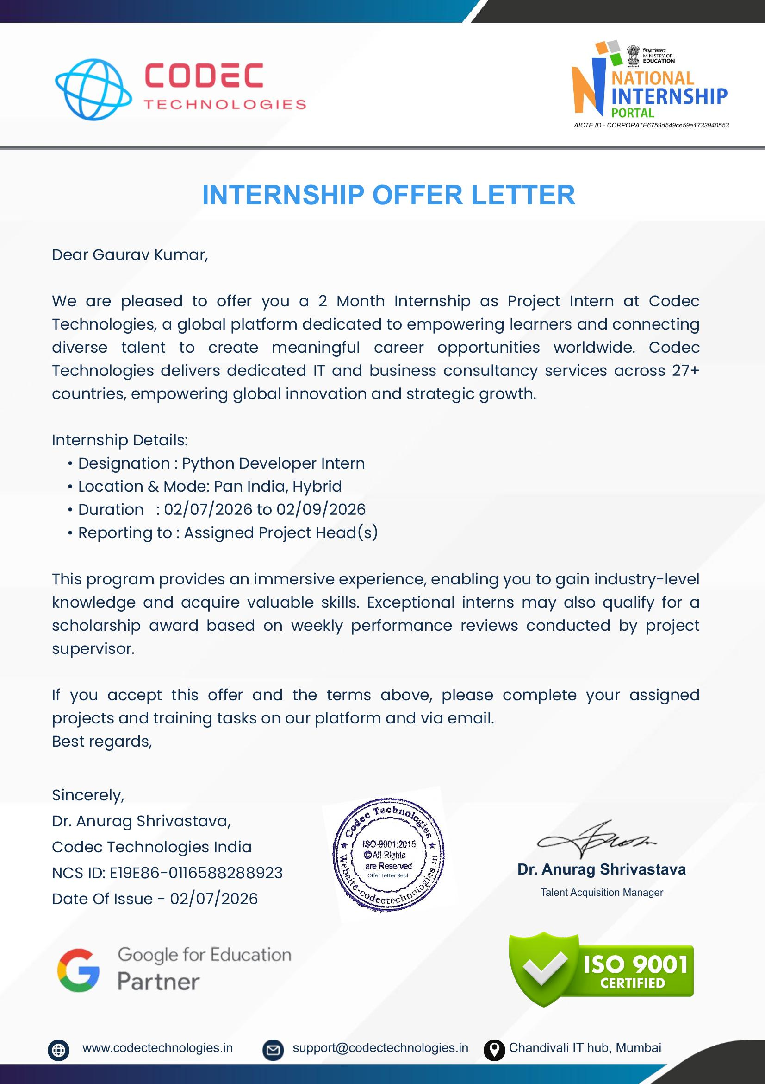

5. Bibliography/References
1. Flask Documentation — https://flask.palletsprojects.com/
2. NLTK Documentation — https://www.nltk.org/
3. scikit-learn Documentation — https://scikit-learn.org/stable/
4. Python 3 Documentation — https://docs.python.org/3/
5. SQLite Documentation — https://www.sqlite.org/docs.html
6. Codec Technologies Pvt. Ltd. — https://www.codectechnologies.in

