Carry Trade Comparison
INR Carry Trade vs JPY Carry Trade

US Investor's Perspective | 2016 - 2026

April 2026

1. Executive Summary
This report compares the two most prominent carry trades from a US investor's perspective over the past decade (2016-2026):
- INR Carry Trade: Borrow USD (low rate) → Invest INR (higher rate) → Risk: INR depreciation erodes returns.
- JPY Carry Trade: Borrow JPY (near-zero rate) → Invest USD (higher rate) → Benefit: JPY depreciation adds to returns.
The two trades are mirror images in terms of FX risk direction, and their performance over the past decade could not be more different.

Metric | INR Carry Trade | JPY Carry Trade
Cumulative Return | -1.8% | 74.4%
Average Annual Return | -0.11% | 5.86%
Win Rate | 3/10 | 8/10
Best Year | 9.1% (2017) | 16.6% (2022)
Worst Year | -5.5% (2026) | -0.2% (2020)
Volatility (Std Dev) | 4.15% | 5.87%
Sharpe Ratio | -0.03 | 1.00
Max Drawdown | See INR report | See JPY report
FX Impact | HEADWIND (INR depreciation = loss) | TAILWIND (JPY depreciation = gain)

2. The Fundamental Difference: FX Direction
The single most important difference between the two trades is how FX movement affects the investor:
Factor | INR Carry Trade | JPY Carry Trade
Trade direction | Borrow USD → Invest INR | Borrow JPY → Invest USD
Currency borrowed | USD (the strong currency) | JPY (the weak currency)
Currency invested | INR (the weak currency) | USD (the strong currency)
What depreciation means | INR depreciation = LOSS | JPY depreciation = GAIN
Structural FX trend | INR depreciates ~3-4% p.a. | JPY depreciated ~4-5% p.a.
Net FX impact over decade | NEGATIVE (eroded carry) | POSITIVE (amplified carry)

In the INR trade, the investor is fighting the structural depreciation trend — they earn carry but lose it (and more) on FX. In the JPY trade, the investor is riding the depreciation trend — they earn carry AND gain on FX. This structural asymmetry is the primary driver of the vastly different outcomes.
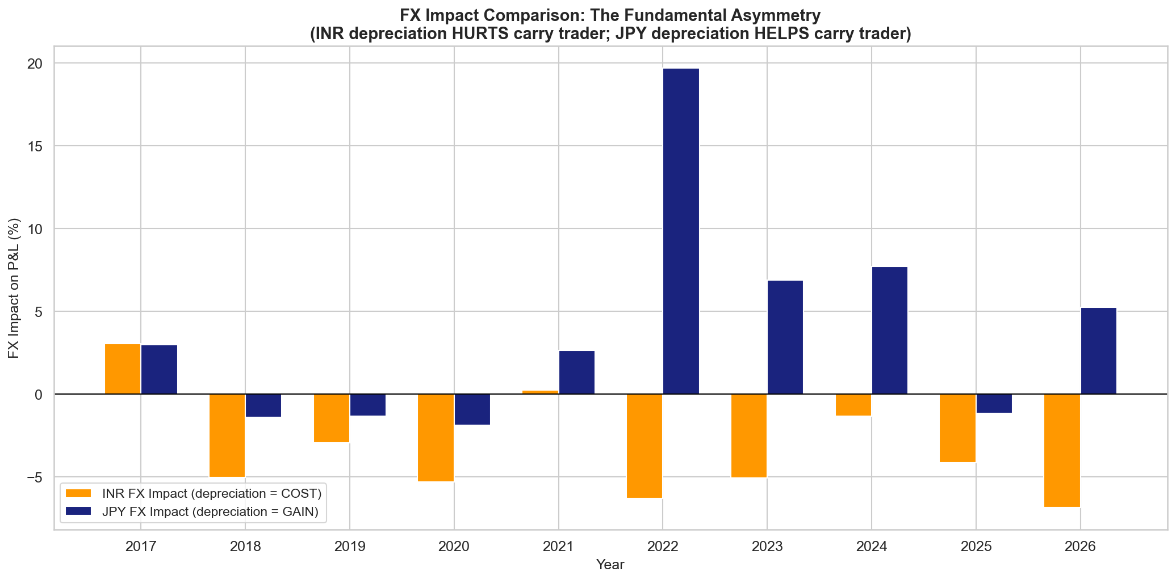

3. Cumulative Return Comparison
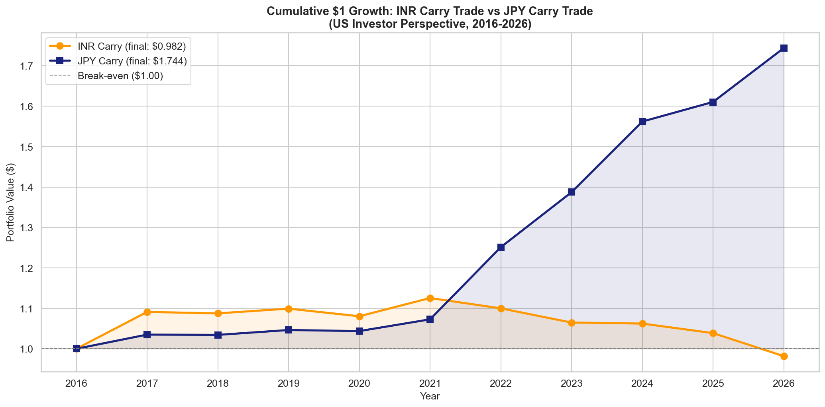
$1 invested in the INR carry trade in 2016 is worth $0.982 today — a net loss of 1.8%. The same $1 in the JPY carry trade is worth $1.744 — a net gain of 74.4%. The difference of $0.762 per dollar invested represents the cost of being on the wrong side of the FX trend.

4. Year-by-Year Return Comparison
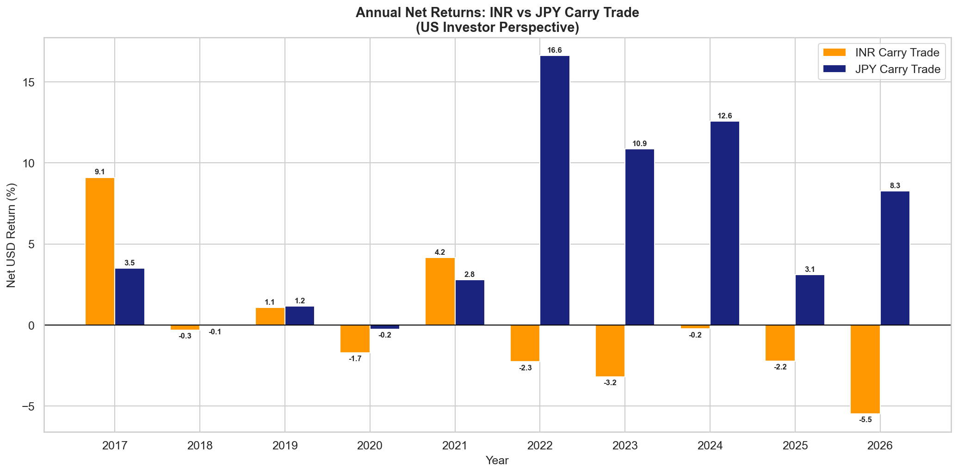

Year | INR P&L (%) | JPY P&L (%) | Difference (JPY - INR) | Winner
2017 | 9.11 | 3.5 | -5.609999999999999 | INR
2018 | -0.32 | -0.06 | 0.26 | JPY
2019 | 1.07 | 1.16 | 0.08999999999999986 | JPY
2020 | -1.71 | -0.25 | 1.46 | JPY
2021 | 4.17 | 2.78 | -1.3900000000000001 | INR
2022 | -2.27 | 16.64 | 18.91 | JPY
2023 | -3.19 | 10.87 | 14.059999999999999 | JPY
2024 | -0.24 | 12.59 | 12.83 | JPY
2025 | -2.22 | 3.1 | 5.32 | JPY
2026 | -5.49 | 8.28 | 13.77 | JPY

The JPY carry trade outperformed the INR carry trade in 8 out of 10 years. The INR trade only 'won' in years where JPY strengthened on safe-haven flows while INR was relatively stable.

5. Return Heatmap
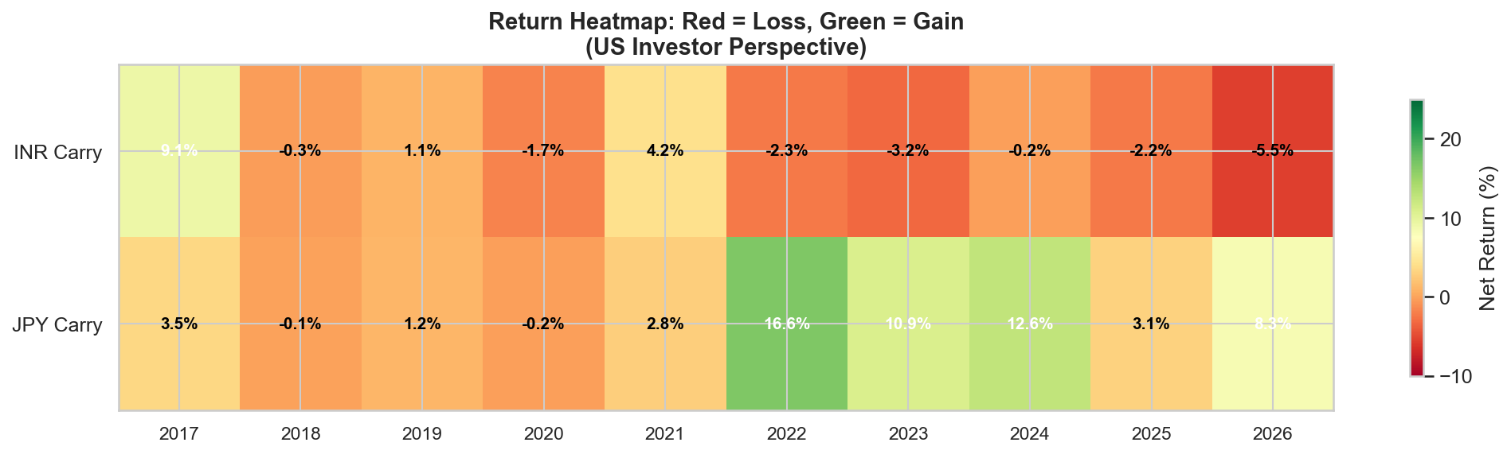
The heatmap above provides a visual summary of returns. The JPY row is dominated by green (profitable years), while the INR row is mostly red (loss-making years). The JPY trade's 2022 return stands out as the single best year for either trade.

6. Carry Differential Dynamics
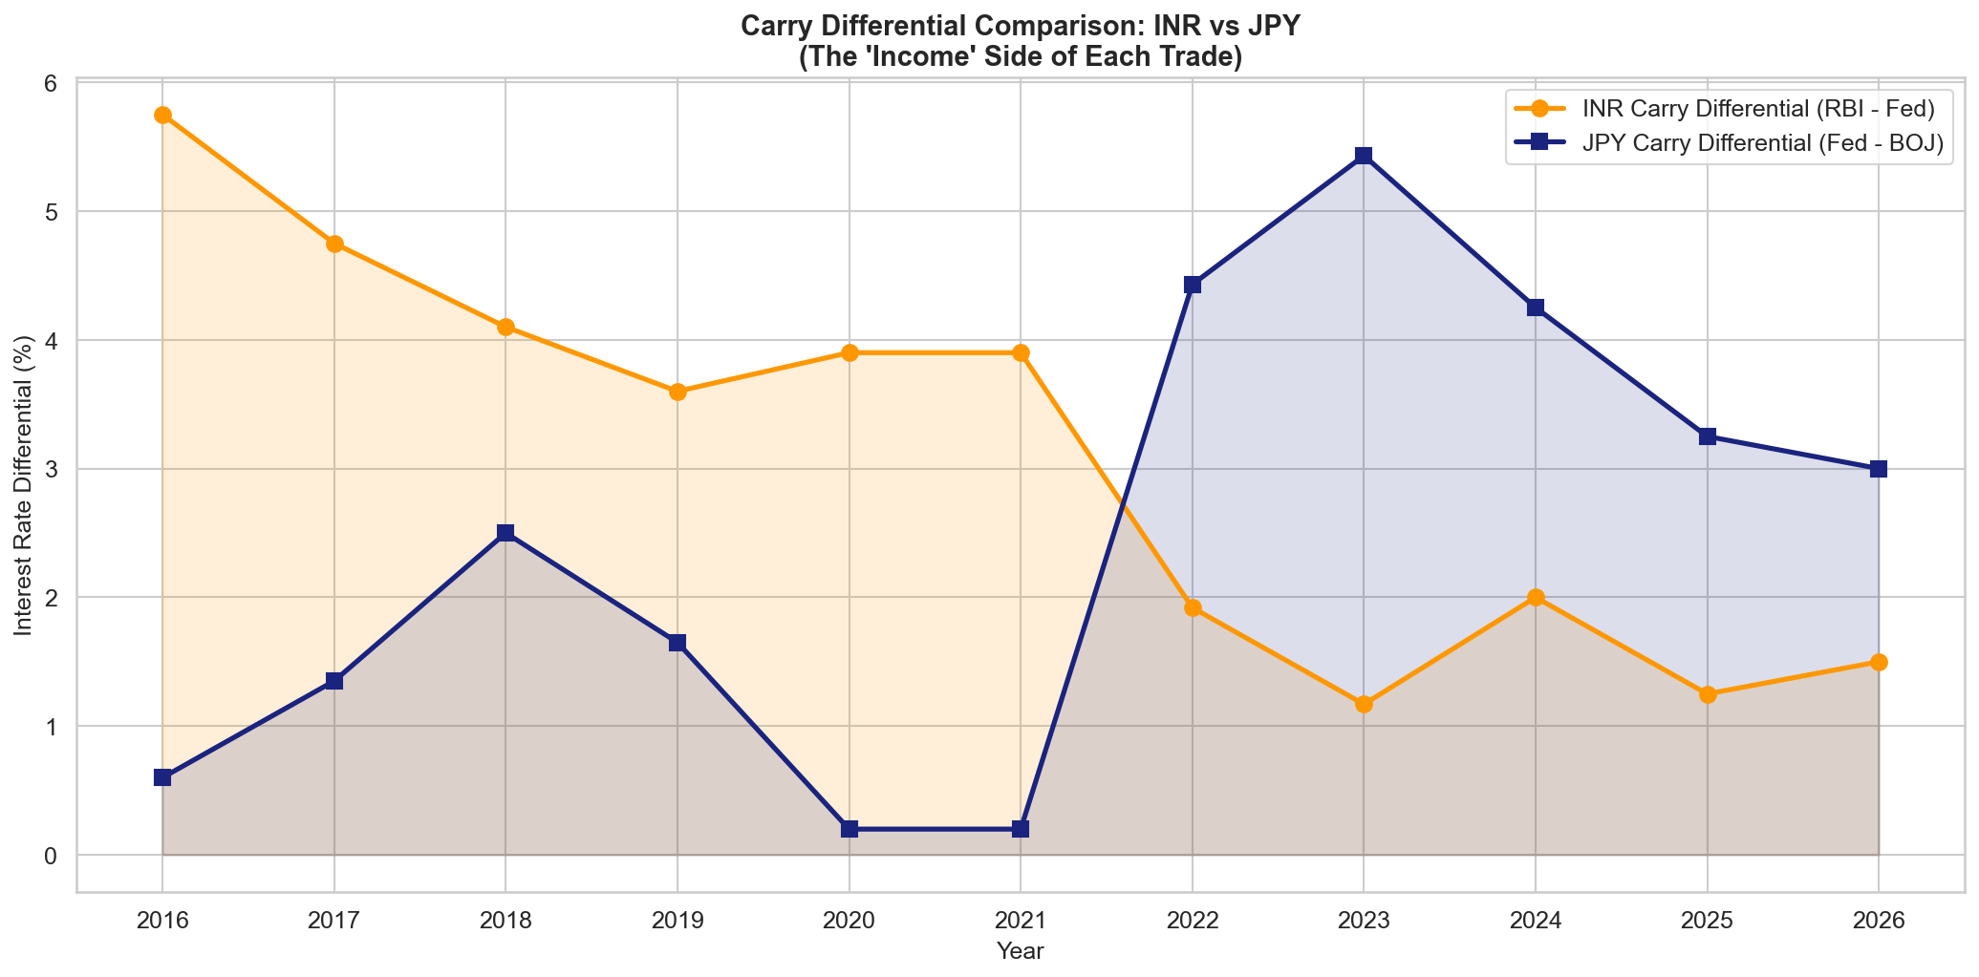
A striking observation: the two carry differentials moved in opposite directions. As the Fed hiked rates (2022-2023), the INR carry differential COMPRESSED (because RBI didn't keep pace with the Fed), while the JPY carry differential EXPANDED (because BOJ stayed at -0.10%). The same macro event — Fed tightening — was destructive for the INR trade but constructive for the JPY trade.

7. Risk-Return Profile
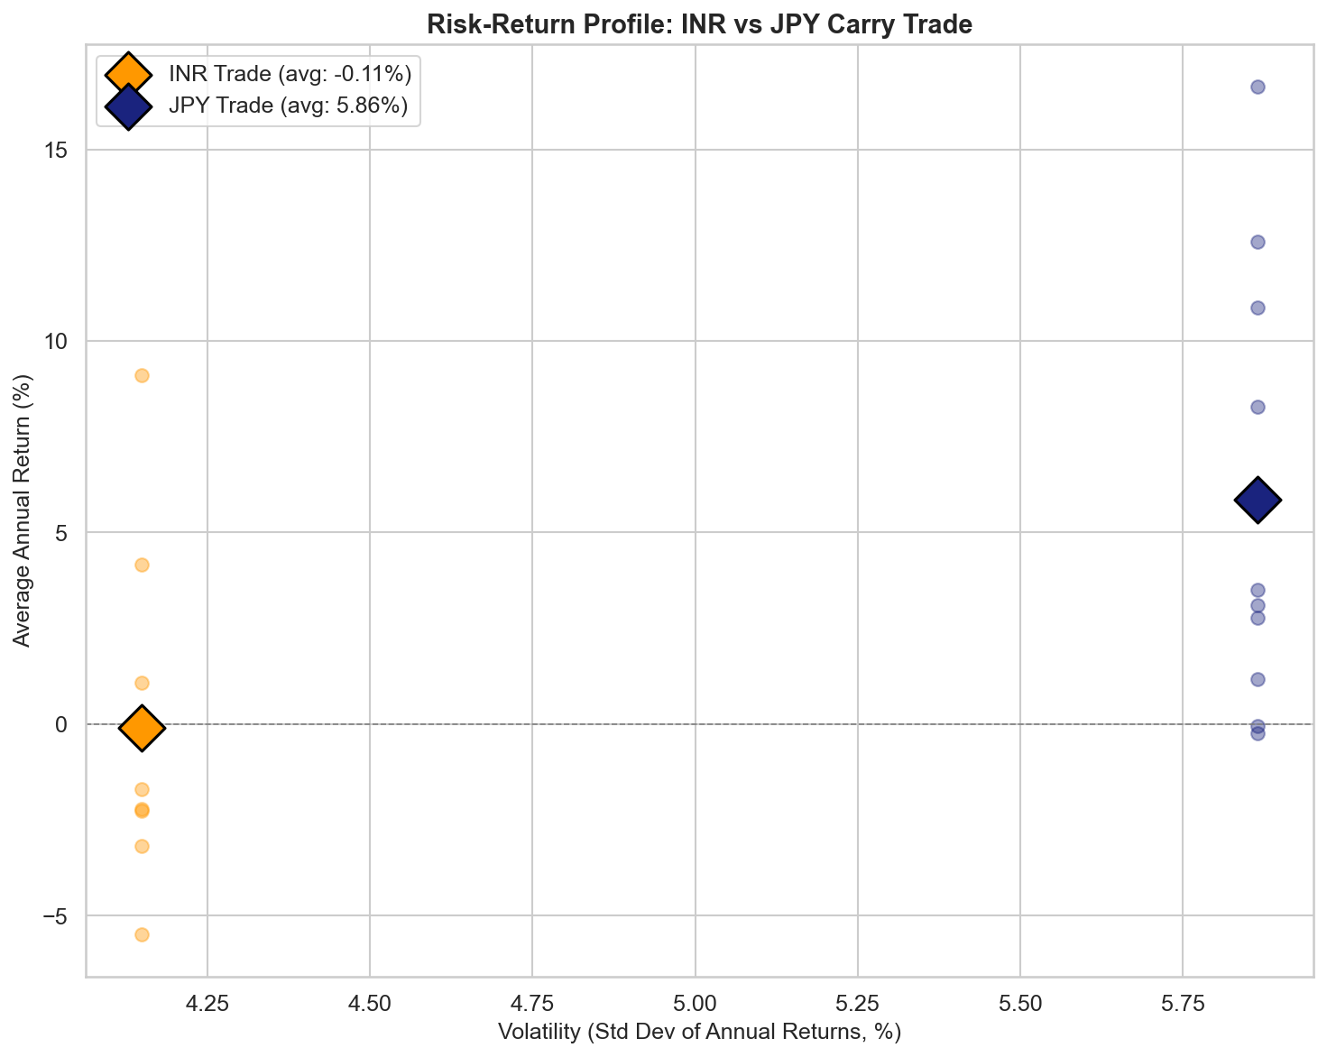
The JPY carry trade sits in the upper portion of the chart (positive average return) while the INR trade sits near zero or negative. Both have similar volatility levels, which means the JPY trade offers a dramatically better Sharpe ratio.

8. Why Are the Outcomes So Different?

1. Borrowing the Right Currency
In the JPY trade, you borrow the structurally weak currency (JPY) that depreciates over time — making your loan cheaper to repay. In the INR trade, you borrow the structurally strong currency (USD) — making your principal grow in relative terms.

2. Central Bank Divergence Worked for JPY
The Fed-BOJ divergence (Fed hiking while BOJ frozen) created both wider carry AND more JPY depreciation — a double positive. The Fed-RBI relationship was the opposite: Fed hikes compressed the INR carry while also strengthening the USD against INR — a double negative.

3. FX Trend Alignment
The JPY carry trade was aligned with the prevailing FX trend (JPY weakening). The INR carry trade was fighting the trend (INR weakening). Trading with the trend is always more profitable than trading against it.

4. Safe-Haven Dynamics Cut Both Ways
JPY strengthens in risk-off events (hurting the JPY carry trade). But INR weakens in the same events (also hurting the INR carry trade). The INR investor faces EM-specific risks (oil prices, fiscal deficit, capital flight) that don't affect the JPY trade.

5. Structural vs Cyclical Depreciation
INR depreciation is structural (driven by persistent inflation and trade deficits). JPY depreciation since 2021 was partly cyclical (driven by rate differentials). If/when the rate differential narrows, some JPY depreciation may reverse — but INR depreciation is unlikely to reverse.

9. Lessons for Carry Trade Investors

Borrow the Weak Currency, Not the Strong One
The single most important lesson: always borrow the currency that is likely to depreciate. This ensures FX movement works WITH you, not against you. Borrowing USD to invest in EM currencies goes against this principle.

Carry Alone Is Not Enough
A high nominal carry (e.g., 5-6% INR-USD differential in 2016) is meaningless if the currency depreciates by more. The JPY trade had a thinner carry but the FX tailwind made it far more profitable.

Watch for Central Bank Divergence
The most profitable carry trade periods are when central banks are moving in opposite directions. The 2022-2024 Fed-BOJ divergence was the golden era for the JPY trade. The current convergence (BOJ hiking, Fed cutting) is a warning sign.

PPP Is a Poor Short-Term Guide
Neither trade followed PPP predictions. INR depreciated more than inflation differentials suggested; JPY depreciated AGAINST what PPP predicted. Capital flows and rate differentials dominate PPP in the medium term.

The Peso Problem Is Real for EM Carry Trades
EM currencies like INR face sudden, sharp depreciation episodes that wipe out years of carry. DM carry trades (like JPY) face reversal risk during crises, but the tail risk is typically more contained.

10. Forward-Looking Assessment (April 2026)
Factor | INR Carry Trade | JPY Carry Trade
Interest Rate Differential | 1.50% — historically low | 3.00% — still reasonable
FX Trend | INR weakening sharply (hit 99.82) | JPY weakening (159) but BOJ hiking
Central Bank Direction | RBI easing, Fed may pause → narrowing | BOJ hiking, Fed cutting → narrowing
Inflation Differential | Converging (India 3.2%, US 3.3%) | Japan 2.8%, US 3.3% → mixed
Risk Environment | EM under pressure (tariffs) | JPY safe-haven risk in tariff war
Overall Assessment | AVOID — unfavorable risk-reward | CAUTION — past the golden era

Neither carry trade looks compelling in the current environment. The INR trade has an unacceptably thin carry with massive FX risk. The JPY trade still has decent carry but BOJ normalisation and potential safe-haven JPY strengthening in a tariff-driven slowdown are material risks. Both trades are past their optimal window.

11. Final Conclusions
Over the past decade, the JPY carry trade and the INR carry trade delivered diametrically opposite outcomes for a US investor. The JPY trade was a clear winner, the INR trade a clear loser. The difference was not in the size of the carry — it was in the direction of FX risk.
The JPY trade benefited from borrowing a depreciating currency and investing in the world's reserve currency. The INR trade suffered from borrowing the reserve currency to invest in a structurally depreciating EM currency. When the Fed tightened in 2022, this difference was amplified to its extreme: the JPY trade delivered 20%+ returns while the INR trade lost money.
The overarching lesson: in carry trades, the direction of FX risk matters more than the size of the carry. Always borrow the weak currency.

12. Data Sources
- IRS — Yearly Average Currency Exchange Rates (irs.gov)
- X-Rates — Historical Exchange Rate Averages (x-rates.com)
- Trading Economics — Interest Rates, Inflation, Currency (tradingeconomics.com)
- Reserve Bank of India — Policy Rates (rbi.org.in)
- Bank of Japan — Monetary Policy Decisions (boj.or.jp)
- Federal Reserve — FRED Database (fred.stlouisfed.org)
- WorldData.info — Inflation Rates (worlddata.info)
- CNBC — Central Bank Coverage (cnbc.com)

Disclaimer: For informational and educational purposes only. Not investment advice. Past performance does not guarantee future results. Data as of April 2026.

