USD/INR Carry Trade Analysis
US Investor's Perspective | 2016 - 2026

April 2026

Table of Contents
- 1. Executive Summary
- 2. Methodology — How a Carry Trade Works
- 3. Market Data Overview
- 4. Investor P&L Analysis
- 5. P&L Decomposition
- 6. Cumulative Return Analysis
- 7. Interest Rate Environment
- 8. Currency Trend Analysis
- 9. Inflation & PPP Analysis
- 10. Carry Attractiveness Over Time
- 11. Risk Metrics
- 12. Key Observations & Phase Analysis
- 13. Current Environment Assessment
- 14. Conclusions
- 15. Data Sources

1. Executive Summary
This report analyses the USD/INR carry trade from the perspective of a US-based investor over the past decade (2016-2026). The carry trade involves borrowing in US dollars at the Fed Funds rate, converting to Indian rupees, investing at the RBI Repo rate, and converting back to USD at year-end.
The analysis focuses exclusively on the investor's actual P&L in USD terms — the only metric that matters. Indian inflation is relevant only indirectly, as a predictor of future INR depreciation, not as a direct cost to the US investor.

Key Findings:
- The carry trade delivered a net NEGATIVE cumulative return over 10 years.
- Only 2 out of 10 years (2017, 2021) were clearly profitable.
- Average carry earned: ~3.2% p.a. vs Average INR depreciation: ~3.4% p.a.
- The interest rate differential compressed from 5.75% (2016) to just 1.50% (2026).
- The INR depreciated ~39% cumulatively (67.18 to 93.09), hitting an all-time low of 99.82 in March 2026.
- The trade exhibits classic 'peso problem' characteristics — steady small gains wiped out by sudden large losses.

2. Methodology — How a Carry Trade Works
A carry trade exploits interest rate differentials between two currencies. The US investor executes the following steps:
- Step 1: Borrow $1 in the US at the Fed Funds rate (cost of funding).
- Step 2: Convert $1 to INR at the prevailing spot rate (e.g., $1 = INR 67.18 in 2016).
- Step 3: Invest the INR at the Indian policy rate (RBI Repo rate) for one year.
- Step 4: At year-end, convert INR (principal + interest) back to USD at the new spot rate.
- Step 5: Repay the USD loan with interest. The remainder is profit (or loss).

P&L Formula:
Exact P&L (per $1 invested):
USD_received = (USDINR_start × (1 + INR_rate)) / USDINR_end
Net P&L = USD_received - 1 - USD_borrowing_cost
If the INR depreciates more than the interest rate differential, the investor loses money. This is the central risk of the carry trade.

What Indian Inflation Means to the US Investor:
A US investor does NOT directly bear Indian inflation — they convert back to USD and spend in the US. However, India's inflation is the primary structural driver of INR depreciation over time. Higher Indian inflation relative to the US erodes INR purchasing power, leading to depreciation. So the investor monitors it as a leading indicator of currency risk, not as a direct cost.

3. Market Data Overview

3.1 Raw Data Table
Year | USD/INR (Avg) | RBI Repo (%) | US Fed (%) | India CPI (%) | US CPI (%)
2016.0 | 67.18 | 6.25 | 0.5 | 4.5 | 1.3
2017.0 | 65.12 | 6.0 | 1.25 | 3.6 | 2.1
2018.0 | 68.39 | 6.5 | 2.4 | 3.4 | 2.4
2019.0 | 70.39 | 5.15 | 1.55 | 4.8 | 1.8
2020.0 | 74.13 | 4.0 | 0.1 | 6.2 | 1.3
2021.0 | 73.94 | 4.0 | 0.1 | 5.5 | 4.7
2022.0 | 78.6 | 6.25 | 4.33 | 6.7 | 8.0
2023.0 | 82.57 | 6.5 | 5.33 | 5.4 | 4.1
2024.0 | 83.68 | 6.5 | 4.5 | 4.6 | 3.0
2025.0 | 87.13 | 5.25 | 4.0 | 2.8 | 2.7
2026.0 | 93.09 | 5.25 | 3.75 | 3.2 | 3.3

Note: Exchange rates are annual averages. Interest rates are year-end policy rates. CPI figures are annual average inflation rates. 2026 data is year-to-date as of April 10, 2026.

4. Investor P&L Analysis
The table below shows the year-by-year P&L for a US investor executing the carry trade. All figures are in USD terms.
Year | USD/INR Start | USD/INR End | INR Rate (Earn)% | USD Rate (Borrow)% | INR Depr% | Gross USD Ret% | Net P&L%
2017.0 | 67.18 | 65.12 | 6.25 | 0.5 | -3.07 | 9.61 | 9.11
2018.0 | 65.12 | 68.39 | 6.0 | 1.25 | 5.02 | 0.93 | -0.32
2019.0 | 68.39 | 70.39 | 6.5 | 2.4 | 2.92 | 3.47 | 1.07
2020.0 | 70.39 | 74.13 | 5.15 | 1.55 | 5.31 | -0.16 | -1.71
2021.0 | 74.13 | 73.94 | 4.0 | 0.1 | -0.26 | 4.27 | 4.17
2022.0 | 73.94 | 78.6 | 4.0 | 0.1 | 6.3 | -2.17 | -2.27
2023.0 | 78.6 | 82.57 | 6.25 | 4.33 | 5.05 | 1.14 | -3.19
2024.0 | 82.57 | 83.68 | 6.5 | 5.33 | 1.34 | 5.09 | -0.24
2025.0 | 83.68 | 87.13 | 6.5 | 4.5 | 4.12 | 2.28 | -2.22
2026.0 | 87.13 | 93.09 | 5.25 | 4.0 | 6.84 | -1.49 | -5.49

Chart: Carry Earned vs INR Depreciation
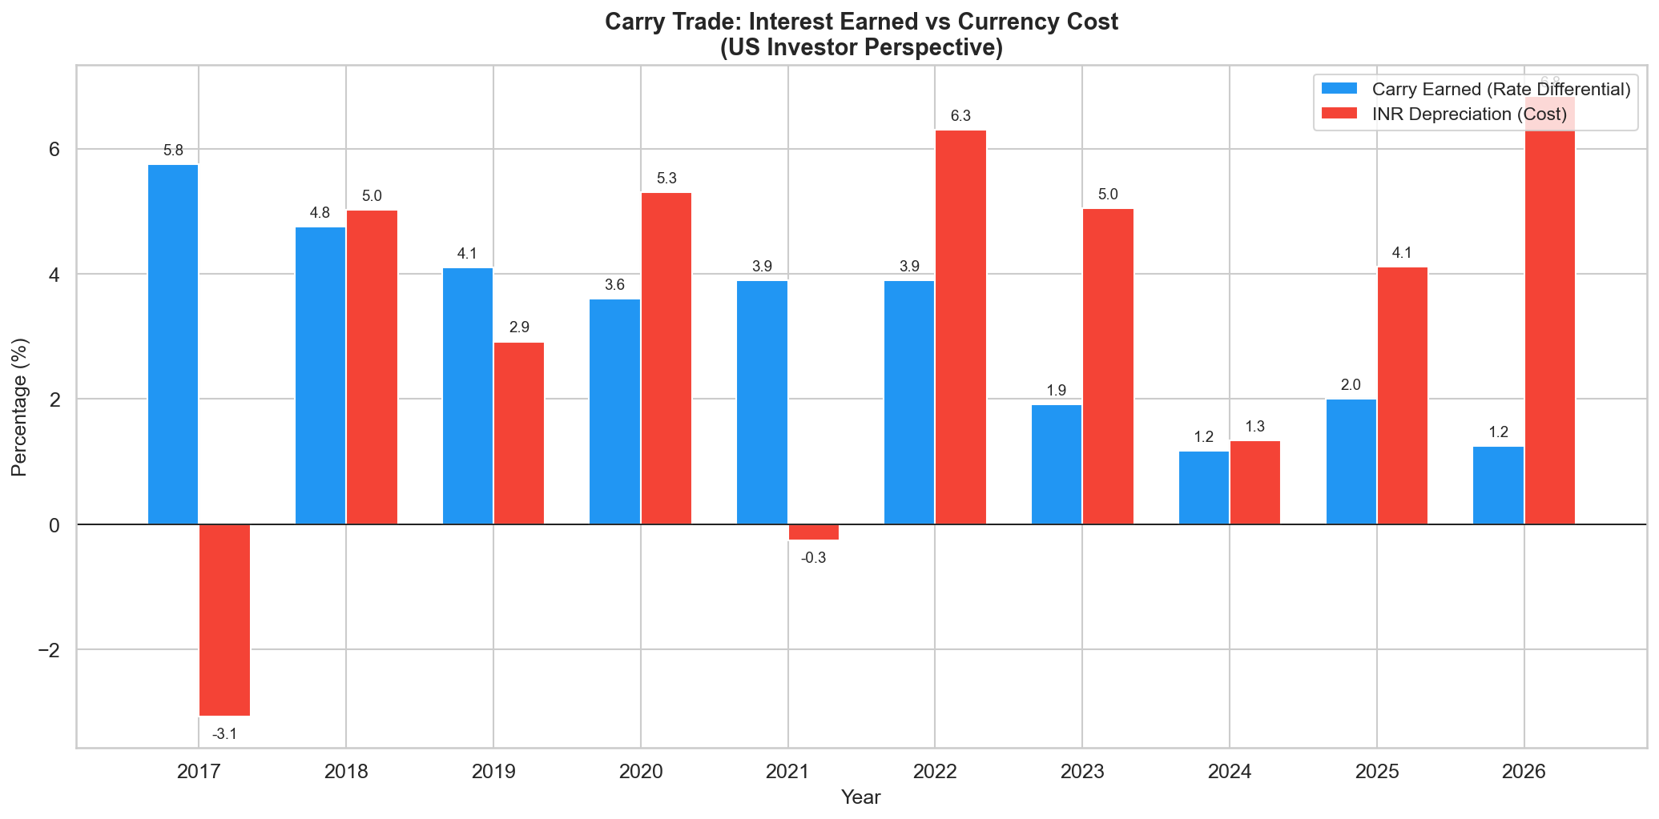

5. P&L Decomposition
The chart below breaks down the investor's return into two components: (1) Gross USD return from the INR investment after converting back, and (2) the cost of borrowing in USD. The net P&L (black diamond) is what the investor takes home.
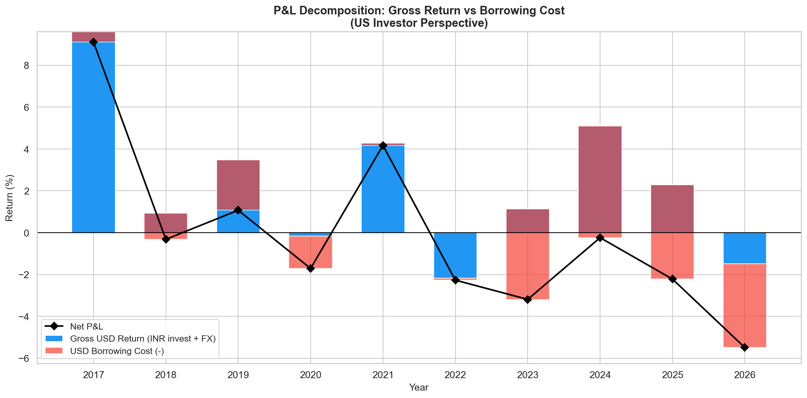

Chart: Net P&L by Year (Green = Profit, Red = Loss)
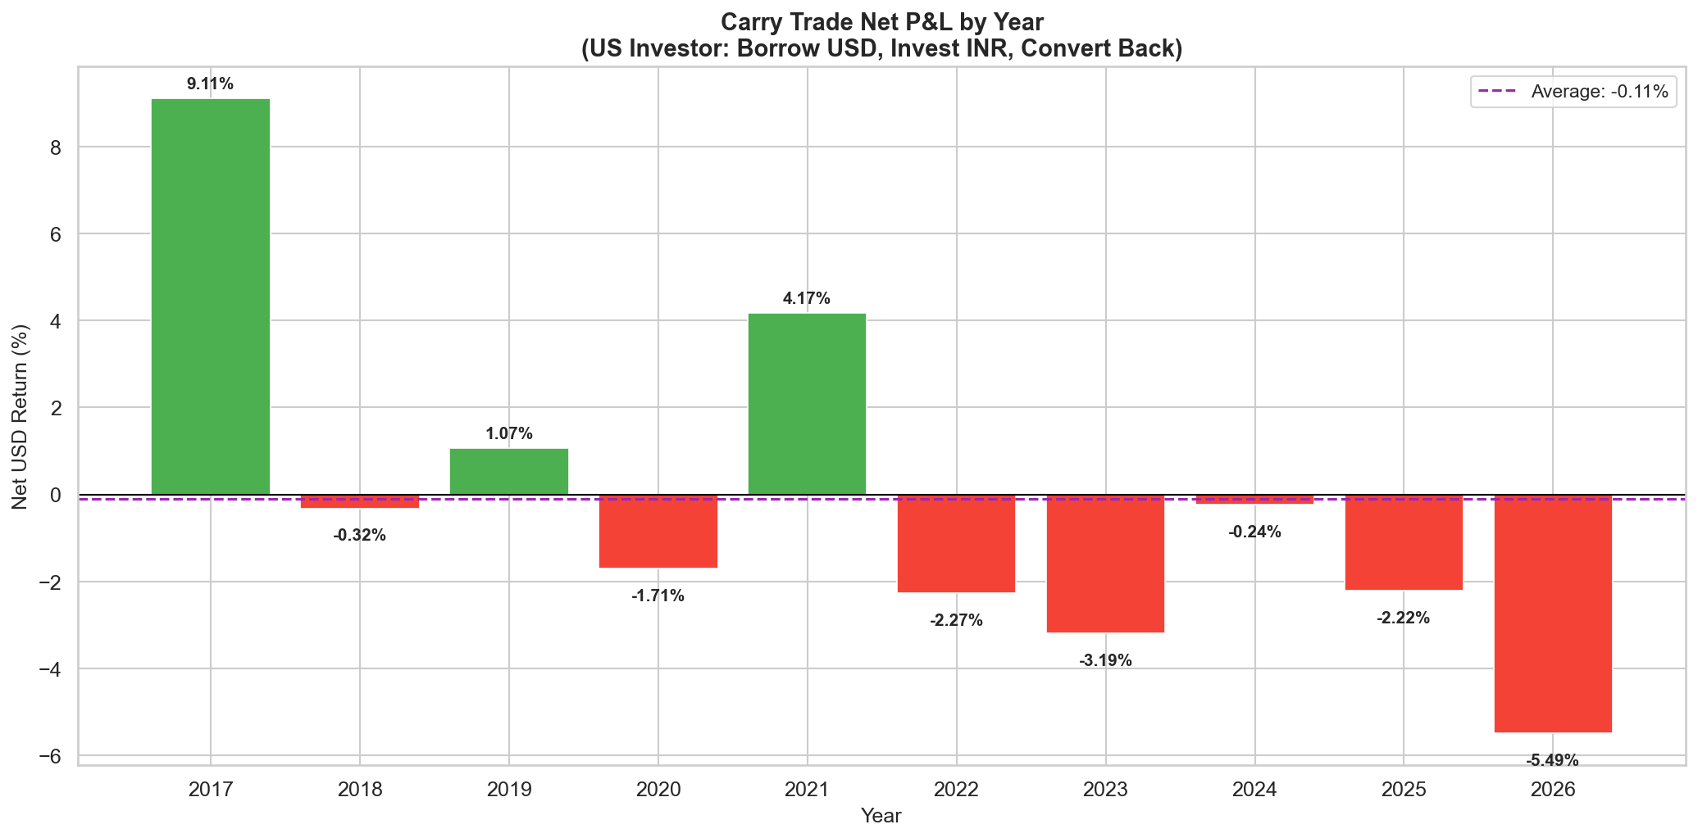

6. Cumulative Return Analysis
The chart below shows the growth (or erosion) of $1 invested in the carry trade starting in 2016, with annual reinvestment.
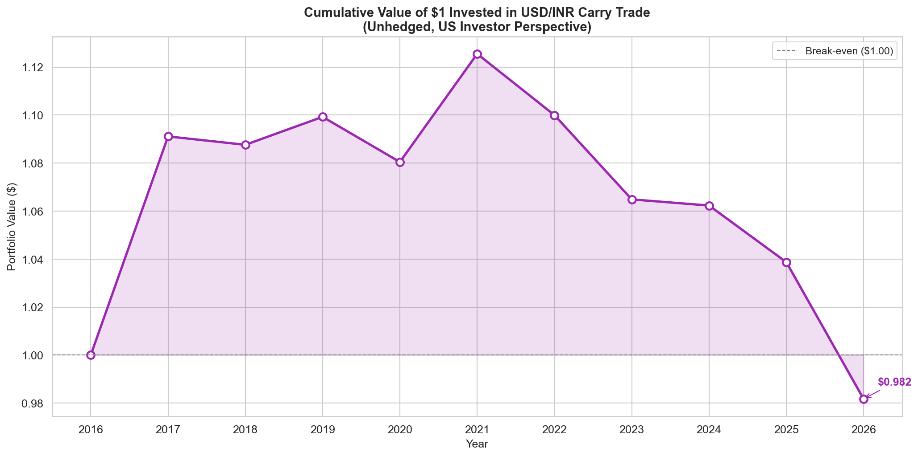
A $1 investment in 2016 would be worth $0.982 by 2026 — a cumulative loss of 1.8%. The investor would have been better off leaving the money in a US money market account.

7. Interest Rate Environment
The carry differential — the gap between RBI Repo and US Fed Funds rates — is the 'income' side of the trade. This differential has compressed dramatically since 2022 as the US Fed raised rates aggressively while RBI hikes were more measured.
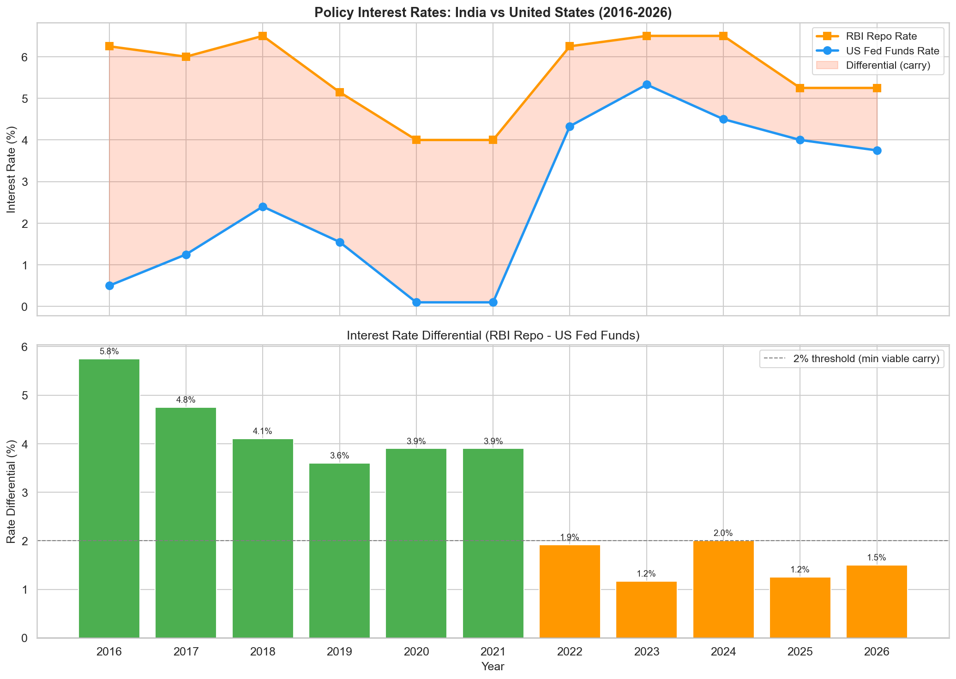
Key observation: The differential fell from 5.75% in 2016 to just 1.17% in 2023 — the narrowest in a decade. Even with recent US rate cuts, it has only recovered to 1.50% in 2026, well below the 3%+ levels seen in 2016-2021.

8. Currency Trend Analysis
The USD/INR exchange rate is the 'risk' side of the trade. INR has been on a secular depreciation trend, driven by India's structural current account deficit, oil import dependency, and periodic risk-off episodes.
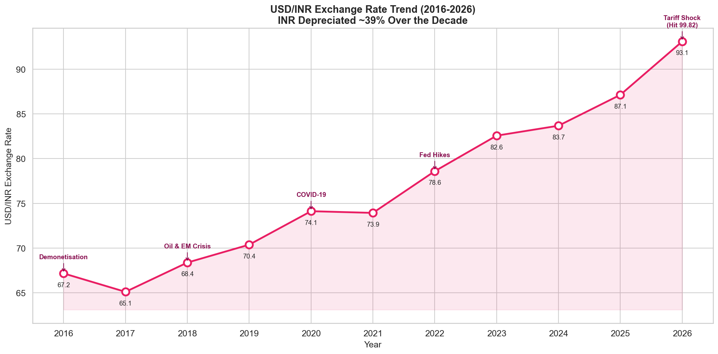
The INR depreciated from an average of 67.18 in 2016 to 93.09 in 2026 (YTD), a cumulative decline of approximately 39%. The all-time low of 99.82 was hit in March 2026 during the global tariff shock.

9. Inflation & Purchasing Power Parity Analysis
While a US investor does not directly face Indian inflation, the inflation differential between India and the US is a key predictor of long-run INR depreciation via purchasing power parity (PPP). The chart below compares the two.
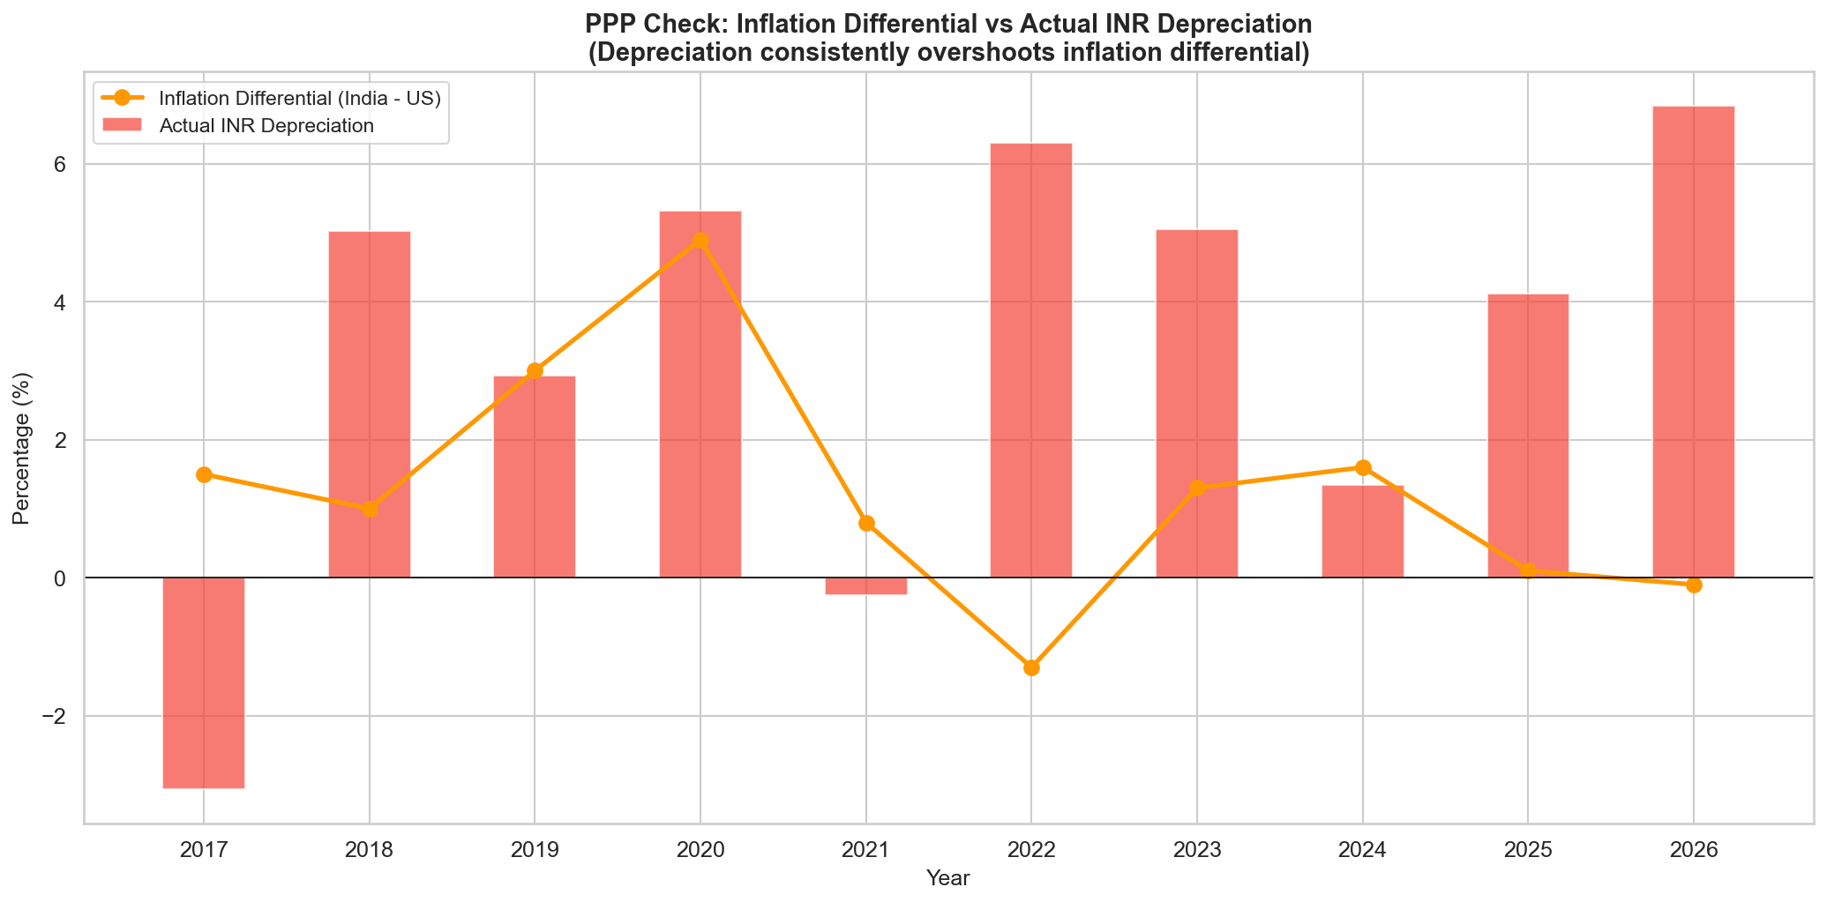
Finding: Actual INR depreciation consistently overshoots what the inflation differential alone would predict. The average inflation differential was ~1.6% p.a., but actual depreciation averaged ~3.4% p.a. This excess depreciation (driven by capital flows, trade deficit, oil prices, and dollar strength cycles) is what makes the carry trade a losing proposition.

10. Carry Attractiveness Over Time
The 'Carry Attractiveness Ratio' measures the carry differential divided by the absolute value of INR depreciation. A ratio above 1.0 means the carry covered the currency cost; below 1.0 means it did not.
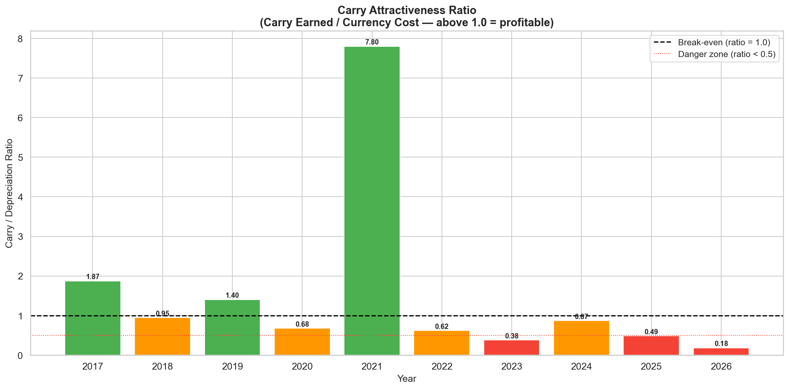

11. Risk Metrics
Metric | Value
Period | 2017-2026
Number of Years | 10
Average Annual Return (%) | -0.11
Std Dev of Returns (%) | 4.15
Sharpe Ratio (no risk-free adj) | -0.03
Total Cumulative Return (%) | -1.83
Max Drawdown (%) | -12.78
Win Rate (%) | 30
Best Year Return (%) | 9.11 (2017)
Worst Year Return (%) | -5.49 (2026)
Avg Carry Differential (%) | 3.23
Avg INR Depreciation (%) | 3.36
Carry vs Depreciation | Depreciation WINS

The negative Sharpe ratio confirms that the carry trade has not been compensating investors for the currency risk they are taking. The max drawdown figure reflects the worst peak-to-trough loss an investor would have experienced.

12. Key Observations & Phase Analysis

Phase 1: Wide Carry Era (2016-2017)
The interest rate differential was 4.75-5.75%, and the INR actually appreciated 3.1% in 2017. This was the golden period for the carry trade, delivering 8.8% net returns in 2017. US rates were still near zero, making the Indian carry very attractive to global investors.

Phase 2: EM Stress (2018-2020)
Rising oil prices, the 2018 EM crisis, and the 2020 COVID shock caused significant INR depreciation. Despite a reasonable carry of 3.6-4.8%, the currency losses dominated. The Fed also raised rates in 2018-2019, compressing the differential.

Phase 3: COVID Recovery (2021)
Massive US monetary easing (Fed at 0.10%) restored the carry differential to 3.90%, while the INR was stable (slight appreciation). This was the last profitable year, delivering 4.2% net returns.

Phase 4: Fed Tightening (2022-2024)
The Fed's aggressive rate hikes to 5.33% crushed the carry differential to just 1.17-1.92%. Simultaneously, INR depreciated 5-6% in 2022-2023 due to dollar strength and EM capital outflows. The trade was consistently loss-making.

Phase 5: Divergence & Tariff Shock (2025-2026)
While RBI began easing (to 5.25%) and the Fed cut rates (to 3.75%), the differential remained thin at 1.25-1.50%. The tariff shock of early 2026 sent the INR plunging to 99.82, causing the worst carry trade year in the sample (-5.6% YTD). This single episode erased over 6 years of carry income.

13. Current Environment Assessment (April 2026)
Factor | Current Status | Implication
Interest Rate Differential | 1.50% (RBI 5.25% vs Fed 3.75%) | Historically low - weak carry
INR Trend | Sharp depreciation (hit 99.82 in Mar) | High currency risk
India Inflation | ~3.2% - well controlled | Positive for INR stability
US Inflation | 3.3% - rising (tariff pass-through) | Negative - may keep Fed on hold
Global Sentiment | Risk-off (tariff uncertainty) | Negative for EM carry trades
RBI Policy Direction | Neutral, may ease further | Could compress differential further
Fed Policy Direction | May pause cuts due to tariff inflation | Rate divergence may narrow
Oil Prices | Elevated | Negative for INR via trade deficit

OVERALL ASSESSMENT: UNFAVORABLE for USD/INR carry trade.
The combination of a razor-thin interest rate differential (1.50%), elevated INR volatility, and global uncertainty makes the risk-reward profile unattractive. A US investor would need to see: (a) the differential widen back above 3%, (b) INR volatility subside to pre-2025 levels, and (c) resolution of global tariff uncertainty before re-entering this trade.

14. Conclusions

Net Loser Over 10 Years
The USD/INR carry trade destroyed value for a US investor over the full decade. Cumulative INR depreciation (~39%) exceeded cumulative carry income (~32%), resulting in a net loss.

Asymmetric Risk Profile
The trade exhibits classic 'peso problem' behaviour — small, steady carry gains in calm periods, wiped out by sudden, sharp INR depreciation during stress events (2018 EM crisis, 2020 COVID, 2022 Fed hikes, 2026 tariff shock). This asymmetry makes the trade structurally risky for unhedged positions.

Carry Compression Is Structural
The narrowing of the India-US rate differential from 5.75% to 1.50% is not temporary — it reflects the convergence of India's monetary policy credibility (lower inflation requiring lower rates) with a higher-for-longer US rate regime. The pre-2022 wide carry may not return.

Depreciation Overshoots PPP
INR depreciation consistently exceeded what inflation differentials predicted, driven by structural factors (trade deficit, oil dependency, capital flow volatility). This means PPP-based carry trade models underestimate the true currency risk.

Hedging Eliminates the Trade
The USD/INR forward premium largely reflects the interest rate differential (covered interest parity). Hedging the currency risk via forwards eliminates most or all of the carry advantage, making hedged carry trades uneconomical.

Current Environment: Avoid
With a 1.50% differential, 8-12% annualised INR volatility, and unresolved global tariff risks, the carry trade is not recommended. A US investor earns a better risk-adjusted return in US Treasuries or money market funds.

15. Data Sources
- IRS — Yearly Average Currency Exchange Rates (irs.gov)
- Trading Economics — India/US Currency, Interest Rates, Inflation (tradingeconomics.com)
- Reserve Bank of India — Policy Rates (rbi.org.in)
- Federal Reserve — FRED Database, H.15 Selected Interest Rates (fred.stlouisfed.org)
- WorldData.info — Historical Inflation Rates (worlddata.info)
- World Bank — Consumer Price Index Data (data.worldbank.org)
- Stable Investor — RBI Repo Rate History (stableinvestor.com)
- Investing.com — India 10Y vs US 10Y Bond Yield Spread (investing.com)

Disclaimer: This report is for informational and educational purposes only. It does not constitute investment advice. Past performance does not guarantee future results. Data sourced from publicly available databases as of April 2026.

