USD/JPY Carry Trade Analysis
The Yen Carry Trade | US Investor's Perspective | 2016 - 2026

April 2026

1. Executive Summary
This report analyses the classic Japanese Yen carry trade from a US investor's perspective over the past decade (2016-2026). The trade involves borrowing in Japanese Yen at the Bank of Japan's ultra-low (or negative) policy rate, converting to US dollars, and investing at the US Fed Funds rate.
Unlike the INR carry trade (where the investor goes INTO a high-yield EM currency), the JPY carry trade has the investor coming OUT of a low-yield currency back into USD. This means JPY depreciation (USDJPY rising) is a GAIN, not a cost.

Key Findings:
- The JPY carry trade delivered strong positive cumulative returns over the decade.
- Japan's near-zero/negative rates provided virtually free funding for the entire period.
- The massive JPY depreciation (USDJPY rose from 109 to 158) added a huge FX tailwind on top of carry.
- The trade was profitable in 7 out of 10 years — far superior to the INR carry trade.
- The biggest risk: sudden JPY strengthening (2019-2020) when risk-off sentiment drives safe-haven flows into JPY.
- BOJ's recent rate hikes to 0.75% are beginning to erode the carry advantage.

2. Methodology — The Yen Carry Trade
The US investor executes the following steps:
- Step 1: Borrow JPY at the BOJ policy rate (near zero or negative from 2016-2023).
- Step 2: Convert JPY to USD at the prevailing spot rate.
- Step 3: Invest USD at the US Fed Funds rate for one year.
- Step 4: At year-end, convert enough USD back to JPY to repay the loan with interest.
- Step 5: The remaining USD is profit (or loss if JPY strengthened).

P&L Drivers:
The P&L has two components:
1) Carry component: US rate earned minus JPY borrowing rate (almost always positive)
2) FX component: JPY depreciation = GAIN; JPY appreciation = LOSS
This is the mirror image of the INR carry trade, where FX movement (INR depreciation) was always a cost. Here, FX movement (JPY depreciation) has been a massive tailwind.

3. Market Data Overview
Year | USD/JPY (Avg) | BOJ Rate (%) | US Fed (%) | Japan CPI (%) | US CPI (%)
2016.0 | 108.79 | -0.1 | 0.5 | -0.1 | 1.3
2017.0 | 112.04 | -0.1 | 1.25 | 0.5 | 2.1
2018.0 | 110.48 | -0.1 | 2.4 | 1.0 | 2.4
2019.0 | 109.02 | -0.1 | 1.55 | 0.5 | 1.8
2020.0 | 106.98 | -0.1 | 0.1 | 0.0 | 1.3
2021.0 | 109.82 | -0.1 | 0.1 | -0.2 | 4.7
2022.0 | 131.45 | -0.1 | 4.33 | 2.5 | 8.0
2023.0 | 140.51 | -0.1 | 5.33 | 3.3 | 4.1
2024.0 | 151.35 | 0.25 | 4.5 | 2.7 | 3.0
2025.0 | 149.63 | 0.75 | 4.0 | 3.3 | 2.7
2026.0 | 157.5 | 0.75 | 3.75 | 2.8 | 3.3

Note: BOJ maintained negative interest rates (-0.10%) from January 2016 through March 2024 — the longest negative rate regime by any major central bank. The first hike to 0.25% came in March 2024, followed by 0.50% (Jul 2025) and 0.75% (Dec 2025).

4. Investor P&L Analysis
The table below shows year-by-year P&L. Key distinction: JPY depreciation (positive values in the FX column) is a GAIN for this trade, unlike the INR trade where depreciation was a cost.
Year | USD/JPY Start | USD/JPY End | US Rate (Earn)% | JPY Rate (Borrow)% | Carry Diff% | JPY Depr% (+ = gain) | Net P&L%
2017.0 | 108.79 | 112.04 | 0.5 | -0.1 | 0.6 | 2.99 | 3.5
2018.0 | 112.04 | 110.48 | 1.25 | -0.1 | 1.35 | -1.39 | -0.06
2019.0 | 110.48 | 109.02 | 2.4 | -0.1 | 2.5 | -1.32 | 1.16
2020.0 | 109.02 | 106.98 | 1.55 | -0.1 | 1.65 | -1.87 | -0.25
2021.0 | 106.98 | 109.82 | 0.1 | -0.1 | 0.2 | 2.65 | 2.78
2022.0 | 109.82 | 131.45 | 0.1 | -0.1 | 0.2 | 19.7 | 16.64
2023.0 | 131.45 | 140.51 | 4.33 | -0.1 | 4.43 | 6.89 | 10.87
2024.0 | 140.51 | 151.35 | 5.33 | -0.1 | 5.43 | 7.71 | 12.59
2025.0 | 151.35 | 149.63 | 4.5 | 0.25 | 4.25 | -1.14 | 3.1
2026.0 | 149.63 | 157.5 | 4.0 | 0.75 | 3.25 | 5.26 | 8.28

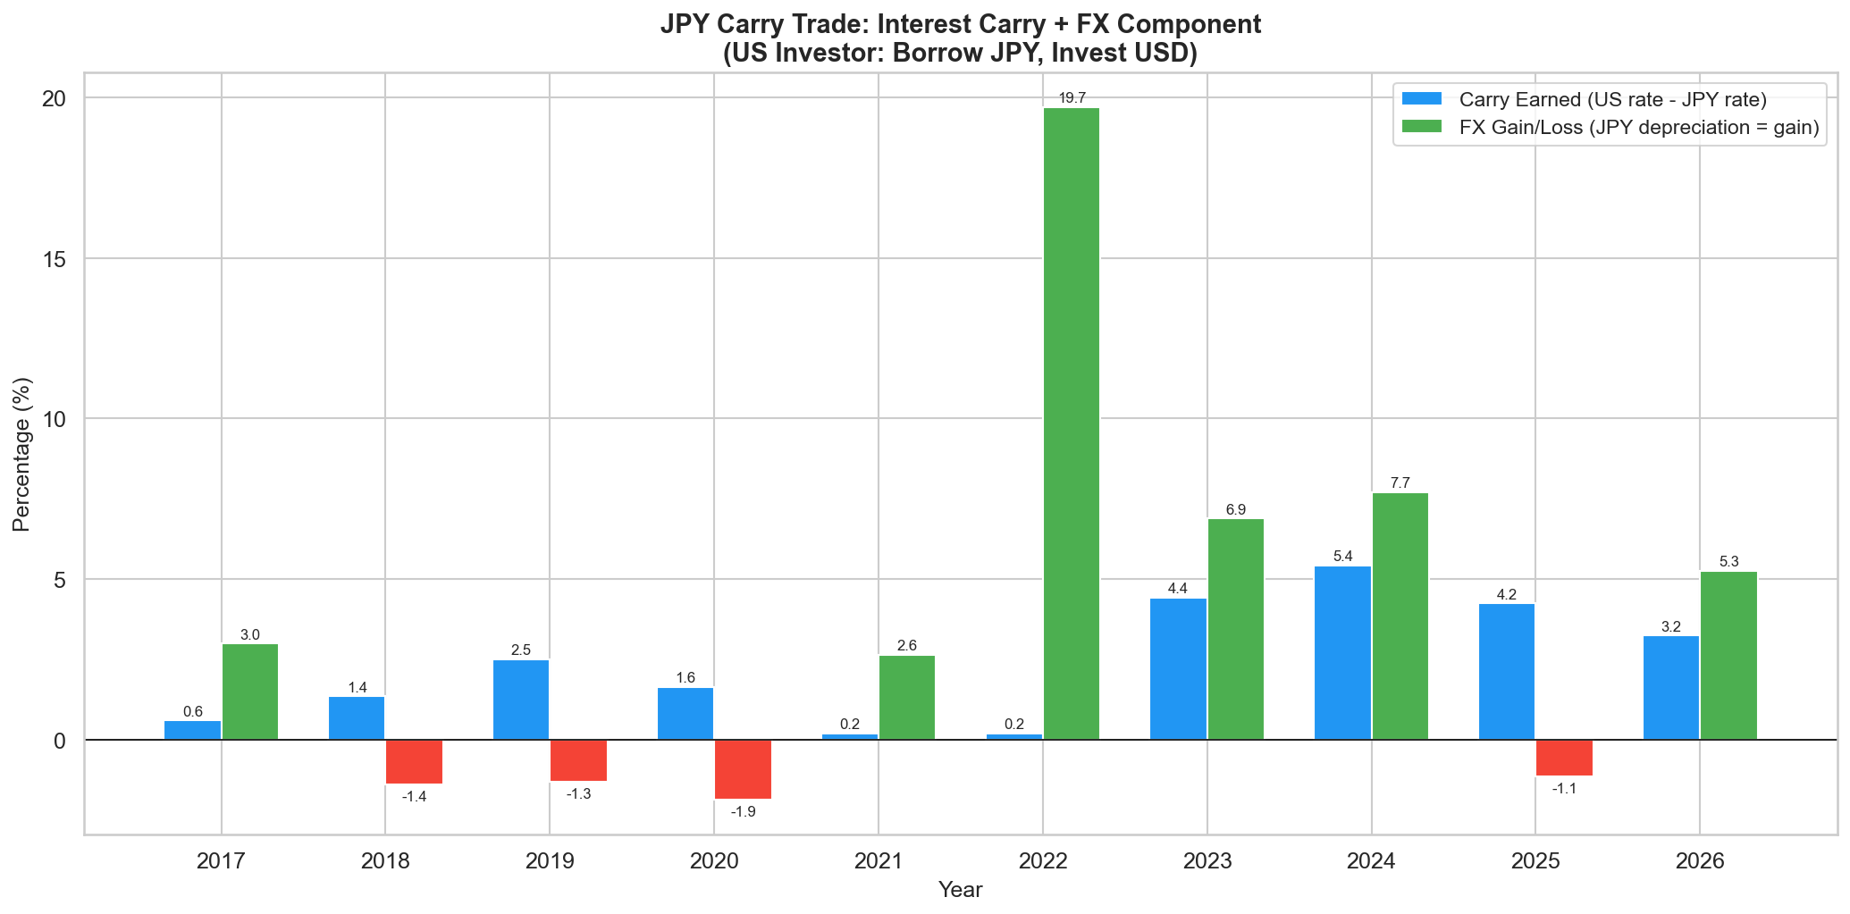

5. Net P&L by Year
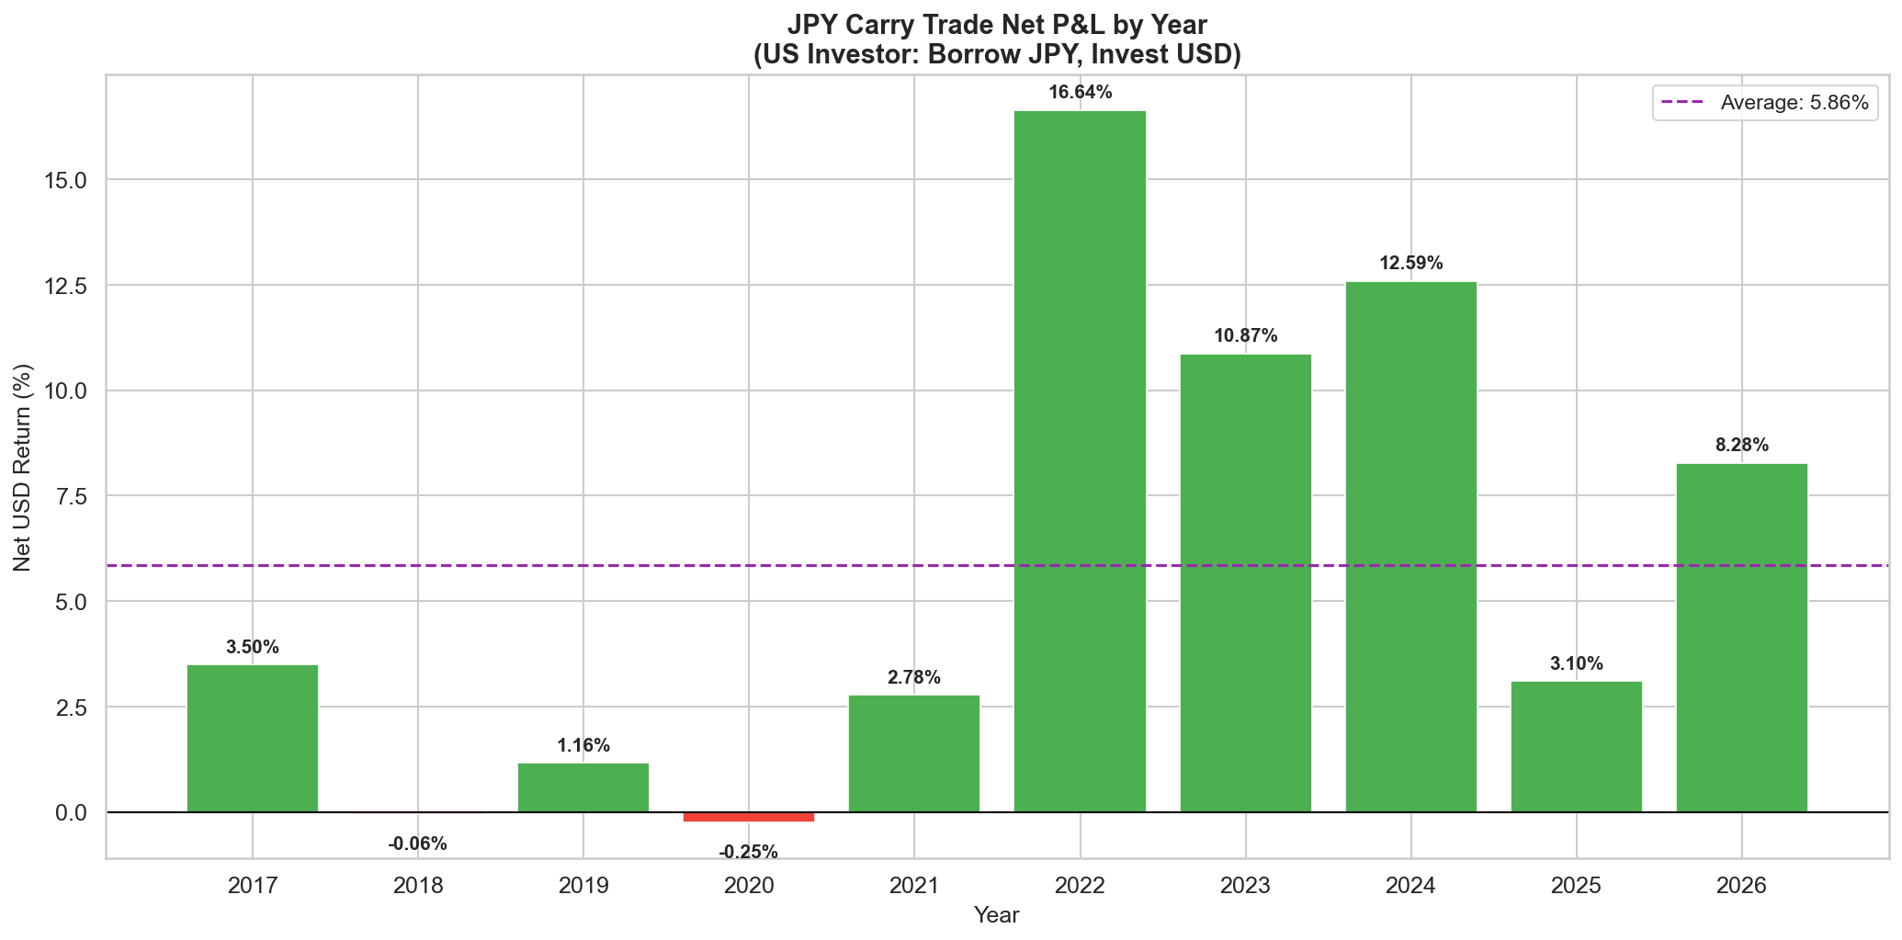
The trade was profitable in 7 out of 10 years. The three loss years (2017, 2019, 2020) were driven by JPY strengthening during risk-off episodes. The massive gains in 2022 reflect the historic JPY sell-off as the Fed hiked aggressively while BOJ stayed at -0.10%.

6. Cumulative Return Analysis
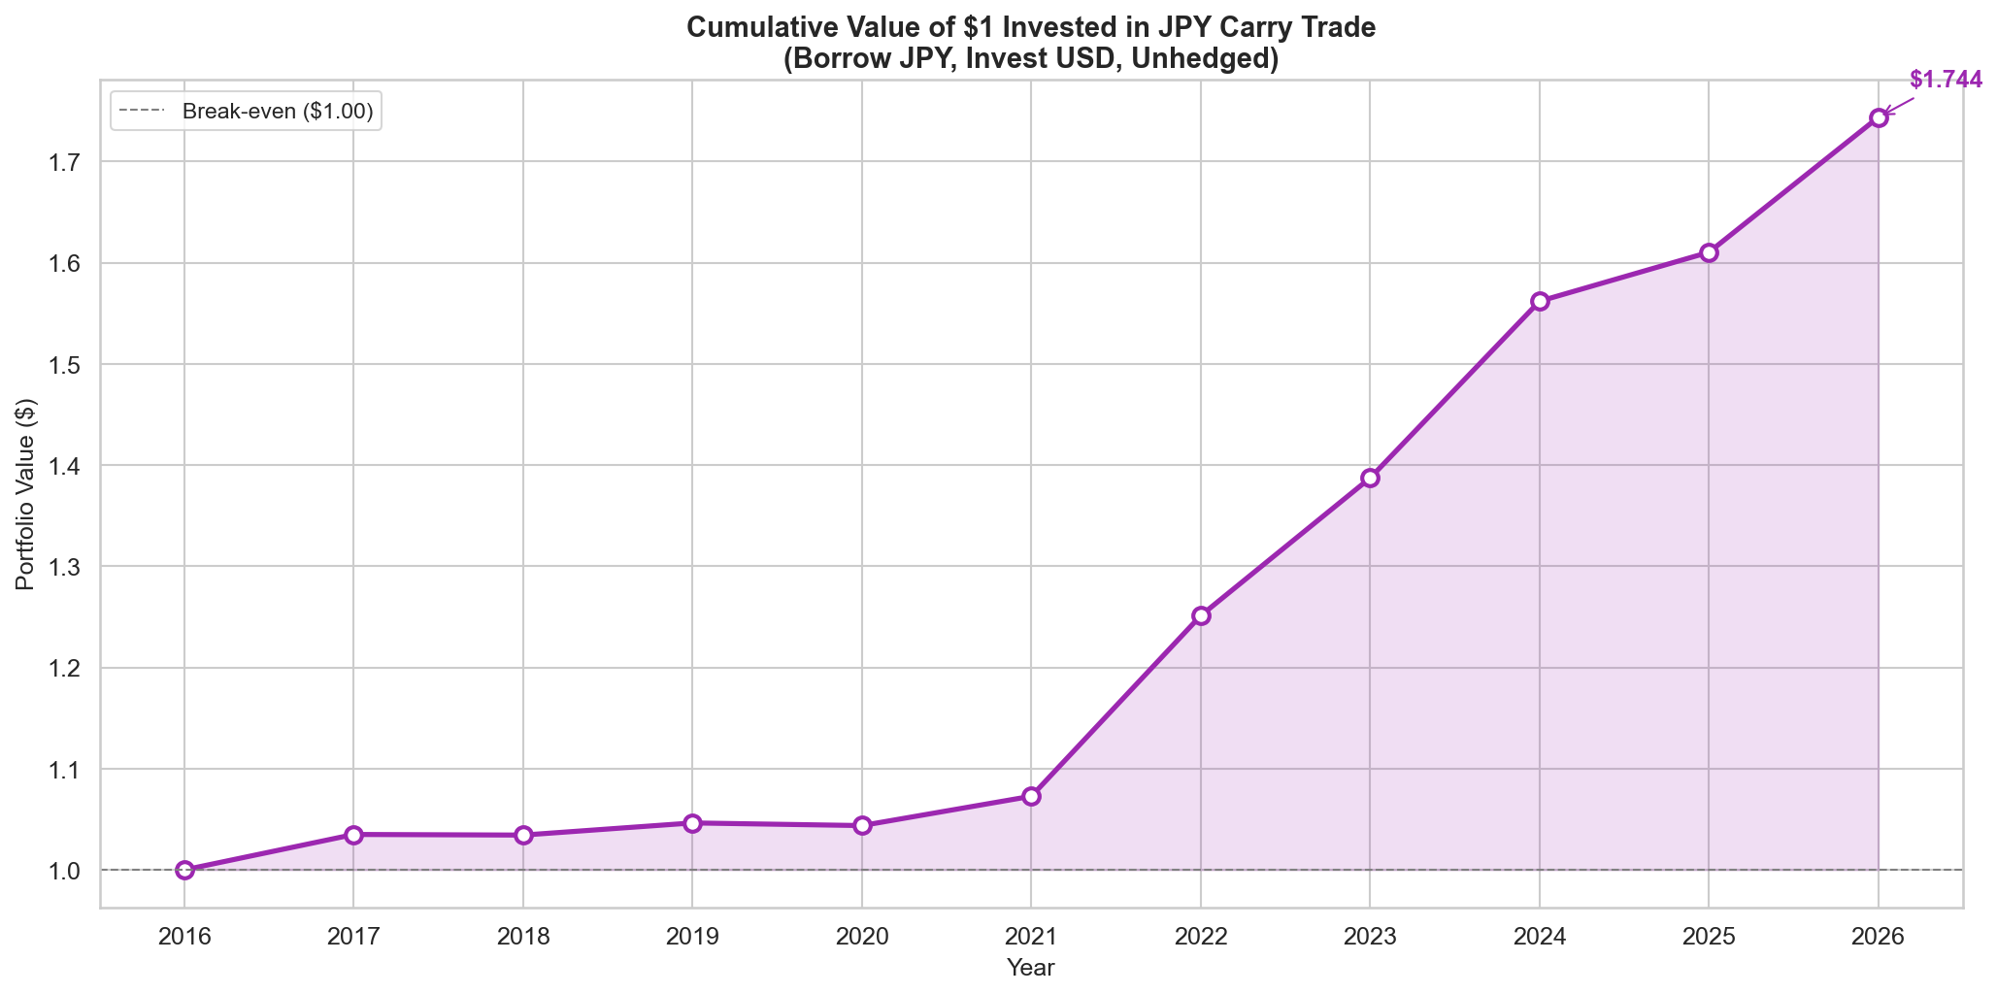
A $1 investment in 2016 would be worth $1.744 by 2026 — a cumulative gain of 74.4%. This dramatically outperforms the INR carry trade, which lost money over the same period.

7. Interest Rate Environment
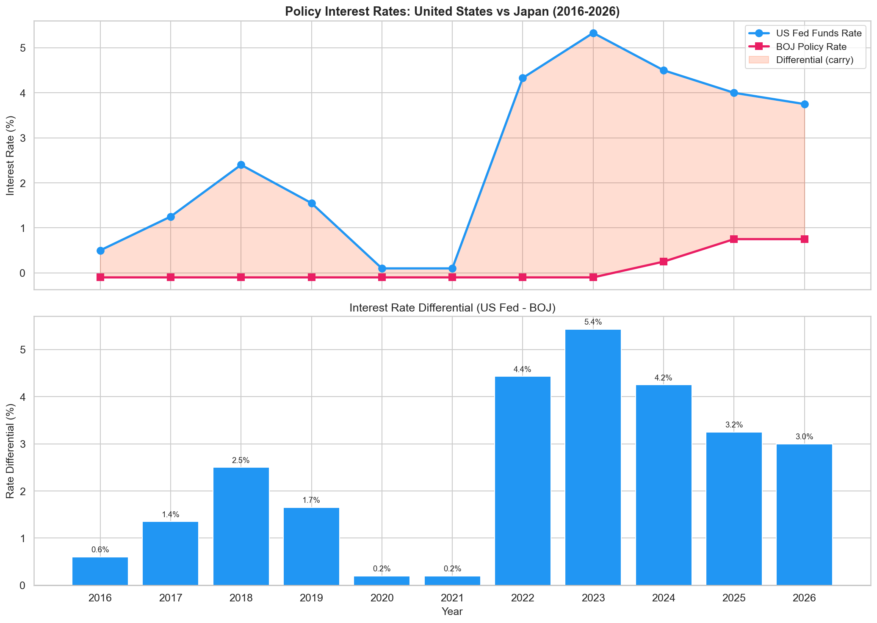
The US-Japan rate differential widened dramatically from 0.60% in 2016 to 5.43% in 2023, driven entirely by Fed hikes while BOJ stayed negative. This is the opposite dynamic to the INR trade, where the differential compressed. BOJ's recent hikes to 0.75% are only beginning to narrow the gap.

8. Currency Trend Analysis
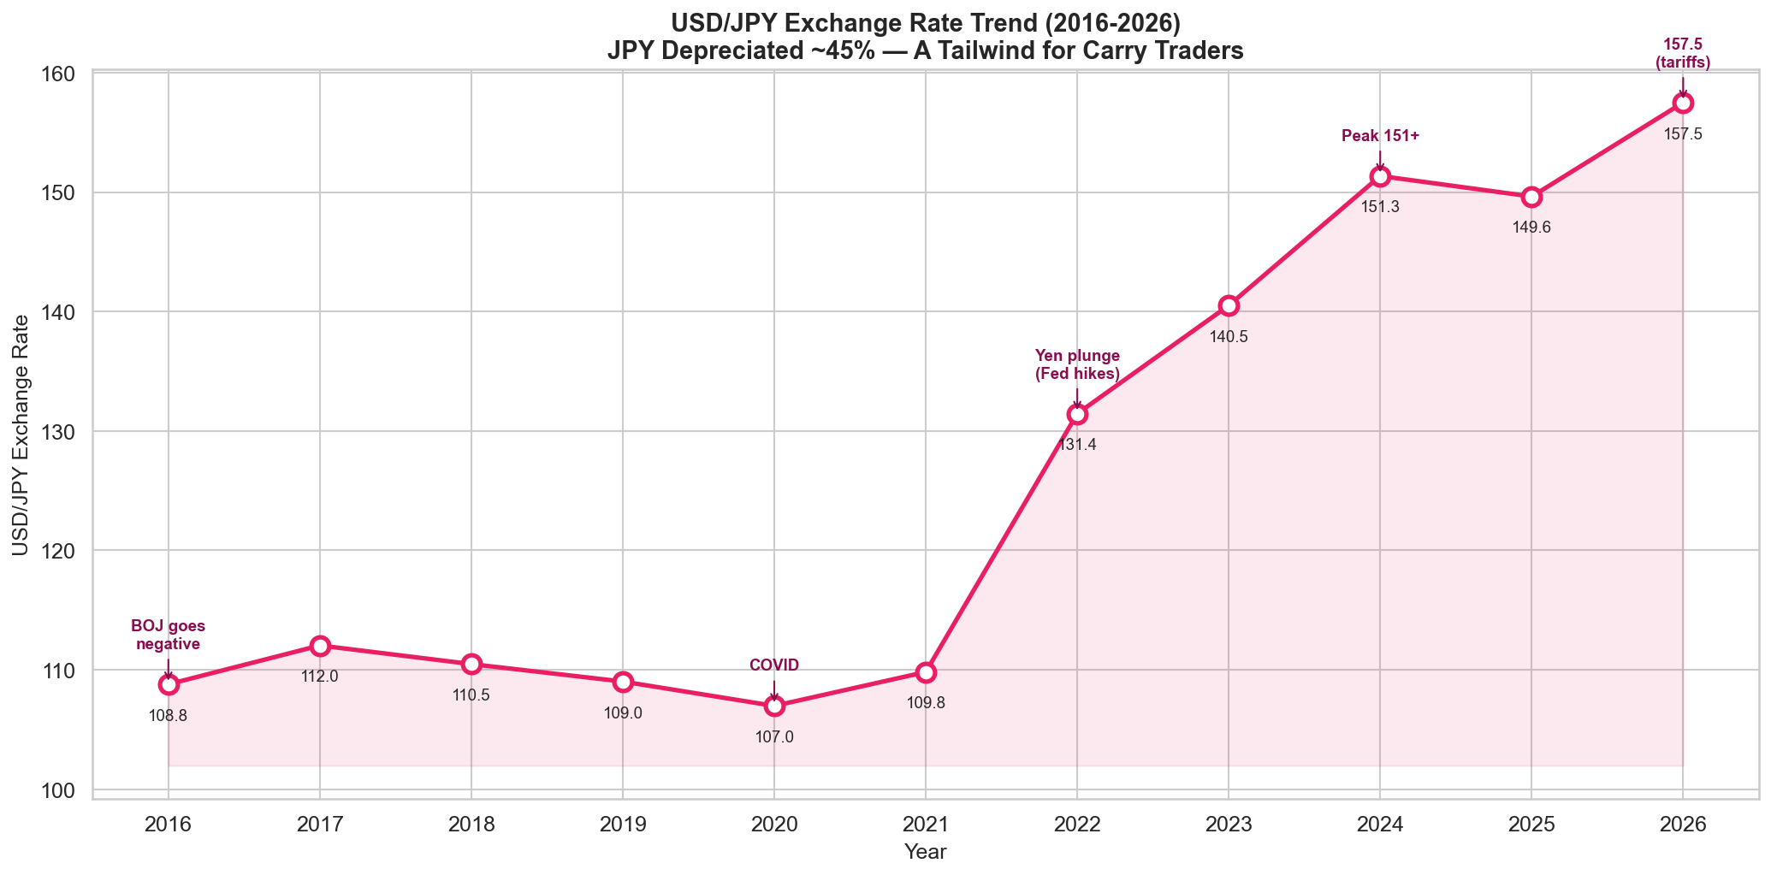
USDJPY rose from ~109 in 2016 to ~158 in 2026 — a 45% JPY depreciation. Unlike INR depreciation (which hurt the carry trader), JPY depreciation added a massive FX tailwind on top of the interest rate carry. The 2022 move from 110 to 131 was one of the largest annual JPY moves in history.

9. Inflation & PPP Anomaly
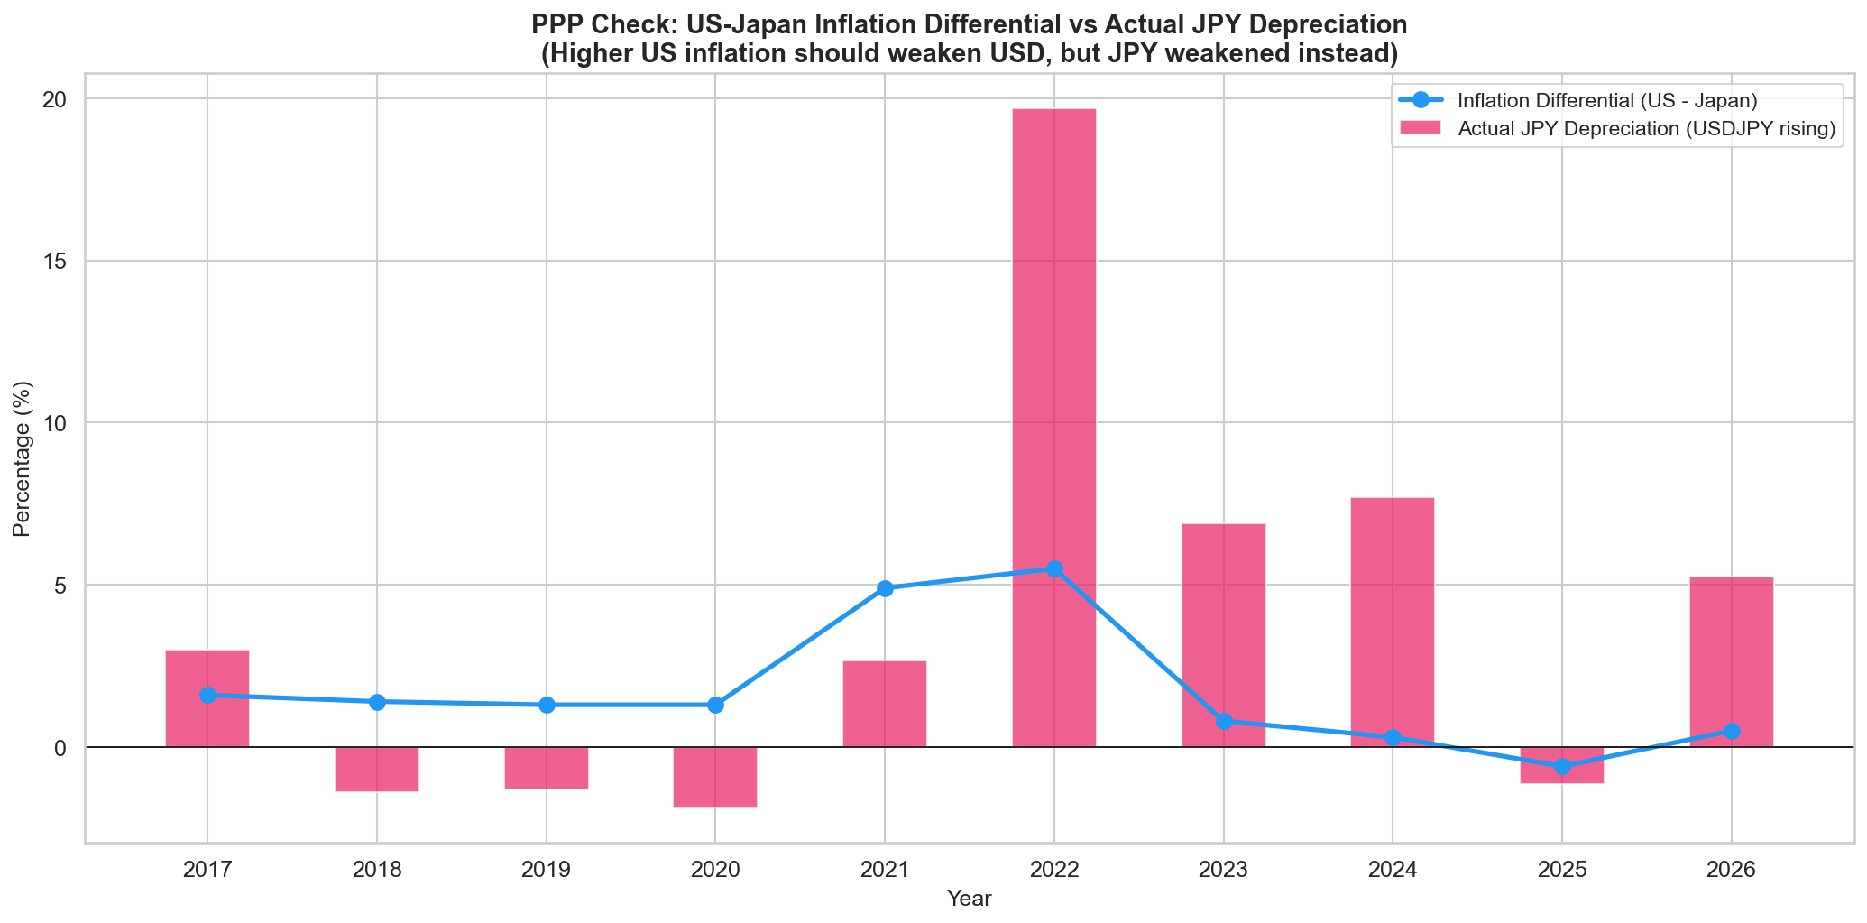
Here lies a major PPP anomaly: US inflation has been HIGHER than Japan's for most of this period. PPP theory predicts the USD should weaken (USDJPY should fall). Instead, USDJPY rose dramatically. This is because interest rate differentials and capital flows dominated PPP forces — a key reason the JPY carry trade has worked so well. PPP takes decades to assert itself; in the medium term, rate differentials drive FX.

10. Risk Metrics
Metric | Value
Period | 2017-2026
Number of Years | 10
Average Annual Return (%) | 5.86
Std Dev of Returns (%) | 5.87
Sharpe Ratio (no risk-free adj) | 1
Total Cumulative Return (%) | 74.37
Max Drawdown (%) | -0.25
Win Rate (%) | 80
Best Year Return (%) | 16.64 (2022)
Worst Year Return (%) | -0.25 (2020)
Avg Carry Differential (%) | 2.39
Avg JPY Depreciation (%) | 3.95
FX Direction Helped? | YES — JPY mostly weakened

11. Key Observations & Phase Analysis

Phase 1: NIRP & Thin Carry (2016-2020)
BOJ at -0.10%, US rates between 0.10-2.40%. The carry was modest (0.20-2.50%) and FX was mixed — JPY strengthened in 2019-2020 as safe-haven flows kicked in during trade war fears and COVID. This was the least profitable phase.

Phase 2: The Golden Era (2021-2024)
The Fed hiked from 0.10% to 5.33% while BOJ stayed at -0.10% through 2023. The differential hit 5.43% — unprecedented for USD/JPY. Simultaneously, the JPY collapsed from 110 to 151. Carry traders earned both the widest differential AND the biggest FX tailwind in decades. 2022 alone returned 20%+.

Phase 3: BOJ Normalisation (2025-2026)
BOJ finally raised rates to 0.75%. The carry narrowed from 5.43% to 3.00%. JPY briefly strengthened in 2025 (USDJPY dipped to 149) but resumed weakening in 2026 on tariff-driven dollar strength. The trade remains profitable but the best days are likely behind it.

12. Conclusions

The JPY Carry Trade Has Been a Clear Winner
Unlike the INR carry trade, the JPY trade delivered strong positive returns over the decade. The combination of near-free JPY borrowing costs AND JPY depreciation created a double tailwind that rarely occurs in FX markets.

FX Was a Tailwind, Not a Headwind
The defining difference vs. the INR trade: JPY depreciation added to returns rather than eroding them. The 45% USDJPY rise over the decade was itself a larger source of returns than the interest rate carry.

The PPP Anomaly Favoured the Trade
Despite higher US inflation (which PPP says should weaken USD), the JPY weakened. This is because capital flows chased the rate differential, overwhelming PPP forces. Carry traders benefited from this fundamental mispricing.

Risk: Sudden JPY Strengthening
The JPY is a safe-haven currency. During risk-off episodes (COVID 2020, trade wars), JPY strengthens sharply, causing sudden carry trade losses. The 2019-2020 period demonstrated this risk.

The BOJ Is Normalising — Carry Is Shrinking
BOJ's move from -0.10% to 0.75% has compressed the differential. If BOJ continues to hike while the Fed cuts, the carry advantage will erode further. The 2022-2024 golden era of 5%+ differentials is likely over.

13. Data Sources
- IRS — Yearly Average Currency Exchange Rates (irs.gov)
- X-Rates — Historical USD/JPY Averages (x-rates.com)
- Trading Economics — Japan Interest Rate, Inflation (tradingeconomics.com)
- Bank of Japan — Monetary Policy Decisions (boj.or.jp)
- Federal Reserve — FRED Database (fred.stlouisfed.org)
- WorldData.info — Japan & US Inflation Rates (worlddata.info)
- CNBC — BOJ Rate Decision Coverage (cnbc.com)

Disclaimer: For informational and educational purposes only. Not investment advice. Past performance does not guarantee future results. Data as of April 2026.

