Vendor and Brand Performance Analysis

# Business Context and Objective

The retail and distribution business involves hundreds of vendors and thousands of product lines, making it challenging to pinpoint which partnerships and product lines drive profitability. This report investigates historical sales and purchase data to evaluate vendor and brand performance, identify inefficiencies, and surface opportunities for pricing, promotion, and consolidation strategies.

# Analytical Approach

The analysis focused on key metrics such as Total Sales Dollars, Profit Margin, Stock Turnover, and Purchase Contribution. Vendors and brands were segmented based on performance thresholds, and statistical methods including confidence intervals and hypothesis testing were applied to quantify the differences between performance groups.

# Key Insights and Visuals

## 1. Brands for Promotional or Pricing Adjustments

This scatterplot visualizes all brands, highlighting those that are low in sales but high in profit margin. These 'target brands' are prime candidates for promotional pushes or price optimization strategies.

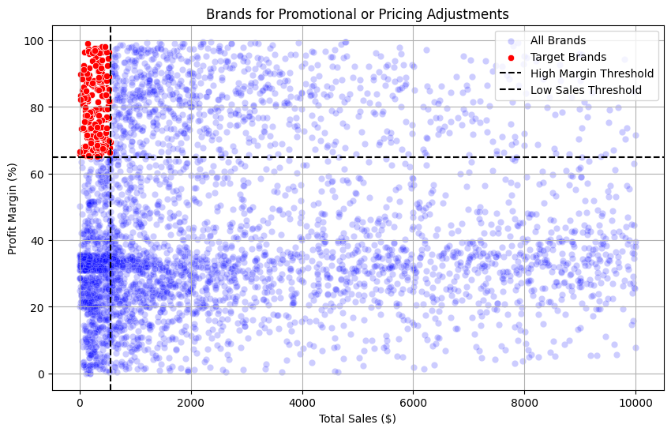

Figure 1: Scatterplot - Promotional Opportunity Brands

## 2. Vendor Concentration

The pie chart illustrates that the top 10 vendors contribute approximately 66% of all purchases. This suggests a significant vendor concentration and presents a case for strategic procurement partnerships.

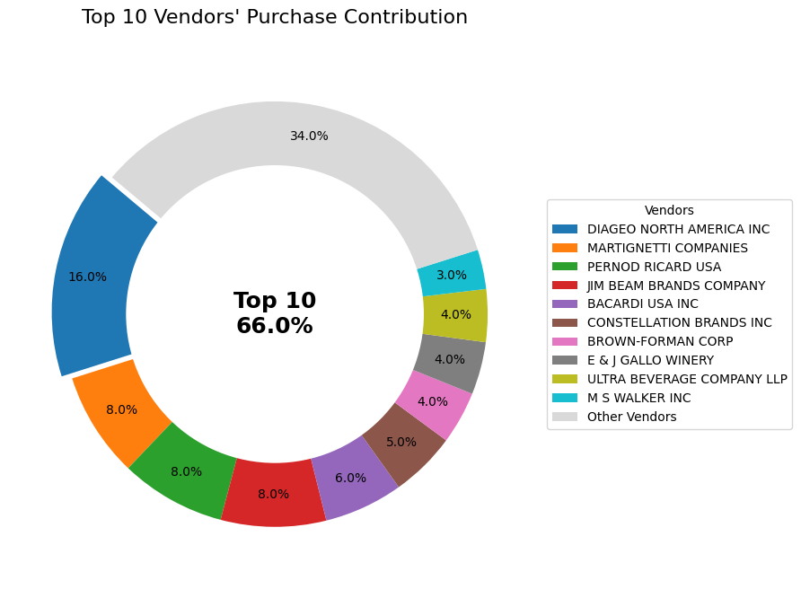

Figure 2: Donut Chart - Top 10 Vendors' Contribution

## 3. Vendor and Brand Popularity

The bar plots show the most frequently appearing vendors and top-selling products by description. This popularity insight helps identify consistent performers in terms of volume.

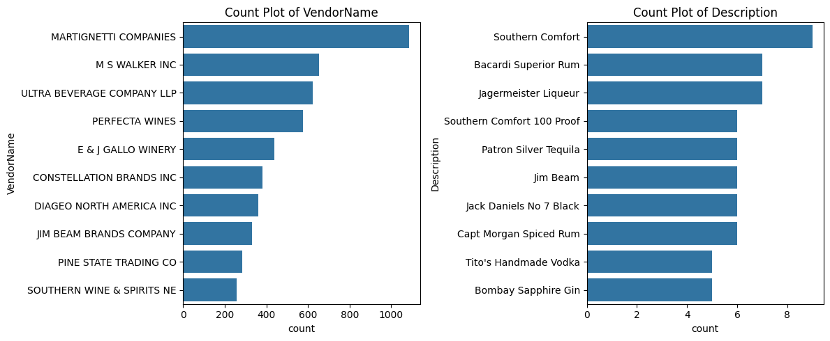

Figure 3: Count Plots - Top Vendors and Products

## 4. Profitability Analysis by Vendor Tier

Vendors were segmented into top and bottom quartiles based on Total Sales Dollars. A comparison of their Profit Margin distributions reveals that top vendors tend to maintain higher and more consistent margins. Statistical hypothesis testing confirmed that this difference is significant.

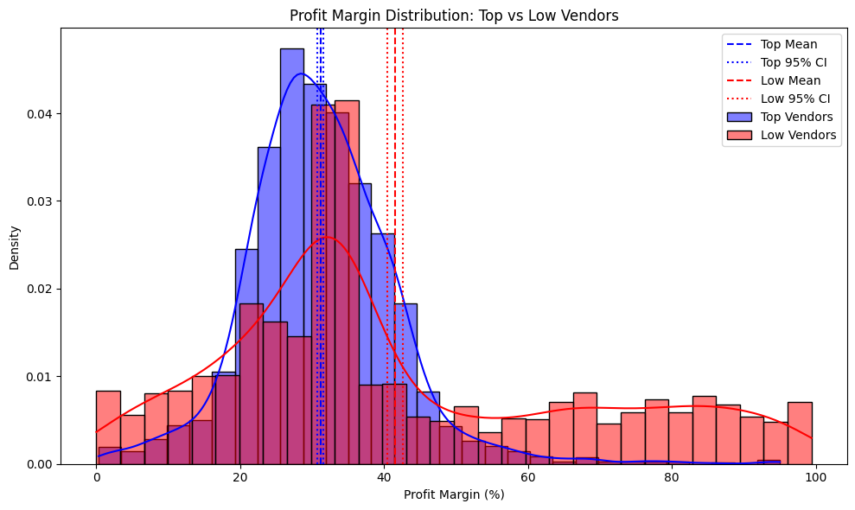

Figure 4: Distribution - Profit Margin (Top vs Low Vendors)

## 5. Distribution of Key Metrics

A comprehensive histogram grid reveals the distribution of numerical variables. Several metrics exhibit high skewness and outliers, emphasizing the need for log-scaling or segmentation in modeling efforts.

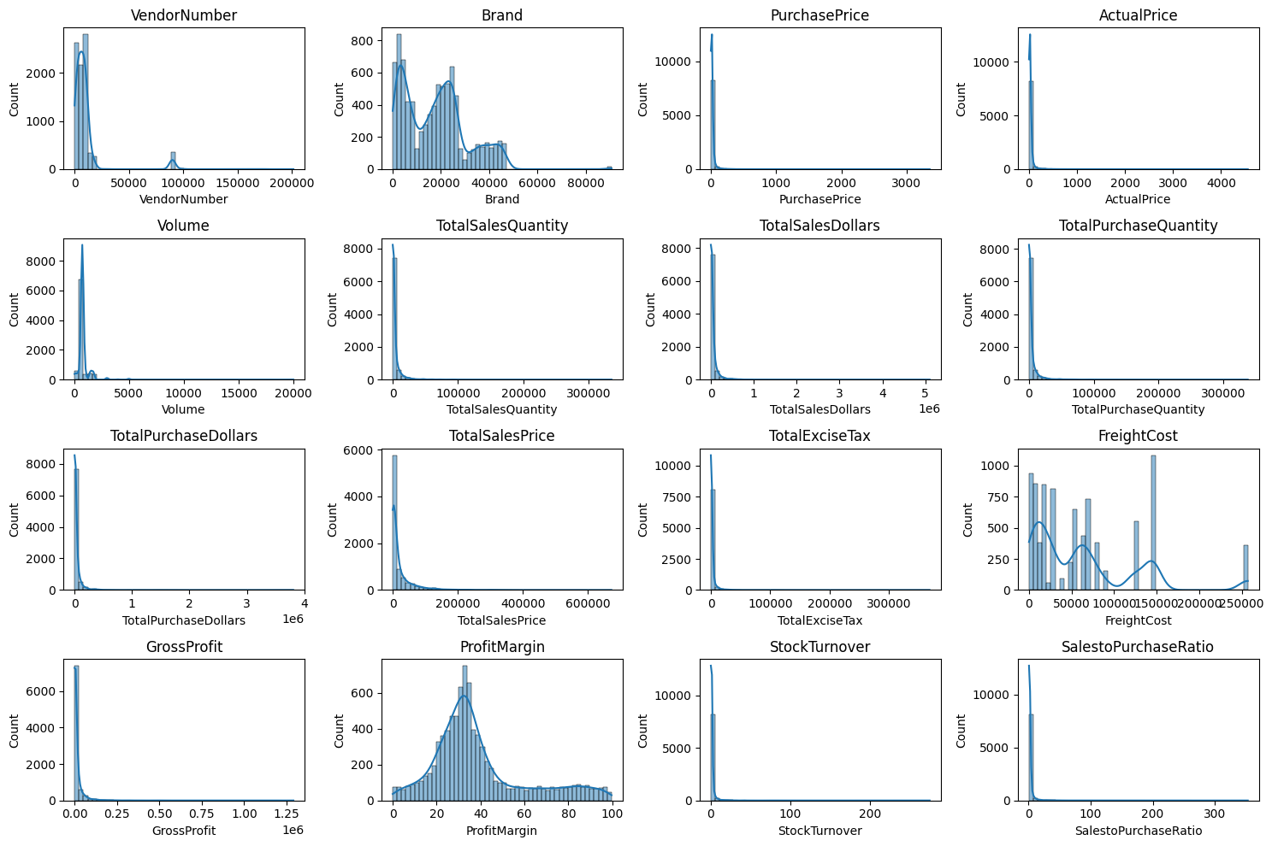

Figure 5: Histograms of Key Metrics

# Conclusion and Recommendations

- Focus procurement and promotional strategies on top vendors and high-margin, low-sales brands.  
- Reevaluate vendor relationships showing low turnover and weak profitability.  
- Leverage the 80/20 rule by doubling down on top contributors.  
- Build an interactive dashboard for continuous monitoring and smarter vendor negotiations.