**Motion Transfer**

**Introduction:**

Here I have shown my approach towards solving the problem [transferring action from one person to another] with the help of Kinect. Kinect directly gives us the skeleton data if a human is in front of it.

For transferring motion we will require Kinect video of Source person (A) and Kinect captured image of another person (B).

**Algorithm:**

1. Since we have a video of person A we know how the current skeleton will change as time changes, and we have starting skeleton of person B. Here is what our skeleton data gives:

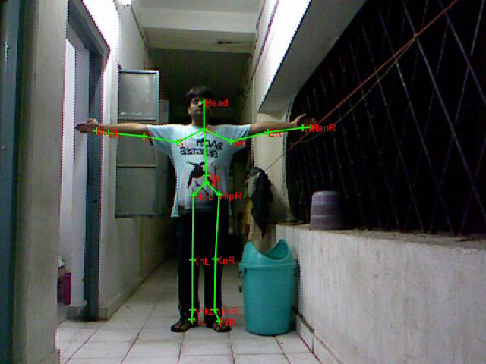

As we can see 20 Joints are correctly identified.

1. Now since we have a video of person ‘A’ we know how the skeleton will look after some frames.

 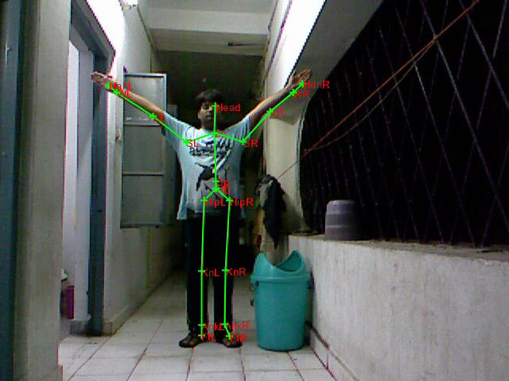

Frame 1 Frame 10

1. Plotting in the same figure what is the position of skeleton as of now and where it is in 10th frame.

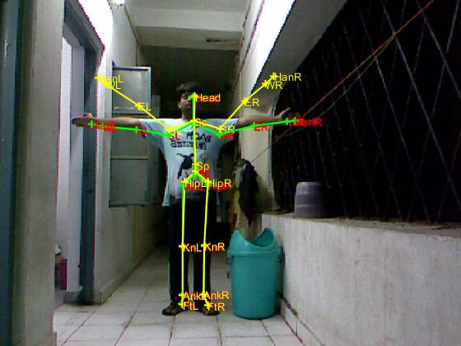

**Green lines shows current skeleton and yellow lines shows where the skeleton is after some n frames (here after 10 frames).**

1. Now we want **‘some transformation’** by which our original ‘green’ skeleton gets aligned with ‘yellow skeleton’. For this my current approach is: make a rectangle around all the skeleton lines (bones) in current skeleton and in next skeleton and then find an **‘affine transformation’** that aligns these. Skeleton with their corresponding rectangles are shown:

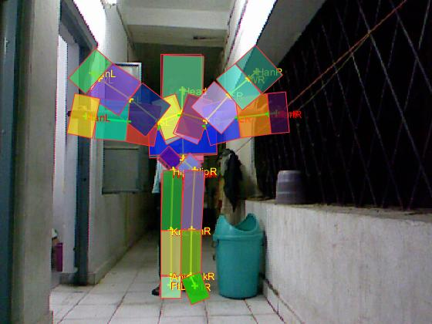

1. Now since we have the transformation we can apply the transformation to **“any skeleton”.** Applying transformation to original skeleton.

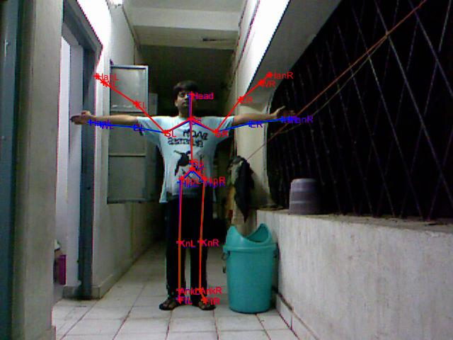

**“Blue line shows original and Red lines shows the transformed skeleton”**

1. Since we have the ground truth in above case (for skeletons and for images as well, as here I am aligning my image to my own image after 10 frames). I have shown them here for comparison.

 

Ground truth Obtained Skeleton

1. Now since our transformation is working for skeleton lets apply the same transformation to the body parts that are there in that skeleton bone. Here I have made a body model that consists of a ‘**convex hull’** around a skeleton bone.

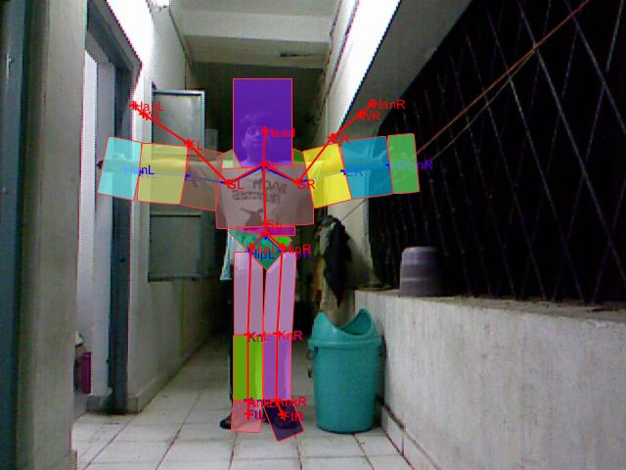

Now we need to align body parts to new skeleton.

1. Image after applying transformation:

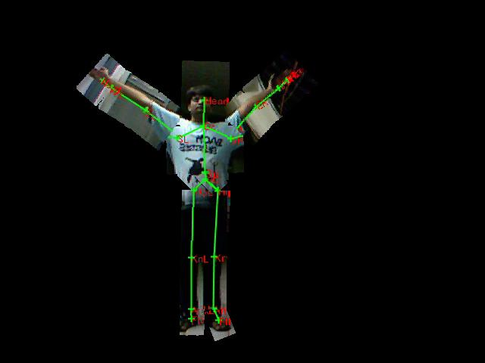

Will work better after segmentation of original video.

1. Result with segmentation.

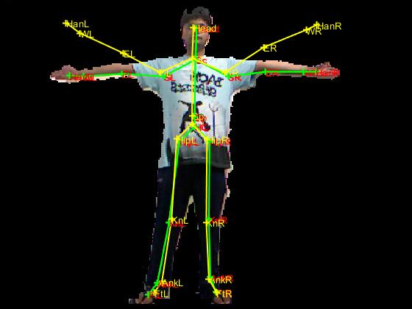 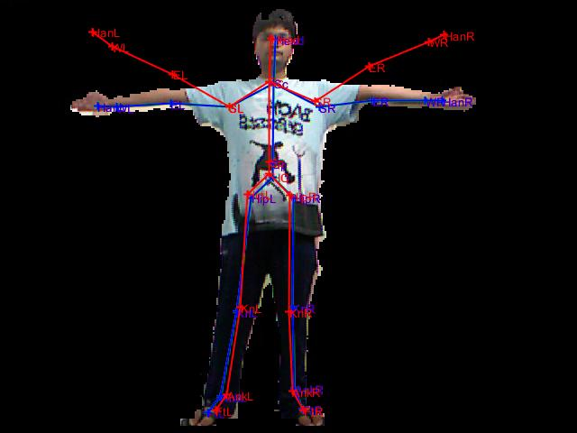

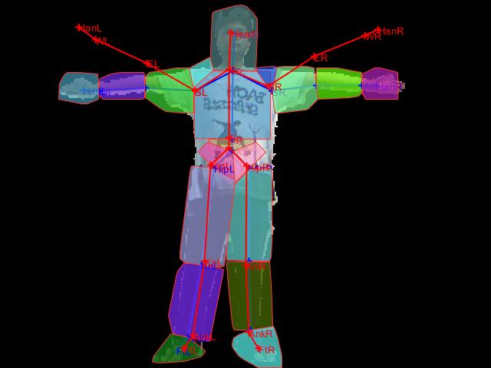

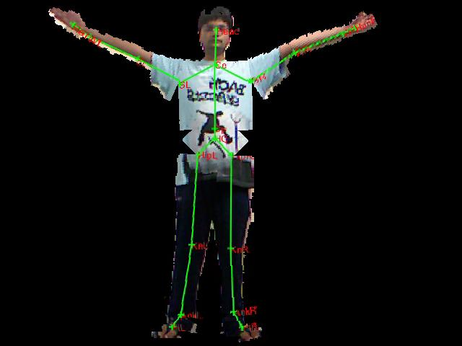

1. Next I have tried to apply the obtained transformations to images of another person. The results are on pages to follow.

**RESULTS:**

**1.**

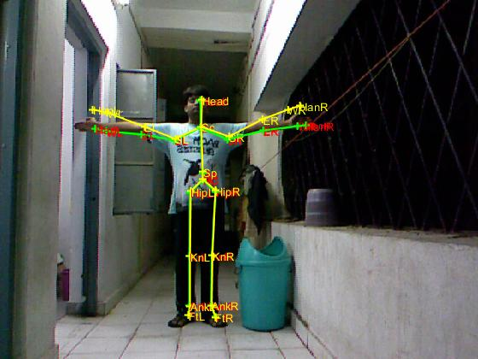 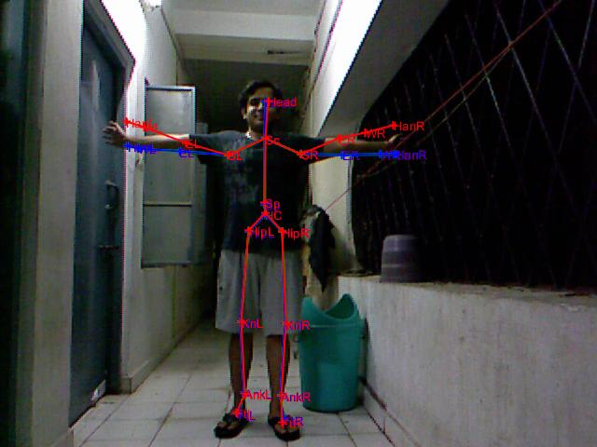

**Original Transformation applied**

**On skeleton of different person**

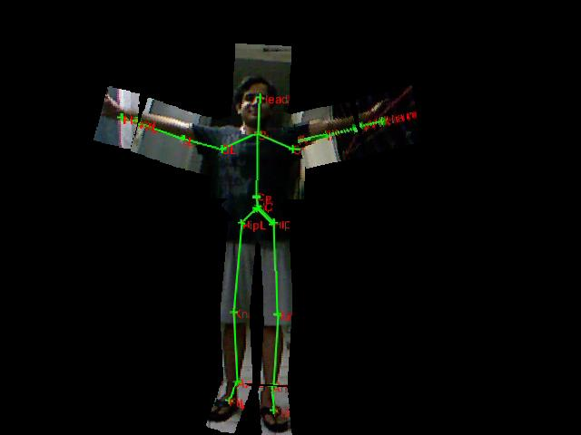

**2.**

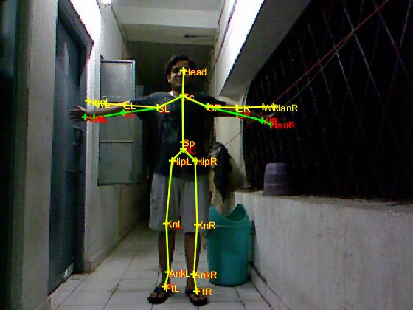 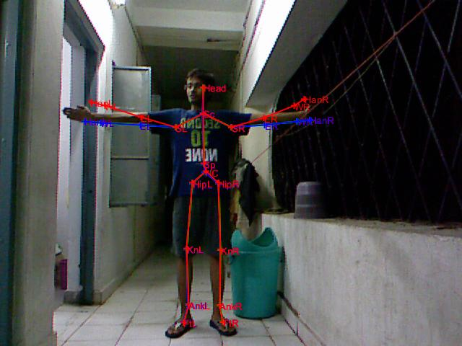

**Original Transformation applied**

**On skeleton of different person**

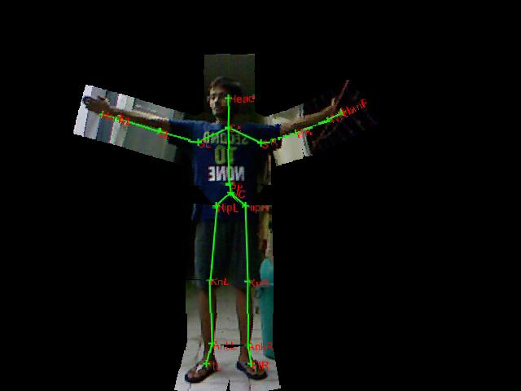

**Conclusion and Doubts:**

* This approach is giving **very good** results as far as **human pose alignment** is concerned.
* Problem with current approach is that when applied progressively to generate a video the transformation distorts the image after 6-7 frames.
* For these alignments I have used transformation as explained in step 4 of Algorithm section. Can we do something different to improve upon it?