Lab Experiment:- 02

Name: Gaurav Makwana
Roll No.: R177219082
SAPID: 500075775
Subject: Object Oriented Programming Lab

AIM: Write a program to find the largest of 3 numbers.

Code:
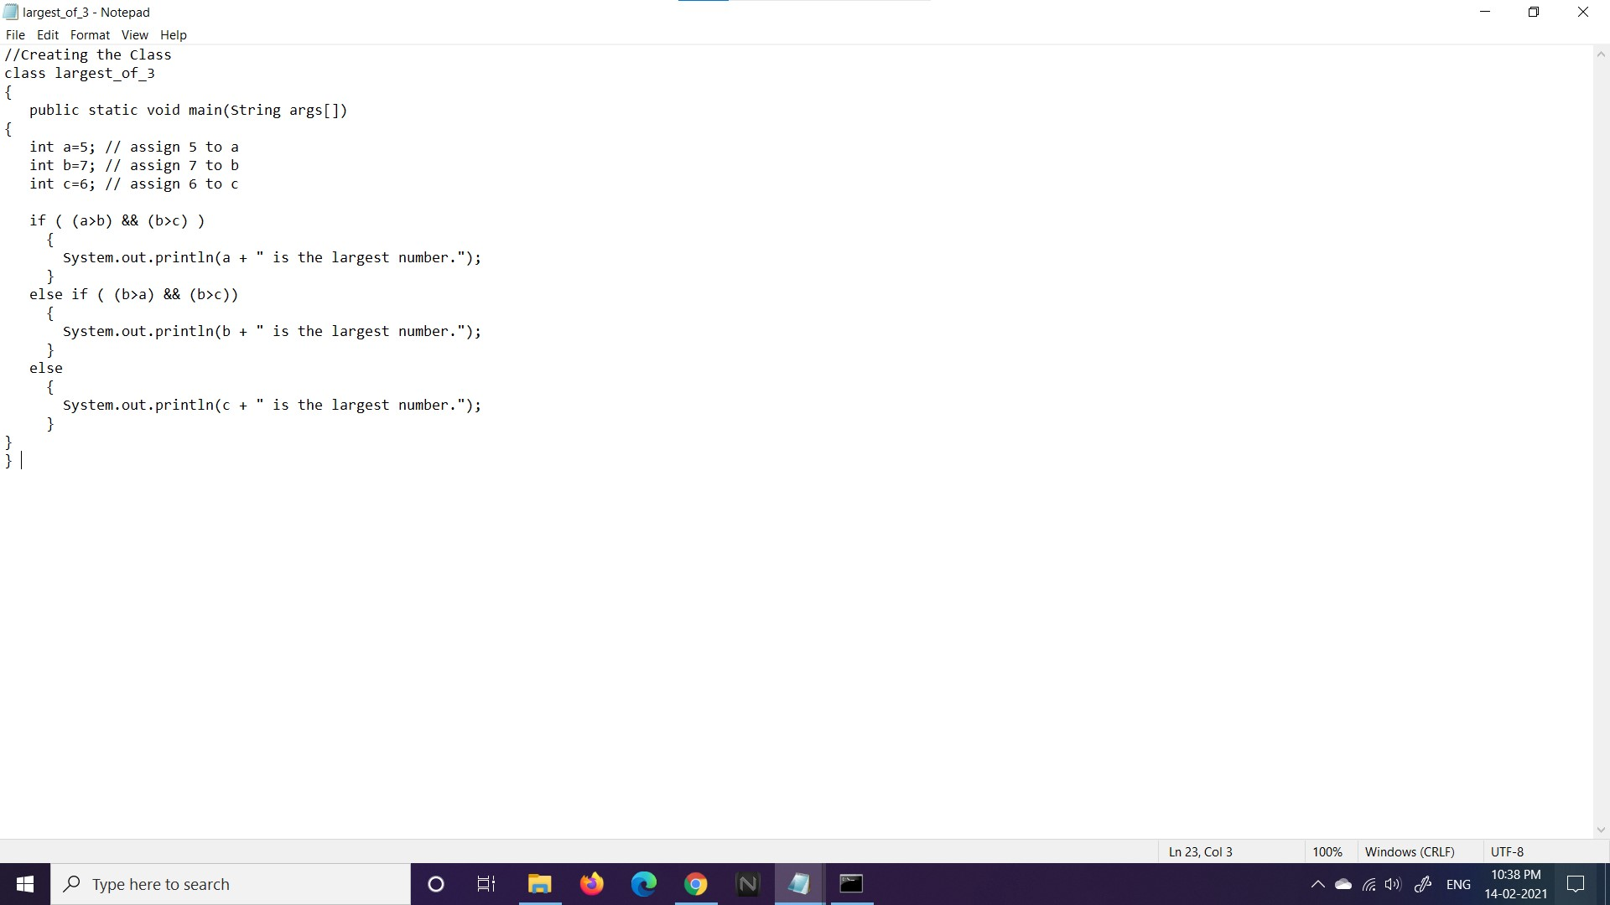

Output:
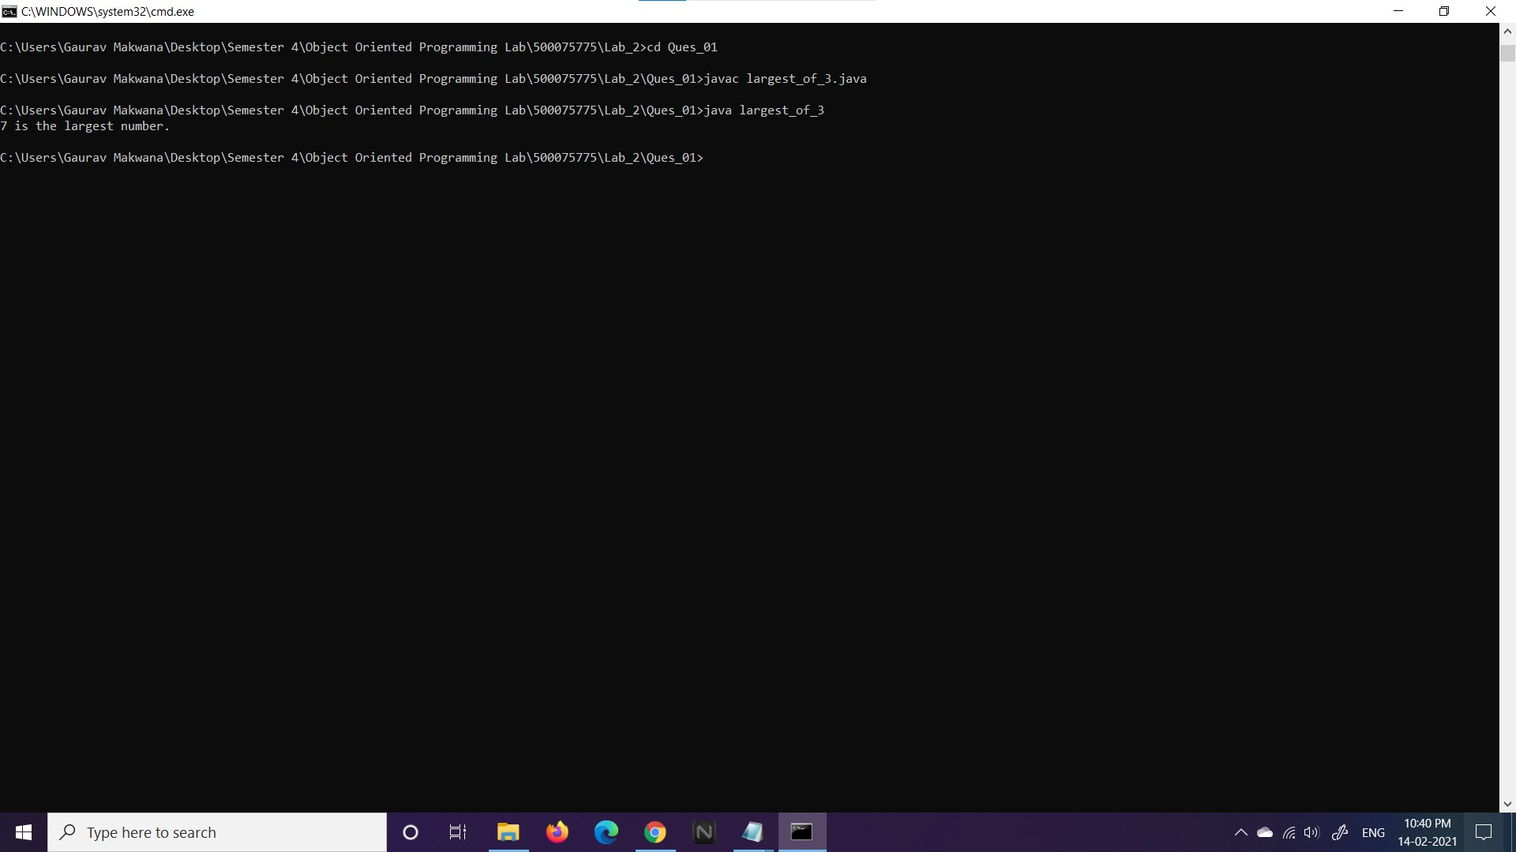

AIM: Write a program to implement a command line calculator.
Code:
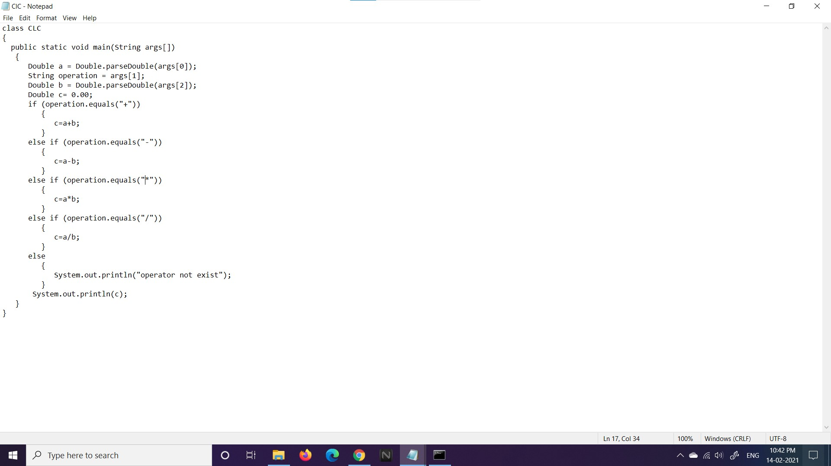

Output:
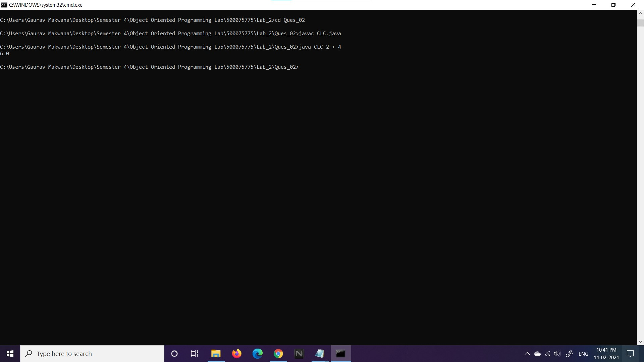

AIM: Write a program using classes and object in java.
Code:
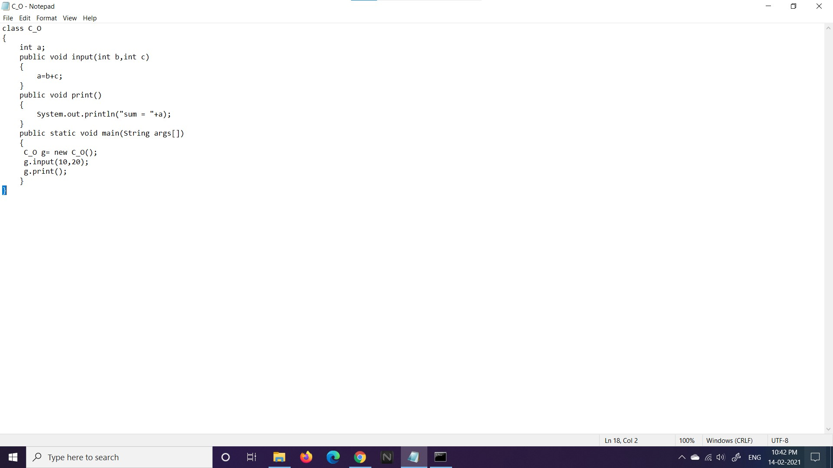

Output:
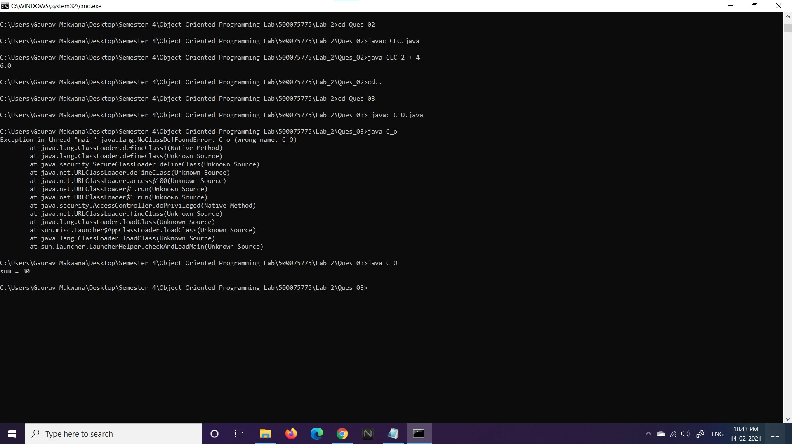

THANK YOU

