Lab Experiment:- 03

Name: Gaurav Makwana
Roll No.: R177219082
SAPID: 500075775
Subject: Object Oriented Programming Lab

AIM: Write a program to take input of 3 numbers and print the combinations of that numbers.

Code and Output:
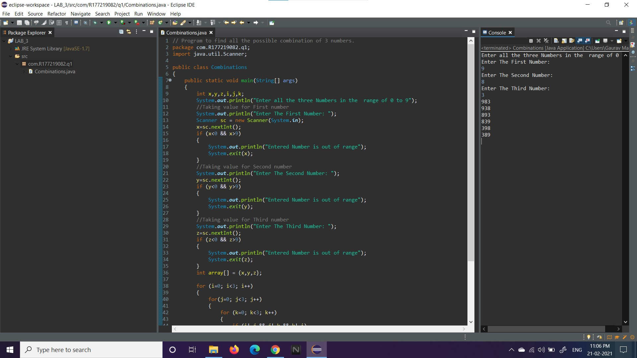
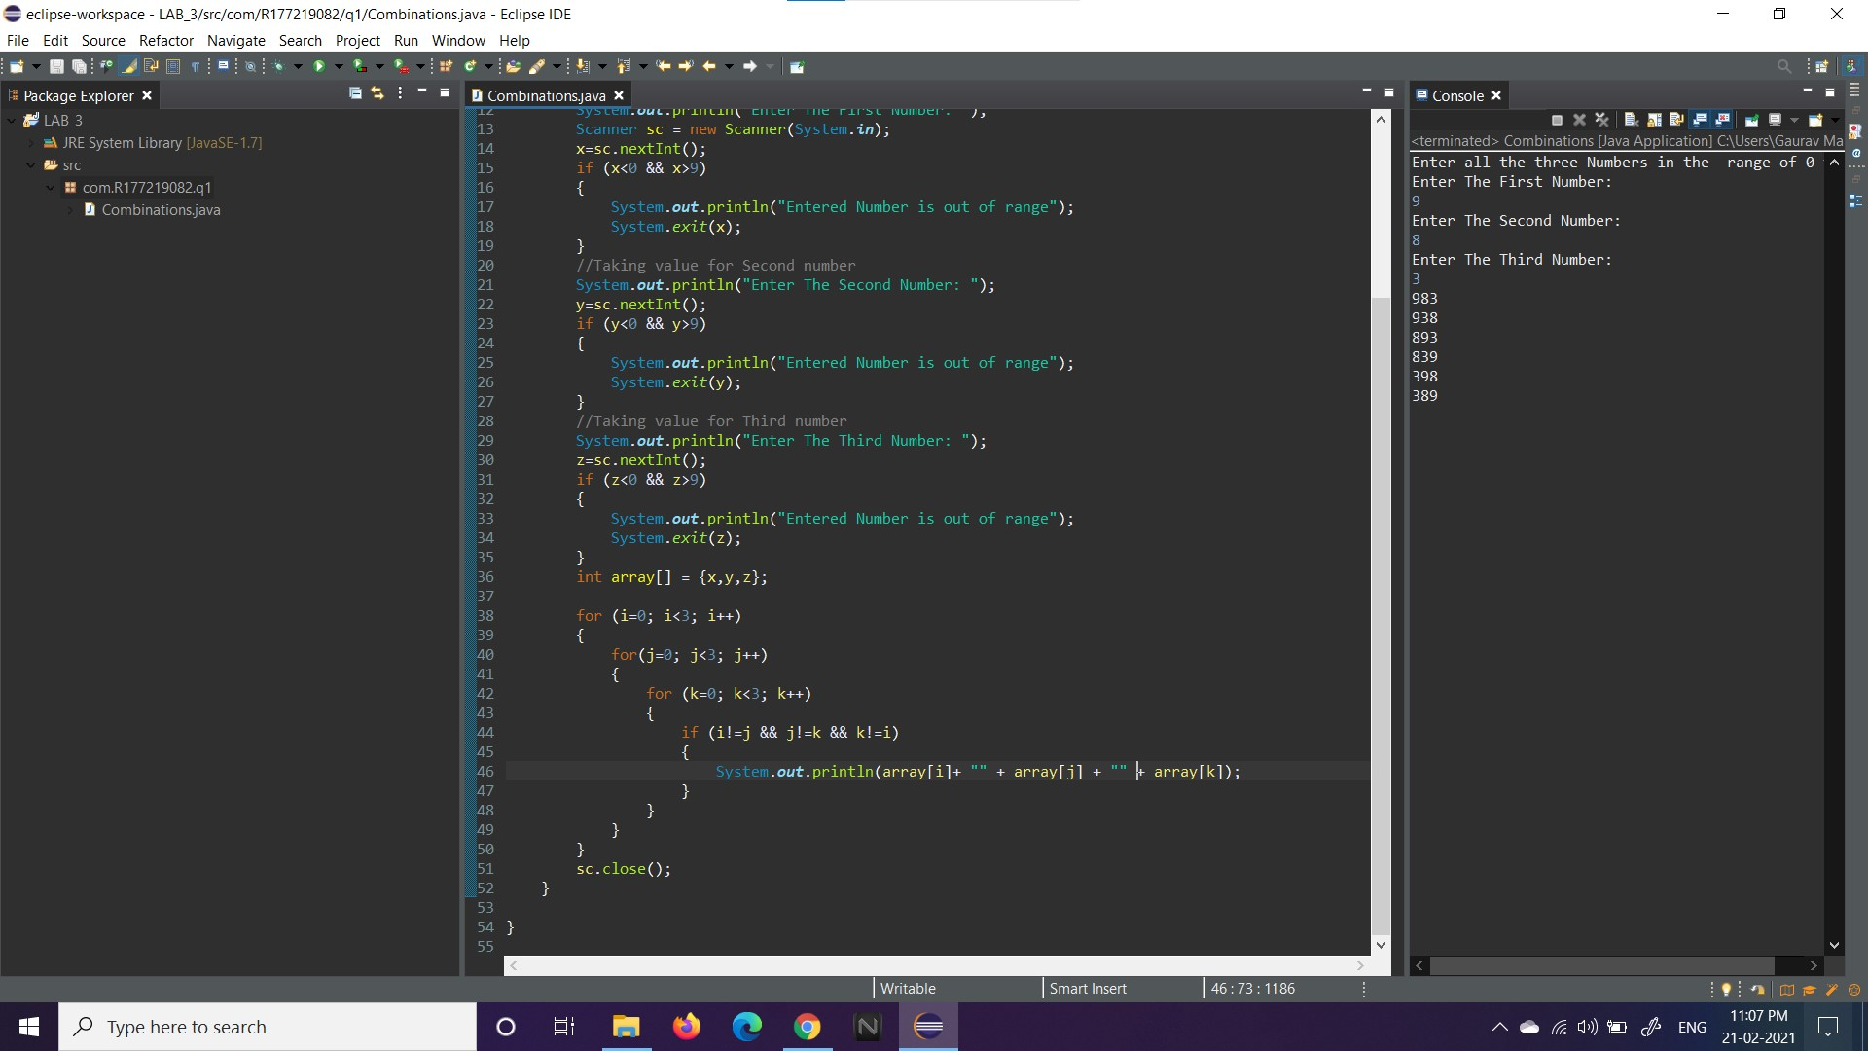
AIM: Write a program to take input of 10 numbers and print the sum of all the numbers after squaring.

Code and Output:
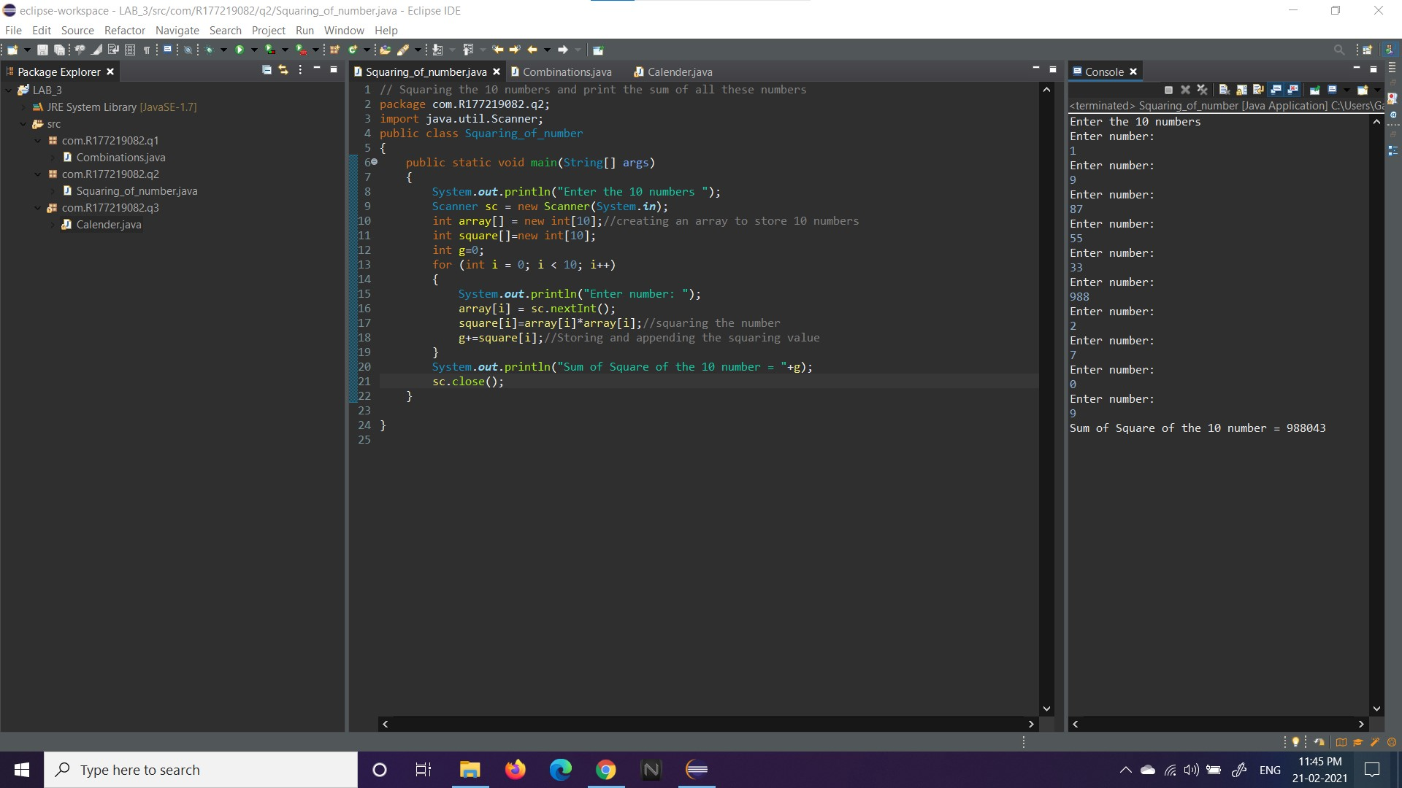

AIM: Write a program to take input as month number and printing the month name

Code and Output:
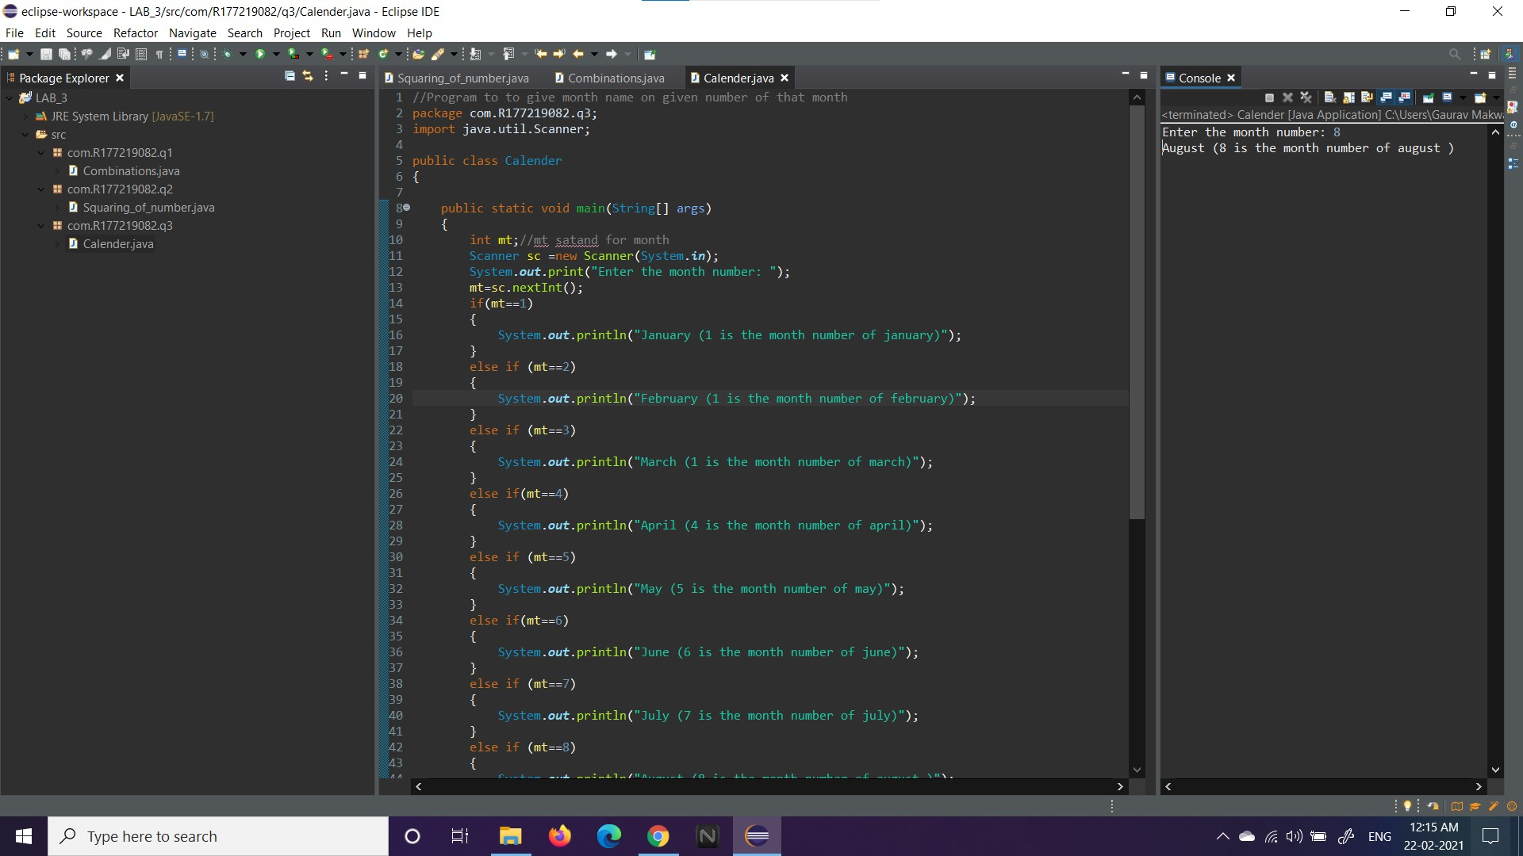
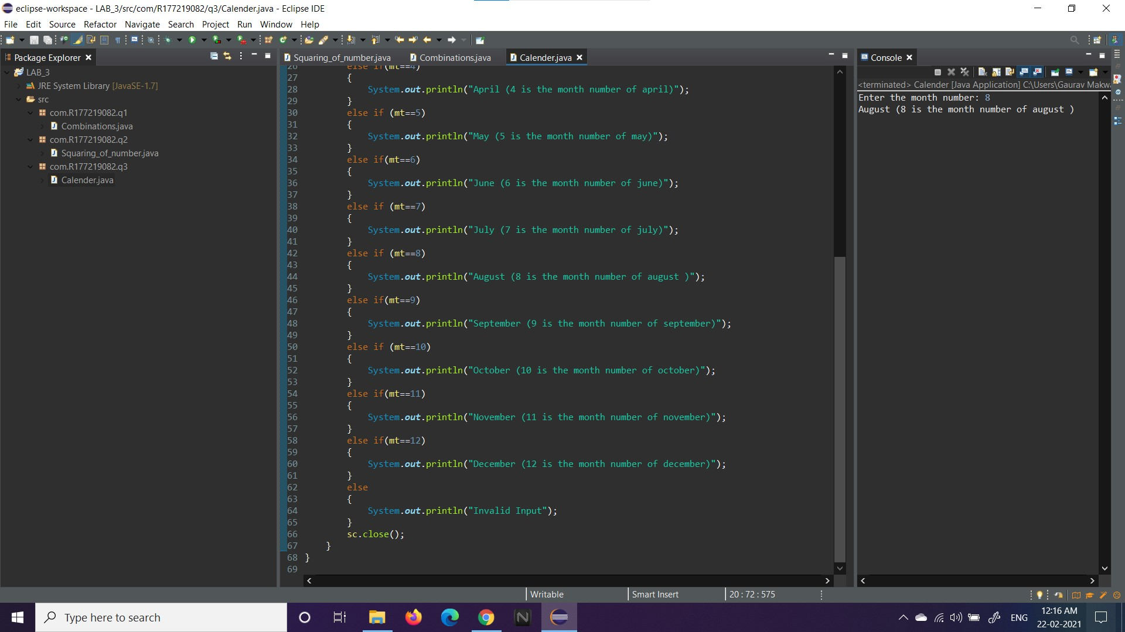
AIM: Write a program to print the sum of all numbers that are divisible by 5 that are greater than 40 and less than 250.
Code and Output:
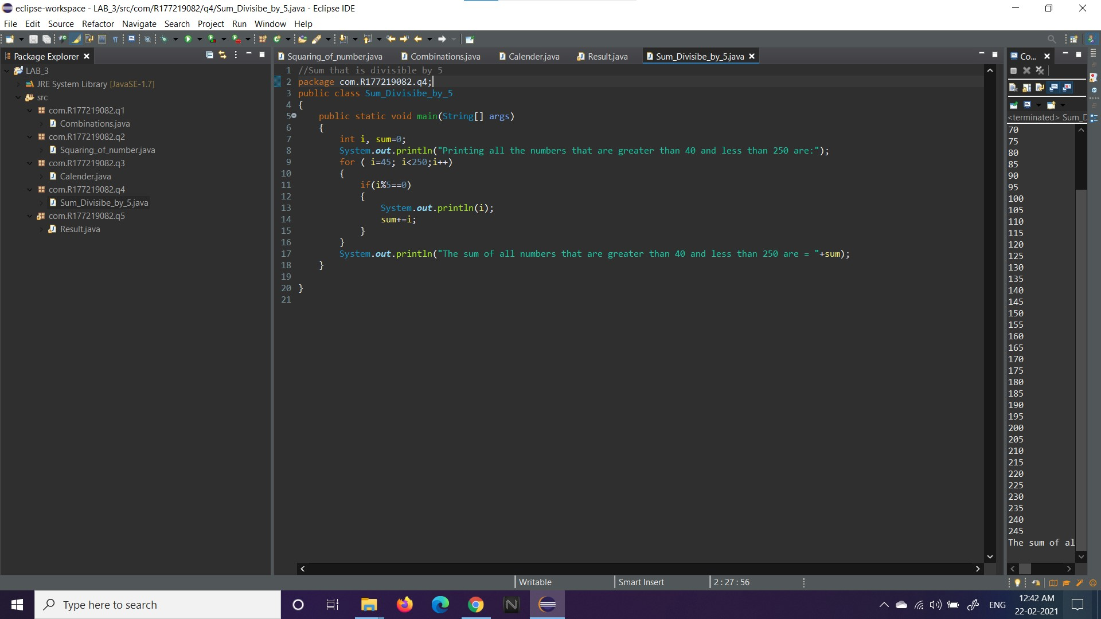
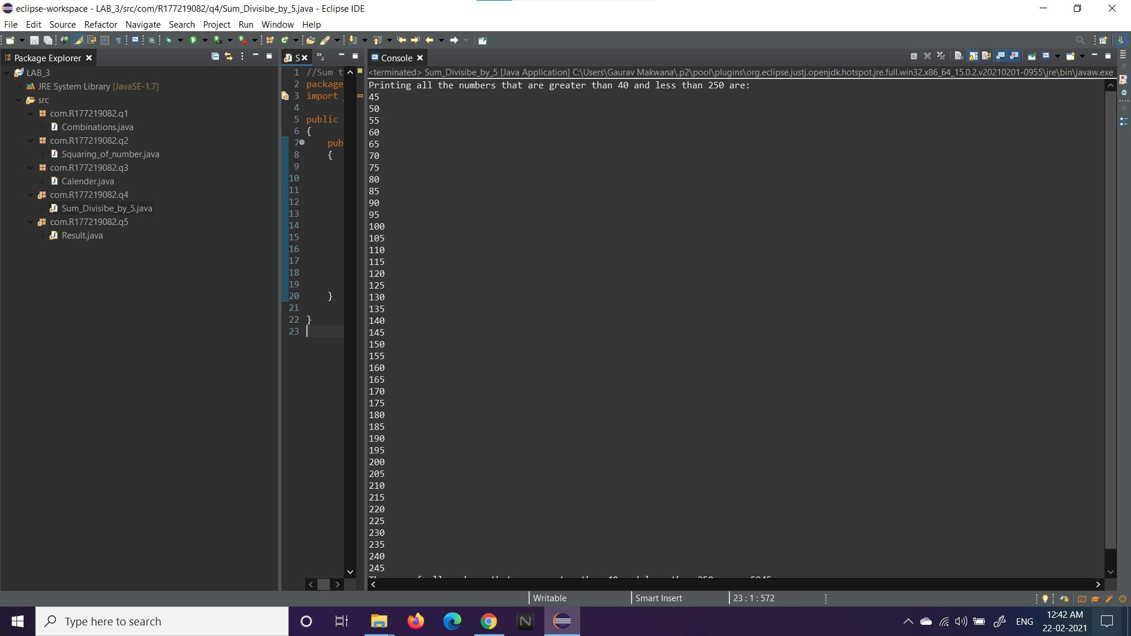

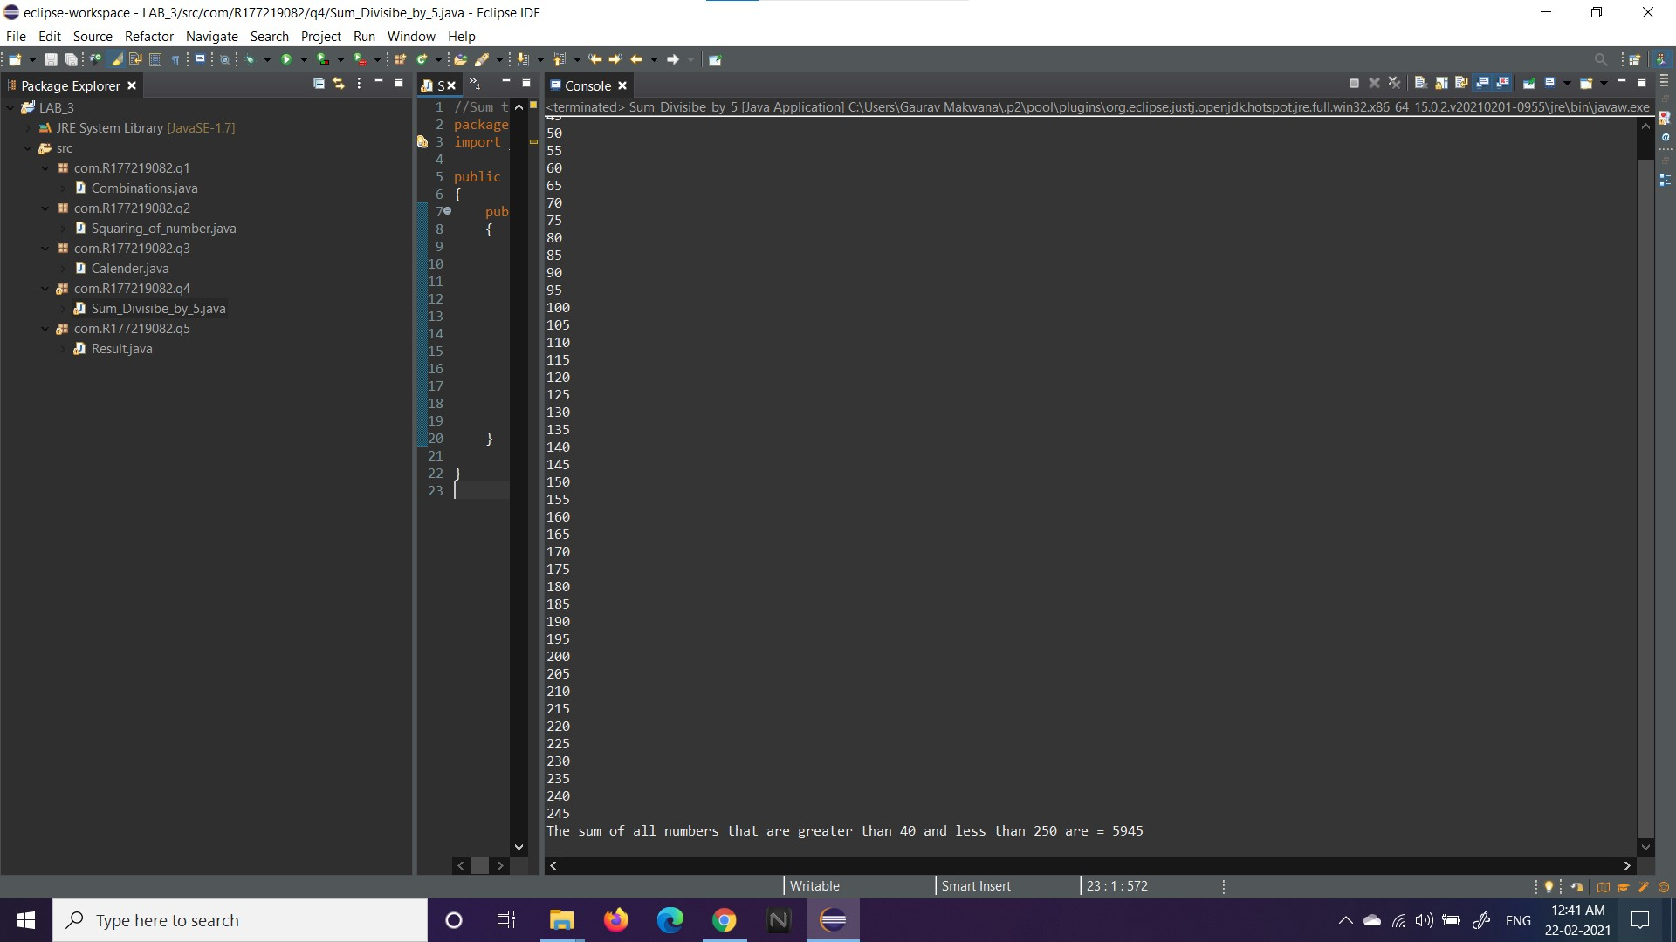

AIM: Write a program to print the result of 10 students.
Code and Output:
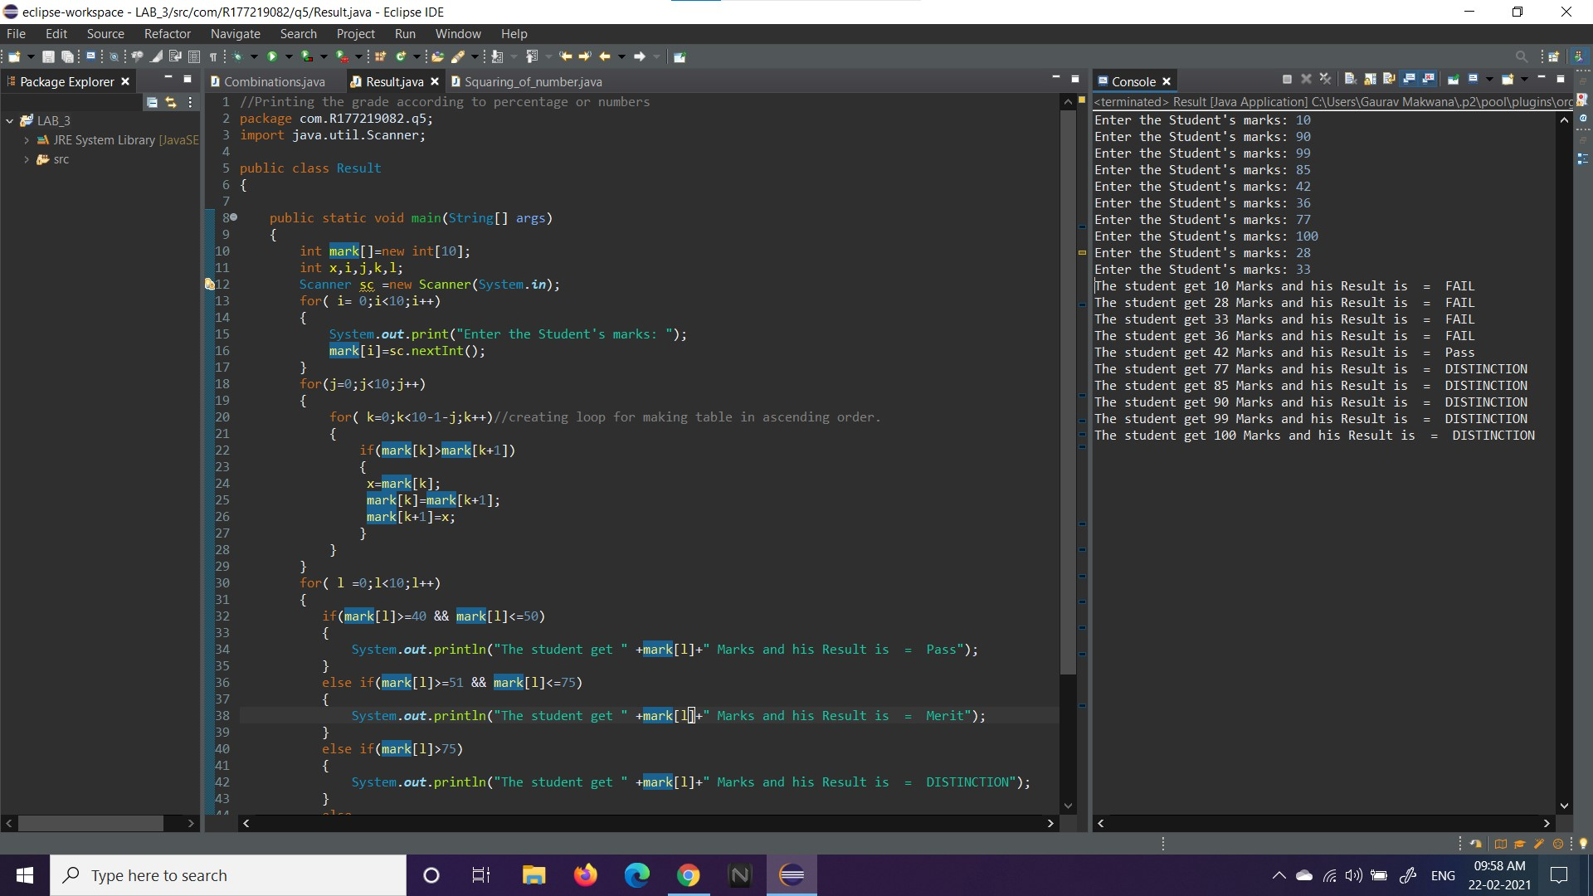
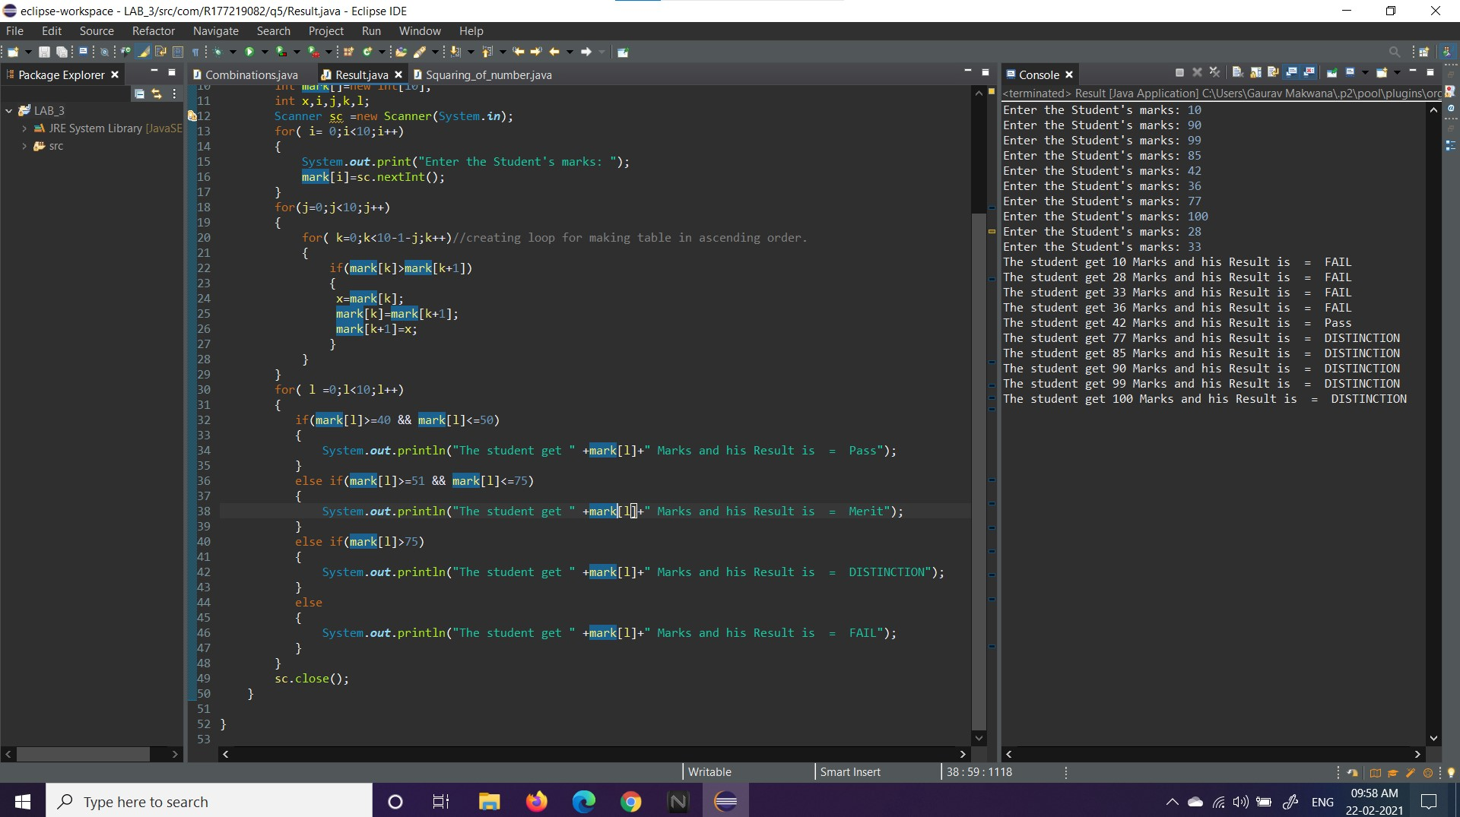

THANK YOU

