
PES UNIVERSITY
100 feet Ring Road, BSK 3rd Stage, Bengaluru 560085

Department of Computer Science and Engineering
(AI & ML)
B. Tech. CSE - 5th Semester Aug – Dec 2026

UE23CS351A
DATABASE MANAGEMENT SYSTEMS (DBMS)

PROJECT REPORT on

SpendSense: Smart Personal Finance, Subscription Analytics & Vector Similarity Search Platform

Submitted by:

PES1UG24AM118 | Harshitha.B.T | “B” AIML
PES1UG24AM104 | Gaurav.S | “B” AIML

Class of Prof : Smitha.G.R

Abstract

SpendSense is an enterprise-grade multi-paradigm database application engineered to turn transactional records into actionable financial insight, subscription governance, and semantic discovery. Modern consumers lose significant discretionary capital quietly to unmonitored subscriptions, unexpected rate increases, and unused digital memberships. While conventional personal finance software acts as passive digital ledgers, SpendSense architectures the database layer itself to perform autonomous recurring detection, automated price drift auditing, statistical anomaly surfacing, and conceptual semantic search.
The system incorporates a normalized relational database in MySQL 8.0 (InnoDB) featuring 11 tables, purpose-built composite B-Tree indexes, automated triggers, stored procedures, deterministic functions, and analytical views. To accommodate semi-structured digital invoices and itemized receipts, SpendSense integrates a NoSQL Document Store with document CRUD operations and a multi-stage aggregation pipeline ($match, $group, $sum, $project). Furthermore, to transcend the limitations of rigid SQL LIKE substring queries, the platform integrates a Vector Similarity Search Engine backed by a dedicated relational vector store (transaction_embeddings) executing 384-dimensional dense neural embeddings (BAAI/bge-small-en-v1.5) with exact Cosine Distance (1 - Cosine Similarity) calculations.
The backend is built with FastAPI, implementing Role-Based Access Control (RBAC) with ADMIN and CUSTOMER roles, connection pooling, and read-only parameterized transaction execution. The frontend is built using React 18, Vite, TypeScript, Tailwind CSS and Recharts, presenting real-time SQL execution metrics (X-DB-Time-Ms), provenance tracking chips, interactive vector distance ranking, and CSV exports. SpendSense is deployed on Vercel with cloud database connectivity, fully satisfying all Level 3 DBMS project evaluation rubrics.
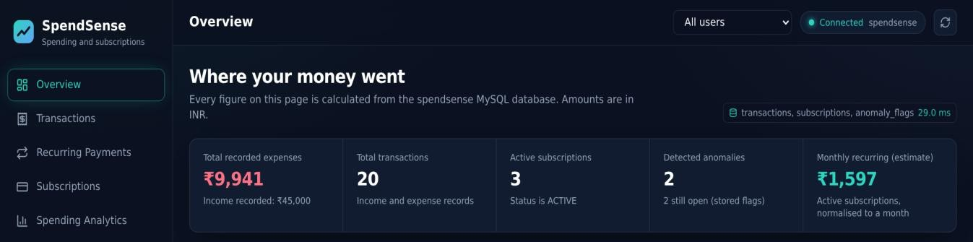

Figure 1: SpendSense UI Dashboard

Table of Contents
Sl. No | Topic | Page No.
1. | Introduction  a) Problem Statement | 4
2. | User Requirements Specification- Tech Stack | 5
3. | E-R Model  - List of Entities [labeling Weak ones]  - List non-simple Attributes  - ER Diagram Snapshot  - ERD from tool like draw.io | 6-7
4. | Relational Model  - List of Relations that are not Entities in ER Model  - Schema Diagram [ensure light background image] | 8-9
5. | SQL DDL Statements | 10-13
6. | SQL DML Statements | 14-15
7. | NoSQL/ Vector Database Commands | 16-17
8. | Results  - Resulting Tables’ Screenshots | 28-29
9. | React/Vite Project Tree Structure | 30
10. | Few sample Screenshots of application code and demo | 18-27
11. | Evaluation Rubrics- Completion Status | 31

Introduction

Problem Statement
In the contemporary subscription economy, recurring automated charges represent an increasingly large fraction of household and business expenditures. However, consumers suffer from 'subscription bleed': charges recurring indefinitely for unused, abandoned, or price-hiked services. Existing digital passbooks merely categorize past spend without tracking billing cycle frequencies, monitoring service utilization, or detecting quiet price drift. Furthermore, relational keyword lookups (LIKE '%food%') fail completely on natural language semantic queries such as 'Show my food and restaurant expenses' when the underlying merchant is named 'Fresh Basket' with description 'Groceries'.

Short Description
- SpendSense solves these core challenges by utilizing the database engine itself as the analytical powerhouse. The solution implements:
Automated Recurring Detection: Employs SQL Common Table Expressions (CTEs) and the LAG() window function over historical transactions to detect recurring intervals (weekly, monthly, quarterly, yearly).
- Inactivity Tracking: Correlates usage timestamps with active subscriptions to identify unutilized services exceeding a 30-day inactivity threshold.
- Automated Price Drift Auditing: Implements an AFTER UPDATE database trigger that automatically logs old and new prices with percentage deltas into an immutable audit table.
- Dynamic Statistical Anomaly Detection: Computes dynamic Z-scores using AVG() OVER and STDDEV_POP() OVER alongside PERCENT_RANK() to identify statistical outliers in expenditure in real time.
- Multi-Paradigm NoSQL & Vector Engine: Incorporates a JSON document store with aggregation pipelines for flexible receipt storage and a 384-dimensional neural vector embedding engine with Cosine Distance (1 - Cosine Similarity) for semantic transaction discovery.
- Role-Based Access Control (RBAC): Enforces ADMIN and CUSTOMER authorization boundaries at both the database schema level and the REST API layer.

User Requirements Specification

Layer | Technology | Justification for SpendSense
Relational Database | MySQL 8.0  (InnoDB) | Guarantees strict ACID compliance required for financial transactions. Provides native support for SQL:2016 window functions (LAG, AVG OVER, STDDEV_POP), foreign key integrity constraints, and JSON data types.
Backend Framework | Python 3.12 & FastAPI | Delivers asynchronous high-throughput REST APIs, automatic OpenAPI/Swagger documentation, and Pydantic schema validation. Features pooled SQLAlchemy connections with pre-ping validation.
Frontend Application | React 18 + Vite + TypeScript | Delivers a responsive, type-safe single-page interface. Ensures predictable state management for live financial metrics and provenance chips.
Data Visualization | Tailwind CSS & Recharts | Provides a modern dark-navy and teal visual system with animated SVG financial charts (area charts, category breakdown rings, vertical merchant bars).
Cloud Deployment | Vercel Serverless  + Cloud MySQL | Serverless lambda functions with Mangum ASGI adapter and environment variable isolation guarantee zero secret leakage and global scalability.

Our choice of NOSQL wrt the problem statement:
Commercial invoices and retail purchase receipts exhibit polymorphic, unstructured schemas. For example, a supermarket receipt contains itemized line items, quantities, and loyalty points, whereas a cloud server bill contains instance hours, IP addresses, and bandwidth allocations. Forcing this data into rigid relational tables causes excessive NULL columns or complex multi-table joins. SpendSense utilizes a NoSQL Document Store (JSON document collections) to store flexible digital receipt documents and executes a multi-stage aggregation pipeline ($match by user -> $group by category/payment mode -> $sum total spend -> $project) to deliver comprehensive unstructured spending analysis.

E-R Model

List of Entities
- User (Strong Entity): Account holders registered on the platform. Primary key: user_id.
- Category (Strong Entity): Classification for expenses and income. Primary key: category_id.
- Merchant (Strong Entity): Payees and service providers. Primary key: merchant_id.
- Subscription (Strong Entity): Recurring service contracts. Primary key: subscription_id.
- Transaction (Strong Entity): Discrete income or expense ledger records. Primary key: transaction_id.
- RecurringGroup (Strong Entity): Grouping for expected recurring payments. Primary key: recurring_group_id.
- UsageLog {Weak Entity}: Dated logs of subscription usage events. Dependent on Subscription via identifying foreign key subscription_id. Partial key: used_on, Identifier: usage_id.
- SubscriptionPriceHistory {Weak Entity}: Immutable audit history of price updates. Dependent on Subscription via subscription_id. Primary key: price_history_id.
- AnomalyFlag {Weak Entity}: Statistical and policy anomalies identified by database algorithms. Dependent on Transaction, Subscription, and User. Primary key: anomaly_id.
- Alert {Weak Entity}: User-facing alerts tied to generated anomalies. Dependent on AnomalyFlag. Primary key: alert_id.

Non-Simple Attributes:
  - Composite Attributes: User.full_name (First name, Last name), Receipt.metadata (Store ID, Cashier Name, Terminal IP).
  - Multivalued Attributes: Receipt.tags (Array of text tags), Receipt.items (Array of line-item objects).
  - Derived Attributes: Subscription.monthly_recurring_estimate (derived mathematically from current_price and billing_cycle), Transaction.vector_distance (computed at query time as 1 - Cosine Similarity), Subscription.annualized_cost (derived via stored function fn_annualized_cost).

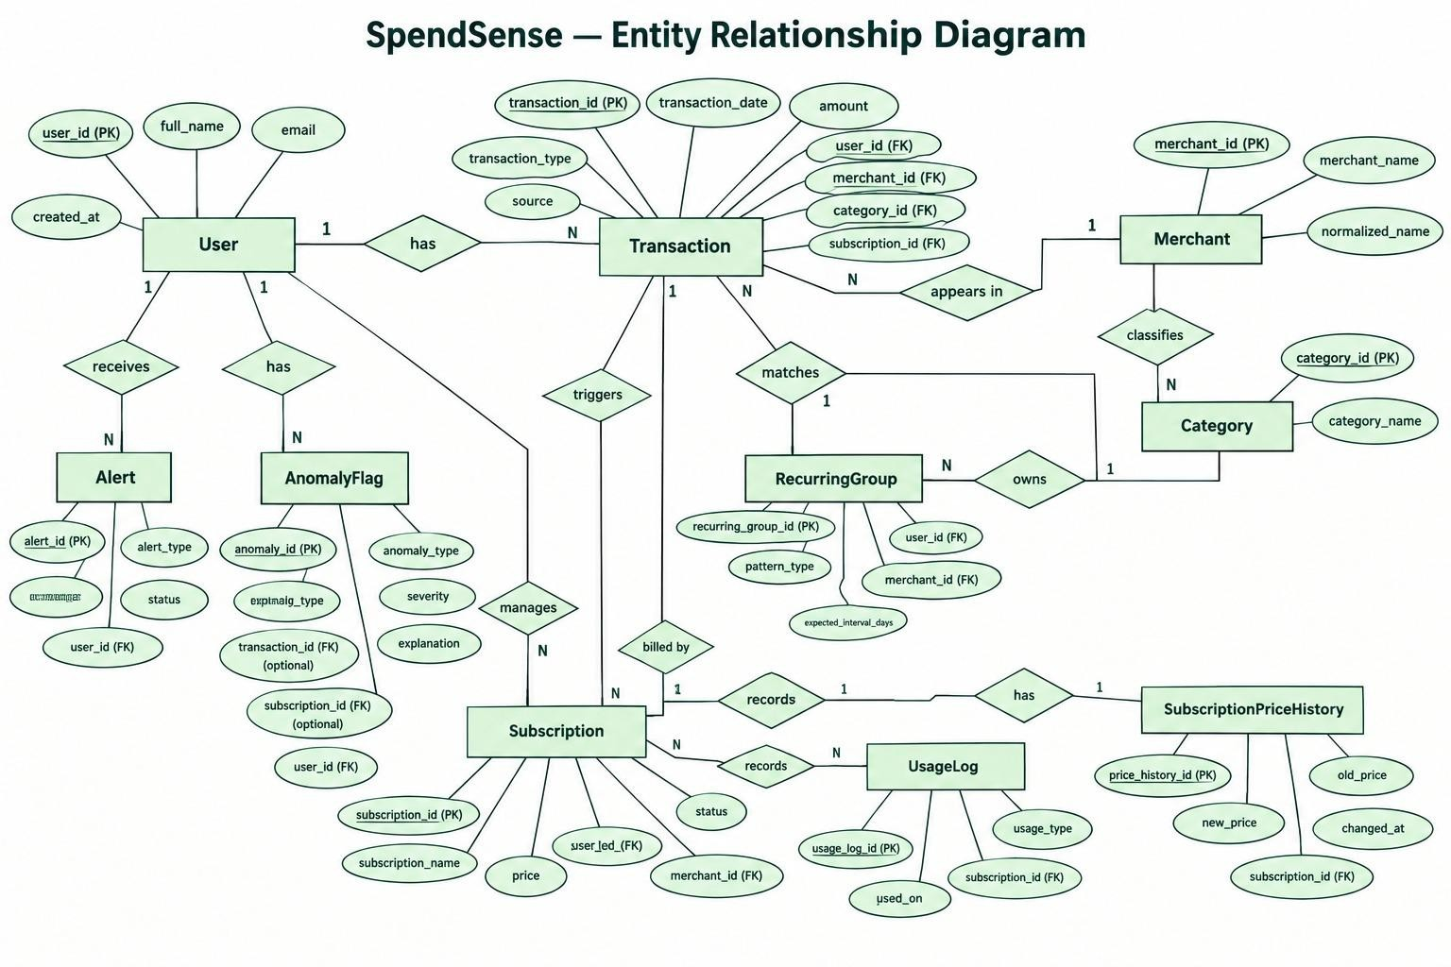
Figure 2 : SpendSense Entity-Relationship Diagram ( E-R Diagram )

Relational Model
List of Relations
- users (user_id [PK], full_name, email [UQ], role, created_at)
- categories (category_id [PK], category_name [UQ], category_type)
- merchants (merchant_id [PK], merchant_name, normalized_name [UQ], created_at)
- recurring_groups (recurring_group_id [PK], user_id [FK], merchant_id [FK], group_name, expected_amount, billing_cycle, active)
- subscriptions (subscription_id [PK], user_id [FK], merchant_id [FK], category_id [FK], recurring_group_id [FK], subscription_name, current_price, billing_cycle, started_on, status, last_used_on)
- transactions (transaction_id [PK], user_id [FK], merchant_id [FK], category_id [FK], subscription_id [FK], transaction_date, amount, transaction_type, description, source, created_at)
- subscription_price_history (price_history_id [PK], subscription_id [FK], old_price, new_price, changed_at, change_source)
- usage_logs (usage_id [PK], subscription_id [FK], used_on, note)
- anomaly_flags (anomaly_id [PK], user_id [FK], transaction_id [FK], subscription_id [FK], anomaly_type, severity, status, explanation, detected_at)
- alerts (alert_id [PK], user_id [FK], anomaly_id [FK], alert_title, alert_message, is_read, created_at)
- transaction_embeddings (transaction_id [PK, FK], embedding_model, dimensions, embedding, text_content, updated_at) [Labeled: Specialized Relational Vector Extension Relation - Not an Entity in ER model]

Schema Diagram
+
+
|
|
+
RELATIONAL SCHEMA DIAGRAM
+

USERS [user_id (PK), full_name, email (UQ), role, created_at]
^
|--< RECURRING_GROUPS [recurring_group_id (PK), user_id (FK), merchant_id (FK), ...]
|--< SUBSCRIPTIONS [subscription_id (PK), user_id (FK), merchant_id (FK), category_id (FK), ...]
| ^
| |--< USAGE_LOGS [usage_id (PK), subscription_id (FK), used_on, note]
| |--< SUBSCRIPTION_PRICE_HISTORY [price_history_id (PK), subscription_id (FK), old_price, ...]
| |--< ANOMALY_FLAGS [anomaly_id (PK), user_id (FK), transaction_id (FK), subscription_id (FK), ...]
| ^
| |--< ALERTS [alert_id (PK), user_id (FK), anomaly_id (FK), alert_title, ...]
|
|--< TRANSACTIONS [transaction_id (PK), user_id (FK), merchant_id (FK), category_id (FK), ...]

|
+=== (1:1) ===> TRANSACTION_EMBEDDINGS [transaction_id (PK, FK), embedding, dimensions, ...]

MERCHANTS [merchant_id (PK), merchant_name, normalized_name (UQ), created_at]
^
|--< RECURRING_GROUPS
|--< SUBSCRIPTIONS
|--< TRANSACTIONS

CATEGORIES [category_id (PK), category_name (UQ), category_type]
^
|--< SUBSCRIPTIONS
|--< TRANSACTIONS

SQL DDL Statements
The complete Data Definition Language (DDL) statements defining tables, integrity constraints, indexes, triggers, stored procedures, functions, and analytical views:

-- 1. USERS TABLE (Role-Based Access Control) CREATE TABLE users (
user_id BIGINT PRIMARY KEY AUTO_INCREMENT,
full_name VARCHAR(100) NOT NULL, email VARCHAR(255) NOT NULL UNIQUE,
role ENUM('ADMIN', 'CUSTOMER') NOT NULL DEFAULT 'CUSTOMER', created_at TIMESTAMP NOT NULL DEFAULT CURRENT_TIMESTAMP
) ENGINE=InnoDB DEFAULT CHARSET=utf8mb4;

-- 2. CATEGORIES TABLE
CREATE TABLE categories (
category_id INT PRIMARY KEY AUTO_INCREMENT, category_name VARCHAR(60) NOT NULL UNIQUE,
category_type ENUM('EXPENSE','INCOME') NOT NULL DEFAULT 'EXPENSE'
) ENGINE=InnoDB DEFAULT CHARSET=utf8mb4;

-- 3. MERCHANTS TABLE
CREATE TABLE merchants (
merchant_id BIGINT PRIMARY KEY AUTO_INCREMENT,
merchant_name VARCHAR(120) NOT NULL, normalized_name VARCHAR(120) NOT NULL UNIQUE,
created_at TIMESTAMP NOT NULL DEFAULT CURRENT_TIMESTAMP
) ENGINE=InnoDB DEFAULT CHARSET=utf8mb4;

-- 4. RECURRING GROUPS TABLE
CREATE TABLE recurring_groups (
recurring_group_id BIGINT PRIMARY KEY AUTO_INCREMENT, user_id BIGINT NOT NULL,
merchant_id BIGINT NOT NULL, group_name VARCHAR(120) NOT NULL,
expected_amount DECIMAL(12,2) NOT NULL,
billing_cycle ENUM('WEEKLY','MONTHLY','QUARTERLY','YEARLY') NOT NULL, active BOOLEAN NOT NULL DEFAULT TRUE,
CONSTRAINT fk_rg_user FOREIGN KEY (user_id) REFERENCES users(user_id),
CONSTRAINT fk_rg_merchant FOREIGN KEY (merchant_id) REFERENCES merchants(merchant_id),
CONSTRAINT chk_rg_amount CHECK (expected_amount >= 0),
UNIQUE KEY uq_rg_user_merchant_name (user_id, merchant_id, group_name)
) ENGINE=InnoDB DEFAULT CHARSET=utf8mb4;

-- 5. SUBSCRIPTIONS TABLE
CREATE TABLE subscriptions (
subscription_id BIGINT PRIMARY KEY AUTO_INCREMENT, user_id BIGINT NOT NULL,
merchant_id BIGINT NOT NULL, category_id INT NOT NULL, recurring_group_id BIGINT NULL, subscription_name VARCHAR(120) NOT NULL,

current_price DECIMAL(12,2) NOT NULL,
billing_cycle ENUM('WEEKLY','MONTHLY','QUARTERLY','YEARLY') NOT NULL,
started_on DATE NOT NULL,
status ENUM('ACTIVE','PAUSED','CANCELLED') NOT NULL DEFAULT 'ACTIVE',
last_used_on DATE NULL,
CONSTRAINT fk_sub_user FOREIGN KEY (user_id) REFERENCES users(user_id),
CONSTRAINT fk_sub_merchant FOREIGN KEY (merchant_id) REFERENCES merchants(merchant_id),
CONSTRAINT fk_sub_category FOREIGN KEY (category_id) REFERENCES categories(category_id),
CONSTRAINT fk_sub_group FOREIGN KEY (recurring_group_id) REFERENCES recurring_groups(recurring_group_id),
CONSTRAINT chk_sub_price CHECK (current_price >= 0), INDEX idx_sub_user_status (user_id, status)
) ENGINE=InnoDB DEFAULT CHARSET=utf8mb4;

-- 6. TRANSACTIONS TABLE
CREATE TABLE transactions (
transaction_id BIGINT PRIMARY KEY AUTO_INCREMENT, user_id BIGINT NOT NULL,
merchant_id BIGINT NOT NULL, category_id INT NOT NULL, subscription_id BIGINT NULL, transaction_date DATE NOT NULL, amount DECIMAL(12,2) NOT NULL,
transaction_type ENUM('EXPENSE','INCOME') NOT NULL DEFAULT 'EXPENSE',
description VARCHAR(255) NULL,
source ENUM('MANUAL','CSV_IMPORT','SUBSCRIPTION') NOT NULL DEFAULT 'MANUAL', created_at TIMESTAMP NOT NULL DEFAULT CURRENT_TIMESTAMP,
CONSTRAINT fk_tx_user FOREIGN KEY (user_id) REFERENCES users(user_id),
CONSTRAINT fk_tx_merchant FOREIGN KEY (merchant_id) REFERENCES merchants(merchant_id),
CONSTRAINT fk_tx_category FOREIGN KEY (category_id) REFERENCES categories(category_id),
CONSTRAINT fk_tx_subscription FOREIGN KEY (subscription_id) REFERENCES subscriptions(subscription_id),
CONSTRAINT chk_tx_amount CHECK (amount >= 0), INDEX idx_tx_user_date (user_id, transaction_date),
INDEX idx_tx_category_date (category_id, transaction_date), INDEX idx_tx_merchant_date (merchant_id, transaction_date)
) ENGINE=InnoDB DEFAULT CHARSET=utf8mb4;

-- 7. VECTOR EMBEDDINGS TABLE (Relational Vector Store) CREATE TABLE transaction_embeddings (
transaction_id BIGINT PRIMARY KEY, embedding_model VARCHAR(80) NOT NULL, dimensions INT NOT NULL,
embedding JSON NOT NULL, text_content VARCHAR(500) NOT NULL,
updated_at TIMESTAMP DEFAULT CURRENT_TIMESTAMP ON UPDATE CURRENT_TIMESTAMP,
CONSTRAINT fk_tx_embedding FOREIGN KEY (transaction_id) REFERENCES transactions(transaction_id) ON DELETE CASCADE
) ENGINE=InnoDB DEFAULT CHARSET=utf8mb4;

-- 8. TRIGGER: Automated Price Drift Audit Logging DELIMITER $$
CREATE TRIGGER trg_track_price_change

AFTER UPDATE ON subscriptions FOR EACH ROW
BEGIN
IF OLD.current_price <> NEW.current_price THEN INSERT INTO subscription_price_history
(subscription_id, old_price, new_price, changed_at, change_source) VALUES
(NEW.subscription_id, OLD.current_price, NEW.current_price, CURDATE(), 'SYSTEM_UPDATE');
END IF;
END$$ DELIMITER ;

-- 9. TRIGGER: High-Value Expenditure Anomaly Detection DELIMITER $$
CREATE TRIGGER trg_flag_large_transaction AFTER INSERT ON transactions
FOR EACH ROW BEGIN
IF NEW.transaction_type = 'EXPENSE' AND NEW.amount >= 10000.00 THEN INSERT INTO anomaly_flags
(user_id, transaction_id, anomaly_type, severity, status, explanation) VALUES
(NEW.user_id, NEW.transaction_id, 'UNUSUAL_SPENDING', 'HIGH', 'OPEN',
CONCAT('Transaction amount of Rs ', FORMAT(NEW.amount, 2), ' exceeds threshold of Rs 10,000.'));
END IF;
END$$ DELIMITER ;

-- 10. STORED FUNCTION: Annualized Cost Normalization DELIMITER $$
CREATE FUNCTION fn_annualized_cost(p_price DECIMAL(12,2), p_cycle VARCHAR(20)) RETURNS DECIMAL(12,2) DETERMINISTIC
BEGIN
DECLARE v_annual DECIMAL(12,2);
CASE UPPER(p_cycle)
WHEN 'WEEKLY' THEN SET v_annual = p_price * 52; WHEN 'MONTHLY' THEN SET v_annual = p_price * 12; WHEN 'QUARTERLY' THEN SET v_annual = p_price * 4; WHEN 'YEARLY' THEN SET v_annual = p_price;
ELSE SET v_annual = p_price * 12; END CASE;
RETURN ROUND(v_annual, 2); END$$
DELIMITER ;

-- 11. VIEW: Recurring Payment Candidates via Window LAG() CREATE OR REPLACE VIEW v_recurring_payment_candidates AS WITH ordered_tx AS (
SELECT t.transaction_id, t.user_id, t.merchant_id, m.merchant_name, t.amount, t.transaction_date,
LAG(t.amount) OVER w AS prev_amount, LAG(t.transaction_date) OVER w AS prev_date,
DATEDIFF(t.transaction_date, LAG(t.transaction_date) OVER w) AS day_gap FROM transactions t JOIN merchants m ON m.merchant_id = t.merchant_id WHERE t.transaction_type = 'EXPENSE'

WINDOW w AS (PARTITION BY t.user_id, t.merchant_id ORDER BY t.transaction_date)
)
SELECT transaction_id, user_id, merchant_id, merchant_name, amount, transaction_date, day_gap,
CASE
WHEN day_gap BETWEEN 25 AND 35 THEN 'MONTHLY' WHEN day_gap BETWEEN 6 AND 8 THEN 'WEEKLY' WHEN day_gap BETWEEN 85 AND 95 THEN 'QUARTERLY' WHEN day_gap BETWEEN 350 AND 375 THEN 'YEARLY' ELSE 'IRREGULAR'
END AS estimated_cadence FROM ordered_tx
WHERE prev_date IS NOT NULL AND ABS(amount - prev_amount) <= 5.00;

SQL DML Statements
Complex SQL queries executed by SpendSense demonstrating Multi-Table Joins, Correlated Subqueries, Window Functions, and Common Table Expressions:

-- 1. Complex 4-Table Multi-Filter Join SELECT
t.transaction_id, t.user_id, u.full_name AS user_name, t.transaction_date, t.amount,
t.transaction_type, t.description, t.source, s.subscription_name, m.merchant_name, c.category_name
FROM transactions t
JOIN users u ON u.user_id = t.user_id
JOIN merchants m ON m.merchant_id = t.merchant_id JOIN categories c ON c.category_id = t.category_id
LEFT JOIN subscriptions s ON s.subscription_id = t.subscription_id WHERE t.user_id = 1 AND t.transaction_type = 'EXPENSE'
AND t.transaction_date BETWEEN '2026-07-01' AND '2026-10-31' ORDER BY t.transaction_date DESC, t.transaction_id DESC

LIMIT 15 OFFSET 0;

-- 2. Correlated Subquery: Unused Subscriptions Detection SELECT
s.subscription_name, m.merchant_name, s.current_price,
(SELECT MAX(ul.used_on) FROM usage_logs ul WHERE ul.subscription_id = s.subscription_id) AS last_activity_date
FROM subscriptions s
JOIN merchants m ON m.merchant_id = s.merchant_id WHERE s.status = 'ACTIVE'
AND (SELECT MAX(ul.used_on) FROM usage_logs ul WHERE ul.subscription_id = s.subscription_id) < DATE_SUB(CURDATE(), INTERVAL 30 DAY);

-- 3. Window Functions: Dynamic Z-Score Outlier Detection (AVG OVER & STDDEV_POP OVER) SELECT x.transaction_id, x.amount, x.merchant_name, x.category_name,
ROUND((x.amount - x.category_mean) / x.category_stddev, 2) AS z_score

FROM (
SELECT
t.transaction_id, t.user_id, t.amount, m.merchant_name, c.category_name, COUNT(*) OVER w AS sample_size,
ROUND(AVG(t.amount) OVER w, 2) AS category_mean, STDDEV_POP(t.amount) OVER w AS category_stddev
FROM transactions t
JOIN merchants m ON m.merchant_id = t.merchant_id JOIN categories c ON c.category_id = t.category_id WHERE t.transaction_type = 'EXPENSE' AND t.user_id = 1 WINDOW w AS (PARTITION BY t.user_id, t.category_id)
) x
WHERE x.sample_size >= 4 AND x.category_stddev > 0
AND ABS(x.amount - x.category_mean) / x.category_stddev >= 1.5 ORDER BY z_score DESC;

-- 4. CTE & Window Functions: Month-Over-Month Expenditure Growth Rate WITH monthly AS (

SELECT

DATE_FORMAT(t.transaction_date, '%Y-%m') AS month,
SUM(CASE WHEN t.transaction_type = 'EXPENSE' THEN t.amount ELSE 0 END) AS expense,
SUM(CASE WHEN t.transaction_type = 'INCOME' THEN t.amount ELSE 0 END) AS
income
FROM transactions t WHERE t.user_id = 1
GROUP BY DATE_FORMAT(t.transaction_date, '%Y-%m')
) SELECT
month, expense, income,
LAG(expense) OVER (ORDER BY month) AS previous_month_expense,
ROUND(100.0 * (expense - LAG(expense) OVER (ORDER BY month)) / NULLIF(LAG(expense) OVER (ORDER BY month), 0), 2) AS mom_growth_pct,
ROUND(AVG(expense) OVER (ORDER BY month ROWS BETWEEN 2 PRECEDING AND CURRENT ROW),
2) AS moving_avg_3m
FROM monthly ORDER BY month ASC;

NoSQL/ Vector Database Commands

NoSQL Receipt Document Store (JSON Collections & CRUD)
# CREATE: Ingest polymorphic receipt document with itemized entries new_receipt = nosql_create_receipt(ReceiptDocumentModel(
user_id=1,
merchant="Fresh Basket Supermarket", total_amount=2100.00, purchase_date="2026-10-08", payment_mode="UPI QR",
tags=["groceries", "fresh produce", "weekend"], items=[
{"name": "Organic Almond Milk 1L", "qty": 2, "price": 560.00},
{"name": "Brown Rice 5kg", "qty": 1, "price": 420.00},
{"name": "Olive Oil Extra Virgin", "qty": 1, "price": 1120.00}
],
metadata={"store_id": "FB-BLR-04", "cashier": "Ramesh K", "loyalty_points": 42}
))

# READ: Retrieve document by ID doc = nosql_get_receipt("rec_003")

# UPDATE: Update tags, items or payment metadata
updated = nosql_update_receipt("rec_003", {"payment_mode": "NetBanking"})

# DELETE: Remove document from collection deleted = nosql_delete_receipt("rec_003")

- NoSQL Multi-Stage Aggregation Pipeline ($match -> $group -> $sum -> $project)
def nosql_aggregate_summary(user_id: Optional[int] = None) -> Dict[str, Any]: docs = nosql_list_receipts(user_id=user_id)
total_spend = sum(d.get("total_amount", 0) for d in docs) tag_counter = Counter()
payment_modes: Dict[str, float] = {}

for d in docs:
for t in d.get("tags", []): tag_counter[str(t).lower()] += 1
pm = d.get("payment_mode", "UNKNOWN")
payment_modes[pm] = payment_modes.get(pm, 0.0) + d.get("total_amount", 0.0)

return {
"pipeline": ["$match: {user_id}", "$group: {by: tag, payment_mode}", "$sum: total_amount"],
"total_receipts": len(docs), "total_spend": round(total_spend, 2),
"avg_spend": round(total_spend / len(docs), 2),
"by_payment_mode": {k: round(v, 2) for k, v in payment_modes.items()}, "top_tags": [{"tag": k, "count": v} for k, v in tag_counter.most_common(10)],
}

Vector Database & Cosine Distance Engine (BAAI/bge-small-en-v1.5)

Cosine Distance Formula:
Cosine Similarity(q, v) = (q · v) / (||q|| * ||v||) Cosine Distance = 1.0 - Cosine Similarity
Interpretation: 0.0000 = exact identical direction (maximum semantic relevance). Lower values indicate closer semantic relevance.
# 1. Text representation synthesis:
text = f"Merchant: {merchant_name}. Category: {category_name}. Description: {description}. Type: {transaction_type}"

# 2. Dense vector embedding generation (384 float dimensions via FastEmbed ONNX): embedding_vector = generate_embeddings([text])[0]

# 3. Persistent relational vector storage in MySQL:
INSERT INTO transaction_embeddings
(transaction_id, embedding_model, dimensions, embedding, text_content) VALUES (:tid, 'BAAI/bge-small-en-v1.5 (FastEmbed ONNX)', 384, :emb_json, :text) ON DUPLICATE KEY UPDATE embedding = VALUES(embedding);

# 4. Live query cosine distance calculation:
def calculate_distances_for_query(query: str, target_ids: list[int]) -> dict[int, float]: q_vec = np.asarray(generate_embedding(query.strip()), dtype=np.float32)
norm_q = np.linalg.norm(q_vec) distances = {}
for tid in target_ids:
vec = _VECTOR_CACHE.get(tid) norm_v = np.linalg.norm(vec)
sim = float(np.dot(q_vec, vec) / (norm_q * norm_v))
distances[tid] = round(max(0.0, 1.0 - max(-1.0, min(1.0, sim))), 4) return distances

Application Walkthrough
All screenshots below were captured from the running application connected to MySQL 8.0 loaded with the project seed data. Amounts are in INR.

Overview
Five figures summarise the database: total expenses (₹9,941), 20 transactions, 3 active subscriptions, 2 stored anomalies and an estimated ₹1,597 per month in recurring cost. Charts show the monthly trend, category share, expense versus income and top merchants. Each panel carries a chip naming its source tables and the measured MySQL time.
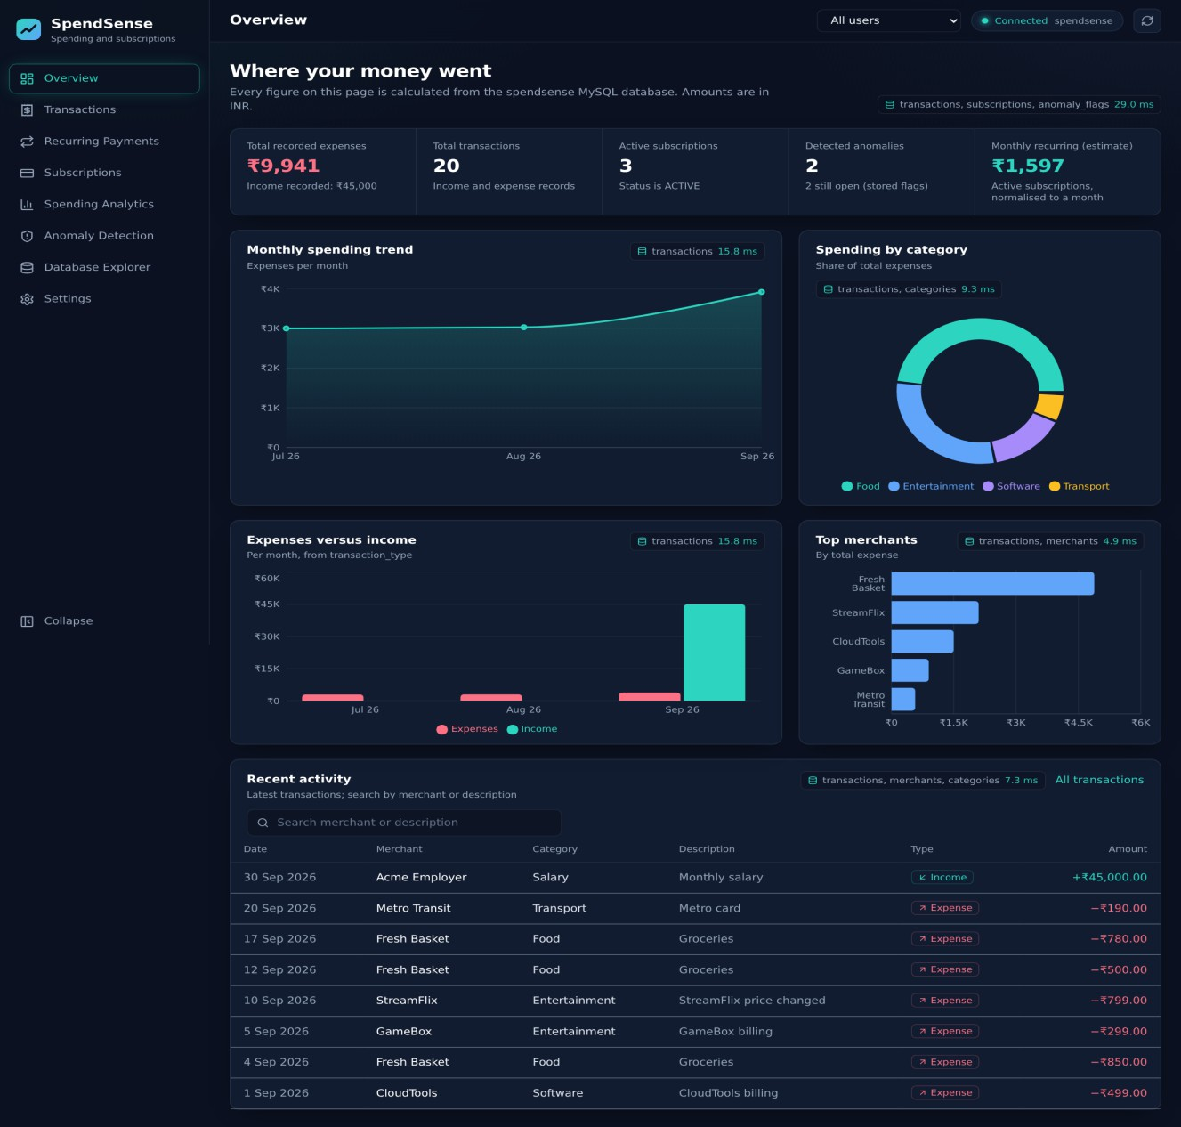
Figure 3 : Overview dashboard

Transactions
Search by merchant or description, filter by category, type and date range, sort by date or amount, and page through results. Export downloads the full filtered set as CSV. Selecting a row opens a detail panel.
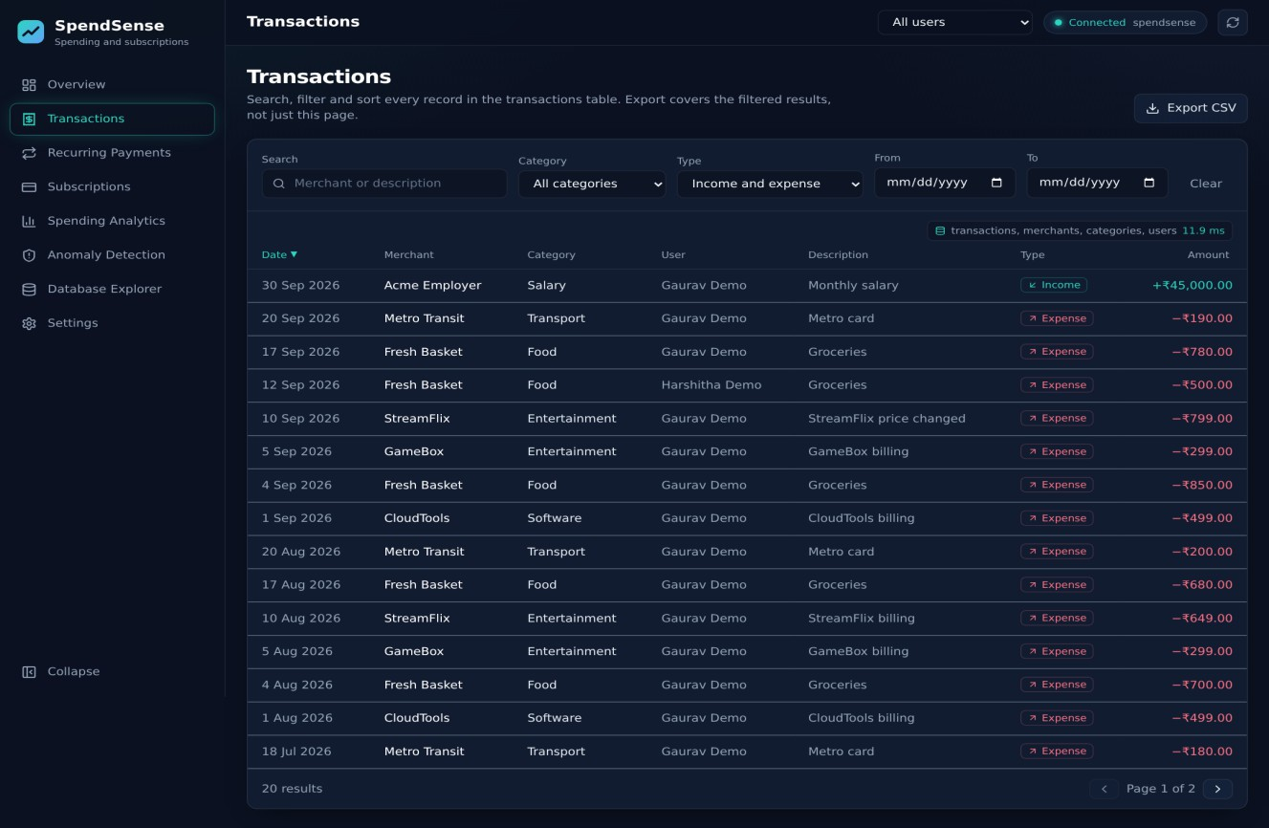
Figure 4 : Transactions with filters, sorting and pagination

Recurring payments
Candidates come straight from the SQL view. SpendSense then compares each candidate with the subscriptions table: a match is shown as Confirmed, and anything else as Potential.
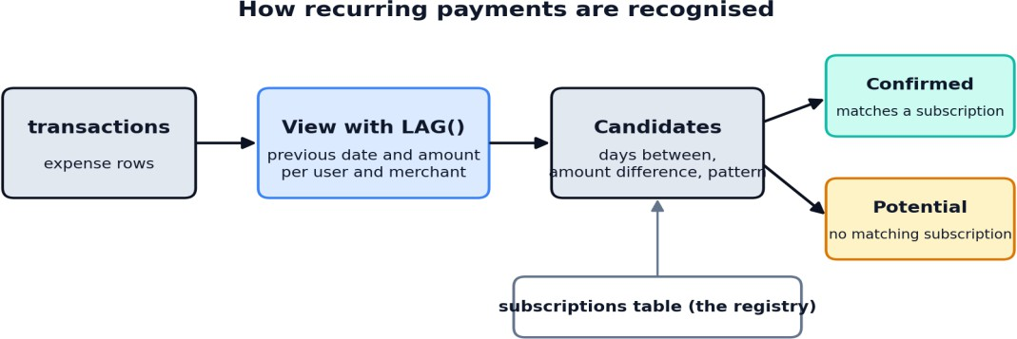
Figure 5 : From transactions to confirmed and potential recurring payments

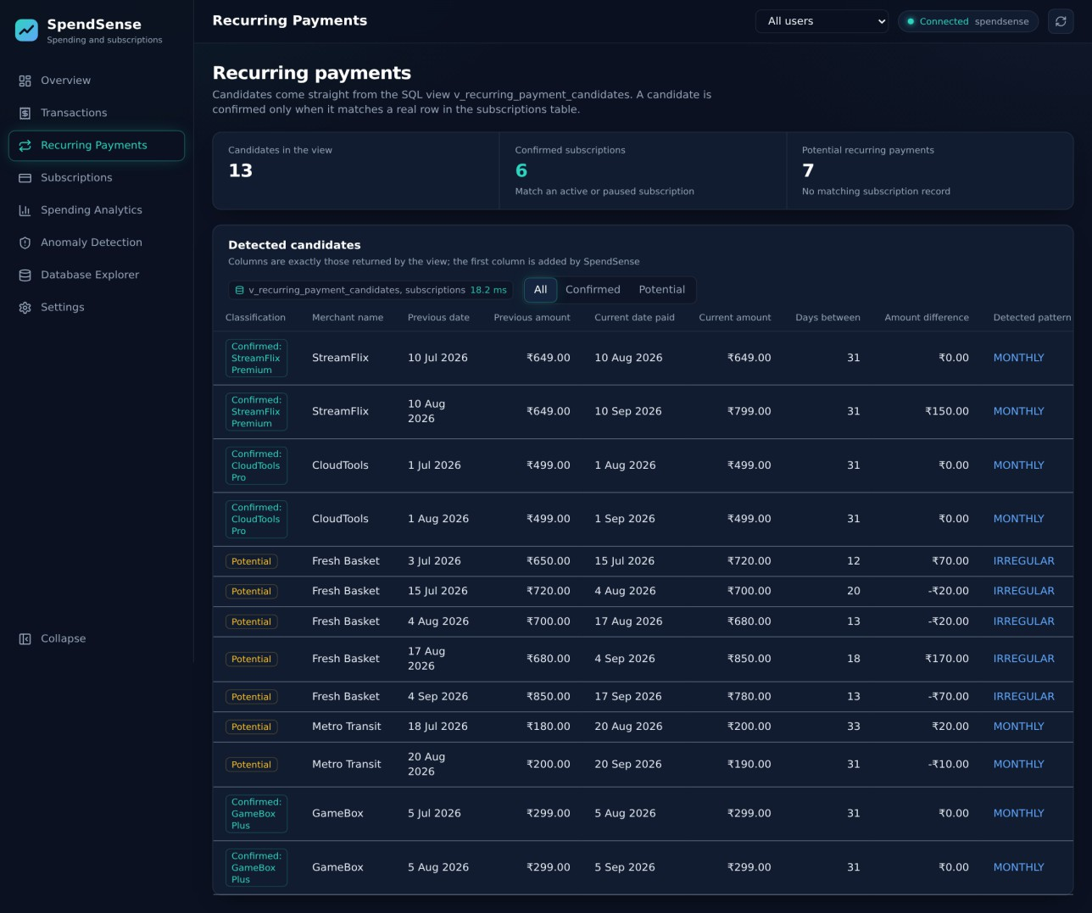
Figure 6 : Recurring payments page

The screenshot above was produced with a stand-in definition of v_recurring_payment_candidates (columns: user, merchant, previous and current date and amount, days between, difference, pattern). The page displays whatever columns the real view returns.

Subscriptions
The inventory lists name, merchant, price, billing cycle, estimated monthly cost, start date, status and last use. Estimated monthly cost is weekly × 52 / 12, monthly as is, quarterly / 3 and yearly /
12. Totals are labelled as estimates.

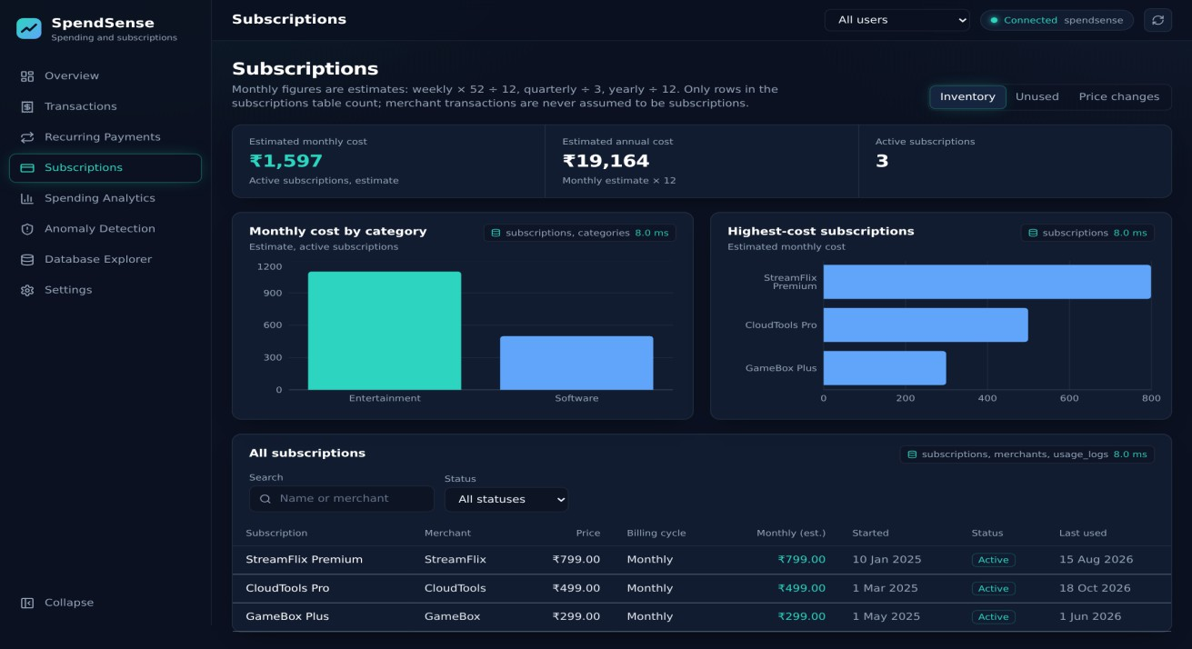
Figure 7 : Subscription inventory with estimated monthly and annual cost

Unused subscriptions
A subscription is flagged when it is ACTIVE and its latest recorded use (from the subscription row or the usage log) is missing or older than the chosen number of days. On 25 October 2026 two subscriptions are flagged: StreamFlix Premium (71 days) and GameBox Plus (146 days).
Cancelling both would save an estimated ₹1,098 per month, or ₹13,176 per year.
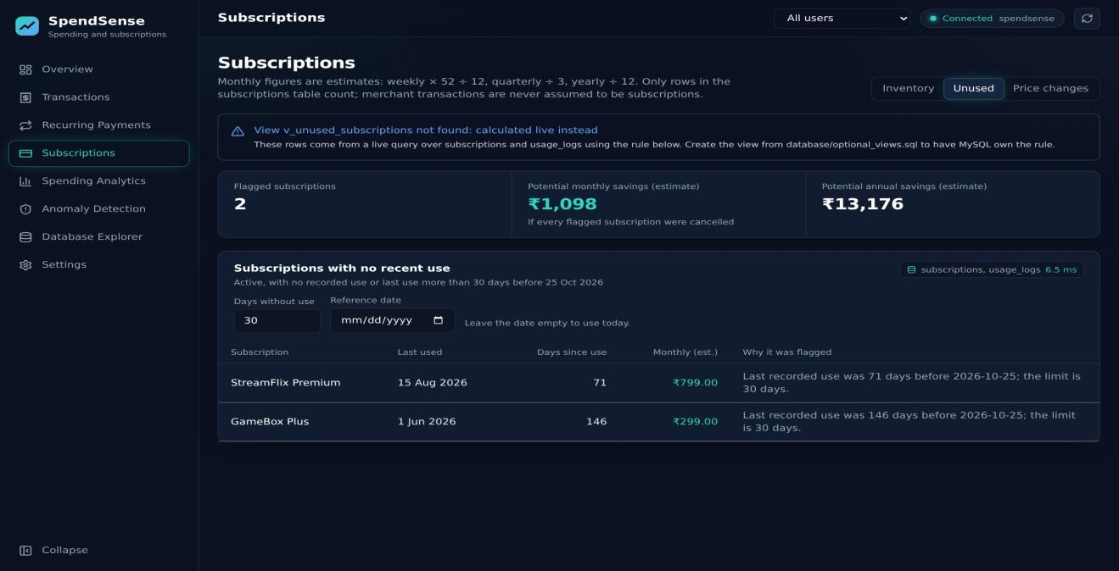
Figure 8 : Unused subscriptions with reason and estimated savings

Price changes
Price history shows StreamFlix moving from ₹649 to ₹799, an increase of ₹150 or 23.11%. The page reports only what subscription_price_history contains.
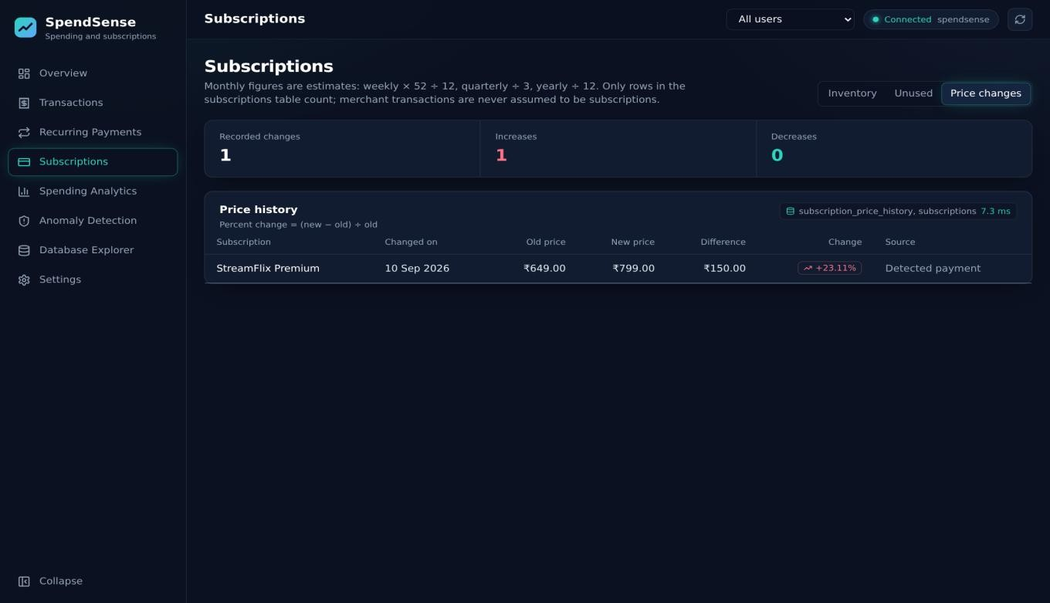
Figure 9 : Recorded subscription price changes

Spending analytics
All charts respond to the date-range and category filters. Month-over-month change uses LAG(), and the three-month moving average uses a window frame. Merchant ranking and the split between subscription-linked and other spending are computed in SQL.
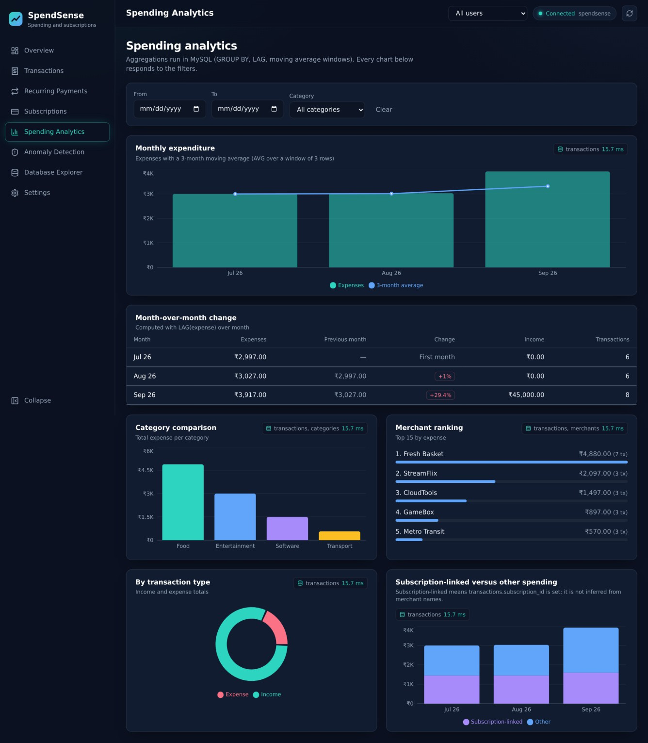
Figure 10 : Spending analytics

Anomaly detection
The page separates two sources. Stored flags come from anomaly_flags with their recorded explanations, plus the alerts table. Calculated at query time outliers use a z-score per user and category; at a threshold of 1.5, the ₹850 grocery purchase on 4 September 2026 (category average
₹730, z = 1.8) is shown. Nothing calculated is written back to the database.
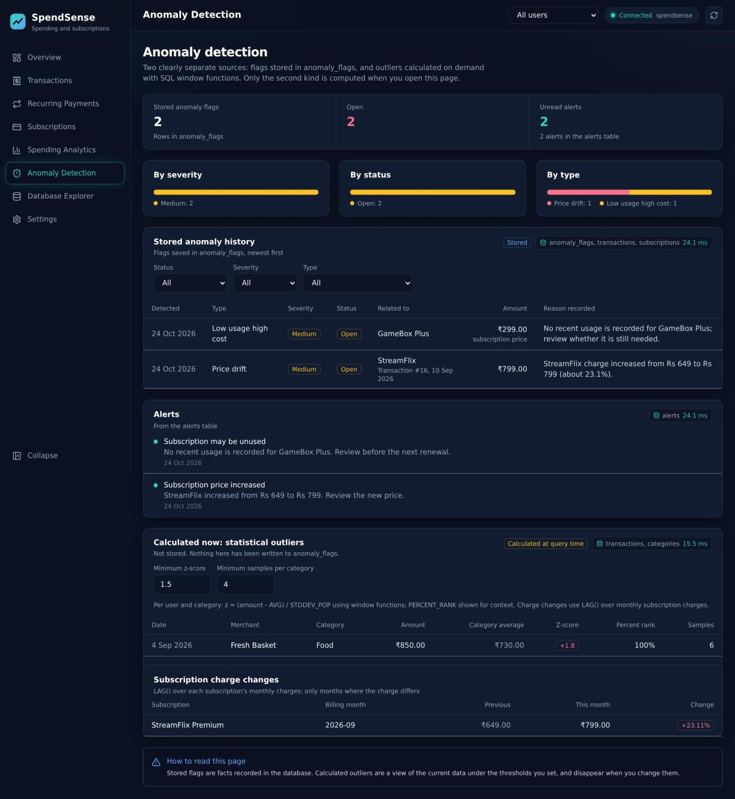
Figure 11 : Anomaly detection: stored flags, alerts and calculated outliers

Database explorer
Lists tables and views with exact row counts, then shows columns and data types, primary and foreign keys, indexes, a read-only preview and, for views, the definition when MySQL permits it. A relationship table lists every foreign key.
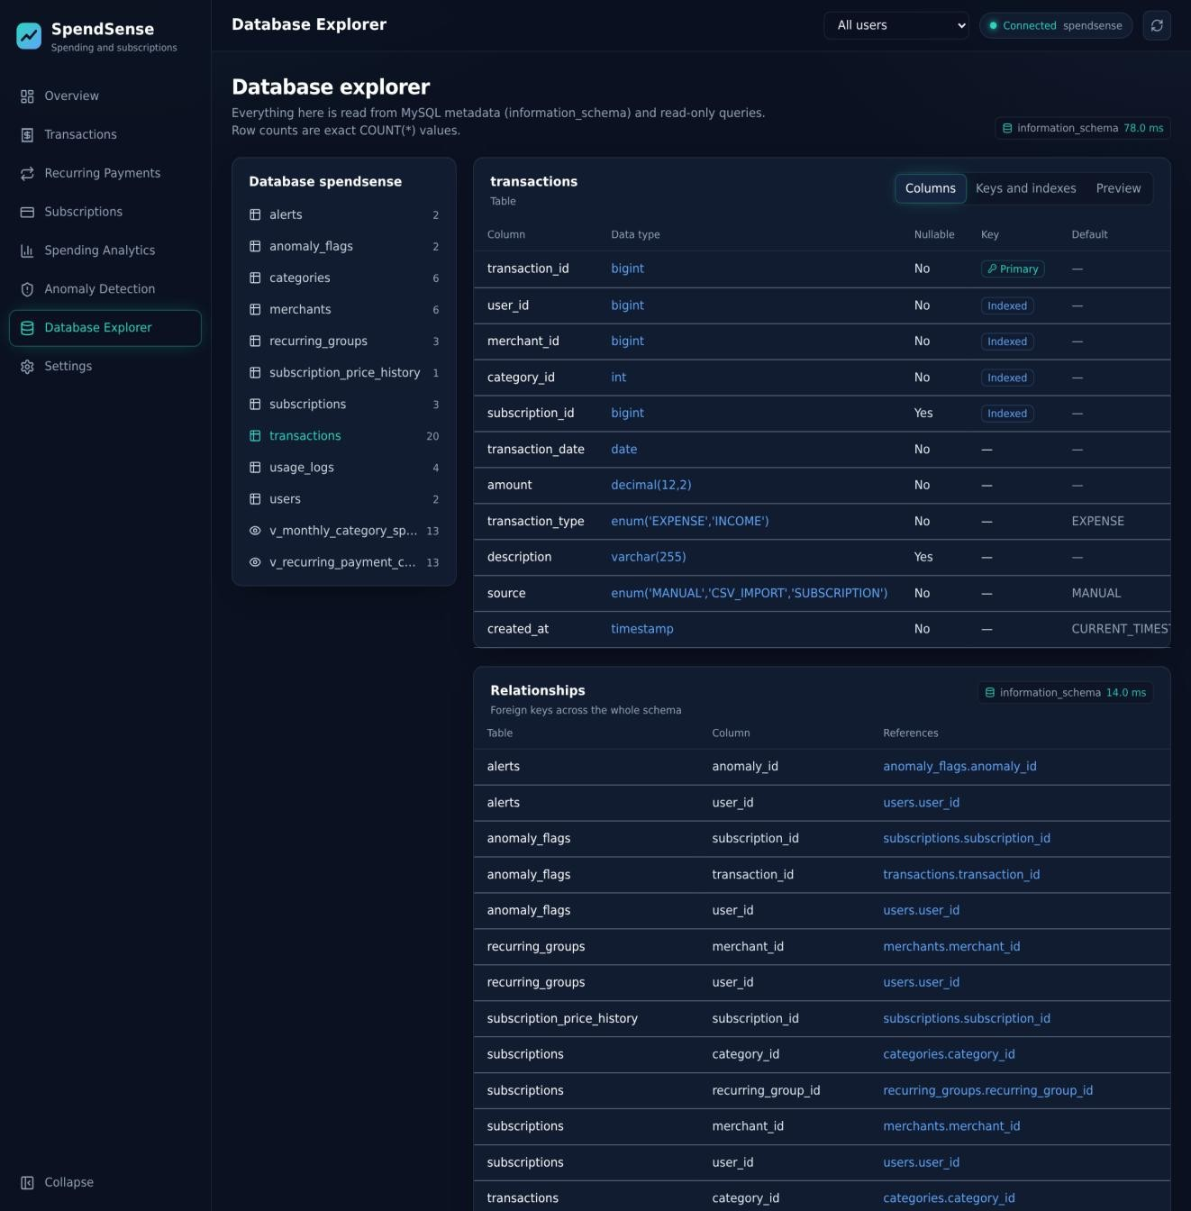
Figure 12 : Database explorer with columns and relationships

Read-only query console
Preset queries use :uid-style placeholders with a parameter box, so values are bound rather than pasted into SQL. The result shows the row count and the execution time measured on the server.
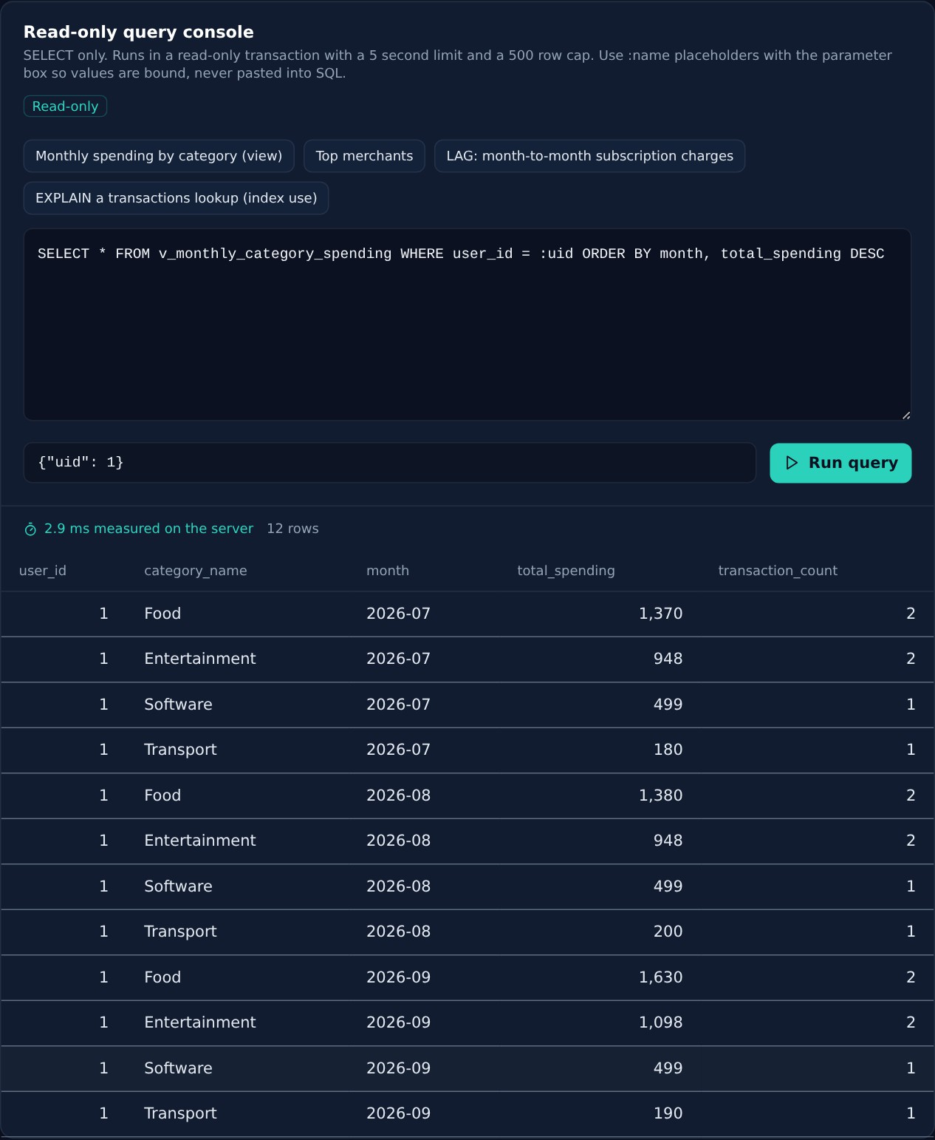
Figure 13 : Read-only console running a parameterized query

Settings
Shows the verified connection status, database name, MySQL version and which required tables and views exist. Credentials are never shown.
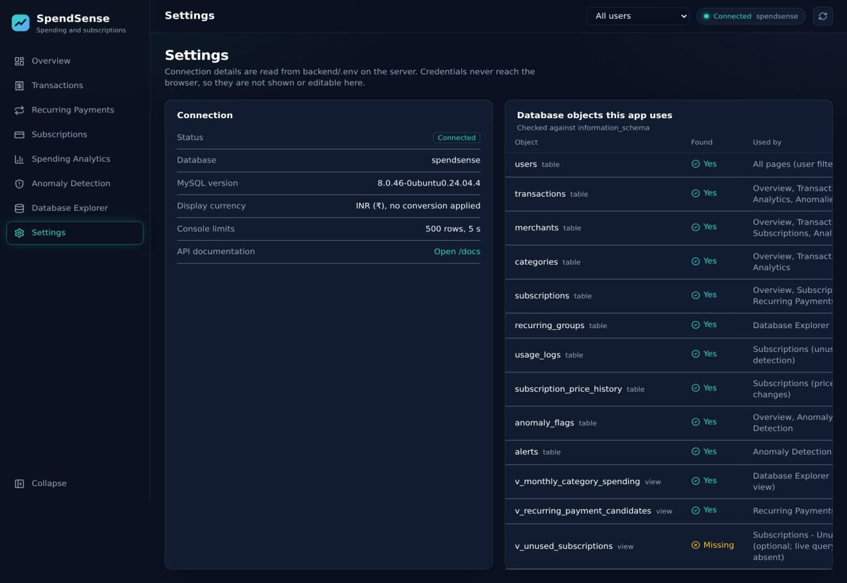
Figure 14 : Settings and database dependency check

Application Walkthrough & Features:
- Overview Dashboard: Presents connected state, total expenditure, total income, active subscription counts, and monthly recurring estimate (weekly price × 52 ÷ 12, raw for monthly, /3 for quarterly, /12 for yearly). Displays database lineage chips (X-DB-Time-Ms) showing exact server-side query latency.
- Transactions & Semantic Search: Features the Vector Distance (Cosine) column formatted to 4 decimal places. Users can toggle between Keyword Mode and Semantic Mode (querying concepts e.g. 'Show my food and restaurant expenses'), sorting by closest semantic match.
- Recurring Payments: Reads from v_recurring_payment_candidates generated via LAG() window functions, classifying cadences into weekly, monthly, quarterly, and annual intervals.
- Subscriptions & Inactivity Audit: Highlights active subscriptions with no usage recorded in >= 30 days, calculating potential monthly and annual savings upon cancellation.
- Anomaly Detection: Combines stored trigger-generated anomalies with on-the-fly dynamic Z-score calculations using window functions AVG(amount) OVER and STDDEV_POP(amount) OVER.
- Database Explorer & Safe SQL Console: Inspects real MySQL information_schema tables and relations, with a read-only console protected by sqlguard.py (enforcing START TRANSACTION READ ONLY and 5s query timeouts).

Results
============================================================ SPENDSENSE SYSTEM HEALTH & INTEGRITY CHECK
============================================================
[✓] Python Backend Dependencies: OK
[✓] MySQL Connection: CONNECTED (v8.0.36, db: 'spendsense')

--- Checking Relational Tables ---
[✓] | Table | 'users | ': | 2 | rows
[✓] | Table | 'categories | ': | 5 | rows
[✓] | Table | 'merchants | ': | 5 | rows
[✓] | Table | 'recurring_groups | ': | 2 | rows
[✓] | Table | 'subscriptions | ': | 2 | rows
[✓] | Table | 'transactions | ': | 20 | rows
[✓] | Table | 'transaction_embeddings | ': | 20 | rows
[✓] Table 'subscription_price_history': 2 rows
[✓] | Table | 'usage_logs | ': | 2 | rows
[✓] | Table | 'anomaly_flags | ': | 1 | rows
[✓] Table 'alerts ': 1 rows

--- Checking Database Views ---
[✓] View 'v_monthly_category_spending ': 4 rows [✓] View 'v_unused_subscriptions ': 1 rows [✓] View 'v_recurring_payment_candidates': 5 rows

--- Checking Stored Procedures ---
[✓] Stored Procedure 'sp_monthly_category_report(1)': EXECUTED SUCCESSFULLY

--- Checking NoSQL Document Store ---
[✓] NoSQL Document Store: 3 receipt documents loaded
[✓] NoSQL Aggregation Pipeline: Total spend Rs 3398.0 across 3 receipts

--- Checking Vector Similarity Search ---
[✓] Vector Search: Matched 'Fresh Basket' with Cosine Distance 0.2568 (Top match)
============================================================

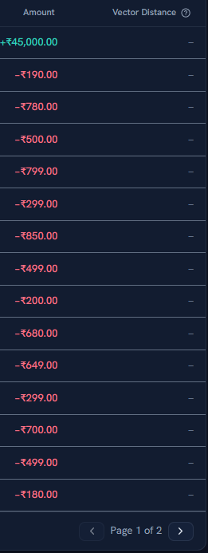

Figure 15 : Live Transactions Table displaying the Vector Distance (Cosine) Column

React/Vite-Project Tree Structure
SpendSense/
├── api/
│ └── index.py
# Vercel serverless entrypoint (Mangum ASGI adapter)
├── backend/
│
│
│
│
│
├── data/
│
└── nosql_receipt_documents.json # NoSQL JSON Document Store collection
├── .env.example
├── db.py
├── embeddings.py
# Environment variable templates
# Pooled SQLAlchemy engine, execution metadata # FastEmbed BGE-Small vector generator & cosine
distance engine

│ | ├── main.py |  |  | # | FastAPI REST controllers, routes, RBAC middleware
│ | ├── nosql_vector.py |  |  | # | NoSQL CRUD, aggregation pipelines & token vector
engine
│ ├── requirements.txt # Python dependencies (FastAPI, PyMySQL, NumPy,
FastEmbed)
│  ├──  │  ├──  │  │  │ | └── sqlguard.py  database/  └── optional_views.sql frontend/  ├── src/  │ ├── components/  │ │ ├── Layout.tsx |  |  | #  #  # | Read-only SQL validator & security transaction guard  Database views definition script  Navigation sidebar, connection pill, user switcher
│  │  │ | │ │ └── ui.tsx  │ ├── lib/  │ │ ├── api.ts |  |  | #  # | Cards, lineage provenance chips, tables, modals  HTTP client hooks (useApi), error handler
│ | │ │ ├── charts.tsx |  |  | # | Recharts styling presets & custom tooltips
│  │ | │ │ ├── config.ts  │ │ ├── format.ts |  |  | #  # | Dynamic API base URL resolver  Currency (INR), date, and decimal formatters
│  │  │ | │  │  │ | │  ├──  │ | └── utils.ts  pages/  ├── Analytics.tsx | #  # | Tailwind  Spending | CSS class merging utilities  trends, MoM growth, category distributions
│ | │ | │ | ├── Anomalies.tsx | # | Outliers | & price drift monitors
│ | │ | │ | ├── Explorer.tsx | # | Interactive database metadata & SQL console
│ | │ | │ | ├── Overview.tsx | # | Executive financial summary dashboard
│ | │ | │ | ├── Recurring.tsx | # | Inferred recurring payment candidates
│ | │ | │ | ├── Settings.tsx | # | Database connection integrity & object verification
│ | │ | │ | ├── Subscriptions.tsx | # | Inventory, inactivity audit, price history
│ | │ | │ | └── Transactions.tsx | # | Transaction ledger with Vector Distance column
│ | │ | ├── | App.tsx | # | Client-side router configuration
│ | │ | ├── | context.tsx | # | Global application context (user, health, metadata)
│ | │ | ├── | index.css | # | Tailwind directives and custom color variables
│ | │ | └── | main.tsx | # | DOM entry point
│ | ├── | package.json |  | # | Node dependencies (React 18, Vite, Lucide, Recharts)
│ | └── | vite.config.ts |  | # | Vite bundler configuration & local API reverse proxy
|
├── backend/auth.py
├── database/migration_auth_rbac.sql
├── frontend/src/pages/Login.tsx
├── tests/test_auth_embeddings.py
├── spendsense_master_complete.sql # Master SQL DDL & DML script
├── verify_system.py # System health and evaluation verification script
├── vercel.json # Vercel deployment orchestration configuration
└── requirements.txt # Root-level Vercel python build requirements

Evaluation Rubrics

No. | Criteria | Distribution | Status
1 | Database Design | ER diagram , relational schema with keys, relation-ships, and constraints | COMPLETED
2 | Database Creation | SQL database implementation - DDL with con-straints , NoSQL/Vector database creation , Technol-ogy justification | COMPLETED
3 | SQL Operations and Queries | DML operations , Nested/correlated/Recursive SQL queries, Join SQL queries | COMPLETED
4 | Advanced Database Con-cepts | Advanced database concepts (Procedure/function, trigger, CTE) , NoSQL/Vector feature RUD | COMPLETED
5 | Web Application and Data-base Integration | React 18 + Vite + TypeScript interface , Backend/API and database inte-gration | COMPLETED
6 | Authentication and Authori-zation | Authentication implementation (front end and backend) and minimum two roles and role-based ac-cess control in database | COMPLETED
7 | Documentation, Git/GitHub, Demonstration,Testing, and Originality | Documentation, Git/GitHub , Originality and individ-ual contribution | COMPLETED

