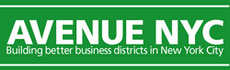
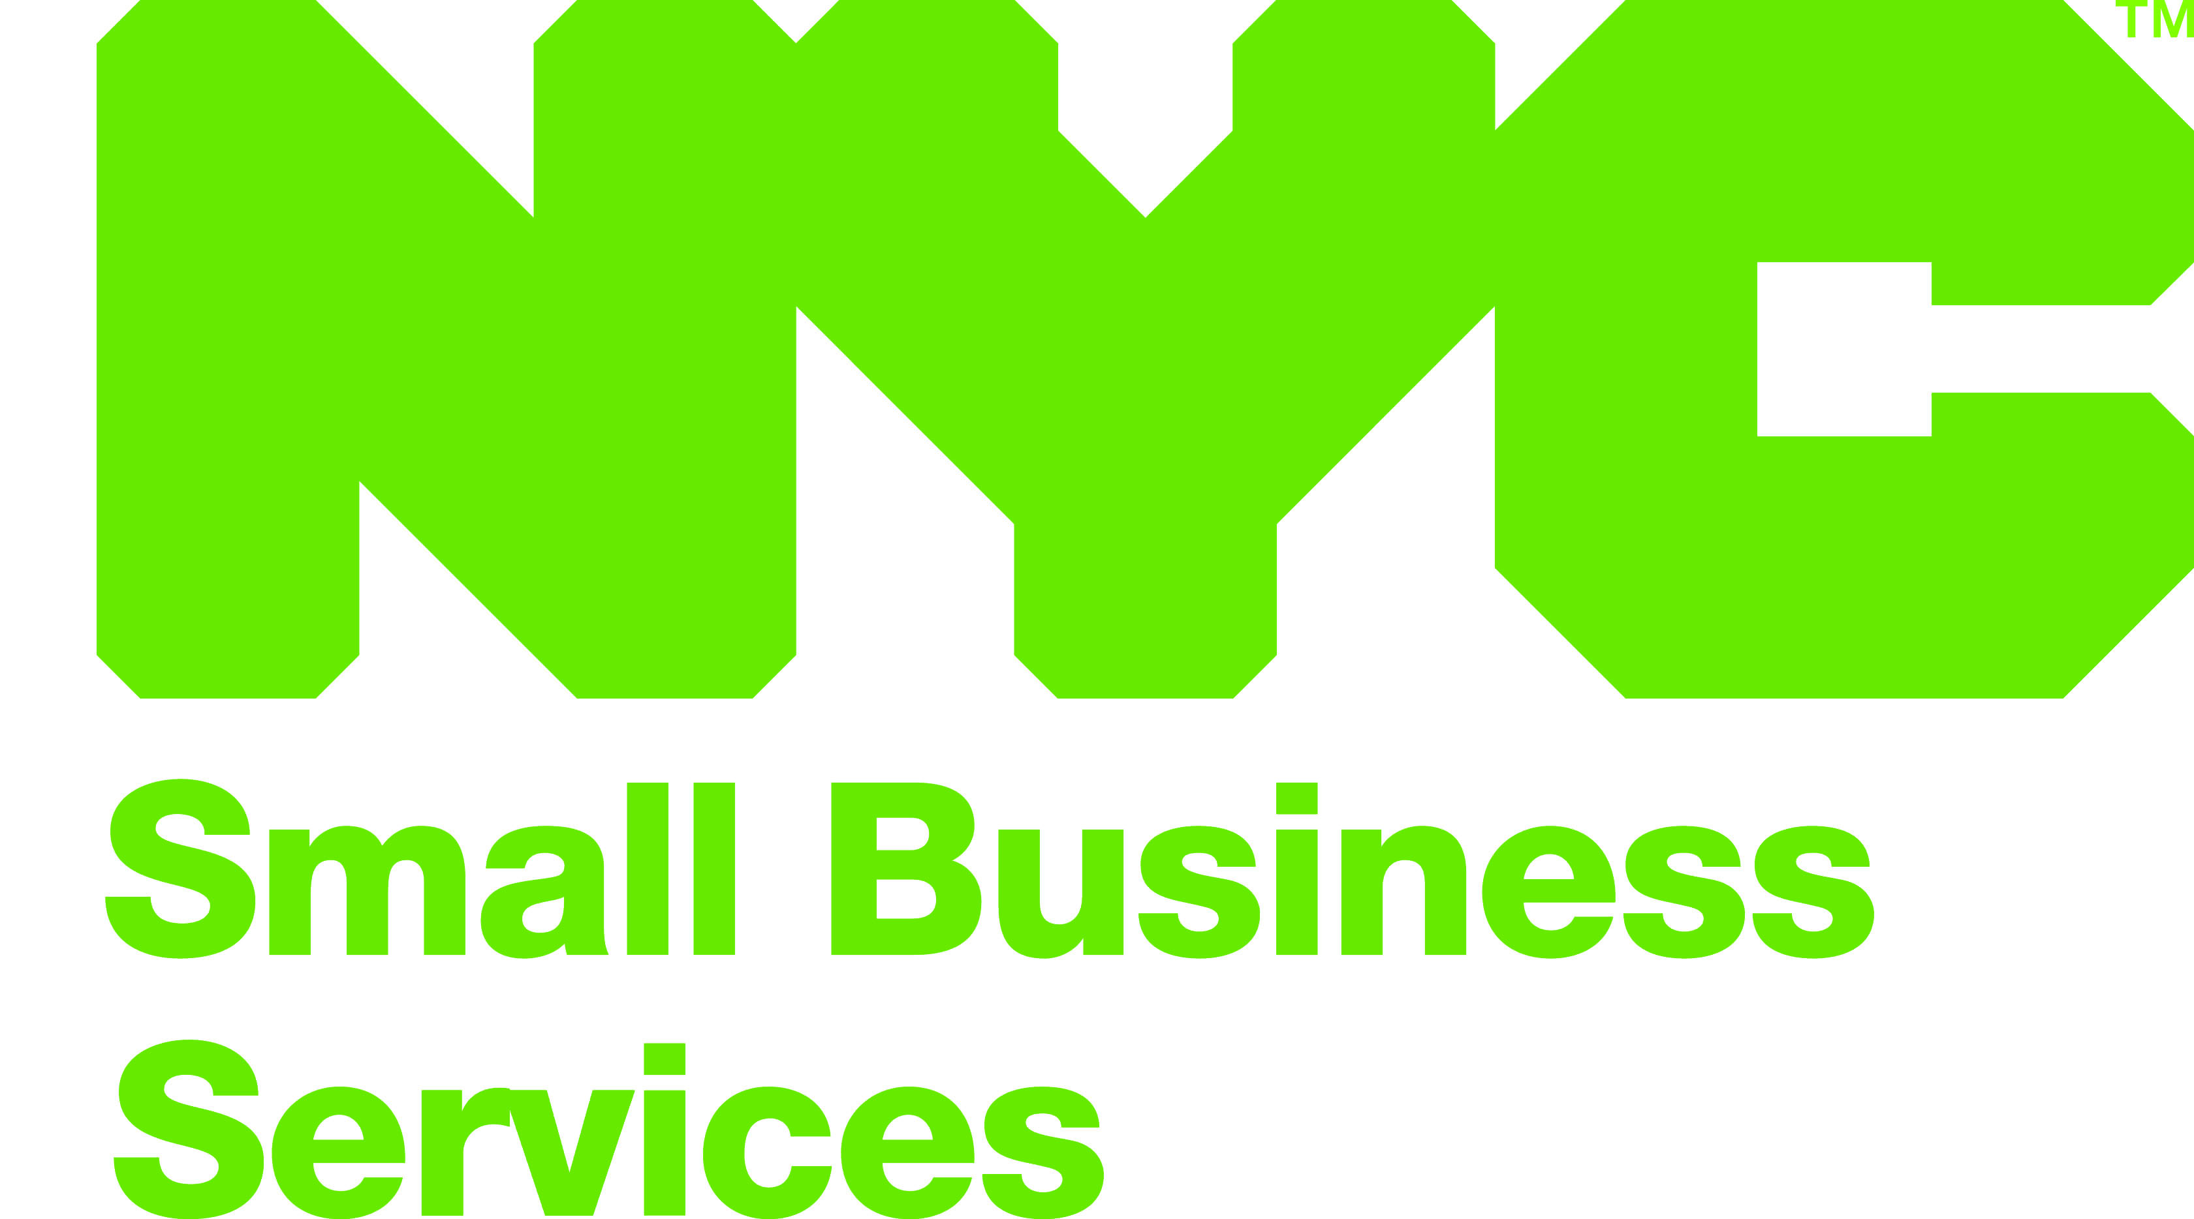
- 1 -

SAMPLE APPROVAL REQUEST LETTER FOR PURCHASING GOODS EXCEEDING $2,500

Last Updated: 08/06/2009
PLEASE PRINT LETTER ON ORGANIZATION LETTERHEAD AND SUBMIT IN DUPLICATE

[Date]

[Name of SBS Contract Manager]
New York City Department of Small Business Services
110 William Street, 7th Floor
New York, NY 10038

Re: Request for Approval to Purchase Goods Exceeding $2,500

Dear [Name of SBS Contract Manager]:

[Name of organization] hereby requests approval for the use of [SBS contract number] program funds to be expended in the following manner:

PROJECT DESCRIPTION

- Avenue NYC Project (e.g., Placemaking)

- Estimated Cost

- Reason(s) for Purchasing Goods

- Description of Selection Process (see Article 7 of your contract for specific requirements regarding what to include in this section)

We understand that this request for Approval is not authorized until two (2) copies have been submitted to and signed-off by the New York City Department of Small Business Services, and one (1) copy is returned to us.

Sincerely,

[Name and Title]

APPROVAL: Purchase Request

__________________________________ ___________________
[Name of SBS Contract Manager] Date
Department of Small Business Services

