**Installation of RHEL**

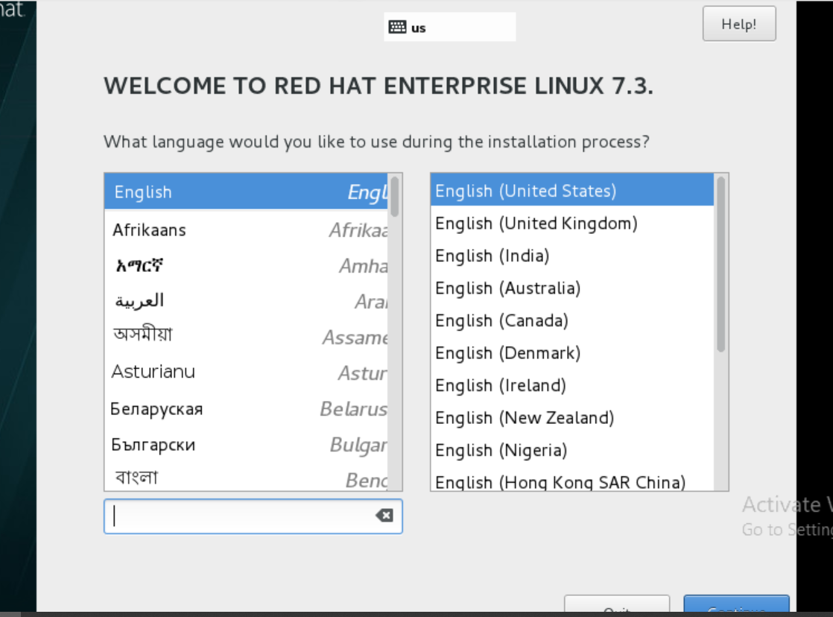

**Creating user orguser01 to orguser25 setting their password and directory by scripting by creating vim 25user.sh file**

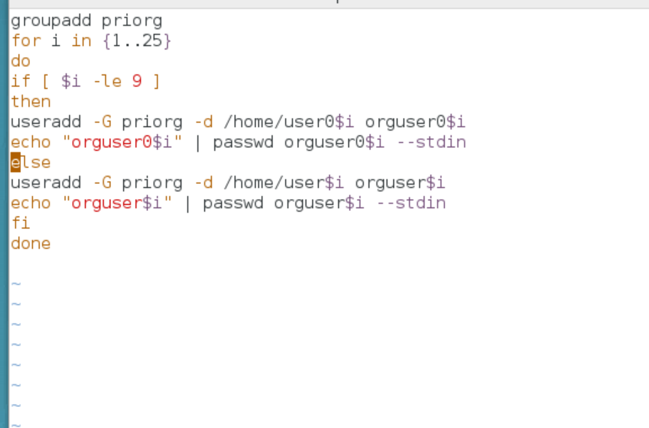

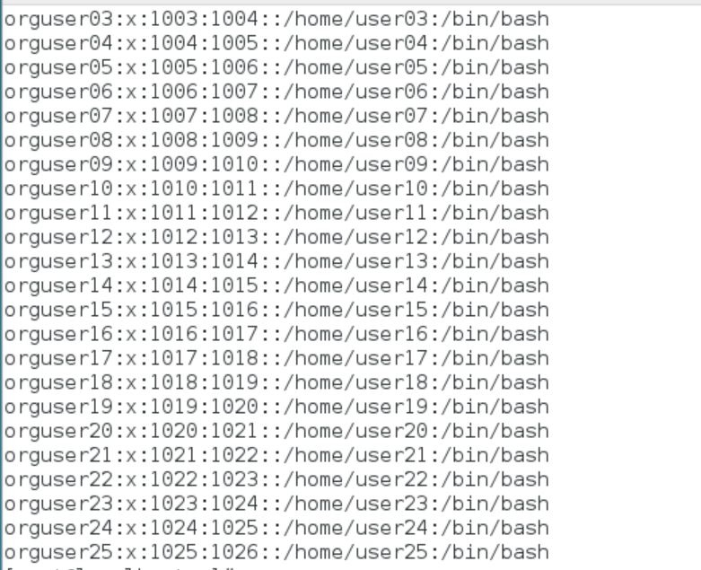

**Changing Root paaswd**

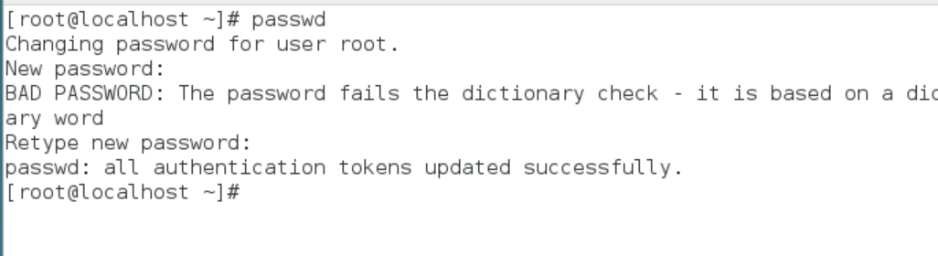

**NETWORK CONFIGURATION**

**Setting the ip address by using nmtui command below are the attached screenshots**

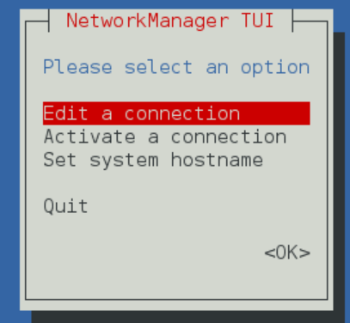

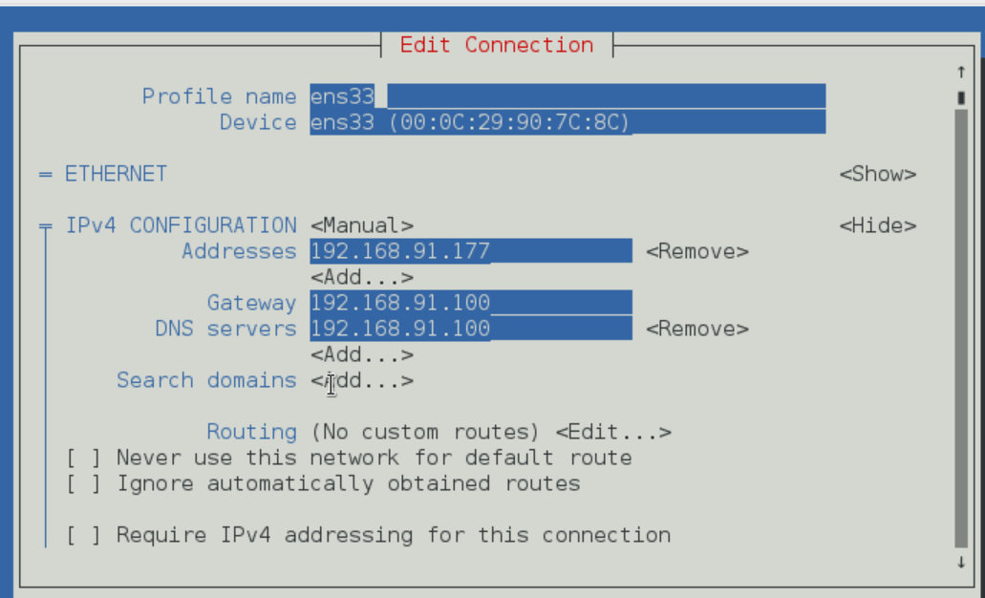

Then after give systemctl restart network and bring up the interface ifup enss33 and check with ifconfig | more

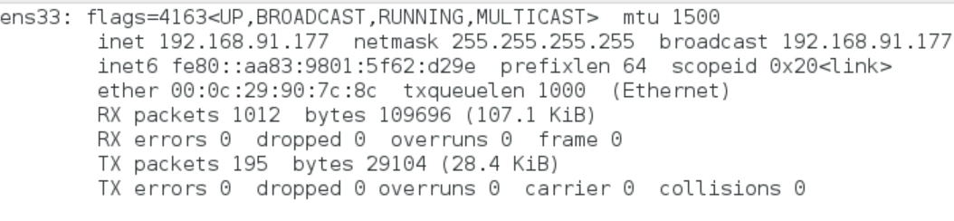

**But for changing netmask we have to type ifconfig ens33 netmask 255.255.255.0 and check again with ifconfig | more**

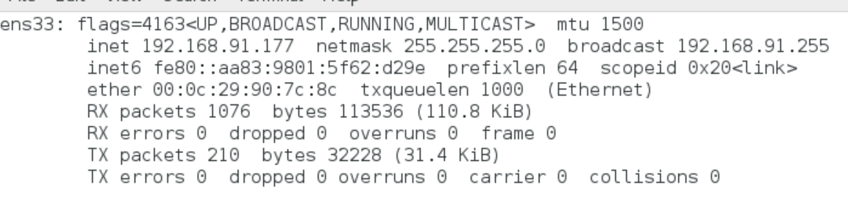

**Setting hostname by hostnamectl set-hostname rhvmm77.priorg.com command**

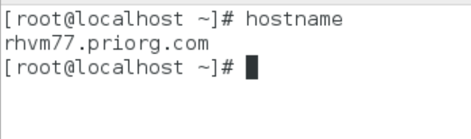

**Answer 7 -SSH – edit the last line Deny Users root in vim /etc/ssh/sshd_config file**

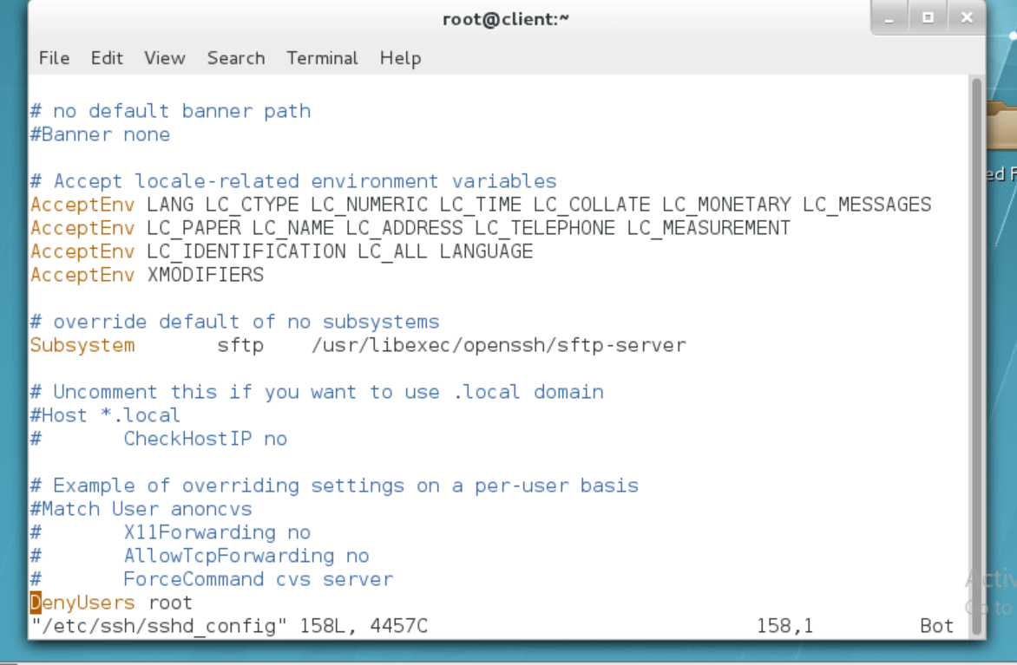

**Then form another mission check by ssh** [**root@192.168.91.177**](mailto:root@192.168.91.177)

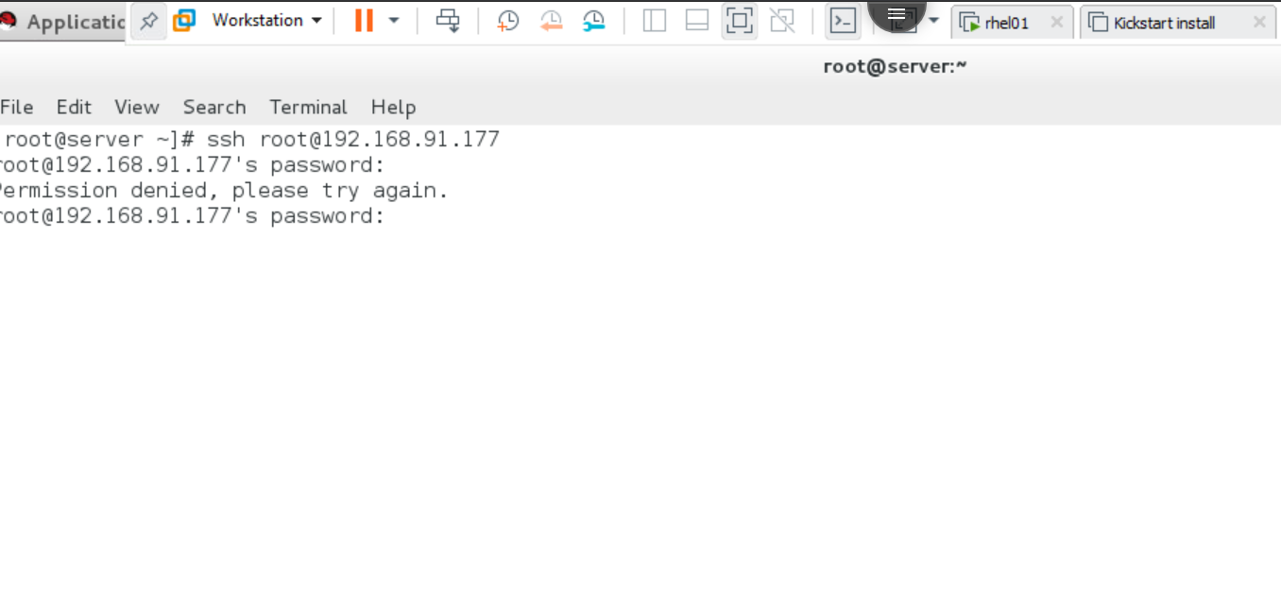

**SSH allows for normal user here we can have remote access through normal user**

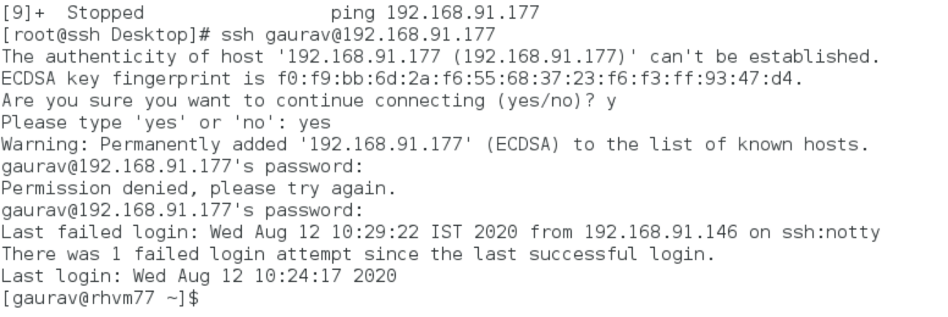

**Answer 8**

**First of all we have to create directory /etc/orgbackups by mkdir command then write a script for backup using tar command.**

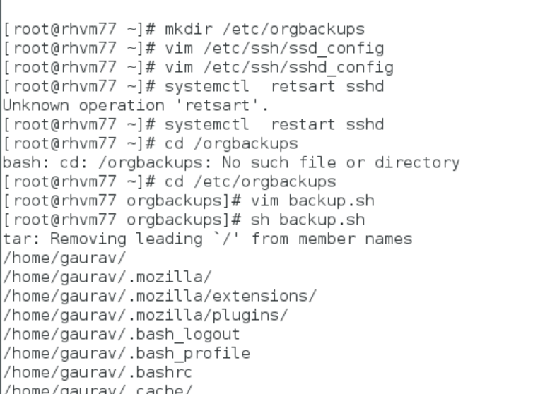

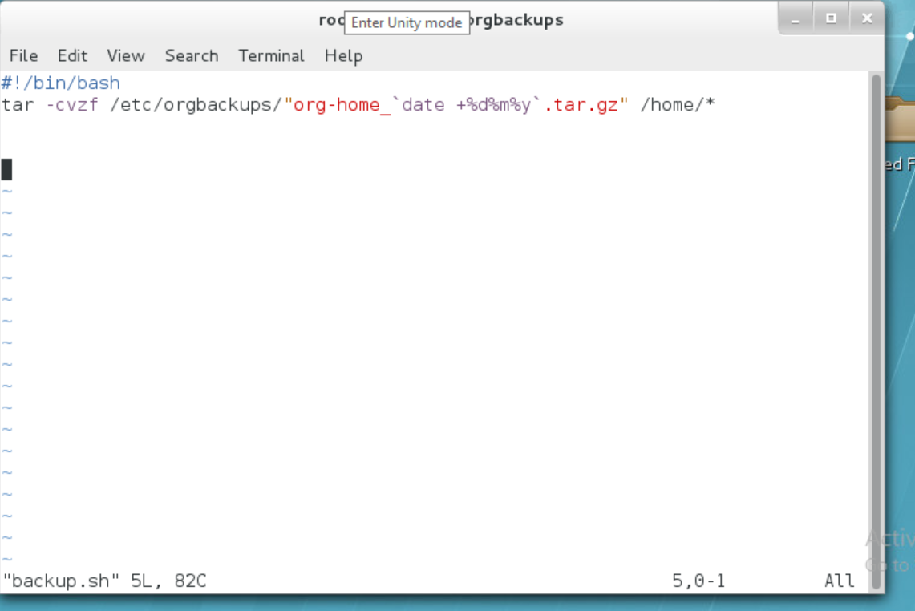

**After that create a cornjob-**

