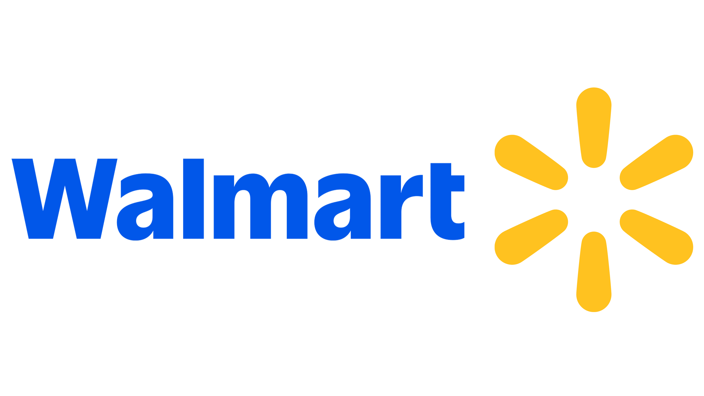  ✦ WALMART  INDUSTRY: SUPPLY CHAIN & LOGISTICS  Blockchain at Walmart  Improving supply chain and logistics using blockchain technology |  |  |  |  |  |  | RETAIL TECHNOLOGY  Presented By  Gaurav Nikam
7 days -> 2 sec  Traceability Speed | 70+ Carriers  DL Freight Network |  |  |  | IBM Hyperledger  Technology Partner | 2019  India Shrimp Pilot |  |  |  | 2020s  Full Blockchain Integration
COLUMN 01 — THE WHY  The Problem: Opacity & Inefficiency  Industry Context  The supply chain industry coordinates goods from raw materials to end consumers at global scale — spanning procurement, production, transportation & delivery.  1. Sourcing — Raw materials & supplier selection  2. Manufacturing — Production & quality control  3. Logistics — Transportation & warehousing  4. Distribution — Fulfilment & last-mile  5. Retail to Consumer — Replenishment & feedback  01 · Traceability Tracing Food Origins Was Slow  In 2016, tracing sliced mangoes required more than 6 days — far too slow for food safety emergencies or contamination recalls.  02 · Finance Invoice & Payment Disputes  Data mismatches in freight invoices caused costly manual checks and payment delays for Walmart Canada's 70+ transport partners.  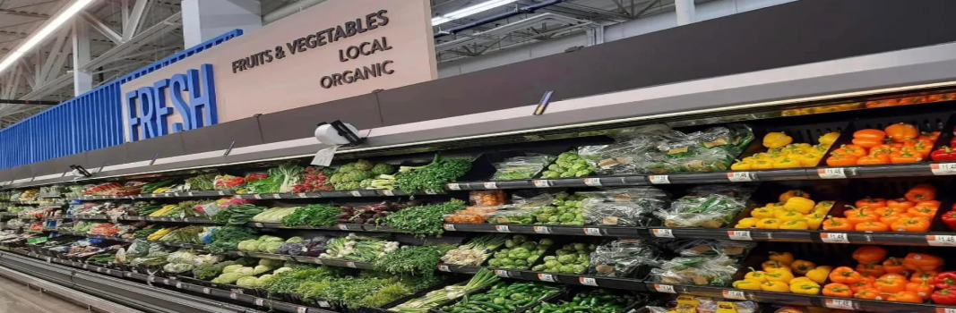  03 · Food Safety Incidents — Massive Damage  In 2018, contaminated romaine lettuce caused illness and deaths. Paper-based tracking stretched the investigation to a full year. |  |  | COLUMN 02 — THE HOW  The Blockchain Solution  PRIVATE · PERMISSIONED · REAL-TIME  Farm / Origin GS1 labels & certifications Chain Blockchain Ledger Immutable tamper-proof records Truck Logistics & Transit Route, temp & time logged  Distribution Smart contract verification Smart Contracts Auto-trigger & payments Retail Store Farm-to-shelf in seconds  IBM Food Trust — Built on Hyperledger Fabric. A shared permissioned network connecting Walmart's farmers, suppliers, carriers, warehouses & retailers in real time.  1 Farm / Origin Upload Producers upload origin, batch ID & certifications via standardized GS1 labels. Farm  2 Logistics & Transit Freight carriers log time, route, temperature & handoffs — permanent record. Logistics  3 Distribution Verification Smart contracts auto-detect inventory mismatches and flag discrepancies. Distrib.  4 Retail Recall Action Staff trace any product's full journey from source to shelf instantly. Retail  5 Automated Payments Smart contracts auto-settle invoices on verified delivery — eliminating disputes. Payments |  |  |  |  |  | COLUMN 03 — THE IMPACT  Real-World Results  USE CASE 2019  Shrimp Export Traceability — India  Walmart piloted blockchain to trace shrimp from farms in Andhra Pradesh to Sam's Club stores in the USA — the first time blockchain was used to trace seafood from local Indian farmers to international retail.  India (Andhra Pradesh Farms) --> USA (Sam's Club)  * Drastically Faster Traceability Food tracing collapsed from 7 days to seconds, enabling lightning-fast recalls and dramatically better safety response.  ~ Enhanced Food Safety & Trust Blockchain records and digital certificates reduce food fraud and build confidence among consumers and regulators.  = Improved Inventory Accuracy Real-time visibility helps Walmart spot delays, avoid overstocking, improve demand forecasting, and cut food waste.  $ Automated Payment Resolution Walmart Canada's DL Freight system eliminated manual invoice processing with 70+ carriers, slashing payment delays.  The Road Ahead  Combining blockchain with IoT sensors and AI/ML analytics will make Walmart's supply chains exponentially smarter, more predictive, and more resilient — setting a new global standard for retail logistics.  IoT Integration | AI Analytics | Real-Time Sensors | Predictive Logistics
* BLOCKCHAIN AT WALMART — Supply Chain & Logistics Case Study |  |  |  |  |  |  |  | IBM Hyperledger | Food Traceability | Smart Contracts | DL Freight

