**BSinCS To-Do:**

Tutorial: <http://www.codeproject.com/Articles/819294/WPF-MVVM-step-by-step-Basics-to-Advance-Level>

Video: <https://www.youtube.com/watch?v=z5t90kvagTw>

* **Iteration 1**

Show all player’s name on game board (First Name only then can look into images)

* + - Enter the human player name
    - Assign human name to player
    - All names should be on same location

3 players i.e. 1 human and 2 AI

Move each player along the board

* + - Start the current location at ECS 308
    - Move up to 3 spaces on the board (Use click logic or list logic)
    - Erase from current location
    - Redraw in new location
    - Move on “Move” button click
    - Move human player then follow by AI’s

List and display all possible rooms for player in list

* + - Must be selectable (Clicked and Highlighted)
    - Update dynamically when moved from one room to another

Prior game points

Create executable.

* **Iteration 2**

Documentation (Due Nov 3)

* + - Use Case for:
      * Taking a turn
      * Play a card
    - Sequence Diagram for Use Cases
      * Taking a turn
      * Play a card
    - “User Stories” for all 40 freshmen cards

Hand

* + - Add a 5 game card “Hand” to the Human Player.
    - Game card should be maintained in a “Deck”.
    - Deck should be randomised at the start of the game.
    - Deck must be randomised at every reshuffle (due to running out of cards).(To be implemented after playing card)

Display game card

* + - Display cards on control panel. (Need path to be relative)
    - Switch card images by clicking on the cards.

“Draw Card” and “Play Card” buttons functionality

* + - Buttons are active at the start of human player’s turn.
    - “Move” and “Play Card” buttons are grayed.
    - Upon clicking "Draw Card" the top card in the deck is added to the human player's hand.
    - Reset the card display to the first card in player's hand.
    - The drawn card is removed from the deck.
    - After processing, gray out "Draw Card" button. Enable "Move" and "Play Card" buttons.
    - Keep "Play Card" grayed out until a card is drawn. After playing, gray it.

Processing for playing all 40 freshmen cards (filter AI)

* + - Each card must be a separate class derived from a base card class.
    - **In the base class provide an abstract method called "play". Override "play" in each card class.**
    - Discard played card to discard deck.
    - -2 for not in room
    - allow only given chips to display
    - Remove if more than 7 cards in hand

Information Panel

* + - Add an "Information Panel" (IP) that occupies about 2/3 of the right width and 2/3 of the top height of the control panel.
    - The IP shows:
      * Each player's "name", Learning, Craft and Integrity Chip count, and Quality Points horizontally
      * "Cards in deck:" and the number of cards remaining in the "deck"
      * "Discards out of play:" and count of cards in "discard deck"
      * Who is currently playing and what room they are in.

Current Play

* + - Add a "Current Play" (CP) panel the occupies about 2/3 of the right width and 1/3 of the bottom height of the control panel.
    - The CP shows "played " ("for" | "failed") for each card played

a. *<Player> "played " <card name> ("for" <reward> | "failed")* for each card played

Move button

* + - Keep "Move" button enabled until (and if) player uses all three moves.
    - After that, gray it (disable).

Add AI Player move and play card features.(Add exception for reward selection)

Add a Dialog for discarding a card from the human player

Add a Dialog for selecting a Skill Chip

Optional: Give 5 cards to AI

Iteration 3

New Cards Added

Documents:

revised and updated UML class diagram including all cards

Code tasks:

Monitor accumulated QP for all players

When total of QP exceeds 60,remove following cards

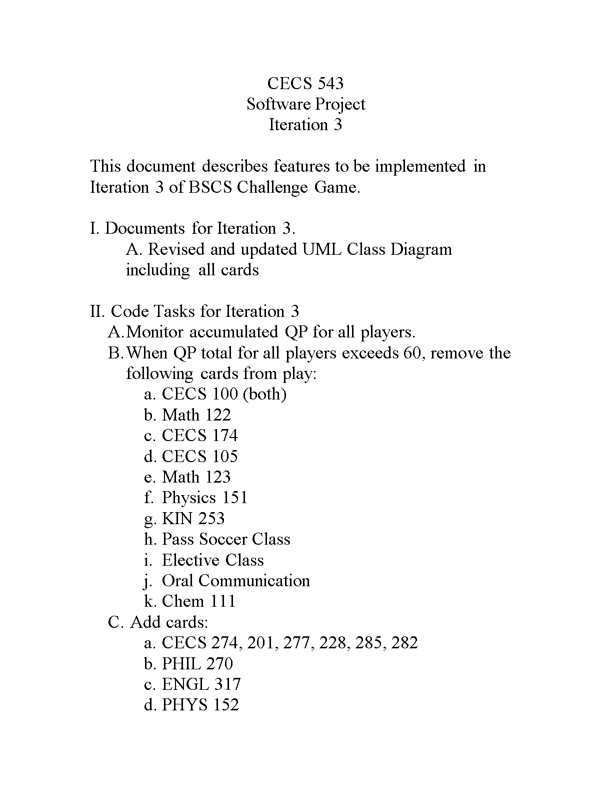

Add cards



Three other cards involving non academic behaviour (anywhere on board)

Before next human player’s turn remove all cards from human player’s hand and draw 5 cards from updated card deck

**Questions**:

1. Are the walkways connecting regions?

No. They are just for aesthetic reasons.

**Errors after Testing :**

1. After 1 turn the rooms accessible to Human player are the rooms that are available to him in South Hall.
2. When three of players are in South Hall,last player is on room line.
3. What does keeping card in room mean? Pg 4 Goodbye Professor