Veermata Jijabai Technological Institute (VJTI), Mumbai
Department of Electrical Engineering
FINAL YEAR PROJECT REPORT
Smart Grid Stability Monitoring & Automated Fault Diagnostic Platform
Submitted by: Madhura Dhondu Shinde
Guide: [Name of Guide] Academic Year: [Year]
Tools: MATLAB/Simulink, Python, Streamlit, MATLAB Engine API

Abstract
Modern electrical grids contain converter-interfaced sources, variable loads and changing topologies. These alter fault currents and voltage profiles, so protection must detect abnormal conditions, characterise their severity and isolate the faulted section quickly. Operators additionally need clear visualisation of what happened. This project develops a simulation-driven platform that meets these needs in an academic environment.
A MATLAB/Simulink model named main_model represents a synchronous machine source, a two-winding transformer, series and parallel RLC elements, two PWM-controlled voltage-source converters, a three-phase breaker, a π-section transmission line, a parallel RLC load and a programmable three-phase fault. A protection chain of signal processing, fault detection, protection logic and a trip-signal generator drives the breaker. All signals are logged through a Bus Creator into a To Workspace block named ScopeData.
Python controls the model through the MATLAB Engine API. The script run_sim.py runs the model and produces a five-panel, 300-dpi waveform figure. The Streamlit application app.py lets the user change primary and secondary voltage, power factor, line resistance, inductance and capacitance, fault type and fault resistance. It runs the model, computes peak current and estimated real and reactive power, classifies fault severity, displays voltage, current and breaker waveforms, and raises an audible alarm when the breaker trips. Machine-learning classification, fault location and hardware validation are described as future work. Measured values are marked [FILL] and must be taken from the user's own simulation runs.
Keywords: smart grid, fault diagnosis, power-system protection, Simulink, MATLAB Engine API, Streamlit, circuit breaker, voltage-source converter.

Contents
1. Introduction
2. Literature Background and Theory
3. System Architecture
4. Simulink Model Description
5. Protection Scheme
6. Software Implementation
7. Experimental Methodology
8. Results and Analysis
9. Discussion, Findings and Corrections
10. Limitations
11. Future Scope
12. Conclusion
References
Appendix A: Code listings and corrected snippets
Appendix B: Checklist for finalising the report

1. Introduction

1.1 Background
Electrical power systems are changing quickly. Distributed generation, battery storage, electric vehicles and power-electronic converters have replaced the simple one-way flow of the traditional grid. Converter-interfaced sources limit their fault current to a small multiple of rated current, while synchronous machines can supply several times their rating. As a result, the same fault can produce very different current magnitudes depending on which sources are connected, and fixed protection settings can lose sensitivity or selectivity.
Faults such as single line-to-ground, line-to-line and three-phase short circuits cause voltage sags, current surges and possible loss of stability. Fast detection and isolation limit equipment damage and the area affected. Protection engineers also need to know the type and severity of the disturbance to choose the correct response, such as reclosing, blocking or escalation to backup protection.

1.2 Problem Statement
Conventional protection devices are reliable, but they typically provide limited integrated visualisation and limited ability to experiment with system parameters. Students and researchers need a platform in which grid parameters can be changed easily, the protection response can be observed, and the outcome can be summarised for an operator. The problem addressed is to develop an integrated platform that models a grid with converter-interfaced sources, detects faults, trips a breaker, and presents the results in an interactive dashboard.

1.3 Objectives
- Model a three-phase grid in Simulink with a synchronous machine, transformer, converters, line, load and fault.
- Measure three-phase voltage and current and compute their magnitude and angle.
- Implement fault detection, protection logic and a trip signal that opens a breaker.
- Log all signals to the MATLAB workspace for post-processing in Python.
- Provide a Streamlit interface for editing voltage, power factor, line R-L-C and fault resistance.
- Compute peak current and estimated real and reactive power, and classify fault severity.
- Produce publication-quality waveform figures for the report.
- Raise an audible and visual alarm when the breaker trips.

1.4 Scope and Methodology
The work is simulation-based. Python launches MATLAB through the MATLAB Engine API, writes parameters into Simulink blocks with set_param, simulates with sim, and reads the logged data. The project does not yet include a trained machine-learning classifier, impedance-based fault location or a hardware prototype; these are described in Section 11. Reporting only what has been implemented keeps the report defensible.

1.5 Organisation of the Report
Section 2 reviews the theory used. Sections 3 and 4 describe the architecture and the Simulink model. Section 5 explains the protection scheme. Section 6 describes the Python software. Section 7 gives the experimental plan, Section 8 the results to be recorded, and Sections 9 to 12 discuss findings, limitations, future work and conclusions.

2. Literature Background and Theory

2.1 Power-System Faults
Faults are classified as symmetrical (three-phase) or asymmetrical (single line-to-ground, line-to-line and double line-to-ground). Single line-to-ground faults are the most frequent in overhead systems, while three-phase faults are rarer but usually produce the highest current [1], [2]. The fault current depends on source impedance, line impedance, transformer connection and fault resistance.
Fault | Phases involved | Typical characteristic
AG | One phase to ground | Zero-sequence current present; moderate current
AB | Two phases | Negative-sequence current; no ground path
ABG | Two phases and ground | Zero and negative sequence present
ABC | All three phases | Balanced; highest current, deep voltage sag
Table 1. Fault types and their characteristics.

2.2 RMS Values and Magnitude
The RMS value of a sampled signal is X_rms = sqrt((1/N) Σ x_n²). In this project the Signal Processing block provides magnitude and angle (Vmag, Vang, Imag, Iang) from the three-phase voltage and current. These magnitudes are the inputs to fault detection because a fault produces a voltage sag and a current rise.

2.3 Three-Phase Power
For a balanced system the apparent power is S = √3 V_LL I_L, the real power is P = S cos φ and the reactive power is Q = S sin φ. The dashboard estimates S from the primary line voltage and the peak simulated current, then applies the user-selected power factor. This estimate is useful for comparison between runs, but it is not a measured value; Section 9 recommends computing power from instantaneous v·i inside Simulink.

2.4 Symmetrical Components
Unbalanced conditions are analysed with symmetrical components. With a = e^(j120°), the zero, positive and negative sequence voltages are obtained from the phase voltages by the transformation V012 = (1/3)[[1,1,1],[1,a,a²],[1,a²,a]]·[Va, Vb, Vc]. Zero-sequence quantities indicate a ground fault and negative-sequence quantities indicate unbalance. These are the natural features for a future classifier.

2.5 Per-Unit System
The base impedance is Z_base = V_base² / S_base, and the base current is I_base = S_base / (√3 V_base). Per-unit values allow quantities from different voltage levels to be compared directly. The synchronous machine block in the model uses the pu standard parameterisation.

2.6 Effect of Fault Resistance
A larger fault resistance Rf reduces the fault current and the voltage sag. Because the dashboard allows Rf from 0.001 to 50 Ω, the platform can show how high-resistance faults become harder for threshold-based relays to detect. This is a well-known limitation of simple overcurrent schemes [2].

2.7 Impedance-Based Fault Location (Concept)
For a transmission line of length L and impedance Z_line, the apparent impedance seen by a relay is Z_app = V/I. A first approximation of the distance to the fault is d = (|Z_app| / |Z_line|)·L. The method ignores fault resistance, remote infeed and mutual coupling, so it is a concept only and is listed as future work [2].

2.8 Power-Quality Monitoring
IEEE Std 1159 provides recommended practice for monitoring electric power quality, including voltage sags and swells and harmonics [4]. The voltage sag observed during the fault window in this project corresponds to such a disturbance. Total harmonic distortion is not computed in the current software and is a candidate future feature.

3. System Architecture
The platform has two cooperating halves. The Simulink model is the physical grid and its protection logic. The Python layer is the user interface and analysis layer. The MATLAB Engine API connects them: Python can set block parameters, run the simulation and read workspace variables. Figure 1 shows the data flow.
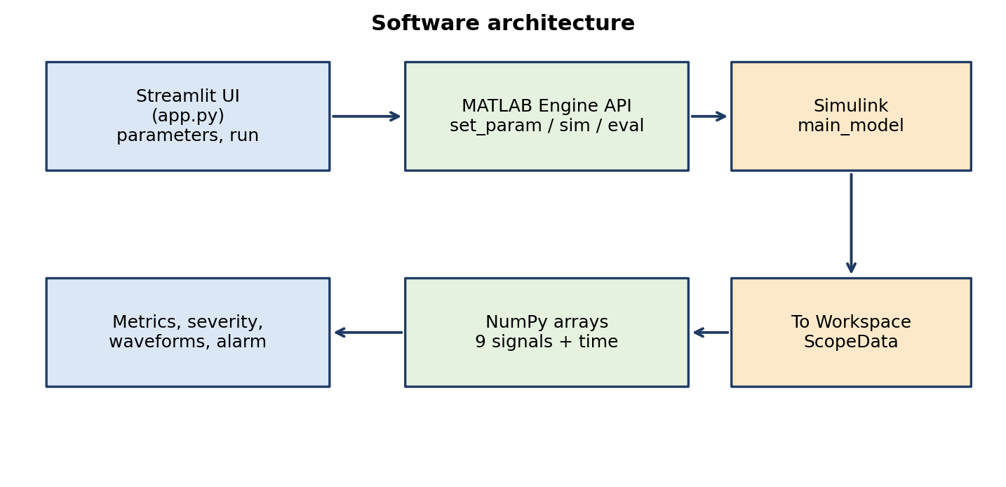
Figure 1. Software architecture of the platform.
When the user presses the run button, the application writes the new parameters into the model, simulates it for the stop time of one second, and collects the logged structure ScopeData. The time vector and a nine-column signal matrix are converted to NumPy arrays. The application then computes metrics, evaluates the trip signal, and draws the plots.

3.1 Design Choices
- Persistent MATLAB session. The engine is cached with st.cache_resource, so MATLAB starts once and the model is loaded once per session, which greatly reduces run time.
- Workspace logging. A To Workspace block in structure format keeps signals and time together.
- Separation of concerns. The protection logic stays in Simulink, so it is tested with the grid, while presentation and advice are in Python.
- Batch and interactive modes. run_sim.py produces figures for the report and app.py supports exploration.

3.2 Data Flow Summary
Stage | Component | Output
1 | Streamlit sidebar | Parameter values
2 | MATLAB Engine set_param | Updated block parameters
3 | Simulink sim() | simOut with ScopeData
4 | eval + NumPy | time[] and data[:, 0..8]
5 | Analysis | Ipk, Vmin, P, Q, severity, alarm
6 | Matplotlib / Streamlit | Dashboard and figures
Table 2. End-to-end data flow.

4. Simulink Model Description
Figure 2 shows the Simulink model main_model. It uses blocks from the Specialized Power Systems library, with a discrete powergui solver (sample time 5×10⁻⁵ s), a stop time of 1 s and a variable-step discrete solver. The upper row contains the power circuit and the lower row contains the protection and logging chain.
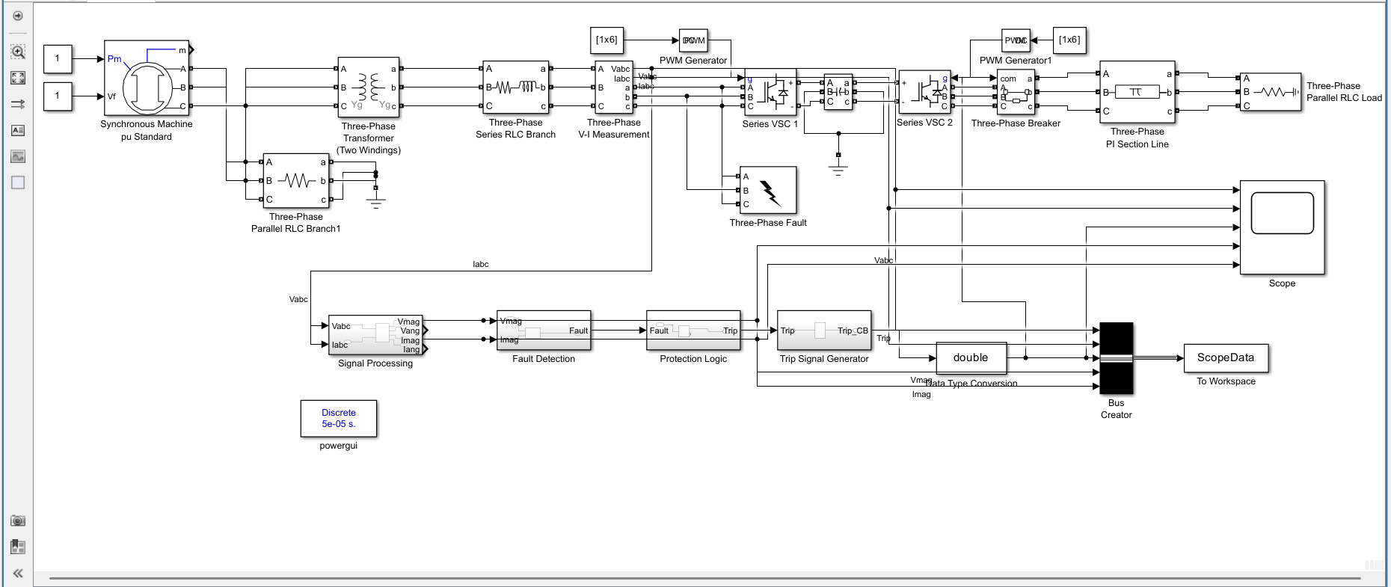
Figure 2. Simulink model main_model (screenshot).

4.1 Power Circuit
Block | Role in the model
Synchronous Machine pu Standard | Main source. Inputs Pm and Vf are both constants of 1 (mechanical power and field voltage).
Three-Phase Parallel RLC Branch1 | Grounded resistive branch at the machine terminals, giving a neutral/damping reference.
Three-Phase Transformer (Two Windings) | Voltage step-down with Yg–Yg windings.
Three-Phase Series RLC Branch | Series impedance representing source or line; R, L and C are set from the dashboard.
Three-Phase V-I Measurement | Measures Vabc and Iabc and feeds the protection chain.
Series VSC 1 and Series VSC 2 | Voltage-source converter stages; pulses come from PWM Generator and PWM Generator1 (constant 1×6 pulse vectors). A capacitor bank with grounded midpoint forms the link.
Three-Phase Breaker | Opens the circuit when Trip_CB is applied.
Three-Phase PI Section Line | Transmission line model.
Three-Phase Parallel RLC Load | Load at the receiving end.
Three-Phase Fault | Programmable fault; fault resistance set from the dashboard.
Table 3. Power-circuit blocks.

4.2 Measurement and Logging
The V-I Measurement block provides Vabc and Iabc. These go to the Signal Processing subsystem and also to the Bus Creator. The Bus Creator packs nine signals into the To Workspace block ScopeData. The same signals also feed a Scope block for on-screen viewing in Simulink.
Column | Signal | Column | Signal
0 | Va | 5 | Ic
1 | Vb | 6 | Trip (0 means breaker open)
2 | Vc | 7 | Vmag
3 | Ia | 8 | Imag
4 | Ib | – | –
Table 4. Column map of ScopeData.

4.3 Parameters to Document
For a complete report, record the following values from each block dialog and insert them here: machine rating, voltage and frequency; transformer power and winding voltages; line length and per-kilometre R, L, C; load active and reactive power; PWM carrier frequency; fault switching times; breaker initial state and switching time. These values were not visible in the screenshot, so they are marked [FILL].
Item | Value
Machine rating (MVA, kV, Hz) | [FILL]
Transformer rating and ratio | [FILL]
Line length and R, L, C | [FILL]
Load P and Q | [FILL]
PWM carrier frequency | [FILL]
Fault start and end time | [FILL] (plots shade 0.2 s to 0.6 s)
Breaker switching time | [FILL]
Table 5. Model parameter table to complete.

5. Protection Scheme
The protection chain is shown in Figure 3. It is a conventional detect-decide-act sequence implemented with Simulink subsystems.
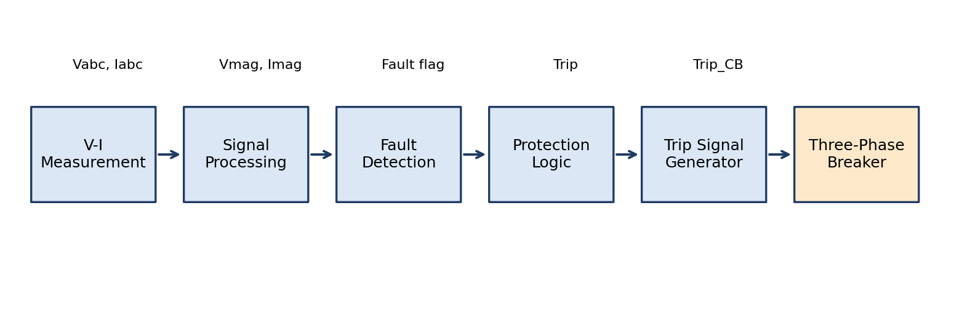
Figure 3. Signal chain from measurement to breaker.

5.1 Signal Processing
This subsystem receives Vabc and Iabc and outputs Vmag, Vang, Imag and Iang. Computing magnitudes first makes the later logic independent of waveform phase.

5.2 Fault Detection
The Fault Detection subsystem takes Vmag and Imag and produces a Fault flag. A fault is indicated by a voltage sag combined with a current rise. The exact thresholds are stored inside the subsystem and should be reported in Table 6 [FILL].

5.3 Protection Logic and Trip Generation
Protection Logic converts the Fault flag into a Trip signal, and the Trip Signal Generator creates Trip_CB for the breaker. In the logged data the Trip signal is 1 when the breaker is closed and 0 when it is open, which is why the dashboard tests for values below 0.5.
Setting | Value
Voltage sag threshold | [FILL]
Current pickup threshold | [FILL]
Detection delay | [FILL]
Trip hold or reset logic | [FILL]
Table 6. Detection and protection settings.

5.4 Severity Classification in the Dashboard
Separately from the Simulink logic, the dashboard classifies severity using the selected fault type and peak current, as shown in Figure 4. These rules supply advice text and do not control the breaker.
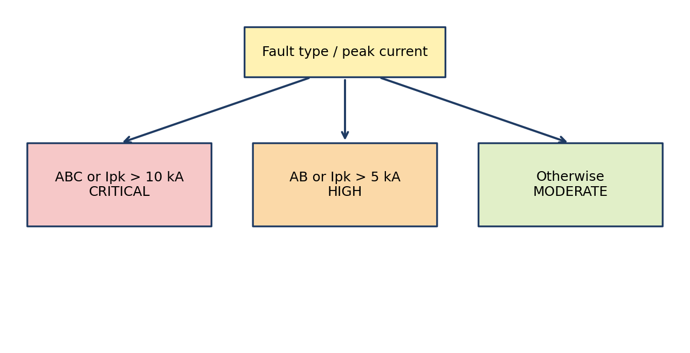
Figure 4. Severity classification rules in app.py.
Severity | Mitigation advice shown | Basis
Critical | Zone 1 distance trip, no auto-reclose, STATCOM support, surge-arrester check | Three-phase fault or Ipk > 10 kA
High | Delayed Zone 2 trip, negative-sequence (ANSI 46) protection, inductance tuning | Line-to-line fault or Ipk > 5 kA
Moderate | Single-pole auto-reclose, grounding reactor tuning, arc-resistance compensation | Otherwise
Table 7. Severity levels and advice.
The times quoted in the advice (15 ms, about 300 ms, 500 ms) are typical setting values and are not measured outputs of this model.

6. Software Implementation

6.1 run_sim.py
This script starts the MATLAB Engine, loads main_model, runs sim and retrieves ScopeData. It checks array orientation: if the first dimension of the data does not equal the length of the time vector, the array is transposed. It then draws a five-panel figure with Vabc, Iabc, the trip status, Vmag and Imag, using legends for the phases and shading the 0.2 s to 0.6 s fault window. The figure is saved as simulation_results.png at 300 dpi, shown on screen, and the MATLAB session is closed.

6.2 app.py
The Streamlit application is wide-layout with a sidebar. Figure 5 shows the layout. The sidebar groups inputs into voltage and power factor, transmission-line R-L-C, and fault condition.
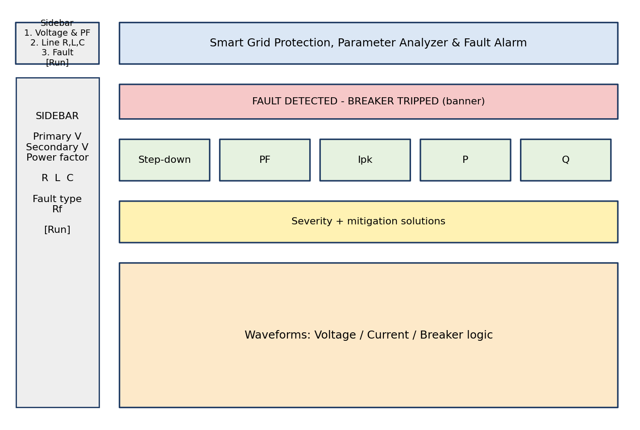
Figure 5. Dashboard layout (schematic of app.py).
Parameter | Range | Default
Primary voltage | 1 kV to 132 kV | 11 kV
Secondary voltage | 100 V to 11 kV | 415 V
Power factor | 0.50 to 1.00 | 0.85
Line resistance R | 0.01 to 100 Ω | 1 Ω
Line inductance L | 0.1 to 1000 mH | 10 mH
Line capacitance C | 0.01 to 100 µF | 1 µF
Fault resistance Rf | 0.001 to 50 Ω | 5 Ω
Fault type | AG, AB, ABC | AG
Table 8. Dashboard inputs.

6.3 Execution Flow
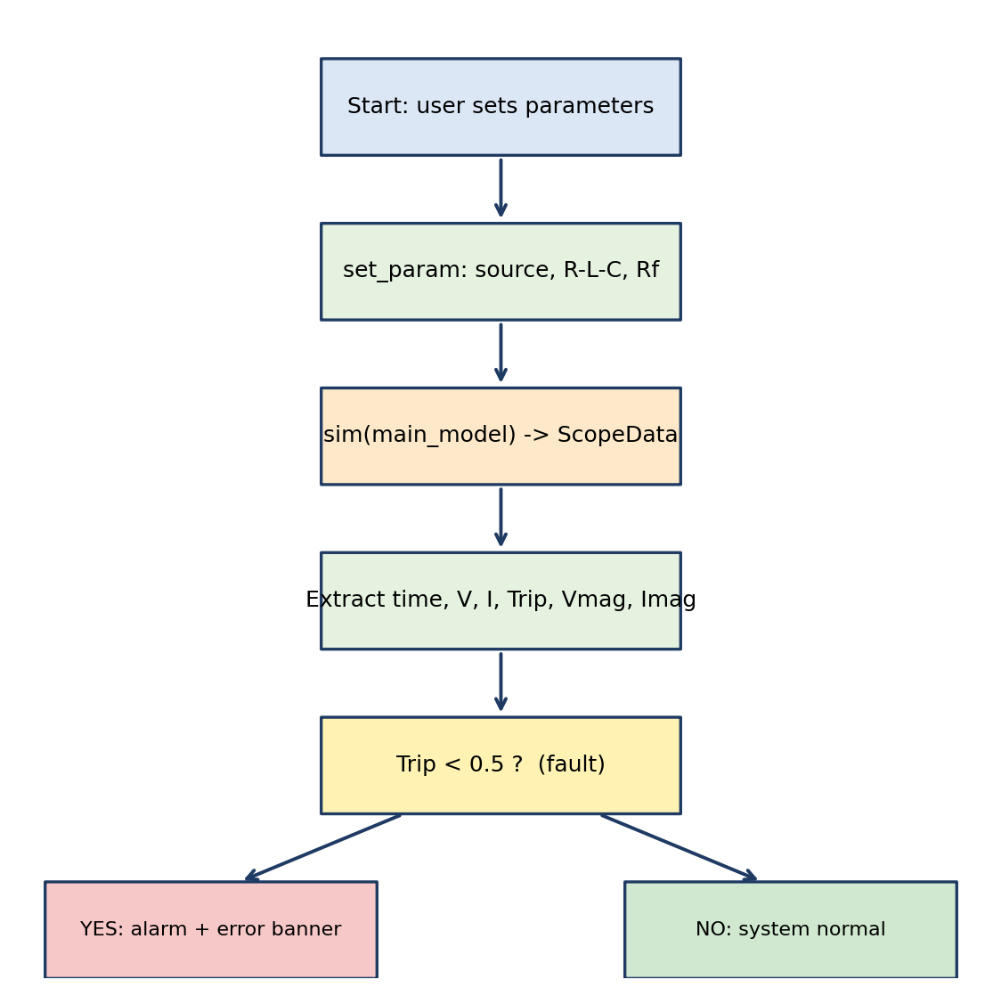
Figure 6. Execution flow when the run button is pressed.
- Source update. Phase peak = V_primary·√2/√3 is written to the programmable source. The code first tries PositiveSequence, then Amplitude.
- Line update. Resistance in ohms, inductance converted from mH to H, capacitance converted from µF to F.
- Fault update. FaultResistance is written to the Three-Phase Fault block.
- Simulation. sim runs and ScopeData is read, with time flattened and data oriented to match.
- Metrics. Peak current is the maximum of column 8 and minimum voltage the minimum of column 7.
- Power estimate. S = √3·V_primary·Ipk/1000 kVA, P = S·pf, Q = S·sin(arccos pf).
- Alarm. If any trip sample is below 0.5, a red banner is shown and a 1 kHz sawtooth tone plays for 3 s using the Web Audio API.
- Display. Five metric tiles, the severity panel and three stacked plots with the fault window shaded.

7. Experimental Methodology
The experiments should vary one factor at a time, run the model for the one-second stop time, and record the same metrics each time. Figure 7 shows the waveform behaviour expected qualitatively; it is a conceptual illustration, not simulation output, and must be replaced by the figure that run_sim.py produces.
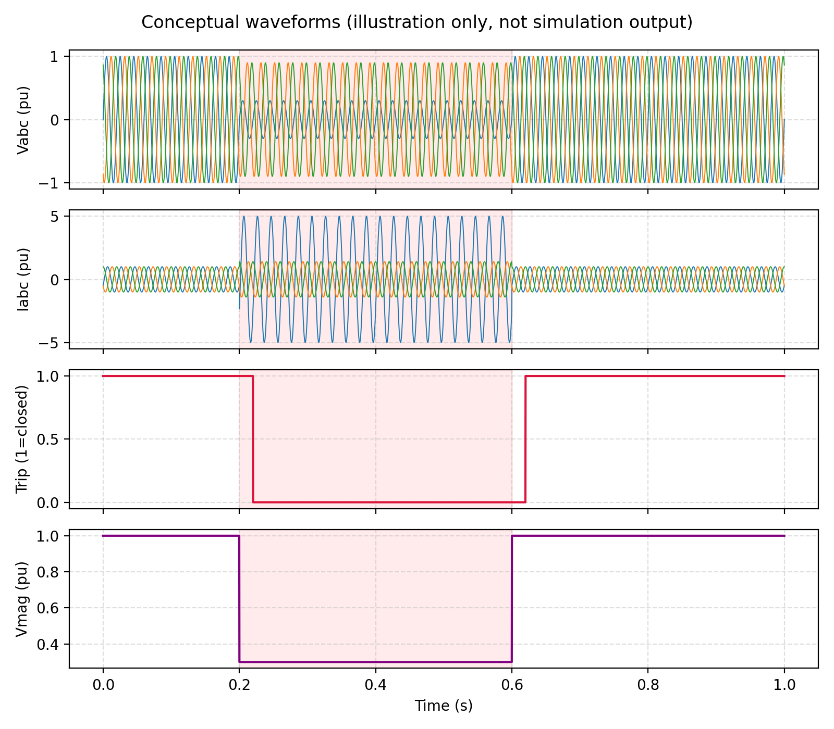
Figure 7. Conceptual waveform behaviour during the 0.2 s to 0.6 s fault window (illustration only).

7.1 Test Cases
No. | Fault | Rf (Ω) | Purpose
1 | None | – | Baseline healthy operation
2 | AG | 0.001, 5, 50 | Effect of fault resistance
3 | AB | 5 | Asymmetrical line-to-line fault
4 | ABC | 5 | Symmetrical worst case
5 | AG | 5 | Vary L (1, 10, 100 mH)
6 | AG | 5 | Vary C (0.1, 1, 10 µF)
7 | AG | 5 | Vary primary voltage (11, 33, 66 kV)
Table 9. Proposed test cases.

7.2 Metrics
- Peak current Ipk (A) and minimum voltage Vmin (V).
- Trip time = time at which Trip falls to 0 minus the fault inception time.
- Post-trip current, to confirm isolation.
- Estimated P, Q and S for comparison between runs.
- Severity category reported by the dashboard.

7.3 Procedure
- Open MATLAB and confirm that main_model.slx is on the path.
- Run streamlit run app.py and wait for the MATLAB session to start.
- Set parameters for a test case and press Run Fast Simulation & Analyze.
- Record the metrics and save a screenshot of the dashboard.
- Run run_sim.py for the same case to save simulation_results.png at 300 dpi.
- Repeat for all cases and complete Table 10.

8. Results and Analysis
This section holds the measured results. Entries marked [FILL] must come from the user's own runs. No numerical results are claimed here.
Case | Rf (Ω) | Ipk (A) | Vmin (V) | Trip time (ms) | Severity
Normal | – | [FILL] | [FILL] | – | –
AG | 5 | [FILL] | [FILL] | [FILL] | [FILL]
AB | 5 | [FILL] | [FILL] | [FILL] | [FILL]
ABC | 5 | [FILL] | [FILL] | [FILL] | [FILL]
Table 10. Summary of measured results.
Rf (Ω) | Ipk (A) | Vmin (V) | Trip (ms) | Detected?
0.001 | [FILL] | [FILL] | [FILL] | [FILL]
5 | [FILL] | [FILL] | [FILL] | [FILL]
50 | [FILL] | [FILL] | [FILL] | [FILL]
Table 11. Sensitivity to fault resistance (AG fault).

8.1 Figures to Insert
Insert simulation_results.png here and describe: the healthy balanced waveforms before 0.2 s, the voltage sag and current rise from 0.2 s, the instant at which Trip changes from 1 to 0, the behaviour of Vmag and Imag, and the restoration after 0.6 s. Also insert dashboard screenshots showing the metrics, severity panel and alarm banner.

8.2 Points for Analysis
- Compare fault current for AG, AB and ABC and explain the difference using sequence networks.
- Explain how increasing Rf reduces fault current and may delay or prevent detection.
- Explain how the line inductance limits fault current and how capacitance affects the transient.
- Comment on how the converter stages influence the fault current.
- State whether the breaker isolates the fault and the time taken.

9. Discussion, Findings and Corrections
A careful review of the code revealed several points that should be corrected or stated openly in the report, because an examiner can test them directly.
# | Finding | Recommended action
1 | The fault-type dropdown only changes the severity text and does not set the Three-Phase Fault block. | Set FaultA, FaultB, FaultC and GroundFault before sim (Appendix A).
2 | Secondary voltage and the power-factor slider do not change the simulation. | Either connect them to the model or state they are used only for estimates.
3 | P and Q are estimated from peak current and a chosen power factor. | Compute P and Q from instantaneous v·i inside Simulink.
4 | The advice is rule-based, but headed 'AI'. | Rename to rule-based protection advice.
5 | The 15 ms and 300 ms values are advisory settings. | Do not present them as measurements.
6 | Bare except hides a wrong parameter name. | Catch specific exceptions and log them.
7 | The 0.2–0.6 s fault window is hard-coded in plots. | Read the switching times from the fault block.
8 | The source voltage is derived from the primary voltage. | Check against the transformer ratio and machine rating.
Table 12. Review findings and corrective actions.
Addressing findings 1 and 3 gives the largest improvement because they make the dashboard's fault-type comparison and power values genuinely depend on the simulation.

10. Limitations
- The study is simulation-only; no hardware was built or tested.
- Detection uses fixed thresholds and has no machine-learning component.
- Measurement noise, CT/PT errors and communication delays are not modelled.
- Fault location, sequence-component analysis and harmonic analysis are not implemented in the software.
- Results depend on solver settings and sample time.
- The severity rules and advice are indicative and are not utility protection settings.
- The platform is an academic prototype and not a replacement for certified protection equipment.

11. Future Scope
Extension | Description
Machine learning | Random Forest classifier using RMS values, sequence components and THD; start with Normal, LG, LL, LLG, LLL, then move to phase-specific classes.
Fault location | Impedance-based estimate with error reporting against the known fault distance.
MATPOWER | Use benchmark systems for power-flow context and per-unit parameter conversion.
Event logging | CSV log and automatic PDF report for each event.
Hardware | Low-voltage Arduino relay with current sensor and serial telemetry, kept isolated from any high-voltage system.
Standards and data | PMU measurements and COMTRADE disturbance records.
Advanced models | Deep-learning classifiers and edge deployment.
Table 13. Future extensions.
When adding machine learning, report accuracy, precision, recall, F1 score and a confusion matrix from a held-out test set, and state clearly that the training data are simulated.

12. Conclusion
This project developed a simulation-driven smart-grid protection platform. The Simulink model combines a synchronous machine, transformer, converters, line, load and fault with a detect-decide-trip chain. Python and Streamlit provide an interactive interface that runs the model, computes metrics, classifies severity, plots waveforms and raises an alarm. After the measured tables are completed and the corrections in Section 9 are applied, the platform provides a clear basis for the planned classification, fault-location and hardware stages.

References
[1] P. Kundur, Power System Stability and Control. New York, NY, USA: McGraw-Hill, 1994.
[2] P. M. Anderson, Power System Protection. New York, NY, USA: IEEE Press/McGraw-Hill, 1999.
[3] R. D. Zimmerman, C. E. Murillo-Sánchez and R. J. Thomas, "MATPOWER: Steady-state operations, planning, and analysis tools for power systems research and education," IEEE Trans. Power Syst., vol. 26, no. 1, pp. 12–19, Feb. 2011.
[4] IEEE Recommended Practice for Monitoring Electric Power Quality, IEEE Std 1159-2019.
[5] IEEE Guide for Protective Relay Applications to Transmission Lines, IEEE Std C37.113.
[6] MathWorks, MATLAB Engine API for Python, and Simscape Electrical documentation.

Appendix A: Code Listings and Corrected Snippets

A.1 Applying the selected fault type
flags = {
"Single Line-to-Ground (AG)": ("on","off","off","on"),
"Line-to-Line (AB)": ("on","on","off","off"),
"Three-Phase Fault (ABC)": ("on","on","on","off"),
}[fault_type]
for p, v in zip(["FaultA","FaultB","FaultC","GroundFault"], flags):
eng.set_param(f"{model_name}/Three-Phase Fault", p, v, nargout=0)
Confirm parameter names with get_param(block,'DialogParameters') in MATLAB.

A.2 Trip time from logged data
import numpy as np
trip = data[:, 6]
idx = np.where(trip < 0.5)[0]
t_trip = time[idx[0]] if idx.size else None
t_fault = 0.2 # read from the fault block in a final version
trip_ms = (t_trip - t_fault) * 1000 if t_trip else None

A.3 Avoiding silent failures
try:
eng.set_param(blk, "PositiveSequence", f"[{v_peak} 0 50]", nargout=0)
except Exception as e:
st.warning(f"Could not set source voltage: {e}")

Appendix B: Checklist for Finalising the Report
- Replace every [FILL] with measured values.
- Insert simulation_results.png (Section 8) and dashboard screenshots.
- Replace the conceptual Figure 7 with real simulation output, or delete it.
- Complete Tables 3, 5 and 6 with the block parameters.
- Add guide name, academic year, certificate, declaration and acknowledgement pages as required by VJTI.
- Update the table of contents in Word after final edits.
- Apply the code corrections or list them as known limitations.

