**Technical task to develop a mobile application**

1. The server part of the application / backend is, this is the site <http://fasteda.ru/>
2. The site has an API, so all the data the application will pull from the site
3. The design of all application pages is ready

It is necessary to develop a mobile client application for the site <http://fasteda.ru/> using its API.

**2. STRUCTURE OF THE APPLICATION**

The mobile application should consist of the following sections:

2.1 Welcome slider - Slideshow of 4-5 pictures, which is shown the first time the application is launched

2.2 Map showing the shipping address - A Google Maps map is used. The application automatically detects the user's GPS address, if it is enabled and received permission, or the user can specify the address manually.

2.3. Catalog of restaurants with selection filters - List of restaurants that are displayed by parameters:

- By delivery zones (only the establishments are shown whose delivery zone includes the address of the user)

- By the type of kitchen (filter in the form of a scroll at the top of the screen)

- By the cost of delivery

- By delivery time

2.4. Personal cards of restaurants - personal page of the institution, containing text and graphic information about the restaurants, the button "add to your favorite"

Page has additional subsections:

- Menu of restaurant - contains a list of categories of goods of this institution. In each category, you can see products that can be added to the shopping cart.

- Terms of delivery - contains text and graphic information on the terms of delivery

- Information about the restaurant - contains text and graphic information about the institution

- Leave a review - contains a form for writing a text review and the function of "star rating"

2.5. The product page is a personal page of each product in the catalog, it contains the product image, name and description, cost, and also the "add to cart" button

- Variants of the goods - variants of the goods with different cost in the form of radio buttons.

- Additions of goods - additional options in the form of checkboxes with the option of plus each.

2.6. Cart - display of goods that the user added to the basket for each institution, with the ability to edit the number of items

2.7. Ordering page - the opportunity to arrange delivery, as well as choose the payment method:

- Online payment width bank acquiring "Alfabank"

- Payment by points from the balance

- Payment upon delivery

2.8. Personal account of the user - the opportunity to register in the application, as well as specify personal information and delivery information.

2.9. User Points - Displays the amount of the cashback that is credited to the user for each order.

Points, this is a fixed percentage of the value of the order, which is accrued to the user.

2.10. My Orders - a section containing detailed information on all new orders, as well as information on completed orders.

2.11. Favorite restaurants - a section in which the restaurants added by the user to "favorite" are displayed

2.12. Special offers - a section in which all the shares of the restaurants are displayed.

2.13. Administration contacts - a page containing a feedback form, as well as a "phone" button for quick communication with the administration of the application.

2.14. Information about the application - a section containing reference information about the application, as well as a public offer.

**3. FUNCTIONS**

3.1 All the data about restaurants, categories, products, ratings and other things the application receives by API.

3.2 The application receives data via the API about all users of the site so that they can log in with their login and password in the application and see their orders and bonus points.

3.3. You need to send the PUSH notification of the status change to the user

3.4. You must send each order to the site database or immediately to the CRM system using the CRM system API.

3.5. It is necessary to accept a change in order statuses from the database or the CRM system.

3.6. Registration of new users is carried out with confirmation by SMS

**4. ДИЗАЙН СТРАНИЦ ПРИЛОЖЕНИЯ**

4.1. Define the user address on the card or enter manually

**4.1. Define the user address on the card or enter manually**

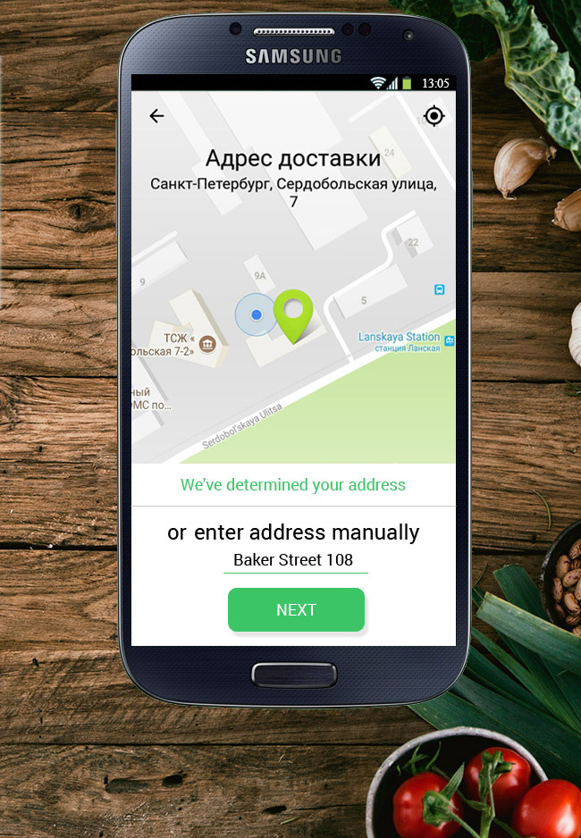

**4.2. List of restaurants**

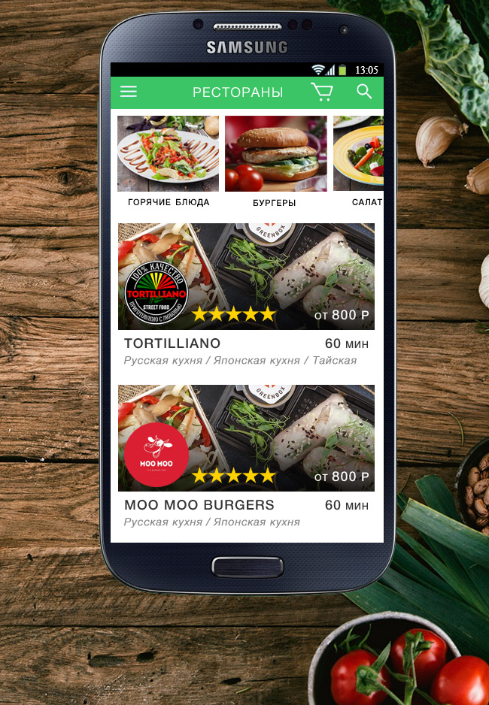

**4.3. Personal page of the restaurant**

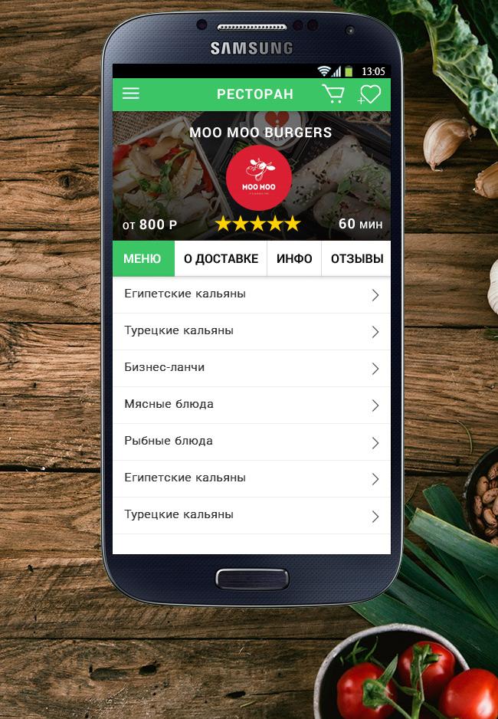

**4.4 Product list page**

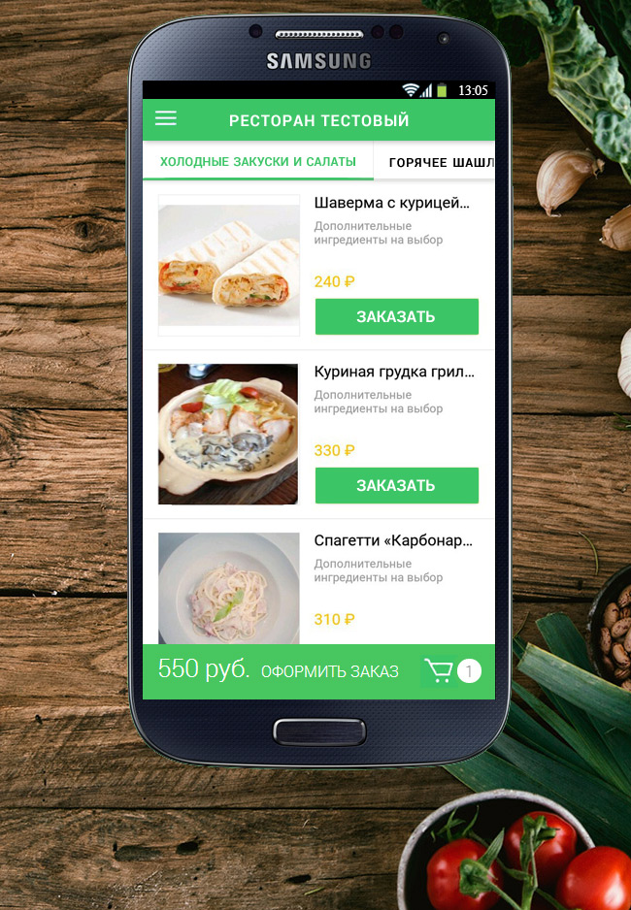

**4.5 Product page**

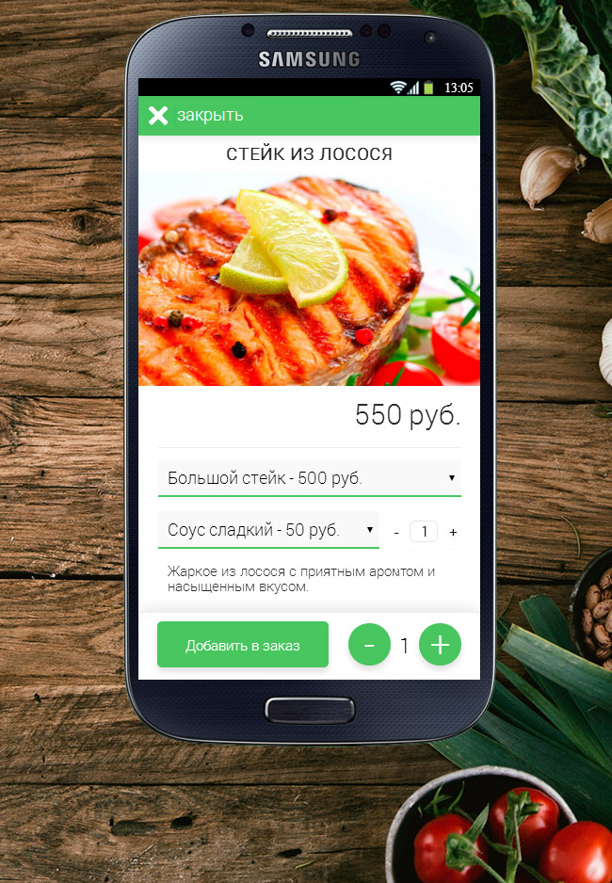

**4.6 Page review and rating**

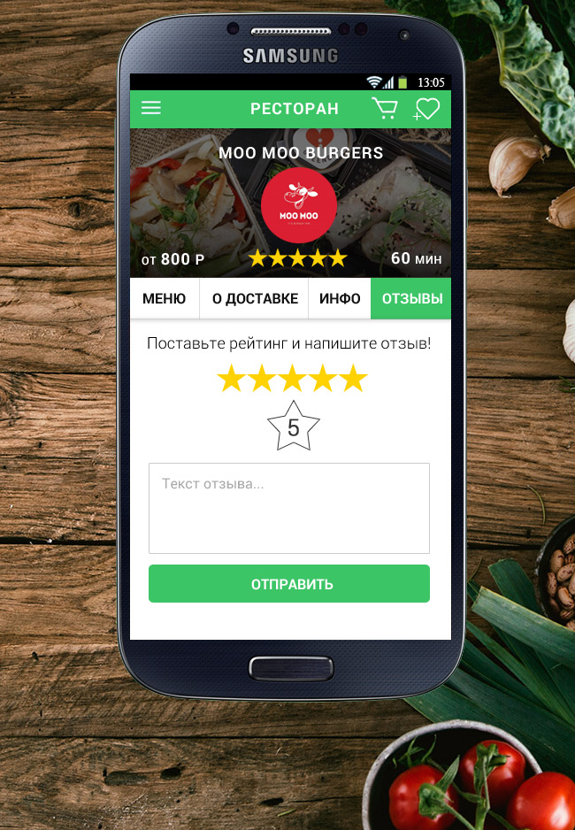

**4.7 Page User account**

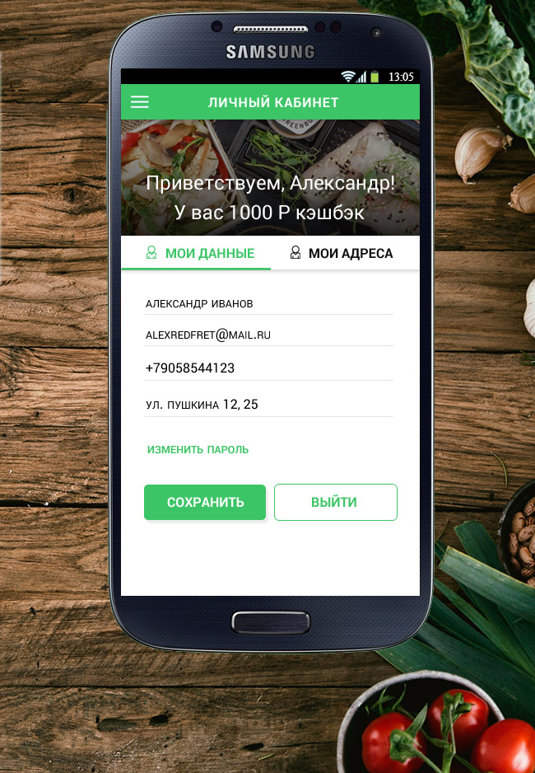

**4.8 Page My Orders**

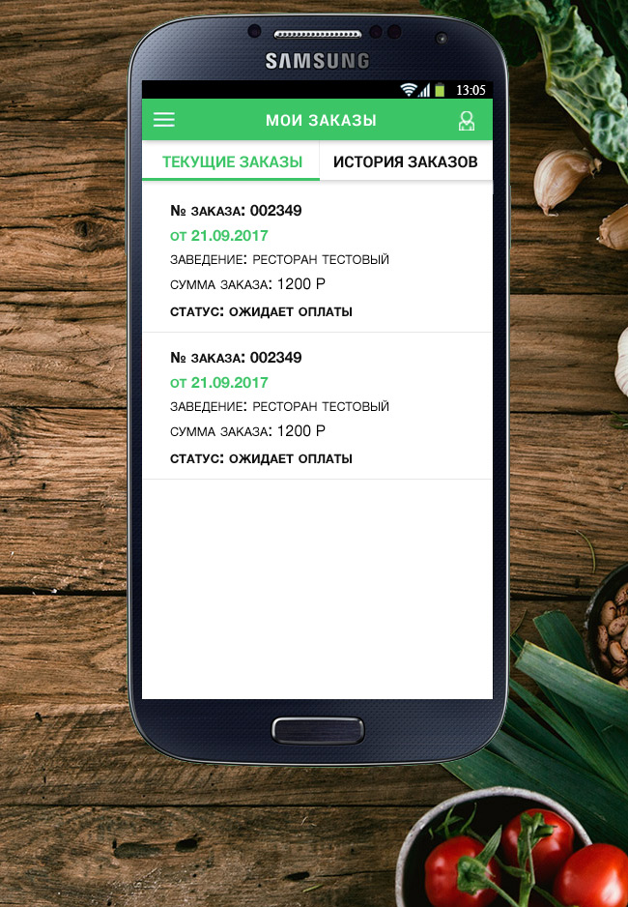

**4.9 Left swap menu**

