Website for Placement Materials

1) Problem Statement

Placement Preparation is hectic. Many B.Tech and M.Tech students does not have the right paved path for their preparation. Everyone says different paths. They also don’t have the right materials and guidance to start their preparation.

Create a database in which roadmap for different types of roles offered is present there (like SDE, Data Analyst, Data Scientist, Sales, Marketing etc.). Materials and courses can also be provided.

Seniors or alumni can also conduct courses approved by NITT required for their placement during the Summer Vacation. The attendees can also get certificate from NITT.

Seniors who are placed & alumni who has experience in their fields can give advice, their experience for their upcoming campus placement.

2) Database

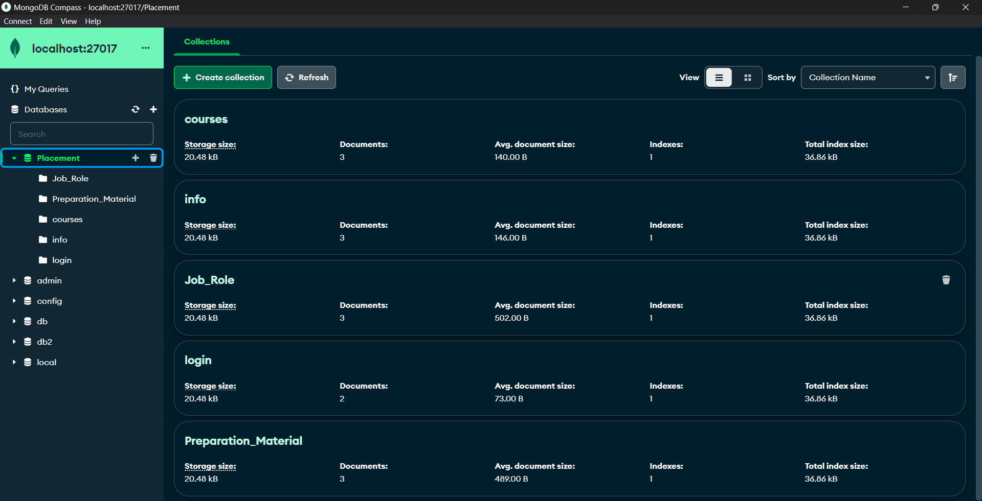

Login Information-

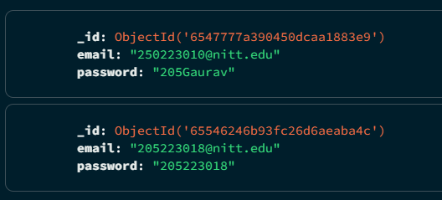

Student’s Information-

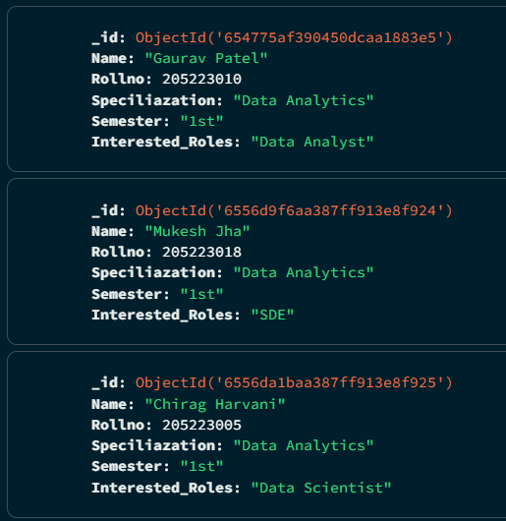

Placement Material-

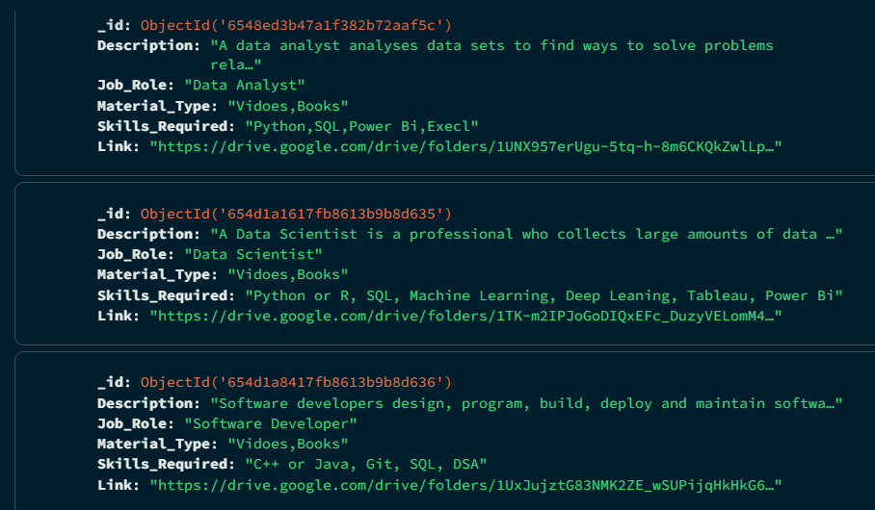

Courses-

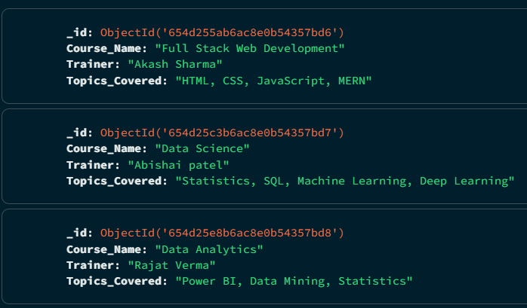

Job Role-

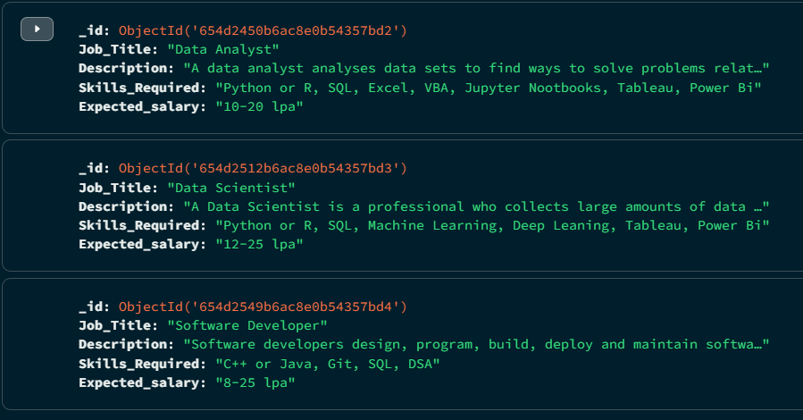

4) List of stakeholders for the problem

* 1st, 2nd year students of M.Tech & 1st, 2nd, 3rd, 4th year students of B.Tech.
* Admin

5) Schema for individual stakeholders and their views

For 1st, 2nd year students of M.Tech & 1st, 2nd, 3rd, 4th year students of B.Tech, they can login using their email and password. They can see

* Information
* Placement Materials
* Job Roles
* Courses offered

6) Database type used

Database used is MongoDB.

7) Screenshot of front end developed for the views of stakeholders

Student Information-

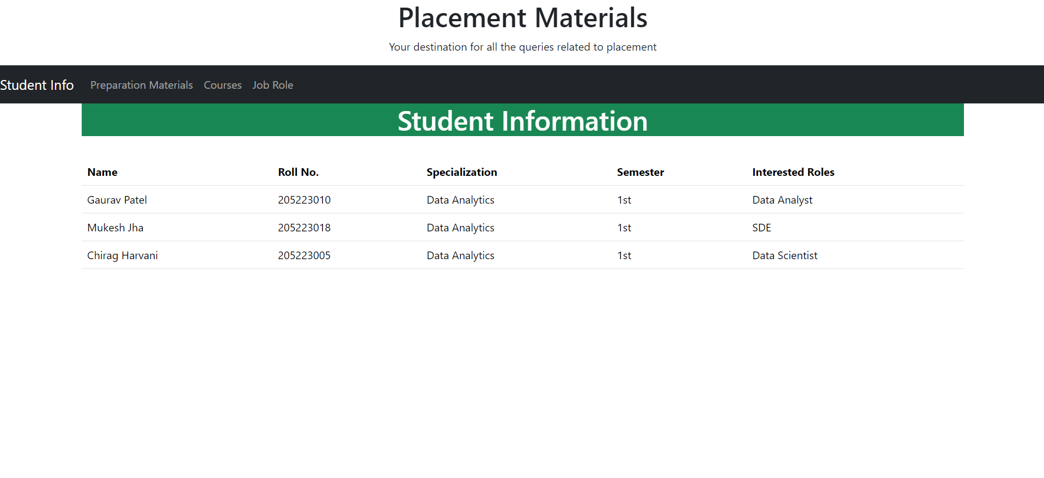

Preparation Materials-

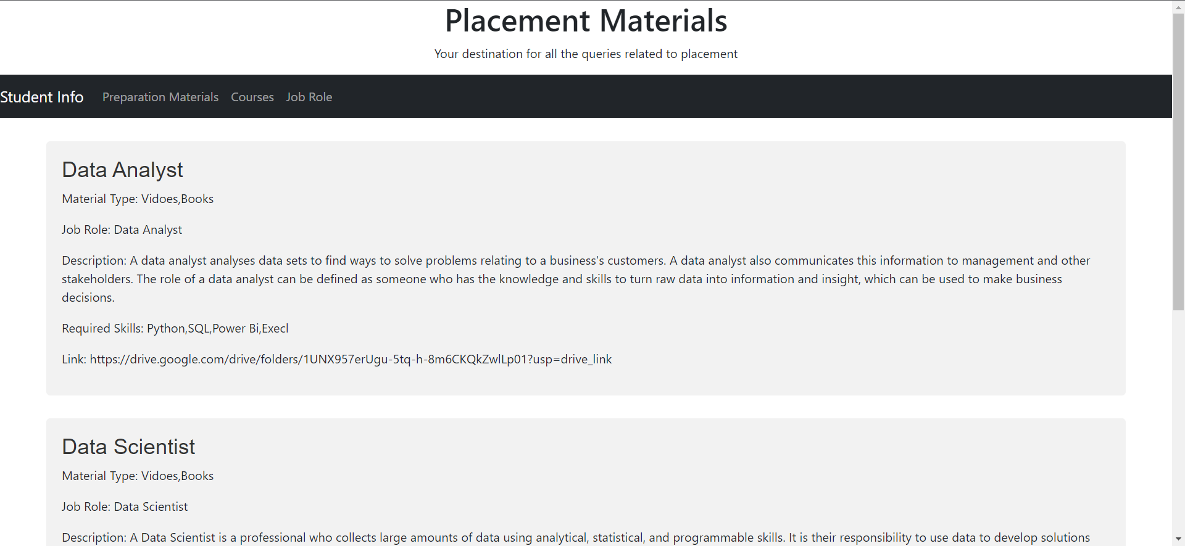

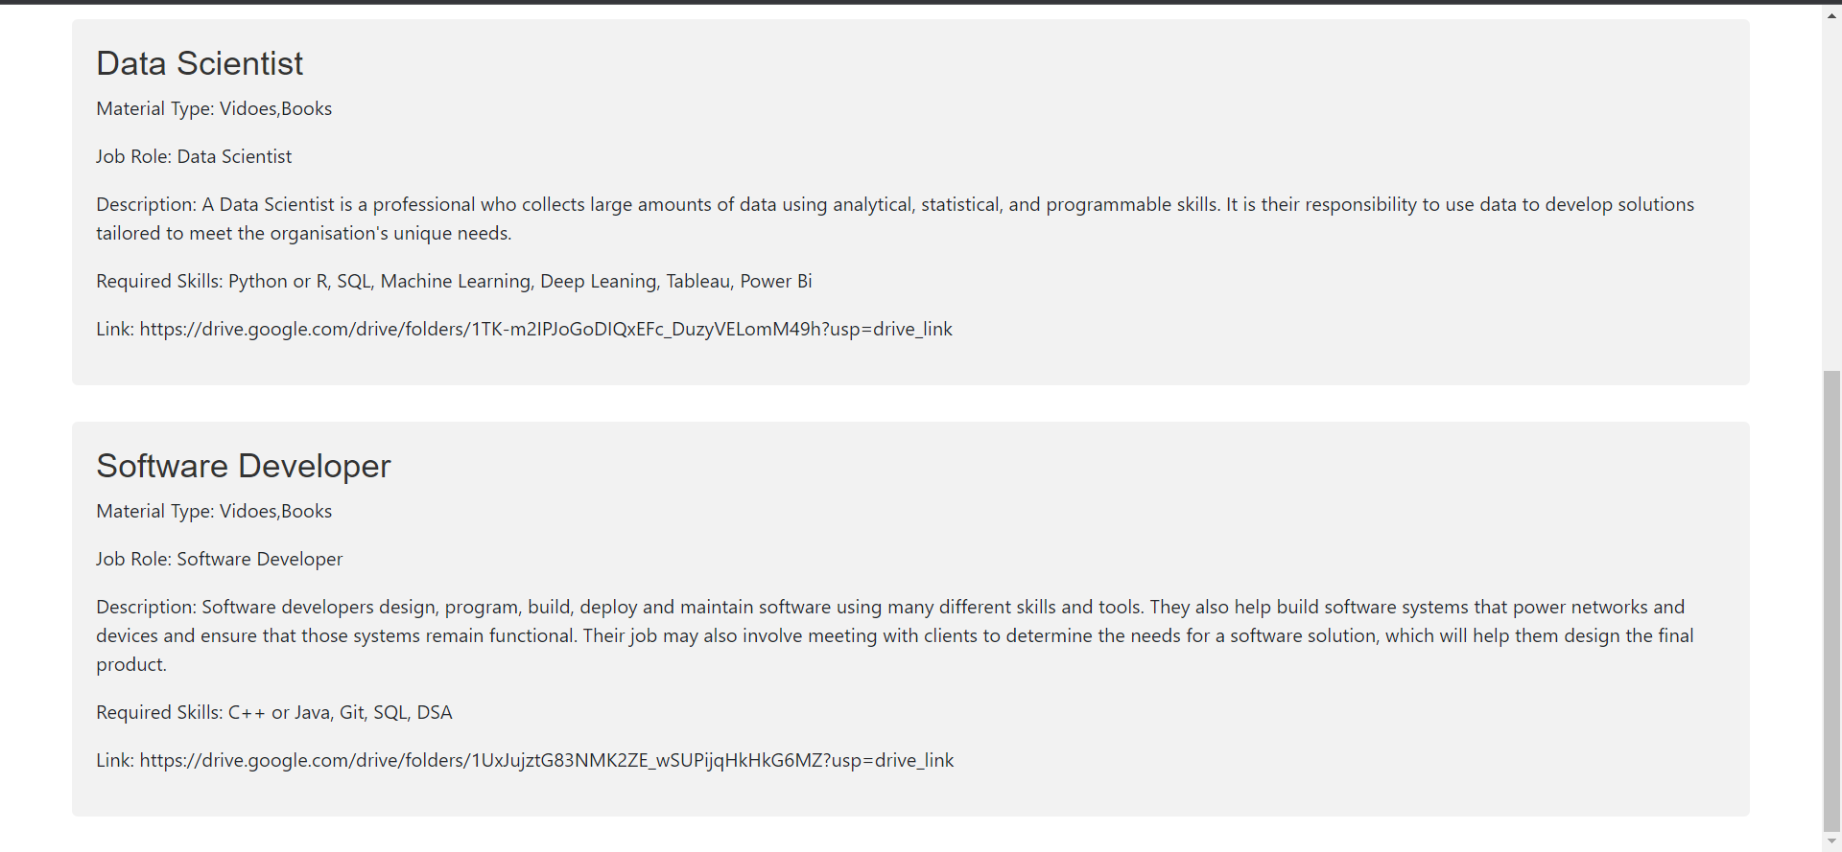

Courses Offered-

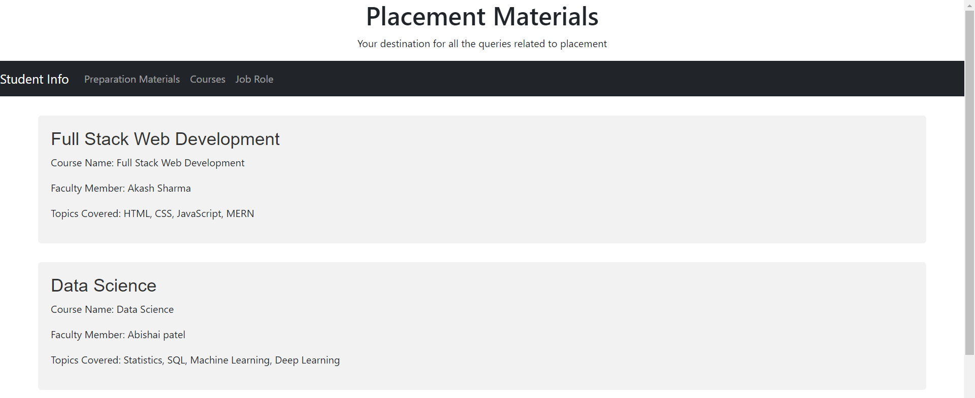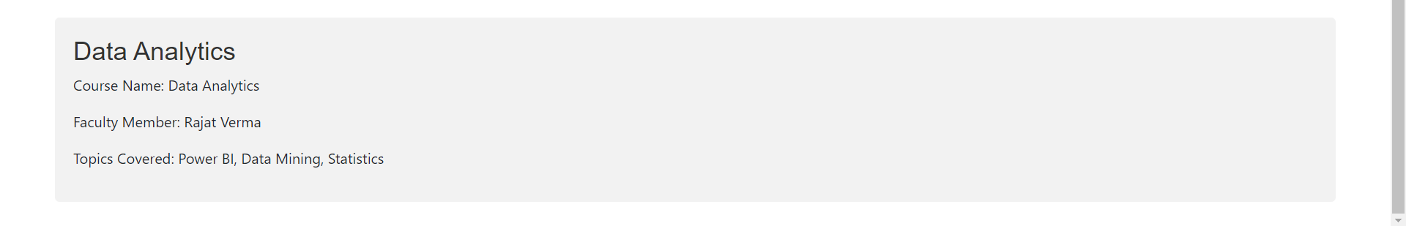

Job Role-

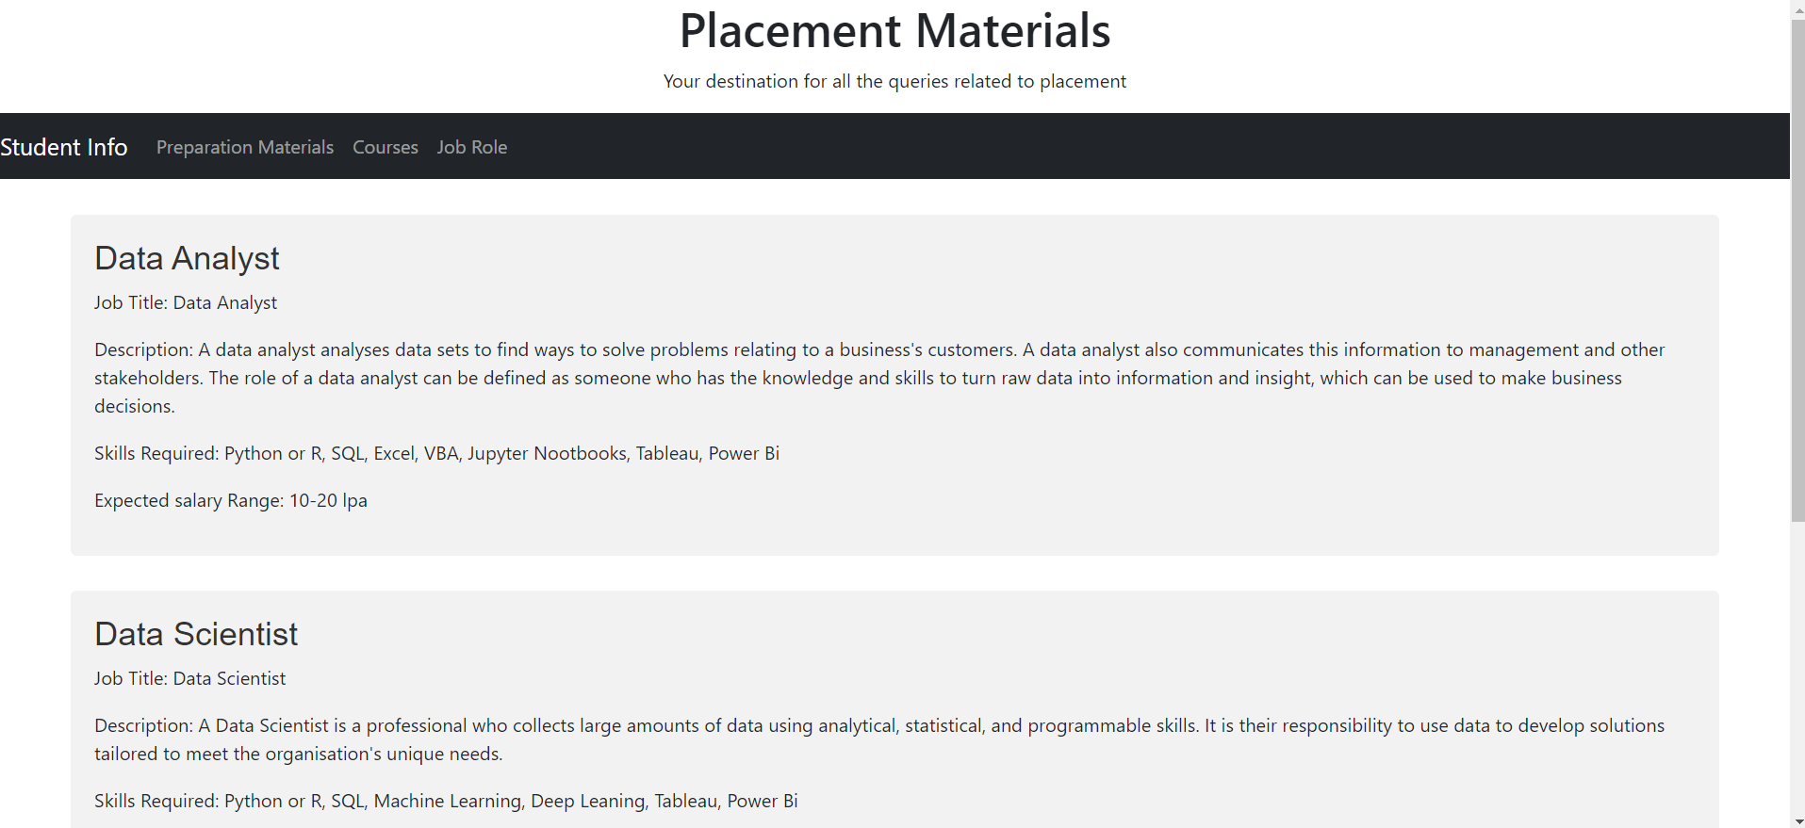 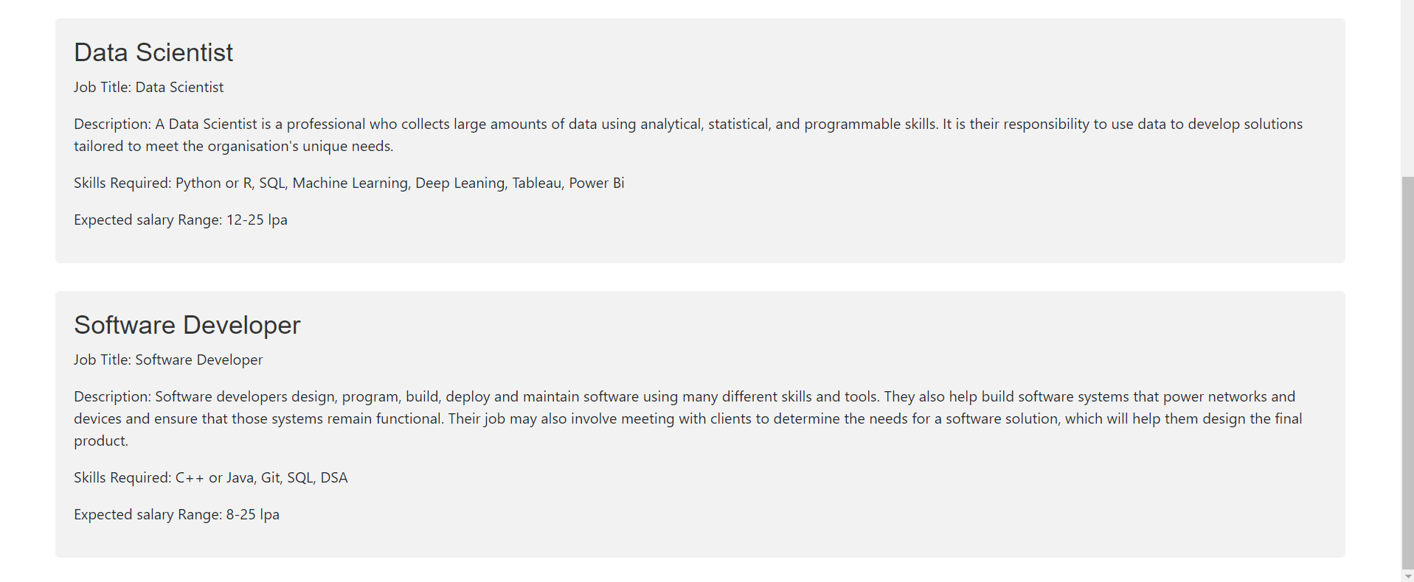

Submitted by-

Name- Gaurav Patel

Roll no.- 205223010

Course- MTech in Data Analytics

Year- 1st Year

Dept.- Computer Application