#Modern-Web-Applications
Gaurav Patrekar A30
Experiment No.05
HTML CODE:
<!doctype html>
<html lang="en">
<head>
<meta charset="UTF-8" />
<meta name="viewport" content="width=device-width, initial-scale=1.0" />
<title>Array Operations</title>
<link rel="stylesheet" href="lab5.css" />
<script src="lab5.js"></script>
</head>
<body>
<div id="container">
<h2>Sort N Reverse</h2>
<p style="margin-top: 2px;">
Designed by
<a href="https://github.com/gauravpatrekar01"> Gaurav Patrekar </a>
</p>
<input id="inputString" placeholder="Enter Your String" />

<button id="b1" onclick="reverseString()">Reverse</button>
<button id="b2" onclick="sortString()">Sort</button>

<div id="result"></div>
</div>
</body>
</html>

JS CODE:
function reverseString() {
var str = document.getElementById("inputString").value; var arr = str.split(""); var rev = arr.reverse().join("");
document.getElementById("result").innerHTML = "<p>Reversed Input: " + rev + "</p>";
}
function sortString() {
var str = document.getElementById("inputString").value; var arr = str.split(""); var sorted = arr.sort().join(""); #Modern-Web-Applications Gaurav Patrekar A30 document.getElementById("result").innerHTML = "<p>Sorted Input: " + sorted + "</p>";
}

CSS CODE:
body {
font-family:Arial,Helvetica,sans-serif; height:100vh; margin:0; display:flex; justify-content:center;
align-items:center;
background:linear-gradient(149deg,# 0318,#0909af);
}
#container{ width:340px; padding:30px 25px; background:white; border-radius:20px;
box-shadow:0 15px 40px rgba(0,0,0,.25);
text-align:center;
}
input { padding: 20px; width: 80%; height: 10px; font-size: 17px;
border-radius: 4px;
}
input:hover{
border-color: #18cf5e;
}
h2{ font-size: 35px; justify-content: center;
margin-bottom:8px;
}
button { padding: 8px 15px; margin-top: 15px;
font-size: 18px; cursor: pointer; width: 40%; background-color: #4c0966;
color: white; border: none; border-radius: 4px;
}
button:hover { background-color: #13de0c;
}
#b1{
background-color: #8f2406;
}
#b2{
background-color: #14068f;
}
#result {
background:linear-gradient(149deg,#d7cbcc,#dfee99 );
padding: 15px; margin-top: 20px; border-radius: 15px; width: 300px;
box-shadow: 0px 0px 10px rgba(0, 0, 0, 0.1);
}

OUTPUT:
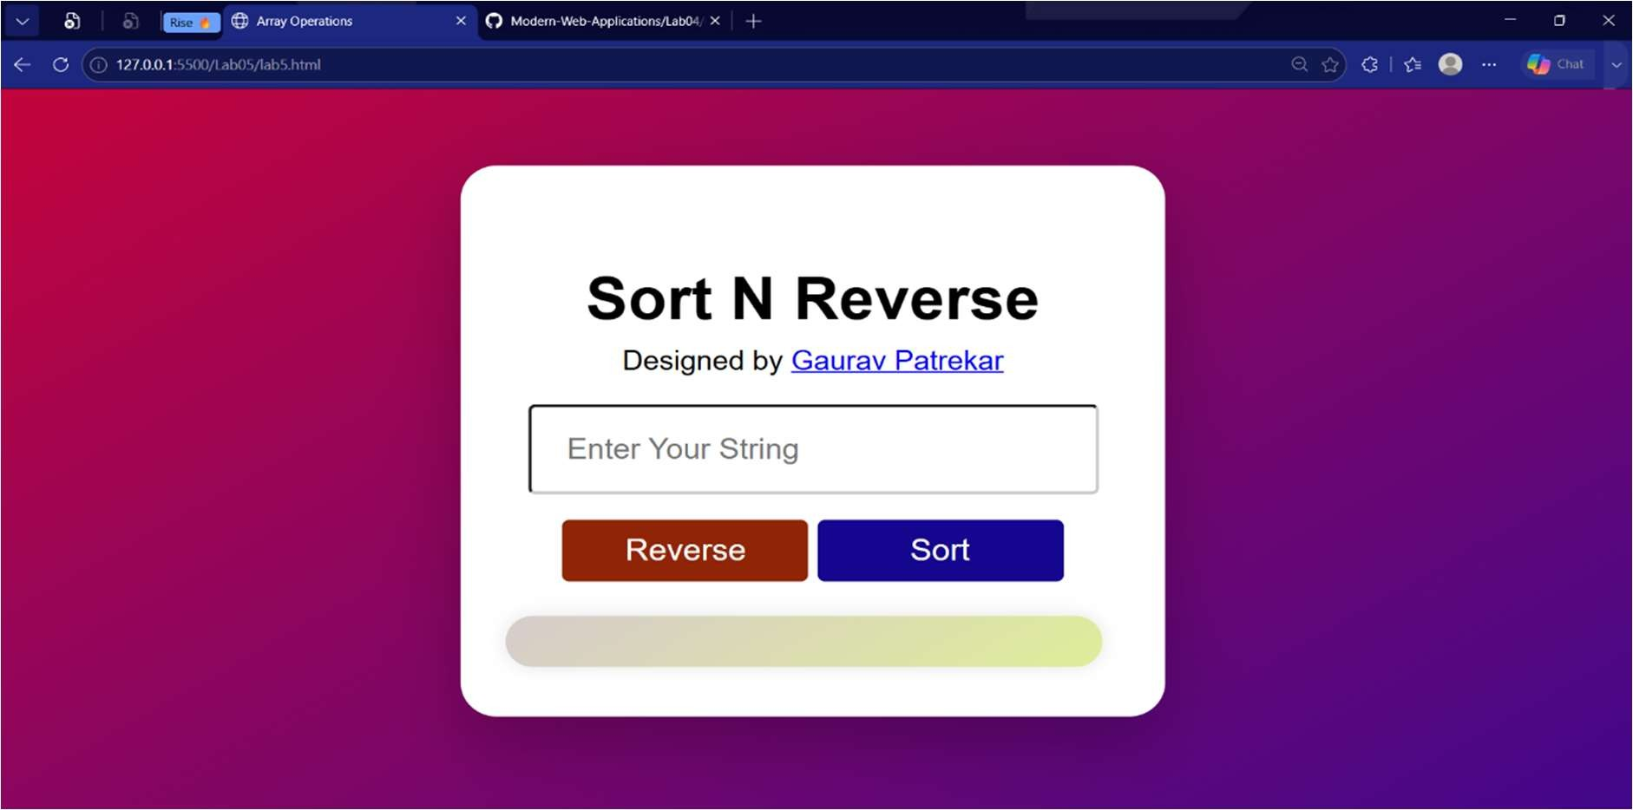

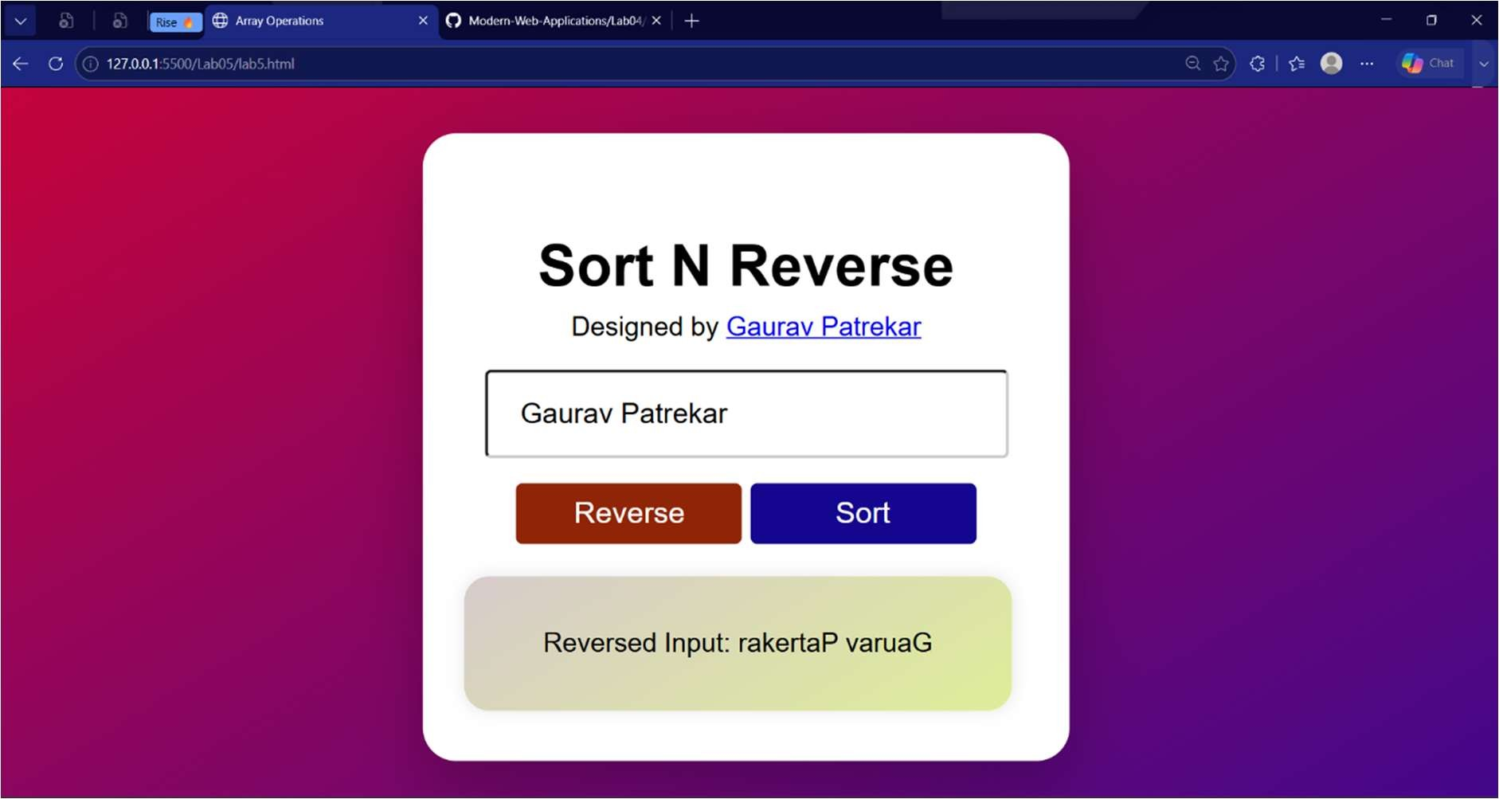
Entering String for Sort alphabetically:
