# VISVESVARAYA TECHNOLOGICAL UNIVERSITY, BELAGAVI 590018

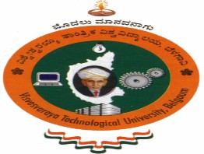

Research Methodology and IPR AAT Report on

# “US20200111105A1”

By

Gaurav (1BM22CS100) BBBB (1BM15CS002) CCCC (1BM15CS003) DDDD (1BM15CS004)

Under the Guidance of

# M Lakshmi Neelima

Assistant Professor,

Department of CSE

BMS College of Engineering

Research Methodology and IPR AAT Report carried out at

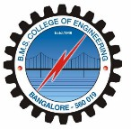

Department of Computer Science and Engineering BMS College of Engineering

(Autonomous college under VTU)

P.O. Box No.: 1908, Bull Temple Road, Bangalore-560 019 2022-2023