**Method and system for tracking and using carbon credits via blockchain (US20200111105A1)**

**1. Patent No., Date of Patent, Type, Inventors**

* Publication No.: US20200111105A1
* Publication Date: 2020‑04‑09
* Application (Type): U.S. Patent Application (Abandoned)
* Inventors: Pulkit Gupta; Ashish Jain; Bhupinder Singh Narang; Shuvam Sengupta
* Original Assignee: Mastercard International Inc.
* Link: <https://patents.google.com/patent/US20200111105A1/en>

**2. Selected Patent Overview**

This disclosure describes a blockchain‑based system for rewarding carbon dioxide sequestration. Sequestering entities apply for “carbon credits” (tokenized blockchain currency) upon proof of CO₂ removal. A processing server verifies sequestration, issues digital‑signature‑signed tokens, and records all transactions immutably on a distributed ledger, enabling trading or cash‑out of credits.

**3. Structure or Architecture**

* System 100 Components (Fig. 1):
  1. Processing Server (102) – central node for credit issuance and verification.
  2. Sequestering Entities (104) – entities that remove CO₂, each with a blockchain wallet.
  3. Verifying Entities (108) – third parties that confirm actual sequestration.
  4. Blockchain Network (106) – distributed ledger maintained by multiple nodes, storing blocks with timestamps, block‑reference and data‑reference hashes.
* Module Breakdown (Fig. 2):
  1. Receiving Device (202): captures data from sequestering/verifying entities and blockchain nodes.
  2. Communication Module (204): internal messaging between server components.

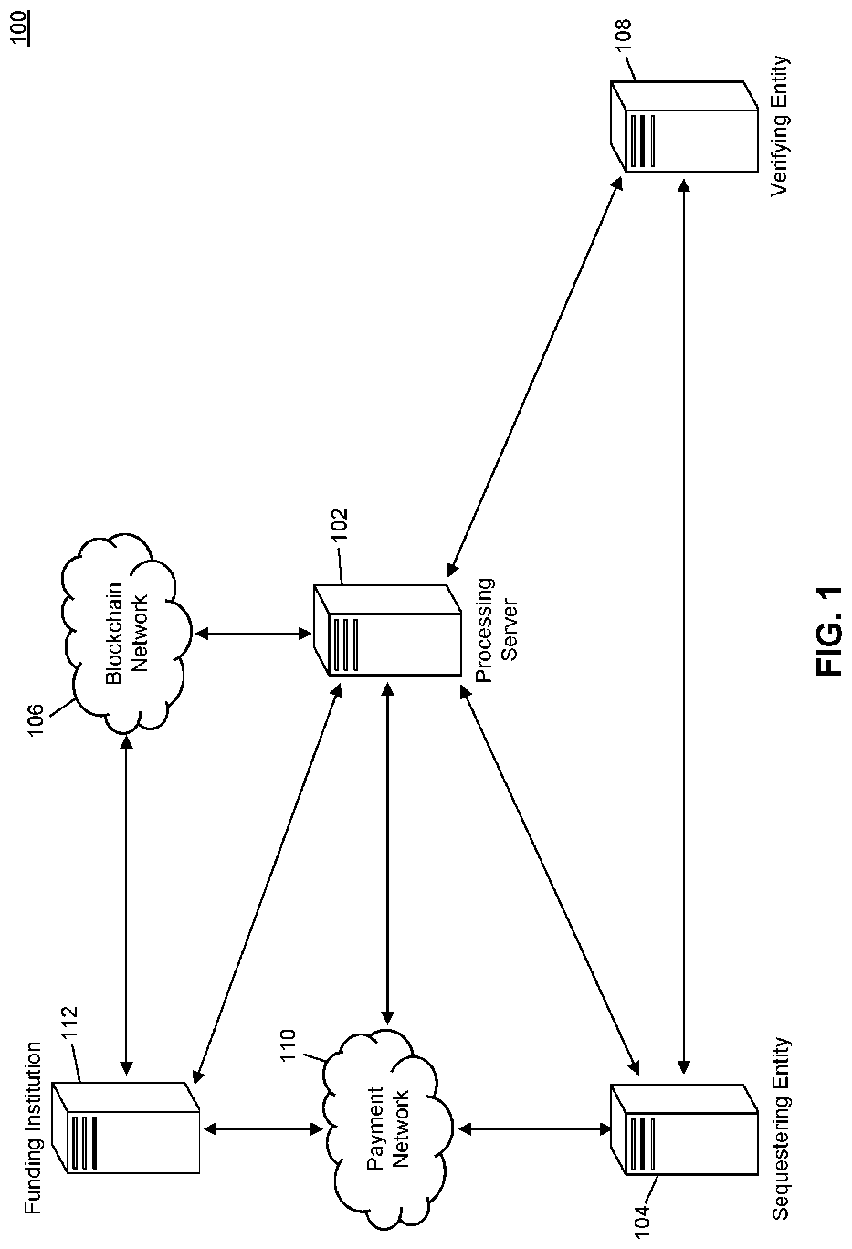

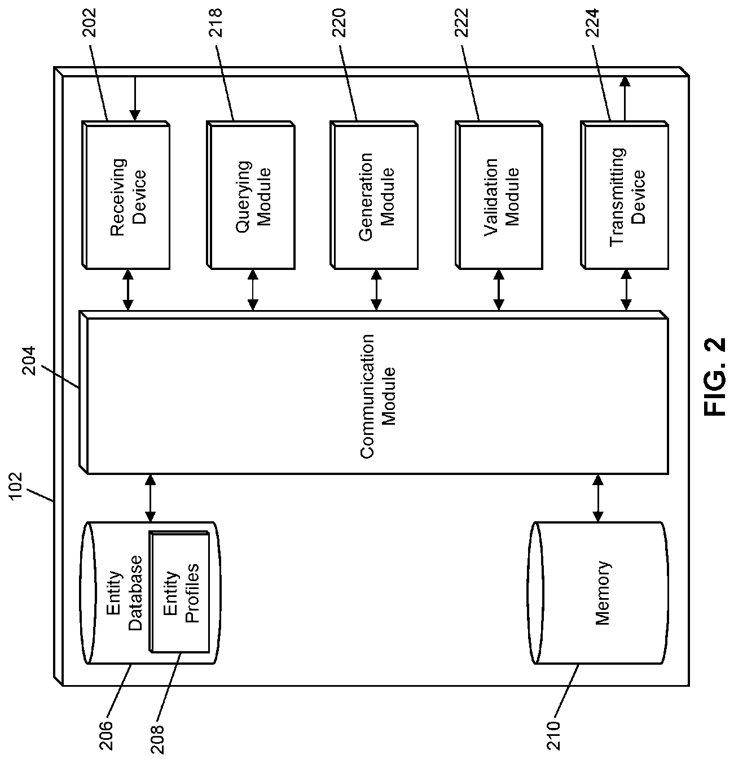

**4. Technical Explanation**

1. Initialization: A finite supply of carbon‑credit tokens is created in a “genesis block” and assigned to the processing server.
2. Application: Sequestering entity submits proof (e.g., public key, sequestration data).
3. Verification: Processing server selects or receives confirmation from a verifying entity.
4. Issuance: Server signs a transaction (digital signature, source address, recipient address, credit amount) and sends it to a blockchain node.
5. Blockchain Processing: Nodes validate signature, create a new block with header (timestamp, block‑reference, data‑reference), and append to the ledger.
6. Trading/Cashing‑Out: Entities transfer tokens via signed transactions; funding institutions may exchange credits for fiat.

**5. Key Innovations or Claims**

* Pre‑allocated Credit Supply: Ensures credits never exceed total potential sequestration.
* Immutable Audit Trail: Merkle‑tree–based hashing renders falsification computationally infeasible.
* Digital‑Signature Issuance: Cryptographic security for proof of origin and transfer.
* Third‑Party Verification Workflow: Mitigates collusion by allowing server‑initiated verifier selection.
* Geographic Valuation Flexibility: Credit value may adjust based on region‑specific pollution metrics.

**6. Areas Where Applicable**

* Voluntary & Compliance Carbon Markets
* Corporate Sustainability Reporting
* IoT‑Enabled Sequestration Monitoring
* Environmental Commodities Trading Platforms
* Regulatory Audit & Certification

**7. Team’s Observations**

* Strengths:
  + Strong data integrity via immutable ledger.
  + Clear workflow from application to trading.
* Limitations:
  + Centralized processing server introduces a single point of trust.
  + Abandoned status suggests practical or commercial hurdles.
  + Verification relies on external entities; automation could be improved.
* Recommendations:
  + Integrate IoT sensors and ML algorithms for real‑time sequestration proof.
  + Migrate to a consortium blockchain to distribute trust among stakeholders.
  + Implement smart‑contract–driven automatic issuance and retirement to reduce server overhead.