**LockedMe.com**

This is a prototype application LockedMe.com created for Company Lockers Pvt. Ltd. This application can be used for file handling, main features of this application are Adding new files and storing information in it. Stored files can be retrieved in ascending order. Searching and deleting a specific file can be done using this application.

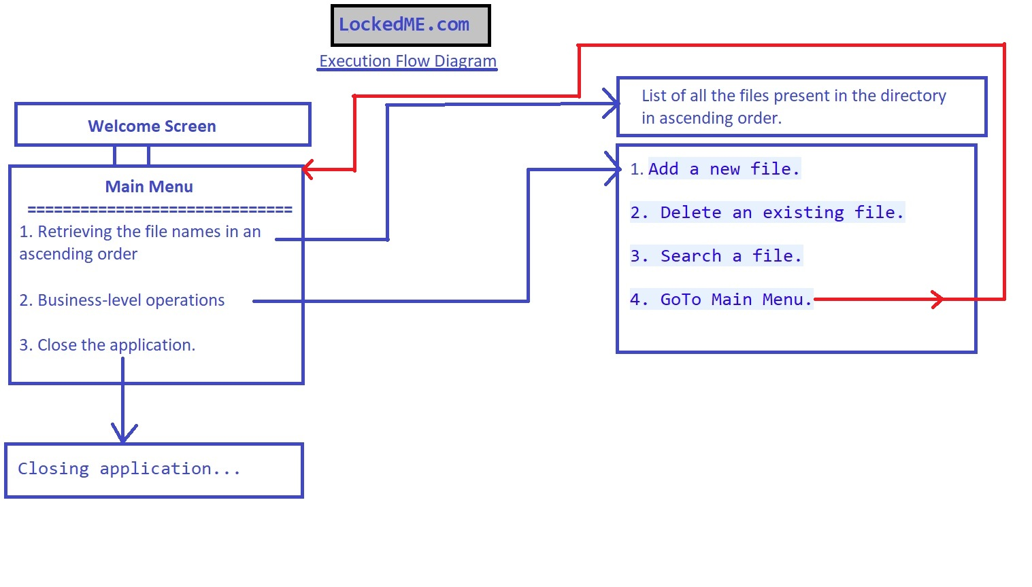

**Main Menu**

1. List of all the existing files in Ascending order.

This application is designed in such a way that it will automatically create a folder with name LockedMe in “C:” of your computer. The main purpose of this is to provide user a convenient way to track and retrieve changes in the directory.

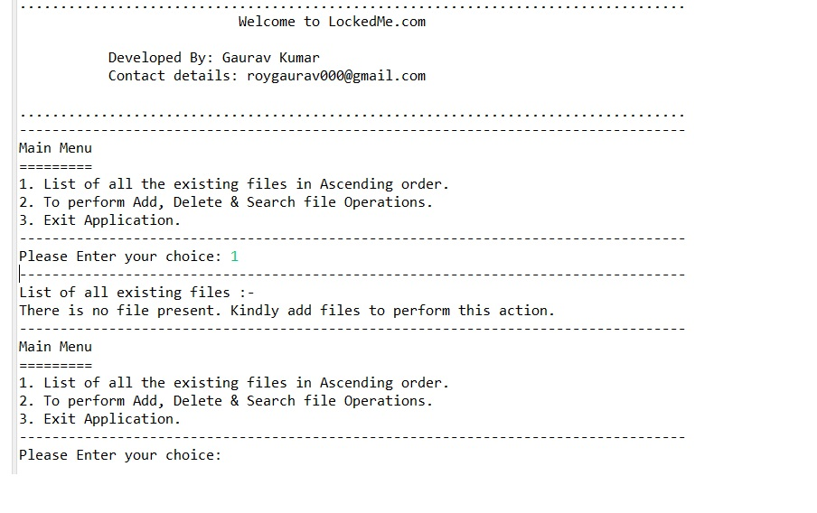

Once the files are added then this feature will show the file names in ascending order as shown below :

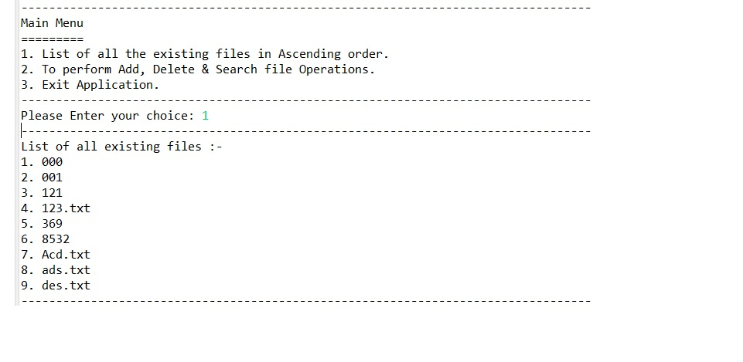

1. To perform Add, Delete & Search file Operations.

This option will allow a User to Add, Delete & Search a file.

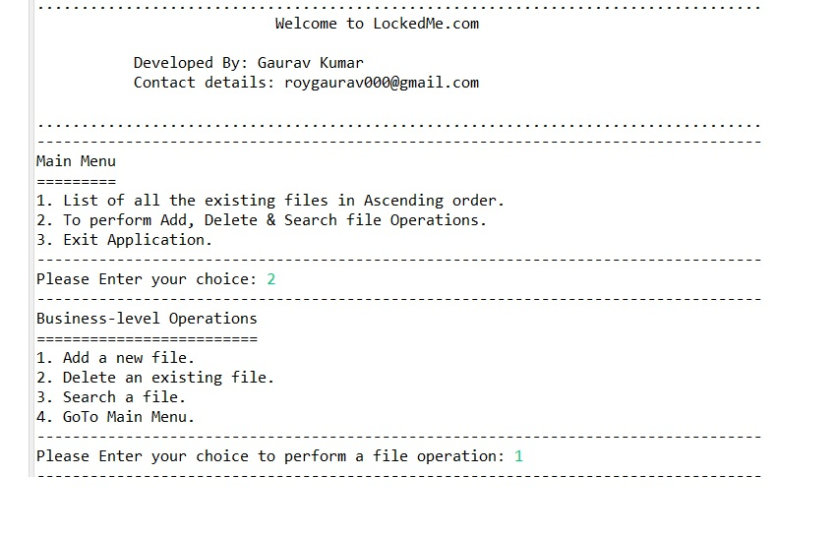

1. Exit Application.

This option will lead to closing the application.

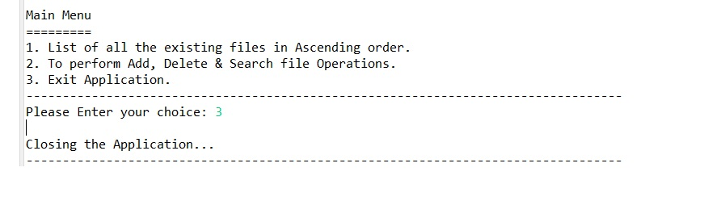

**Business-level Operations**

1. Add a new file

This will allow the User to create a new along with contents to be added in that file.

For the first a new folder will be created with name “LockedMe” in the “C:” of computer and afterwards all the operation will be performed in that folder.

First-time creating a file :

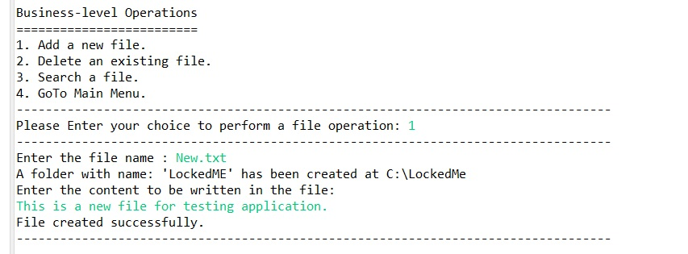

Afterwards all files will be created at “C:\LockedMe\” in computer:

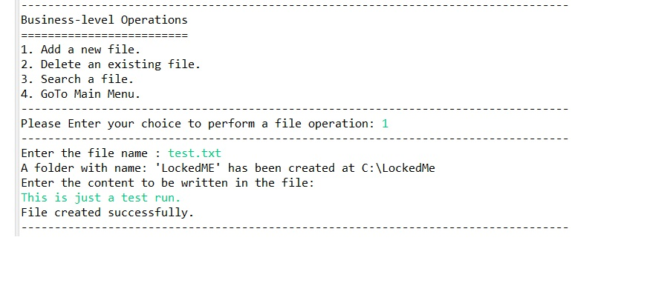

1. Delete an existing file

This option is to delete a specific file already existing in the directory. This option is case sensitive to ensure right file is deleted.

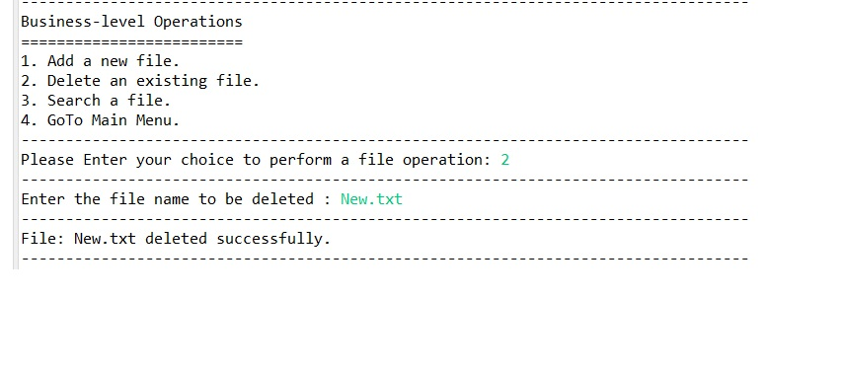

1. Search a file

This option is search for an existing file and see all the details along with the contents of the file.

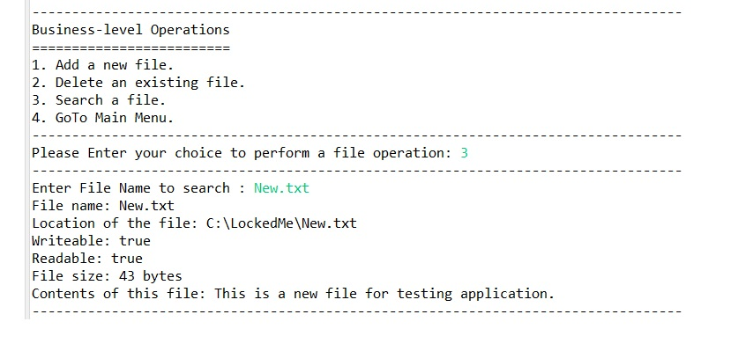

1. GoTo Main Menu

This feature allows user to go back to main menu to perform retrieval of all files or to close the application.

