1. **Project and developer details**

Project Name: LockedMe.com

Developer Name: Gaurav Kumar

Contact: [roygaurav000@gmail.com](mailto:roygaurav000@gmail.com)

1. **Algorithms and flowcharts of the application**

For Searching the file names Linear Search is Algorithm is used.

For arranging the filenames into ascending order List and TreeSet collection is used.

Execution Flow Diagram:

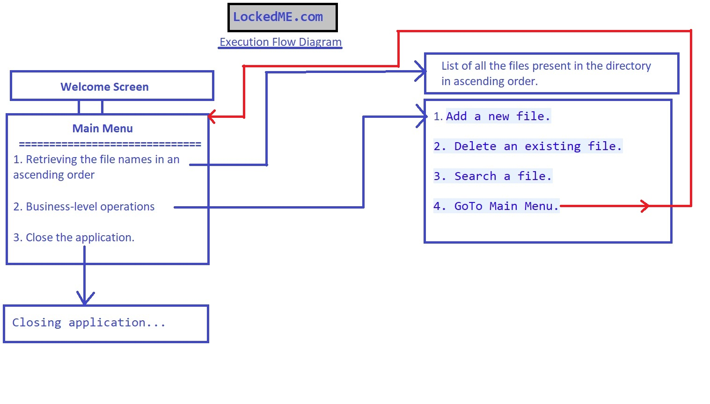

1. **GitHub Repository Link**: <https://github.com/gauravroy4/LockedMe.com.git>
2. **Conclusion on enhancing the application:**

This application can be enhanced by using database concepts and cloud concepts so that every action performed over this can be made more efficient.