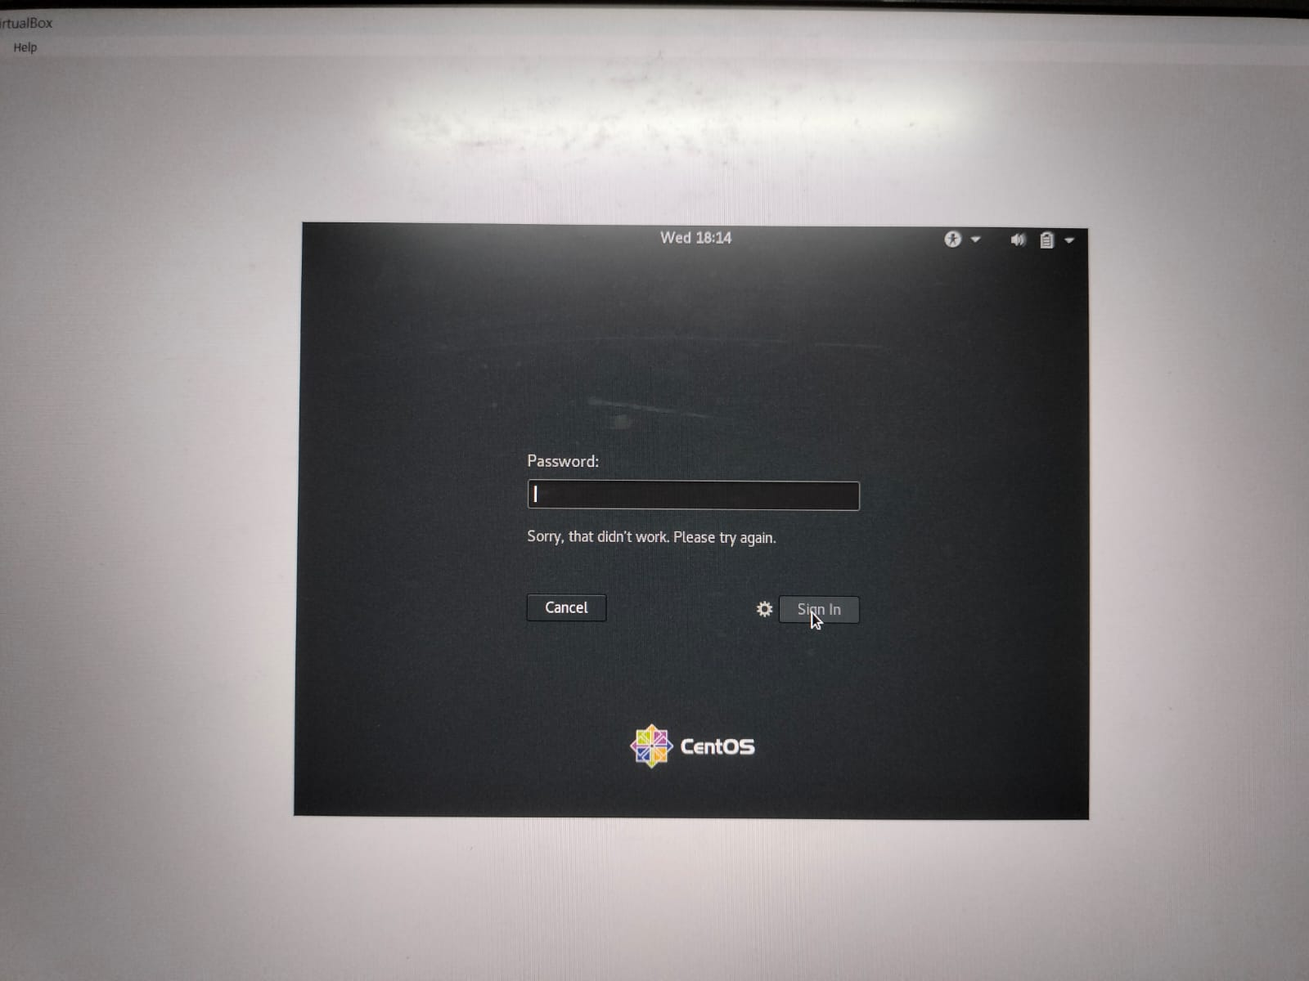

Assignment - 1

When try to login as a non-existent user, it does not allow us to login as the registration(signup) of the new user is not there in the system.

Assignment -2

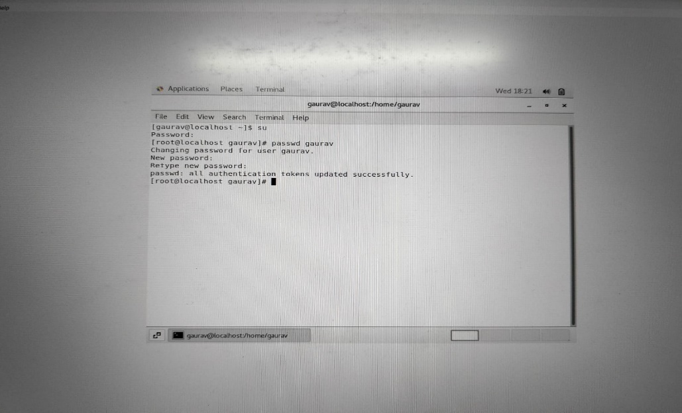

***IneuR0n#42*** Password changed successfully with all authentication

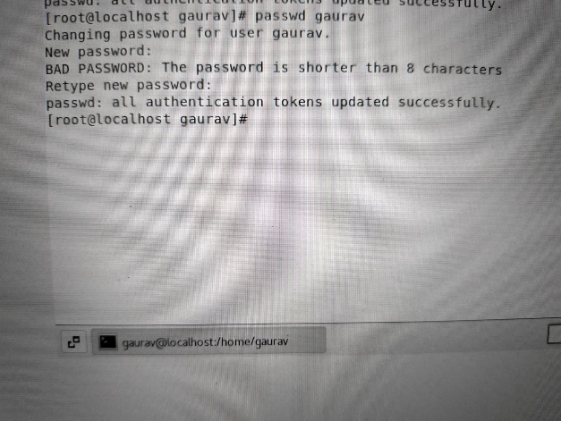

1234 or abcd password shorter passwd less than 8 characters 🡪 not such a strong password as the previous password but this also accepted.

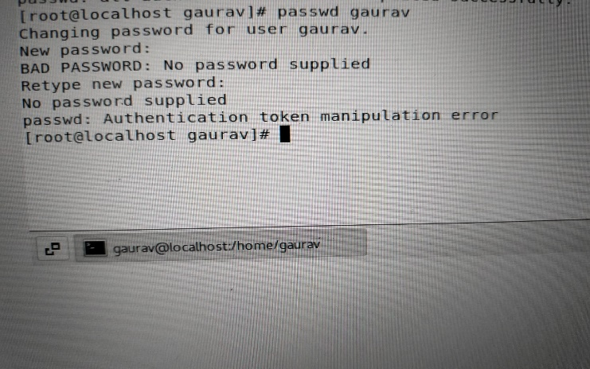

Hitting direct enter without typing any password 🡪 authentication error no password supplied.

Assignment – 3

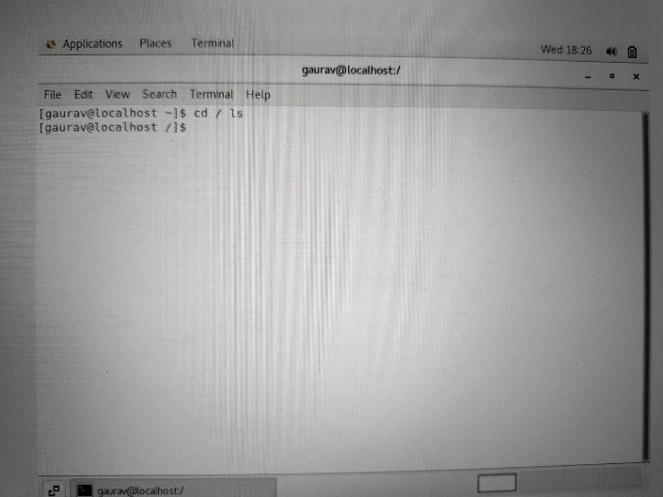

cd / ls 🡪 It is asking next directory path to enter after home directory.

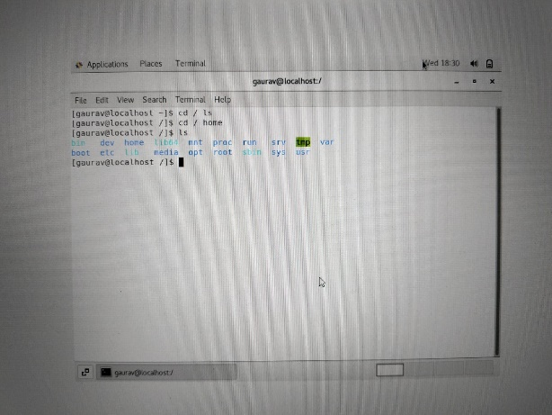

Home directory is for the user to store all their personal information, files, login scripts and user information.

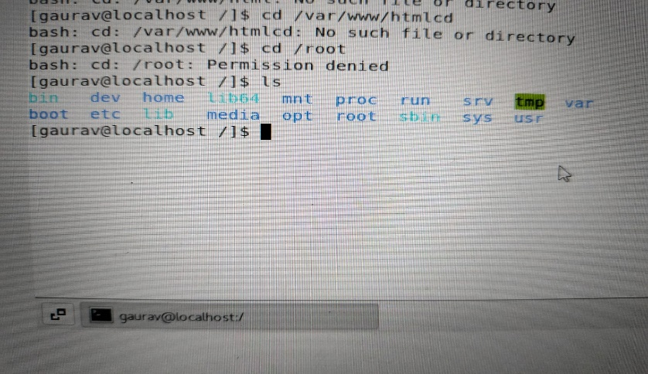

cd / root cd /var/www/html cd no such directory found

Assignment – 4

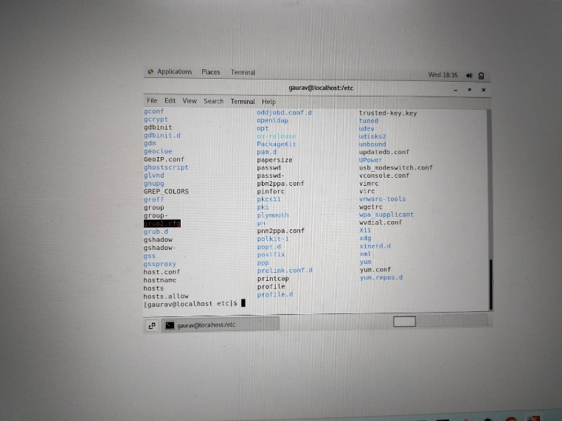

cd /etc 🡪 then ls gives list of all the configuration file in it.

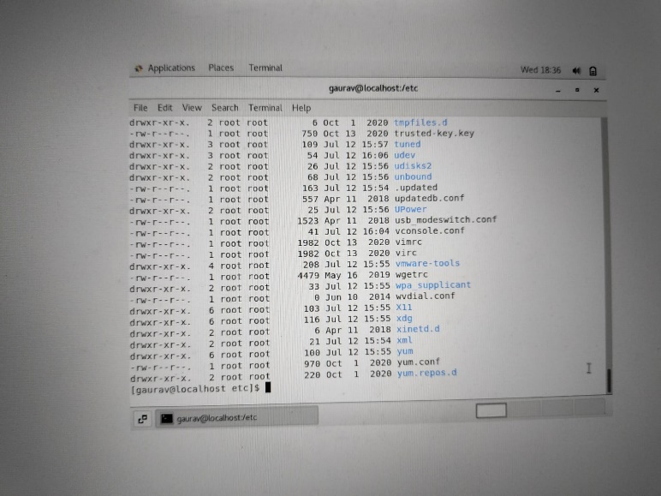

ls –al Can see the file permissions of Read, Write & Execute.

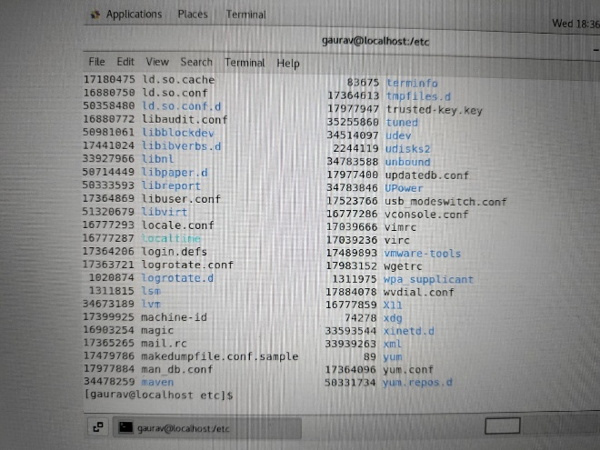 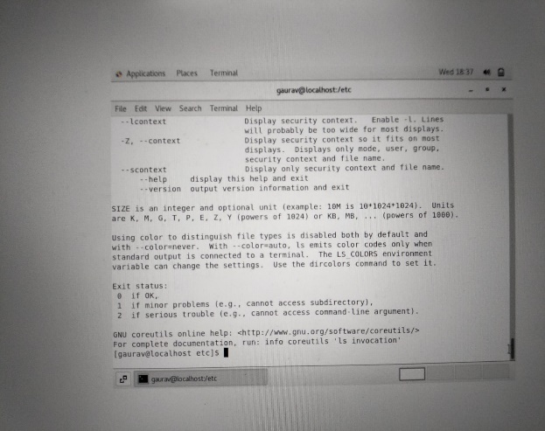

ls –i ls –help

Assignment – 5

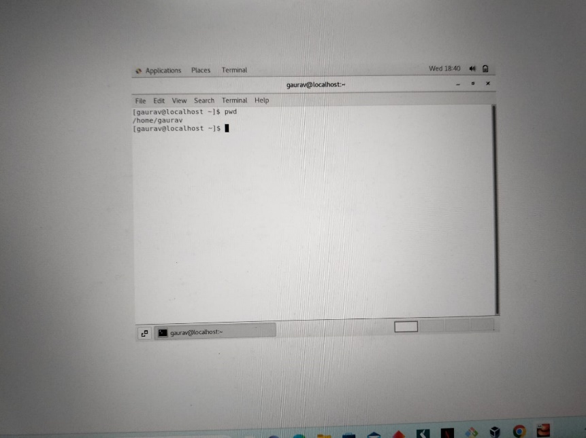

Pwd command for the your location.

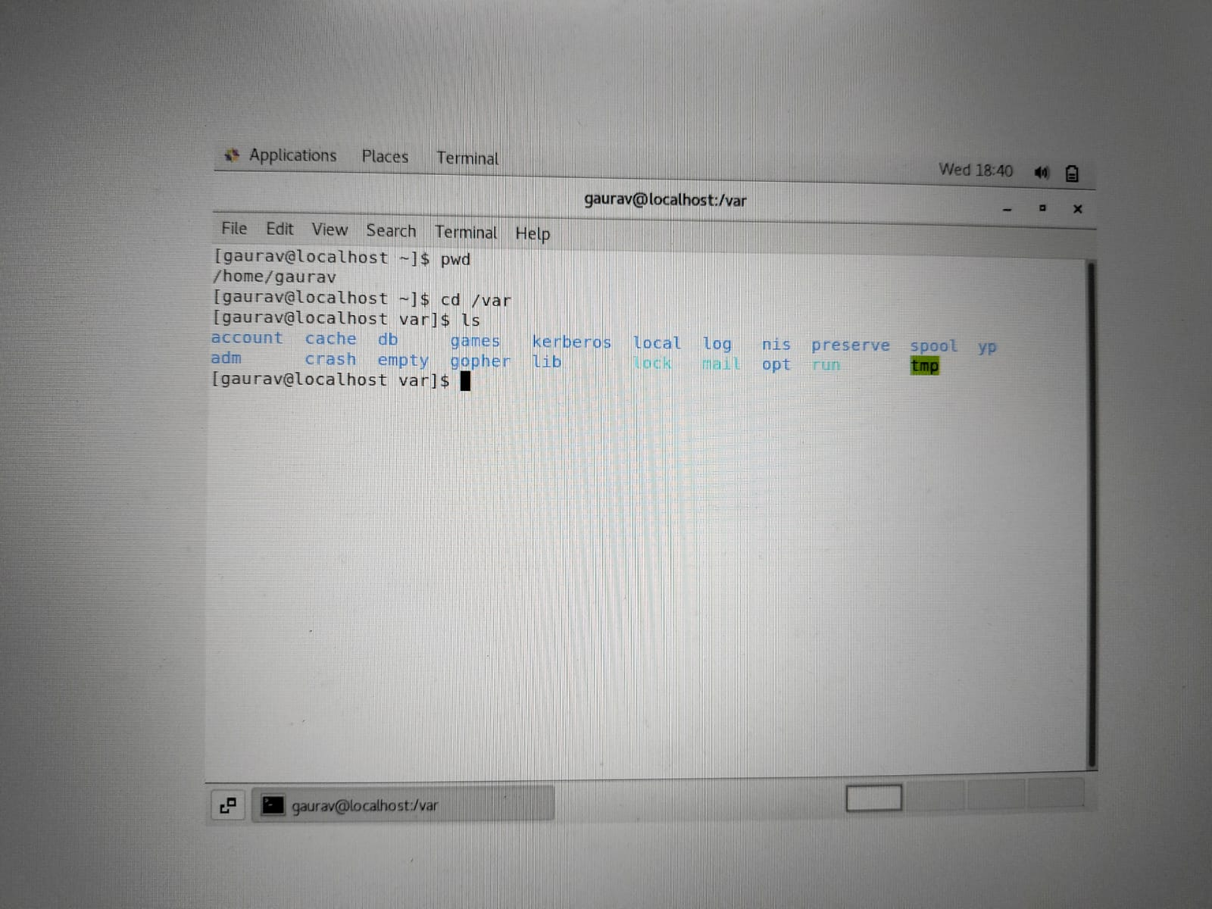

cd /var then ls