Assignment 2
CSL7360: Computer Vision

Gaurav Sangwan (B20AI062)

Question: Segmentation

Kmeans Segmentation

In our implementation, we have developed the kmeans function from scratch, which takes an image and the number of clusters k as input. The function iteratively assigns each pixel to the nearest cluster centroid and updates the centroids based on the assigned pixels. The segmented image is obtained by replacing each pixel with its corresponding cluster centroid value.

Radio-Cut Spectral Clustering

Our implementation constructs a graph from the image pixels using the image.img_to_graph function from the scikit-image library. The Laplacian matrix L is computed from the graph's adjacency matrix A. The eigenvectors of the Laplacian matrix are then calculated, and K-means clustering is performed on these eigenvectors to partition the graph into clusters. The resulting cluster assignments are stored in the label_im array.

Experiments and Results

Input Images
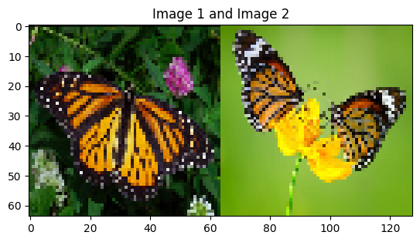

Kmeans with 3 clusters
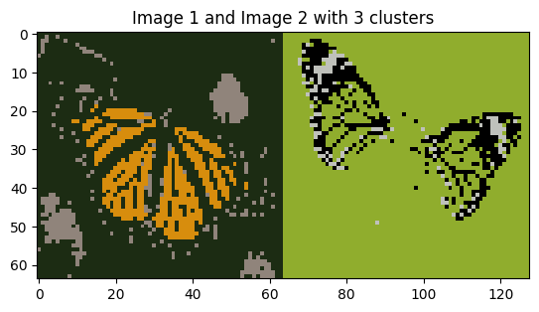

Kmeans with 6 clusters
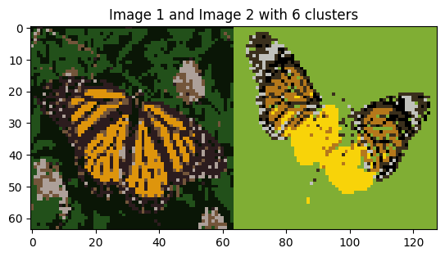

Spectral Clustering with 3 clusters

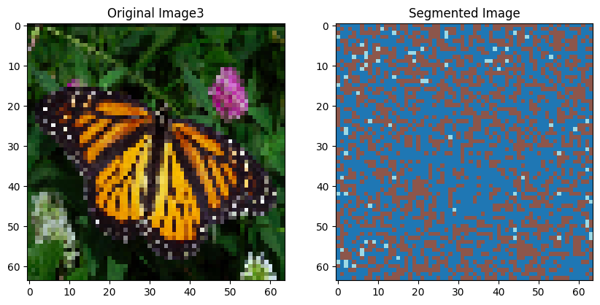
image2
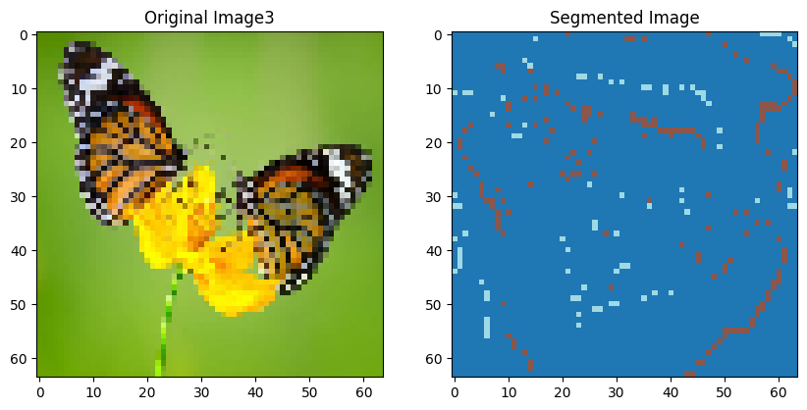

Spectral Clustering with 6 clusters
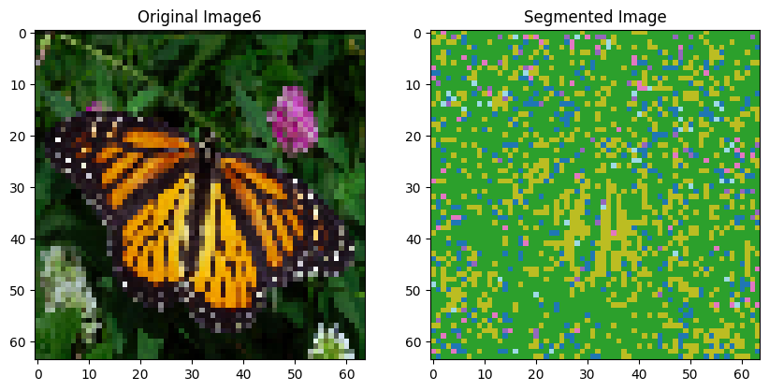
image2
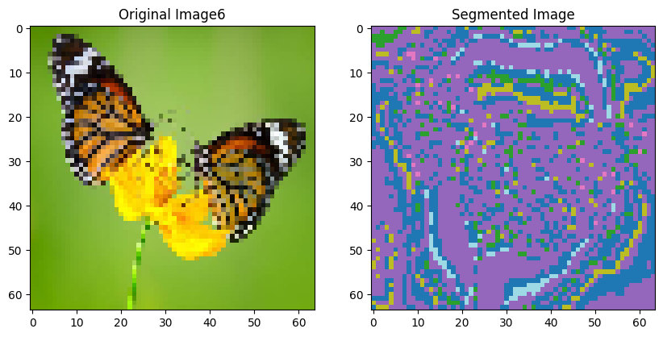

Result Discussion

- K Means Clustering algorithm
  - For k=3, the K-means algorithm tends to segment the images based on broad color regions, often merging visually distinct objects or regions.
  - For k=6, the algorithm captures more detailed segmentation, separating objects and regions with slightly different color shades.
  - However, K-means struggles with capturing non-convex cluster shapes and can lead to over-segmentation or under-segmentation in certain cases, which is evident from the pictures of butterflies.
- Radio-Cut Spectral Clustering
  - Spectral clustering generally provides better segmentation results, capturing the natural boundaries and shapes of objects or regions more accurately, which is not the result in our case as we are unable to access and correctly plot the segmented region.
  - For k=3, the algorithm effectively separates the main objects or regions in the images, even when they have similar colors but distinct boundaries.
  - For k=6, the algorithm further refines the segmentation, separating smaller details and textures within the main objects or regions.
  - Spectral clustering is particularly effective in handling non-convex cluster shapes and preserving the overall structure of the image.

In general, Spectral clustering provides more accurate and visually pleasing segmentation results, especially for complex images with non-convex cluster shapes and varying textures. However, it comes at a higher computational cost compared to the simpler K-means algorithm.
In my experiments as well, every image of Spectral clustering was taking over 5 minutes, therefore I used concurrent.futures to do parallel processing.

Reasoning for poor results in spectral clustering

While doing the resizing we have lost very prominent information regarding the image and the final image is pixilated when resized to 64x64. Therefore, and thus causing poor results by spectral clustering.

Conclusion

In this assignment, we implemented and compared two image segmentation techniques: K-means clustering and Spectral clustering (Ratio-Cut based clustering). Our experiments on two input images demonstrated the strengths and weaknesses of each technique. While K-means clustering is computationally efficient and suitable for simple segmentation tasks, Spectral clustering provides more accurate and detailed segmentation results, especially for complex images with non-convex cluster shapes and varying textures.

