- DAIRY_DATASET_ANALYSIS

1: Total revenue generated by each product.

SQL_COMMAND>
select round(sum(approx_total_revenue_inr)) as total_revenue_generated from dairy;

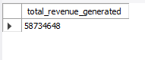

2: Give Brand with the highest total revenue.

SQL_COMMAND>

select brand ,round(sum(approx_total_revenue_inr)) as highest_total_revenue from dairy group by brand order by highest_total_revenue desc limit 1;

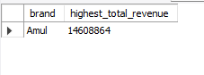

3: Give Monthly revenue trend across all products.
SQL_COMMAND>
select sum(approx_total_revenue_inr) as total_revenue ,monthname(record_date) as month ,product_name from dairy group by product_name ,month ;

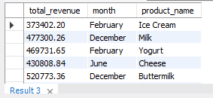

4: Products below the minimum stock threshold.
SQL_COMMAND>
select product_name,min(min_stock_threshold_liters_kg) as min_stock_threshold from dairy group by product_name;

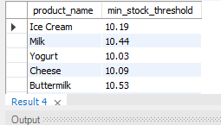

5: Total reorder quantity required per product.
SQL_COMMAND>
select product_name,round(sum(reorder_quantity_liters_kg )) as total_reorder from dairy group by product_name ;

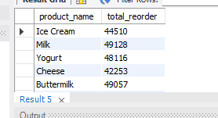

6: Which sales channel generates the most revenue.
SQL_COMMAND>
select sales_channel from dairy where approx_total_revenue_inr = (select max(approx_total_revenue_inr) from dairy);

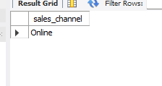

7: Top 5 customer locations by purchase volume.
SQL_COMMAND>
select location,approx_total_revenue_inr as total_revenue from dairy order by total_revenue desc limit 5 ;
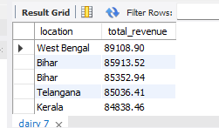

8: Average selling price per product.
SQL_COMMAND>
select avg(price_per_unit) as avg_price , product_name from dairy group by product_name ;
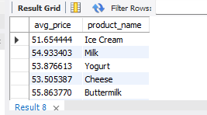

9: Compare selling price with listed price with category.
SQL_COMMAND>
select sum(price_per_unit-price_per_unit_sold) as diff_between_listed_price_and_price_sold , brand from dairy group by brand;
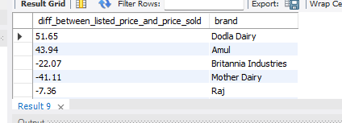

10: Products with less than 10 days shelf life remaining.
SQL_COMMAND>
select product_name from dairy where shelf_life_days > 10;

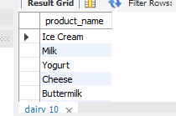

11: Average shelf life by product category.
SQL_COMMAND>
select round(avg(shelf_life_days)) as avg_self_life,product_name from dairy group by product_name ;

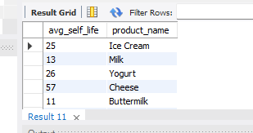
12: Average number of cows per farm size category.
SQL_COMMAND>
select round(avg(number_of_cows)) as avg_number_of_cows ,farm_size from dairy group by farm_size ;

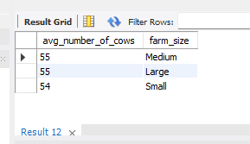

13: Location with the largest total land area.
SQL_COMMAND>
select location ,max(total_land_area_acres) as largest_land_area from dairy group by location ;
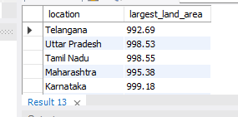

14: Top 3 locations by average production quantity.
SQL_COMMAND>
select location ,round(avg(quantity_liters_kg)) as avg_quantity from dairy group by location order by avg_quantity desc limit 5;

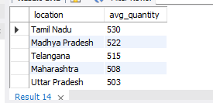

15: Calculate profit for each product.
SQL_COMMAND>
select product_name,round(sum(approx_total_revenue_inr-total_value)) as profit from dairy group by product_name;
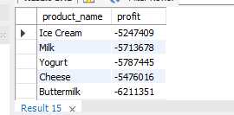

16: Most profitable brand overall.
SQL_COMMAND>
select brand,max(approx_total_revenue_inr-total_value) as profit from dairy group by brand order by profit desc limit 1;

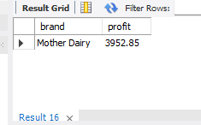

17: Yearly revenue growth.
SQL_COMMAND>
select year(record_date) as year , sum(approx_total_revenue_inr) as total_approx_revenue from dairy group by year;

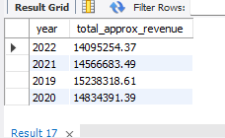

18: Best-selling product each year.
SQL_COMMAND>
select year(record_date) as year ,product_name,sum(quantity_sold_liters_kg) as total_sold_quantity from dairy group by product_name,year order by total_sold_quantity ;

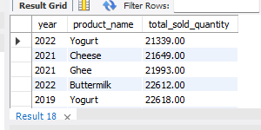

19: Products that need immediate restock.
SQL_COMMAND>
select product_name from dairy where min_stock_threshold_liters_kg<(select avg(reorder_quantity_liters_kg));

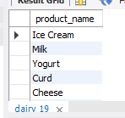
20: Identify expired products still in stock.
SQL_COMMAND>
SELECT product_name, quantity_in_stock_liters_kg, expiration_date
FROM dairy
WHERE expiration_date < CURDATE()
AND quantity_in_stock_liters_kg > 0
ORDER BY expiration_date ASC;

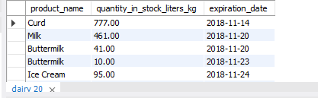

21: Average shelf life per brand.
SQL_COMMAND>
select brand ,round(avg(shelf_life_days)) as avg_shelf_life from dairy group by brand;

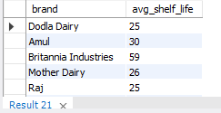

22: Most popular product in each customer location.
SQL_COMMAND>
select product_name ,location ,sum(quantity_sold_liters_kg) as total_sold_quantity from dairy group by location ,product_name order by total_sold_quantity desc;
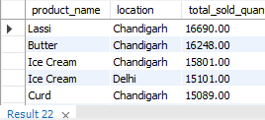

DAIRY_DATA >>>>>>>>

1.DATABASE = DDS
2.TABLE NAME = DAIRY

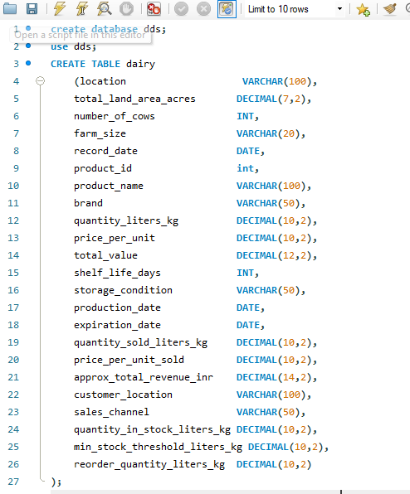
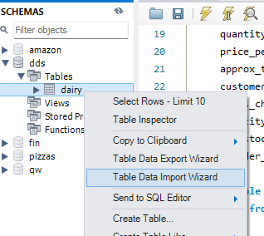
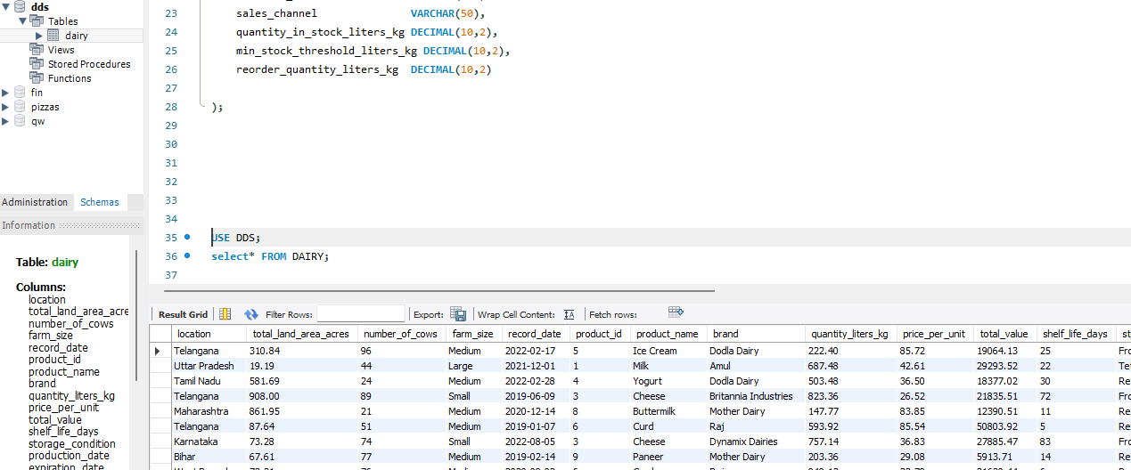

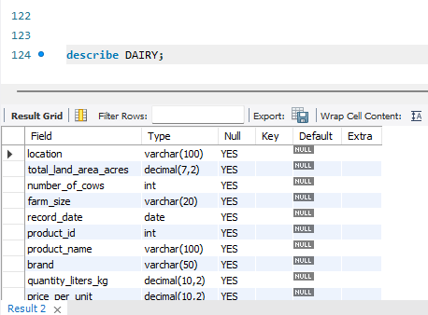
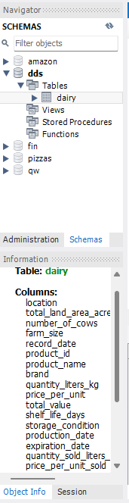

EER_DAIGRAM_OF_TABLE>>>

