# Part A

## Introduction

Different people from different places often go for a vacation. I will be creating an application for them who travel and store their memories. I will have included everything that is required to build this app. Once, (Pinola, 2021) said, a paper notebook and pen are fine for journaling, but apps often more. They give you more context on what you’ve accomplished and where you might want to go. They also let you include photos from your phone or posts from your social media feeds to make the journaling experience more rewarding. Add in reminders and the ability to search your journal entries, and digital journaling is almost a no-brainer.

In this part, I will be talking about the analysis and evaluation that includes the various methods and approaches to native app development. Also, the brief description about designs implemented in my application. Test and test results are also shown in this report.

**Mostly, I have used tables to understand the work easy and quick.**

## System Requirements

|  |  |  |  |
| --- | --- | --- | --- |
|  | **Microsoft Windows** | **Mac** | **Linux** |
| **OS version** | Microsoft Windows 8/10 (64-bit) | MacOS 10.14 (Mojave or higher) | Any 64-bit Linux distribution that supports Gnome, KDE, or UNITYDE; or later |
| **RAM** | 8 GB or more | | |
| **Free digital storage** | 8 GB of available disk space minimum | | |
| **Minimum screen resolution** | 1280 x 800 minimum resolution | | |

## Programming language

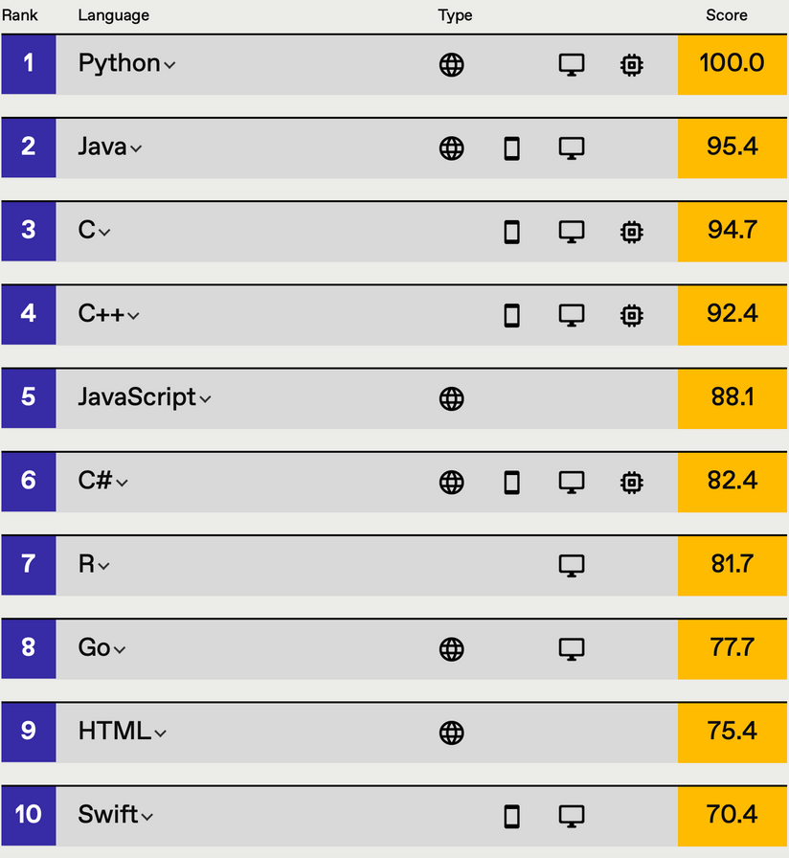

Source: <https://twitter.com/kirkdborne/status/1433289189894860800>

(Borne, 2021)

Here are the different programming languages which can be used for different platforms. For mobile app development there are quiet few languages such as Java, C, C++, C#, Swift and so on. Therefore, I have used java programming language for my app.

## Approaches to mobile app design and development

Application development is complex. To build applications that reach all users, developers must

deal with many different applications, SDKs, development tools, screen sizes and form features, and the state of the art in a constant state of flux. And if that were not enough, there are several different ways to build a cell phone application that development teams need to address before starting any new mobile attempt. (Oladele, 2021)

|  |  |  |  |
| --- | --- | --- | --- |
|  | **NATIVE** | **HYBRID** | **WEB** |
| **COST** | Highest of all three choices | Similar to pure web costs, but extra skills required | Lowest cost due to single codebase and common skillset |
| **CODE REUSABILITY** | Code for one platform only works for that specific platform | Most hybrid tools will enable portability of a single code base | Browser combability and performance are the only concerns |
| **DEVICE ACCESS** | Platform SDK enables access to all device APIs | Many devices’ APIs closed to web apps can be accessed, depending on the tool | Only a few devices APIs like geolocation can be accessed |
| **UI CONSISTENCY** | It comes with familiar, original UI components | UI frameworks can achieve a fairly native look | UI frameworks can achieve a fairly native look |
| **DISTRIBUTION** | App stores provide marketing benefits | App stores provide marketing benefits | No restrictions to launch, but there are no app store benefits |
| **PERFORMANCE** | Native code has direct access to platform functionality | For complex apps, the abstraction layers often prevent native-like performance | Performance is based on browser and network connection |
| **MONETIZATION** | More monetization opportunities, but stores take a percentage | More monetization opportunities, but stores take a percentage | No store commissions or setup cost, but there are few monetization methods. |

|  |  |
| --- | --- |
|  | **Rapid Mobile App Development: RMAD** |
| **COST** | Little investment ratio to ROI |
| **CODE REUSABILITY** | It involves the usage of specific code-free or low-code development tools |
| **UI CONSISTENCY** | UI frameworks can achieve a fairly native look |
| **DISTRIBUTION** | App stores provide marketing benefits |
| **PERFORMANCE** | Low-code/no-code development. It cuts off the need for database coding |
| **MONETIZATION** | Less monetization |

(Oladele, 2021) (Unknown, 2016)

## Android, IOS and Windows Mobile development

When choosing between Android, iOS or Windows mobile development, software engineers are often puzzled. Both systems, despite having architectural similarities still have different development and maintenance approaches. (ego-cms, n.d.)

Here are some key differences between them:

|  |  |  |  |
| --- | --- | --- | --- |
|  | **Android** | **iOS** | **Windows** |
| **Language** | Java | Objective-C | C#, Visual Basic, C or C++ |
| **Development Tool** | Eclipse or IntelliJ IDEA | XCode (only on MAC) | Visual Studio (Only on windows) |
| **Application** | Apk | Ipa | Cab/XAP/APPX |
| **Development Cost** | Free | Tools are free but need publisher account | Visual Studio cost |
| **Publisher account needed?** | No | Yes | No |
| **App Publisher** | Google Play, Amazon Store, Samsung Store, etc | Apple Store | Windows Store |
| **Publisher account cost** | 25$ onetime payment for Google Play | $99 per year | $19 per year |
| **Verification process** | When app goes to trending | Every time app is published or updated | Every time app is published or updated |
| **Time taken for the app to be visible in app store after publishing** | 2 hours | 2 weeks | 2 weeks |

## Design

Design section is the most important and interesting part of the project. As the design shows how well you managed to show the look and function of the app. User experience/interaction is the important section to look after.

Here, the wireframe design and layout details/screenshot will be given below:

1. **Splash Screen:**

It is a screen that is visible for 2 or 3 sec.



1. **Startup page**

Choose whether to login or sign up.

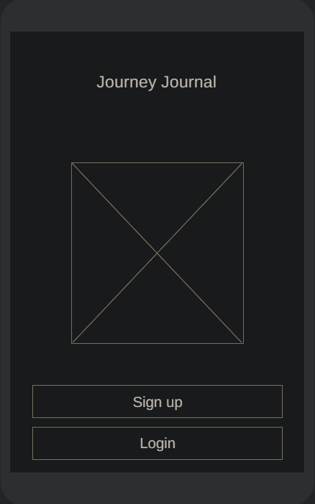

1. **Signup Page**

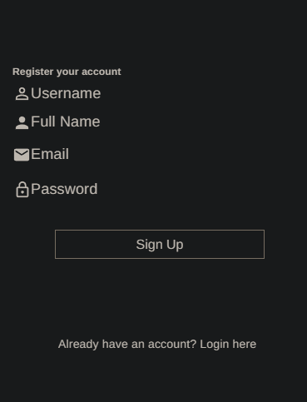

Sign up your account using the given details

1. **Login Page**

Login In to your account using the same username and password you entered while register.

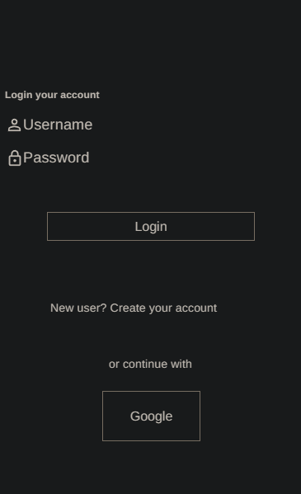

1. **Dashboard Page**

Here, the title and description are seen in the dashboard. Similarly, we can see the delete and edit icon on right side of it where we can delete and update the datas.

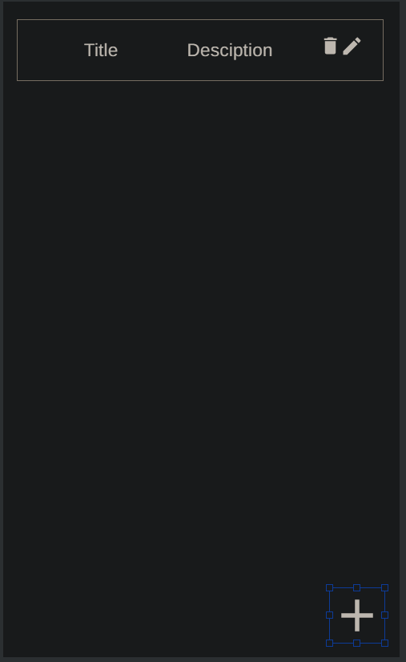

1. **Add journal page**

This is an page where you are going to add the journals.

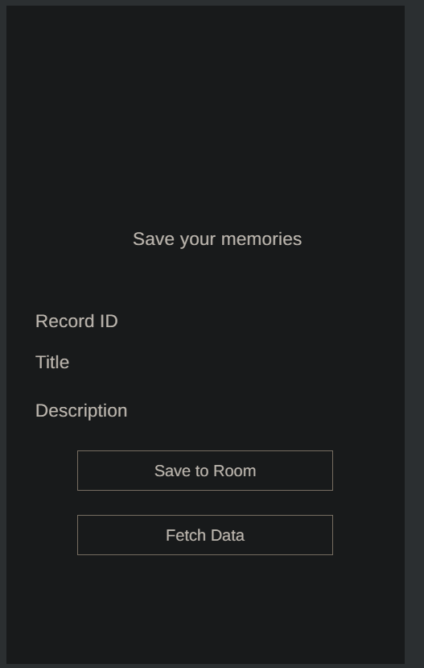

1. **Update Page**

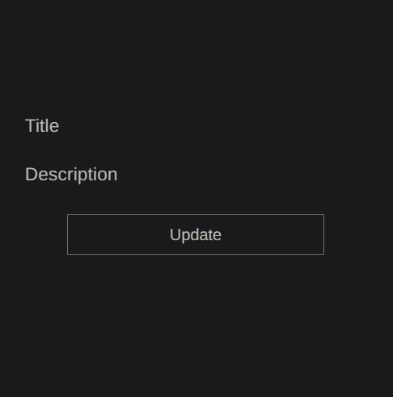

# Functionality

Main purpose of this application is to keep your travel memories in your mobile phone forever. More people will use the app if there are many different features like adding date, time, photos, location, weather situation, etc. Login and register are there surer.

In my app, there are some of the features like login, registering new user, adding your memories into the app.

**Firstly**, after you open the app, you will see the splash screen which will display for 2 or 3 sec. Secondly, you will navigate to the page where you will choose to Sign Up or Login.

**On Sign Up page**, you can see four inputs, Username, Full Name, Email and Password, but you are required to input Username and Password. As, they are required to Login to your account. There are different validations on this page such as duplicate Username where the user cannot give username which is already taken by others. Similarly, if the user gives empty data, he/she will see an error message and cannot let him/her to entry.

**On Login page,** the same username and password should be given and you can login. There is also some validation as it was in **SignUp** page. If the username or password is incorrect, app doesn’t let them to enter. If the user gives empty data, he/she will see an error message and cannot let him/her to Login.

**On Dashboard page,** you will see all your journal data which can be edited and deleted.

# Test Strategy and Test Results

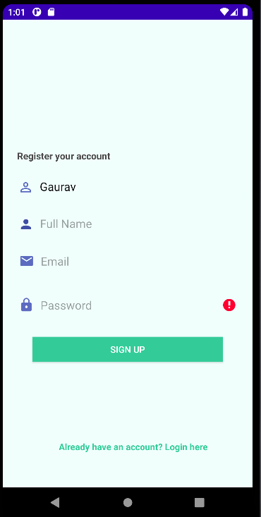Here, I tried to register with no any inputs that are required. There is an error on right side of the Username and Password.

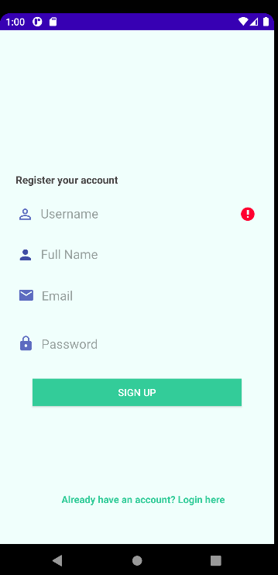

In the following photo, you can see the pop-up message “Already taken”, it is because I have already created one account called ‘Gaurav’. It won’t let me to enter same username.

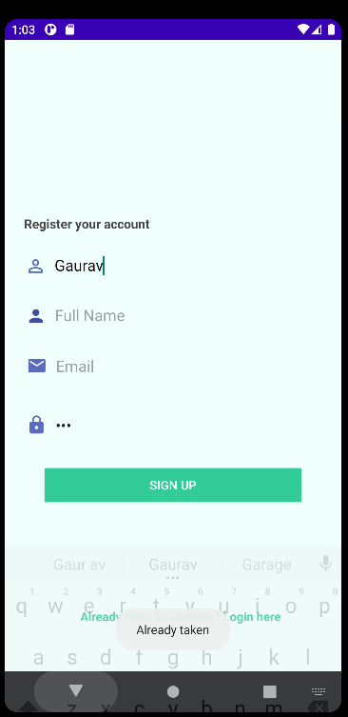

Here, I Login without entering the required data and popup message occurred saying:

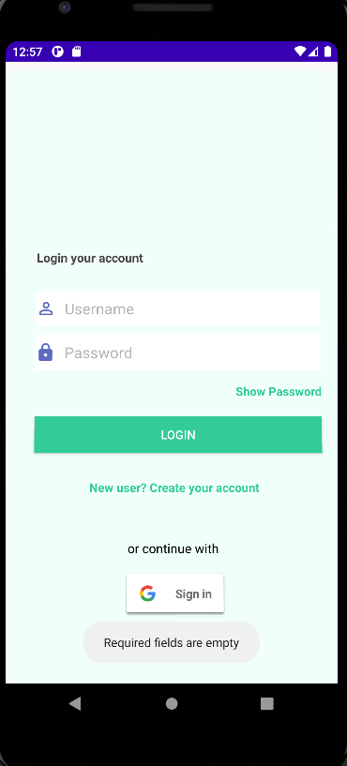

In the picture given below, I entered a random password and the app says “Invalid Username or password” and wont let me to login.

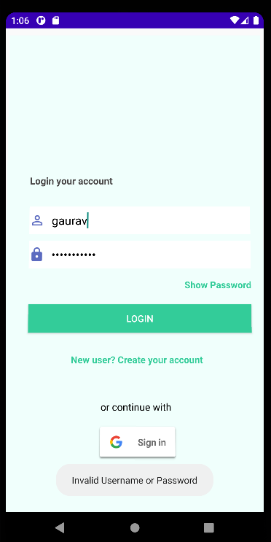

After you login with right credentials, you will the following picture given below:

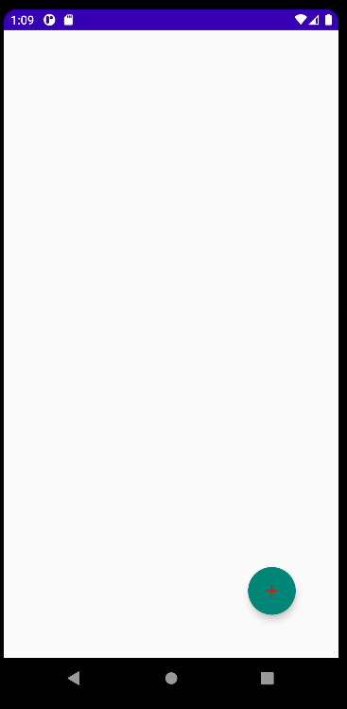

When you click the ‘+’ icon you will navigate to the entry page where you can enter the journal data as shown in following picture:

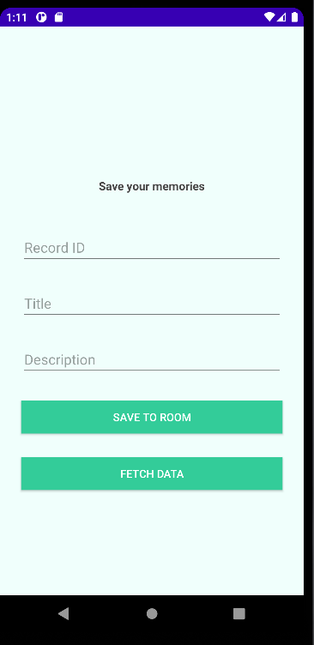

When you provide the information, your data will be saved and you can fetch data to see the dashboard again. You can see the saved data as give below.

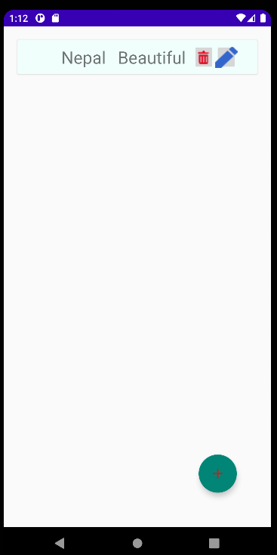

When you click the update or pencil icon, you can see the update page and edit your information.

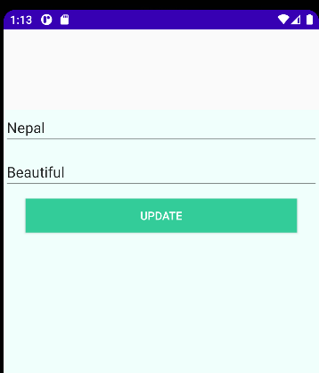

Data updated in the dashboard.

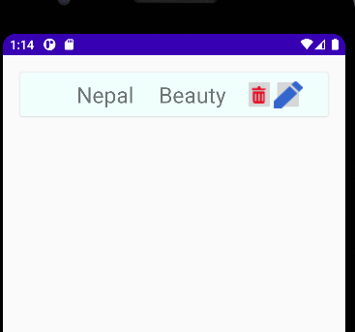

Lastly, when you press the delete icon, the respective data is deleted.

