# Planning Documentation

Any project or task require planning before completing them. It helps us to identify our objective clearly with right number of resources. Here is the project schedule of my project.

|  |  |  |  |  |  |  |
| --- | --- | --- | --- | --- | --- | --- |
| **Task to complete** | **Time (Hrs)** | **Evaluated Start-Date** | **Evaluated End Date** | **Actual Start Date** | **Actual**  **End Date** | **Deliverable** |
| Project scope | **20** |  |  |  |  |  |
| Discussion | 5 | 7/1/2022 | 7/6/2022 | 7/2/2022 | 7/6/2022 | Initial discussion and research of the project/website. |
| Proposal | 10 | 7/6/2022 | 7/10/2022 | 7/7/2022 | 7/10/2022 | Preparation of Proposal on the website. |
| Agreement | 5 | 7/10/2022 | 7/15/2022 | 7/10/2022 | 7/15/2022 | Agreement of the project was completed with the client. |
|  |  |  |  |  |  |  |
| Designed phase | **30** |  |  |  |  |  |
| Initial deigned idea | 10 | 7/15/2022 | 7/19/2022 | 7/16/2022 | 7/19/2022 | Discussion of designing the website (Flowchart and Wireframes) and its tools |
| Client requirement | 10 | 7/19/2022 | 7/25/2022 | 7/19/2022 | 7/24/2022 | Discussed functional and non-functional requirements from the client |
| Deigned revisions | 5 | 7/25/2022 | 7/29/2022 | 7/27/2022 | 7/29/2022 | Revised all the rough design and started preparing. |
| Final deigned approval | 5 | 8/1/2022 | 8/4/2022 | 8/1/2022 | 8/5/2022 | Completed Wireframe and Flowchart |
|  |  |  |  |  |  |  |
| Coding phase | **80** |  |  |  |  |  |
| Designed wireframe | 10 | 8/4/2022 | 8/10/2022 | 8/6/2022 | 8/10/2022 | Working on WordPress accordingly to Wireframes. |
| Database collection | 10 | 8/10/2022 | 8/15/2022 | 8/10/2022 | 8/15/2022 | Required data and information for website was collected. |
| Code validation | 10 | 8/15/2022 | 8/20/2022 | 8/15/2022 | 8/20/2022 | Validating the system. |
| Cross browser testing | 10 | 8/20/2022 | 8/25/2022 | 8/20/2022 | 8/25/2022 | Tested if the website worked on every browser. |
| Development | 30 | 8/25/2022 | 9/5/2022 | 8/26/2022 | 9/6/2022 | Developing of website started (Importing plugins, themes, etc) |
| Shown to client | 10 | 9/5/2022 | 9/8/2022 | 9/6/2022 | 9/8/2022 | Prepared for client meeting. |
|  |  |  |  |  |  |  |
| Content build phase | **20** |  |  |  |  |  |
| Site content pages | 10 | 9/8/2022 | 9/14/2022 | 9/8/2022 | 9/13/2022 | Different content of site was built up gradually. |
| Navigation structure | 10 | 9/14/2022 | 9/18/2022 | 9/14/2022 | 9/16/2022 | Shown how different pages on site were organized and connected to one another. |
|  |  |  |  |  |  |  |
| User experience phase | **20** |  |  |  |  |  |
| Final development | 15 | 9/18/2022 | 9/25/2022 | 9/17/2022 | 9/24/2022 | Finishing of the site. |
| Testing | 5 | 9/25/2022 | 9/28/2022 | 9/25/2022 | 9/29/2022 | Testing the website for final review. |
|  |  |  |  |  |  |  |
| Presentation phase | **20** |  |  |  |  |  |
| Review and testing | 10 | 9/28/2022 | 9/30/2022 | 9/29/2022 | 10/01/2022 | Review and final testing were completed |
| Final weeks | 5 | 9/30/2022 | 10/5/2022 | 10/01/2022 | 10/6/2022 |  |
| Shown to client | 5 | 10/5/2022 | 10/08/2022 | 10/6/2022 | 10/10/2022 | Final product shown to the client. Evaluation of the project. |
|  |  |  |  |  |  |  |
| Completion and launch | **10** | 10/08/2022 | 10/10/2022 | 10/10/2022 | 10/12/2022 | Launching the website (Domain name, Web Hosting, etc.) |
|  |  |  |  |  |  |  |

## Agile Method

**Introduction**

One of the newest development methodologies is the Agile Method. Due to the work-based technology, adaptability, and flexibility of this model—where developers are not needed to record their work—many developers find it to be stress-free. In this development model, the client will also be one of the members, therefore developers regard the consumer as one. As a result, member development is more rapid and effective than in other models. It combines a gradual and iterative procedure. (Hamilton, 2022) As a result, it constantly emphasizes flexibility and client pleasure while completing tasks quickly. In this strategy, consumers receive some minor builds in each iteration and the model is ready to use in one to three weeks. The cross-functional team collaborates on several topics during each iteration such as:

* Planning
* Requirements Analysis
* Design
* Coding
* Unit testing
* Acceptance testing

### Process of agile model

The process of agile model is given below:

1. **Requirements gathering**

In the agile approach, the team first gathers all the requirements via careful planning, maps out the documents for the specifications, determines the software or hardware requirements, and also gets ready for the subsequent phases of the cycle. It is the most crucial phase when adopting an agile development strategy to create any kind of application.

1. **Design**

After the needs are acquired, the planned stage takes place, during which the technical specifications that will be used are determined. At this point, the software's layout is appropriately created. The development step of software cannot be completed without adequate design.

1. **Development**

This is the third phase of the agile model's software development process. The software development stage starts when the layout of the program has been successfully designed. According to the software's requirements and design, the programmer begins writing code. Additionally, it is the pivotal step in the agile approach.

1. **Testing**

The testing phase of the software development cycle is started after the program has been created in order to find and track down any potential defects or problems. Testing is a crucial step after software creation since it identifies flaws and faults that may be repaired before the product is released to the public or made available to clients.

1. **Deploy**

The most crucial stage—implementation—begins after the testing phase. All planning, specification, and design papers created up to this point have been incorporated into the project's initial iteration.

1. **Review**

The review step starts once the program has been put into use. Sometimes there may be glitches or defects in the program that are not caught during testing. When such an issue arises, the customer will submit an evaluation of the program, which is crucial for future reference. Program review allows us to upgrade the software by correcting bugs and problems that have appeared in it.

**Justification for Decision**

As, I have been following Agile Methodology for my project/website. It helped me with the speed and agility as it is iterative nature. The product was high-quality at the end which was quite impressive. I had to change project requirements during the development process, as agile method is flexible, I was able to resolve this issue on the fly. Another benefit of Agile method is that the client was fully aware of the project progress time to time. Clients were not kept in dark. Using Agile method, I was able to complete my project on time and under the budget. Quick feedback is the plus point of Agile method on every section of the process.

### Use case for the agile model:

* User needs to be up-to-date dynamically.
* Low pricing for the changes because of the many iterations.
* No documentation requires like waterfall model, it requires only initial planning to start the project.

**Conclusion**

Therefore, I am learning to use Agile Project Management methodology more effectively. However, Agile method helped me to be more flexible, reduce risks, improve productivity and similarly, reduce costs of the project.

# Solution Design Documentation

Here are the **Flowchart** and **Wireframes** of my website.

**Flowchart**

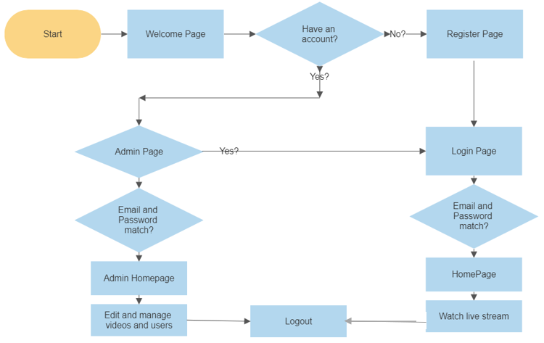

**Wireframes**

1. **Wireframe**
2. Register page where users can register their account. These fields are validate with different validation such as users cannot register with blank fields, Email should be

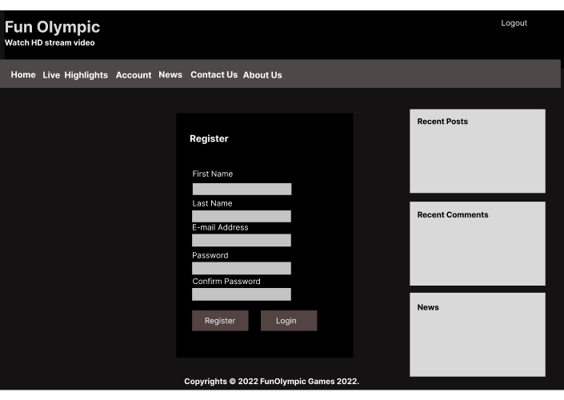

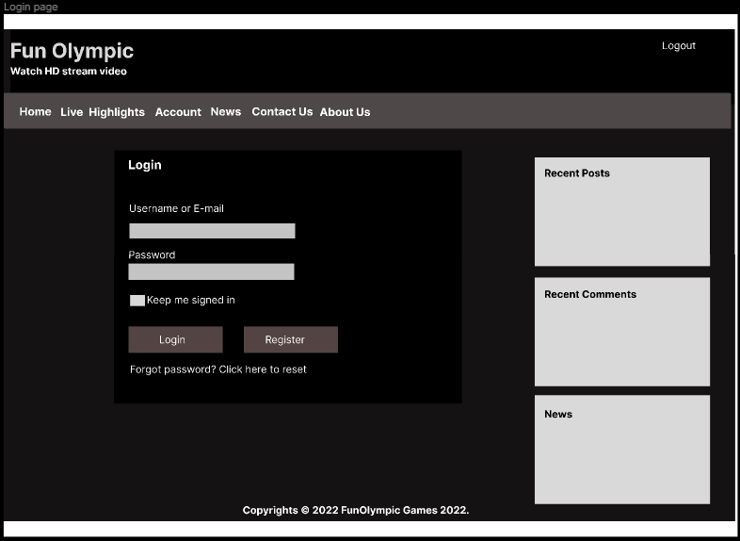

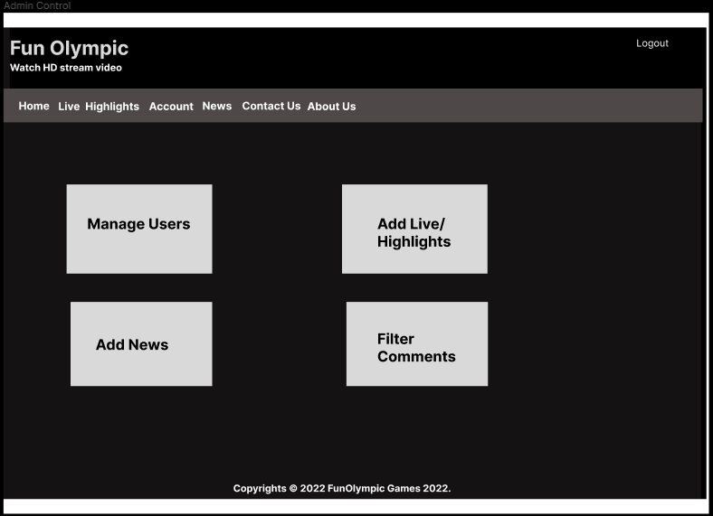

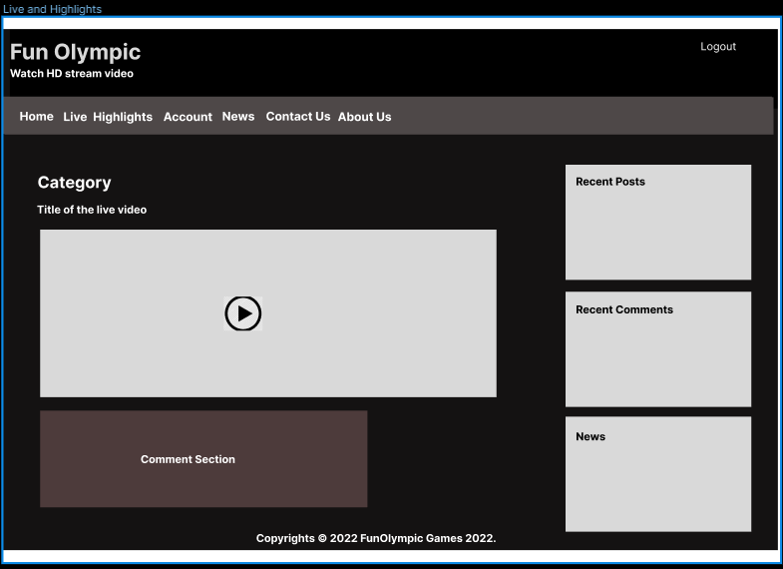

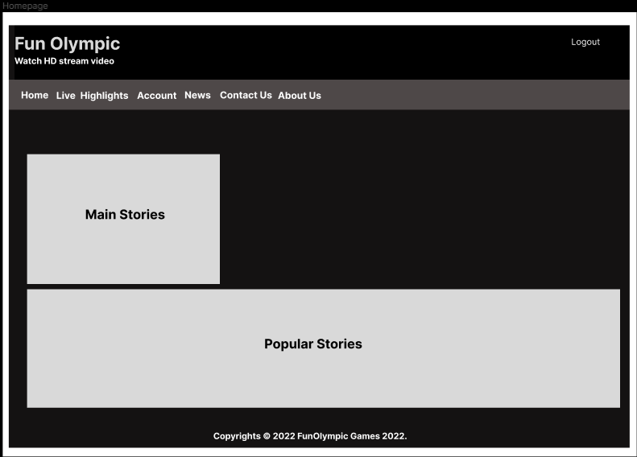

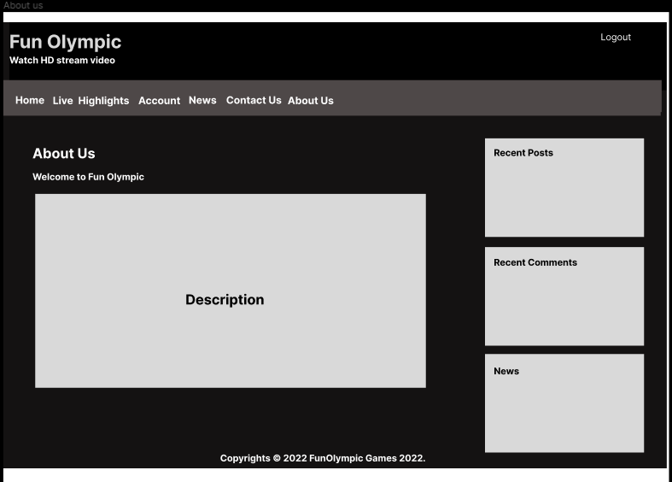

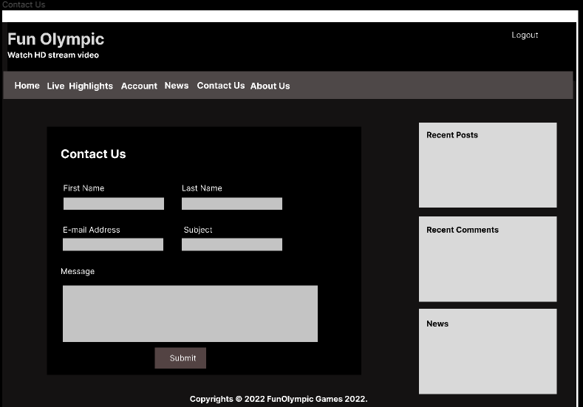

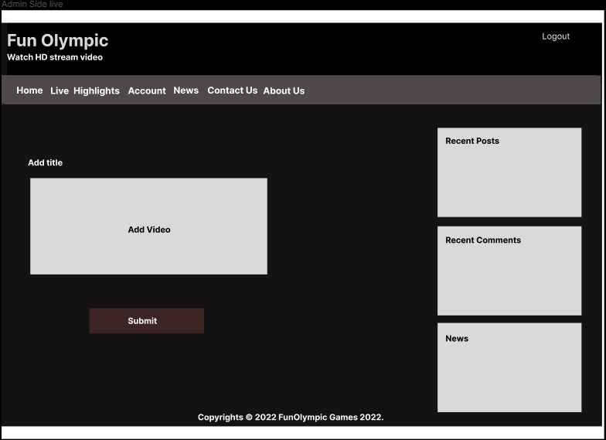

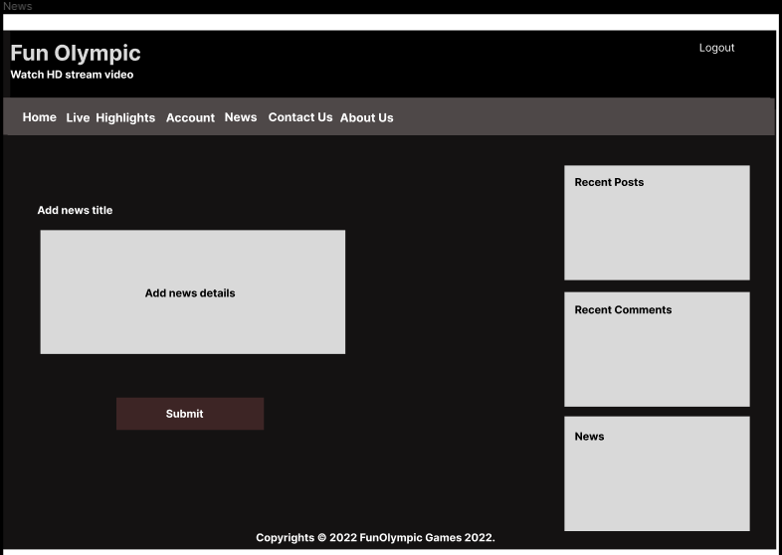

**6. Testing:**

|  |  |  |  |  |
| --- | --- | --- | --- | --- |
| **No.** | **Test Description** | **Expected Result** | **Performed as expected?** | **If no, what happened? (Fixed/ Unfixed)** |
| 1. | Checking if the database is working fine. | Database named ‘productdev’ will be created by the admin and all the tables will create automatically. | Yes |  |
| 2. | Verify if user filled all mandatory fields before submitting a form | Error message will top up informing user to fill the required fields. | Yes |  |
| 3. | Verity if admin and user member type are working correctly. | Users are redirected to respective pages so is admin. | Yes |  |
| 4. | Regression Testing Performed after module has completed. | Every Functional and some non-functional works as expected. | Yes |  |
| 5. | Random user trying to view the content by entering URL specifically | Error message will pop up warning them. | Partial | Visitors are allowed to see the recent comments section but cannot access them |
| 6. | Logged In users allow to watch stream. | Only logged in user are allowed to watch it. | Yes |  |
| **Admin View** | | | | |
| 1. | Allow to add/edit/delete live and highlight streaming. | Admin are allowed to do so. | Yes |  |
| 2. | Check if admin can Update/Delete users and their account. | Admin can delete and update user’s account. | Yes |  |
| 3. | Are admin allowed to delete bad comments and block the respective user? | Admin can easily remove comment and block the user. | Yes |  |
| 4. | Can Admin also watch the videos? | Admin can even watch the stream | Yes |  |
| **User View** | | | | |
| 1. | Logged out user attempt to view content. | Error message will display and content will be hidden. | Yes |  |
| 2. | Logged in user attempt to view content | Logged in user can view the content but cannot edit or delete. | Yes |  |
| 3. | Allow to comment on live and highlight videos. | Users are allowed to comment and even like the other user’s comment. | Partial | User cannot like their own comment. |
| 4. | Video like and dislike button. | Users can like and dislike videos. | Yes |  |
| 5. | Add personal information and profile pictures of your won. | Any Logged In users can add their personal information and profile pictures. | Yes |  |
| 6. | User allow to hide profile from public directory. | Users can hide their profile. | Yes |  |
| 7. | User allow to Request Data and Request data erase. | Every user can Request all their Data and Request to erase the data. | Yes |  |
| 8. | Delete account. | Users can delete their account. (They need to enter password before deleting) | Yes |  |
| 9. | Change language of their nationality. | Every international user can change view to their respective language. | Yes |  |
| **Register Page** | | | | |
| 1. | Tried to register with blank fields. | Error message shows up informing the user to fill every fields. | Yes |  |
| 2. | Tried to register with invalid Email. (Example: gaurav@.com) | Error message shows up informing the user to enter valid Email | Yes |  |
| 3. | Tried to register with weak password. (Example: 1234, abcd) | Error message shows up saying ‘Your Password must contain at least 8 characters, at least one lowercase letter, one capital letter and one number’ | Yes |  |
| 4. | Tried to register with no blank fields and all valid information. | Registered the user | Yes |  |
| **Login Page** | | | | |
| 1. | Tried to login inserting incorrect username and password | He/she cannot login and error message is shown up. | Yes |  |
| 2. | Tried to log in inserting incorrect username and correct password | He/she cannot login and error message is shown up saying “input valid credentials” | Yes |  |
| 3. | Tried to log in inserting valid username and password | He/she will finally be logged in and redirect to the homepage based on his/her member type (Admin/User) | Yes |  |
| 4. | Clicks ‘Forgot your password?’ | User will be redirect to Password Reset page and be able to reset his/her password | Yes |  |

**7. Technical Deployment of the Solution:**

## Technical Requirements

1. **Mobile Responsive Design:** Well Responsive Design is said when your website runs smoothly on different devices such as mobile phone, tablet (tab), laptop and desktop.
2. **SSL Certificate:** Websites can switch from HTTP to HTTPS, which is more secure, thanks to SSL certificates. A data file called an SSL certificate is kept on the origin server of a website. The public key and identity of the website, as well as other pertinent data, are both contained in SSL certificates, which enable SSL/TLS encryption. In order to retrieve the public key and confirm the server's legitimacy, devices attempting to interact with the origin server will consult this file. The private key is secured and kept confidential.
3. **Website Hosting Service:** The online service of web hosting makes the content of your website available to internet users. When you buy a hosting package, you are renting space on a real server to keep all the files and information for the website. Web hosts offer the resources and hosting technologies needed for your website to run efficiently and securely. They are in charge of maintaining the server's functionality, putting security measures in place, and making sure that information like texts, pictures, and other files are correctly delivered to the visitors' browsers.
4. **Create and submit XML Sitemap:** A website's key pages are listed in an XML sitemap file so that Google can easily identify and index them all. Additionally, it aids in the structure-understanding of search engines. You want Google to index all of your website's key pages. However, occasionally pages are created without internal links connecting to them, making it difficult to discover them. The finding of material can be sped up with a sitemap.
5. **Browser Capacity:** Browser capacity refers to a website, web application, script, or HTML design's capacity or flexibility to work on various market-available web browsers. The advantage of designing a website with browser capacity is that it expands its audience and reduces performance loss. Browser compatibility is also the ability of a web browser to effectively render HTML code and execute scripts on online sites.
6. **Website Page Load Time:** Page load time, put simply, is the length of time it typically takes for a page to appear on your screen. It is determined from the point of inception (when you click on a page link or enter a Web URL) to the point of completion (when the page is fully loaded in the browser).

## Development Environment

WordPress is not just blogging tool; it is a powerful website builder and a content management system (CMS). It is easy and flexible enough to use and navigate. Therefore, I will be using WordPress for my website development. It is perfect for everyone with Windows, Linux and Unix-like OS. As I have been using this tool, I found that it provides different Themes and Plugins that changes and adds different kind of colors and features.

Similarly, WordPress uses MySQL for its database, which is open-source software. I also used [www.figma.com](http://www.figma.com) for my design.

## Platform Environment

I have used XAMPP which includes PHP, MySQL, Apache Server, etc for hosting the website for instance in my PC. System requirements defines the configuration that a system must have for a hardware or software, application to run smoothly and efficiently. Incase these requirements are not met, there might be failure of installing the software or performance problems. Performance can differ from different computers, laptops according to their System.

**Recommended Hardware Requirements for WordPress are:**

**Disk Space:** 1GB+

**Web Server:** Apache or Nginx.

**Database:** MySQL version 5.0. 15 or greater or any version of MariaDB.

**RAM:** 512MB+

**PHP:** Version 7.3 or greater.

**Processor:** 1.0GHz+

Note: Always use computers on which there is NTFs file format. It is most secured file system. Also, use windows 8 or above for better performance.

Website Deployment(Anon., n.d.)

It is the final process where website is moved from local environment (local host) to live servers from where anyone in the world can access the website. Here are the steps to **deploy a website:**

1. **Prepare**
2. **Set up DNS Records**
3. **Set up Live Testing Site**
4. **Set up Email Accounts**
5. **Backup, and go live**

**Step I: Prepare**

Preparation is the initial stage of website deployment. Depending on the type of deployment you are carrying out, there are a few factors you should take into account at this point. Typically, there are three possible outcomes when deploying a website:

* **Client’s first website and starting website from zero:** Because you get to start over, the first scenario is the simplest. All you have to do is purchase or offer web hosting and register their domain name.
* **If the client currently hosts their website, you will either move it to their server or deploy it there:** The deployment step will be more engaged in these scenarios due to their complexity and involvement. To manage DNS records, we need to get information on domain management from the current web-host.

**Step II: DNS Records**

Second phase applies to create DNS records. A DNS record is a database entry that links an IP address to a URL. DNS servers hold DNS records, which are used to assist users in connecting their websites to the outside world. The URL is passed to the DNS servers and then directed to the particular Web server when it is typed into the browser and searched. The requested website specified in the URL is subsequently served by this Web server, or the user is instead sent to an email server that handles incoming mail.

**Step III: Set Up a Live Testing Site**

This is the most important part where the purpose is to determine whether the website functions properly on a live server.

**Step IV: Set Up Email Accounts**

Setting up email is a task that many web developers frequently forget. It is frequently, nonetheless, of utmost importance to your customer.

**Step V: Backup, and Go Live!**

Last but not least, always remember to back up any databases on the previous web-server or website. You never know when anything could come in handy. You are now prepared to go live!

Simply go back to the previous webpage and do some testing if you discover a problem.