✈️ Flight Delays – Exploratory Data Analysis in R

Gaurav Sharma

2025-09-02

# Objective

Analyze a flight delays dataset to understand how departure time, weather, carriers, and distance affect delays.

# Tools Used

* R
* ggplot2
* dplyr
* psych

# Process

* Imported & cleaned dataset
* Checked missing values
* Summarized descriptive statistics
* Plotted histograms, bar plots, scatter plots, box plots, and pie chart
* Defined departure hours (0–23)
* Built categorical tables (delay vs weather, carrier, day of week)
* Redefined delay variables

# Key Insights

* 🌅 Morning flights are more punctual than evening ones
* 🌦️ Bad weather strongly increases delays
* 🏢 Certain carriers show higher delay rates
* 📊 About XX% of flights were delayed overall

# Visuals

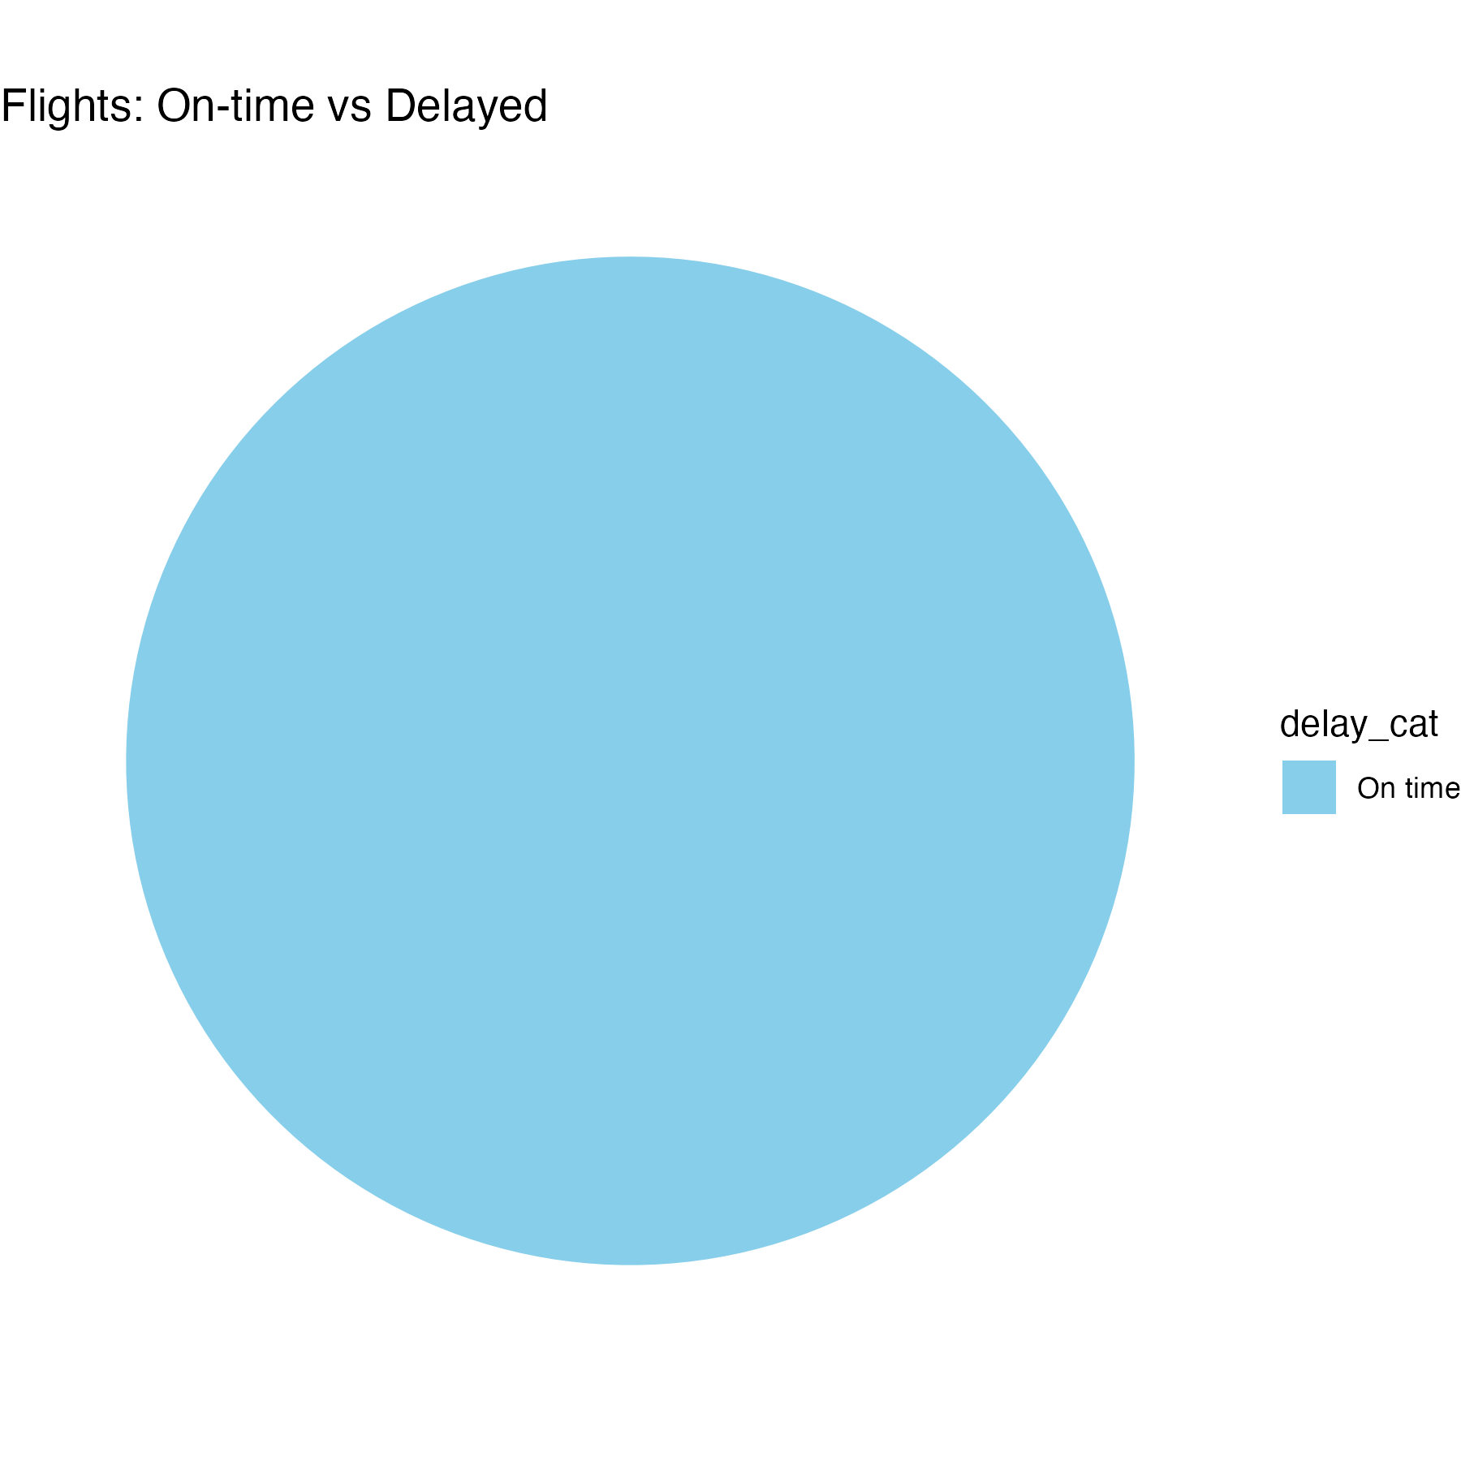  
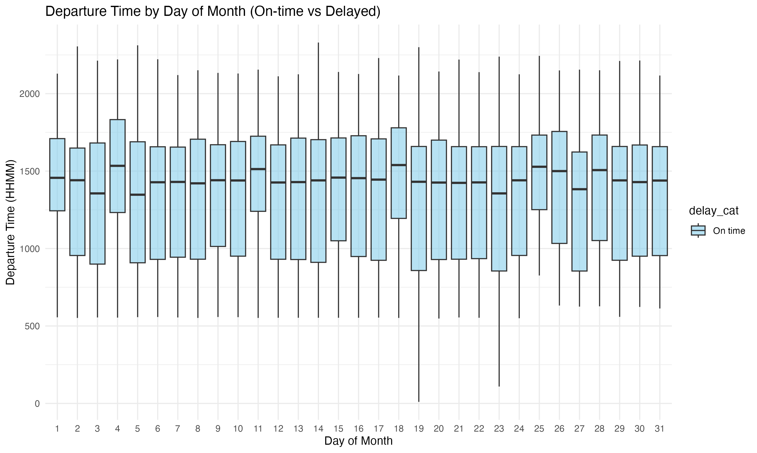  
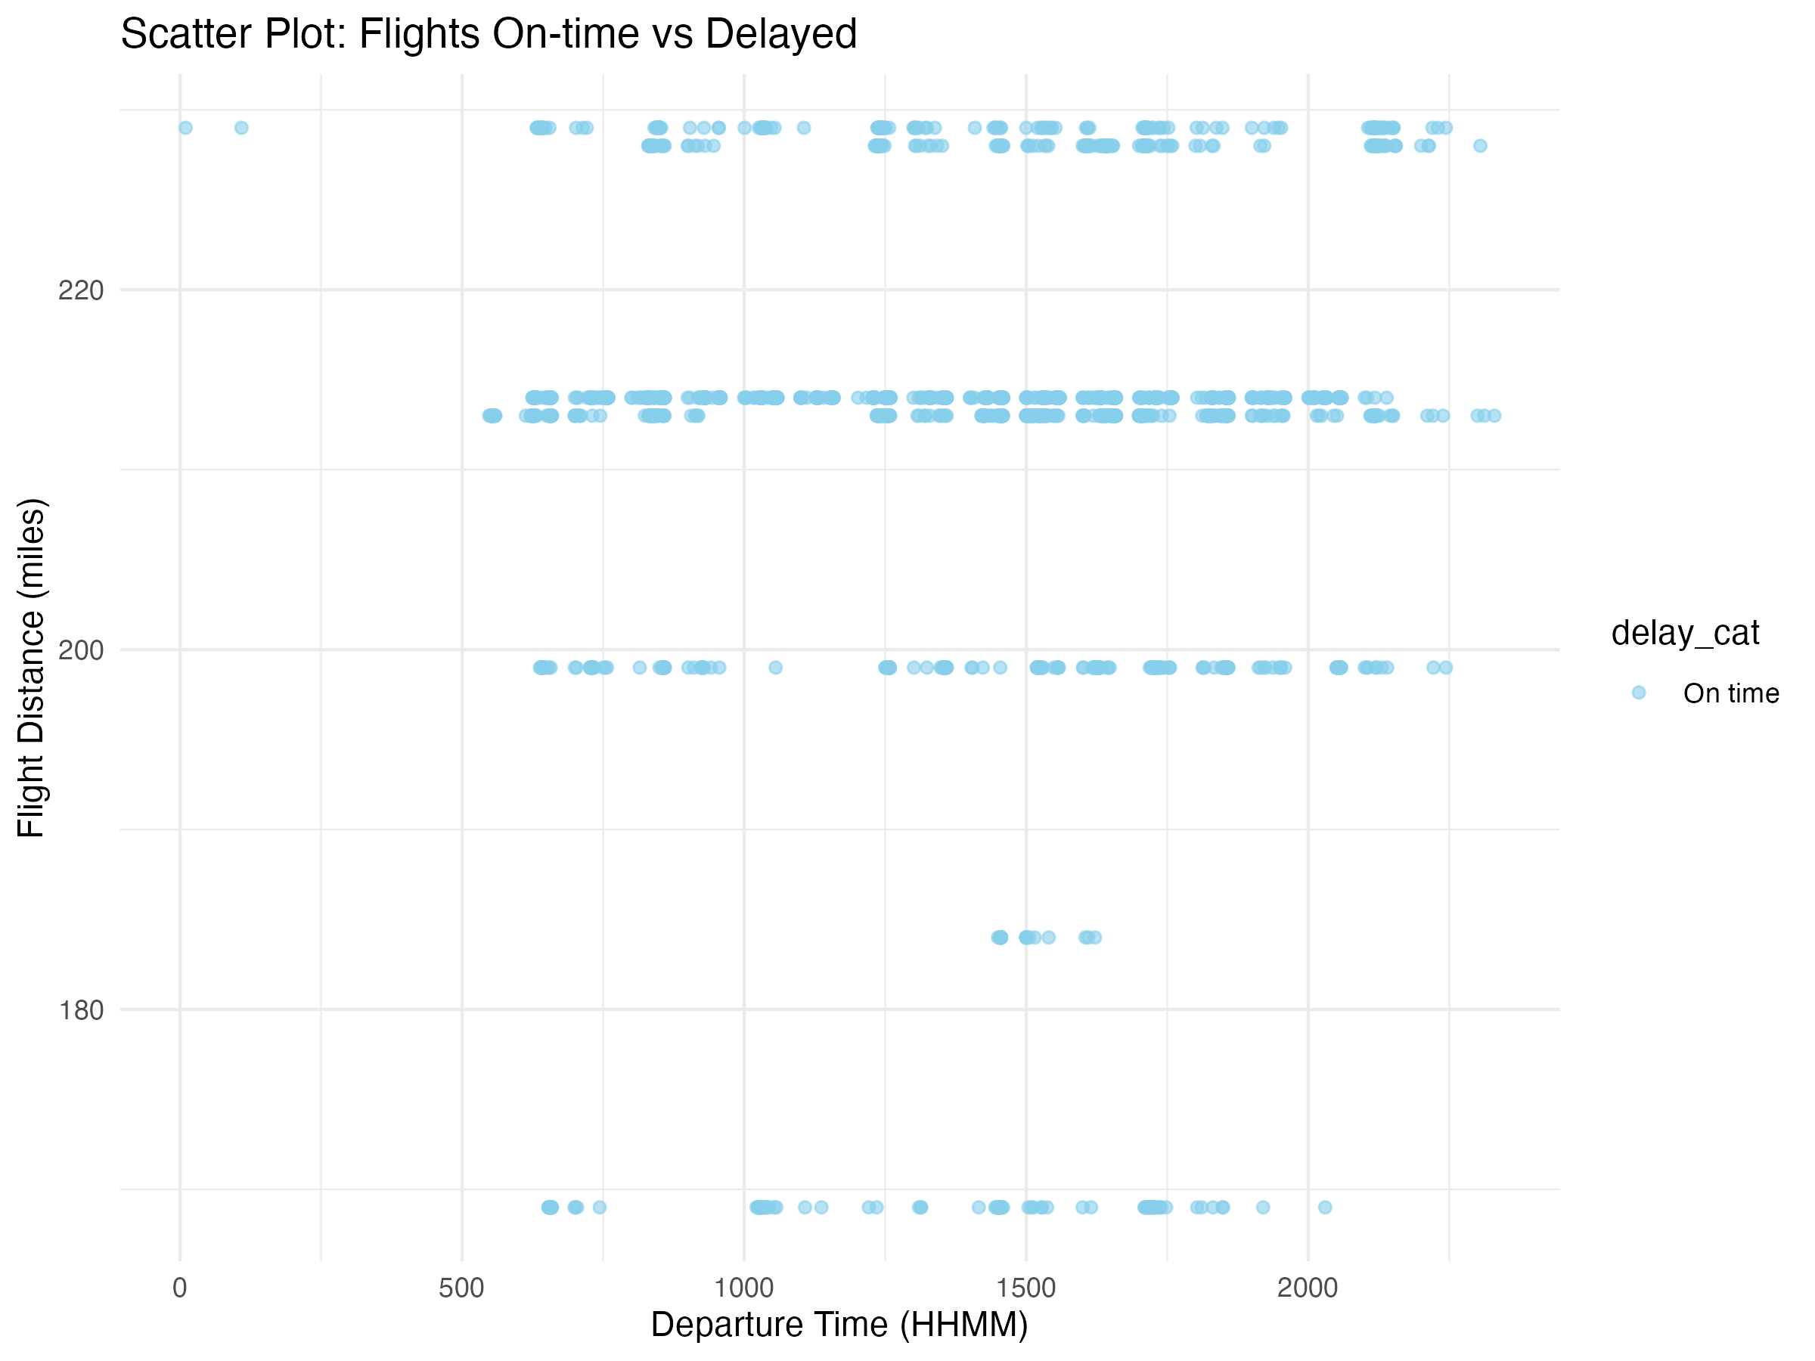

# Conclusion

This project strengthened my skills in **data cleaning, descriptive statistics, visualization, and storytelling with R**.