1. Our National Anthem originally compose in bangla but later translated in hindi and adopted as national Anthem of india on 24 jan 1950
2. The Sulaiman and Kirthar hills to the northwest. Some of the areas where women and men first began to grow crops such as wheat and barley about 8000 years ago are located here.
3. 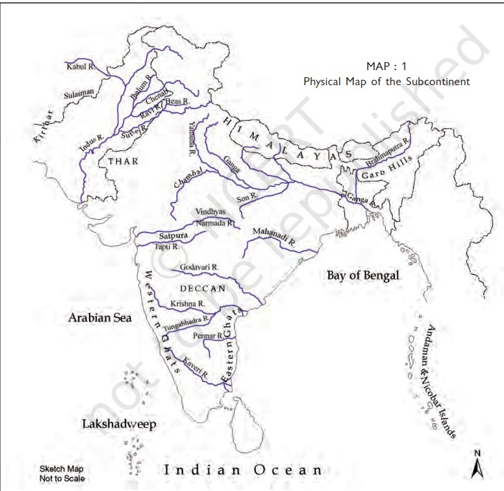

3) Locate the Garo hills to the north-east and the Vindhyas in central India.

4)The places where rice was first grown are to the north of the Vindhyas.

5)Trace the river Indus and its tributaries (tributaries are smaller rivers that flow into a larger river.

6)Locate the Ganga and its tributary called the Son. In ancient times the area along these rivers to the south of the Ganga was known as Magadha now lying in the state of Bihar.

7)In ancient times the area along these rivers to the south of the Ganga was known as Magadha now lying in the state of Bihar. Its rulers were very powerful, and set up a large kingdom. Kingdoms were set up in other parts of the country as well.

8)Two of the words we often use for our country are India and Bharat. The word India comes from the Indus, called Sindhu in Sanskrit.

9) The Iranians and the Greeks who came through the northwest about 2500 years ago and were familiar with the Indus, called it the Hindos or the Indos, and the land to the east of the river was called India

10)The name Bharata was used for a group of people who lived in the northwest, and who are mentioned in the Rigveda

11)A page from a palm leaf manuscript. This manuscript was written about a thousand years ago. The palm leaves were cut into pages and tied together to make books

12)Inscriptions. These are writings on relatively hard surfaces such as stone or metal.

13)An old inscription. This inscription dates to about 2250 years ago, and was found in Kandahar, present-day Afghanistan. It was inscribed on the orders of a ruler named Ashoka. Scripts consist of letters or signs. When we read what is written, or speak, we use a language. This inscription was inscribed in two different scripts and languages, Greek (top) and Aramaic (below), which were used in this area.

14)BC, we have seen stands for ‘Before Christ.’ You will sometimes find AD before dates. This stands for two Latin words, ‘Anno Domini’, meaning ‘in the year of the Lord’ (i.e. Christ). So 2012 can also be written as AD 2012.

15)We have seen that inscriptions are inscribed on hard surfaces. Many of these were inscribed several hundreds of years ago. All inscriptions contain both scripts and languages. Languages which were used, as well as scripts, have changed over time. So how do scholars understand what was inscribed? This can be done through a process known as decipherment.

16)

One of the most famous stories of decipherment comes from Egypt, a country in north Africa where there were kings and queens about 5000 years ago.

Rosetta is a town on the north coast of Egypt, and here an inscribed stone was found, which contained inscriptions in three different languages and scripts (Greek, and two forms of Egyptian). Scholars who could read Greek figured out that the names of kings and queens were enclosed in a little frame, called a cartouche. They then placed the Greek and the Egyptian signs side by side, and identified the sounds for which the Egyptian letters stood.

As you can see, a lion stood for L, and a bird for A. Once they knew what the letters stood for, they could read other inscriptions as well.

17) hunter-gatherers: They hunted wild animals, caught fish and birds, gathered fruits, roots, nuts, seeds, leaves, stalks and eggs.

There are at least four reasons why huntergatherers moved from place to place.

First, if they had stayed at one place for a long time, they would have eaten up all the available plant and animal resources. Therefore, they would have had to go elsewhere in search of food.

Second, animals move from place to place — either in search of smaller prey, or, in the case of deer and wild cattle, in search of grass and leaves. That is why those who hunted them had to follow their movements.

Third, plants and trees bear fruit in different seasons. So, people may have moved from season to season in search of different kinds of plants.

Fourth, people, plants and animals need water to survive. Water is found in lakes, streams and rivers. While many rivers and lakes are perennial (with water throughout the year) others are seasonal. People living on their banks would have had to go in search of water during the dry seasons (winter and summer).

Besides, people may have travelled to meet their friends and relatives. Remember, they travelled on foot

18)

All the places marked with red triangles are sites from which archaeologists have found evidence of hunter-gatherers.

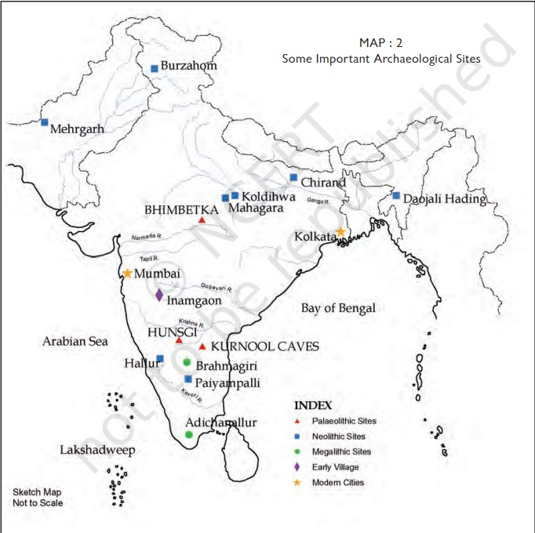

19)

Bhimbetka (in presentday Madhya Pradesh). Some sites, known as habitation sites, are places where people lived. These include caves and rock shelters such as the one shown here. People chose these natural caves because they provided shelter from the rain, heat and wind. Natural caves and rock shelters are found in the Vindhyas and the Deccan plateau. These rock shelters are close to the Narmada valley.

20)

The major rivers of India are:

* Flowing into the Arabian Sea: [Narmada](https://en.wikipedia.org/wiki/Narmada_River), [Tapi](https://en.wikipedia.org/wiki/Tapti_River), [Sindhu](https://en.wikipedia.org/wiki/Sindhu_River), [Sabarmati](https://en.wikipedia.org/wiki/Sabarmati_River), [Mahi](https://en.wikipedia.org/wiki/Mahi_River), [Purna](https://en.wikipedia.org/wiki/Purna_River_(Gujarat))
* Flowing into the Bay of Bengal: [Brahmaputra](https://en.wikipedia.org/wiki/Brahmaputra), [Yamuna](https://en.wikipedia.org/wiki/Yamuna), [Ganga](https://en.wikipedia.org/wiki/Ganga), [Meghna](https://en.wikipedia.org/wiki/Meghna), [Mahanadi](https://en.wikipedia.org/wiki/Mahanadi_river), [Godavari](https://en.wikipedia.org/wiki/Godavari), [Krishna](https://en.wikipedia.org/wiki/Krishna_River), [Kaveri](https://en.wikipedia.org/wiki/Kaveri_River), [Penna River](https://en.wikipedia.org/wiki/Penna_River)

people lived here for longer spells of time. These sites are called habitation-cum-factory sites.

If you had to describe the place you live in, which of the terms would you choose?

(a) habitation-cum-factory

21)

Find the Kurnool caves on Map 2 (page14). Traces of ash have been found here. This suggests that people were familiar with the use of fire. Fire could have been used for many things: as a source of light, to roast meat, and to scare away animals.

22)

Archaeologists have given lengthy names for the time that we are studying. They call the earliest period the Palaeolithic. This comes from two Greek words, ‘palaeo’, meaning old, and ‘lithos’, meaning stone.

The Palaeolithic period extends from 2 million years ago to about 12,000 years ago

23)

The period when we find environmental changes, beginning about 12,000 years ago till about 10,000 years ago is called the Mesolithic (middle stone). Stone tools found during this period are generally tiny, and are called microliths. Microliths were probably stuck on to handles of bone or wood to make tools such as saws and sickles.

24)

The next stage, from about 10,000 years ago, is known as the Neolithic.

25)

A closer look – Hunsgi Find Hunsgi on Map 2 (page14). A number of early Palaeolithic sites were found here. At some sites, a large number of tools, used for all sorts of activities, were found. These were probably A painting from a rock shelter. Describe the painting. 2018-19 19 n habitation-cum factory sites.Most tools were made from limestone

26) The Mesolithic period (12,000-10,000 years ago)

The beginning of the Neolithic (10,000 years ago)

