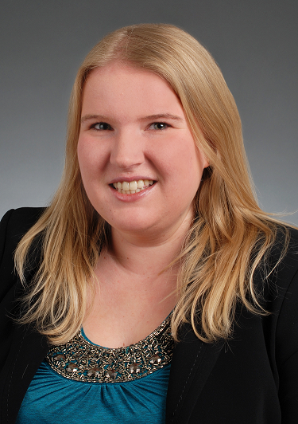

**Sonja Weder**

**Address:**  Dufourstrasse 85, 8008 Zurich

**Telephone:** +41(0)797438225

**E-mail:** Sonja.Weder@gmail.com

**Date of Birth:** 15 August 1989

**Nationality:** Switzerland & USA

## WORK EXPERIENCE

**Trans Adriatic Pipeline (TAP)-(Plans, develops and builds the natural gas pipeline, from Greece/Turkey to Italy) February 2014-November 2015**

Baar, Switzerland

**Procurement Assistant**

* Typed and formatted documents for Statements of Work, Requisition Forms, and Formal Letters
* Filed over hundreds of contracts electronically and manually per company procedure.
* Processed and controlled 6 electronic mailboxes: opening, forwarding and responding as needed.
* Handled and sorted incoming boxes full of documents needed for large team project
* Assisted with meetings including sending meeting invitations, taking notes, preparing schedules, setting up conference calls/video conference calls and helping with presentations/reports to make sure its quality standard.
* Sent out and created contracts, amendments, and requisition forms, in TAP’s SAP system, and Edoras system.
* Assisted in preparation, review and administration of contractual documents relating to PO’s, and change orders.
* Assisted with development of written materials and manuals and standardizing systems and procedures
* Performed a variety of clerical duties in support of the procurement department, which included managing phones, emailing documents, report creation and generation.

**SASE Company, Inc-(Surface Preparation Equipment (Concrete Polishing & Grinding) September 2011-July 2013**

Phoenix, Arizona

**Administrative Assistant, part time**

* Coordinated calendars, scheduled meetings and travel arrangements
* Composed, designed, edited and prepared various correspondences, documents, invoices and reports
* Greeted and directed customers to relevant parties to receive proper service
* Arranged transportation, food, sleep and activities for relevant parties and guests arriving
* Answered phones and maintained stationary supplies
* Received, sorted and redirected and prioritized incoming mail
* Assisted accounts payable and receivable with payment processing for outside contractors and vendors.

**Safeway-(American Supermarket Chain)**

**September 2011-July 2013**

Phoenix, Arizona

**Wine Steward, part time**

* Established and developed relationships with customers by educating them about wines, beers and or spirits
* Developed and organized unique customer tasting and sampling events
* Maintained superior customer service and increasing customer loyalty by having friendly, casual conversations with customers about wine, beer, spirits, and beverage pairing
* Enhanced the customer shopping experience by recommending wines, beers, and spirits and food and beverage pairings
* Handled customer complaints, comments, suggestions, and special orders
* Communicated with wine buyer for special orders and information needed to maintain standards and customer service in the spirits area
* Implemented the liquor department’s monthly/weekly liquor merchandising plan
* Ensured the proficiency and profitability of the liquor departments by executing marketing plans
* Maintained liquor department schematics, safety and sanitation

**JW Marriott Camelback Inn & Spa-(Worldwide & International Hotel Chain)**

**February 2010-September 2011**

Phoenix, Arizona

**Spa Attendant**

* Served as a primary support for the Massage Therapists, technicians and guests
* Ensured that every guest had a friendly, inviting and memorable experience
* Answered incoming calls, scheduled appointments and gave service recommendations
* Ensured shelves were maintained by cleaning and stocking shelves especially when product orders were delivered

## LANGUAGES

**English -** Mother tongue

**German –** A1 (In the process of learning)

## EDUCATION

**High School Diploma August 2003-May 2007**

Sedona Red Rock High School

Sedona, Arizona

**Arizona State University August 2007-May 2008**

Tempe, Arizona

**Scottsdale Community College August-2008-May 2011**

Scottsdale, Arizona

## KNOWLEDGE

* Microsoft Office (Word, Excel, Power-point)
* Microsoft Outlook
* SAPGui-Citrix Ink- Advanced
* Edoras

## Acquired Skills

* Communication skills
* Organizational skills affirmed in multi-tasks handling
* Excellent team player and quick learner in fast paced environment
* Quick and responsive to solving problems
* Excellent interpersonal skills

## PERSONAL INTERESTS

* Culinary Arts
* Travelling
* NBA Basketball